Supplementary Information Figure S1.
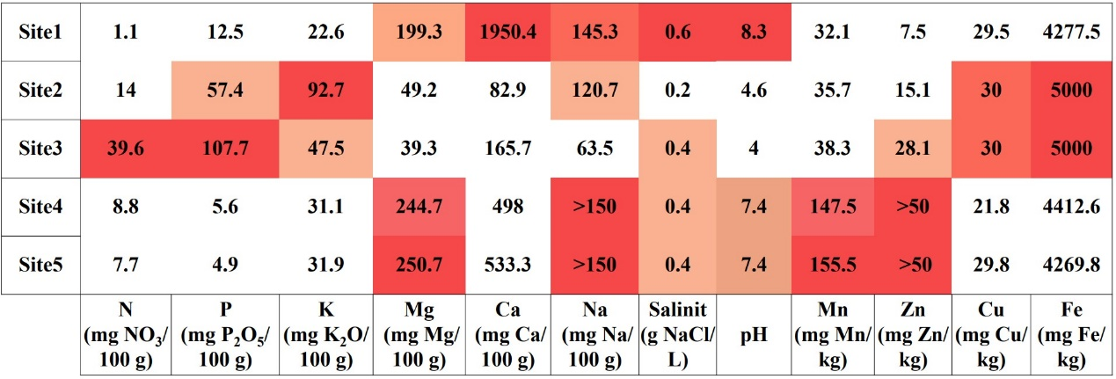
Sampling sites 1–5 geochemical composition of the soil.

Supplementary Information Table 1. Sampling site characteristics.
Sampling  Site | Geographical  coordinates | Distance  to the sea | Altitude | Structure of vegetation | Landform and habitat
S1 | 62° 08′01″ S  58° 07′25″ W  Lions Rump | 100 m | 1 m.a.s.l, | Dense with crustose, fruticose and foliose lichens (60%), mosses (30%), isolated Deschampsia antarctica (5%), and Colobanthus quitensis (5%) specimens | Scree debris; Eutric Protic  Skeletic Leptic Regosol (Turbic). Very limited human infuence, remains under direct infuence of marine aerosols
S2 | 62° 09′48″ S  58° 28′09″ W  Puchalski Hill | 500 m | 110 m.a.s.l, | Dense with Colobanthus quitensis (15%), Deschampsia antarctica (15%), mosses (20%), and fruticose and foliose lichens (50%) | Tundra on slope; Skeletic  Protic Turbic Cryosol  (Dystric, Humic, Ornithic).  The site is located on an abandoned penguin colony, fertile, dry and exposed,  with a little infuence of  marine aerosols
S3 | 62° 09′45″ S  58° 27′46″ W  Point Thomas  Penguin Rookery | 100–120 m | 10 m.a.s.l, | Dense with Deschampsia antarctica (60%), mosses (15%),  crustose lichens (15%), and Colobanthus quitensis (10%) | Bare rocks with soils enriched by penguins; Eutric Skeletic Lithic Leptosol (Humic, Ornithic, Protic). Area in the vicinity of breeding colony of penguins. Moist site supplied with water from melting snow with washings of guano deposits from penguin's rookeries, remains under direct infuence of marine aerosols
S4 | 62° 09′35″S  58° 28′26″ W  Arctowski Station | 120 m | 0.5 m.a.s.l, | Colobanthus quitensis (15%), Deschampsia antarctica (25%), Poa annua (10%), mosses (25%) and fruticose,  folioseand crustose lichens (25%). | Base station, soil mechanically altered by human activities;  Skeletic Eutric Fluvisol (Turbic) The site is strongly influenced  by marine aerosols, moist, with large human influence.
S5 | 62° 09′33″ S  58° 28′25″ W  Arctowski Station | 100 m | 0.5 m.a.s.l, | Colobanthus quitensis (15%), Deschampsia antarctica (25%), Poa annua (10%), mosses (25%) and fruticose,  folioseand crustose lichens (25%). | Base station, soil, mechanically altered by human activities;  Skeletic Eutric Fluvisol (Turbic). The site is medium influenced by marine aerosols, moist, with large human influence, especially by using big vehicles.

Note: S1–S3—Deschampsia antarctica samples；S4–S5—Poa annua samples.

