Compound Impacts of Monsoon and Westerlies on Summer Precipitation over Tibetan Plateau
Xuefeng Dong^{1,2}, Yuzhi Liu^{1,3*}, Xiaoqiang Yan⁴, Yingsi Wang⁵, Ziyuan Tan¹, Min Luo¹, Dan Li¹, Ying Wang², Shijia Tang²

¹Key Laboratory for Semi-Arid Climate Change of the Ministry of Education, College of Atmospheric Sciences, Lanzhou University, Lanzhou 730000, China
²Sanshui Meteorological Bureau, Foshan 528000, China
³Collaborative Innovation Center on Forecast and Evaluation of Meteorological Disasters (CIC-FEMD), Nanjing University of Information Science & Technology, Nanjing 210000, China
⁴Chengdu Weather Modification Office, Chengdu 610000, China
⁵Puning Meteorological Bureau, Jieyang 522000, China

Author: Xuefeng Dong, 120220900961@lzu.edu.cn
Corresponding author: Yuzhi Liu, liuyzh@lzu.edu.cn

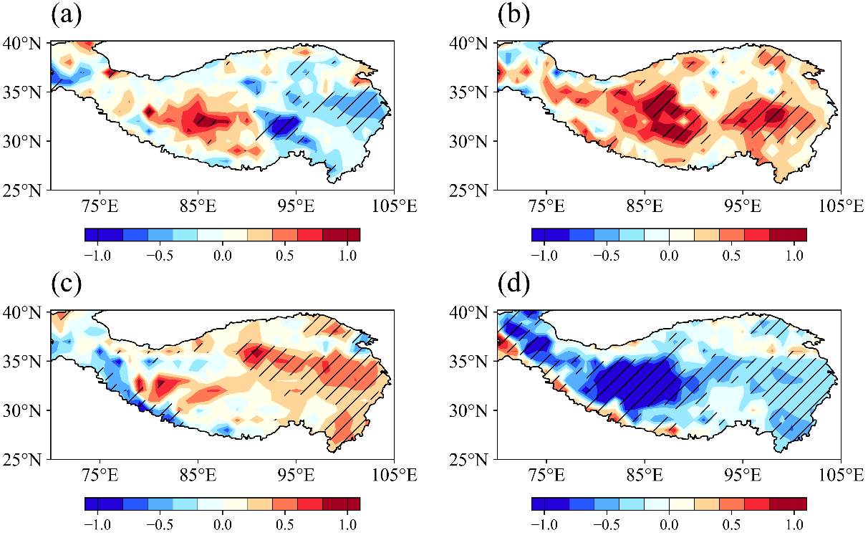
Fig. S1 Composite anomalies (colors; unit: mm d⁻¹) of evaporation for a stronger SASM and stronger TPW b weaker SASM and weaker TPW c stronger SASM and weaker TPW and d weaker SASM and stronger TPW. The black oblique lines denote differences are significant above the 95% confidence level。

