Supplementary information to GaAs nano-ridge laser diodes fully fabricated on 300 mm CMOS pilot line

S1. Mirror reflectivity

The mirror reflectivity at the cleaved facet is calculated with 3D FDTD (Ansys Lumerical software). We consider normal incidence of a Gaussian beam (with 0.5 µm mode-field diameter) at the nano-ridge (NR)/air interface (fig. S1a). We get the transmission and reflection spectra displayed in fig. S1b, yielding 45 % and 37 % at the wavelength range of interest (near 1020 nm). Finally, the far field radiation pattern is depicted in fig. S1c, showing strong beam divergence along the horizontal axis.

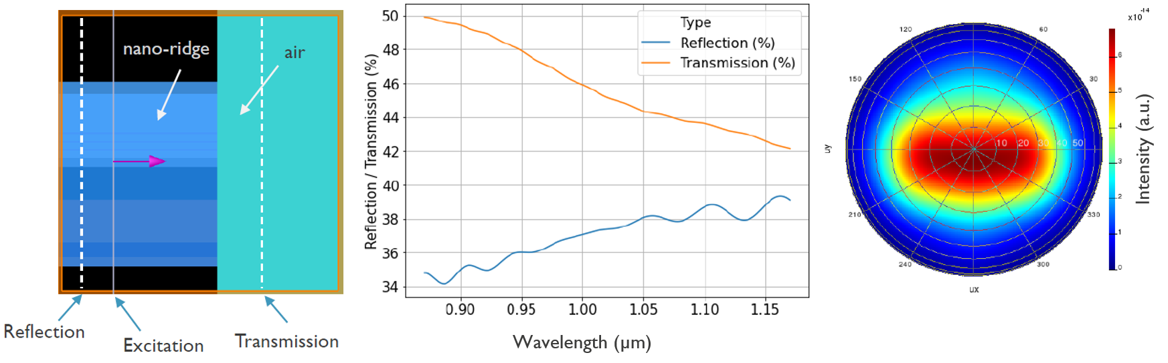
c
b
a
Fig. S1. a, Cross-section of the simulated structure along the propagation axis, with the broad Gaussian source directly launched in the NR and the two monitors to detect the transmitted and reflected part of the beam. b, Reflection and transmission spectrum. c, Simulated far-field profile of the beam radiated by the NR cleaved facet.

We also carried out 3D FDTD simulations to assess the impact of the etched facet angle. As this etched facet forms the second mirror of the NR laser cavity, it is essential to evaluate the influence of the sidewall angle on the mirror reflection and transmission. This is also important for estimating the amount of power coupled to the inline photodiode (PD) and radiated vertically for light collection with a multimode fibre (MMF). Our simulation results are depicted in fig. S2. We consider an etched area filled with oxide along the NR axis characterized by its sidewall angle $φ$, its depth D and its length L (fig. S2a). In the simulation cell, three monitors are placed such as to detect the reflected power by the etched facet, the transmitted power through the inline PD facet and the power scattered upward and collected by an MMF. An inset showing a cross-sectional high-angle annular dark-field scanning transmission electron microscopy (HAADF-STEM) image of the etched (fig. S2a) indicates that for our fabricated devices, the sidewall angle is 12° while the etch depth is 1000 nm. We estimate from the laser rate equation model that a minimum reflection of 2.5 % is required to reach threshold (dashed line in fig. S2b-c). We observe that for our etched facets, the reflection is ~5 % when L is 4 µm (fig. S2b) and 1 µm (fig. S2c). The transmission into the inline PD is estimated to be around ~12.5 % (fig. S2d), while ~1 % of the power is scattered upwards (fig. S2e). This estimation enables to correlate the collected photocurrent with the total emitted power from the NR laser.

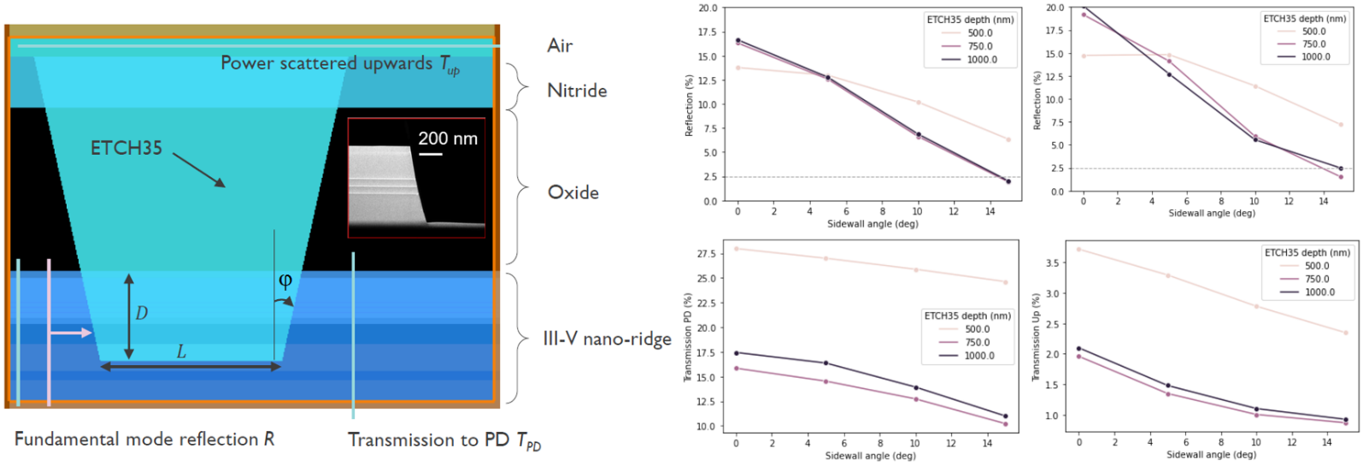
e
d
b
c
a
Fig. S2. a, Cross-section of the simulated structure along the propagation axis, with the broad Gaussian source directly launched in the NR and the three monitors to detect the transmitted and reflected part of the beam along the NR axis, as well as the power scattered upwards, emulating the case of light collection with a multi-mode fibre. Inset shows an HAADF-STEM picture of an etched facet, showing an etch depth around 1000 nm and a sidewall angle of 12°. b, Facet reflection as a function of sidewall angle for various etch depths D in the case of a gap L=4 µm. c, Facet reflection as a function of sidewall angle for various etch depths D in the case of a gap L=1 µm. d, Transmission into the inline photodiode as a function of sidewall angle for various etch depths. e, Power radiated into free space as a function of sidewall angle for various etch depths D in the case of a gap L=4 µm.

S2. Laser rate equations

The standard laser rate equations describe the intracavity dynamics of carrier and photon densities $N$ and $N_{p}$ [1]:

$$\frac{dN}{dt}=\frac{η_{i}I}{qV_{a}}-AN-BN^{2}-CN^{3}-v_{g}g_{0}\log\left(\frac{N}{N_{tr}}\right)N_{p}$$

$$\frac{dN_{p}}{dt}=\left(Γv_{g}g_{0}\log\left(\frac{N}{N_{tr}}\right)-γ_{p}\right)N_{p}+ΓβBN^{2}$$

Recalling that the laser is at threshold when the modal gain exactly compensates the total loss of the laser, we set the threshold modal gain as:

$$Γg_{th}=α_{i}+α_{m}$$

This allows us to readily express the threshold carrier density:

$$N_{th}=N_{tr}\exp\left(\frac{α_{i}+α_{m}}{Γg_{0}}\right)$$

Since we are operating our lasers in continuous wave, we can reduce the rate equations to the steady-state case. As no stimulated emission occurs at threshold, we get:

$$0=\frac{η_{i}I_{th}}{qV_{a}}-AN_{th}-BN_{th}^{2}-CN_{th}^{3}$$

$$0=-γ_{p}N_{p}+ΓβBN^{2}$$

We finally obtain the threshold current value:
$$I_{th}=\frac{qV_{a}}{η_{i}}\left(AN_{th}+BN_{th}^{2}+CN_{th}^{3}\right)$$

As the gain is clamped at threshold, we can express above threshold the steady-state carrier density rate equation:
$$\frac{η_{i}I}{qV_{a}}-\frac{qV_{a}}{η_{i}}\left(AN_{th}+BN_{th}^{2}+CN_{th}^{3}\right)-v_{g}g_{th}N_{p}=0$$

With appropriate substitutions, we have:
$$v_{g}g_{th}N_{p}=\frac{η_{i}I}{qV_{a}}-\frac{η_{i}I_{th}}{qV_{a}}$$

We get the linear relationship between intracavity photon density and the injected current:

$$N_{p}=\frac{η_{i}}{qV_{a}v_{g}g_{th}}\left(I-I_{th}\right)$$

To obtain the total output power, we can readily express the energy stored in the cavity:

$$E_{cav}=ℏωN_{p}\frac{V_{a}}{Γ}$$

The total output power corresponds to the energy loss rate through the mirrors, that is:

$$P_{out}=v_{g}α_{m}E_{cav}$$

By applying the appropriate substitutions, we get:

$$P_{out}=\frac{η_{i}α_{m}}{α_{i}+α_{m}}\frac{ℏω}{q}\left(I-I_{th}\right)=η_{i}η_{d}\frac{ℏω}{q}\left(I-I_{th}\right)$$

Where $η_{d}=α_{m}/(α_{m}+α_{i})$ is the slope efficiency. The output power per facet can be expressed by adding a coefficient $F_{1\left(2\right)}$ derived from the facet reflectivity $r_{1(2)}$ and transmittivity $t_{1(2)}$:

$$F_{1\left(2\right)}=\frac{t_{1\left(2\right)}^{2}}{\left(1-r_{1(2)}^{2}\right)+\frac{r_{1(2)}}{r_{2(1)}}\left(1-r_{2(1)}^{2}\right)}$$

The expression of $F_{1\left(2\right)}$ also accounts for lossy mirrors when $r_{1(2)}^{2}+t_{1(2)}^{2}<1$. We can therefore relate the measured output power at each facet $P_{1(2)}$:
$$P_{1(2)}=F_{1(2)}η_{i}η_{d}\frac{ℏω}{q}\left(I-I_{th}\right)$$

To model our NR devices using the laser rate equation model, we summarize the different parameter definitions and their respective values in Table 1.
Parameter name | Definition | Value | Source
$$η_{i}$$ | QW injection efficiency | $$0.85$$ | TCAD simulations
$$q$$ | Electron charge | $1.6021892×{10}^{-19}$ C | Fundamental constant
$$V_{a}$$ | Active volume | $$N_{QW}×h_{QW}×W_{QW}×L$$ | HAADF-STEM
$$N_{QW}$$ | Number of quantum wells | 3 | HAADF-STEM
$$h_{QW}$$ | Quantum well thickness | 12 nm | HAADF-STEM
$$W_{QW}$$ | Quantum well width | 400 nm | HAADF-STEM
$$L$$ | Laser length | 1, 1.5 and 2 mm | Designed
$$A$$ | Shockley-Read-Hall coefficient | $4×{10}^{7} s$ | From measurement fit
$$B$$ | Bimolecular recombination coefficient | $$1×{10}^{-10} cm^{3}.s^{-1}$$ | Ref [2]
$$C$$ | Auger recombination coefficient | $$3.5×{10}^{-30} cm^{6}.s^{-1}$$ | Ref [2]
$$v_{g}$$ | Group velocity | $$c/n_{g}$$ | Ansys Lumerical Simulations
$$g_{0}$$ | Gain coefficient | $$1200 {cm}^{-1}$$ | Ref [3]
$$N_{tr}$$ | Transparency carrier density | $$1.8×{10}^{18} cm^{3}.s^{-1}$$ | Ref [3]
$$Γ$$ | Confinement factor | $$N_{QW}×Γ_{0}=0.08$$ | Ansys Lumerical Simulations
$$R_{1}$$ | Etched facet reflection coefficient | 0.05 | Ansys Lumerical Simulations
$$R_{2}$$ | Etched / cleaved facet reflection coefficient | 0.05 / 0.37 | Ansys Lumerical Simulations
$$α_{m}$$ | Mirror loss | $$\frac{1}{L}\log\left(\frac{1}{\sqrt{R_{1}R_{2}}}\right)$$ | Ansys Lumerical Simulations
$$α_{i}$$ | Internal loss | $$57 cm^{-1}$$ | Ansys Lumerical Simulations
$$γ_{p}$$ | Photon decay rate | $$v_{g}×\left(α_{i}+α_{m}\right)=0.5432 THz$$ | Ansys Lumerical Simulations
$$β$$ | Spontaneous emission factor | $${1.5×10}^{-2}$$ | From measurement fit
Table 1: List of parameters and their respective values used to model our NR lasers.

S3. Optical loss

The intracavity photon loss rate $γ_{p}$ is a key attribute driving laser performance. A high mirror loss rate $v_{g}α_{m}$ is desired to maximize the output power and wall-plug efficiency through a large slope efficiency $η_{d}$, but competes with the need to have a small intracavity photon loss rate $γ_{p}$ to minimize the threshold current, as the total intracavity loss can in some cases exceeds the maximum achievable modal gain, preventing lasing operation.

In the demonstrated nano-ridge lasers, the presence of W vias in the vicinity of the active region induces optical scattering and absorption. These vias pierce through the InGaP passivation layer and land on the p-doped GaAs layer to form the anode. The arrangement of these W plugs with respect to the NR waveguide requires a careful optimization. Fig. S3 shows the optical loss spectrum for a one-dimensional array of tungsten contact plugs with 150 nm plug diameter and 300 nm plug pitch (50 % fill factor) in blue, similarly to the case depicted in fig. 2e in the main text. The loss spectrum is calculated using 3D FDTD simulations by launching the fundamental TE mode into the laser waveguide and observing the transmission through a segment of fixed length with tungsten plugs. The resulting optical loss is relatively flat across wavelength and is as high as 1500 $cm^{-1}$. Such a high loss number cannot be compensated by the gain from the quantum wells and therefore prevents the device from lasing. We observe that the propagating light quicky decays as shown in fig. 2e from the main text.

The absorption loss can be reduced by reducing the plug density. By increasing the pitch from 0.3 µm to 4.8 µm while keeping the plug diameter fixed at 150 nm, the plug density is reduced by a factor of 16 which should result in a similar decrease in optical loss. Figure S1 shows the simulated loss spectrum by 3D FDTD for this configuration in orange. As expected, the baseline loss decreases by roughly a factor of 16 from 1500 $cm^{-1}$ down to 100 $cm^{-1}$. However, the loss spectrum is no longer flat but displays several dips where the optical loss reaches values as low as 19 $cm^{-1}$ at a dip wavelength near 1040 nm.

To understand the nature of these low loss dips, we have investigated light propagation through the nano-ridge waveguide structure. First, let us consider the nano-ridge waveguide without the tungsten contact plugs. This waveguide supports multiple eigenmodes. The 5 modes with the lowest orders are shown in Table 2 at a wavelength of 1020 nm, from TE₀₀ to TE₁₁.
Wavelength (nm)
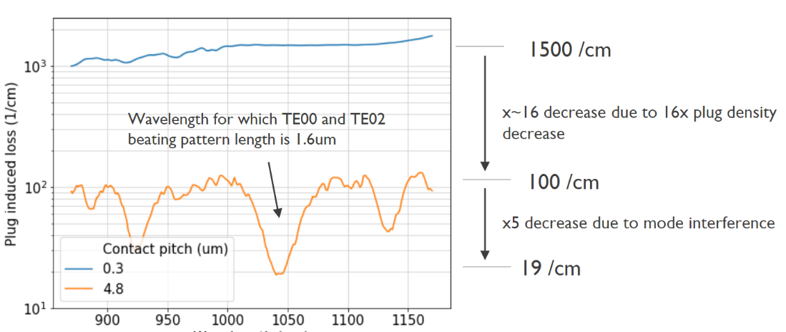

Fig. S3. W contact induced loss as function of wavelength in the case of very dense pitch of 0.3 µm (blue) and in the case of the dense plug array with a sparse pitch of 4.8 µm (orange), showing nearly two orders of magnitude reduction of absorption loss near 1040 nm.

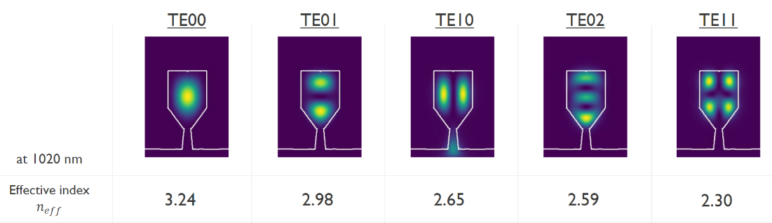
Table 2. Simulations showing nano-ridge cross-section supporting multiple higher order modes with different effective indices.
When we inspect the field profile from the 3D FDTD simulation with 4.8 µm plug pitch at the dip wavelength (see fig. S2), we observe a beating pattern with a 1.6 µm beating period. The CON35 pitch is a multiple of the beating period and the field profile is aligned in such a way that there is minimal interaction between the optical field and the tungsten plug, resulting in low optical loss. The engineering of the interference patterns between these two modes through the optimization of the p-contact pitch is crucial to reduce the internal loss to a level that enables to reach threshold. As we have seen, setting the CON35 pitch to 4.8 µm in our case allows reducing the optical loss down to 19 $cm^{-1}$.
c
b
a
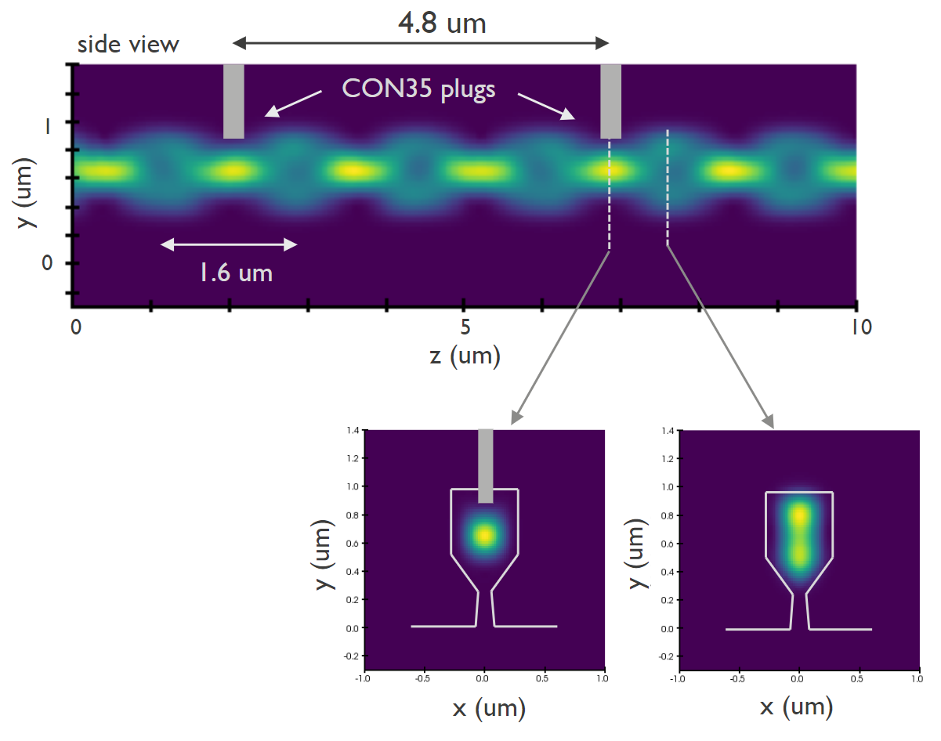
Fig. S4. a, Simulated electric field propagation along the z axis, showing a beating pattern with a period of 1.6 µm. b, Cross-section taken below the W plug, showing the TE₀₀ mode profile pushed away from the top surface of the NR and well confined in the centre of the NR. c, Cross-section of the NR away from the plug at the middle of the beating pattern, showing the TE₀₂ mode extending across the NR vertical axis.

S4. Linewidth measurements

The self-homodyne interferometric setup used to measure the laser linewidth of various devices is depicted in fig. S5a. The device under test (DUT) is electrically probed by DC needles connected to a Keithley current source. A current compliance is set to 20 mA to prevent from damaging the laser diode. The laser light is collected at the cleaved facet forming one of the laser cavity mirrors by a lensed fibre. This fibre is connected to a fibered Mach-Zehnder interferometer containing a polarization controller (PC) in one arm and a 1 km long fibre delay line in the other arm. The combined signal from the two arms is collected by a balanced photodiode (400 MHz balanced photodetector Thorlabs PDB471C-AC) and the electrical readout signal is sent to an Electrical Spectrum Analyzer (Rhode & Schwartz 100 Hz-13 GHz), enabling extraction of the laser phase noise. No acousto-optic modulator (AOM) is used in the setup to offset the frequency due to lack of AOM in the laser wavelength range (~ 1030 nm) in our setup. No optical isolator is placed in front of the DUT, making the laser unshielded from parasitic reflections and yielding to an overestimate of the laser linewidth.

In addition to the electrical power spectral density shown in the main text, electrical power spectra of 10 additional devices are shown in fig. S5b. The RF power spectra of the measured beat notes are measured at a bias current of 15 and 18 mA, i.e., > 2Ith. The linewidths extracted using a Voigt fit range from 46 MHz for the best device (as shown in the main text) up to 186 MHz and are reported in table 3. The difference in linewidths is manifold:
- The laser performance is affected by nano-ridge shape variability across the wafer, impacting the threshold current, the slope and the SMSR.
- Laser performance depends on the interaction of multiple optical modes, which in turn depends on the (varying) nano-ridge laser dimensions (Fabry-Perot cavity design with transverse mode beating, trench width design for aspect ratio trapping, p-contact W plug pitch design).
- The laser is not shielded from optical feedback with an optical isolator.
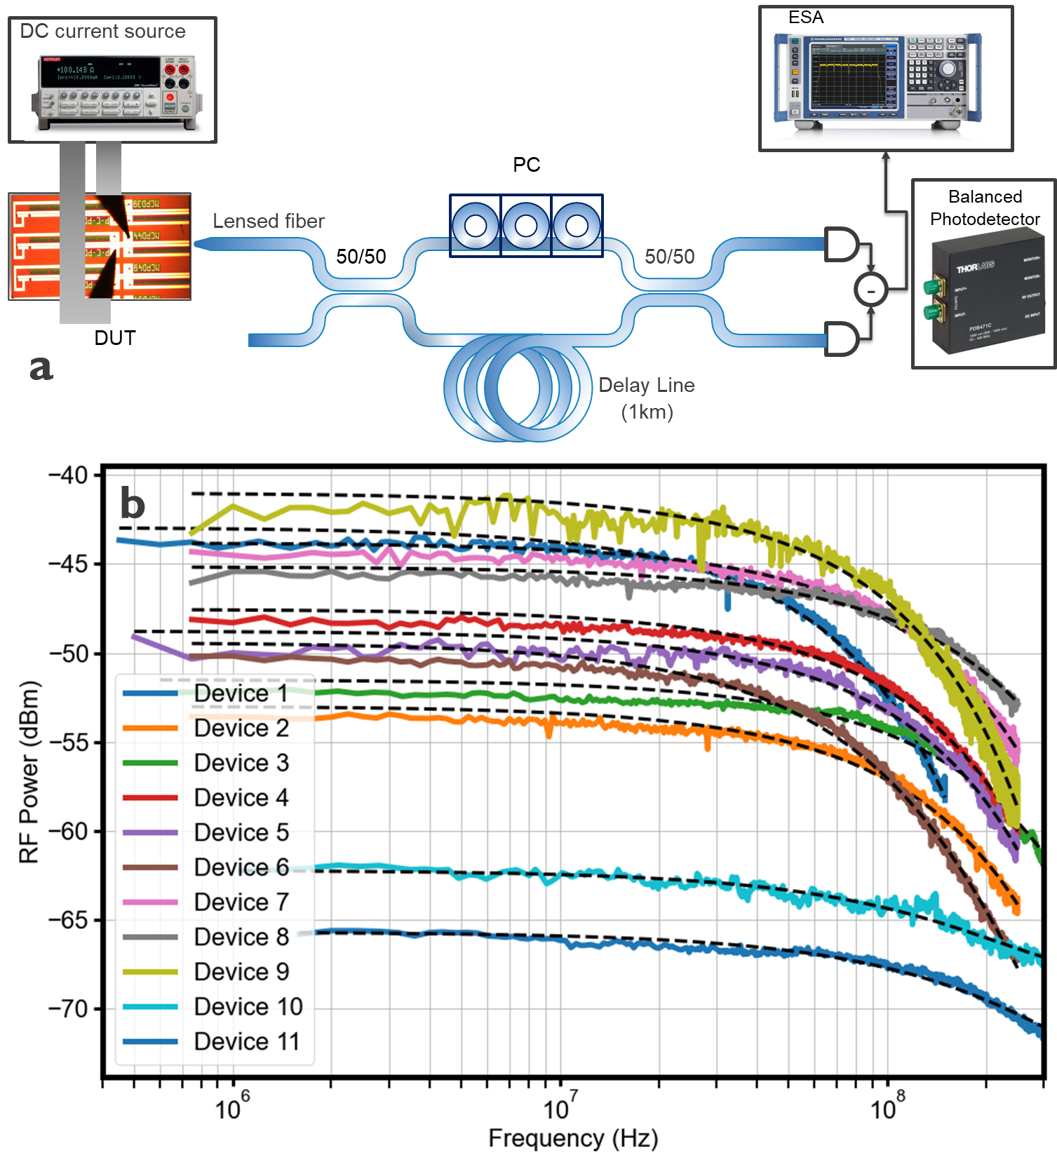
Fig. S5. a, Schematic of the self-homodyne interferometric setup used to measure the laser linewidth. b, Electrical spectra of 11 measured lasers with superimposed Voigt fit (dashed lines).

- The laser operates at a moderate bias current (~2 Ith) in order to prevent laser failure.
- No active stabilization besides temperature control is applied to the DUT.

Nonetheless, the measured linewidths place our nano-ridge lasers between commercial distributed feedback (DFB) lasers ($≤$ 1MHz) and vertical cavity surface emission lasers (VCSELs) (> 1 GHz) [4]. More importantly, these measurements confirm that our nano-ridge devices are lasing and are not in an amplified spontaneous regime. Additionally, we compare the measured linewidths with the theoretical expression of the modified Schawlow-Townes linewidth [5]:
$$Δν_{ST}=\frac{ℏωv_{g}Γg_{th}n_{sp}α_{m}}{{8πη_{d}P}_{out}}\left(1+α^{2}\right),$$

Where $n_{sp}$ is the population inversion factor, typically around 1.25-1.75, and $α$ is the well-known linewidth enhancement factor, typically around 4-6 for quantum well lasers. By assuming $n_{sp}=1.5$ and $α=4.5$, and by setting the total output power of one of our NR lasers to 2.3 mW (for a cleaved facet output power of 0.5 mW), we get $Δν_{ST}=$30 MHz, which is in line with the best measured linewidth ($Δν=$46 MHz) among the devices that were tested.

We expect to strongly reduce the laser linewidth in future designs by suppressing the beating modes, by improving the p-contact scheme allowing to operate at much large currents and by introducing DFB grating in the nano-ridge devices to reduce $α_{m}$. Future experiments will also expand the laser characterization to include relative intensity noise (RIN) measurements and extend the bias current range to larger values to observe reduction of the Schawlow-Townes linewidth.
Device Number | 1 | 2 | 3 | 4 | 5 | 6 | 7 | 8 | 9 | 10 | 11
Measured linewidth (MHz) | 46 | 70.7 | 132.6 | 82 | 85.8 | 56.7 | 87.2 | 124.7 | 67 | 162.7 | 186
Table 3. Measured linewidth for each tested devices, ranging from 46 to 186 MHz.
S5. Epitaxy and crystal defects

Nano-ridge engineering of the III-V nano-ridges (NRs) on trench-patterned Si was carried out by metal-organic vapor phase epitaxy (MOVPE) in a 300 mm deposition chamber applying tertiarybutyl arsine (TBAs), tertiarybutyl phosphine (TBP), trimethyl arsine (TMAs), triethylgallium (TEGa), trimethylgallium (TMGa) and trimethylindium (TMIn) as group-V and -III precursors, respectively. Silane (SiH₄) and carbon tetrabromide (CBr₄) were used to achieve n- and p-doped layers. Before the III-V deposition, the patterned Si wafers were loaded into an Siconi chamber from Applied Materials for the native oxide removal from the {111} Si surfaces at the trench bottom at temperatures below 200 °C. The GaAs nucleation was done at 360 °C applying TEGa before the growth temperature was raised to 590 °C for the n-doped GaAs (~5$×{10}^{18}$ cm⁻³) trench filling and first n-doped box formation using TMGa. The undoped InGaAs/GaAs multi-quantum well (MQW) stack was deposited at 570 °C and the TMIn/TMGa+TMIn ratio was adjusted to achieve an In-concentration of about 21% inside the QWs. The p- and p+-doped GaAs layers (~1$×{10}^{19}$ and 5$×{10}^{19}$ cm⁻³) were grown at 580 and 550 °C, respectively, and the InGaP layer added at high growth temperature again. The TBAs/III, TMAs/III and TBP/III ratio were varied between 4 and 60 as a function of the material, doping and growth temperature.
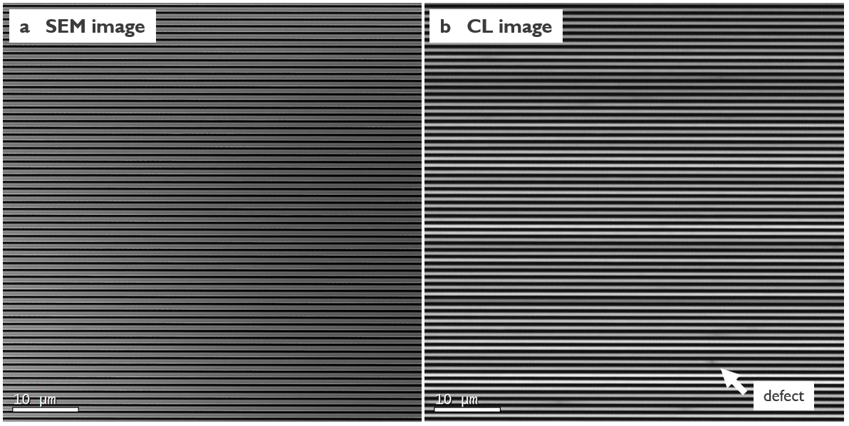
Fig. S6. a, Scanning electron microscope (SEM) image of the surface of an array of NRs. b, Cathodoluminescence (CL) image of the same area, showing only a single defect in an area covering more than $60×60 μm^{2}$, assessing the very low threading dislocation density in our NR devices.

The threading dislocation and planar defect densities of the GaAs NR were investigated before by electron channelling contrast imaging (ECCI) and the results are reported in [6,7]. Especially for narrow trenches (< 120 nm), the misfit defect density was so low that our ECCI investigation did not provide sufficient defect statistics. To explore a larger sample area, we applied cathodoluminescence (CL) on a cleaved wafer piece at 77 K to reduce carrier mobility. The inspected die area was chosen at a wafer radius of about 75 mm. 10 images were acquired where each image covers about 60 NRs with a length of 64 µm to achieve good defect statistics. Fig. S6 shows a representative image pair: (a) is the standard top-view scanning electron microscopy (SEM) image to identify any NR line cuts and/or surface particles and (b) the corresponding CL image integrated over the complete emission spectra. A dark spot in CL can be caused by the presence of a threading dislocation but also by any NR line cut or particle. In this investigation we did not distinguish the defect character but considered every indication of a dark spot as a defect. This led to a final defect density based on this first CL investigation of $6×{10}^{4} cm^{-2}$.

Planar defects such as micro twins and stacking faults lie in a crystallographic plane perpendicular to the trench line. They penetrate the complete NR volume and always reach the NR surface. However, they do not cause any dark spot in CL of NRs. This is caused by the fact that no partial dislocation, always present at the end of a planar defect, remains inside the NR volume as it would be the case for a planar defect in a blanket two-dimensional layer. This conclusion is also supported by the observation that the planar defect density of the GaAs NRs, which is in the range of 0.1-0.5 µm⁻¹ (defect per micrometre NR length) [6], is much higher than the extracted dark spot density in CL.

S6. Spontaneous emission factor

We extract the spontaneous emission factor $β$ from the I-I curve of one of our lasers and we fit it with the laser rate equation model. From the fig. S7, we infer a $β$ as large as 1.5$×{10}^{-2}.$ We attribute this large $β$ to the fact that the nano-ridge lasers operate below threshold as a SLED (Superluminescent light emitting diode) [8] due to the low mirror reflectivity (5 %) and the strong optical confinement.

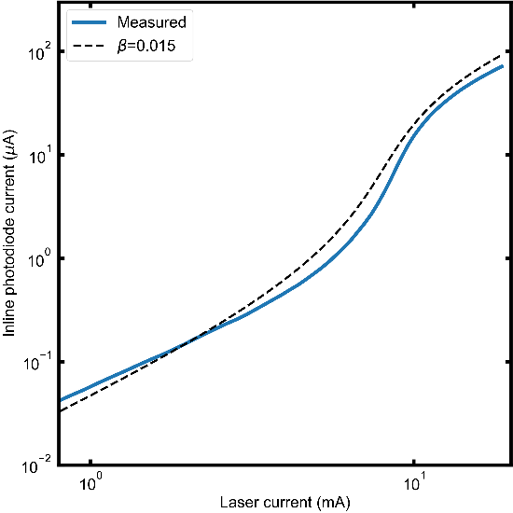
Fig. S7 I-I plot of a 2mm long laser (blue solid line) showing good agreement with a modelled laser with a $β=0.015$ (black dashed line).

S7. GaAs-Si diode resistance

We note in the main text that the laser diodes have a relatively large operating voltage of 3-4 V (see fig. 4a). To assess the origin of this large diode voltage, we compare the J-V characteristics (current density vs. diode voltage) of multiple laser diodes ($p_{con35}$= 4.8 µm) with photodetectors ($p_{con35}$= 0.3 µm), suspecting the sparsity of the W plug contacting the p-GaAs (i.e., a large contact pitch $p_{con35}$) as a main contributor to high device resistance. As shown in fig. S8a, a voltage of ~3.5V enables a current density of ~1 k$A.cm^{-2}$ when $p_{con35}$= 4.8 µm, while in the case of $p_{con35}$= 0.3 µm, it enables a much higher current density of 3-4 k$A.cm^{-2}$. From the J-V characteristics, we extract the associated series resistances at a voltage of 4 V for the two configurations. We infer a mean series resistance of 57 $Ω.mm$ for $p_{con35}$= 0.3 µm and 115 $Ω.mm$ for $p_{con35}$= 4.8 µm, showing a two-fold increase as shown in the box plots in fig. S8b. While a $p_{con35}$ of 4.8 µm is key in achieving lasing through mode beating minimizing optical loss below the W plug in our current designs, we see room for improving the laser diode operating voltage and resistance in future designs by moving the W plugs away from the active region and increasing the W plug density. Furthermore, increasing the doping level in the p-type GaAs contact layer will help to realize ohmic contacts to further reduce operating voltage and improve wall-plug efficiency [9].

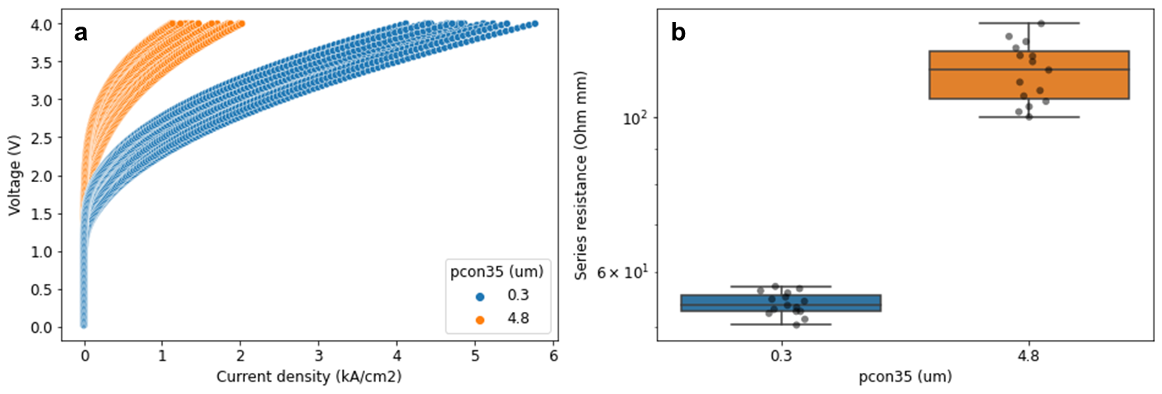
Fig. S8 a J-V characteristics measured across the wafer for a p-contact W plug pitch ($p_{con35}$) of 0.3 µm (blue) and 4.8 µm (orange), showing an increase of diode voltage for the case of sparse W plugs, up to 4 V at current density $J$=1 k$A.cm^{-2}$. b Extracted series resistance, showing a two-fold increase in series resistance when $p_{con35}$= 4.8 µm compared to $p_{con35}$= 0.3 µm.

References

- Coldren, L. A., Corzine, S. W. & Mashanovitch, M. L. Diode lasers and photonic integrated circuits (John Wiley & Sons, 2012).
- Strand, T. A. et al. Low regrowth-interface recombination rates in InGaAs-GaAs buried ridge lasers fabricated by in situ processing. Appl. Phys. Lett. 66, 1966–1968 (1995)
- Tsvid, G., et al. Spontaneous Radiative Efficiency and Gain Characteristics of Strained-Layer InGaAs–GaAs Quantum-Well Lasers. IEEE J. Quant. Electron. 44, 732-739 (2008).
- Haglund, E. et al. 25 Gbit/s transmission over 500 m multimode fibre using 850 nm VCSEL with integrated mode filter. Electron. Lett. 48, 517-519 (2012).
- Henry, C. H. Theory of the Linewidth of Semiconductor Lasers. IEEE J. Quant. Electron. QE-18, 259-264 (1982).
- Kunert, B. et al. How to control defect formation in monolithic III/V heteroepitaxy on (100) Si? A critical review on current approaches. Semiconductor Sci. Technol. 33, 093002 (2018).
- Baryshnikova, M. et al. Nano-Ridge Engineering of GaSb for the Integration of InAs/GaSb Heterostructures on 300 mm (001) Si. Crystals 10 (2020).
- Zhao, Y. et al. Spontaneous emission factor for semiconductor superluminescent diodes. J. Appl. Phys. 85, 3945-3948 (1999).
- Hsieh, P.-Y., et al. Advanced Current–Voltage Model of Electrical Contacts to GaAs-and Ge-Based Active Silicon Photonic Devices. IEEE Transactions on Electron Devices (2023).

