Supplement Figure 1: The entire analytical process of the study

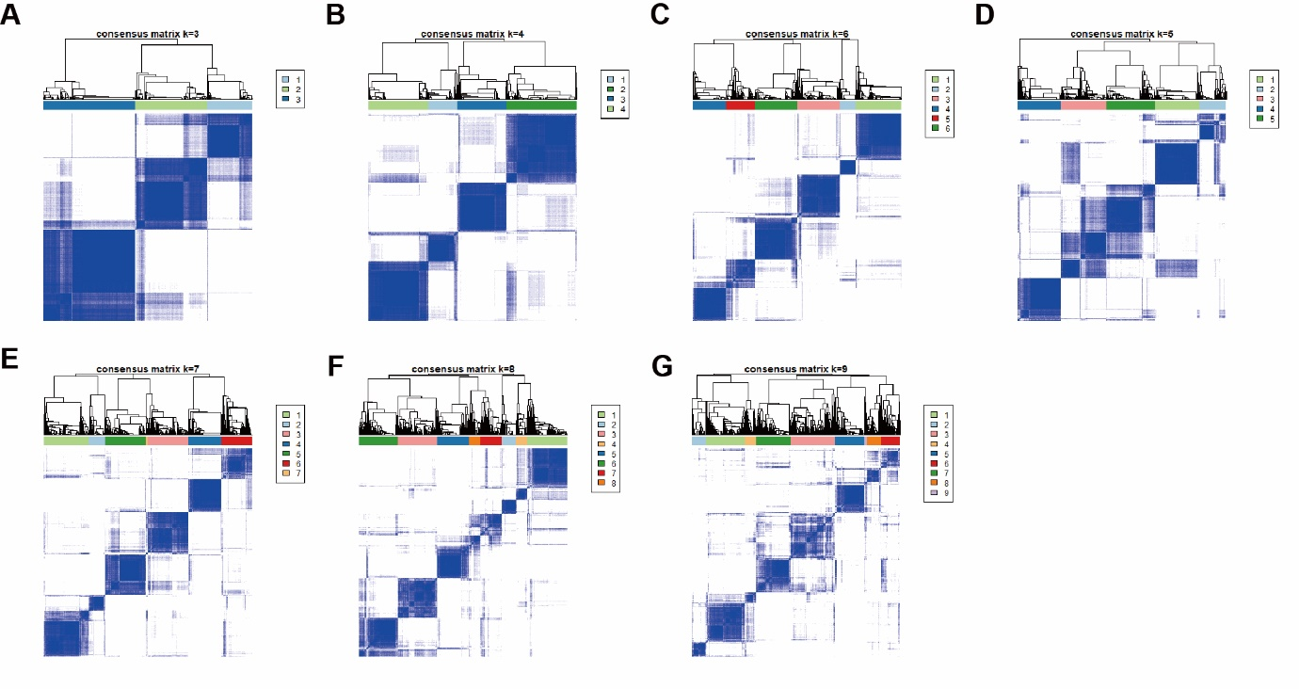
Supplement Figure 2: Unsupervised consensus clustering analysis identified ARG_Clusters in BC cohort based on different expressed ARGs. When K = 3 (A), 4 (B), 5 (C), 6 (D), 7 (E), 8 (F), 9 (G), the boundary of angiogenesis subtypes was not clear

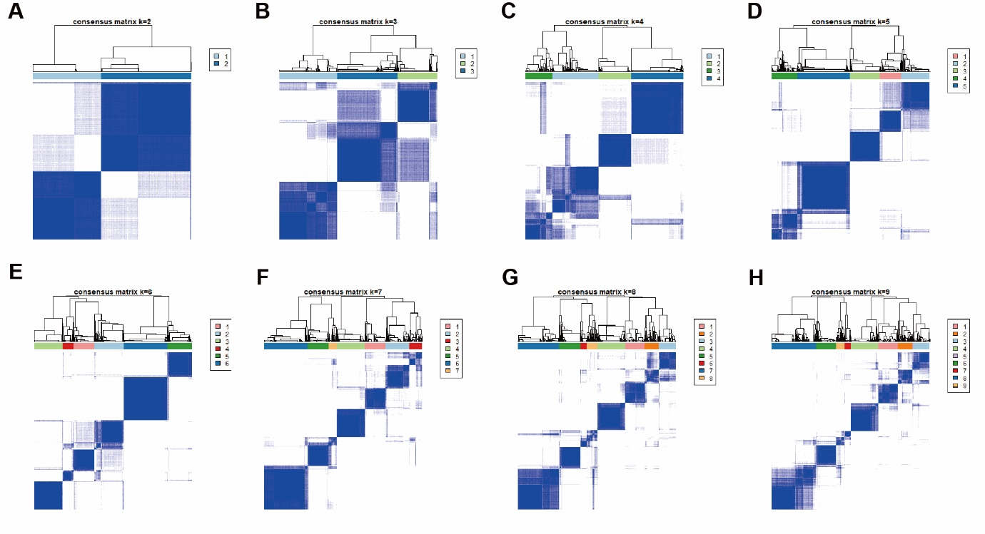
Supplement Figure 3: Unsupervised consensus clustering analysis identified gene subtypes based on DEGs among two angiogenesis subgroups in BC cohort. When K = 3 (B), 4 (C), 5 (D), 6 (E), 7 (F), 8 (G), 9 (H), the boundary of angiogenesis subtypes was not clear

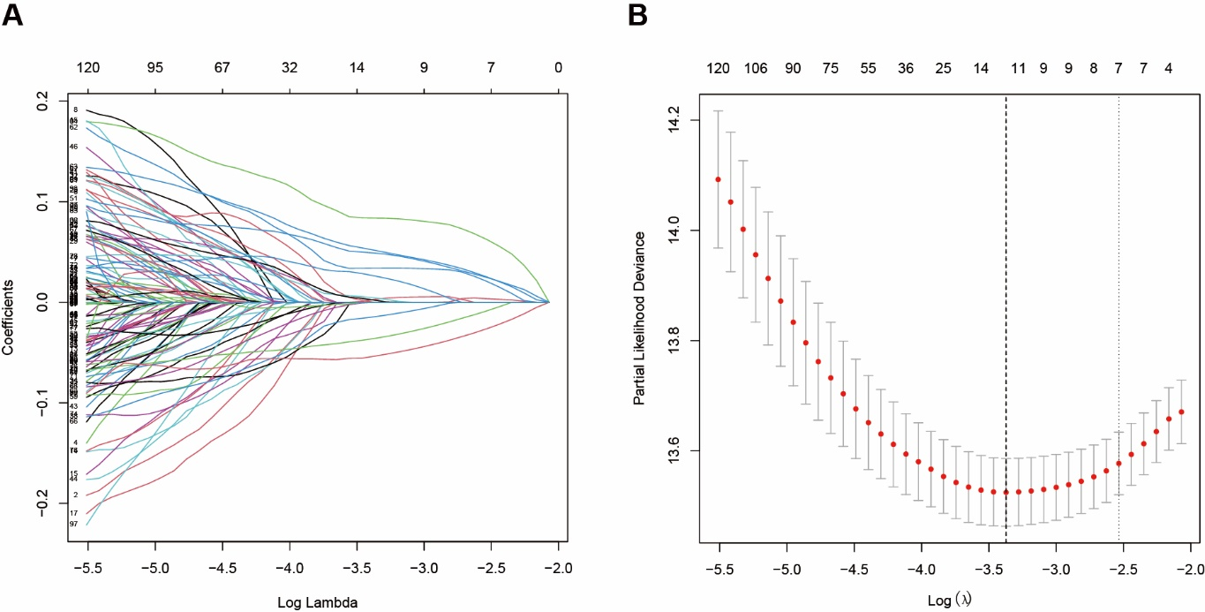
Supplement Figure 4: The LASSO regression analysis and partial likelihood deviance on the prognostic genes

