Appendix A
The locations of meteorological and air quality monitoring stations in Beijing, Shanghai, and GBA are demonstrated in Fig. A1-A3. The meteorological monitoring stations are national surface meteorological monitoring stations and location information is provided by China National Meteorological Information Centre. The air quality monitoring network is built by The China National Environmental Monitoring Center (CNEMC).

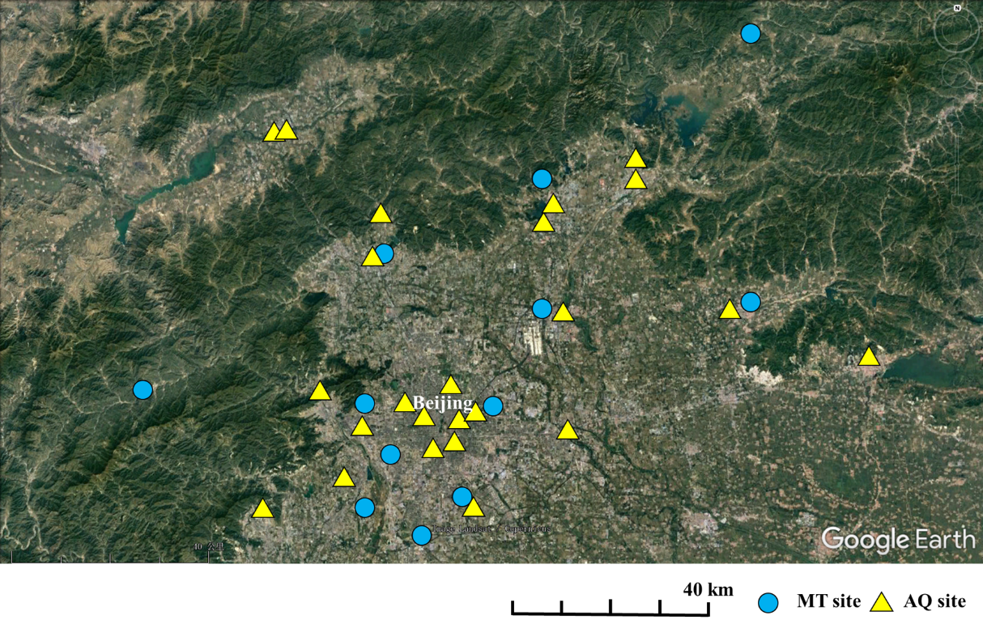
Fig. A1. The location of meteorological monitoring sites (12 MT sites) and air quality monitoring sites (24 AQ sites) in Beijing.
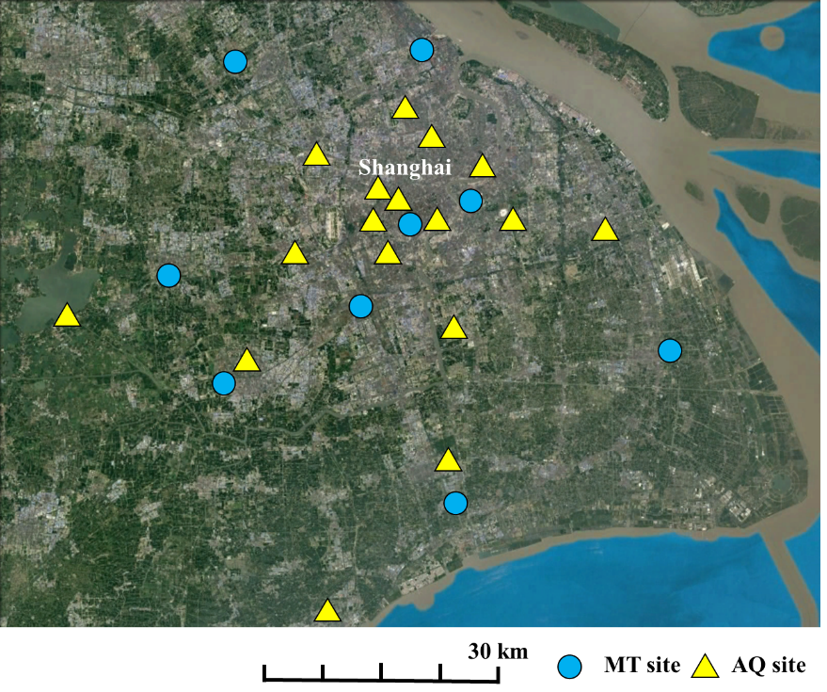
Fig. A2. The location of meteorological monitoring sites (9 MT sites) and air quality monitoring sites (17 AQ sites) in Shanghai.
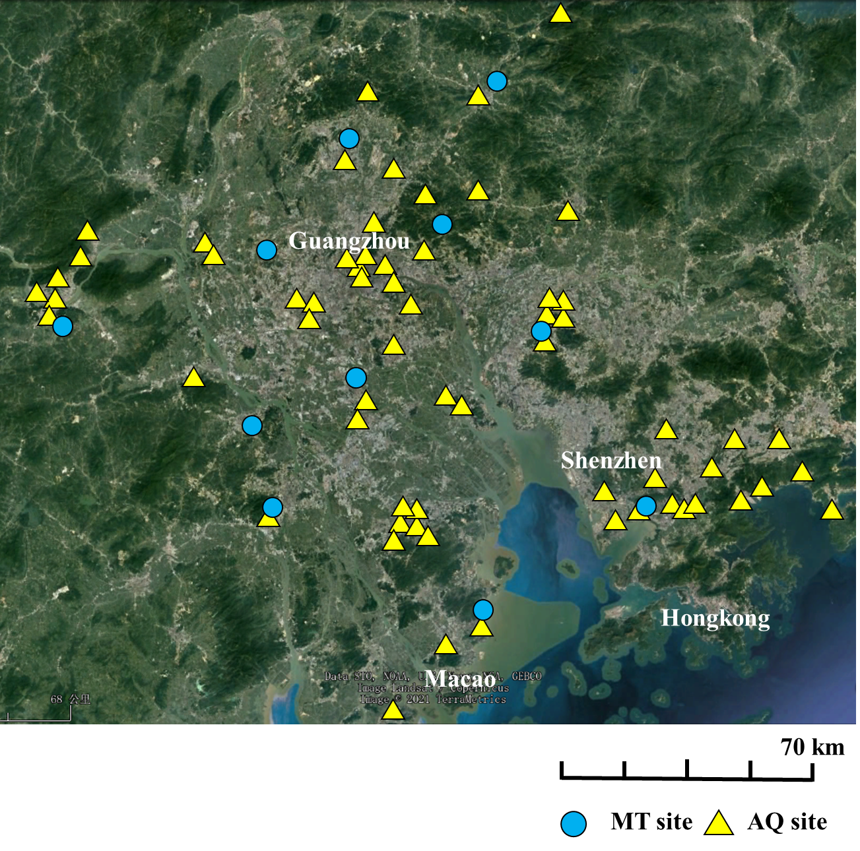
Fig. A3. The location of meteorological monitoring sites (12 MT sites) and air quality monitoring sites (66 AQ sites) in GBA.

Appendix B. Detailed settings for the training of deep learning models

The whole process was coded in the PyTorch (v1.10) (Mazza and Pagani 2020) framework. To reduce the dependence on the computer memory size, each training sample was furtherly divided into 64 patches [256m×256m for one patch and 8×8 patches (2048/256=8)]. 80% of the training dataset was used for training and the remaining 20% was reserved for performance evaluation. Data augmentation is a common strategy used in deep learning training (Wong et al. 2016; Diakogiannis et al. 2020), especially when the training dataset is not sufficient. In this study, training samples were augmented with the transform modules implemented in torchvison(Mazza and Pagani 2020) including RandomHorizontalFlip, RandomVerticalFlip, ColorJitter, RandomAdjustSharpness, and RandomAutocontrast. Following Li’s work (Li et al. 2019b), the initial learning rate for training the classification model is 2.5 × 10⁻⁴ and decreased with a ‘poly’ learning rate policy with power as 0.9. The batch size is set to 4 and the CycleGAN model was trained for 15 epochs. The training process was conducted on a computer platform with an Intel(R) Core i7 9700K CPU, 64 GB of RAM, and two Nvidia RTX 2080Ti graphics processing units (GPUs).

Appendix C
Correlation analysis was conducted using meteorological parameters from 2020. Seasonal and annual average values were used for analysis. Additional analysis for air quality parameters hasn't been conducted, because the available air quality stations in Shanghai are all located in compact urban areas which are inappropriate for analysis. As listed in Table C1, the results indicate a small seasonal variation for most of the correlation coefficients except for two cases: first, the relative humidity is correlated with artificial surfaces in the summer of Beijing which is not shown in other seasons; Second, in the autumn of Beijing and GBA, the correlation coefficients is different from other seasons.

Table C1
Correlation coefficients between land cover and meteorological factors for each season in 2020. Bold values (with |r| ≥ 0.3) indicate a linear correlation.
 |  | Artificial |  |  | Natural
 | Season | Beijing | Shanghai | GBA | Beijing | Shanghai | GBA
AT | Spring | 0.70** | 0.64** | 0.60 | −0.75** | −0.62** | −0.60**
AT | Summer | 0.70** | 0.67* | 0.60 | −0.73** | −0.64** | −0.52**
AT | Autumn | 0.68** | 0.83** | 0.59** | −0.73** | −0.81** | −0.66**
AT | Winter | 0.66** | 0.71** | 0.60** | −0.71** | −0.75** | −0.64**
AT | Annual | 0.70** | 0.73** | 0.66 | −0.75** | −0.73** | −0.68*
RH | Spring | −0.24 | −0.33** | −0.41** | 0.31 | 0.28* | 0.31**
RH | Summer | −0.41** | −0.41** | −0.39** | 0.45** | 0.34** | 0.25**
RH | Autumn | −0.03** | −0.49** | −0.64** | 0.06 | 0.44* | 0.59
RH | Winter | −0.02 | −0.41** | −0.55** | 0.05 | 0.39* | 0.49
RH | Annual | −0.16** | −0.42** | −0.53** | 0.20 | 0.37** | 0.44
WS | Spring | −0.47** | −0.29** | −0.20** | 0.50** | 0.44** | 0.14**
WS | Summer | −0.38** | −0.21** | −0.05** | 0.42** | 0.37** | −0.02**
WS | Autumn | −0.26** | −0.19** | −0.41** | 0.27** | 0.34** | 0.30**
WS | Winter | −0.36** | −0.27** | −0.26** | 0.36** | 0.40** | 0.19**
WS | Annual | −0.39** | −0.25** | −0.25** | 0.41** | 0.39** | 0.18**
**. Significant correlation at 0.01 level (bilateral)
*. Significant correlation at 0.05 level (bilateral)

