Table 1. Comparison of reported and our modeled concentrations of microplastic. Modeled concentration has been fitted to the observed size range according to Fig. 1.
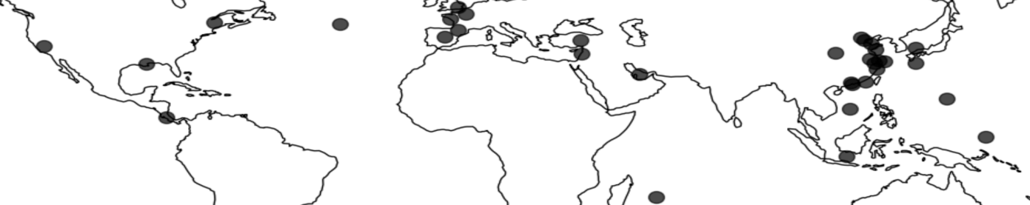
 | Location | Elevationn  (m) | Size range  (μm ) | Concentration (MP/m³) | Extrapolated modeled concentration (MP/m³)* | Ref
Land | Beijing |  | 5.9–5000 | 282 ± 127 | 756 | 5
Land | Beijing |  | 5 – 2000 | 5778 | 1289 | 6
Land | Tianjin |  | 5.9–5000 | 324 ± 145 | 1240 | 5
Land | Hangzhou |  | 5.9–5000 | 246 ± 78 | 466 | 5
Land | Nanjing |  | 5.9–5000 | 177 ± 59 | 694 | 5
Land | Shanghai |  | 5.9–5000 | 267 ± 117 | 1682 | 5
Land | Shanghai |  | 23.07-9955 | 0-4.2 | 36 | 7
Land | Persian Gulf |  | 2.5-45 | 0-14.2 | 107.7 | 8
Land | Pic du Midi | 2877 | 5-60 | 0.09–0.66 | 0.11 | 17
Land | French Atlantic |  | 10-140 | 2.9-19.38 | 18.8 | 13
Land | Paris |  | 50-5000 | 0.3-1.5 | 1.16 | 9
Land | California |  | 20–3000 | 12.6 ± 8.0 | 10.7 | 44
Land | Spain | 701-3496 | 25-500 | 1.5 -13.9 | 0.4-11.8 | 18
Land | Turkey |  | 15– 5 | 116-3424 | 504 | 45
Land | London |  | 4.7-2200 | 2502 | 890 | 10
Land | Wenzhou |  | 5 – 5000 | 104 -294 | 466 | 33
Land | Xian |  | 10 | 3500 | 1815 | 47
Land | Surabaya |  | 500-5000 | 55.93- 174.97 | 0.9 | 48
Oceans | West Pacific |  | 16–2086 | Nearshore 0.1  Pelagic 0.01  Remote 0.01 | 13.3  0.3  0.065 | 46
Oceans | Bohai Sea |  | 16.14-2,986.01 | 0.1 | 3.2 | 14
Oceans | Yellow Sea; |  | 16.14-2,986.01 | 0.2 | 0.5 | 14
Oceans | East China Sea |  | 16.14-2,986.01 | 0.15 | 0.02 | 14
Oceans | South China Sea |  | 16.14-2,986.01 | 0.05 | 0.002 | 14
Oceans | South China Sea |  | 58-1111 | 0.008 | 0.006 | 16
Oceans | North Atlantic |  | 5-100 | 0.1 | 0.1 | 15
Oceans | Pearl River |  | 58-1111 | 0.04 | 3.17 | 16
Oceans | East Indian Ocean |  | 58-1111 | 0.004 | 0.08 | 16
* Extrapolated modeled concentrations refer to the equilibrium concentration values from our simulation extrapolated to the measured diameter ranges by the proposed size-distribution relation in Fig. 1.

