Supplementary Information (Nature Communications)
Microplastics in the Atmosphere: A Global Perspective
Shanye Yang^{1,3,4}, Guy Brasseur^{1,2*}, Stacy Walters², Pablo Lichtig¹, Cathy W. Y. Li¹

¹Environmental Modeling Group, Max Planck Institute for Meteorology, Hamburg 20146, Germany
²Atmospheric Chemistry Observations and Modeling Laboratory, National Center for Atmospheric Research, Boulder, CO, 80307, The United States of America
³Shanghai Key Laboratory of Atmospheric Particle Pollution and Prevention, Department of Environmental Science and Engineering, Fudan University, Shanghai 200433, China
⁴Shanghai Institute of Pollution Control and Ecological Security, Shanghai 200092, P.R. China

Supplementary notes
All figures have been created using the open access general-purpose programming language Python version 3.
Fig. S1 microplastic particle emissions in mass. Emission spatial distribution of microplastic particles in diameter of 0.5 (a), 1.5 (b), 5 (c), 10 (d), 35 (e), and 70 (f) μm.
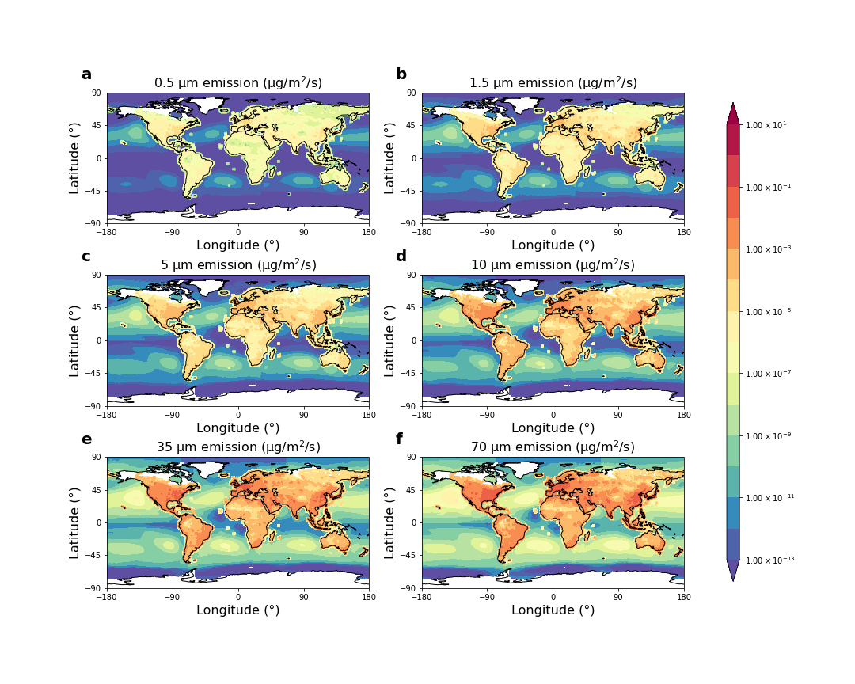
Fig. S2 The emissions fluxes of 0.5-70 μm microplastic particles. Mass fluxes in this study for current and the year of 2050 conditions, in (Brahney et al., 2021)¹, and in (Nikolaos et al., 2022)². The increasing factors for the ocean, road, population, and agriculture emission fluxes are 2.2^{3,4} , 16.15⁵, 127⁶, and 2.2^{3,4} respectively.
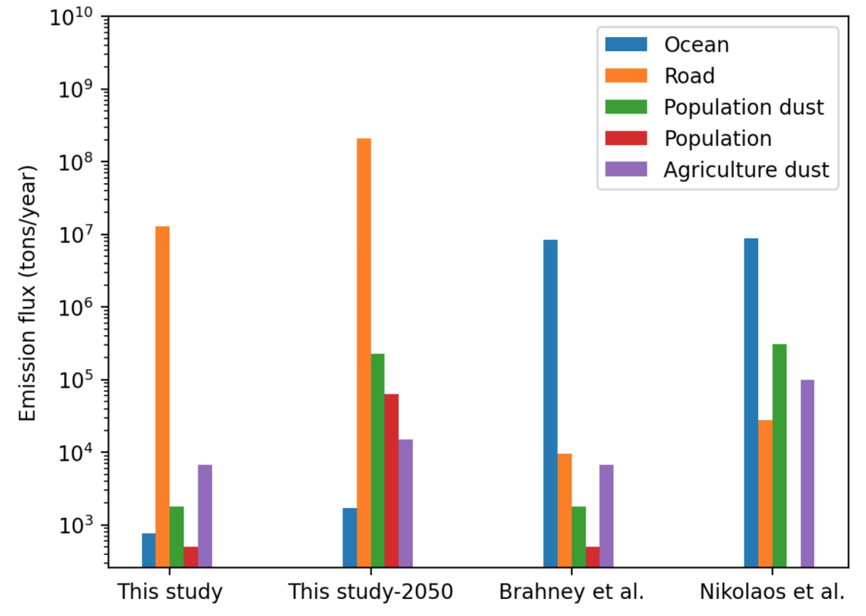
Fig. S3 Global concentrations range of microplastic particles in 6 size bins in the first layer of the model (0 to 50 m).

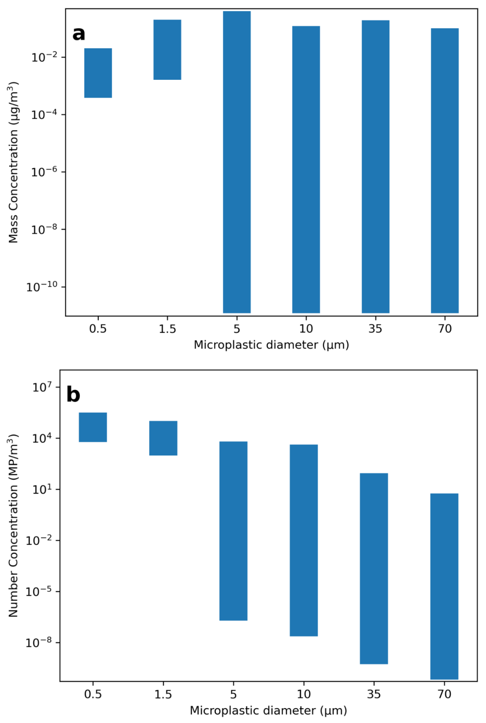
Fig. S4 The horizontal distribution of microplastic particles in mass. Spatial concentration distribution of microplastic particles in diameter of 0.5 (a), 1.5 (b), 5 (c), 10 (d), 35 (e), and 70 (f) μm in the first layer of the model (0 to 50 m).
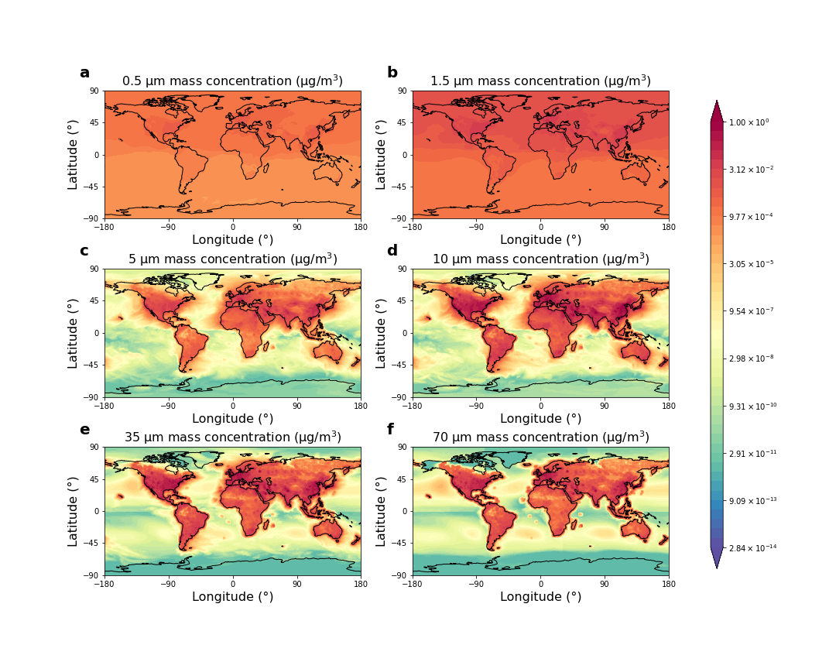

Fig. S5 The horizontal distribution of microplastic particles in number. Spatial concentration distribution of microplastic particles in diameter of 0.5 (a), 1.5 (b), 5 (c), 10 (d), 35 (e), and 70 (f) μm in the first layer of the model (0 to 50 m).
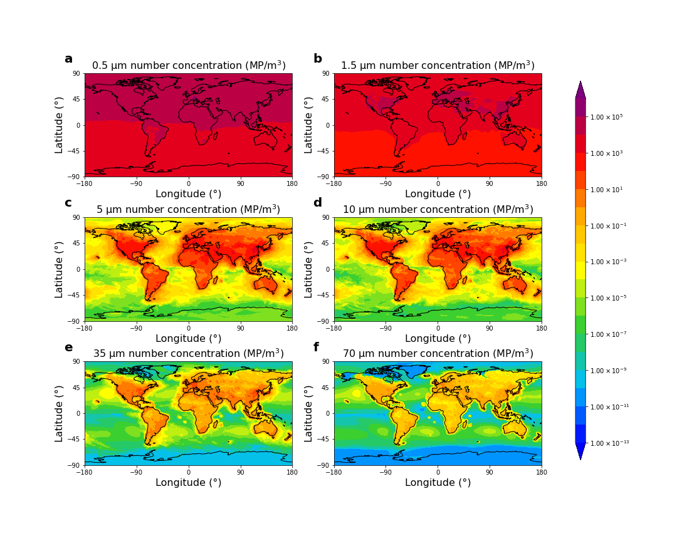

Fig. S6 The vertical distribution of microplastic particles in mass. Spatial concentration distribution of microplastic particles in diameter of 0.5 (a), 1.5 (b), 5 (c), 10 (d), 35 (e), and 70 (f) μm with the average of longitude.
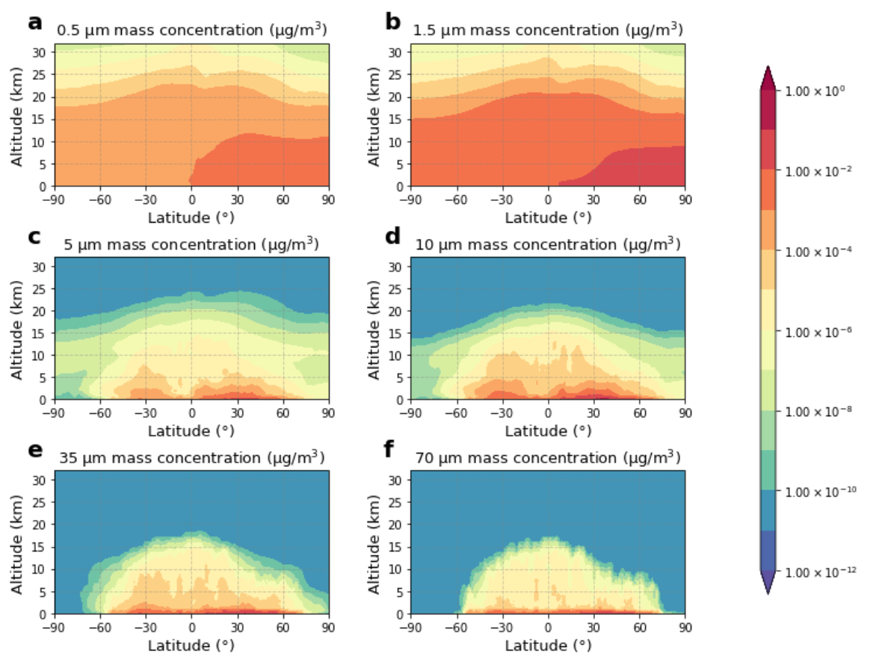

Fig. S7 The vertical distribution of microplastic particles in number. Spatial concentration distribution of microplastic particles in diameter of 0.5 (a), 1.5 (b), 5 (c), 10 (d), 35 (e), and 70 (f) μm with the average of longitude.
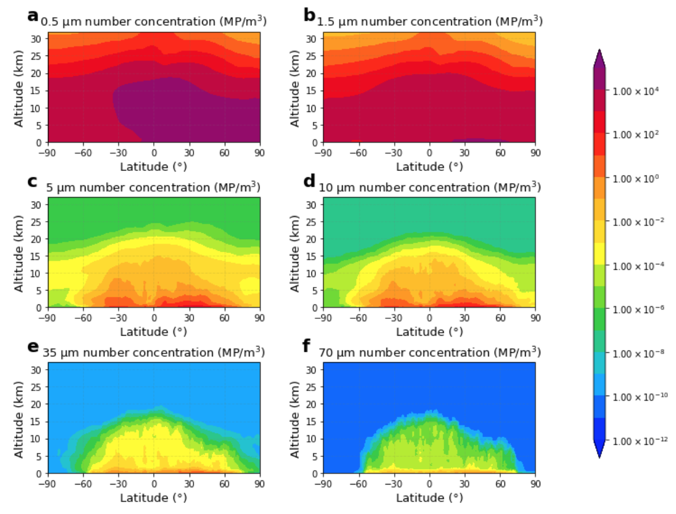

Fig. S8 Mass deposition range of microplastic particles in 6 size bins.

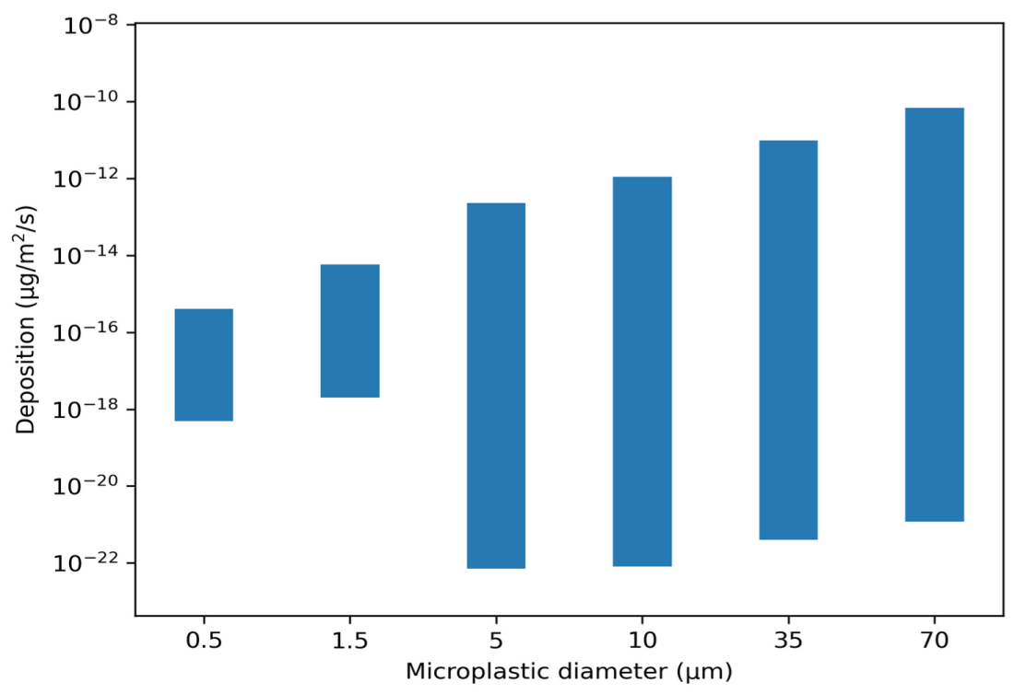
Fig. S9 The deposition distribution of microplastic particles in mass. Deposition mass distribution of microplastic particles in diameter of 0.5 (a), 1.5 (b), 5 (c), 10 (d), 35 (e), and 70 (f) μm on the ground.
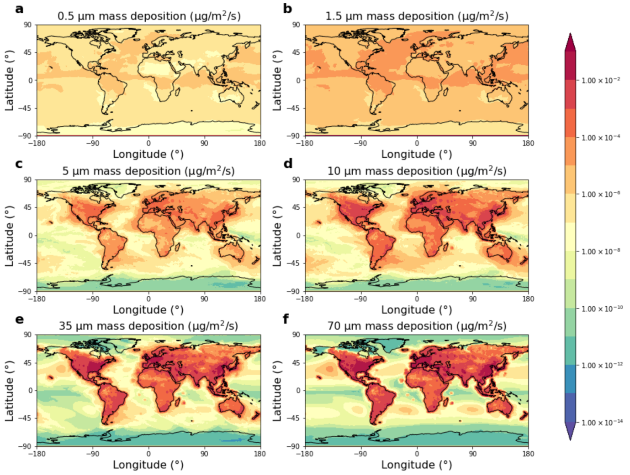

Fig. S10 The deposition distribution of microplastic particles in number. Deposition number distribution of microplastic particles in diameter of 0.5 (a), 1.5 (b), 5 (c), 10 (d), 35 (e), and 70 (f) μm on the ground.
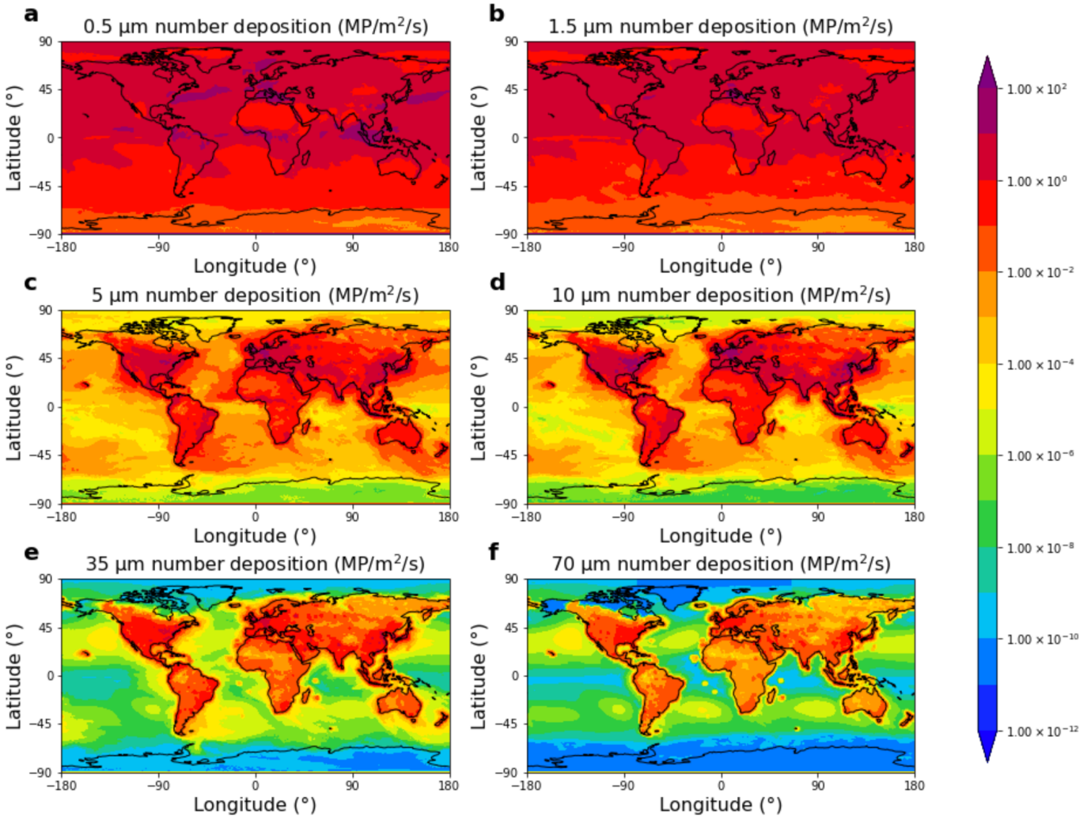
Table S1 Countries and regions that receive the atmospheric microplastic particle mass deposition.

 | 0.5 μm |  | 1.5 μm |  | 5 μm |  | 10 μm |  | 35 μm |  | 70 μm
No. | Country | Dep.  (kg/year) | Country | Dep.  (kg/year) | Country | Dep. (kg/year) | Country | Dep. (kg/year) | Country | Dep. (kg/year) | Country | Dep. (kg/year)
1 | Brazil | 2.46×10⁵ | Brazil | 2.39×10⁶ | U.S.A | 3.57×10⁷ | U.S.A | 4.45×10⁸ | U.S.A | 1.46×10⁹ | U.S.A | 2.78×10⁹
2 | Russia | 1.33×10⁵ | Russia | 2.04×10⁶ | China | 1.95×10⁷ | China | 2.64×10⁸ | China | 9.38×10⁸ | China | 1.79×10⁹
3 | Indonesia | 6.81×10⁴ | U.S.A | 1.26×10⁶ | Brazil | 6.95×10⁶ | Brazil | 8.01×10⁷ | India | 2.63×10⁸ | Brazil | 5.01×10⁸
4 | Dem. Rep. Congo | 6.80×10⁴ | Canada | 1.02×10⁶ | Russia | 5.16×10⁶ | India | 7.38×10⁷ | Brazil | 2.61×10⁸ | India | 4.99×10⁸
5 | Canada | 6.74×10⁴ | China | 8.61×10⁵ | India | 5.01×10⁶ | Russia | 5.30×10⁷ | Germany | 1.71×10⁸ | Germany | 3.23×10⁸
6 | U.S.A | 6.50×10⁴ | Dem. Rep. Congo | 7.40×10⁵ | Canada | 4.72×10⁶ | Germany | 5.10×10⁷ | Russia | 1.50×10⁸ | Russia | 2.78×10⁸
7 | Colombia | 4.16×10⁴ | Indonesia | 6.63×10⁵ | Germany | 3.98×10⁶ | Canada | 4.79×10⁷ | Canada | 1.33×10⁸ | Canada | 2.51×10⁸
8 | China | 3.48×10⁴ | Colombia | 4.10×10⁵ | Mexico | 2.87×10⁶ | Mexico | 3.77×10⁷ | Mexico | 1.28×10⁸ | Mexico | 2.43×10⁸
9 | Peru | 2.80×10⁴ | Kazakhstan | 3.28×10⁵ | Iran | 2.80×10⁶ | Iran | 3.40×10⁷ | Iran | 1.26×10⁸ | Japan | 2.40×10⁸
10 | Australia | 2.77×10⁴ | Mexico | 2.81×10⁵ | France | 2.55×10⁶ | France | 3.34×10⁷ | Saudi Arabia | 1.24×10⁸ | Iran | 2.36×10⁸
11 | Venezuela | 2.73×10⁴ | Australia | 2.80×10⁵ | Japan | 2.44×10⁶ | Saudi Arabia | 3.09×10⁷ | Japan | 1.16×10⁸ | Saudi Arabia | 2.32×10⁸
12 | Angola | 2.31×10⁴ | India | 2.79×10⁵ | Indonesia | 2.07×10⁶ | Japan | 3.08×10⁷ | France | 1.13×10⁸ | France | 2.19×10⁸
13 | Mexico | 2.03×10⁴ | Venezuela | 2.75×10⁵ | Saudi Arabia | 2.01×10⁶ | Italy | 2.53×10⁷ | Italy | 8.56×10⁷ | Australia | 1.64×10⁸
14 | Tanzania | 1.99×10⁴ | Peru | 2.64×10⁵ | Italy | 1.91×10⁶ | Indonesia | 2.37×10⁷ | Australia | 8.50×10⁷ | Italy | 1.62×10⁸
15 | Kazakhstan | 1.98×10⁴ | Angola | 2.20×10⁵ | Poland | 1.87×10⁶ | Poland | 2.33×10⁷ | Turkey | 8.22×10⁷ | Turkey | 1.59×10⁸
16 | Bolivia | 1.86×10⁴ | Tanzania | 2.04×10⁵ | Iraq | 1.77×10⁶ | Turkey | 2.15×10⁷ | United Kingdom | 7.75×10⁷ | United Kingdom | 1.57×10⁸
17 | Malaysia | 1.78×10⁴ | Malaysia | 1.91×10⁵ | Australia | 1.67×10⁶ | Australia | 2.01×10⁷ | Poland | 7.24×10⁷ | Spain | 1.37×10⁸
18 | Zambia | 1.58×10⁴ | Bolivia | 1.73×10⁵ | Turkey | 1.66×10⁶ | United Kingdom | 2.00×10⁷ | Indonesia | 7.16×10⁷ | Indonesia | 1.34×10⁸
19 | India | 1.28×10⁴ | Zambia | 1.45×10⁵ | Kazakhstan | 1.58×10⁶ | Iraq | 1.71×10⁷ | Spain | 6.99×10⁷ | Poland | 1.32×10⁸
20 | Congo | 1.28×10⁴ | Congo | 1.44×10⁵ | United Kingdom | 1.44×10⁶ | Spain | 1.68×10⁷ | Argentina | 6.07×10⁷ | Argentina | 1.14×10⁸
21 | Gabon | 1.20×10⁴ | Algeria | 1.40×10⁵ | South Africa | 1.31×10⁶ | Argentina | 1.59×10⁷ | Egypt | 6.01×10⁷ | South Korea | 1.13×10⁸
22 | Philippines | 1.15×10⁴ | Greenland | 1.34×10⁵ | Argentina | 1.24×10⁶ | Egypt | 1.50×10⁷ | South Korea | 5.68×10⁷ | Egypt | 1.11×10⁸
23 | Papua New Guinea | 1.07×10⁴ | Gabon | 1.33×10⁵ | Vietnam | 1.22×10⁶ | South Africa | 1.49×10⁷ | Iraq | 5.55×10⁷ | South Africa | 1.02×10⁸
24 | Cameroon | 1.04×10⁴ | France | 1.31×10⁵ | Egypt | 1.17×10⁶ | South Korea | 1.47×10⁷ | South Africa | 5.26×10⁷ | Iraq | 1.02×10⁸
25 | Mozambique | 9.67×10³ | Cameroon | 1.25×10⁵ | Algeria | 1.11×10⁶ | Thailand | 1.32×10⁷ | Thailand | 4.86×10⁷ | Thailand | 9.36×10⁷
26 | Argentina | 9.59×10³ | Iran | 1.18×10⁵ | South Korea | 1.10×10⁶ | Colombia | 1.17×10⁷ | Pakistan | 4.24×10⁷ | Pakistan | 8.03×10⁷
27 | Kenya | 9.56×10³ | Saudi Arabia | 1.15×10⁵ | Colombia | 1.09×10⁶ | Libya | 1.14×10⁷ | Libya | 4.15×10⁷ | Libya | 7.78×10⁷
28 | France | 8.77×10³ | Philippines | 1.15×10⁵ | Spain | 1.06×10⁶ | Pakistan | 1.13×10⁷ | Malaysia | 3.46×10⁷ | Venezuela | 6.64×10⁷
29 | Greenland | 8.62×10³ | Libya | 1.15×10⁵ | Thailand | 1.01×10⁶ | Vietnam | 1.13×10⁷ | Venezuela | 3.39×10⁷ | Malaysia | 6.64×10⁷
30 | Madagascar | 8.40×10³ | Kenya | 1.12×10⁵ | Malaysia | 9.20×10⁵ | Algeria | 1.10×10⁷ | Algeria | 3.28×10⁷ | Algeria | 6.06×10⁷
31 | South Africa | 8.23×10³ | Myanmar | 1.10×10⁵ | Libya | 8.86×10⁵ | Malaysia | 1.09×10⁷ | Colombia | 3.25×10⁷ | Colombia | 6.06×10⁷
32 | Antarctica | 8.20×10³ | Nigeria | 1.09×10⁵ | Dem. Rep. Congo | 8.39×10⁵ | Kazakhstan | 9.13×10⁶ | Vietnam | 2.75×10⁷ | Vietnam | 5.08×10⁷
33 | Guyana | 7.90×10³ | Japan | 1.08×10⁵ | Sweden | 8.07×10⁵ | Venezuela | 8.95×10⁶ | Netherlands | 2.57×10⁷ | Czechia | 4.90×10⁷
34 | Nigeria | 7.74×10³ | Argentina | 1.06×10⁵ | Ukraine | 7.86×10⁵ | Ukraine | 8.63×10⁶ | Czechia | 2.53×10⁷ | Netherlands | 4.79×10⁷
35 | Myanmar | 7.63×10³ | Thailand | 9.44×10⁴ | Venezuela | 7.19×10⁵ | Netherlands | 8.21×10⁶ | Ukraine | 2.45×10⁷ | Austria | 4.71×10⁷
36 | Japan | 7.02×10³ | Mozambique | 9.24×10⁴ | Nigeria | 7.10×10⁵ | Peru | 7.89×10⁶ | Peru | 2.41×10⁷ | Peru | 4.64×10⁷
37 | Suriname | 6.18×10³ | South Africa | 8.97×10⁴ | Peru | 7.07×10⁵ | Sweden | 7.68×10⁶ | Austria | 2.38×10⁷ | Ukraine | 4.50×10⁷
38 | Algeria | 6.11×10³ | Antarctica | 8.80×10⁴ | Afghanistan | 6.95×10⁵ | Czechia | 7.36×10⁶ | Nigeria | 2.15×10⁷ | Chile | 4.30×10⁷
39 | Thailand | 5.54×10³ | Turkey | 8.52×10⁴ | Syria | 6.63×10⁵ | Austria | 6.23×10⁶ | Chile | 2.10×10⁷ | Nigeria | 4.01×10⁷
40 | Libya | 5.14×10³ | Germany | 8.45×10⁴ | Pakistan | 6.53×10⁵ | Afghanistan | 5.90×10⁶ | Morocco | 1.94×10⁷ | Morocco | 3.67×10⁷
41 | Norway | 5.12×10³ | Papua New Guinea | 7.99×10⁴ | Netherlands | 6.50×10⁵ | Syria | 5.78×10⁶ | Sweden | 1.88×10⁷ | Sweden | 3.51×10⁷
42 | Ecuador | 4.99×10³ | Guyana | 7.88×10⁴ | Sudan | 5.99×10⁵ | Belarus | 5.75×10⁶ | Kazakhstan | 1.87×10⁷ | Kazakhstan | 3.46×10⁷
43 | Sweden | 4.87×10³ | Madagascar | 7.44×10⁴ | Turkmenistan | 5.85×10⁵ | Nigeria | 5.35×10⁶ | Afghanistan | 1.65×10⁷ | Belgium | 3.40×10⁷
44 | Côte d'Ivoire | 4.81×10³ | Italy | 7.40×10⁴ | Belarus | 5.81×10⁵ | Turkmenistan | 5.07×10⁶ | Belgium | 1.62×10⁷ | Switzerland | 3.01×10⁷
45 | Ethiopia | 4.47×10³ | Ukraine | 7.30×10⁴ | Czechia | 5.70×10⁵ | Myanmar | 5.02×10⁶ | Switzerland | 1.52×10⁷ | Afghanistan | 3.00×10⁷
46 | Turkey | 4.24×10³ | Sweden | 7.27×10⁴ | Uzbekistan | 5.53×10⁵ | Ecuador | 4.93×10⁶ | Ecuador | 1.49×10⁷ | Ecuador | 2.81×10⁷
47 | Uganda | 4.21×10³ | Egypt | 7.24×10⁴ | Myanmar | 5.38×10⁵ | Chile | 4.67×10⁶ | Syria | 1.41×10⁷ | Romania | 2.58×10⁷
48 | Finland | 4.16×10³ | Sudan | 7.19×10⁴ | Laos | 4.94×10⁵ | Hungary | 4.67×10⁶ | Hungary | 1.41×10⁷ | Hungary | 2.58×10⁷
49 | Iran | 4.08×10³ | Norway | 6.89×10⁴ | Austria | 4.49×10⁵ | Sudan | 4.66×10⁶ | Romania | 1.38×10⁷ | Syria | 2.55×10⁷
50 | Nicaragua | 3.98×10³ | Ethiopia | 6.63×10⁴ | Ecuador | 4.34×10⁵ | Morocco | 4.59×10⁶ | Portugal | 1.29×10⁷ | Portugal | 2.50×10⁷
51 | United Kingdom | 3.95×10³ | Mongolia | 6.59×10⁴ | North Korea | 4.05×10⁵ | Romania | 4.41×10⁶ | Turkmenistan | 1.25×10⁷ | Yemen | 2.28×10⁷
52 | Central African Rep. | 3.86×10³ | Poland | 6.32×10⁴ | Hungary | 3.94×10⁵ | North Korea | 4.25×10⁶ | Belarus | 1.24×10⁷ | Philippines | 2.27×10⁷
53 | Ukraine | 3.75×10³ | Suriname | 6.25×10⁴ | Romania | 3.75×10⁵ | Dem. Rep. Congo | 4.25×10⁶ | Myanmar | 1.18×10⁷ | North Korea | 2.27×10⁷
54 | Germany | 3.67×10³ | Côte d'Ivoire | 6.06×10⁴ | Bolivia | 3.62×10⁵ | Laos | 4.17×10⁶ | Yemen | 1.18×10⁷ | Greece | 2.24×10⁷
55 | Botswana | 3.66×10³ | Finland | 6.00×10⁴ | Morocco | 3.60×10⁵ | Belgium | 4.09×10⁶ | Greece | 1.17×10⁷ | Belarus | 2.22×10⁷
56 | Italy | 3.54×10³ | Vietnam | 5.82×10⁴ | Cameroon | 3.59×10⁵ | Bolivia | 3.58×10⁶ | Philippines | 1.17×10⁷ | Turkmenistan | 2.20×10⁷
57 | Zimbabwe | 3.45×10³ | Spain | 5.72×10⁴ | Finland | 3.46×10⁵ | Greece | 3.56×10⁶ | North Korea | 1.15×10⁷ | Dem. Rep. Congo | 2.12×10⁷
58 | Panama | 3.42×10³ | United Kingdom | 5.63×10⁴ | Chile | 3.12×10⁵ | Switzerland | 3.55×10⁶ | Dem. Rep. Congo | 1.12×10⁷ | Myanmar | 2.09×10⁷
59 | Namibia | 3.40×10³ | Iraq | 5.59×10⁴ | Greece | 3.06×10⁵ | Portugal | 3.51×10⁶ | Tunisia | 1.03×10⁷ | Tunisia | 1.94×10⁷
60 | Liberia | 3.25×10³ | Central African Rep. | 5.38×10⁴ | Belgium | 2.94×10⁵ | Philippines | 3.48×10⁶ | Bolivia | 1.00×10⁷ | Laos | 1.90×10⁷
61 | Saudi Arabia | 3.22×10³ | Ecuador | 5.10×10⁴ | Tunisia | 2.83×10⁵ | Finland | 3.45×10⁶ | Bangladesh | 9.90×10⁶ | Israel | 1.90×10⁷
62 | Vietnam | 3.14×10³ | Uganda | 5.03×10⁴ | Cambodia | 2.82×10⁵ | Uzbekistan | 3.28×10⁶ | Jordan | 9.81×10⁶ | Bolivia | 1.88×10⁷
63 | Somalia | 3.11×10³ | Uzbekistan | 4.91×10⁴ | Tanzania | 2.80×10⁵ | Bangladesh | 3.22×10⁶ | Tanzania | 9.76×10⁶ | Jordan | 1.87×10⁷
64 | Spain | 3.00×10³ | Mauritania | 4.44×10⁴ | Philippines | 2.80×10⁵ | Cambodia | 3.04×10⁶ | Israel | 9.66×10⁶ | Bangladesh | 1.87×10⁷
65 | Poland | 2.96×10³ | Turkmenistan | 4.38×10⁴ | Norway | 2.77×10⁵ | Tanzania | 3.04×10⁶ | Laos | 9.62×10⁶ | Tanzania | 1.86×10⁷
66 | Ghana | 2.85×10³ | Somalia | 4.26×10⁴ | Bangladesh | 2.77×10⁵ | Yemen | 2.90×10⁶ | Kenya | 9.58×10⁶ | Kenya | 1.83×10⁷
67 | Guatemala | 2.80×10³ | Mali | 4.22×10⁴ | Kenya | 2.72×10⁵ | Kenya | 2.88×10⁶ | Finland | 9.54×10⁶ | Bulgaria | 1.82×10⁷
68 | Mongolia | 2.76×10³ | Pakistan | 4.18×10⁴ | Lithuania | 2.68×10⁵ | Norway | 2.71×10⁶ | Bulgaria | 9.39×10⁶ | Finland | 1.78×10⁷
69 | Uzbekistan | 2.66×10³ | Nicaragua | 4.03×10⁴ | Ethiopia | 2.66×10⁵ | Tunisia | 2.71×10⁶ | Paraguay | 9.13×10⁶ | New Zealand | 1.68×10⁷
70 | Egypt | 2.48×10³ | Afghanistan | 4.00×10⁴ | Central African Rep. | 2.52×10⁵ | Serbia | 2.66×10⁶ | Cambodia | 8.88×10⁶ | Paraguay | 1.64×10⁷
71 | Honduras | 2.46×10³ | Laos | 3.89×10⁴ | Portugal | 2.41×10⁵ | Jordan | 2.63×10⁶ | Serbia | 8.63×10⁶ | Serbia | 1.63×10⁷
72 | Malawi | 2.20×10³ | Morocco | 3.87×10⁴ | S. Sudan | 2.38×10⁵ | Bulgaria | 2.58×10⁶ | New Zealand | 8.14×10⁶ | Cambodia | 1.60×10⁷
73 | Sudan | 2.16×10³ | Niger | 3.77×10⁴ | Denmark | 2.31×10⁵ | Lithuania | 2.55×10⁶ | Slovakia | 8.06×10⁶ | Ireland | 1.59×10⁷
74 | Turkmenistan | 2.11×10³ | Liberia | 3.77×10⁴ | Yemen | 2.11×10⁵ | Slovakia | 2.51×10⁶ | Ethiopia | 7.67×10⁶ | Slovakia | 1.57×10⁷
75 | Sierra Leone | 2.11×10³ | Chad | 3.73×10⁴ | Serbia | 2.10×10⁵ | Paraguay | 2.48×10⁶ | Norway | 7.48×10⁶ | Norway | 1.45×10⁷
76 | Laos | 2.05×10³ | Belarus | 3.72×10⁴ | Slovakia | 2.07×10⁵ | Denmark | 2.38×10⁶ | Ireland | 7.35×10⁶ | Ethiopia | 1.38×10⁷
77 | Belarus | 2.04×10³ | Ghana | 3.70×10⁴ | Côte d'Ivoire | 2.06×10⁵ | Croatia | 2.36×10⁶ | Oman | 7.30×10⁶ | Guatemala | 1.36×10⁷
78 | Costa Rica | 2.02×10³ | Botswana | 3.62×10⁴ | Switzerland | 2.05×10⁵ | Ethiopia | 2.29×10⁶ | Croatia | 7.05×10⁶ | Croatia | 1.33×10⁷
79 | Paraguay | 1.98×10³ | Namibia | 3.44×10⁴ | Croatia | 2.03×10⁵ | New Zealand | 2.27×10⁶ | Sudan | 6.78×10⁶ | Oman | 1.32×10⁷
80 | Guinea | 1.96×10³ | Panama | 3.33×10⁴ | Jordan | 2.03×10⁵ | Israel | 2.14×10⁶ | Guatemala | 6.74×10⁶ | Uzbekistan | 1.22×10⁷
81 | Sri Lanka | 1.95×10³ | Zimbabwe | 3.29×10⁴ | New Zealand | 1.85×10⁵ | Oman | 2.09×10⁶ | Uzbekistan | 6.72×10⁶ | Zimbabwe | 1.17×10⁷
82 | Mauritania | 1.93×10³ | Cambodia | 3.06×10⁴ | Bulgaria | 1.85×10⁵ | Guatemala | 1.93×10⁶ | Zimbabwe | 6.04×10⁶ | Somalia | 1.16×10⁷
83 | Chile | 1.93×10³ | Guatemala | 3.03×10⁴ | Mongolia | 1.84×10⁵ | Angola | 1.79×10⁶ | Somalia | 5.70×10⁶ | Sudan | 1.05×10⁷
84 | Morocco | 1.87×10³ | S. Sudan | 2.80×10⁴ | Mauritania | 1.83×10⁵ | Azerbaijan | 1.76×10⁶ | Denmark | 5.41×10⁶ | Sri Lanka | 1.04×10⁷
85 | Cambodia | 1.85×10³ | Greece | 2.71×10⁴ | Chad | 1.77×10⁵ | Ireland | 1.69×10⁶ | Angola | 5.32×10⁶ | Denmark | 1.01×10⁷
86 | Iraq | 1.80×10³ | Guinea | 2.58×10⁴ | Oman | 1.74×10⁵ | Zimbabwe | 1.59×10⁶ | Sri Lanka | 5.25×10⁶ | Angola | 1.01×10⁷
87 | Eq. Guinea | 1.79×10³ | Honduras | 2.54×10⁴ | Paraguay | 1.68×10⁵ | Botswana | 1.54×10⁶ | Lithuania | 5.24×10⁶ | Mozambique | 1.01×10⁷
88 | Afghanistan | 1.78×10³ | Syria | 2.49×10⁴ | Angola | 1.63×10⁵ | Sri Lanka | 1.53×10⁶ | Mozambique | 5.09×10⁶ | Lithuania | 9.24×10⁶
89 | Greece | 1.68×10³ | Sierra Leone | 2.45×10⁴ | Guatemala | 1.63×10⁵ | Nepal | 1.45×10⁶ | Azerbaijan | 5.03×10⁶ | Azerbaijan | 9.03×10⁶
90 | Cuba | 1.66×10³ | Sri Lanka | 2.36×10⁴ | Tajikistan | 1.63×10⁵ | Mozambique | 1.43×10⁶ | Botswana | 4.76×10⁶ | Uruguay | 8.63×10⁶
91 | New Zealand | 1.50×10³ | Romania | 2.29×10⁴ | Latvia | 1.62×10⁵ | Latvia | 1.36×10⁶ | Uruguay | 4.47×10⁶ | Botswana | 8.36×10⁶
92 | Mali | 1.48×10³ | Tunisia | 2.24×10⁴ | Azerbaijan | 1.61×10⁵ | Cameroon | 1.35×10⁶ | Slovenia | 4.38×10⁶ | United Arab Emirates | 8.36×10⁶
93 | S. Sudan | 1.43×10³ | Paraguay | 2.15×10⁴ | Ghana | 1.54×10⁵ | Slovenia | 1.28×10⁶ | United Arab Emirates | 4.31×10⁶ | Slovenia | 8.34×10⁶
94 | Ireland | 1.41×10³ | South Korea | 2.14×10⁴ | Kyrgyzstan | 1.52×10⁵ | Somalia | 1.27×10⁶ | Georgia | 3.85×10⁶ | Nicaragua | 7.45×10⁶
95 | Iceland | 1.34×10³ | Chile | 2.09×10⁴ | Israel | 1.43×10⁵ | Chad | 1.26×10⁶ | Nepal | 3.69×10⁶ | Georgia | 7.22×10⁶
96 | Tunisia | 1.28×10³ | Malawi | 2.09×10⁴ | Somalia | 1.37×10⁵ | Côte d'Ivoire | 1.25×10⁶ | Guinea | 3.57×10⁶ | Bosnia and Herz. | 7.08×10⁶
97 | Dominican Rep. | 1.23×10³ | Eq. Guinea | 2.03×10⁴ | Botswana | 1.37×10⁵ | Uruguay | 1.23×10⁶ | Bosnia and Herz. | 3.56×10⁶ | Nepal | 6.72×10⁶
98 | Syria | 1.23×10³ | Costa Rica | 2.00×10⁴ | Niger | 1.36×10⁵ | S. Sudan | 1.18×10⁶ | Nicaragua | 3.40×10⁶ | Guinea | 6.60×10⁶
99 | Burundi | 1.13×10³ | Cuba | 1.88×10⁴ | Zimbabwe | 1.28×10⁵ | Kyrgyzstan | 1.16×10⁶ | Zambia | 3.22×10⁶ | Honduras | 6.32×10⁶
100 | Pakistan | 1.08×10³ | Ireland | 1.79×10⁴ | Nepal | 1.28×10⁵ | Zambia | 1.16×10⁶ | Cameroon | 3.11×10⁶ | Cuba | 5.83×10⁶
101 | Niger | 1.05×10³ | Iceland | 1.74×10⁴ | Sri Lanka | 1.25×10⁵ | Georgia | 1.11×10⁶ | Côte d'Ivoire | 3.08×10⁶ | Zambia | 5.78×10⁶
102 | Portugal | 1.04×10³ | Yemen | 1.68×10⁴ | Guinea | 1.24×10⁵ | Tajikistan | 1.09×10⁶ | Kyrgyzstan | 3.02×10⁶ | Cameroon | 5.66×10⁶
103 | Chad | 9.62×10² | Portugal | 1.62×10⁴ | Mozambique | 1.21×10⁵ | Niger | 1.05×10⁶ | Niger | 2.98×10⁶ | Kyrgyzstan | 5.62×10⁶
104 | Romania | 9.02×10² | Czechia | 1.52×10⁴ | Uganda | 1.18×10⁵ | United Arab Emirates | 1.02×10⁶ | Honduras | 2.94×10⁶ | Côte d'Ivoire | 5.59×10⁶
105 | South Korea | 8.99×10² | Hungary | 1.49×10⁴ | Ireland | 1.17×10⁵ | Guinea | 1.02×10⁶ | Senegal | 2.77×10⁶ | Niger | 5.49×10⁶
106 | Eritrea | 8.84×10² | New Zealand | 1.44×10⁴ | Uruguay | 1.09×10⁵ | Bosnia and Herz. | 1.01×10⁶ | North Macedonia | 2.76×10⁶ | El Salvador | 5.46×10⁶
107 | Lithuania | 8.54×10² | Lithuania | 1.43×10⁴ | Zambia | 1.08×10⁵ | Mauritania | 9.86×10⁵ | Cuba | 2.71×10⁶ | North Macedonia | 5.35×10⁶
108 | Benin | 8.17×10² | Oman | 1.43×10⁴ | Congo | 1.05×10⁵ | Mongolia | 9.47×10⁵ | Albania | 2.71×10⁶ | Albania | 5.19×10⁶
109 | Latvia | 7.93×10² | North Korea | 1.37×10⁴ | Estonia | 9.89×10⁴ | Mali | 8.87×10⁵ | Mali | 2.58×10⁶ | Senegal | 5.07×10⁶
110 | Kyrgyzstan | 7.62×10² | Bangladesh | 1.36×10⁴ | United Arab Emirates | 9.77×10⁴ | Ghana | 8.79×10⁵ | Latvia | 2.57×10⁶ | Mali | 4.98×10⁶
111 | Tajikistan | 7.45×10² | Kyrgyzstan | 1.34×10⁴ | Slovenia | 9.59×10⁴ | Namibia | 8.50×10⁵ | Namibia | 2.55×10⁶ | Latvia | 4.70×10⁶
112 | Denmark | 7.37×10² | Austria | 1.32×10⁴ | Sierra Leone | 8.84×10⁴ | Estonia | 8.25×10⁵ | Mongolia | 2.54×10⁶ | Mongolia | 4.67×10⁶
113 | Belize | 6.96×10² | Dominican Rep. | 1.31×10⁴ | Namibia | 8.45×10⁴ | Honduras | 7.69×10⁵ | Mauritania | 2.47×10⁶ | Mauritania | 4.53×10⁶
114 | Uruguay | 6.61×10² | Latvia | 1.25×10⁴ | Mali | 8.40×10⁴ | Nicaragua | 7.61×10⁵ | El Salvador | 2.45×10⁶ | Armenia | 4.52×10⁶
115 | Bangladesh | 6.44×10² | Eritrea | 1.24×10⁴ | Bosnia and Herz. | 8.33×10⁴ | Central African Rep. | 7.29×10⁵ | Armenia | 2.34×10⁶ | Burkina Faso | 4.46×10⁶
116 | Rwanda | 6.42×10² | Burundi | 1.21×10⁴ | Georgia | 8.31×10⁴ | North Macedonia | 7.29×10⁵ | Tajikistan | 2.31×10⁶ | Madagascar | 4.45×10⁶
117 | Hungary | 6.22×10² | Tajikistan | 1.20×10⁴ | Liberia | 7.98×10⁴ | Uganda | 7.14×10⁵ | Madagascar | 2.29×10⁶ | Namibia | 4.42×10⁶
118 | North Korea | 6.14×10² | Benin | 1.18×10⁴ | Benin | 7.78×10⁴ | Congo | 6.93×10⁵ | Burkina Faso | 2.29×10⁶ | Tajikistan | 4.29×10⁶
119 | Netherlands | 6.12×10² | Netherlands | 1.14×10⁴ | Bhutan | 7.16×10⁴ | Madagascar | 6.90×10⁵ | Chad | 2.05×10⁶ | Qatar | 3.85×10⁶
120 | Estonia | 6.05×10² | Bulgaria | 1.11×10⁴ | Senegal | 6.78×10⁴ | Albania | 6.73×10⁵ | S. Sudan | 2.03×10⁶ | Lebanon | 3.77×10⁶
121 | Czechia | 5.97×10² | Denmark | 1.09×10⁴ | Madagascar | 6.22×10⁴ | Armenia | 6.15×10⁵ | Lebanon | 1.98×10⁶ | Congo | 3.76×10⁶
122 | Brunei | 5.50×10² | Croatia | 1.05×10⁴ | Honduras | 6.11×10⁴ | Lebanon | 5.99×10⁵ | Congo | 1.98×10⁶ | Chad | 3.75×10⁶
123 | Croatia | 5.22×10² | Jordan | 1.03×10⁴ | Lebanon | 5.72×10⁴ | Moldova | 5.96×10⁵ | Ghana | 1.97×10⁶ | Costa Rica | 3.71×10⁶
124 | Haiti | 4.98×10² | Estonia | 9.35×10³ | Nicaragua | 5.52×10⁴ | Senegal | 5.87×10⁵ | Moldova | 1.92×10⁶ | Moldova | 3.63×10⁶
125 | Jordan | 4.96×10² | Serbia | 9.09×10³ | Moldova | 5.15×10⁴ | Sierra Leone | 5.87×10⁵ | Costa Rica | 1.88×10⁶ | S. Sudan | 3.46×10⁶
126 | Solomon Is. | 4.86×10² | Azerbaijan | 8.50×10³ | Eritrea | 5.13×10⁴ | Cuba | 5.85×10⁵ | Estonia | 1.79×10⁶ | Ghana | 3.42×10⁶
127 | Togo | 4.82×10² | Senegal | 8.37×10³ | North Macedonia | 5.00×10⁴ | Costa Rica | 5.47×10⁵ | Qatar | 1.78×10⁶ | Estonia | 3.26×10⁶
128 | Austria | 4.67×10² | Burkina Faso | 8.05×10³ | Armenia | 4.66×10⁴ | Benin | 5.26×10⁵ | Uganda | 1.57×10⁶ | Somaliland | 3.14×10⁶
129 | Yemen | 4.62×10² | Israel | 7.73×10³ | Albania | 4.64×10⁴ | Bhutan | 4.85×10⁵ | Somaliland | 1.49×10⁶ | Uganda | 2.81×10⁶
130 | Israel | 4.58×10² | Uruguay | 7.60×10³ | Costa Rica | 4.58×10⁴ | Liberia | 4.79×10⁵ | Benin | 1.47×10⁶ | Sierra Leone | 2.50×10⁶
131 | Bulgaria | 4.51×10² | Belize | 7.27×10³ | Kuwait | 4.58×10⁴ | Burkina Faso | 4.36×10⁵ | Sierra Leone | 1.38×10⁶ | Benin | 2.47×10⁶
132 | Trinidad and Tobago | 4.51×10² | Rwanda | 7.25×10³ | Lesotho | 4.41×10⁴ | Kuwait | 4.28×10⁵ | Kuwait | 1.24×10⁶ | Malawi | 2.42×10⁶
133 | Oman | 3.90×10² | Switzerland | 6.91×10³ | Togo | 4.33×10⁴ | Lesotho | 4.08×10⁵ | Kosovo | 1.24×10⁶ | Kosovo | 2.38×10⁶
134 | Azerbaijan | 3.84×10² | Slovakia | 6.83×10³ | Somaliland | 4.30×10⁴ | El Salvador | 3.74×10⁵ | Malawi | 1.22×10⁶ | Liberia | 2.10×10⁶
135 | Timor-Leste | 3.67×10² | Togo | 6.59×10³ | Cuba | 4.24×10⁴ | Qatar | 3.46×10⁵ | Central African Rep. | 1.17×10⁶ | Burundi | 2.09×10⁶
136 | Serbia | 3.57×10² | Georgia | 6.22×10³ | Burundi | 3.26×10⁴ | Burundi | 3.37×10⁵ | Liberia | 1.13×10⁶ | Central African Rep. | 2.07×10⁶
137 | Senegal | 3.53×10² | Belgium | 6.15×10³ | Gabon | 3.25×10⁴ | Malawi | 3.29×10⁵ | Lesotho | 1.09×10⁶ | Dominican Rep. | 2.01×10⁶
138 | Guinea-Bissau | 3.43×10² | Nepal | 6.07×10³ | Cyprus | 3.23×10⁴ | Kosovo | 3.27×10⁵ | Burundi | 1.08×10⁶ | Kuwait | 1.98×10⁶
139 | Fiji | 3.19×10² | W. Sahara | 5.61×10³ | Qatar | 3.17×10⁴ | Somaliland | 3.10×10⁵ | Bhutan | 1.06×10⁶ | Bhutan | 1.97×10⁶
140 | Belgium | 3.09×10² | Bosnia and Herz. | 5.50×10³ | Burkina Faso | 2.96×10⁴ | Panama | 2.80×10⁵ | Dominican Rep. | 9.85×10⁵ | Lesotho | 1.95×10⁶
141 | Georgia | 3.04×10² | Haiti | 5.41×10³ | Malawi | 2.73×10⁴ | Dominican Rep. | 2.71×10⁵ | Panama | 8.87×10⁵ | Montenegro | 1.74×10⁶
142 | Bhutan | 3.01×10² | Somaliland | 5.27×10³ | W. Sahara | 2.66×10⁴ | Togo | 2.65×10⁵ | Montenegro | 8.63×10⁵ | Panama | 1.70×10⁶
143 | Slovakia | 2.91×10² | Brunei | 5.10×10³ | Rwanda | 2.53×10⁴ | Rwanda | 2.38×10⁵ | Rwanda | 7.89×10⁵ | Rwanda | 1.55×10⁶
144 | Puerto Rico | 2.89×10² | United Arab Emirates | 4.86×10³ | Panama | 2.44×10⁴ | Cyprus | 2.28×10⁵ | Haiti | 7.61×10⁵ | Haiti | 1.53×10⁶
145 | Lesotho | 2.76×10² | Guinea-Bissau | 4.61×10³ | Guinea-Bissau | 2.39×10⁴ | eSwatini | 2.22×10⁵ | Guinea-Bissau | 7.19×10⁵ | Guyana | 1.43×10⁶
146 | W. Sahara | 2.69×10² | Trinidad and Tobago | 4.60×10³ | Kosovo | 2.28×10⁴ | Gabon | 2.20×10⁵ | Belize | 6.77×10⁵ | Jamaica | 1.34×10⁶
147 | Burkina Faso | 2.63×10² | Albania | 4.57×10³ | eSwatini | 2.21×10⁴ | Brunei | 2.18×10⁵ | Guyana | 6.74×10⁵ | Belize | 1.32×10⁶
148 | Jamaica | 2.60×10² | Bhutan | 4.56×10³ | El Salvador | 2.21×10⁴ | Eritrea | 2.16×10⁵ | Brunei | 6.40×10⁵ | Guinea-Bissau | 1.25×10⁶
149 | Bosnia and Herz. | 2.59×10² | Moldova | 3.98×10³ | Dominican Rep. | 2.14×10⁴ | Montenegro | 2.11×10⁵ | Togo | 6.28×10⁵ | Brunei | 1.19×10⁶
150 | Albania | 2.47×10² | Solomon Is. | 3.69×10³ | Brunei | 1.94×10⁴ | Guinea-Bissau | 2.09×10⁵ | Gabon | 6.17×10⁵ | Gabon | 1.17×10⁶
151 | eSwatini | 2.35×10² | Lebanon | 3.45×10³ | Suriname | 1.92×10⁴ | Suriname | 2.06×10⁵ | Jamaica | 6.05×10⁵ | Iceland | 1.14×10⁶
152 | Lebanon | 2.23×10² | Slovenia | 3.23×10³ | Belize | 1.67×10⁴ | Belize | 2.05×10⁵ | Suriname | 5.78×10⁵ | Suriname | 1.05×10⁶
153 | Bahamas | 2.21×10² | Timor-Leste | 3.12×10³ | Guyana | 1.65×10⁴ | Guyana | 1.93×10⁵ | eSwatini | 5.69×10⁵ | Togo | 1.04×10⁶
154 | Switzerland | 2.12×10² | Lesotho | 3.05×10³ | Montenegro | 1.53×10⁴ | Haiti | 1.89×10⁵ | Iceland | 5.52×10⁵ | eSwatini | 1.04×10⁶
155 | Somaliland | 2.07×10² | Puerto Rico | 3.01×10³ | Haiti | 1.47×10⁴ | W. Sahara | 1.43×10⁵ | Puerto Rico | 4.56×10⁵ | Puerto Rico | 9.05×10⁵
156 | El Salvador | 2.00×10² | North Macedonia | 2.82×10³ | Jamaica | 9.95×10³ | Jamaica | 1.38×10⁵ | Cyprus | 4.43×10⁵ | Cyprus | 7.27×10⁵
157 | Nepal | 1.88×10² | Jamaica | 2.74×10³ | Iceland | 9.71×10³ | Iceland | 1.37×10⁵ | Eritrea | 3.56×10⁵ | Eritrea | 5.95×10⁵
158 | Moldova | 1.81×10² | Bahamas | 2.67×10³ | Puerto Rico | 8.68×10³ | Puerto Rico | 1.21×10⁵ | W. Sahara | 3.15×10⁵ | W. Sahara | 5.72×10⁵
159 | United Arab Emirates | 1.57×10² | Fiji | 2.46×10³ | Eq. Guinea | 7.76×10³ | Djibouti | 4.77×10⁴ | Djibouti | 2.03×10⁵ | Djibouti | 4.75×10⁵
160 | Cyprus | 1.37×10² | eSwatini | 2.45×10³ | Djibouti | 7.29×10³ | Eq. Guinea | 4.44×10⁴ | Gambia | 1.89×10⁵ | Gambia | 3.57×10⁵
161 | Slovenia | 1.30×10² | El Salvador | 2.41×10³ | Bahamas | 3.52×10³ | Gambia | 3.67×10⁴ | Eq. Guinea | 1.18×10⁵ | Eq. Guinea | 2.24×10⁵
162 | Vanuatu | 1.28×10² | Armenia | 2.24×10³ | Gambia | 3.46×10³ | Papua New Guinea | 2.66×10⁴ | Papua New Guinea | 7.43×10⁴ | Papua New Guinea | 1.36×10⁵
163 | North Macedonia | 1.19×10² | Cyprus | 2.11×10³ | Papua New Guinea | 2.58×10³ | Bahamas | 2.59×10⁴ | Falkland Is. | 5.56×10⁴ | Falkland Is. | 1.23×10⁵
164 | New Caledonia | 1.06×10² | Kuwait | 1.64×10³ | Falkland Is. | 1.72×10³ | Falkland Is. | 1.95×10⁴ | Trinidad and Tobago | 5.45×10⁴ | Trinidad and Tobago | 1.21×10⁵
165 | Armenia | 8.50×10¹ | Montenegro | 1.29×10³ | Timor-Leste | 1.37×10³ | Timor-Leste | 1.48×10⁴ | Timor-Leste | 4.31×10⁴ | Timor-Leste | 8.01×10⁴
166 | Montenegro | 6.60×10¹ | Kosovo | 1.10×10³ | Trinidad and Tobago | 9.84×10² | Trinidad and Tobago | 1.36×10⁴ | Bahamas | 3.92×10⁴ | Bahamas | 5.09×10⁴
167 | Falkland Is. | 6.10×10¹ | Qatar | 1.01×10³ | Greenland | 5.33×10² | Greenland | 1.07×10³ | Fr. S. Antarctic Lands | 4.32×10² | Fr. S. Antarctic Lands | 1.07×10³
168 | Djibouti | 4.80×10¹ | Vanuatu | 1.01×10³ | New Caledonia | 9.50×10¹ | New Caledonia | 2.61×10² | Greenland | 6.20×10¹ | Antarctica | 2.00
169 | Kosovo | 4.20×10¹ | Djibouti | 9.59×10² | Antarctica | 4.70×10¹ | Fr. S. Antarctic Lands | 1.30×10² | New Caledonia | 2.00×10¹ | Greenland | 0.00
170 | Fr. S. Antarctic Lands | 3.00×10¹ | New Caledonia | 8.81×10² | Fr. S. Antarctic Lands | 1.30×10¹ | Antarctica | 1.24×10² | Antarctica | 2.00 | New Caledonia | 0.00
171 | Kuwait | 2.80×10¹ | Falkland Is. | 5.15×10² | Fiji | 6.00 | Fiji | 1.40×10¹ | Vanuatu | 1.00 | Solomon Is. | 0.00
172 | Gambia | 2.70×10¹ | Gambia | 5.12×10² | Vanuatu | 3.00 | Vanuatu | 1.40×10¹ | Fiji | 0.00 | Fiji | 0.00
173 | Qatar | 2.20×10¹ | Fr. S. Antarctic Lands | 2.59×10² | Solomon Is. | 3.00 | Solomon Is. | 7.00 | Solomon Is. | 0.00 | Vanuatu | 0.00
174 | N. Cyprus | 0.00 | Luxembourg | 0.00 | N. Cyprus | 0.00 | Palestine | 0.00 | N. Cyprus | 0.00 | N. Cyprus | 0.00
175 | Palestine | 0.00 | N. Cyprus | 0.00 | Palestine | 0.00 | Luxembourg | 0.00 | Palestine | 0.00 | Luxembourg | 0.00
176 | Luxembourg | 0.00 | Palestine | 0.00 | Luxembourg | 0.00 | N. Cyprus | 0.00 | Luxembourg | 0.00 | Palestine | 0.00

Table S2 Deposition parameters for each particle size D.
$D$ (μm) | 0.5 | 1.5 | 5 | 10 | 35 | 70
$C_{c}$ of sphere | 1.326 | 1.082 | 1.032 | 1.016 | 1.008 | 1.003
Dry velocity of sphere (cm/s) | 0.00097 | 0.0087 | 0.097 | 0.39 | 3.61 | 14.39
$$a$$ | $$7.1×{10}^{-8}$$ | $$1.1×{10}^{-7}$$ | $$9.7×{10}^{-5}$$ | $$1.7×{10}^{-4}$$ | $$2.8×{10}^{-4}$$ | $$3.9×{10}^{-4}$$
$$b$$ | $$6.9×{10}^{-7}$$ | $$1.2×{10}^{-6}$$ | $$1.8×{10}^{-3}$$ | $$3.6×{10}^{-3}$$ | $$5.5×{10}^{-3}$$ | $$6.4×{10}^{-3}$$

References
1. Brahney, J. et al. Constraining the atmospheric limb of the plastic cycle. Proc National Acad Sci 118, e2020719118 (2021).
2. Evangeliou, N., Tichý, O., Eckhardt, S., Zwaaftink, C. G. & Brahney, J. Sources and fate of atmospheric microplastics revealed from inverse and dispersion modelling: From global emissions to deposition. J Hazard Mater 432, 128585 (2022).
3. Union, E. Microplastics from textiles: towards a circular economy for textiles in Europe. (2022).
4. Tiseo, I. Managed and mismanaged microplastics worldwide in 2016 with a forecast to 2040 under business-as-usual scenario. (2021).
5. Union, E. Car ownership rates projections. (2010).
6. Nations, U. World population projected to reach 9.8 billion in 2050, and 11.2 billion in 2100. (2017).

