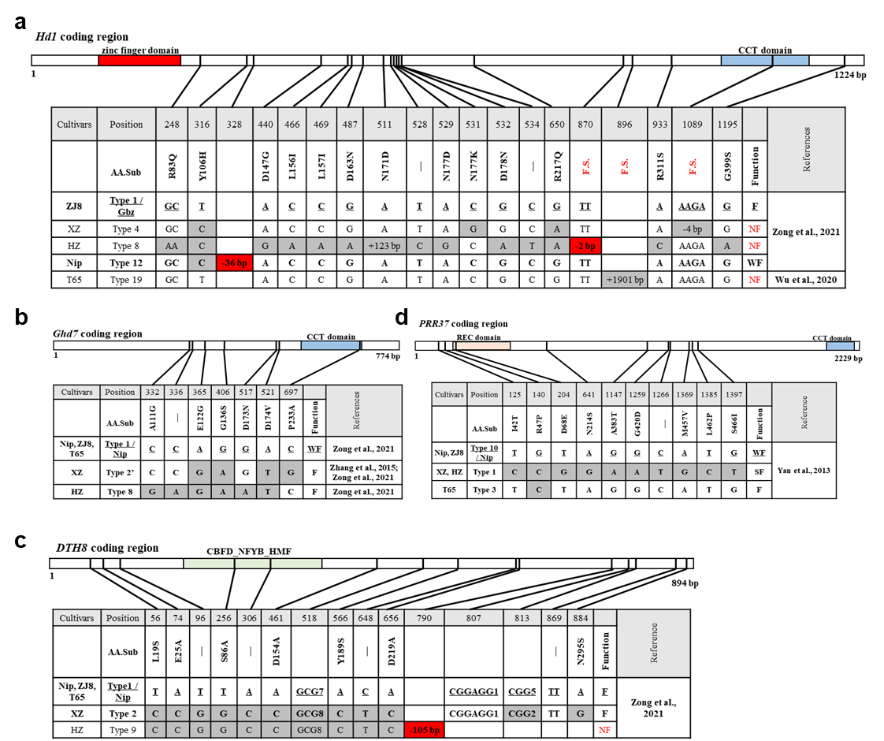
Supplementary Fig. S1. Haplotypes of Hd1, Ghd7, DTH8, and PRR37 in several rice materials.
(a) Hd1, (b) Ghd7, (c) DTH8, and (d) PRR37. F, functional; WF, weakly functional; SF, strongly functional; NF, non-functional (red). Deletions are indicated in red. The CCT domain is indicated in blue. Gbz, Ginbouzu; Nip, Nipponbare; XZ, Xiang Zhan; HZ, Hua Zhan; ZJ8, Zhong Jia 8; T65, Taichung 65.
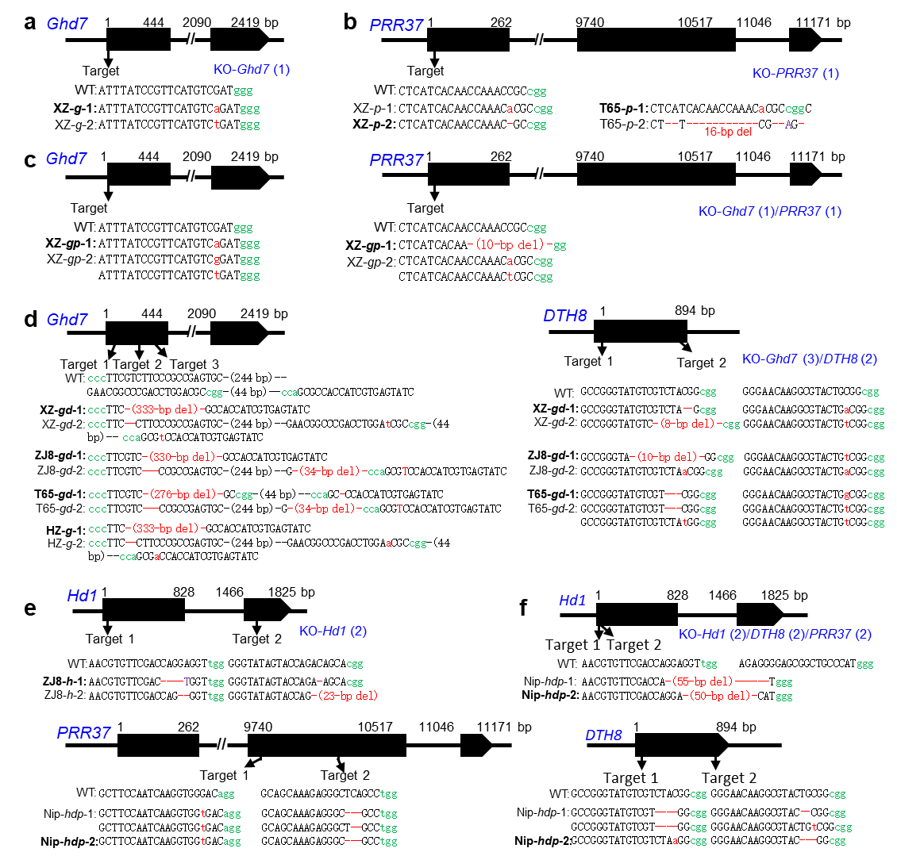
Supplementary Fig. S2. CRISPR/Cas9-mediated targeted mutagenesis in XZ, HZ, ZJ8, T65, and Nip.
(a–f) Diagrams of Hd1, Ghd7, DTH8, and PRR37 loci showing the target sites. Exons and introns are represented by black boxes and lines, respectively. The protospacer adjacent motifs (PAMs) are indicated in green. Selected T₁ plants with mutations in the targeted gene(s) are shown in bold font.
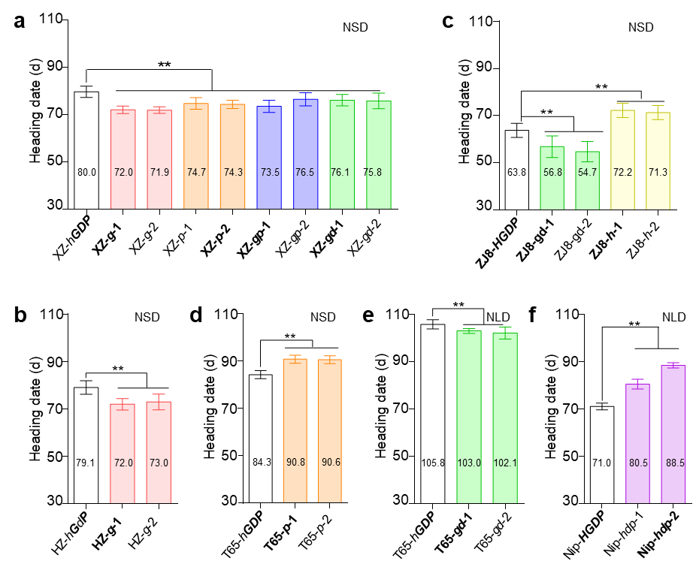
Supplementary Fig. S3. Heading date of XZ, HZ, ZJ8, T65, Nip, and their T₁ mutant plants.
(a–d) Heading date of (a) XZ, (b) HZ, (c) ZJ8, (d) T65, and their T₁ knockout lines under natural short-day conditions. (e and f) Heading date of (e) T65, (f) Nip, and their T₁ knockout lines under natural long-day conditions. Data are means ± SD (n = 20).
XZ, Xiang Zhan; HZ, Hua Zhan; ZJ8, Zhong Jia 8; T65, Taichung 65; Nip, Nipponbare. The significances of heading date at 0.01 probability level were tested by two-tailed Student’s t-test.

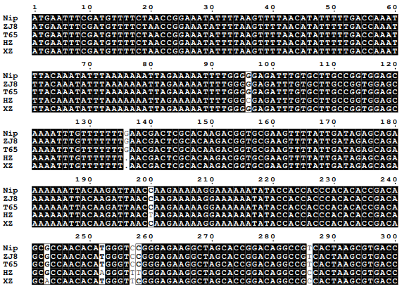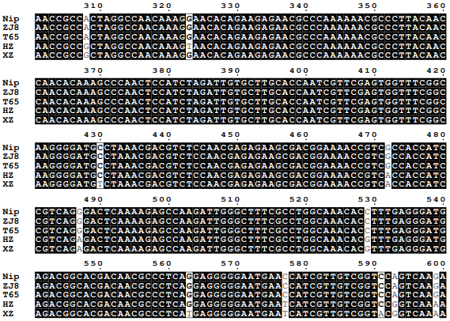
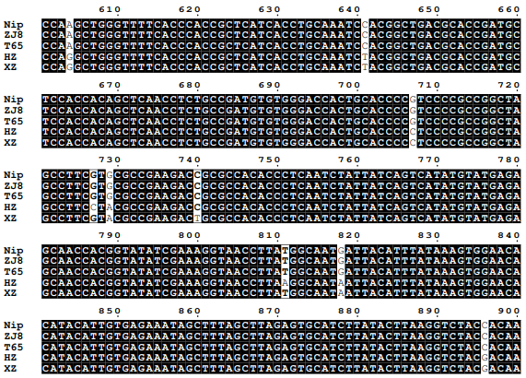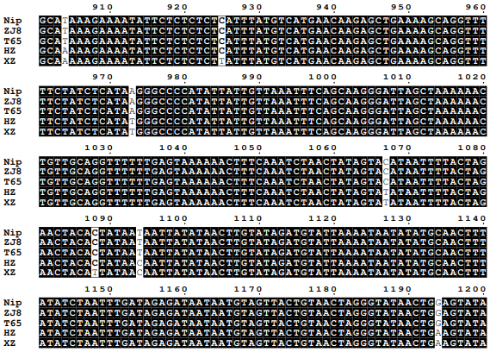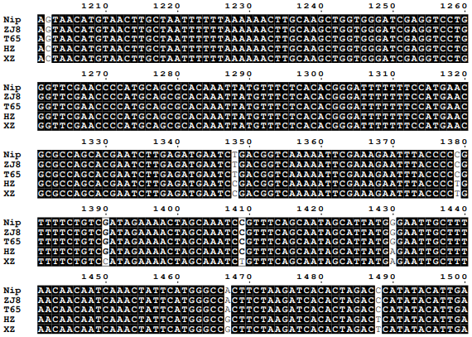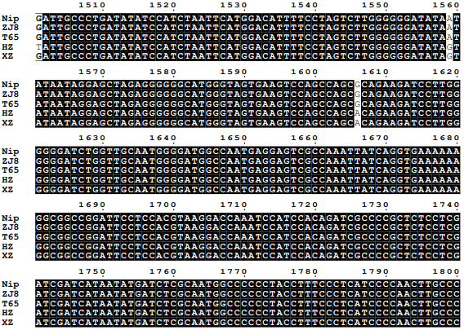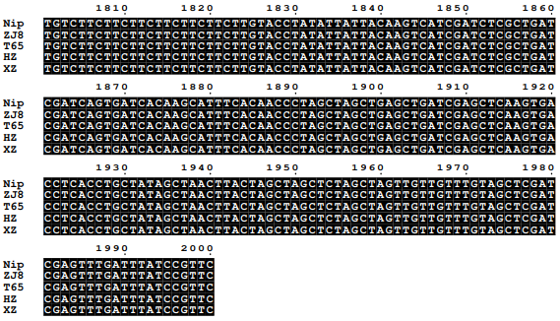
ATG
ATG
ATG
ATG
ATG
Supplementary Fig. S4. The 2-kb Ghd7 promoter sequence upstream of the ATG.
XZ, Xiang Zhan; HZ, Hua Zhan; ZJ8, Zhong Jia 8; T65, Taichung 65; Nip, Nipponbare.

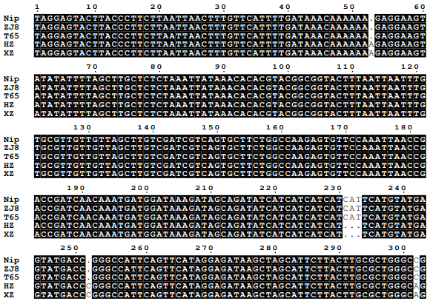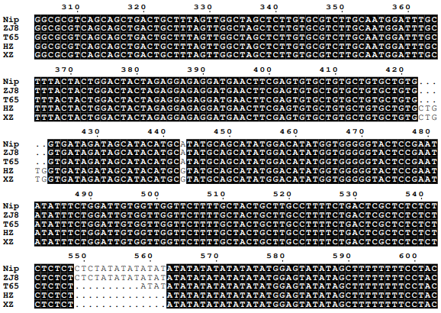
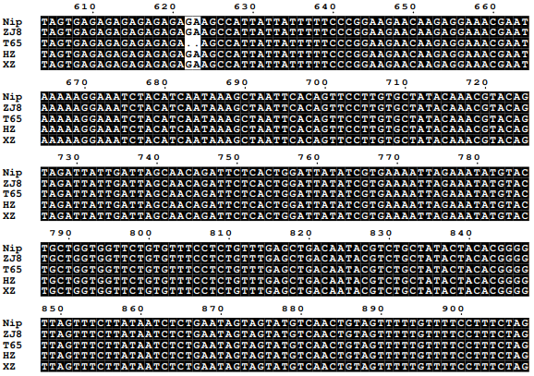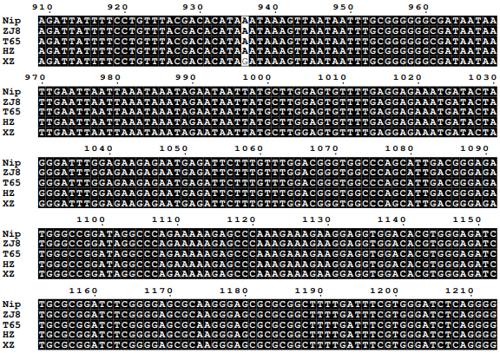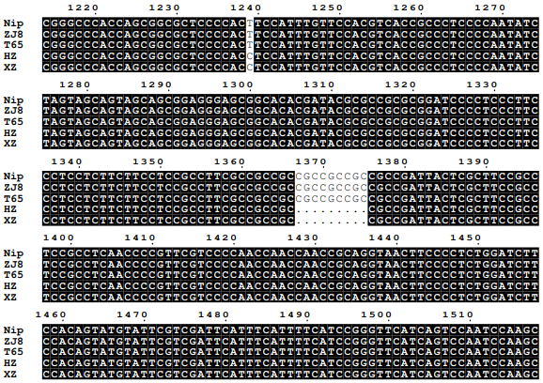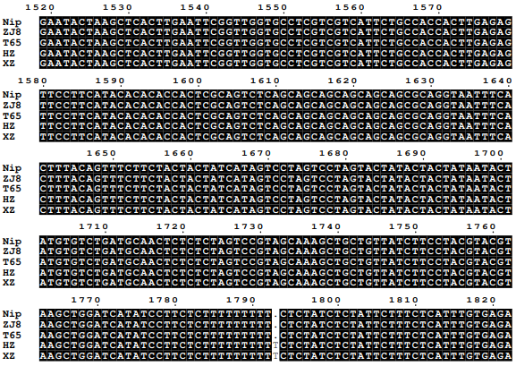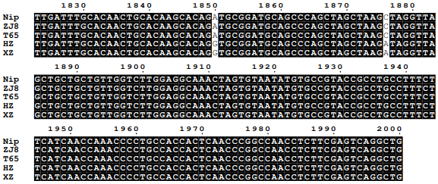
ATG
ATG
ATG
ATG
ATG
Supplementary Fig. S5. The 2-kb promoter PRR37 sequence upstream of the ATG.
XZ, Xiang Zhan; HZ, Hua Zhan; ZJ8, Zhong Jia 8; T65, Taichung 65; Nip, Nipponbare.

Table S1. Primer sequences.
Primer | Sequence (5′ to 3′) | Purpose
Hd1-1F | GTAGAGGAACAGGAGAAGAC | Sequencing for CDS
Hd1-1R | ACTCCTTTTGCATCTCCTGC | Sequencing for CDS
Hd1-2F | TGGCTTCTCCTCTCCAAAGA | Sequencing for CDS
Hd1-2R | AGTAGTCAACTGGTCTGCCT | Sequencing for CDS
Hd1-3F | CTTTAGGCAGACCAGTTGACTAC | Sequencing for CDS
Hd1-3R | TTGTCTAGAACTACTCCCACT | Sequencing for CDS
Ghd7-1F | CAAGTGACCTCACCTGCTAT | Sequencing for CDS
Ghd7-1R | GACGAGGAGGATCGATGAAT | Sequencing for CDS
Ghd7-2F | CTAACTGCATTTGCTTATGCG | Sequencing for CDS
Ghd7-2R | GTTAGTGGTATATACGCACTG | Sequencing for CDS
DTH8-F | GAGCATCACCACTCCATCCT | Sequencing for CDS
DTH8-R | GGGCCAAACTACACATATCTG | Sequencing for CDS
PRR37-1F | GCAGCCCAGCTAGCTAAGATAG | Sequencing for CDS
PRR37-1R | CAAATTGTAAAGCAGAGGCGG | Sequencing for CDS
PRR37-2FA | TTGTTAAGGACAGGGAGCCA | Sequencing for CDS
PRR37-2RB | ATGCAATGAACCAACCGCTG | Sequencing for CDS
PRR37-2FB | AAGTGTTTGTCAAAGGGCGC | Sequencing for CDS
PRR37-2RA | ACACCATCGTCGTCATCATC | Sequencing for CDS
PRR37-3F | GCCACTGAAATGTTCAGTGAC | Sequencing for CDS
PRR37-4R | TGTGTGTCCATTAGCCTTAACAG | Sequencing for CDS
PRR37-4F | GCTGCACCAATAAAACAAGG | Sequencing for CDS
PRR37-5R | GCCTGTTTTCAATTGCATG | Sequencing for CDS
PRR37-5F | CATGCAATTGAAAACAGGC | Sequencing for CDS
PRR37-6R | CGCAGATCACCATTATCATATC | Sequencing for CDS
PC1 | TAGGCTACGAGGAAGGATGG | Sequencing for 2-kb promoter
PR1 | CTAAAGCAGTCAGCTGCTGAC | Sequencing for 2-kb promoter
PF2 | CACACGTACGGCGGTACTTT | Sequencing for 2-kb promoter
PR2 | TCTTCTTCTGGATGAAGCGC | Sequencing for 2-kb promoter
PF3 | TGGTGTACACGGTGTGTACAC | Sequencing for 2-kb promoter
PC2 | TATGTACTGCTGGTGGTTCTG | Sequencing for 2-kb promoter
PR3 | TCCCTAGTATCATTTCTCCTC | Sequencing for 2-kb promoter
GC1 | TTGCATATCCGGTGGAGGGG | Sequencing for 2-kb promoter
GF2 | GAGAAGGCTAGCACCGGACA | Sequencing for 2-kb promoter
GR1 | CCAATCTTGGCTCTTTTGAG | Sequencing for 2-kb promoter
GC2 | GTCATGAACAAGAGCTGAAAAG | Sequencing for 2-kb promoter
GR2 | CGAAGAACTGGAACTCGTGC | Sequencing for 2-kb promoter
Ghd7-inF1 | GAACGGCCCGACCTGGAC | Reverse transcription PCR
Ghd7-inR2 | GTTTGGGTTCAAGCTCTC | Reverse transcription PCR
Actin1-5a | GGAATGGAAGCTGCGGGTA | Reverse transcription PCR
Actin1-3a | ACCACAGGTAGCAATAGGTA | Reverse transcription PCR and qPCR
Actin1-5b | GCATCTCTCAGCACATTCCA | qPCR
Ehd1-RT-F | GGATGCAAGGAAATCATGGA | qPCR
Ehd1-RT-R | AATCCCATCGGAAATCTTGG | qPCR
Hd3a-RT-F | GTCTACCCCTAGCTAACGATGA | qPCR
Hd3a-RT-R | CACCATCATATATATGTTGTGTGTCG | qPCR
RFT1-RT-F | GTCGCCACCGTCTACTTCAA | qPCR
RFT1-RT-R | ATACAGCTAGGCAGGTCTCAG | qPCR
Ghd7-RT-F | AATCCGGTACGCGTCCAGA | qPCR
Ghd7-RT-R | CCAAGCTCAAGCCTACTAGG | qPCR
PRR37-RT-F | CGGCAGTGGCAATGACATGT | qPCR
PRR37-RT-R | CCTCTTTCTGCTCTGGTACC | qPCR
U3gR-Hd1-T1 | ACGTGTTCGACCAGGAGGTgtttcagagctatgct | Gene knockout
OsU3-Hd1-T1 | ACCTCCTGGTCGAACACGTTgccacggatcatctgc | Gene knockout
U3gR-Hd1-T2 | GAGGGGAGCGGCTGCCCATgtttcagagctatgct | Gene knockout
OsU3-Hd1-T2 | ATGGGCAGCCGCTCCCCTCTgccacggatcatctgc | Gene knockout
U6agR-Hd1-T3 | gccGGGTATAGTACCAGACAGCA | Gene knockout
OsU6a-Hd1-T3 | aaacTGCTGTCTGGTACTATACC | Gene knockout
U6agR-Ghd7-T1 | CACTCGGCGGGAAGACGAAgtttcagagctatgct | Gene knockout
OsU6a-Ghd7-T1 | TTCGTCTTCCCGCCGAGTGCggcagccaagccagca | Gene knockout
U6agR-Ghd7-T2 | AACGGCCCGACCTGGACGCgtttcagagctatgct | Gene knockout
OsU6a-Ghd7-T2 | GCGTCCAGGTCGGGCCGTTCggcagccaagccagca | Gene knockout
U6agR-Ghd7-T3 | ATACTCACGATGGTGGCGCgtttcagagctatgct | Gene knockout
OsU6a-Ghd7-T3 | GCGCCACCATCGTGAGTATCggcagccaagccagca | Gene knockout
U6bgR-DTH8-T1 | CCGGGTATGTCGTCTACGGgtttcagagctatgct | Gene knockout
OsU6b-DTH8-T1 | CCGTAGACGACATACCCGGCaacacaagcggcagc | Gene knockout
U6bgR-DTH8-T2 | ACGGCGGCGTCAGGGAACAgttttagagctagaaat | Gene knockout
OsU6b-DTH8-T2 | TGTTCCCTGACGCCGCCGTCaacacaagcggcagc | Gene knockout
prr37-U6a-F | gccgCTCATCACAACCAAACCGC | Gene knockout
prr37-U6a-R | aaacGCGGTTTGGTTGTGATGAG | Gene knockout
ghd7-U3-F | ggcATTTATCCGTTCATGTCGAT | Gene knockout
ghd7-U3-R | aaacATCGACATGAACGGATAAA | Gene knockout
PRR37-F-AD | CCATACGACGTACCAGATTACGCTCATATGATGATGGGAACCGCTCATC | Yeast two-hybrid
PRR37-R-AD | CCCGTATCGATGCCCACCCGGGTGGAATTCTCATCTGTCCGCTGCCGCT | Yeast two-hybrid
HAP5A-BD-F | CTGATCTCAGAGGAGGACCTGCATATGATGGAACCATCCTCACAGC | Yeast two-hybrid
HAP5A-BD-R | TGCAGGTCGACGGATCCCCGGGAATTCTTAGCTACTTTCTGGCAGAG | Yeast two-hybrid
HAP5E-BD-F | CTGATCTCAGAGGAGGACCTGCATATGATGGATCCCACCAAATCCAG | Yeast two-hybrid
HAP5E-BD-R | TGCAGGTCGACGGATCCCCGGGAATTCTTACTGCTGGGGCACATAGT | Yeast two-hybrid
Ghd7-AD-F | CCATACGACGTACCAGATTACGCTCATATGATGTCGATGGGACCAGCAGC | Yeast two-hybrid
Ghd7-AD-R | CCCGTATCGATGCCCACCCGGGTGGAATTCCTATCTGAACCATTGTCC | Yeast two-hybrid
HAP3K-BD-F | CTGATCTCAGAGGAGGACCTGCATATGATGGCAGGGAACAAAAAGCG | Yeast two-hybrid
HAP3K-BD-R | TGCAGGTCGACGGATCCCCGGGAATTCTCACATATTTTTTCCATAGCC | Yeast two-hybrid
HAP3H-BD-F | CTGATCTCAGAGGAGGACCTGCATATGATGAAGAGTAGGAAGAGCT | Yeast two-hybrid
HAP3H-BD-R | TGCAGGTCGACGGATCCCCGGGAATTCAGCTCTTCCTACTCTTCAT | Yeast two-hybrid
HAP3G-BD-F | CTGATCTCAGAGGAGGACCTGCATATGATGGCCGACCACCATGGC | Yeast two-hybrid
HAP3G-BD-R | TGCAGGTCGACGGATCCCCGGGAATTCAGCTCCAGGCAGTTCTAG | Yeast two-hybrid
HAP3F-BD-F | CTGATCTCAGAGGAGGACCTGCATATGATGCCGGATTCGGACAACG | Yeast two-hybrid
HAP3F-BD-R | TGCAGGTCGACGGATCCCCGGGAATTCTCATAGCCTGTCTTGCCG | Yeast two-hybrid
HAP3E-BD-F | CTGATCTCAGAGGAGGACCTGCATATGATGGAGGCCGGCTACCCG | Yeast two-hybrid
HAP3E-BD-R | TGCAGGTCGACGGATCCCCGGGAATTCCTACTTGTATCCGAACGG | Yeast two-hybrid
HAP3A-BD-F | CTGATCTCAGAGGAGGACCTGCATATGATGATGATGATGGATCTAGG | Yeast two-hybrid
HAP3A-BD-R2 | TGCAGGTCGACGGATCCCCGGGAATTCTCACCCTACCAACTCTCTGT | Yeast two-hybrid

Table S2. Gene knockout vectors used in this study.
Vector | Target gene | Target sequence | Transformation material | Progeny genotype (mutant plant name)
KO-Ghd7 (1) | Ghd7 | ATTTATCCGTTCATGTCGATggg | XZ (hGDP) | XZ-hgDP (XZ-g)
KO-Ghd7 (3) | Ghd7 | cccTTCGTCTTCCCGCCGAGTGC  GAACGGCCCGACCTGGACGCcgg  ccaGCGCCACCATCGTGAGTATC | HZ (hGdP) | HZ-hgdP (HZ-g)
KO-PRR37 (1) | PRR37 | CTCATCACAACCAAACCGCcgg | XZ (hGDP),  T65 (hGDP) | XZ-hGDp (XZ-p),  T65-hGDp (T65-p)
KO-Hd1 (2) | Hd1 | AACGTGTTCGACCAGGAGGTtgg  GGGTATAGTACCAGACAGCAcgg | ZJ8 (HGDP) | ZJ8-hGDP (ZJ8-h)
KO-Ghd7 (1)/PRR37 (1) | Ghd7 | ATTTATCCGTTCATGTCGATggg | XZ (hGDP) | XZ-hgDp
 | PRR37 | CTCATCACAACCAAACCGCcgg
KO-Ghd7 (3)/DTH8 (2) | Ghd7 | cccTTCGTCTTCCCGCCGAGTGC  GAACGGCCCGACCTGGACGCcgg  ccaGCGCCACCATCGTGAGTATC | XZ (hGDP),  T65 (hGDP),  ZJ8 (HGDP) | XZ-hgdP (XZ-gd),  T65-hgdP (T65-gd),  ZJ8-HgdP (ZJ8-gd)
KO-Ghd7 (3)/DTH8 (2) | DTH8 | GCCGGGTATGTCGTCTACGGcgg  GGGAACAAGGCGTACTGCGGcgg
KO-Hd1 (2)/DTH8 (2)/PRR37 (2) | Hd1 | AACGTGTTCGACCAGGAGGTtgg  AGAGGGGAGCGGCTGCCCATggg | Nip (HGDP) | Nip-hGdp (Nip-hdp)
 | DTH8 | GCCGGGTATGTCGTCTACGGcgg  GGGAACAAGGCGTACTGCGGcgg
 | PRR37 | GCTTCCAATCAAGGTGGGACagg  GCAGCAAAGAGGGCTCAGCCtgg

Table S3. Heading date and yield-related traits of XZ, HZ, ZJ8, T65, Nip, and their knockout lines under NSD and NLD conditions.
NSD | HD (d)  CR(%) | PH (cm)  CR(%) | TN  CR(%) | PL (cm)  CR(%) | NPB  CR(%) | NSB  CR(%) | SPP  CR(%) | TGW (g)  CR(%) | GWP (g)  CR(%) | DWG (g/d)  CR(%)
XZ-hGDP | 77.7±1.3A | 121.4±2.6A | 5.9±1.0A | 29.3±0.7A | 11.3±1.0A | 44.6±3.4A | 170.9±14.8A | 23.8±0.4A | 14.5±1.9A | 0.1±0.0A
XZ-g | 71.9±1.4C  –7.4 | 103.1±2.6BC  –15.1 | 6.6±1.3A  12.87 | 28.5±0.8AB  –2.8 | 11.3±0.9A  –0.4 | 36.4±2.8CD  –18.4 | 148.3±13.0B  –13.3 | 22.1±0.8B  –7.2 | 11.5±3.0B  –20.5 | 0.1±0.0AB  –16.0
XZ-p | 71.0±1.3C  –8.6 | 100.3±3.6C  –17.4 | 5.22±1.0A  –11.1 | 27.8±0.8B  –4.9 | 10.9±0.9AB  –3.9 | 39.4±3.8BC  –11.6 | 153.4±11.9B  –10.3 | 21.1±0.9B  –11.3 | 9.8±2.0B  –32.8 | 0.1±0.0B  –28.3
XZ-gp | 71.8±1.7C  –7.6 | 91.7±2.6D  –24.5 | 7.0±0.8A  19.2 | 26.3±0.8C  –10.1 | 10.8±0.7AB  –4.9 | 43.3±2.7AB  –3.0 | 145.5±9.3B  –14.9 | 17.2±0.6C  –27.7 | 9.8±1.3B  –32.7 | 0.1±0.0B  –28.8
XZ-gd | 75.1±1.4B  –3.4 | 105.4±2.5B  –13.2 | 5.0±1.3A  –3.0 | 28.0±0.6B  –4.3 | 9.9±1.0B  –12.4 | 32.9±2.5D  –26.3 | 128.3±8.3C  –25.0 | 24.7±0.4A  3.7 | 11.6±2.4B  –20.2 | 0.1±0.0AB  –18.3
HZ-hGdP | 78.6±1.4 | 102.4±3.4 | 8.1±0.8 | 23.3±1.1 | 15.6±2.4 | 42.2±2.9 | 187.1±14.6 | 19.9±0.8 | 25.0±2.3 | 0.2±0.1
HZ-g | 75.7±1.9**  –3.7 | 67.9±6.1**  –33.7 | 14.0±2.2**  72.3 | 19.3±1.1**  –17.0 | 10.3±0.7**  –34.4 | 10.0±1.5**  –76.3 | 55.7±5.2**  –70.2 | 18.3±0.8**  –8.4 | 12.2±1.5**  –51.3 | 0.1±0.0**  –51.3
ZJ8-HGDP | 67.2±2.1B | 65.1±4.4B | 6.4±1.1B | 17.6±0.9B | 8.7±0.5B | 13.3±1.3B | 68.1±3.3B | 32.3±1.9A | 12.1±0.8B | 0.1±0.0B
ZJ8-gd | 61.8±4.1C  –8.1 | 60.1±1.7C  –7.7 | 9.3±1.9A  45.8 | 17.3±0.5B  –0.7 | 8.8±0.7B  1.3 | 15.8±1.3B  19.3 | 56.0±5.5C  –17.7 | 29.2±1.3B  –9.6 | 11.6±1.1B  –4.6 | 0.1±0.0B  1.1
ZJ8-h | 74.4±2.4A  10.7 | 75.6±1.9A  16.2 | 6.8±0.7B  5.5 | 21.1±2.1A  21.8 | 13.1±1.8A  51.4 | 22.8±1.7A  72.3 | 109.3±8.7A  60.6 | 28.5±1.6B  –11.7 | 16.0±2.4A  31.8 | 0.2±0.0A  22.7
T65-hGDP | 81.7±3.4C | 111.7±2.1B | 5.6±0.5A | 25.0±0.9B | 12.0±0.7B | 35.3±3.1A | 136.2±12.0A | 23.7±0.9B | 14.5±1.7A | 0.1±0.0A
T65-p | 99.5±3.0A  21.8 | 118.2±3.6A  5.8 | 6.4±0.5A  14.3 | 26.7±1.2A  6.6 | 12.6±0.8B  5.0 | 28.7±3.4B  –18.8 | 116.8±10.8B  –14.3 | 25.1±0.7A  5.7 | 16.6±1.3A  14.2 | 0.1±0.0A  –1.5
T65-gd | 86.7±2.8B  6.1 | 117.3±2.4A  5.0 | 6.7±1.3A  19.6 | 24.7±1.5B  –1.3 | 13.6±0.7A  13.3 | 23.8±2.4C  –32.5 | 117.9±9.7B  –13.5 | 23.2±1.1B  –2.1 | 15.4±0.6A  6.1 | 0.1±0.0A  1.6
Nip-HGDP | 50.4±4.2 | 69.0±4.7 | 13.2±2.2 | 17.5±0.8 | 5.7±0.5 | 8.0±1.9 | 46.3±2.1 | 24.4±2.2 | 11.3±1.8 | 0.1±0.0
Nip-hdp | 72.9±3.1**  44.6 | 88.4±5.5**  28.1 | 10.5±2.0*  –20.5 | 18.6±1.6  6.4 | 8.9±0.6**  56.6 | 11.0±0.7**  37.5 | 64.4±6.4**  39.2 | 26.8±0.8*  9.7 | 15.1±3.4*  33.4 | 0.2±0.0  4.2

NLD | HD (d)  CR(%) | PH (cm)  CR(%) | TN  CR(%) | PL (cm)  CR(%) | NPB  CR(%) | NSB  CR(%) | SPP  CR(%) | TGW (g)  CR(%) | GWP (g)  CR(%) | DWG (g/d)  CR(%)
XZ-hGDP | 90.2±1.5A | 122.6±5.0A | 6.3±0.5B | 27.9±1.1AB | 10.7±0.7A | 37.0±3.3A | 152.4±11.2A | 22.6±0.8AB | 15.6±2.4A | 0.1±0.0A
XZ-g | 79.6±2.5C  –11.8 | 93.8±3.9C  –23.5 | 7.9±0.9A  25.7 | 28.4±1.2A  1.7 | 9.7±0.7B  –9.7 | 34.3±2.9AB  –7.3 | 137.2±7.3AB  –10.0 | 21.0±1.1C  –6.9 | 14.6±1.3AB  –6.5 | 0.1±0.0A  2.5
XZ-p | 79.0±1.4C  –12.3 | 92.8±3.5C  –24.3 | 6.3±1.3B  2.4 | 26.5±0.5C  –5.0 | 9.3±0.7B  –13.1 | 31.8±2.7B  –14.1 | 137.5±14.1AB  –9.8 | 22.1±0.8B  –2.0 | 14.1±1.0AB  –9.7 | 0.1±0.0A  –0.5
XZ-gp | 79.2±1.4C  –12.2 | 95.6±2.4C  –22.0 | 5.7±0.8B  –8.8 | 27.0±0.9BC  –3.4 | 9.4±0.7B  –12.4 | 32.1±3.0B  –13.2 | 148.7±11.3AB  –2.4 | 22.3±0.6AB  –1.2 | 13.0±1.1B  –16.8 | 0.1±0.0A  –8.4
XZ-gd | 87.6±1.2B  –2.8 | 106.5±3.2B  –13.1 | 5.8±0.7B  –8.0 | 28.7±0.8A  2.8 | 10.7±1.0A  0 | 33.3±3.4AB  –10.1 | 133.6±8.5B  –12.3 | 23.2±0.5A  2.7 | 9.4±0.9C  –39.7 | 0.1±0.0B  –38.3
HZ-hGdP | 93.1±2.1 | 120.0±3.8 | 5.9±1.0 | 26.0±0.7 | 13.3±1.2 | 60.1±5.1 | 221.5±15.2 | 17.8±0.5 | 17.8±3.2 | 0.2±0.0
HZ-g | 86.4±2.4**  –7.2 | 66.1±4.2**  –44.9 | 15.0±1.8  155.1 | 18.7±0.8**  –28.3 | 8.6±0.7**  –35.3 | 8.8±0.4**  –85.3 | 51.1±4.8**  –76.9 | 14.2±0.5**  –20.1 | 7.7±1.2**  –56.8 | 0.1±0.0**  –54.4
ZJ8-HGDP | 80.2±2.1B | 86.3±3.5A | 6.8±1.5B | 23.6±0.7A | 12.5±1.1A | 32.5±3.2B | 142.0±6.5B | 25.3±0.9A | 21.2±2.6A | 0.2±0.0A
ZJ8-gd | 69.4±2.9C  –13.5 | 73.3±2.9B  –15.1 | 8.9±1.5A  30.5 | 18.3±0.8B  –22.7 | 7.8±0.6B  –37.6 | 25.5±2.7C  –21.5 | 92.5±7.2C  –34.9 | 23.7±0.5B  –6.1 | 14.1±1.1C  –33.4 | 0.2±0.0B  –24.5
ZJ8-h | 82.0±2.6A  2.2 | 87.0±2.3A  0.8 | 5.3±1.0B  –22.8 | 23.4±0.8A  –0.9 | 12.5±0.9A  0 | 43.3±4.3A  33.1 | 160.1±13.7A  12.7 | 24.7±0.9AB  –2.3 | 18.2±1.3B  –14.3 | 0.2±0.0B  –15.7
T65-hGDP | 95.0±3.5B | 123.6±3.4AB | 5.8±0.5A | 27.0±1.4AB | 10.6±0.7B | 27.0±2.8A | 116.2±8.2A | 21.1±1.5B | 10.4±0.7AB | 0.1±0.0B
T65-p | 102.9±3.6A  8.3 | 122.8±2.1B  –0.7 | 6.3±1.3A  8.6 | 27.3±2.0A  1.1 | 11.8±0.7A  11.1 | 20.8±1.5B  –22.8 | 97.7±8.9B  –15.9 | 20.5±1.5B  –2.6 | 9.3±0.8B  –10.5 | 0.1±0.0B  9.1
T65-gd | 91.4±2.9C  –3.8 | 126.8±2.7A  2.6 | 6.5±0.9A  12.1 | 25.1±1.7B  –7.2 | 11.3±1.0AB  6.6 | 24.3±3.1AB  –9.9 | 99.1±6.1B  –14.7 | 23.0±1.3A  9.0 | 12.3±1.4A  17.9 | 0.1±0.0A  21.37
Nip-HGDP | 61.8±5.2 | 77.2±2.3 | 9.4±2.0 | 21.3±1.3 | 6.1±1.1 | 14.1±1.8 | 59.8±3.6 | 22.2±1.0 | 9.4±1.6 | 0.1±0.0
Nip-hdp | 86.6±3.1**  40.1 | 100.2±3.9**  29.8 | 8.0±2.4  –14.9 | 21.2±1.2  –0.5 | 9.1±0.8**  49.6 | 20.7±2.0**  46.6 | 81.5±7.4**  36.4 | 23.3±0.8*  6.0 | 13.4±2.6**  42.0 | 0.1±0.0  11.8
NSD, natural short day; NLD, natural long day; HD, heading date; PH, plant height; TN, tiller number; PL, panicle length; NPB, number of primary branches; NSB, number of secondary branches; SPP, number of spikelets per panicle; TGW, thousand-grain weight; GWP, grain weight per plant; DWG, daily weight gain; DWG is GWP divided by the whole growth period. The whole growth period is heading date plus 30 d. H, Hd1; h, hd1; G, Ghd7; g, ghd7; D, DTH8; d, dth8; P, PRR37; p, prr37. The wild-type plants were used as a control and to calculate the contribution rate (CR) of agronomic traits (AT). CR_{mutant}% = (AT_{mutant} – AT_{WT})/AT_{WT} × 100. Capital letters indicate significant differences test by least significant difference (LSD) method. * and **” indicate the significance at 5% and 1% levels by Student’s t-test, respectively.
Table S4. Rice materials carrying the XZ-Ghd7 haplotype in The 3000 Rice Genomes database
Number | Sample ID | Subpopulation | Location
1 | B011 | indica intermediate | India
2 | B026 | indica intermediate | Indonesia
3 | CX206 | indica2 | Philippines
4 | CX24 | indica intermediate | India
5 | IRIS_313-10662 | indica3 | Sri Lanka
6 | IRIS_313-10836 | indica intermediate | India
7 | IRIS_313-11639 | indica intermediate | India
8 | IRIS_313-7824 | indica2 | Senegal
9 | IRIS_313-8265 | indica intermediate | India
10 | IRIS_313-8412 | indica intermediate | China
11 | IRIS_313-9351 | indica intermediate | India
12 | IRIS_313-9925 | indica2 | Korea

