Supplementary materials
Table S1. The antibodies used for Western blot and immunohistochemical staining
Antibody | Weight (KDa) | Working dilution |  |  | Species |  | Source and Cat. Number
NRG1 | 34 |  | 1:1000 |  |  | Mouse monoclonal | Santa Cruz  (Cat. No. SC-393006)
p-IKKα/β (Ser176/180) | 85 |  | 1:1000 |  |  | Rabbit polyclonal | Cell Signaling Technology  (Cat. No. 2697)
p-IκBα (Ser32/36) | 40 |  | 1:1000 |  |  | Rabbit polyclonal | Abmart  (Cat. No. TP56280)
IκBα | 39 |  | 1:1000 |  |  | Rabbit polyclonal | Abmart  (Cat. No. T55026)
p-NF-κB p65 (Ser536) | 65 |  | 1:1000 |  |  | Rabbit polyclonal | Cell Signaling Technology  (Cat. No. 3033S)
NF-κB p65 | 65 |  | 1:1000 |  |  | Rabbit polyclonal | Cell Signaling Technology  (Cat. No. 8242S)
MMP9 | 84 |  | 1:1000 |  |  | Rabbit polyclonal | Cell Signaling Technology  (Cat. No. 13667)
N-Cadherin | 140 |  | 1:1000 |  |  | Rabbit polyclonal | Cell Signaling Technology  (Cat. No. 13116)
E-Cadherin | 135 |  | 1:1000 |  |  | Rabbit polyclonal | Cell Signaling Technology  (Cat. No. 3195)
Vimentin | 57 |  | 1:1000 |  |  | Rabbit polyclonal | Cell Signaling Technology  (Cat. No. 5741)
Slug | 30 |  | 1:1000 |  |  | Rabbit polyclonal | Cell Signaling Technology  (Cat. No.9585)
Bax | 20 |  | 1:1000 |  |  | Rabbit polyclonal | Cell Signaling Technology  (Cat. No.5023)
Bcl-2 | 26 |  | 1:1000 |  |  | Rabbit polyclonal | Cell Signaling Technology  (Cat. No.3498)
Cleaved-PARP | 89 |  | 1:1000 |  |  | Rabbit polyclonal | Cell Signaling Technology  (Cat. No.5625)
H3 | 17 |  | 1:1000 |  |  | Rabbit polyclonal | Cell Signaling Technology  (Cat. No.4909)
HER3 | 185 |  | 1:1000 |  |  | Rabbit polyclonal | Cell Signaling Technology  (Cat. No. 12708)
p-HER3 | 185 |  | 1:1000 |  |  | Rabbit polyclonal | Cell Signaling Technology  (Cat. No. 2842)
HER2 | 185 |  | 1:1000 |  |  | Rabbit polyclonal | Cell Signaling Technology  (Cat. No. 4290)
p-HER2 | 185 |  | 1:1000 |  |  | Rabbit polyclonal | Cell Signaling Technology  (Cat. No.6942)
AKT | 60 |  | 1:1000 |  |  | Rabbit polyclonal | Cell Signaling Technology  (Cat. No.4691)
p-AKT | 60 |  | 1:1000 |  |  | Rabbit polyclonal | Cell Signaling Technology  (Cat. No.4060)
ERK | 42 |  | 1:1000 |  |  | Mouse monoclonal | Cell Signaling Technology  (Cat. No.4696)
p-ERK | 44 |  | 1:1000 |  |  | Rabbit polyclonal | Cell Signaling Technology  (Cat. No.4370)
MEK | 45 |  | 1:1000 |  |  | Mouse monoclonal | Cell Signaling Technology  (Cat. No.4694)
p-MEK1/2 | 45 |  | 1:1000 |  |  | Rabbit polyclonal | Cell Signaling Technology  (Cat. No.3958)
GAPDH | 37 |  | 1:1000 |  |  | Mouse monoclonal | ZSGB-BIO  (Cat. No. TA-08)
Anti-rabbit，Alexa Fluor 488 antibody | -- |  | 1:400 |  |  | Rabbit polyclonal | ZSGB-BIO  (Cat. No. ZF-0511)

Table S2 siRNA and lentiviral vector of shRNA sequences
Name | Sequence
Negative control (NC) | Sense 5’-UUCUCCGAACGUGUCACGUTT-3’
Negative control (NC) | Antisense 5’-ACGUGACACGUUCGGAGAATT-3’
NRG1-homo-899 (si-1) | Sense 5’-GGUCUGAACGAAACAAUAUTT-3’
NRG1-homo-899 (si-1) | Antisense 5’-AUAUUGUUUCGUUCAGACCTT-3’
NRG1-homo-1151 (si-2) | Sense 5’-GCCACUCUGUAAUCGUGAUTT-3’
NRG1-homo-1151 (si-2) | Antisense 5’-AUCACGAUUACAGAGUGGCTT-3’
NRG1-homo-1706 (si-3) | Sense 5’-CCAAUGGCCACAUUGCUAATT-3’
NRG1-homo-1706 (si-3) | Antisense 5’-UUAGCAAUGUGGCCAUUGGTT-3’
NF-κB p65-homo-1007 (si-7) | Sense 5’-CAGAUACAGACGAUCGUCATT-3’
NF-κB p65-homo-1007 (si-7) | Antisense 5’-UGACGAUCGUCUGUAUCUGTT-3’
NF-κB p65-homo-1180 (si-8) | Sense 5’-CCCUAUCCCUUUACGUCAUTT-3’
NF-κB p65-homo-1180 (si-8) | Antisense 5’-AUGACGUAAAGGGAUAGGGTT-3’
NF-κB p65-homo-1729 (si-9) | Sense 5’-GAUGAAGACUUCUCCUCCATT-3’
NF-κB p65-homo-1729 (si-9) | Antisense 5’-UGGAGGAGAAGUCUUCAUCTT-3’
GAPDH Control (si-G) | Sense 5’-UGACCUCAACUACAUGGUUTT-3’
GAPDH Control (si-G) | Antisense 5’-AACCAUGUAGUUGAGGUCATT-3’
LV16-sh NRG1-homo-899 | 5'-GGTCTGAACGAACAATT-3'
LV16-sh NC | 5'- TTCTCCGAACGTGTCACGT-3'

Table S3 Haematological parameters of xenograft mice
Parameters | Control | Afatinib | si-1 |  | si-1+Afatinib
WBC (10⁹/L) | 5.173±0.748 | 5.997±0.986 |  | 5.617±1.770 |  | 5.910±1.536
RBC (10¹²/L) | 11.367±0.411 | 10.223±0.560 |  | 11.710±0.442 |  | 11.413±0.528
HCT (%) | 55.933±3.066 | 50.767±2.739 |  | 58.400±2.352 |  | 57.333±2.739
HGB (g/L) | 167.000±9.539 | 149.333±7.638 |  | 171.333± 7.095 |  | 170.000±8.544
MCV (fL) | 49.200±0.954 | 49.633±0.321 |  | 49.900±1.212 |  | 50.233±0.651
MCH (Pg) | 14.667±0.351 | 14.600±0.100 |  | 14.633±0.252 |  | 14.867±0.252
MCHC (g/L) | 298.333±3.215 | 294.333±1.155 |  | 293.333±2.887 |  | 296.667±1.527
RDW-CV(%) | 14.067±0.321 | 14.600±0.265 |  | 14.333±0.058 |  | 13.733±0.153
RDW-SD(fL) | 29.333±0.578 | 30.667± 0.578 |  | 30.000±1.000 |  | 29.000±0.000
PLT (10⁹/L) | 1382.333±88.951 | 1255.667±74.51 |  | 1315.667±171.188 |  | 1233.000±108.669
At the end of treatment, blood samples were used to measure the routine haematological parameters. No statistically significant differences were found.

Table S4 Relative organ weights (%) of xenograft mice
Organ | Control | Afatinib | si-1 | si-1+Afatinib
Heart | 0.595±0.006 | 0.558±0.003 | 0.606±0.001 | 0.575±0.008
Liver | 5.666±0.300 | 5.734±0.052 | 6.038±0.054 | 5.912±0.086
Spleen | 0.505±0.002 | 0.458±0.017 | 0.506±0.006 | 0.502±0.013
Lung | 0.754±0.014 | 0.734±0.001 | 0.735±0.019 | 0.761±0.007
Left kidney | 0.925±0.010 | 0.942±0.034 | 0.929±0.013 | 0.865±0.006
Right kidney | 0.915±0.003 | 0.942±0.001 | 0.975±0.001 | 0.903±0.010
During necropsy, the heart, liver, kidney, spleen and lung tissues were collected and weighed separately to calculate the relative organ weight (organ weight/body weight ×100). No statistically significant differences were found.

Supplementary Figures
Fig. S1
a
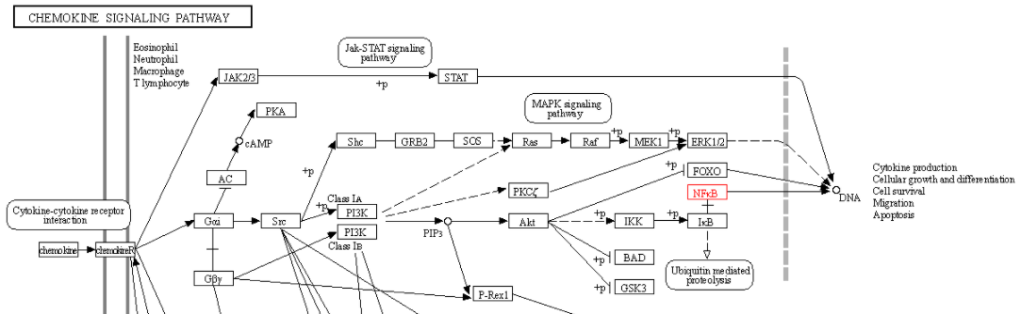
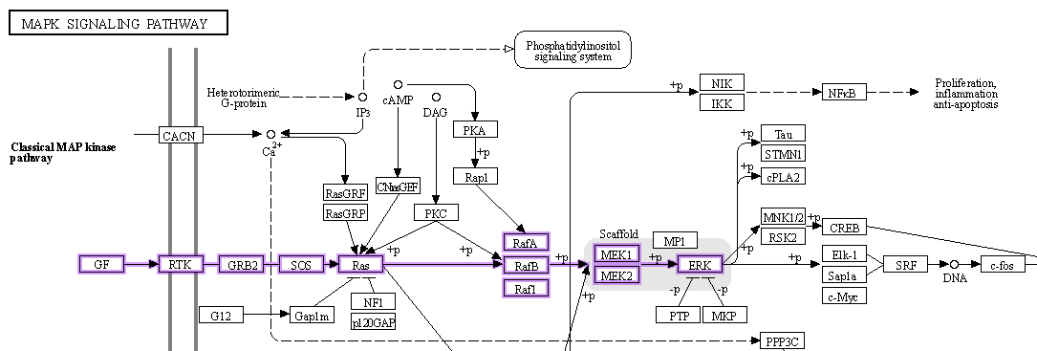
b

Fig. S1 The regulation relationship of MAPK pathway to NF-κB analyzed using KEGG database. a Regulation of MAPK pathway to NF-κB in classical pathway; b Regulation of MAPK pathway to NF-κB was reflected in kinases and receptors pathway.

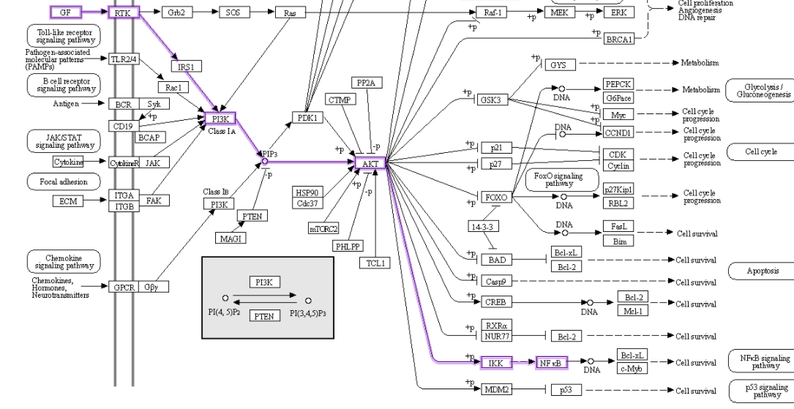
Fig. S2
Fig. S2 The regulation relationship of PI3K/AKT pathway to NF-κB.
Fig. S3
a
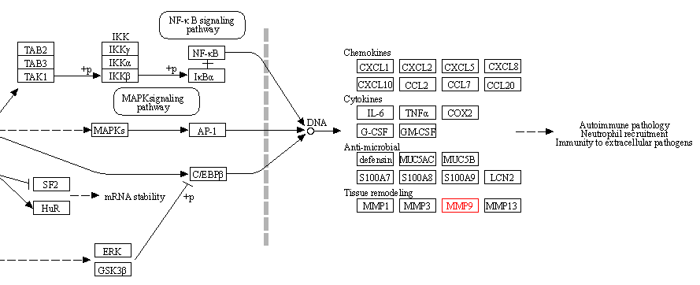
b
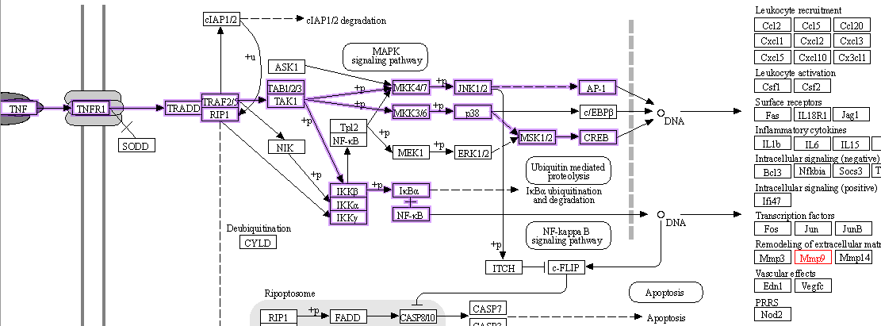

Fig. S3 The regulation relationship of NF-κB to MMP9. a NF-κB regulated MMP9 through entry the nucleus. b NF-κB regulated MMP9 in TNF pathway

Fig. S4

Fig. S4 Cell morphology of liver and kidney tissues from mice analyzed by H&E staining (a) and Body weight curve of mice (b). The arrows indicated the hepatic vein and glomerulus, respectively.

