Original bands for WB

Fig. 1C

NRG1
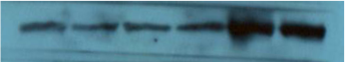

GAPDH

Figure 2
Fig.2A
NRG1

GAPDH

Fig. 2J
ECa109 (P_{NRG1})
- Cadherin

- Cadherin

Vimentin

Slug

GAPDH

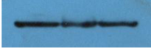
KYSE150 (P_{NRG1} )
E-Cadherin
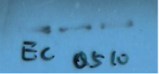

N-Cadherin

VIM
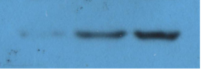


Slug

GAPDH
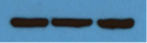

ECa109 (CM)
E-Cadherin

N-Cadherin

VIM
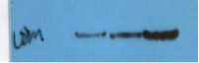

Slug
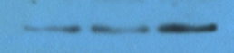

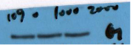
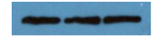
GAPDH
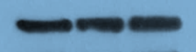

Fig. 2K
ECa109 (P_{NRG1})
PARP
Cleaved-PARP

Bax

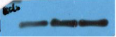
Bcl-2

GAPDH

KYSE150 (P_{NRG1})
PARP
Cleaved-PARP
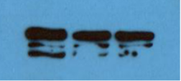

Bax
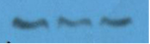
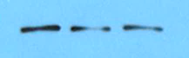

Bcl-2
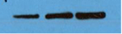
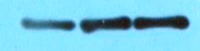

GAPDH

ECa109 (CM)
PARP
Cleaved-PARP

Bax

Bcl-2
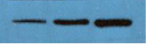
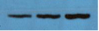
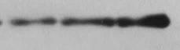

GAPDH

Figure 4
Fig. 4C
ECa109 (P_{NRG1})
HER3

p-HER3

HER2
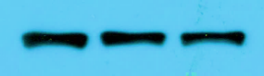

p-HER2
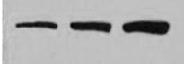

AKT
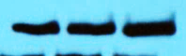

p-AKT

ERK
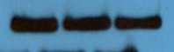

p-ERK

MEK

p-MEK1/2
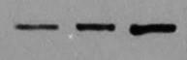

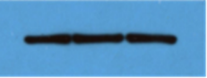
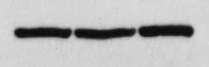
GAPDH

KYSE150 (P_{NRG1})
HER3
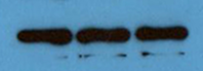

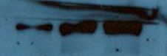
p-HER3
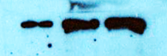

HER2
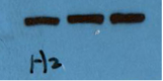

p-HER2
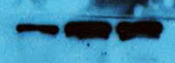

AKT

p-AKT

ERK
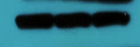

p-ERK
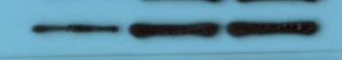

MEK
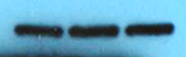

p-MEK1/2

GAPDH

ECa109 (CM)
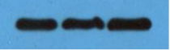
HER3
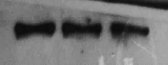
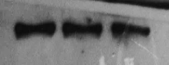

p-HER3
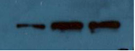

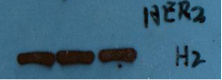
HER2
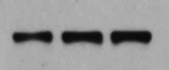

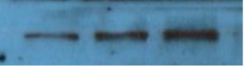
p-HER2

AKT

p-AKT

ERK

p-ERK
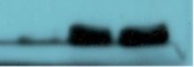

MEK
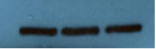
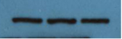
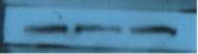

p-MEK1/2

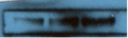
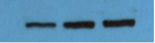

GAPDH

Fig. 4D
Eca109 cells
p-IKKα/β (Ser176/180)
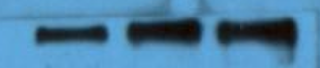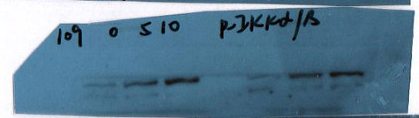
p-IκBα (Ser32/36)
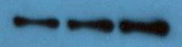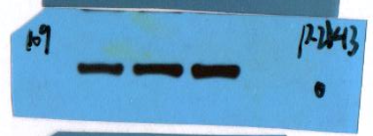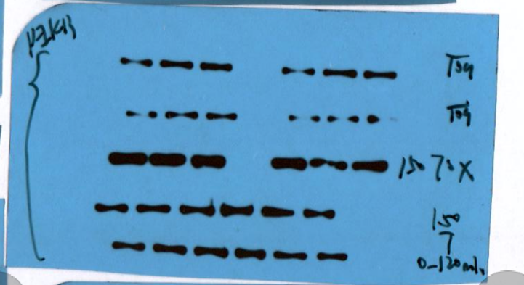
IκBα
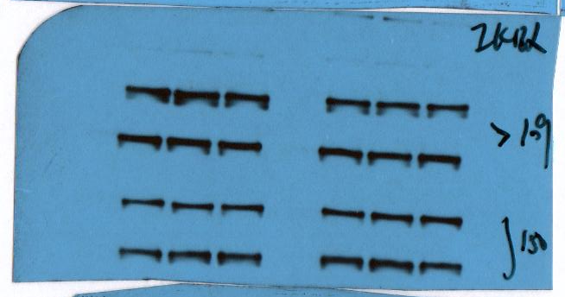
p-NF-κB p65 (Ser536)
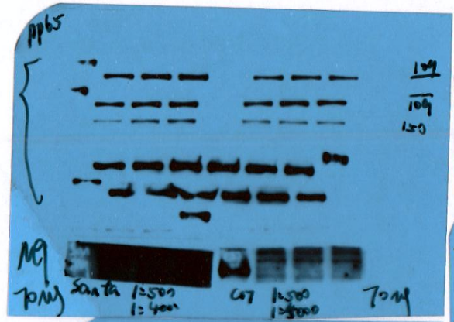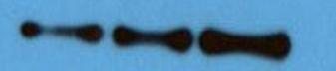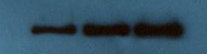
NF-κB p65
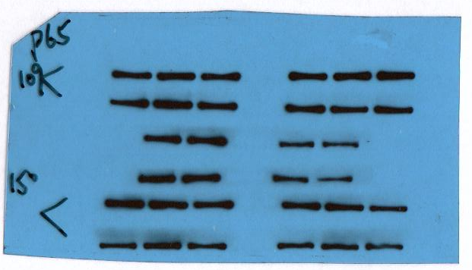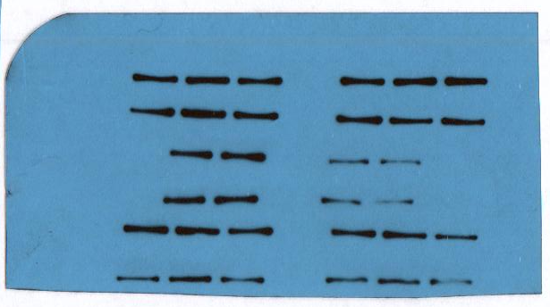
MMP9
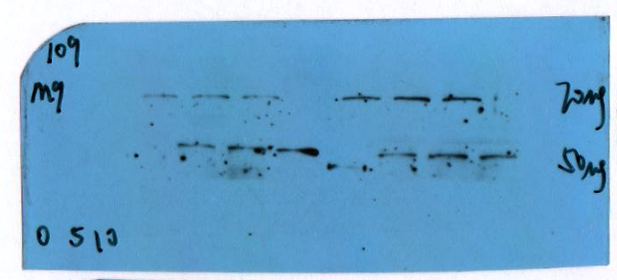
GAPDH
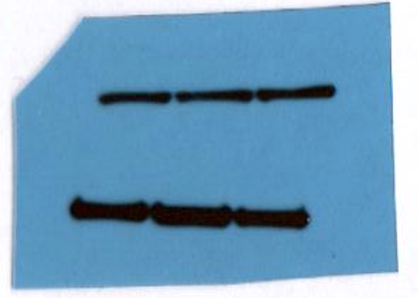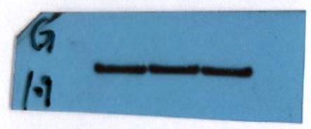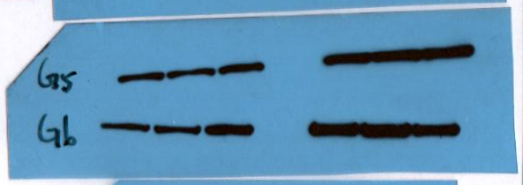
KYSE150 cells
p-IKKα/β (Ser176/180)
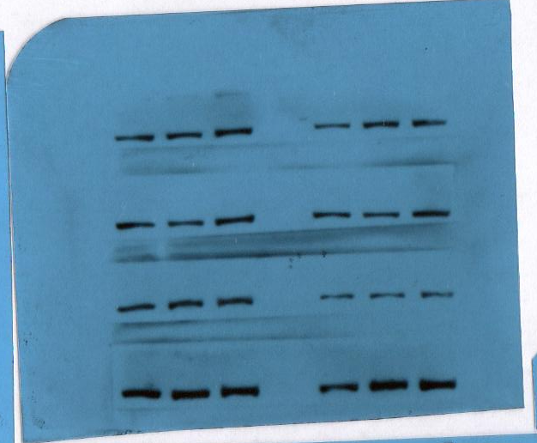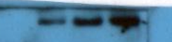
p-IκBα (Ser32/36)
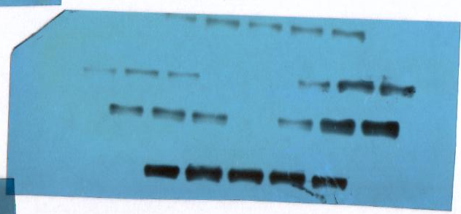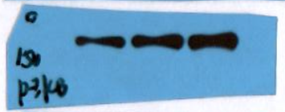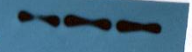
IκBα
p-NF-κB p65 (Ser536)
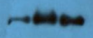
NF-κB p65
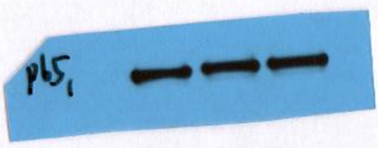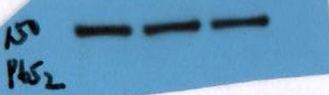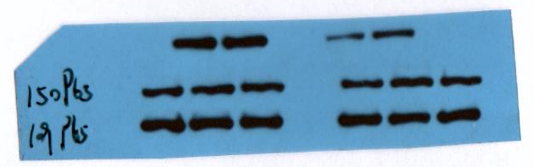

MMP9 7.23
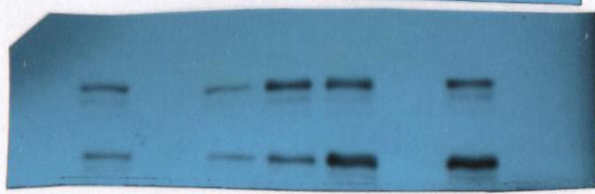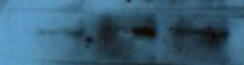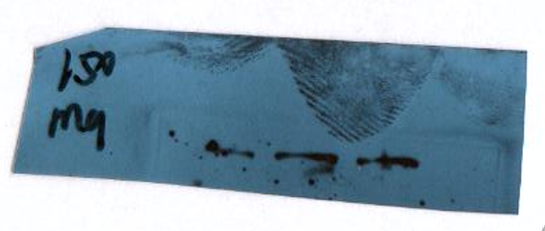

GAPDH
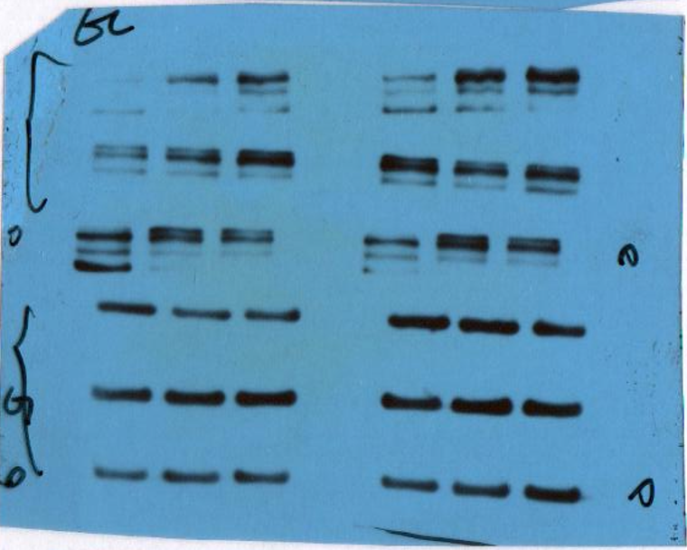
Fig.4E
NRG1

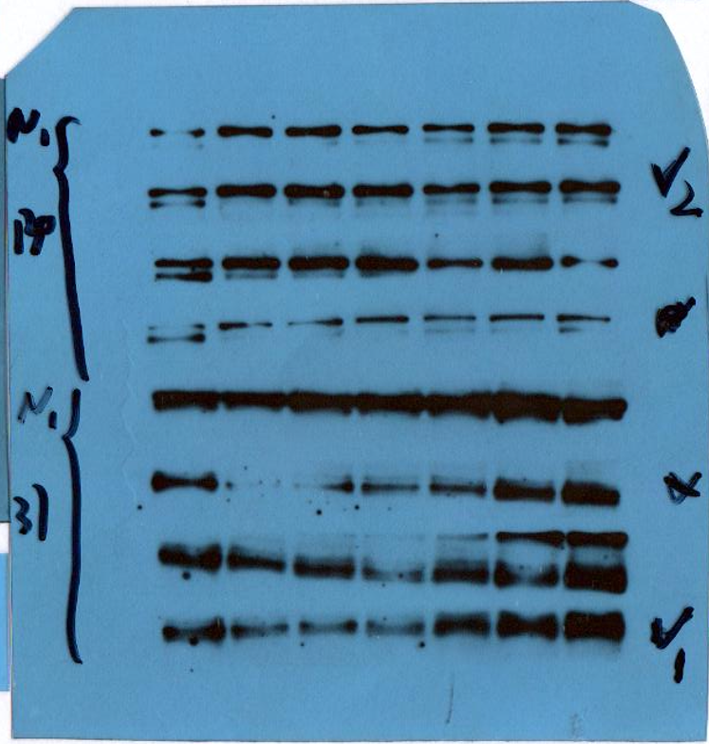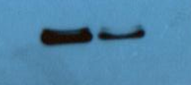
p-IKKα/β (Ser176/180)
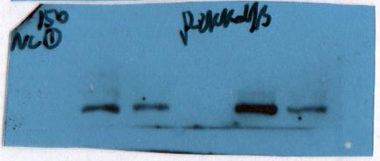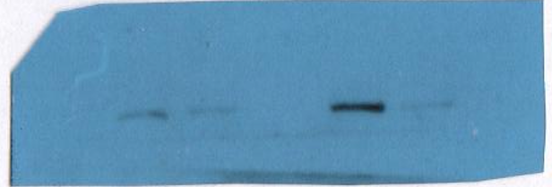
p-IκBα (Ser32/36)
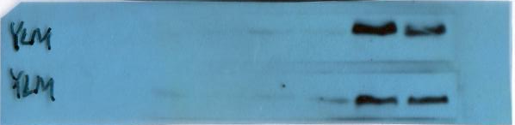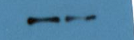
IκBα
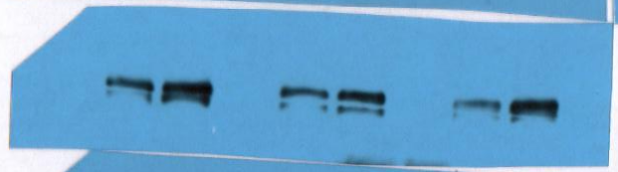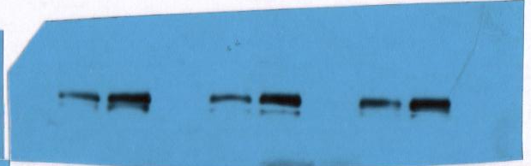
p-NF-κB p65 (Ser536)
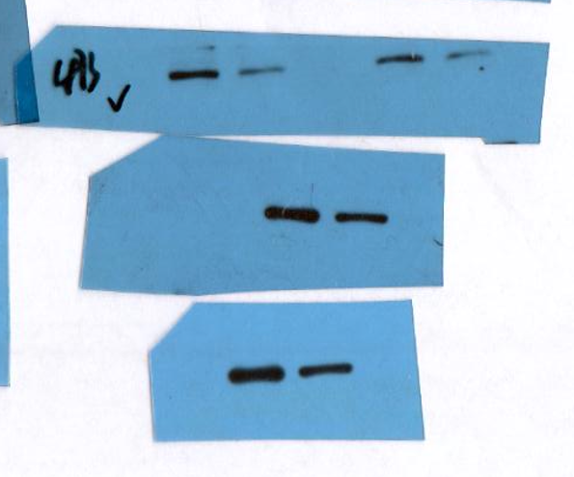
NF-κB p65
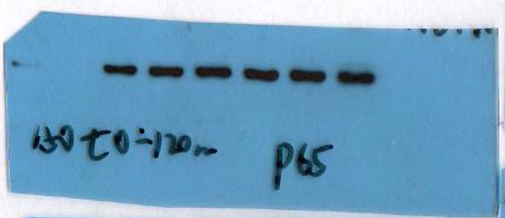
MMP9
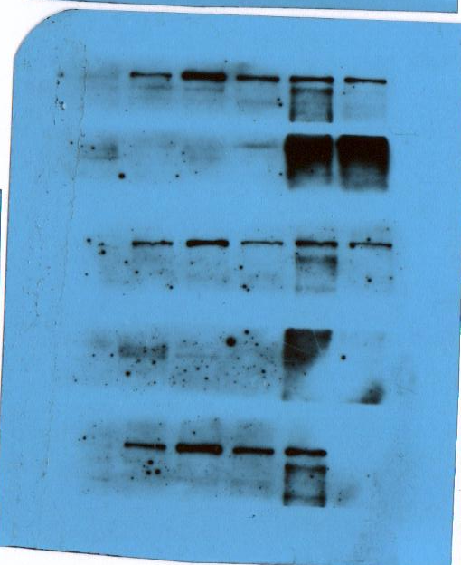
GAPDH
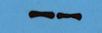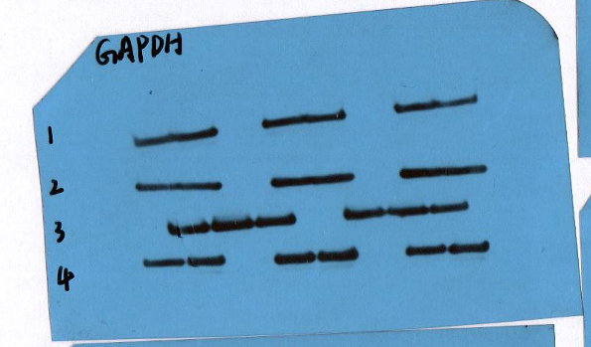

Fig.4F
NF-κB p65
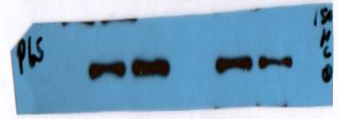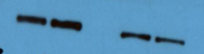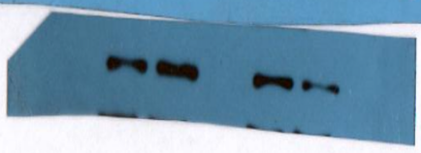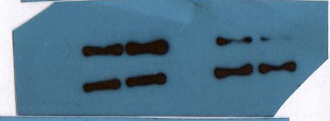
H3
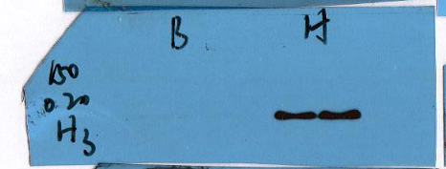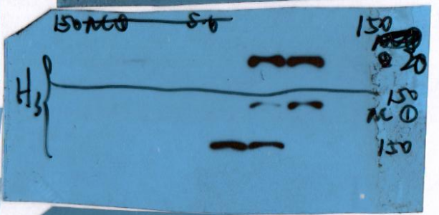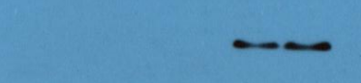
GAPDH
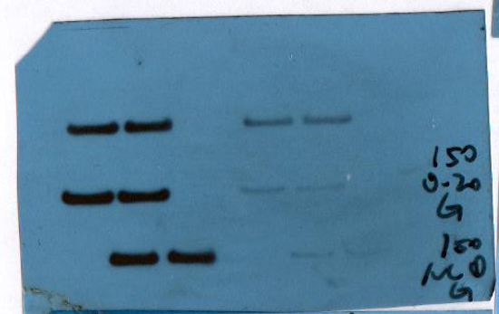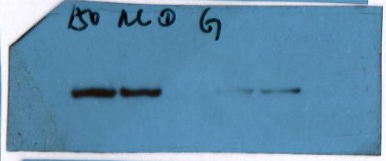

Fig.4G
KYSE150 cells
NF-κB p65
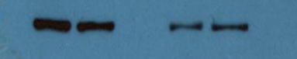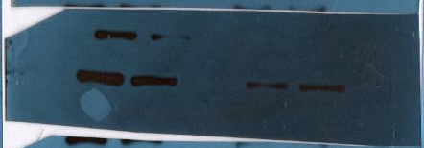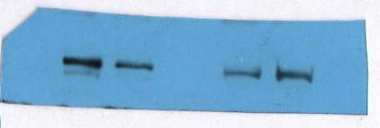
H3
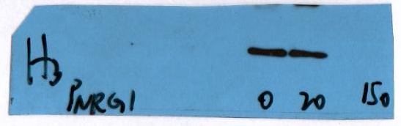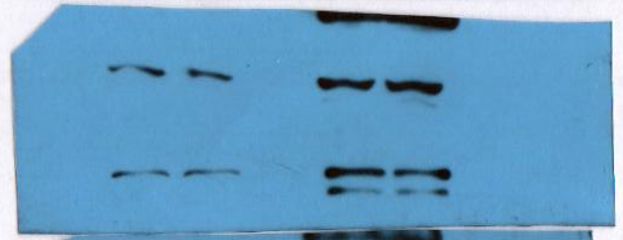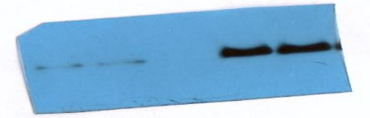
GAPDH
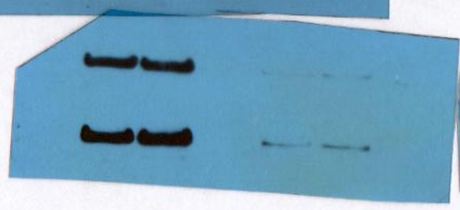
Eca109 cells
NF-κB p65
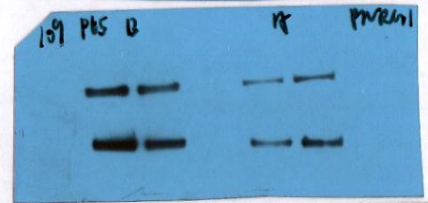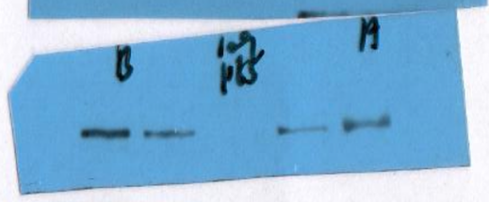
H3
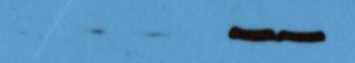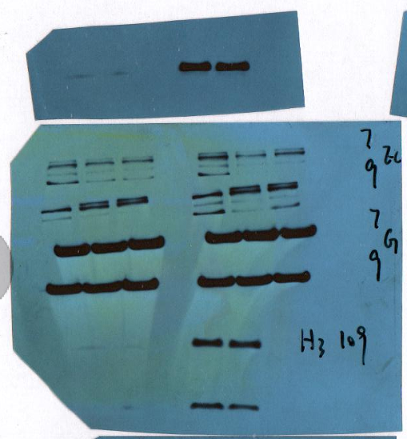
GAPDH
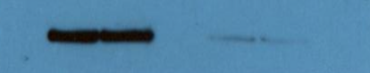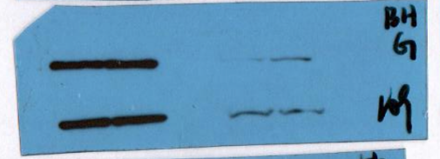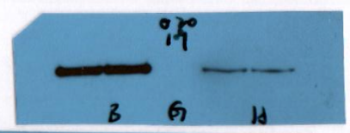

Figure 5
Fig.5A
KYSE150 cells
NF-κB p65
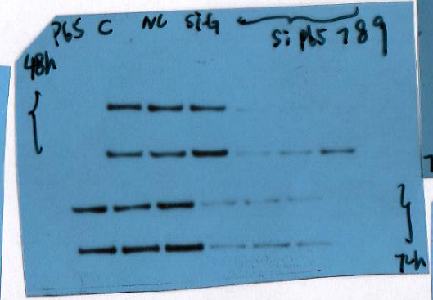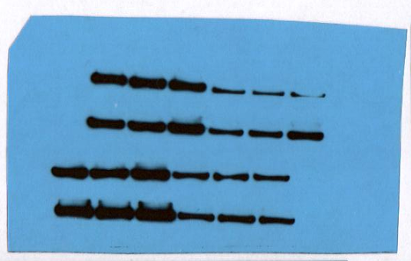
GAPDH
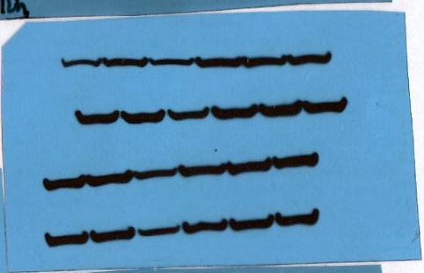
Eca109 cells
NF-κB p65
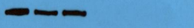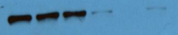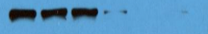
GAPDH
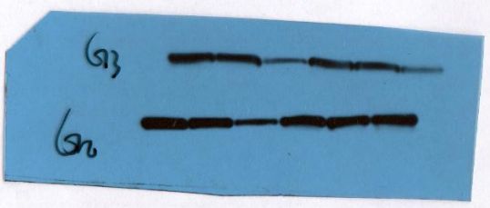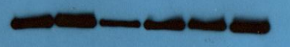
Fig.5I
KYSE150 cells
E-Cadherin
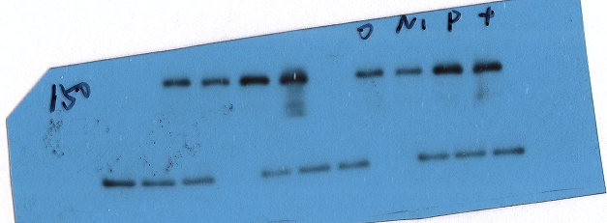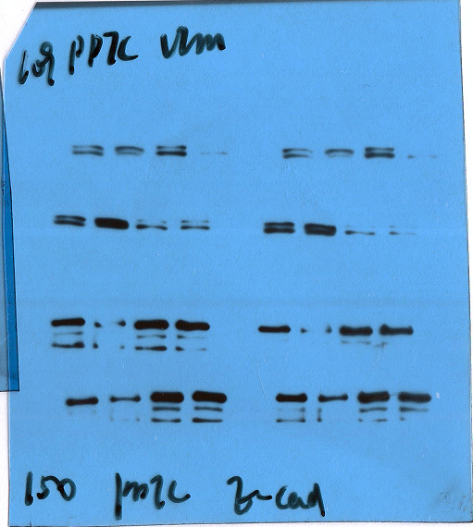
N-Cadherin
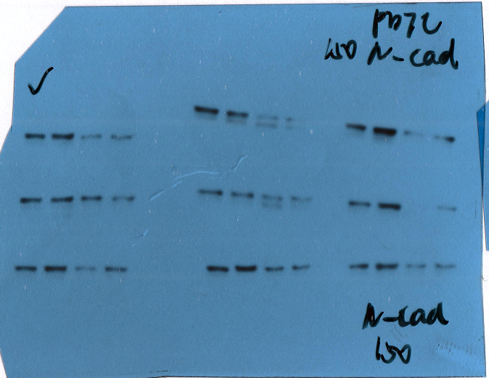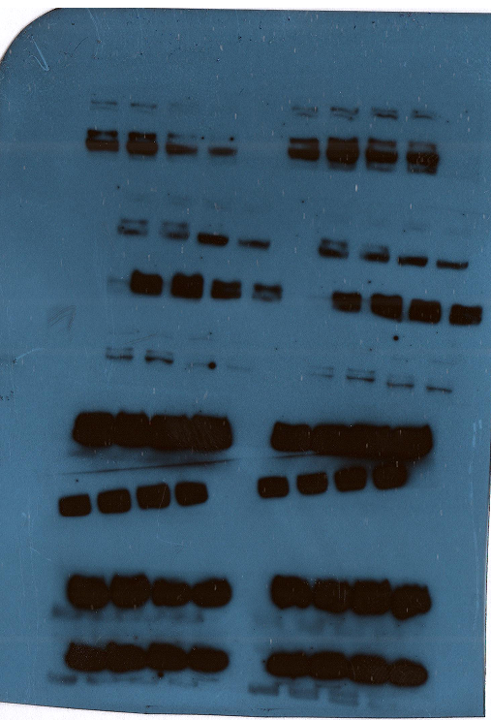
VIM
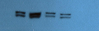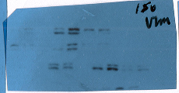
Slug
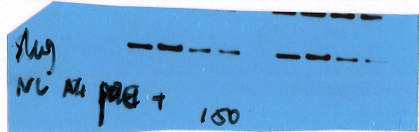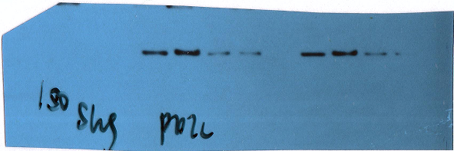

MMP9
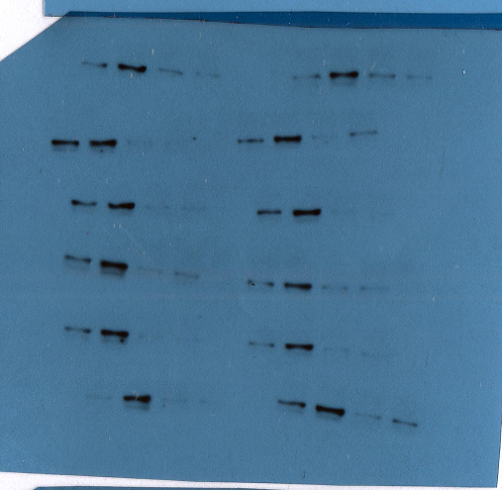
GAPDH
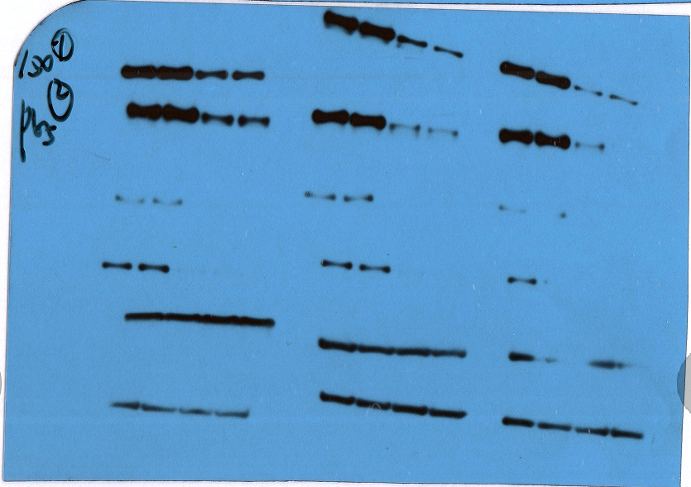
Eca109 cells
E-Cadherin
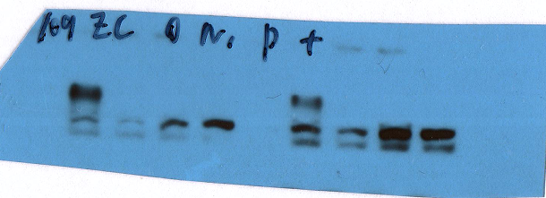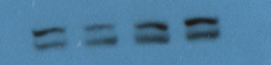
N-Cadherin
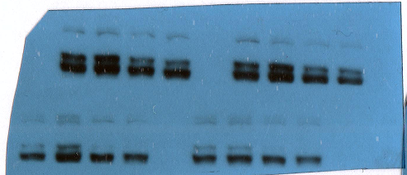
VIM
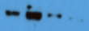
Slug
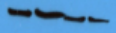
MMP9
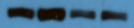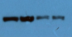
GAPDH
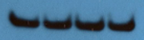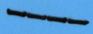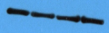
Fig.5J
KYSE150 cells
NF-κB p65
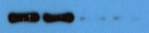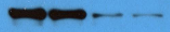
E-Cadherin
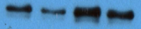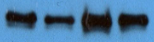
N-Cadherin
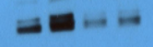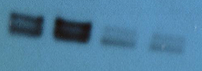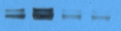
VIM
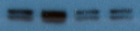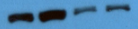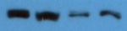
Slug
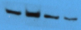
MMP9
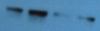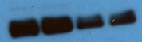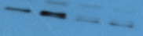
GAPDH
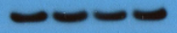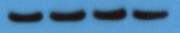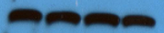
Eca109 cells
NF-κB p65
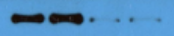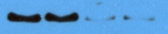
E-Cadherin

N-Cadherin
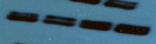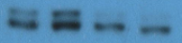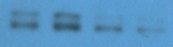
VIM
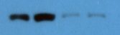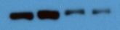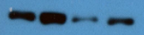
Slug
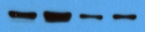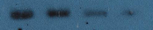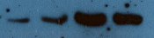
MMP9
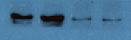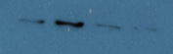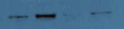
GAPDH
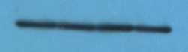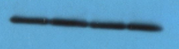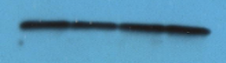

Figure 7
Fig. 7F
Afatinib (µmol/L)
E-Cadherin

N-Cadherin

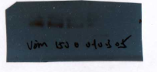
VIM

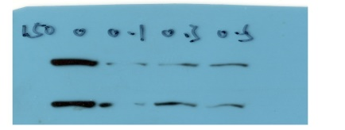
Slug

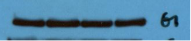
GAPDH

NC si-1
E-Cadherin
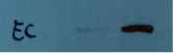

N-Cadherin
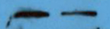


VIM

Slug
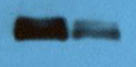
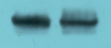

GAPDH


Fig. 7G
Afatinib (µmol/L)
PARP
Cleaved-PARP
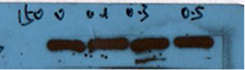

Bax

Bcl-2

GAPDH
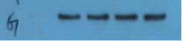
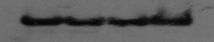

NC si-1
PARP
Cleaved-PARP
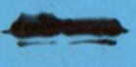
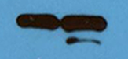
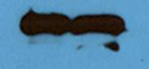

Bax
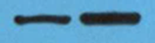

Bcl-2

GAPDH

Fig. 7H
Afatinib (µmol/L)
HER3

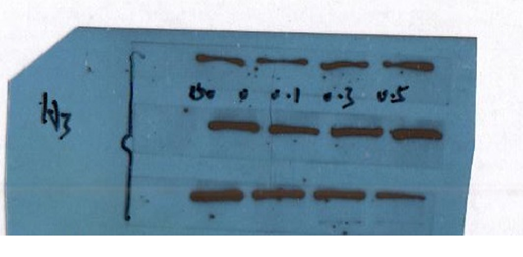

p-HER3

HER2

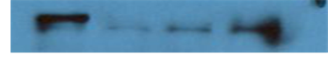
p-HER2

AKT

\

p-AKT

ERK

p-ERK

GAPDH

NC si-1
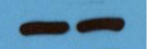
HER3

p-HER3

HER2
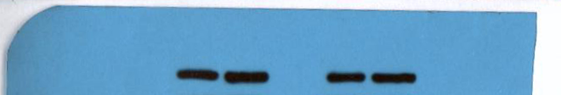

p-HER2
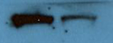
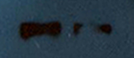

AKT

p-AKT
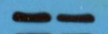
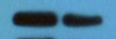


ERK

p-ERK
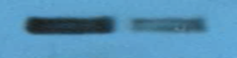

GAPDH

