Appendix

Figure 1 illustrates the location of stations and Köppen-Geiger climate categories.
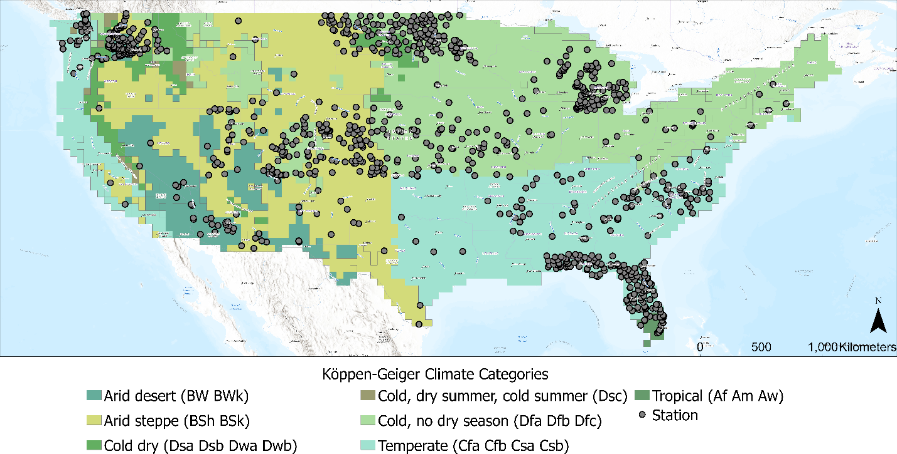
Figure 1 Köppen-Geiger and station locations

Figure 2 shows the relationship between observed data and data products (ERA5, Daymet, and PRISM) of the variables we applied for this study according to Köppen-Geiger climate categories.

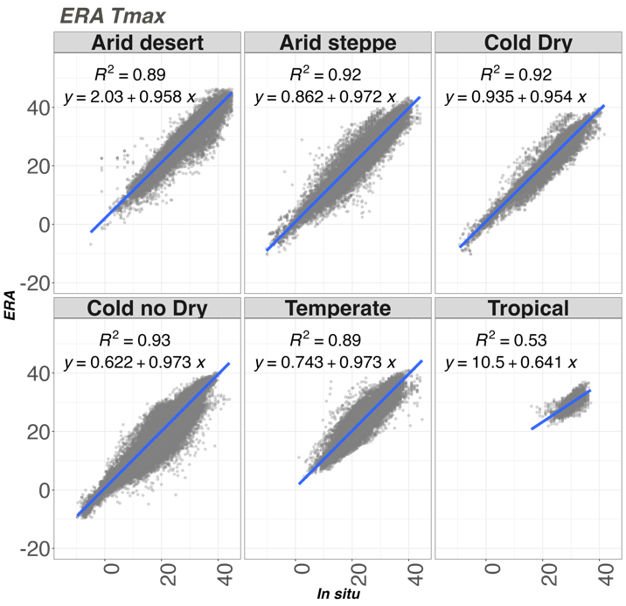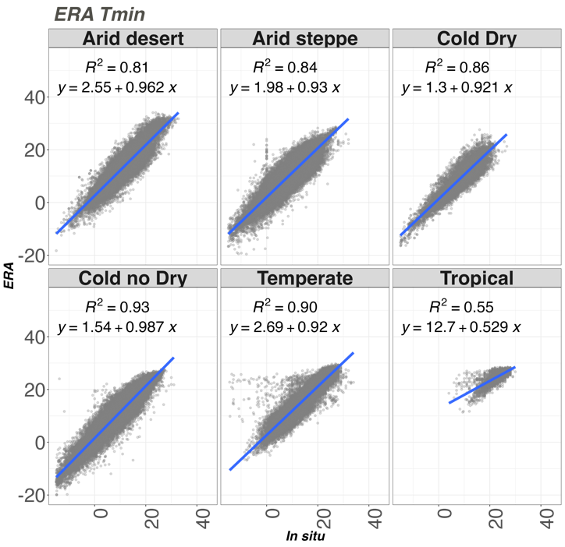
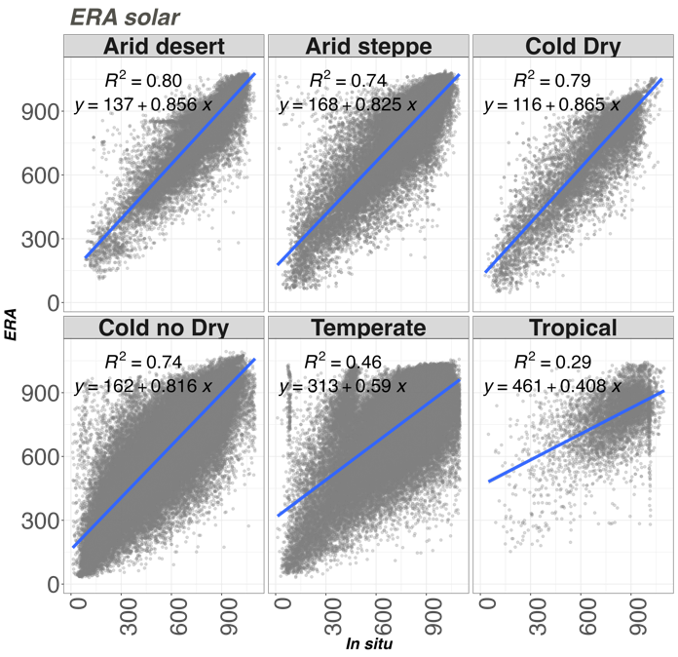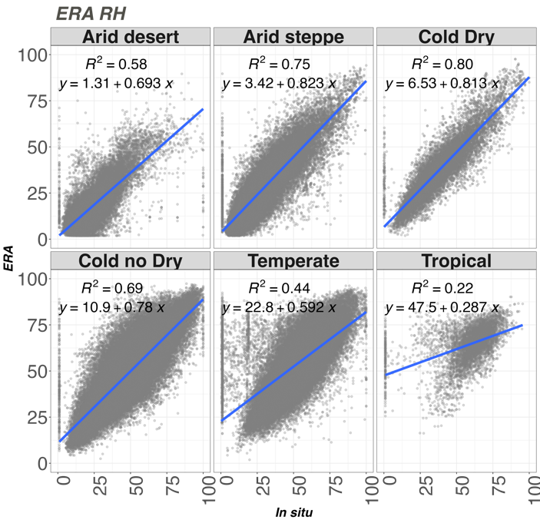
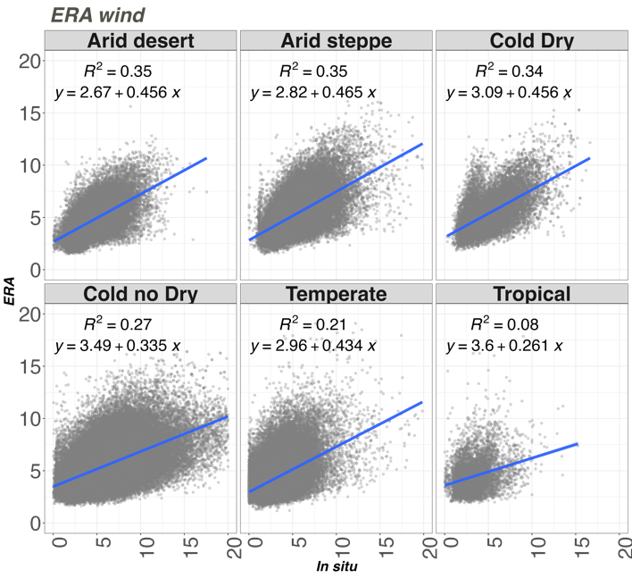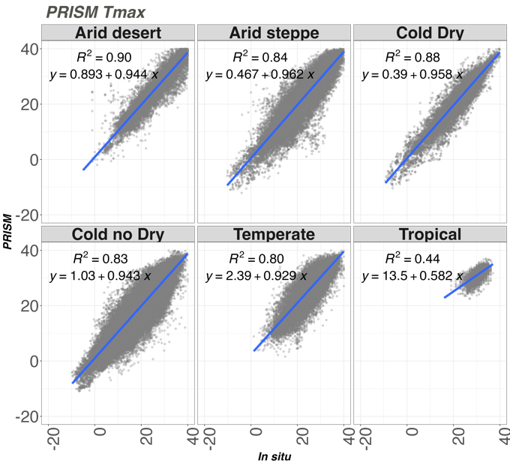
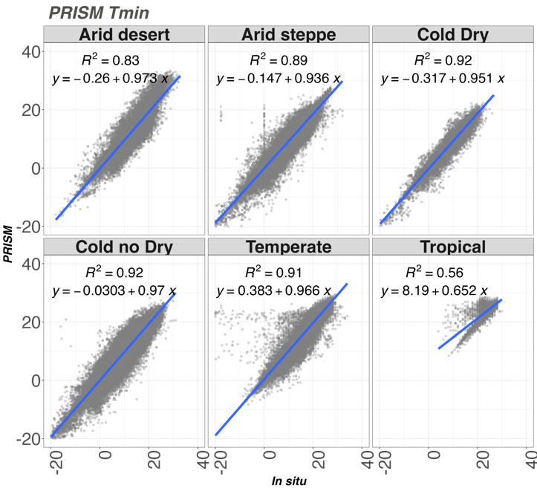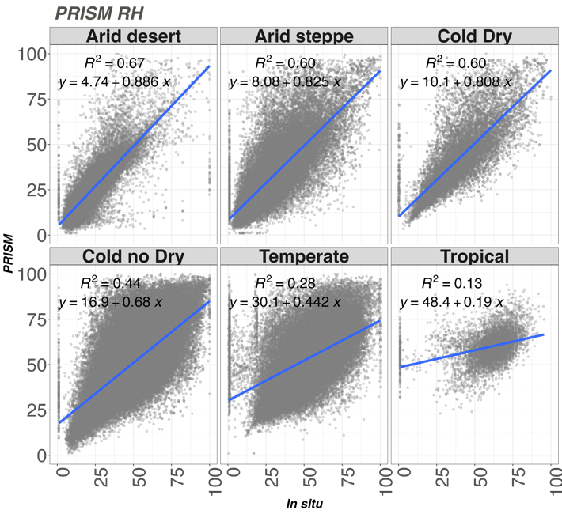
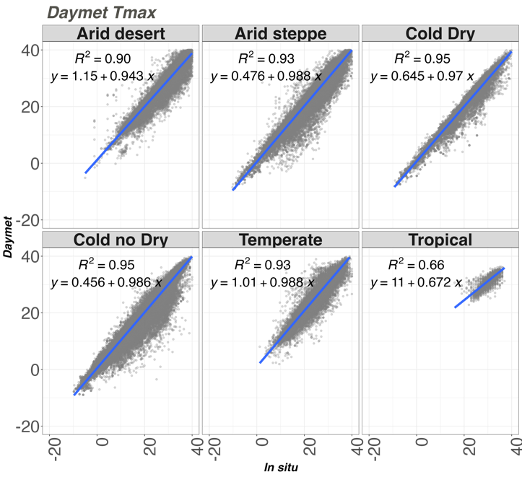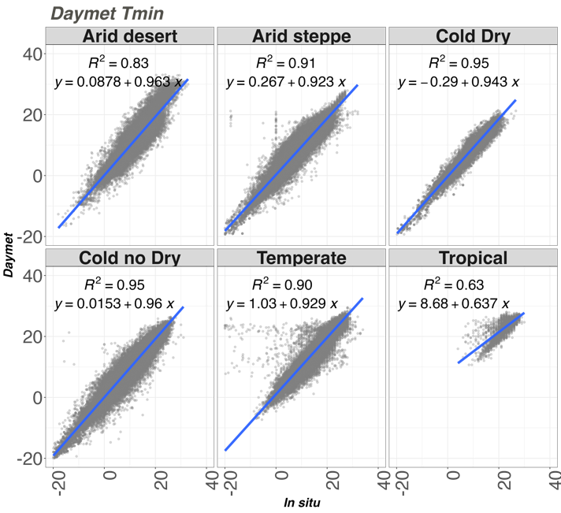
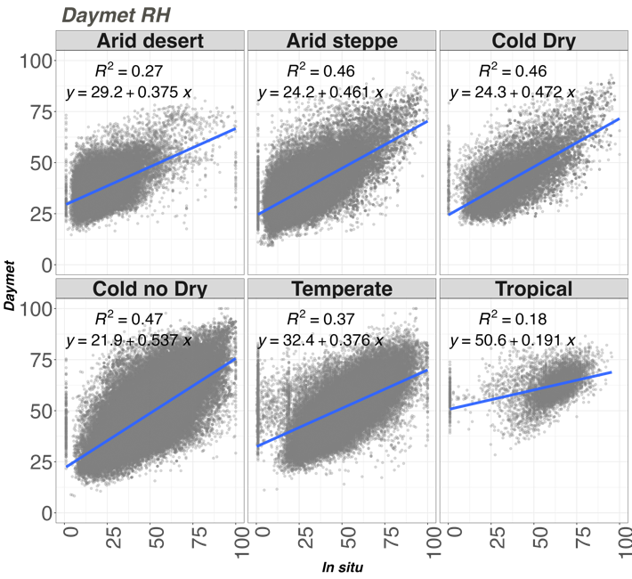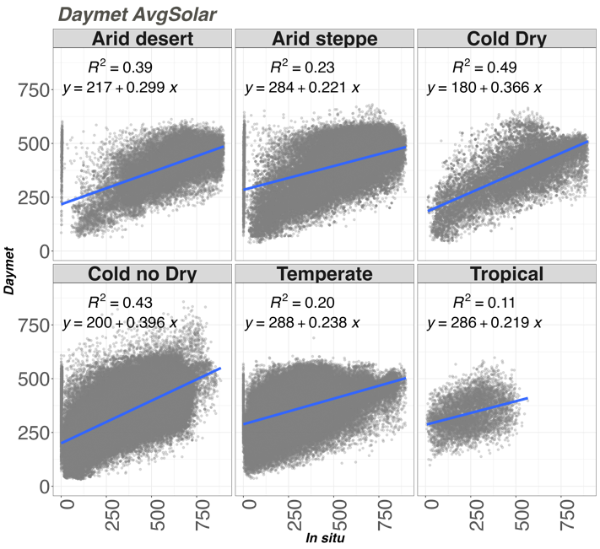
Figure 2 Linear regression of weather station observations on gridded climate datasets according to Köppen-Geiger climates categories
Table 1 represents the number of stations according to Köppen-Geiger climate categories.
Table 1 Number of stations according to Köppen-Geiger climate categories
Köppen-Geiger climate groups | Köppen-Geiger climate categories | Number of stations (%) | Köppen-Geiger climate groups summary
Arid desert | BWh | 20 (2) | 103 (11)
Arid desert | BWk | 83 (9)
Arid steppe | BSh | 3 (0) | 197 (21)
Arid steppe | BSk | 194 (21)
Cold Dry | Dsa | 1 (0) | 34 (4)
Cold Dry | Dsb | 14 (2)
Cold Dry | Dwa | 4 (0)
Cold Dry | Dwb | 15 (2)
Cold no Dry | Dfa | 157 (17) | 311 (34)
Cold no Dry | Dfb | 145 (16)
Cold no Dry | Dfc | 9 (1)
Temperate | Cfa | 233 (25) | 262 (28)
Temperate | Cfb | 6 (1)
Temperate | Csa | 1 (0)
Temperate | Csb | 22 (2)
Tropical | Af | 4 (0) | 17 (2)
Tropical | Am | 8 (1)
Tropical | Aw | 5(1)

Table 2 shows the number of stations included during the study period (April to October 2018-2019) after quality control process.

Table 2 Number of Stations Included for the Analysis After Quality

Year | Month | Number of stations
2018 | 4 | 696
2018 | 5 | 712
2018 | 6 | 559
2018 | 7 | 559
2018 | 8 | 558
2018 | 9 | 562
2018 | 10 | 479
2019 | 4 | 761
2019 | 5 | 554
2019 | 6 | 558
2019 | 7 | 561
2019 | 8 | 547
2019 | 9 | 524
2019 | 10 | 459

Table 3 Equations for User-Derived Meteorological Variables
Variable | Dataset | Expression | Unit | Note
$$T_{D}$$ | in-situ | $T_{D}=T-(\frac{100-RH}{5}$)  - $T_{D}$ = Dew point temperature  - T = air temperature  - RH = relative humidity | T,  $T_{D}$ in ˚C  RH in %
2m wind speed | ERA5, in-situ | V≈V_{ref} *$ln⁡\frac{Z* Z_{0}}{Z_{ref}*Z_{0}}$  - V = velocity to be calculated at height z  - Z = height above ground level for velocity v  - V_{ref} = known velocity at height z_{ref}  - Z_{ref} = reference height where v_{ref} is known  - Z₀ = roughness length in the current wind direction | m/s
Hourly solar radiation (Wm²) | ERA5 | $\frac{Hourly solar radiation }{3600 [s]}$ | Hourly solar. Radiation in Jm²  S represents second
${RH}_{min}$ (%) | ERA | $$100∙\frac{{ e}^{\left(\frac{17.625 ∙ T_{D}}{243.04˚C + T_{D}}\right)}}{{ e}^{\left(\frac{17.625 ∙ T}{243.04˚C + T}\right)}}$$  - $T_{D}$ = Dew point temperature  - T = air temperature | T, $T_{D}$ in ˚C | Minimum based on hourly values
${RH}_{min}$ (%) | PRISM | $$100∙\frac{\left[610.94 Pa ∙{ e}^{\left(\frac{17.625 ∙ T_{max}}{243.04˚C + T_{max}}\right)}\right]-VPD_{max}}{610.94 Pa ∙ { e}^{\left(\frac{17.625 ∙ T_{max}}{243.04˚C + T_{max}}\right)}}$$  - $VPD_{max}$= maximum vapor-pressure deficits (VPD) | $T_{max}$ in ˚C  VPD_{max} in Pa | Assumes ${RH}_{min}$occurs at $T_{max}$
${RH}_{min}$ (%) | Daymet | $$100∙\frac{{ e}^{\left(\frac{17.269 ∙ T_{min}}{237.3˚C + T_{min}}\right)}}{{ e}^{\left(\frac{17.269 ∙ T_{max}}{237.3˚C + T_{max}}\right)}}$$ | $T_{min}$, $T_{max}$ in ˚C | Assumes $T_{D}$ = $T_{min}$ all day
$$T_{mean}$$ | PRISM | $$0.606∙T_{max}+0.394∙T_{min}$$ | $T_{max}$ in ˚C
$${HI}_{max}$$ | ERA5, PRISM, Daymet,  in-situ | 0.5 * {Ta + 61.0 + [(Ta -68.0)*1.2] + (RH *0.094)}  If this heat index value is 80 ˚F or higher, the full equation with adjustments should be applied.  -42.379 + 2.04901523* Ta + 10.14333127* RH - .22475541*Ta* RH - .00683783* Ta2 - .05481717*RH2 + .00122874*Ta2* RH + .00085282* Ta *RH2 - .00000199*Ta2 *RH2-ADJ  *RH <13% and Ta is between 80 and 112◦F  - ADJ₁ = −[(13− RH)/4]∗(17- Ta -95)17  *RH >85% and Tais between 80 and 87◦F  ADJ₂= (RH-8510)*(87-Ta5)  - Ta = Ambient Dry Bulb Temperature  - RH = relative humidity | $T_{a}$ in ˚F  RH in %  $T_{max}$ and ${RH}_{min}$were applied instead for Ta and RH for ERA5, PRISM, and Daymet
$${WBGT}_{Bernard}$$ | ERA5, PRISM, Daymet,  in-situ | -0.0034*HI*2 + 0.96*HI -34  - HI = Heat Index | HI in ˚F
$${ WBGT}_{Liljegren}$$ | ERA5, PRISM, Daymet,  in-situ | 0.7 ∗Tw + 0.2 ∗Tg + 0.1*Ta  - $T_{w}:$Wet-Bulb Temperature  - $T_{g}$: Globe Temperature  - $T_{a}:$Dry Bulb Temperature

