Supplementary data
Table S1. Normality test for EAE score
Test for normal distribution  D'Agostino & Pearson test | Group A | Group B | Group C | Group D | Group E
K2 | 2.355 | 5.938 | 4.668 | 4.802 | 4.638
P value | 0.3080 | 0.0513 | 0.0969 | 0.0906 | 0.0623
Passed normality test (alpha=0.05)? | Yes | Yes | Yes | Yes | Yes
P value summary | ns | ns | ns | ns | ns

Table S2. Normality test for LFB score
Bartlett's test for LFB
F (DFn, DFd) | 0.5168 (6, 14)
P value | 0.7862
P value summary | ns
Are SDs significantly different (P < 0.05)? | No

Table S3. Normality test for CD20⁺ score
Brown-Forsythe test for CD20⁺
F (DFn, DFd) | 0.2966 (4, 20)
P value | 0.8767
P value summary | ns
Are SDs significantly different (P < 0.05)? | No
Bartlett's test
Bartlett's statistic (corrected) | 3.251
P value | 0.5168
P value summary | ns
Are SDs significantly different (P < 0.05)? | No

Table S4. Normality test for CD4⁺ score
Brown-Forsythe test for CD4⁺
F (DFn, DFd) | 2.455 (4, 20)
P value | 0.0791
P value summary | ns
Are SDs significantly different (P < 0.05)? | No

Brown-Forsythe test for CD8⁺
F (DFn, DFd) | 0.8329 (4, 20)
P value | 0.5201
P value summary | ns
Are SDs significantly different (P < 0.05)? | No
Bartlett's test
Bartlett's statistic (corrected) | 8.904
P value | 0.0635
P value summary | ns
Are SDs significantly different (P < 0.05)? | No

Table S5. Normality test for CD8⁺ score

Table S6. EAE Scores for each mice at each time points during study.
Days |  | 7 | 14 | 21 | 28 | 35 | 42 | 49 | 56 | 63
Group A | 1 | 0 | 0.5 | 0.5 | 1 | 2 | 3 | 3 | 3 | 3
 | 2 | 0 | 0 | 0.5 | 1 | 2 | 2.5 | 3 | 3 | 3
 | 3 | 0 | 0 | 0.5 | 1 | 2 | 2 | 2.5 | 3 | 3
 | 4 | 0 | 0 | 0 | 0.5 | 1.5 | 2.5 | 3 | 3 | 3
 | 5 | 0 | 0 | 0.5 | 1 | 2 | 2.5 | 2.5 | 2.5 | 2.5
Group B | 1 | 0 | 0 | 0 | 0.5 | 1.5 | 2 | 2.5 | 2.5 | 2.5
 | 2 | 0 | 0 | 0.5 | 1 | 2 | 2.5 | 3 | 3 | 3
 | 3 | 0 | 0 | 0 | 0.5 | 1.5 | 2.5 | 3 | 3 | 3
 | 4 | 0 | 0 | 0 | 0.5 | 1.5 | 2.5 | 2.5 | 2.5 | 2
 | 5 | 0 | 0 | 0 | 0.5 | 1 | 2 | 2 | 2.5 | 2.5
Group C | 1 | 0 | 0 | 0.5 | 1 | 2 | 3 | 3 | 3 | 3
 | 2 | 0 | 0 | 0 | 1 | 2 | 2.5 | 3 | 3 | 3
 | 3 | 0 | 0 | 0 | 0.5 | 1.5 | 2 | 2.5 | 2 | 2.5
 | 4 | 0 | 0 | 0 | 1 | 2 | 2.5 | 3 | 3 | 3
 | 5 | 0 | 0 | 0 | 0.5 | 1.5 | 2 | 2.5 | 3 | 3
Group D | 1 | 0 | 0 | 0 | 0 | 0.5 | 1.5 | 2 | 2 | 2.5
 | 2 | 0 | 0 | 0 | 0.5 | 1 | 2 | 3 | 3 | 3
 | 3 | 0 | 0 | 0 | 0 | 0.5 | 1.5 | 3 | 3 | 3
 | 4 | 0 | 0 | 0 | 0 | 0.5 | 2 | 2.5 | 3 | 3
 | 5 | 0 | 0 | 0 | 0.5 | 1 | 2 | 3 | 3 | 3
Group E (control) | 1 | 0 | 0 | 0 | 0 | 0 | 0 | 0 | 0 | 0
 | 2 | 0 | 0 | 0 | 0 | 0 | 0 | 0 | 0 | 0
 | 3 | 0 | 0 | 0 | 0 | 0 | 0 | 0 | 0 | 0
 | 4 | 0 | 0 | 0 | 0 | 0 | 0 | 0 | 0 | 0
 | 5 | 0 | 0 | 0 | 0 | 0 | 0 | 0 | 0 | 0

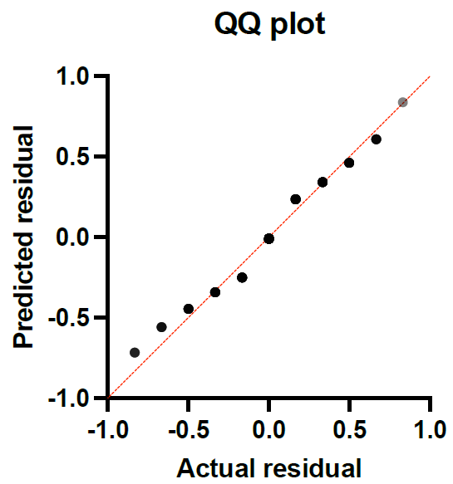

Figure S1. QQ plot- 2way ANOVA of EAE score

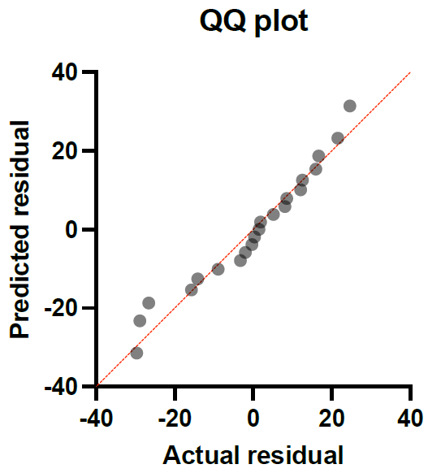
Figure S2. QQ plot- Brown-Forsythe and Welch ANOVA tests of LFB

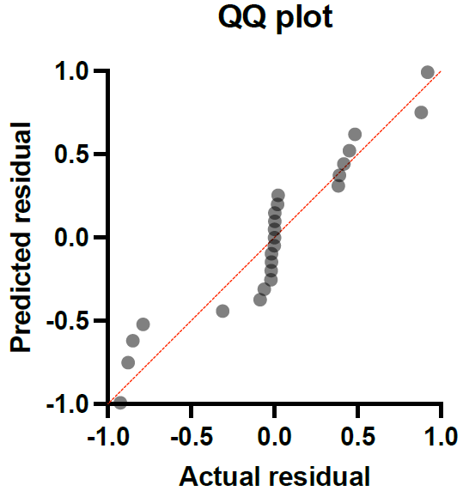
Figure S3. QQ plot- Ordinary one-way ANOVA of CD20⁺
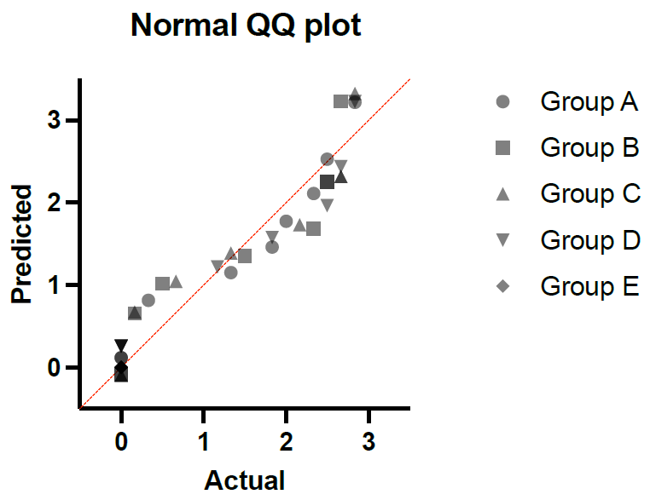
Figure S4. QQ plot- Ordinary one-way ANOVA of CD20⁺

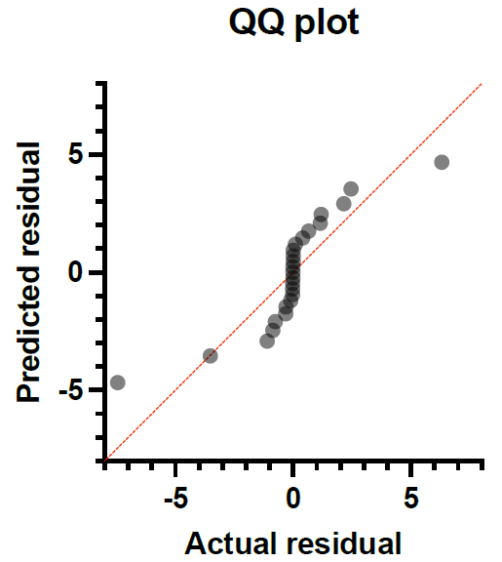
Figure S5. QQ plot- Ordinary one-way ANOVA of CD4⁺

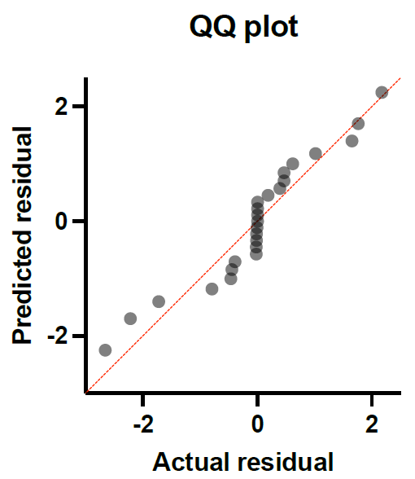
Figure S6. QQ plot- Ordinary one-way ANOVA of C8⁺

Figure S7. Pathological evaluation of the midbrain slides of EAE and control mice by light microscopy (H&E staining, ×4 magnification). CNS tissue of the control group (E) contained glial cells without any inflammatory cell infiltration; whereas groups A to D (mice receiving different doses of recombinant plasmid) showed different degrees of infiltrated inflammatory cells and inflammation in this area (A-D). Group A showed the maximum rate of inflammation among all groups. Group A, 16-16 µg; group B, 32-16 µg; group C, 32-32 µg; group D, 64-64 µg and group E was the control group.

