Extended Data

Extended Data Table 1: List of model equations, units, and interpretation: stocks, their initial stock values, flows, and other model variables.
Variable Type / Model sector | Abbreviation | Variable Name | Equation | Units | Interpretation
Stock | P | Potential Adopters | Potential Adopters (P) = Adopters quitting (Aq) + Hiring educators (Ph) -Adopting (Aa) - Potential adopters retiring (Pr) | People | The stock of potential adopters is increased by the hiring of new educators and the adopters who quit using the innovation. It is decreased by the potential adopters who start using the innovation and the ones who retire.
Initial | P_{i} | Initial Number of Potential Adopters | Initial number of potential adopters (Pi) = Total number of academic programs (AP)*Proportion sustainability programs (PSP)*Average number of potential adopters per program (PAP) | People | Value to initialize the stock of potential adopters. See main text, section 3.4.
Stock | A | Adopters | Adopters (A)= Adopting (Aa)+Ambassadors stepping down (AAsd)-Adopters quitting (Aq)-Adopters retiring (Ar)-Ambassador development (AAd) | People | Adopters are educators who use the innovation. While they may share information about it passively, they do not actively propagate it.
Initial | A_{i} | Initial Number of Adopters | Initial number of adopters (Ai) = 50 | People | Value to initialize the stock of adopters. Our experience with dissemination efforts for the World Climate Simulation¹¹ suggests that an ambitious but reasonable initial number of adopters is 50 people.
Stock | AA | Ambassadors | Ambassadors (AA)=Ambassador development (AAd)-Ambassadors retiring (AAr)-Ambassadors stepping down (AAsd) | People | Ambassadors are educators who actively develop adopters into ambassadors and who actively share the innovation with other educators.
Initial | AA_{I} | Initial Number of Ambassadors | Initial number of ambassadors (AAi) = 8 | People | Value to initialize the number of ambassadors. It encompasses the number of ambassadors and development project leaders. The development team and a small initial cohort of ambassadors is likely to be around eight people.
Flow | P_{h} | Hiring educators | Hiring new educators (Ph)= "New hires (Nh)"+"Replacements (R)" | People Year⁻¹ | Newly hired educators are new potential adopters. They are the sum of those that are replaced and the new hires.
Flow | P_{r} | Potential adopters retiring | Potential adopters retiring (P_{r)}=Potential adopters (P)/Average years as educator (Te) | People/Year | Potential adopters retire from teaching after an average number of years as university instructors.
Flow | A_{a} | Adopting | Adopting (a)= Adopting through outreach efforts (aOE)"+"Adopting through adopters (aA)"+"Adopting through Ambassadors (aAA) | People/Year | "Adopting" is a flow from potential adopters to adopters that represents the process of adopting. Adopting grows with increasing outreach effort by the project, effort of Leaders to encourage Potential Adopters to adopt, and word of mouth diffusion by Adopters.
Flow | A_{q} | Adopters quitting | Adopters quitting (Aq)= Adopters not continuing (Anc) | People/Year | Adopters continue to implement for the Average number of years implementing, after which they return to the Potential adopter pool.
Flow | A_{r} | Adopters retiring | Adopters retiring (Ar)=Adopters (A)/Average years as educator (Te) | People/Year | Like potential adopters and ambassadors, adopters retire from teaching after an average number of years.
Flow | AA_{d} | Ambassador development | Ambassador development (AAd)= Switch for project ambassador development*(PULSE(0 , "Years funded ambassador development (TfAA)"))*  Adopters becoming Ambassadors through Ambassadors (AAA) | People/Year | Ambassador development is the process by which Adopters become Ambassadors. Ambassador development occurs only as long as there is funding is available to support it, as defined by the variable Years funded ambassador development.
Flow | AA_{sd} | Ambassadors stepping down | Ambassadors stepping down (AAsd)= Ambassadors not continuing (AAnc) | People/Year | Once funding for active outreach expires, Ambassadors convert back to Adopters at a rate that is inversely proportional to the Average number of years leading.
Flow | AA_{r} | Ambassadors retiring | Ambassadors retiring (AAr) = Ambassadors (AA)/Average years as educator (Te) | People/Year | Like potential adopters and adopters, ambassadors retire from teaching after an average number of years.
Variable /  Hiring | Ea | Total number of educators | Total number of educators (Ea) = Potential adopters (P)+Adopters (A)+Ambassadors (AA) | People | The total number of educators refers to all Potential Adopters, Adopters, and Ambassadors in the propagation system.
Variable /  Hiring | R | Replacements | Replacements (R) = Potential adopters retiring (Pr)+Adopters retiring (Ar)+Ambassadors retiring (AAr) | People/year | New educators are hired to replace those who retire.
Variable /  Hiring | Nh | New hires | New hires (Nh) = Total number of educators (Ea)*Annual educator growth fraction (Pg) | People/year | The total of new hires in the education system on sustainability. We assume a growth in the field.
Variable /  Word of Mouth | aA | Adopting through adopters | Adopting through adopters (aA) = (Number of contacts per Adopter (cA)*Fraction of Adopter contacts who adopt (fA)*Adopters (A))*(Potential adopters (P)/Total number of educators (Ea)) | People/Year | Potential adopters are exposed to the innovation through adopters. This variable calculates how many potential adopters become adopters through adopters.
Variable / Outreach | aOE | Adopting through outreach efforts | Adopting through outreach efforts=Switch for outreach effort*(PULSE(0 , Years funded outreach (TfO))*  Total number of educators that adopt per year due to outreach (PAORt)*("Potential adopters (P)/Total number of educators (Ea))) | People/Year | If an outreach effort is actively funded and a significant proportion of the total number of educators have not yet adopted, outreach generates new adopters.
Variable / Outreach | PAORt | Total number of educators that adopt per year due to outreach | Total number of educators that adopt per year due to outreach (PAORt)=Adopters from email campaigns (AORe)+Adopters from presentations (AORp) | People/Year | The total number of educators reached by direct outreach efforts by the project per year.
Variable / Outreach | AORp | Adopters from presentations | Adopters from presentations (AORp)=Fraction of attendees who adopt (FAi)*"Number of interactive presentations per year (ORi)*Number of attendees per presentation (PAORi) | People/Year | The number of educators per year who adopt the educational resources as a result of attending an interactive presentation by the project.
Variable / Outreach | AORe | Adopters from email campaigns | Adopters from email campaigns (AORe)=Fraction of adoption from digital campaigns (FAj)*Number of digital outreach campaigns per year (ORj)*Number of people reached per campaign (PAORj) | People/Year | The number of educators per year who adopt the educational resources as a result of digital campaigns.
Variable / Community building | AAA | Adopters becoming Ambassadors through Ambassadors | Adopters becoming Ambassadors through Ambassadors=(1-(Proportion of users who are ambassadors (A/U)/Maximum proportion of Adopters to Users (AUmax)))*Fractional rate of ambassador development (fAAD)*Number of adopters each ambassador mentors (MAA)*Ambassadors (AA) | People/Year | When funding is available, Ambassador development depends on the fractional rate at which Adopters are converted to Ambassadors by the number of Adopters that each Ambassadors mentors per year.
Variable / Community building | AA/U | Proportion of users who are ambassadors (AA/U) | Proportion of users who are ambassadors (A/U)=Ambassadors (AA)/(Ambassadors (AA)+Adopters (A)) | Dmnl | The proportion of users who are ambassadors is the number of ambassadors divided by the total number of educators using the innovation (i.e., adopters and ambassadors).
Variable / Community building | U | Total number of users of the innovation | Total number of users (U) = Adopters (A) + Ambassadors (AA) | People | The number of educators using the innovation is the sum of Adopters and Ambassadors.
Variable / Community building | AAnc | Ambassadors not continuing (AAnc) | Ambassadors not continuing (AAnc)= (Ambassadors (AA)/Average number of years as Ambassador (TAA)) | People/year | Once funding for active outreach expires, Leaders convert back to Adopters at a rate that is inverse proportional to the Average number of years leading.

Extended Data Table 2. Model parameters, their default values, and their sources. Minimum (min) and maximum (max) values show the range of parameter values used in sensitivity analyses. Default values show the parameter value used for scenario and strategy testing when the relevant ‘switch’ for a given model sector is set to one. Parameter name abbreviations (abbr) are also given as are the confidence scale values (CS), with the following values: 1 - relevant data are not available, lowest confidence level; 2 – data from other contexts used to estimate base value; 3 – value estimated from experience of authors and stakeholders; 4 – value estimates are from published research or publicly available datasets, highest confidence level.

Model  Sector | Parameter | Abbr | Default value | Min | Max | Units | CS | Comments and Source
Hiring | Fractional rate of growth in sustainability educators | Pg | 0.01 | NA | NA | 1/year | 3 | From 2012 to 2016, the number of sustainability-related programs in US higher education grew by 15%⁵⁷. We conservatively estimate an annual growth rate of 1% per year to account for potential slowing of that growth rate and the fact that a particular educational innovation is only appropriate for some programs. Note also that the number of potential adopters is so much larger than the initial number of adopters that, even with rapid propagation and slow growth in new potential adopters over time, adoption does not saturate due to lack of potential adopters. Because it has little or no impact on model outcomes, this parameter was not included in sensitivity analyses.
Hiring | Total number of academic programs | AP | 33,688 | NA | NA | Programs | 4 | We used the IPEDS database (https://nces.ed.gov/ipeds/) to extract information about the number of undergraduate academic programs with the potential to teach sustainability. We included categories of programs focused on sustainability (e.g., Natural Resources) as well as those with broader scope (i.e., Business Management) that are increasingly offering individual courses and/or course modules focused on sustainability.
Hiring | Proportion of sustainability-related programs | PSP | 0.33 | NA | NA | Dmnl | 3 | The proportion of academic programs that teach sustainability within relevant NCES (https://nces.ed.gov/ipeds/) academic discipline categories. We assumed that about a third of academic program categories that we included as 'sustainability-related' (parameter AP) are actually teaching sustainability, based on assessments of the programs in those categories in our own institutions.
Hiring | Average number of potential adopters per program | PAP | 2 | NA | NA | People/ Programs | 2 | The average number of educators that could adopt the innovation within each academic department that teaches sustainability to undergraduates in the US. We conservatively estimate an average of two potential adopters per academic program that teaches sustainability. Larger, sustainability-focused programs are likely to have more substantially more than two potential adopters, while smaller programs may have fewer.
Hiring | Average years as educator | Te | 35 | 1 | 40 | Years | 2 | Estimate of the average number of years that a tenure-track faculty member or lecturer teaches in higher education. Our intention is to focus on educators with long-term, stable positions. However, if adjunct professors, teaching fellows, and/or teaching assistants are included, their average number of years teaching may be quite small. We therefore include a wide range of values in sensitivity testing of this parameter⁵⁸.
Word-of-mouth | Fraction of adopter contacts who adopt | fA | 0.05 | 0 | 0.1 | Dmnl | 2 | Estimate of the fraction of colleagues whom adopters contact and who decide to also adopt the innovation. Prior research shows suggests that about 13% of instructors who become aware of evidence-based instructional strategies claim to adopt them but that only about half of those instructors actually do adopt³⁴. We therefore conservatively estimate that 5% of adopter contacts are converted to adopters and vary this parameter from 0 to 0.1 in sensitivity analyses.
Word-of-mouth | Number of contacts per Adopter | c_{A} | 1 | 0 | 5 | Year⁻¹ | 1 | Estimate of the average number of new colleagues contacted by each adopter per year. Here, the term 'contact' specifically refers to communication between adopters and potential adopters about the educational innovation. Its relatively low value and range for sensitivity analyses reflects the fact that faculty tend to talk to the same colleagues over long periods of time and tend not to have conversations focused on educational innovations they are using.
Outreach | Number of interactive presentations per year | O_{rp} | 6 | 1 | 12 | Presenta-tions  Year⁻¹ | 1 | Estimate of the average number of interactive presentations (i.e., live webinars or face-to-face presentations) given by the project per year. This estimate is based on our own experience propagating educational innovations and our familiarity with our peers' efforts to do the same.
Outreach | Number of attendees per presentation | PAOR_{p} | 20 | 1 | 200 | People Presenta-tion⁻¹ | 3 | This parameter reflects the average number of educators who attend a presentation about the educational resources that are being propagated.
Outreach | Fraction of attendees who adopt | F_{ap} | 0.05 | 0 | 0.1 | Dmnl | 2 | Fraction of interactive presentation attendees who adopt the educational resource. See fA.
Outreach | Number of digital outreach campaigns per year | O_{re} | 4 | 0 | 12 | Campaigns Year⁻¹ | 1 | Estimate of the average number of times per year that a project uses digital platforms to share information about the educational innovation and how to adopt it.
Outreach | Number of people reached per campaign | PAOR_{e} | 500 | 0 | 1,000 | People Campaign⁻¹ | 1 | Estimate of the average number of new educators reached per digital campaign.
Outreach | Fraction of adoption from digital campaigns | F_{ae} | 0.0025 | 0 | 0.005 | Dmnl | 2 | Typical click-through rates for email marketing are 2-5% (https://www.campaignmonitor.com/resources/guides/email-marketing-benchmarks/). We further assume that about 5% of potential adopters who are made aware of the innovation are convinced to adopt it (see fA).
Outreach | Years funded outreach | T_{fO} | 4 | 0 | 15 | Years | 3 | The number of years of funded outreach and leadership development by the project. Federally funded education development and research projects are typically 3-5 years. We include a range of 0-15 years in sensitivity testing to allow for projects that leave little time for funded outreach and those that secure long-term funding.
Commun-ity building | Number of adopters each ambassador mentors | M_{AA} | 6 | 0 | 10 | Year⁻¹ | 1 | We assume that if a project is actively supporting ambassadors, each ambassador could reach out to six adopters per year to encourage them to become ambassadors. Our low confidence score for this parameter reflects the fact that the community building propagation approach is new and untested.
Commun-ity building | Maximum proportion of ambassadors to users | A_{umax} | 0.3 | 0 | 0.4 | Dmnl | 1 | We assume that only about 30% of all users of the innovation have the potential to become ambassadors - i.e., most educators who use it simply do not have the time or incentives to do more than use the innovation in their own instructional work. For the maximum we assume that 40% of the adopters have the potential to become users.
Commun-ity propagation | Number of contacts per ambassador | c_{AA} | 10 | 0 | 24 | Year⁻¹ | 1 | This is the number of adopters that each ambassador contacts per year. Again, it relies on an active community-building effort that provides support to ambassadors to amplify their reach. The project invites ambassadors to co-facilitate workshops or webinars, provides ambassadors with contact information of potential adopters, and provides information to ambassadors about how to reach their own networks more effectively.
Commun-ity propagation | Fraction of ambassador contacts who adopt | f_{AA} | 0.2 | 0 | 0.4 | Dmnl | 1 | Ambassadors leverage their personal connections, success using the innovation, and tools the project provides to be compelling and trusted messengers about the innovation. Because this is a new and untested approach, we include a range of values from 0-40% in sensitivity analyses.
Not continu-ing | Average number of years implementing | T_{A} | 5 | 1 | 40 | Years | 1 | Estimate of the average number of years for which adopters implement the innovation in their instructional work. We assume that once an adopter puts the effort into learning how to use an educational innovation, they are likely to use it for many years. In contrast, if they try the adoption and find it is unsuccessful, they are likely to stop implementing it quickly. We therefore take a mid-range estimate of about 5 years. However, in sensitivity analyses, we test a wide range of values from 1-40 years to reflect the full range of possibilities for this parameter, with the maximum of 40 years being in line with the maximum for T_{AA}.
Not continu-ing | Average number of years as ambassador | T_{AA} | 8 | 1 | 40 | Years | 1 | Estimate of the average number of years that an ambassador remains actively engaged in community-based propagation. Given our own experience being actively involved in teaching and research efforts, we use a base case value of 8 years and test a wide range of 1-40 years in sensitivity analyses.

Extended Data Table 3. Sensitivity analysis: Sensitivity run names, parameters, ranges for the sensitivity tests, and notes. Only parameters that can be influenced by a propagation effort are included in sensitivity analyses. Parameters related to the broader field of sustainability education, hiring faculty members, retiring faculty members, etc., are not included.

Sensitivity Run Names | Model sector | Short | Parameter Name | Units | Min | Base | Max
W-1 | Word of Mouth | f_{A} | Fraction of Adopter contacts who adopt | Dmnl | 0 | 0.05 | 0.1
W-2 | Word of Mouth | c_{A} | Number of contacts per Adopter | Year⁻¹ | 0 | 1 | 5
WO-1  WOTfO-1 | Outreach | O_{Rp} | Number of interactive presentations per year | Presentations Year⁻¹ | 1 | 6 | 12
WO-2  WOTfO-2 | Outreach | PAOR_{p} | Number of attendees per presentation | People Presentations⁻¹ | 1 | 20 | 200
WO-3  WOTfO-3 | Outreach | F_{Ap} | Fraction of attendees who adopt | Dmnl | 0 | 0.05 | 0.1
WO-4  WOTfO-4 | Outreach | O_{Re} | Number of digital outreach campaigns per year | Campaigns Year⁻¹ | 0 | 4 | 12
WO-5  WOTfO-5 | Outreach | PAOR_{e} | Number of people reached per campaign | People Campaigns⁻¹ | 0 | 500 | 1000
WO-6  WOTfO-6 | Outreach | F_{Ae} | Fraction of adoption from digital campaigns | Dmnl | 0 | 0.0025 | 0.005
WO-7 | Outreach | T_{fO} | Years funded outreach | Years | 0 | 4 | 15
WO-8  WOTfO-8 | Outreach | f_{A} | Fraction of Adopter contacts who adopt | Dmnl | 0 | 0.05 | 0.1
WO-9  WOTfO-9 | Outreach | c_{A} | Number of contacts per Adopter | Year⁻¹ | 0 | 1 | 5
W-4  WO-10  WOTfO-10 | Outreach | T_{e} | Average years as educator | Years | 1 | 35 | 40
WOC-1  WC-1  WOCTfAA-1  WCTfAA-1 | Community building | M_{AA} | Number of Adopters each Ambassador mentors | Year⁻¹ | 0 | 6 | 10
WOC-2  WC-2  WOCTfAA-2  WCTfAA-2 | Community building | f_{AAD} | Fractional rate of ambassador development | Dmnl | 0 | 0.3 | 0.8
WOC-3  WC-3 | Community building | T_{fAA} | Years funded ambassador development | Years | 0 | 4 | 15
WOC-4  WC-4  WOCTfAA-4  WCTfAA-4 | Community building | A_{Umax} | Maximum proportion of Adopters to Users | Dmnl | 0 | 0.3 | 0.4
WOC-5  WC-5  WOCTfAA-5  WCTfAA-5 | Community propagation | c | Number of contacts per Ambassador | Year⁻¹ | 0 | 10 | 24
WOC-6  WC-6  WOCTfAA-6  WCTfAA-6 | Community propagation | f_{AA} | Fraction of Ambassador contacts who adopt | Dmnl | 0 | 0.2 | 0.4
W-3  WO-11  WOTfO-11  WOC-7  WC-7  WOCTfAA-7  WCTfAA-7 | Not continuing | T_{A} | Average number of years implementing | Years | 1 | 5 | 40
WOC-8  WC-8  WOCTfAA-8  WCTfAA-8 | Not continuing | T_{AA} | Average number of years as Ambassador | Years | 1 | 8 | 40

Extended Data Table 4. Sensitivity analysis: Switches and other parameter settings for the sensitivity runs.
Model switches and parameter | W  Word-of-Mouth | WO  Word-of-Mouth + Outreach | WOC  Word-of-Mouth + Outreach +  Community Building | WC  Word-of-Mouth + Community Building | WOTfO_{max}  Word-of-Mouth + Outreach + TfOmax | WOCTfAA_{max}  Word-of-Mouth +  Outreach +  Community Building + TfAAmax | WCTfAA_{max}  Word-of-Mouth + Community Building + TfAAmax
Switch for outreach effort | 0 | 1 | 1 | 0 | 1 | 1 | 0
Switch for project ambassador development | 0 | 0 | 1 | 1 | 0 | 1 | 1
Years funded outreach (T_{fO}); (years) | 4 | 4 | 4 | 4 | 15 | 4 | 4
Years funded ambassador development (T_{fAA}); (years) | 4 | 4 | 4 | 4 | 4 | 15 | 15
Note: We perform 200 runs in the multi-variate sensitivity analysis, drawing parameter values for the eight variables above within the Min and Max range using a uniform distribution and noise seed value 1234.

Extended Data Table 5. Experts and stakeholders engaged in the group model-building effort.

Name | Affiliation | Title | Relevant Expertise
M. Barlow | University of Massachusetts Lowell | Professor | Educator, climate change
D. Ford | Virginia Tech | Professor | System dynamics, higher education
T. Gao | University of Massachusetts Lowell | Assoc. Professor | Educator
C. Henderson | Western Michigan University | Professor | Propagation of educational innovations; STEM education researcher
F. Kapmeier | ESB Business School, Reutlingen University | Professor | System dynamics, corporate environmental sustainability, higher education
K. Kastens | Columbia University | Research Professor | Educational developer and researcher, climate change and sustainability
K. McNeal | Auburn University | Professor | Educational developer and researcher, climate change and sustainability
K. Rath | Rath Educational Evaluation and Research | Director | Educational researcher
J. N. Rooney-Varga | University of Massachusetts Lowell | Professor | Educator, climate change and sustainability, system dynamics
M. Sobkowicz-Kline | University of Massachusetts Lowell | Professor | Educator, sustainability
L. Stuntz | Creative Learning Exchange | Director | System dynamics, educational developer

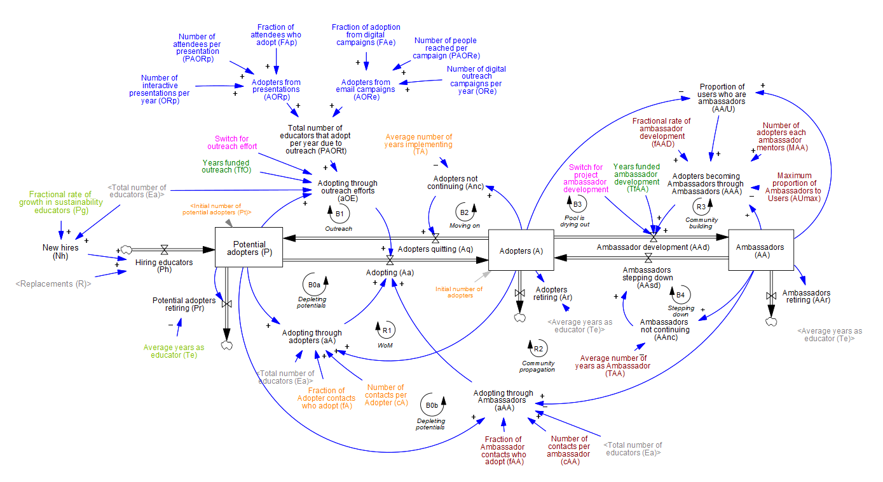
Extended Data Figure 1: Stock-flow diagram for the full model structure. Accumulations, or stocks, are shown as boxes. Flows are shown as pipes with valves, while information feedbacks are shown as blue arrows. Self-reinforcing feedback loops are marked ‘R,’ while balancing feedback loops are marked ‘B’. Signs (“+” or “-“) at arrowheads indicate the polarity of the causality: a “+”represents an increase in the independent parameter or variable causes the dependent variable to increase, ceteris paribus (and a decrease causes a decrease). Variables are shown in black. Parameters involved in word-of-mouth activities are shown in orange, those involved in outreach in dark blue, and those involved in community propagation in maroon. Switches to activate model structures are shown in pink and the time over how long the model subsections are active in dark green. Parameters involved in the growth in the field of sustainability are shown in light green and initial values of the stocks in light blue.
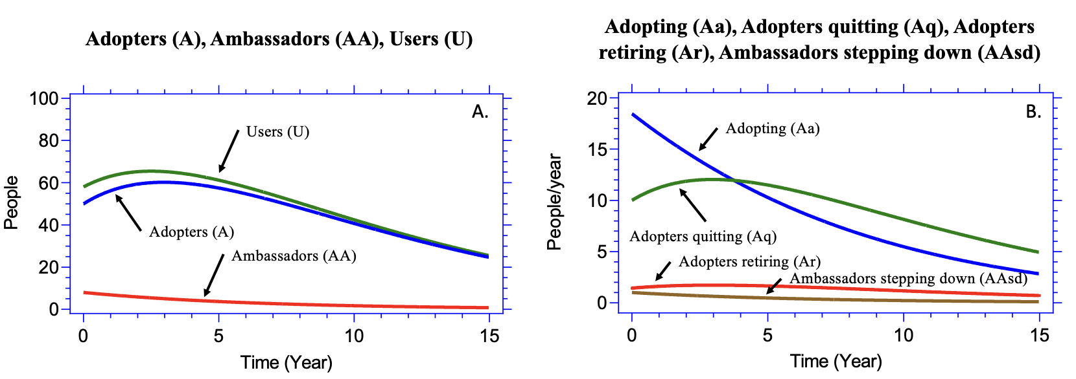
Extended Data Figure 2. Behavior over time for the base case scenario, with only word-of-mouth diffusion, over a time period of 15 years. Panel A: Adopters (A), Ambassadors (AA), and Users (U). Panel B: Inflows and outflows to Adopters (A).

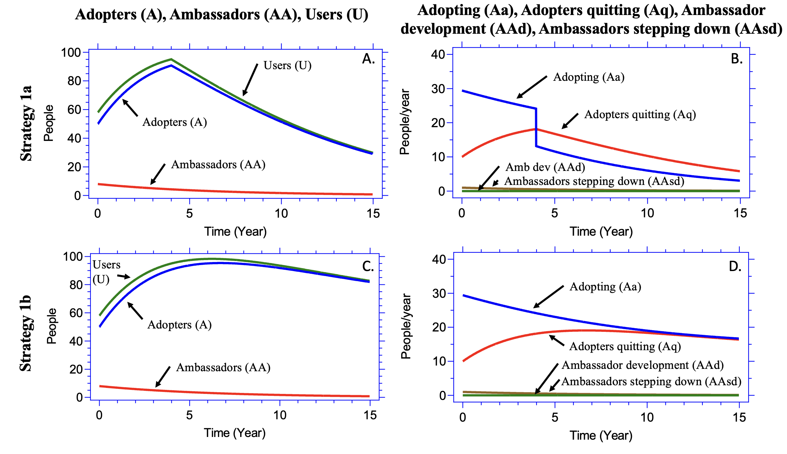
Extended Data Figure 3. Behavior over time for active outreach for four (Strategy 1a; panels A and B) and 15 years (Strategy 1b; panels C and D) over a period of 15 years. Stocks of adopters, ambassadors, and users are shown in panels A and C. Their corresponding inflows and outflows (adopting, adopters quitting, ambassador development, and ambassadors stepping down) are shown in panels B and D.

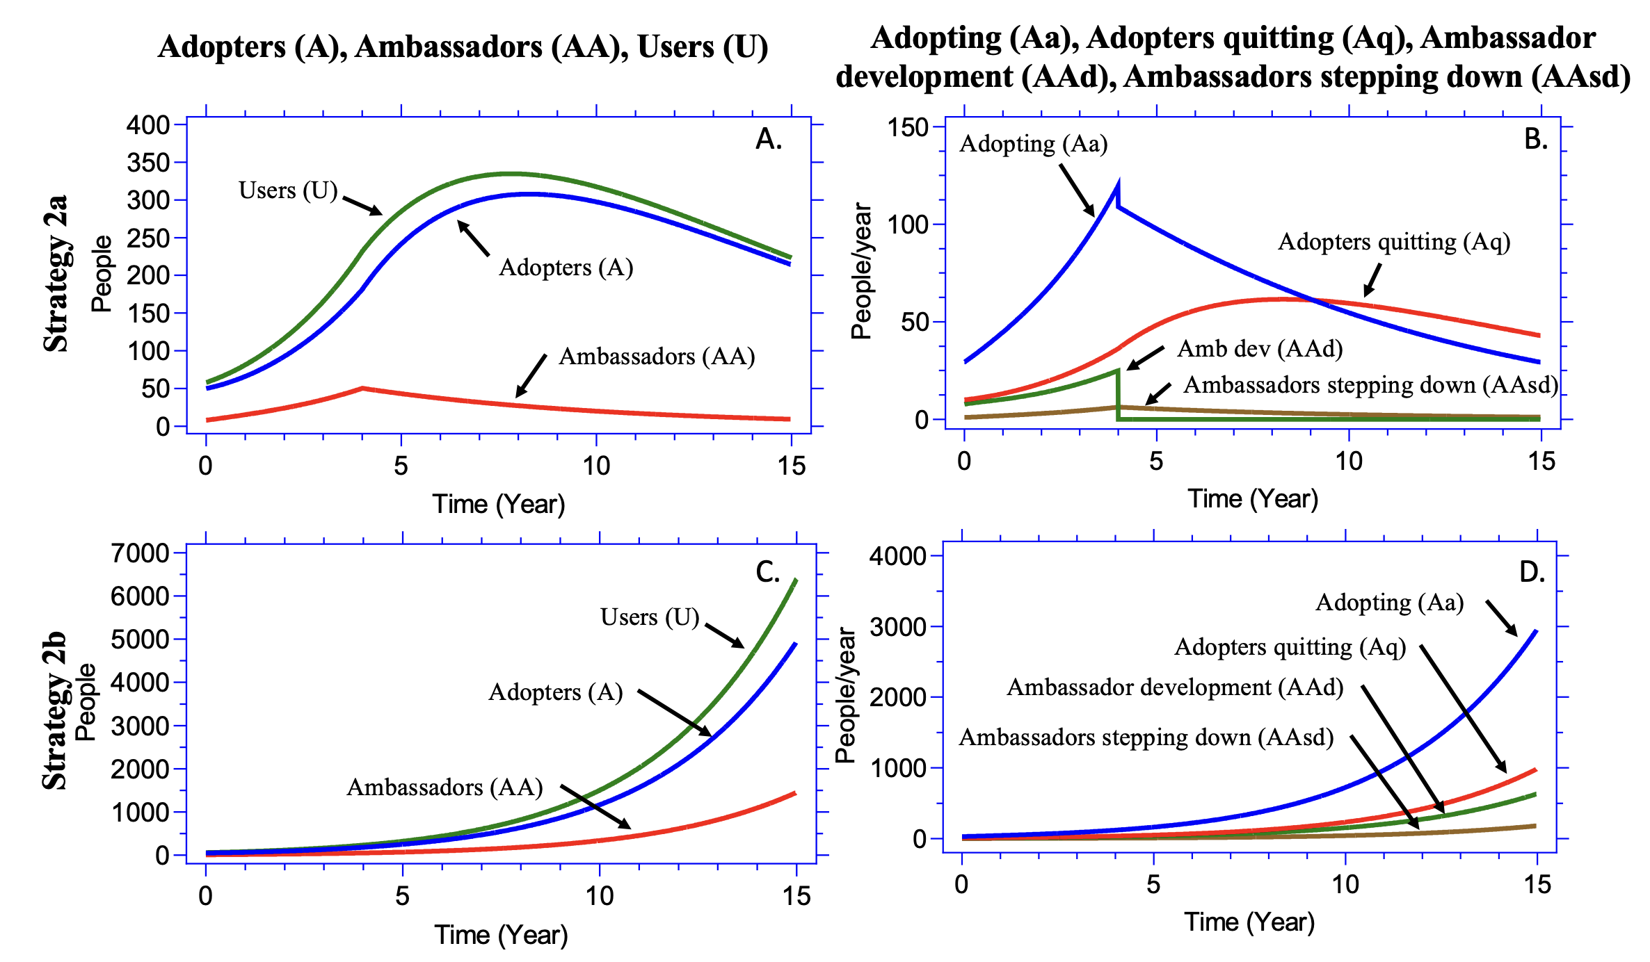
Extended Data Figure 4. Behavior over time for active community building with outreach that is funded for four (Strategy 2a; panels A and B) and 15 years (Strategy 2b; panels C and D) over a simulation period of 15 years. Stocks of adopters, ambassadors, and users are shown in panels A and C. Their corresponding inflows and outflows (adopting, adopters quitting, ambassador development, and ambassadors stepping down) are shown in panels B and D. Note the different scales for the stocks on the top and bottom left; and for the flows on the top and bottom right.

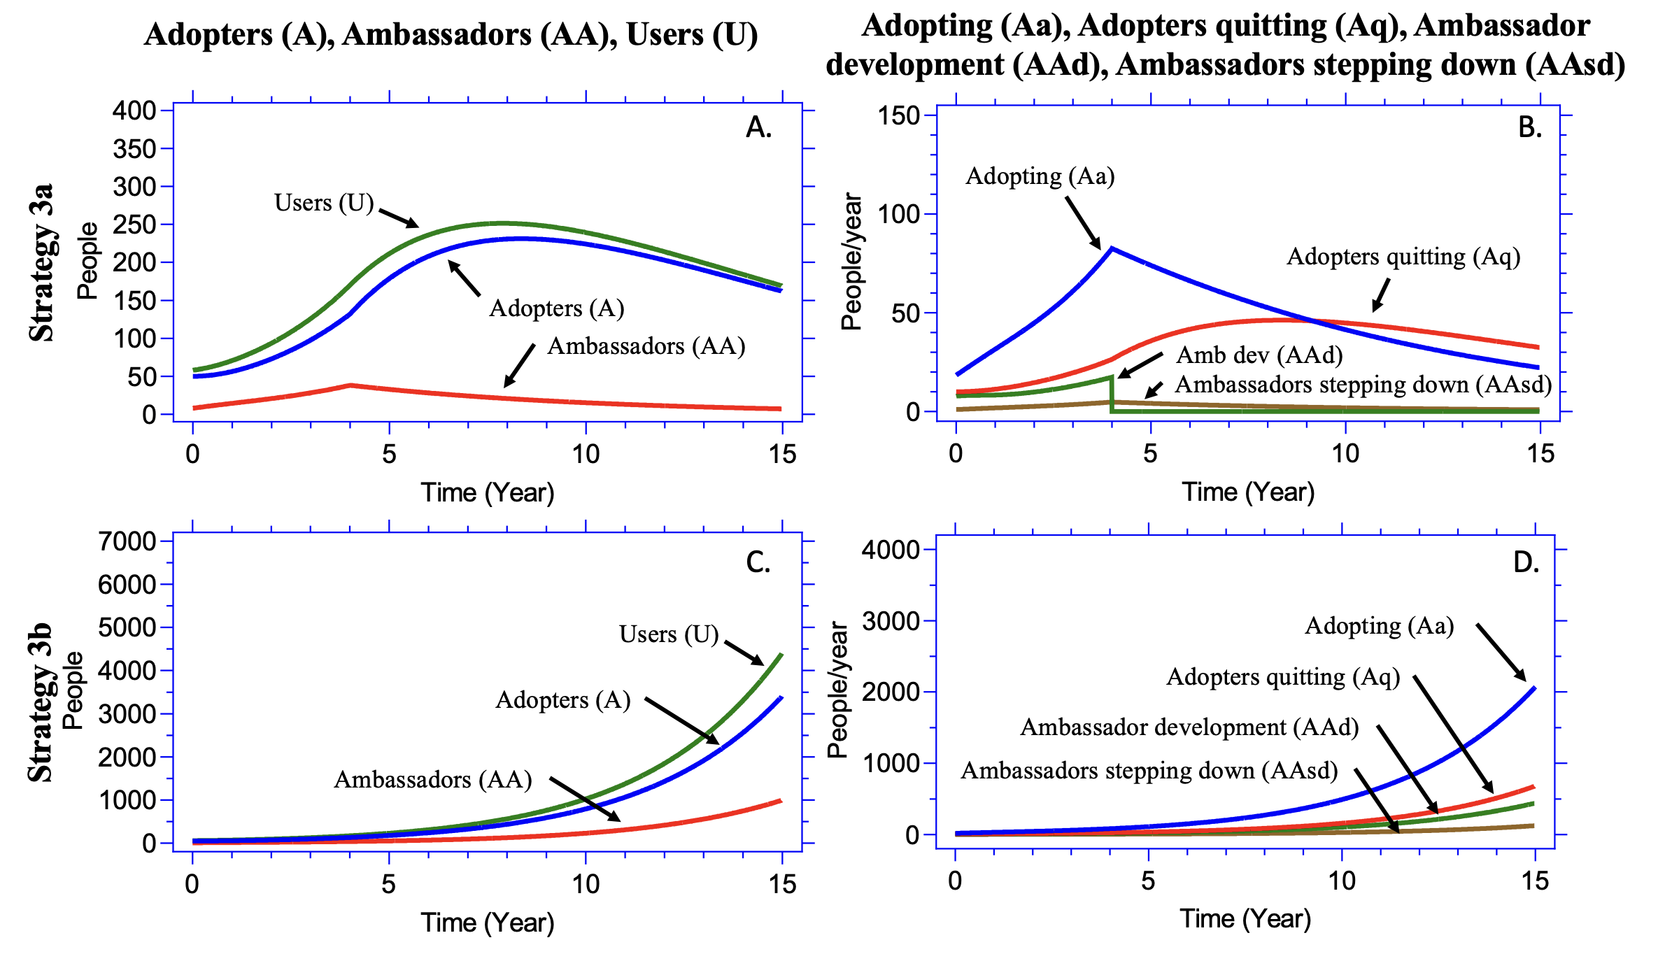
Extended Data Figure 5. Behavior over time for community building without outreach for four (Strategy 3a; panels A and B) and 15 years (Strategy 3b; panels C and D) over a simulation period of 15 years. Stocks of adopters, ambassadors, and users are shown in panels A and C. Their corresponding inflows and outflows (adopting, adopters quitting, ambassador development, and ambassadors stepping down) are shown in panels B and D. Note the different scales for the stocks on the top and bottom left; and for the flows on the top and bottom right.

