Supplementary Materials for

Optics miniaturization strategy for demanding Raman spectroscopy applications

Oleksii Ilchenko^{1,2}, Yurii Pilhun^{2,3}, Andrii Kutsyk^{2,3,4}, Denys Slobodianiuk^{3,4}, Yaman Goksel¹, Elodie Dumont¹, Lukas Vaut¹, Chiara Mazzoni¹, Lidia Morelli¹, Tomas Rindzevicius¹, Thomas Emil Andersen⁶, Mikael Lassen⁷, Hemanshu Mundhada⁸, Christian Bille Jendresen⁸, Peter Alshede Philipsen⁹, Merete Hædersdal⁹, Anja Boisen¹

¹Technical University of Denmark, Department of Health Technology, Center for Intelligent Drug Delivery and Sensing Using Microcontainers and Nanomechanics, Kgs. Lyngby 2800, Denmark
²Lightnovo ApS, Birkerød 3460, Denmark
³Taras Shevchenko National University of Kyiv, Kyiv 01601, Ukraine
⁴Institute of Magnetism, Kyiv 03142, Ukraine
⁵Technical University of Denmark, Department of Energy Conversion and Storage, Kgs. Lyngby 2800, Denmark
⁶ Department of Clinical Microbiology, Odense University Hospital and Research Unit for Clinical Microbiology, University of Southern Denmark, Odense, Denmark
⁷ Danish Fundamental Metrology, Hørsholm 2970, Denmark
⁸Cysbio ApS, Hørsholm 2970, Denmark
⁹Department of Dermatology, Copenhagen University Hospital, Copenhagen 2400, Denmark

Correspondence to: olil@dtu.dk

This PDF file includes:

Supplementary Text
Figs. S1 to S28
Tables S1 to S5
Captions for Movie S1
Captions for Data S1 to S7
References

Supplementary Text

S1 “Mode hop” deconvolution.
Blurred signal can be written as convolution of PSF and real (ideal) signal:
$$\begin{aligned}\tilde{f}\left(x\right)=\int_{-∞}^{∞}{psf\left(x-χ\right)f\left(χ\right)dχ=psf}*f\#\left(1\right)\end{aligned}$$
In matrix form
$$\begin{aligned}\tilde{f}={\hat{A}}_{psf}f={\hat{A}}_{f}⋅psf\#\left(2\right)\end{aligned}$$
The above equation represents symmetry properties of convolution. It allows us to estimate PSF using ideal and blurred signals. The obtained PSF can be used for the deblurring of measured signals.
Since measured blurred signal contains noise, the solution should be found in sense of least squares.
The PSF estimation problem can be rewritten as classical least squares problem:
$$\begin{aligned}psf={{\text{argmin}}_{\text{x}}\left\|\text{y}\text{-}\hat{\text{A}}\text{x}\right\|}_{2}^{2}\#\left(3\right)\end{aligned}$$
To constrain result to be non-negative, NNLS should be used:
$$\begin{aligned}psf={{\text{argmin}}_{\text{x}}\left\|\text{y}\text{-}\hat{\text{A}}\text{x}\right\|}_{2}^{2}subject to \text{x}≥0\#\left(4\right)\end{aligned}$$
These problems are ill-posed and regularization steps are required. We considered several types of regularization¹:
- L1 regularization
$$\begin{aligned}psf={{\text{argmin}}_{\text{x}}\left\|\text{y}\text{-}\hat{\text{A}}\text{x}\right\|}_{2}^{2}+{λ^{2} \left\|\text{x}\right\|}_{1}^{2}\#\left(5\right)\end{aligned}$$
- L2 regularization (robust regression)
$$\begin{aligned}psf={{\text{argmin}}_{\text{x}}\left\|\text{y}\text{-}\hat{\text{A}}\text{x}\right\|}_{2}^{2}+{λ^{2} \left\|\text{x}\right\|}_{2}^{2}\#\left(6\right)\end{aligned}$$
- L2 smooth regularization
$$\begin{aligned}psf={{\text{argmin}}_{\text{x}}\left\|\text{y}\text{-}\hat{\text{A}}\text{x}\right\|}_{2}^{2}+{λ^{2}\left\|{\hat{\text{D}}}_{2}\text{x}\right\|}_{2}^{2}\#\left(7\right)\end{aligned}$$
Here ${\hat{\text{D}}}_{2}$ is a second derivative matrix.
When the ‘ideal’ reference channel spectrum is available, the ‘mod hop’ deconvolution algorithm is the following:
- Considering the reference channel spectrum at each step as blurred one, we can obtain PSF using the ‘ideal’ reference spectrum.
- Data channel spectrum is deblurred using the obtained PSF.
We used the same value of the regularization parameter $λ=0.1$. As the example, the ‘ideal’ reference channel spectrum (Fig. S2) and blurred reference channel spectrum (Fig. S3) were used to estimate the PSF (Fig. S4). The deblurred data channel spectrum is shown in Fig. S5. We used different techniques of regularization. The best result is obtained for L2 smooth regularization (Eq. 7)
The same procedure were applied to the time map (Fig. S6).

S2. Spectral deblurring

Diamond peak at 1332 cm⁻¹ (Fig. S7) was used as for the estimation of PSF. Raman spectrum of diamond was baseline corrected using asymmetrical least squares² (Fig. S8). Parameters used for baseline estimation is the following: $λ={10}^{4},p=0.001$. The obtained PSF is shown in Fig. S9.
We used L2 nonnegative regularization (Eq. 6). FISTA algorithm implemented in IRTools³ was used to solve this problem. Raman spectrum of toluene was used to test this deconvolution approach (Fig. S10). Background was estimated using asymmetric least squares with $λ={10}^{5},p=0.001$. The obtained results are shown in Fig. S11. It worth to be noted that background correction is a crucial step. Otherwise, additional artefacts might occur. As it can be seen from the Fig. S12, such approach allows increasing spectral resolution in 1.5 times.

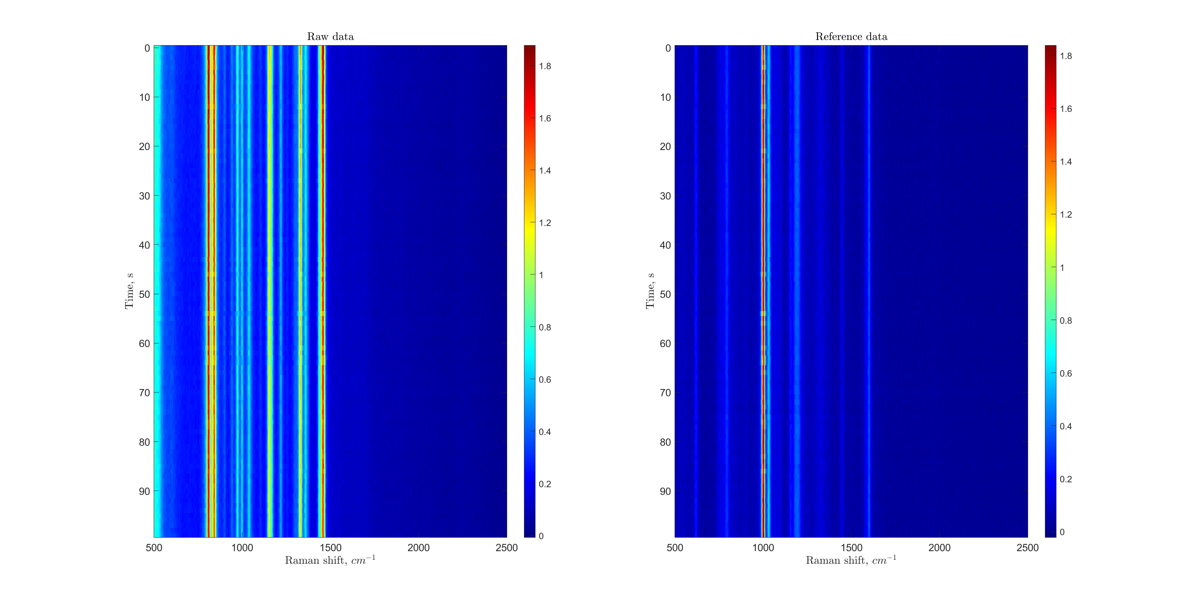
Fig. S1. Raw data and reference spectra.

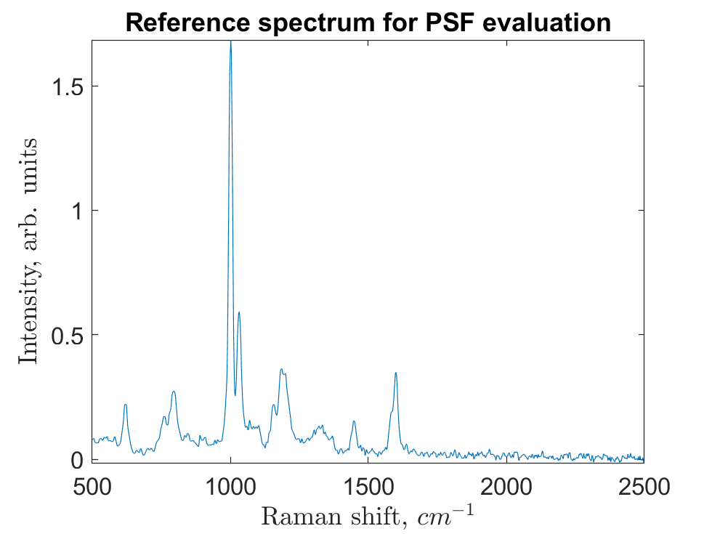
Fig. S2. Reference channel spectrum used as ideal.

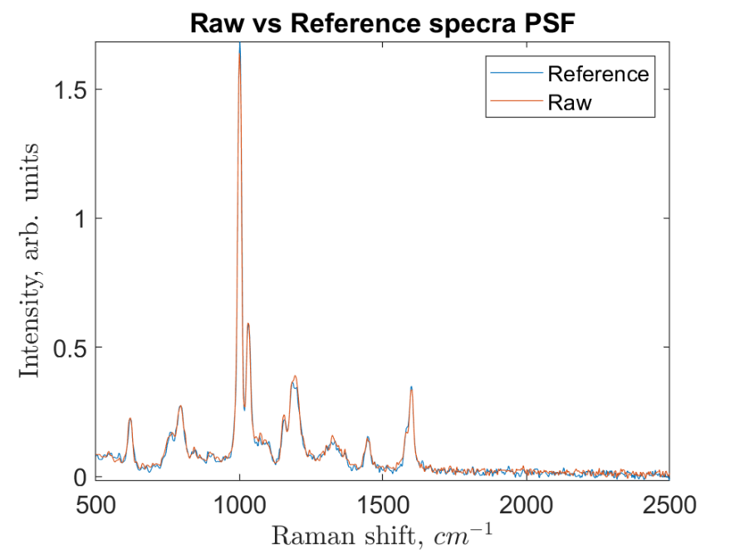

Fig. S3. ‘Raw’ and ‘ideal’ reference channel spectra
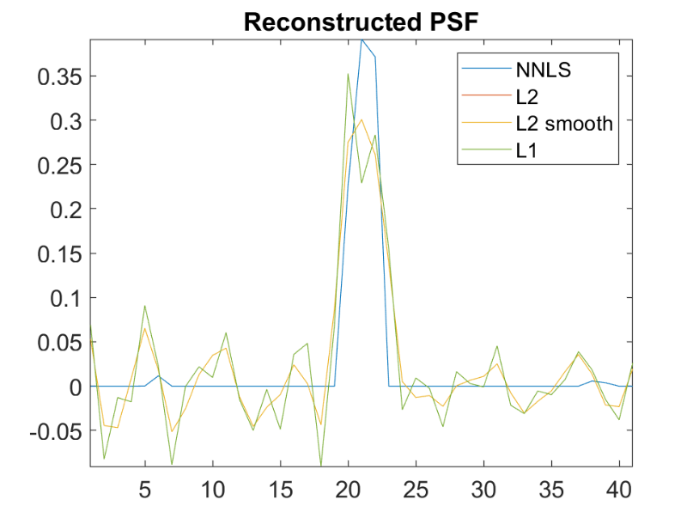
Fig.S4. The estimated PSF.
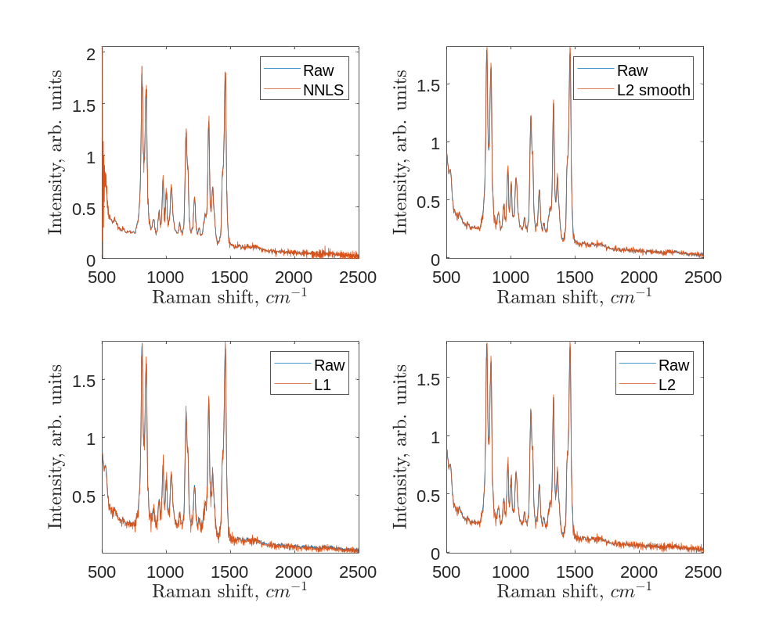
Fig. S5. Deblurred vs. Raw data channel spectra

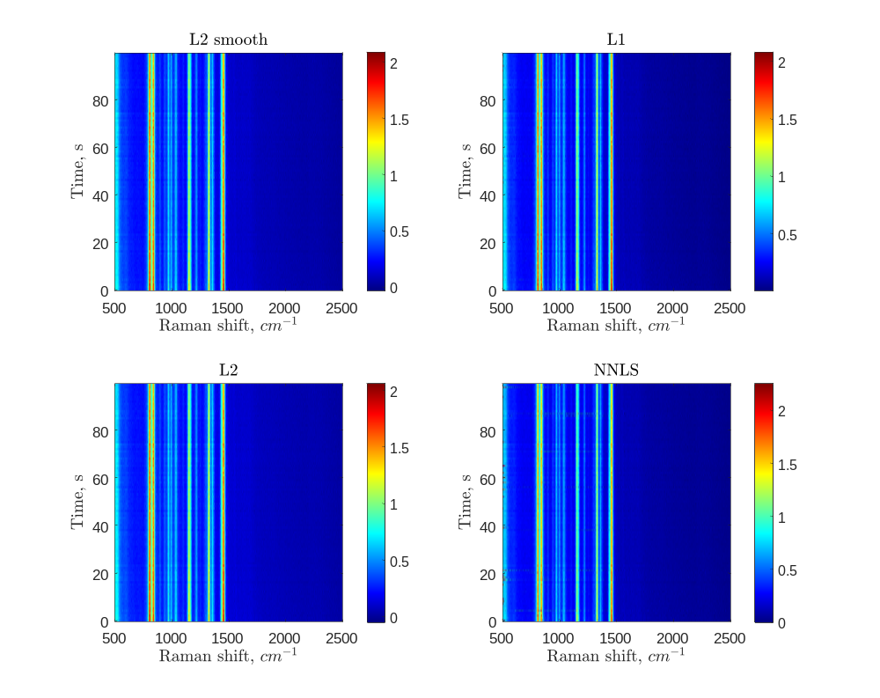
Fig. S6. Deblurred time maps
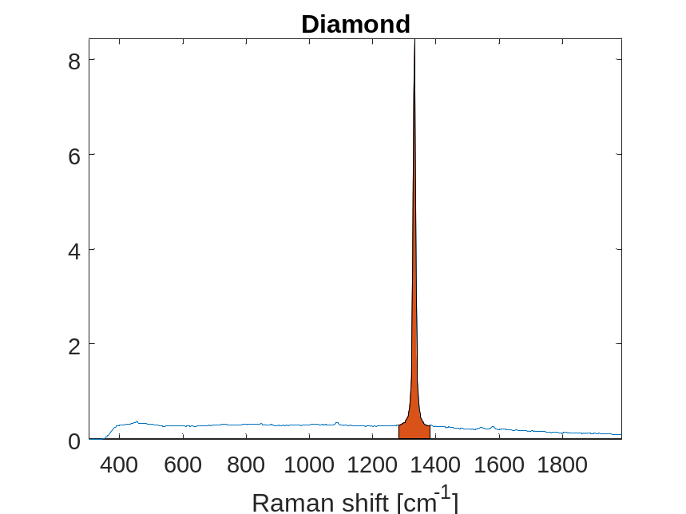
Fig. S7. Raman spectrum of diamond. The highlighted area is used for the PSF estimation.
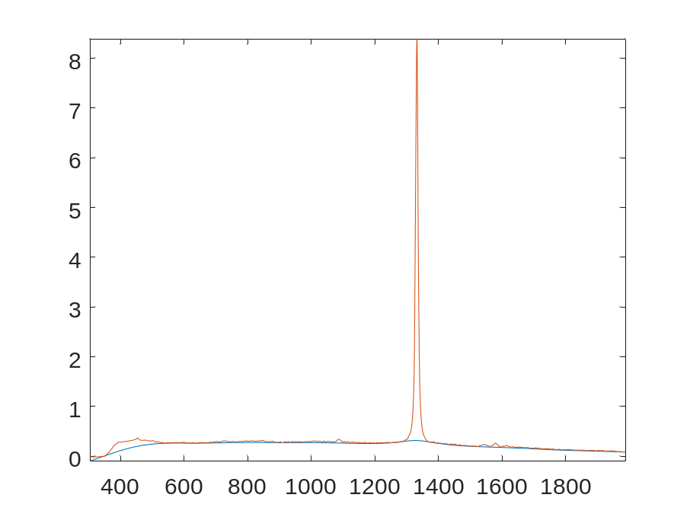
Fig. S8. The calculated baseline.
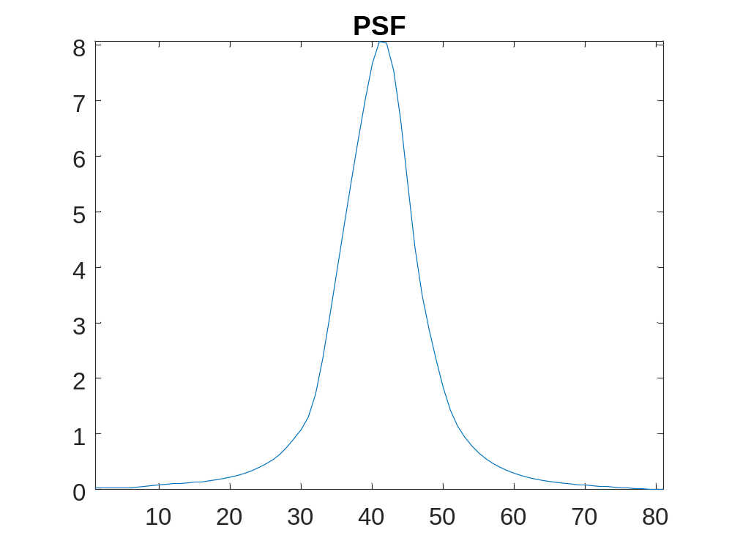
Fig. S9. The estimated PSF.

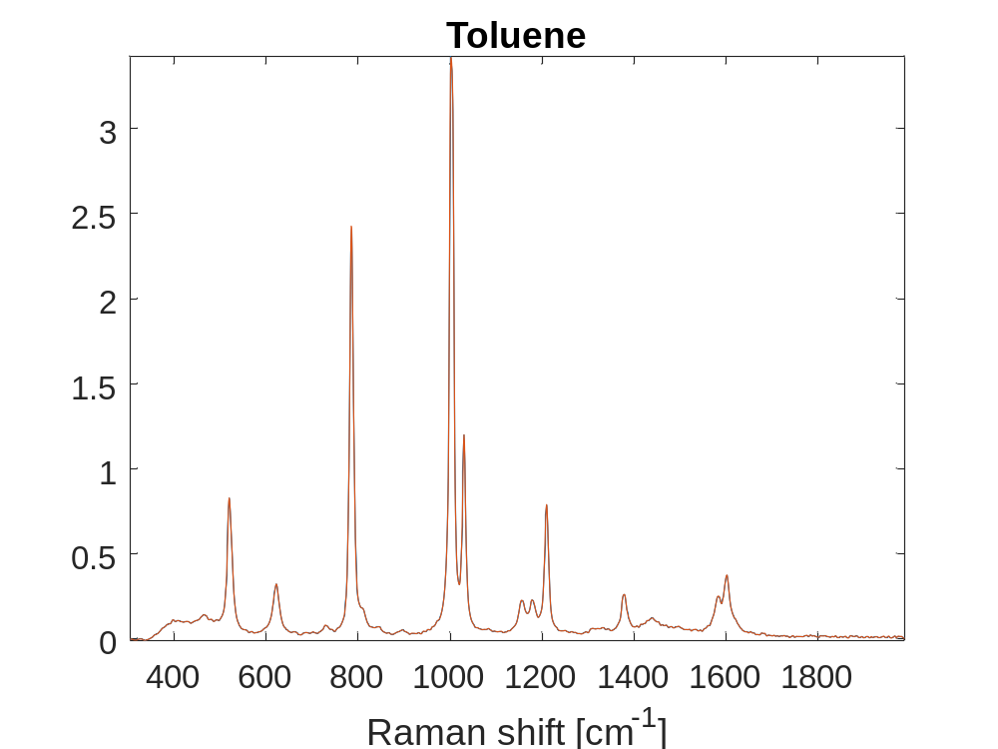
Fig. S10. Raman spectrum of toluene
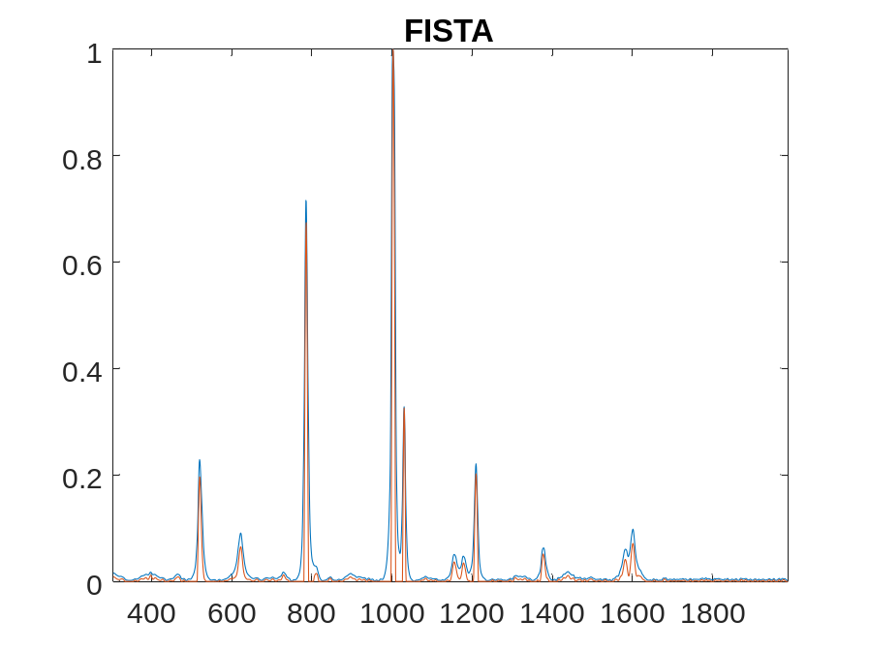
Fig.S11. Raw and deblurred spectra of toluene.
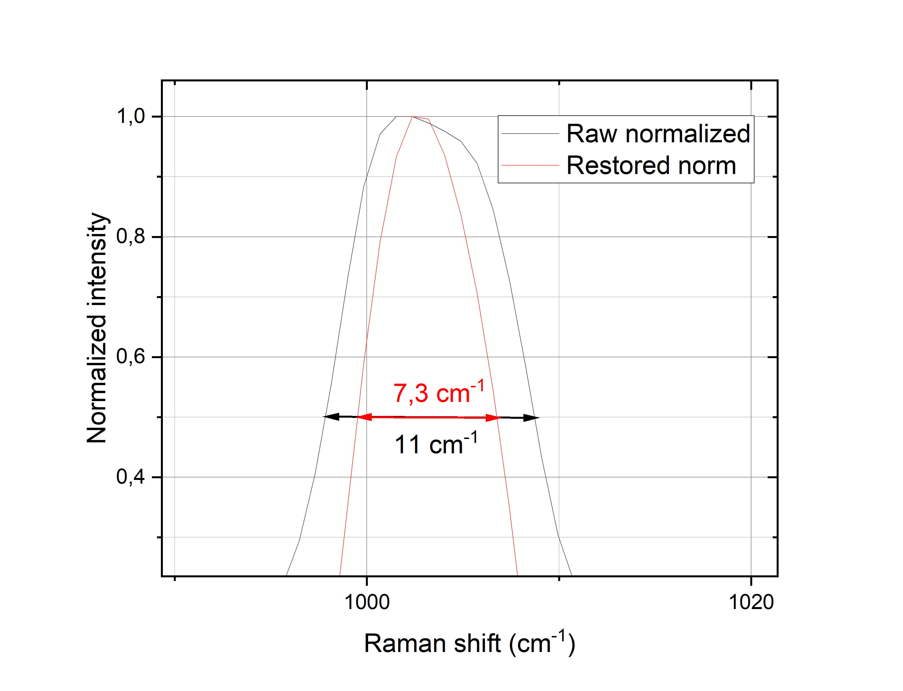
Fig. S12. Peak width at half height for the raw and deblurred spectra. They were peak height normalized.

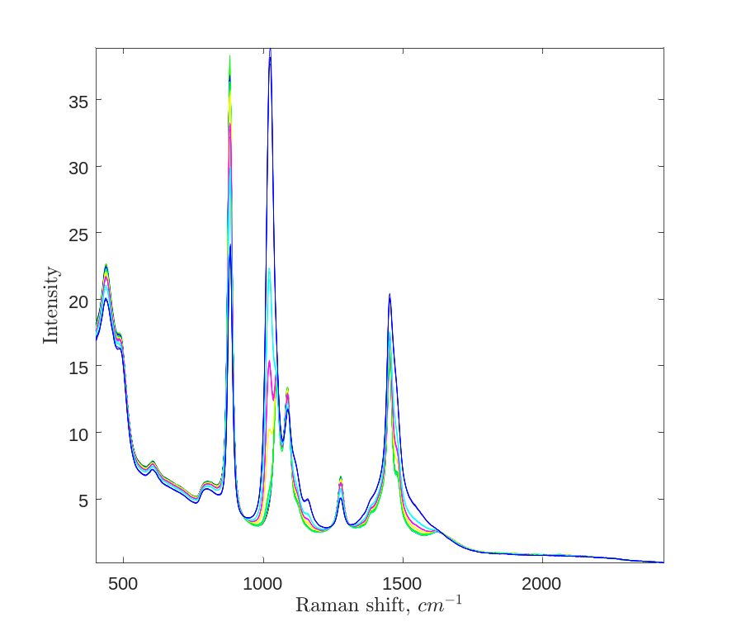
Fig. S13. Raman spectra of water ethanol solution with different concentration of methanol. Data obtained at laser excitation 785nm.

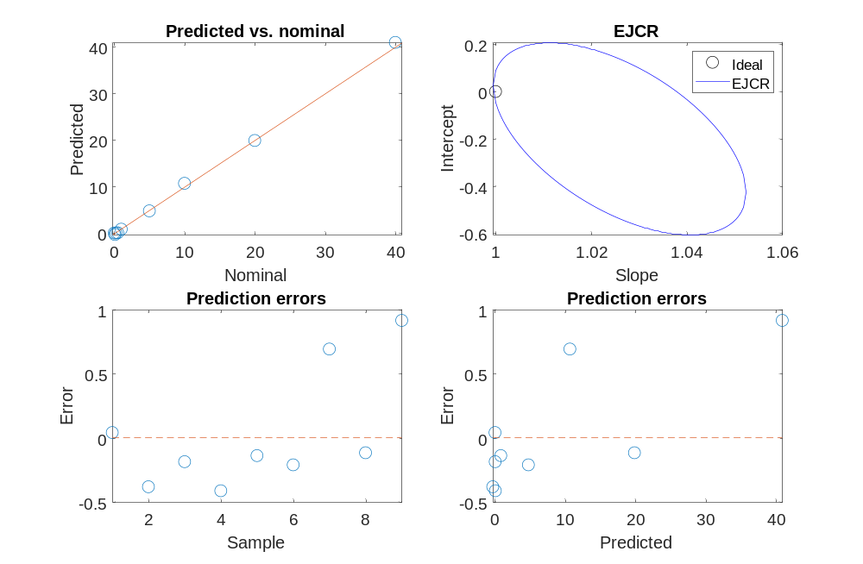
Fig. S14. Methanol quantification results obtained from laser excitation 785nm. Methanol detection was performed by PLS regression using MVC1 toolbox^{4,5}.

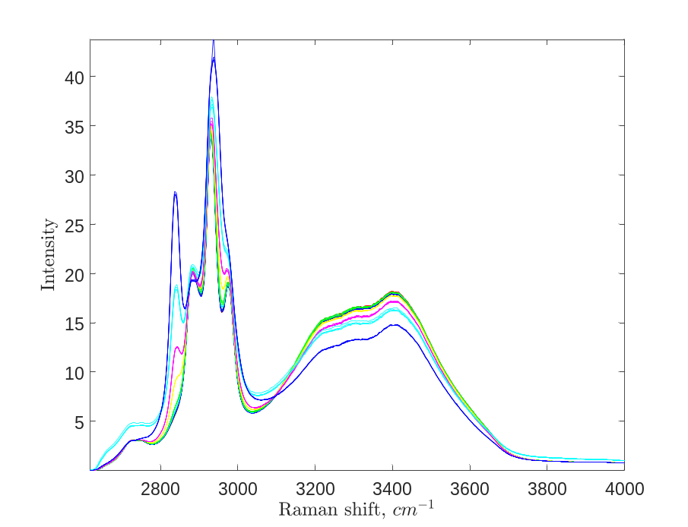

Fig. S15. Raman spectra of water ethanol solution with different concentration of methanol. Data obtained at laser excitation 675nm.

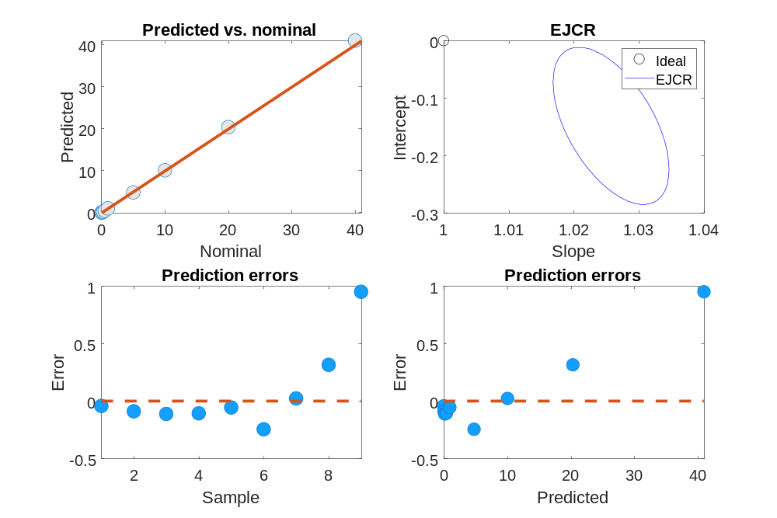

Fig. S16. Methanol quantification results obtained from laser excitation 675nm. Methanol detection was performed by PLS regression using MVC1 toolbox^{4,5}.

Fig. S17. PLS calibration based on Raman data for liquid samples of pHCA diluted in PBS

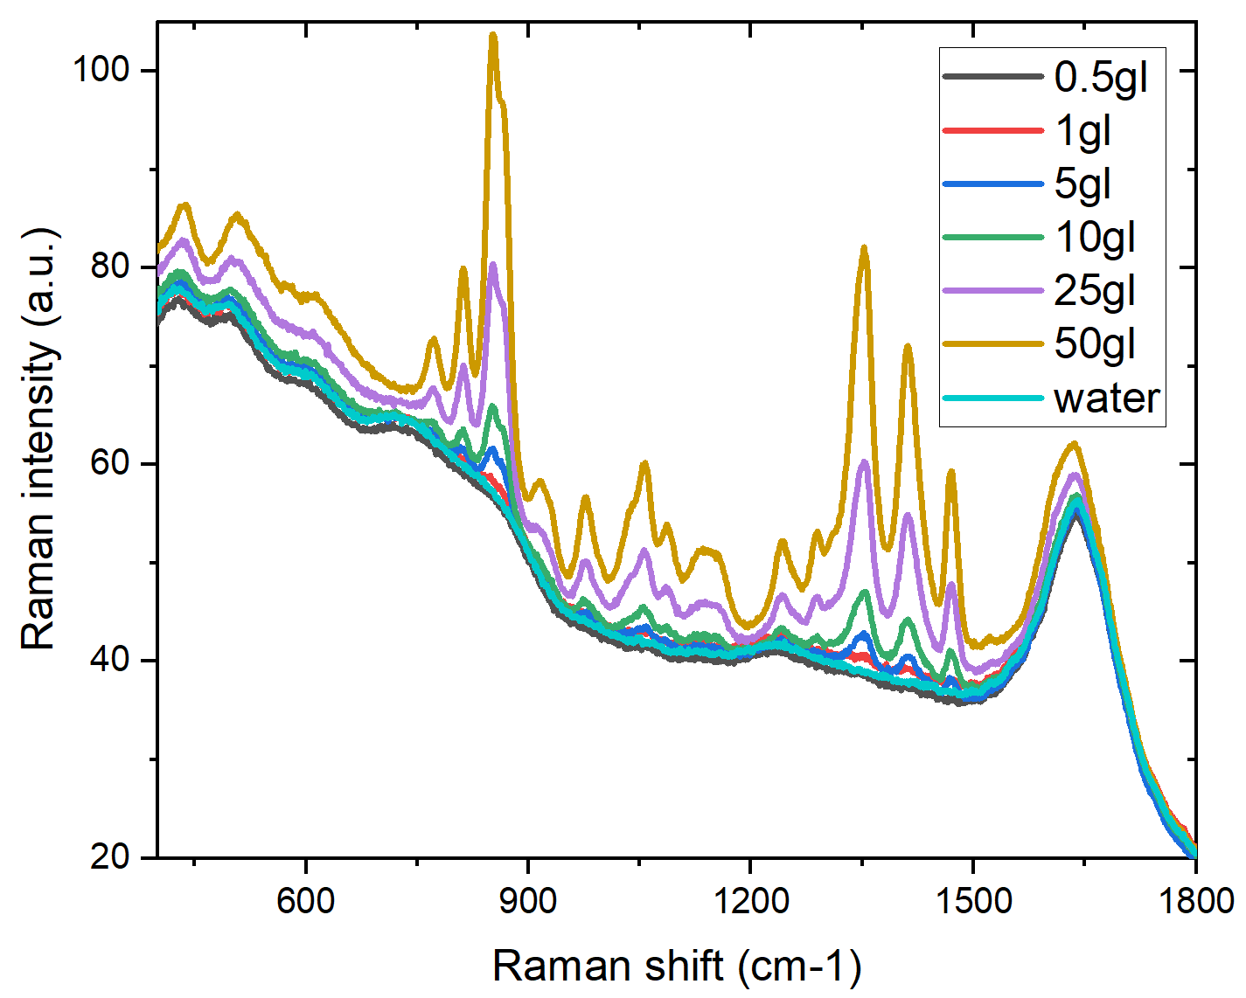
Fig. S18. Raman spectra of the different concentrations of Serine diluted in PBS

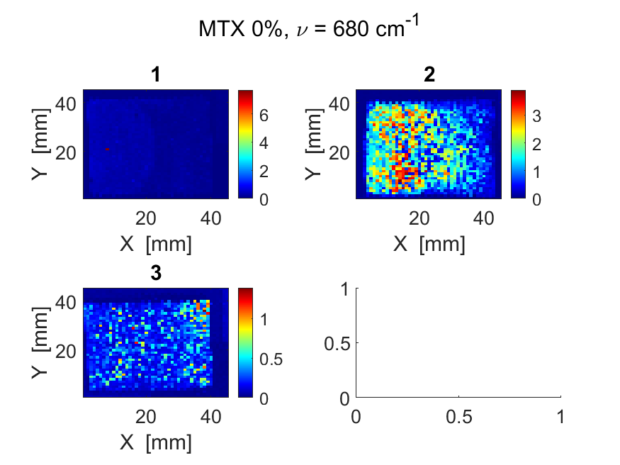 | 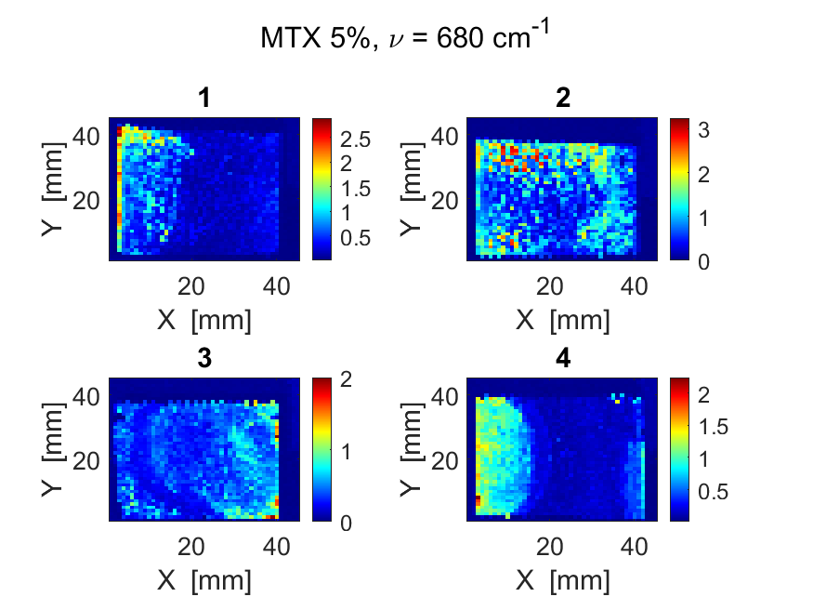
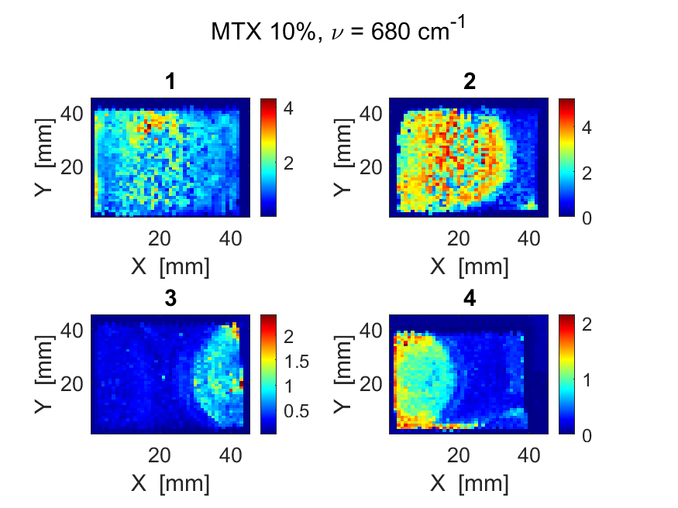 | 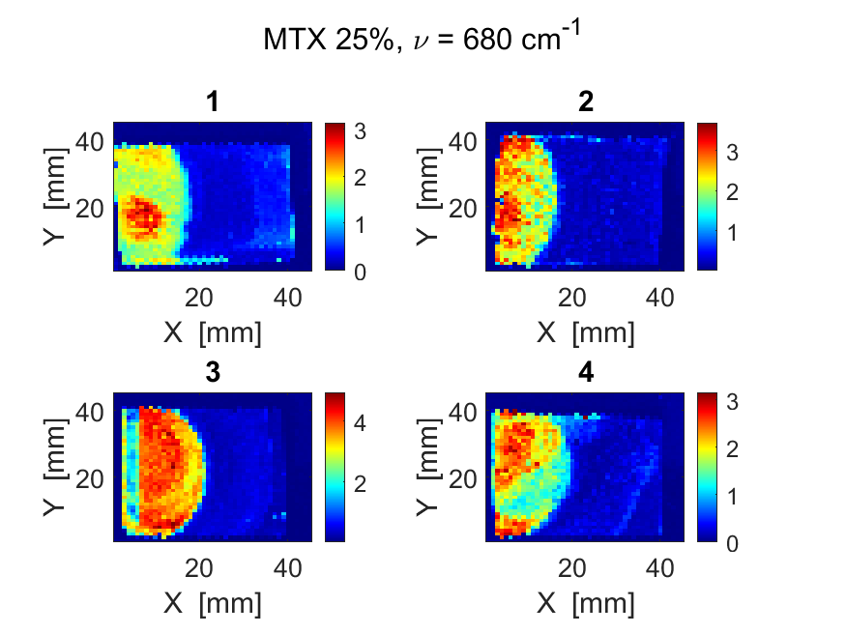
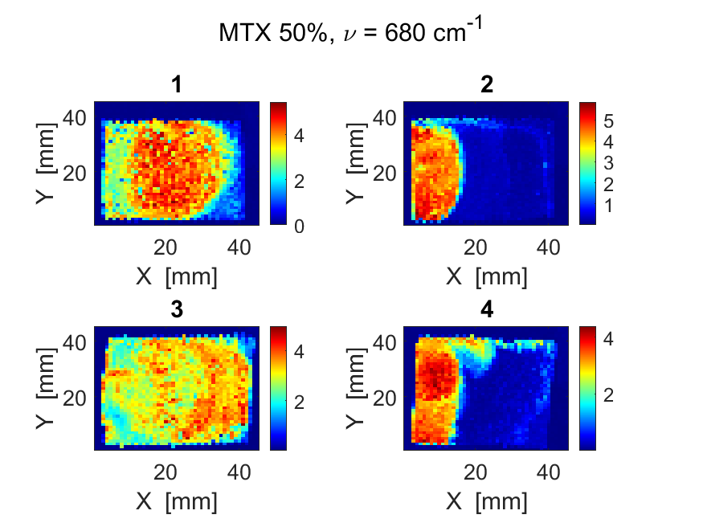 | 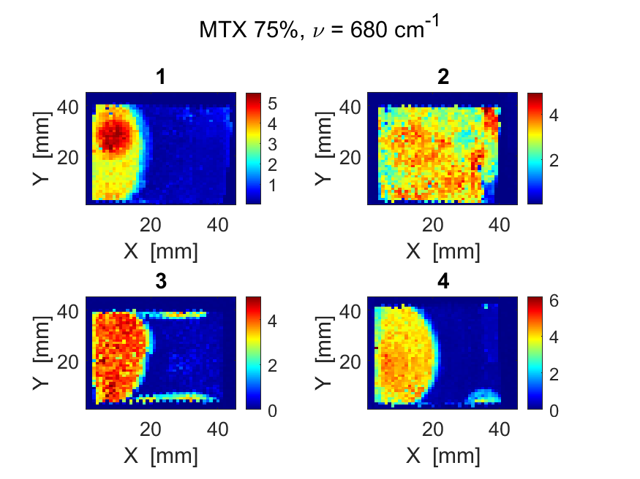
Fig. S19. Peak intensity spatial distribution of MTX

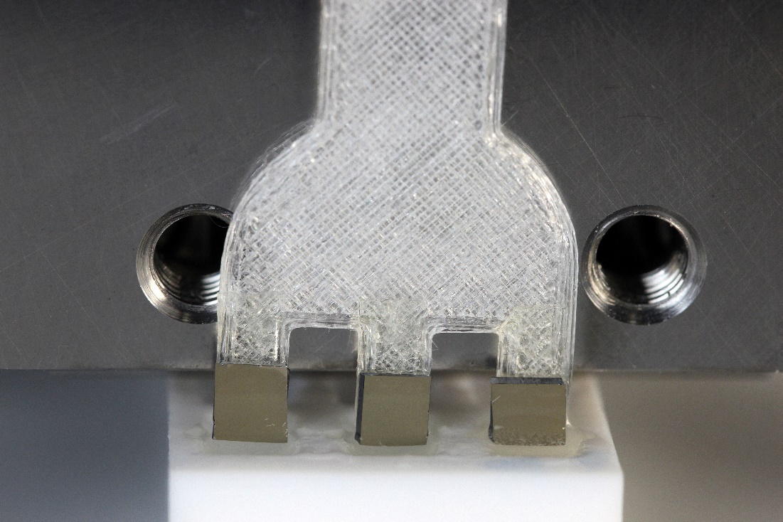
Fig. S20. Photograph of silver coated NP SERS chips inserted into solution with MTX.

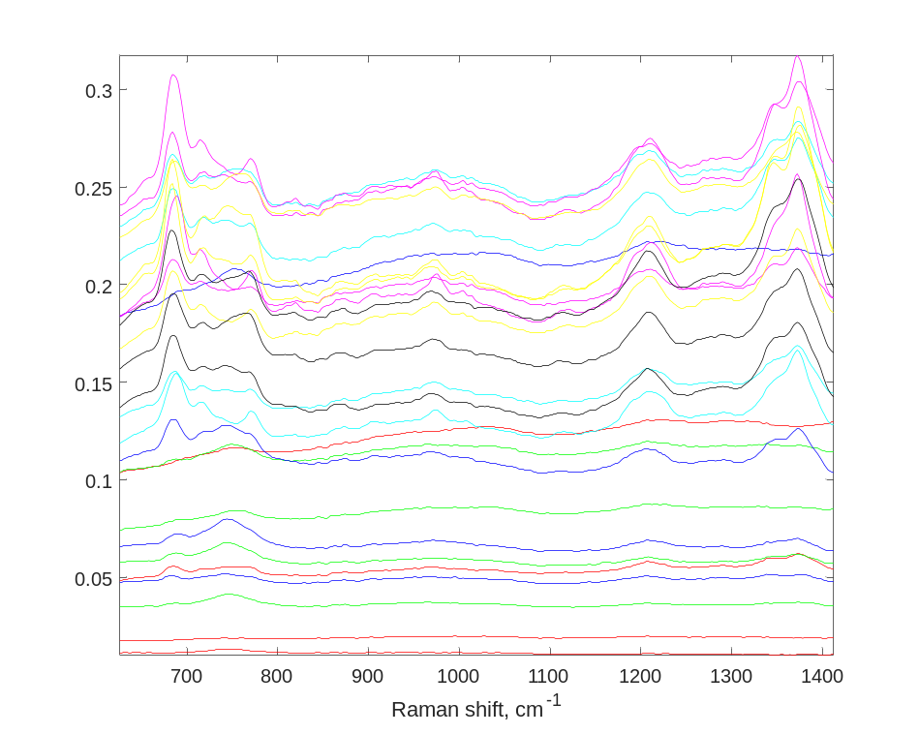
Fig. S21. Map averaged MTX spectra.
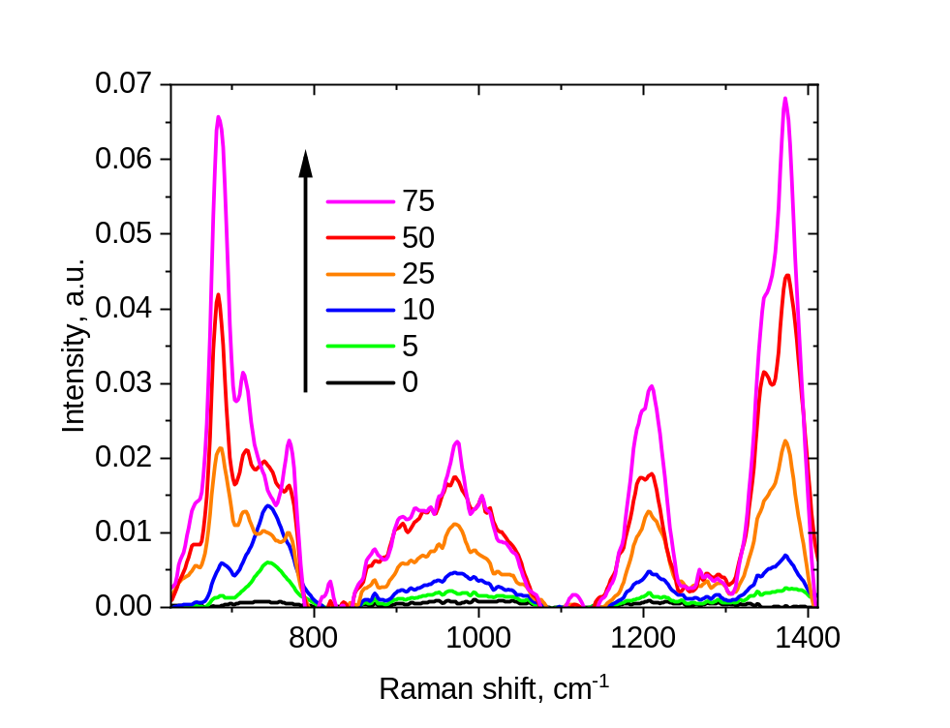
Fig. S22. Background corrected spectra. Background was eliminated using asymmetrical least squares with $λ={10}^{5},p=0.01$ with further mean-centering. Spectral range 626-1412 cm⁻¹ was used for calibration.

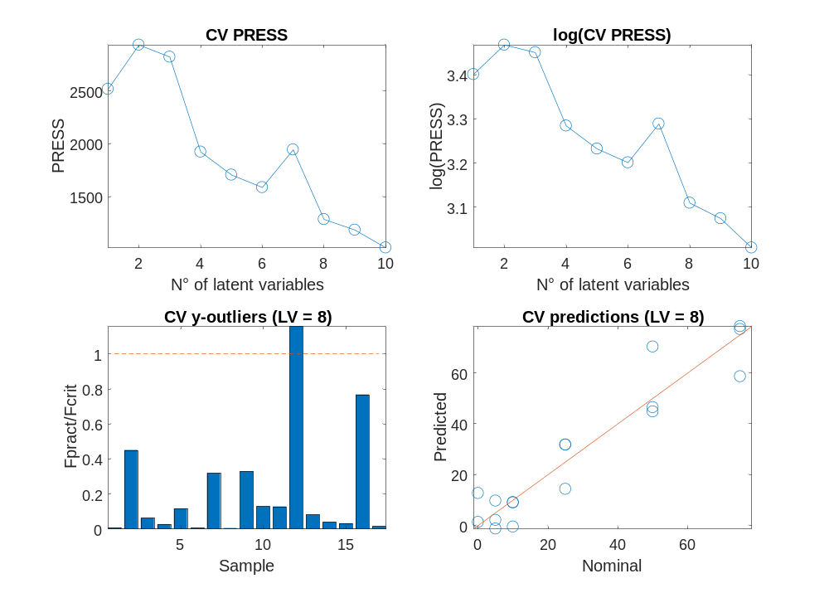
Fig. S23. MTX PLS calibration results. Analysis was performed by PLS regression using MVC1 toolbox^{4,5}.
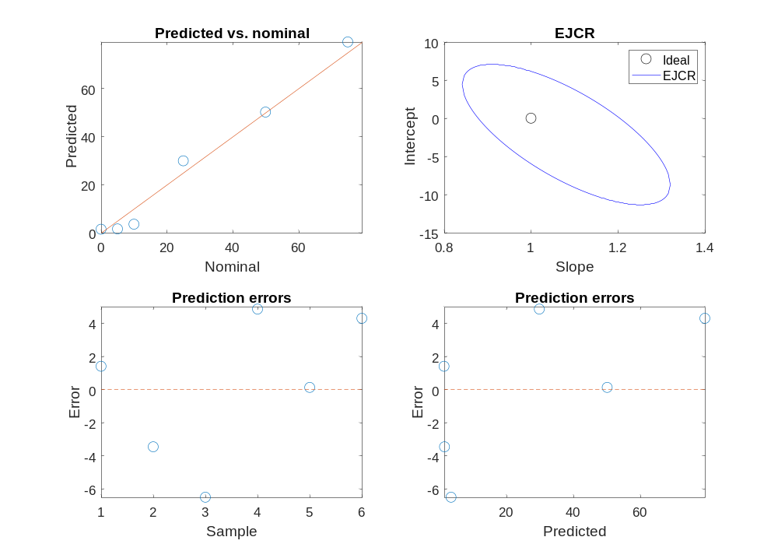
Fig. S24. MTX. PLS validaiton results. Analysis was performed by PLS regression using MVC1 toolbox^{4,5}.

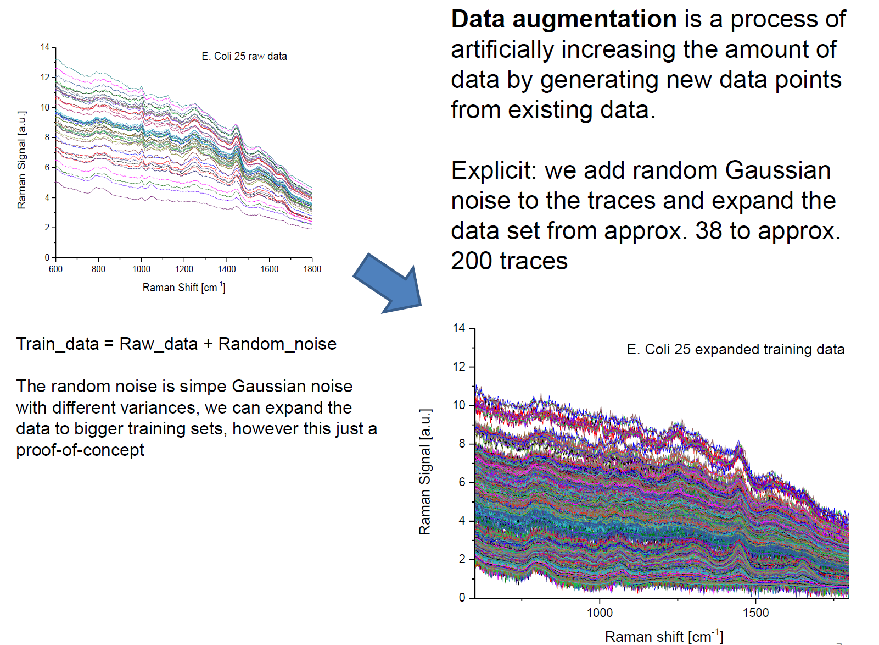
Fig. S25. ML of bacteria data

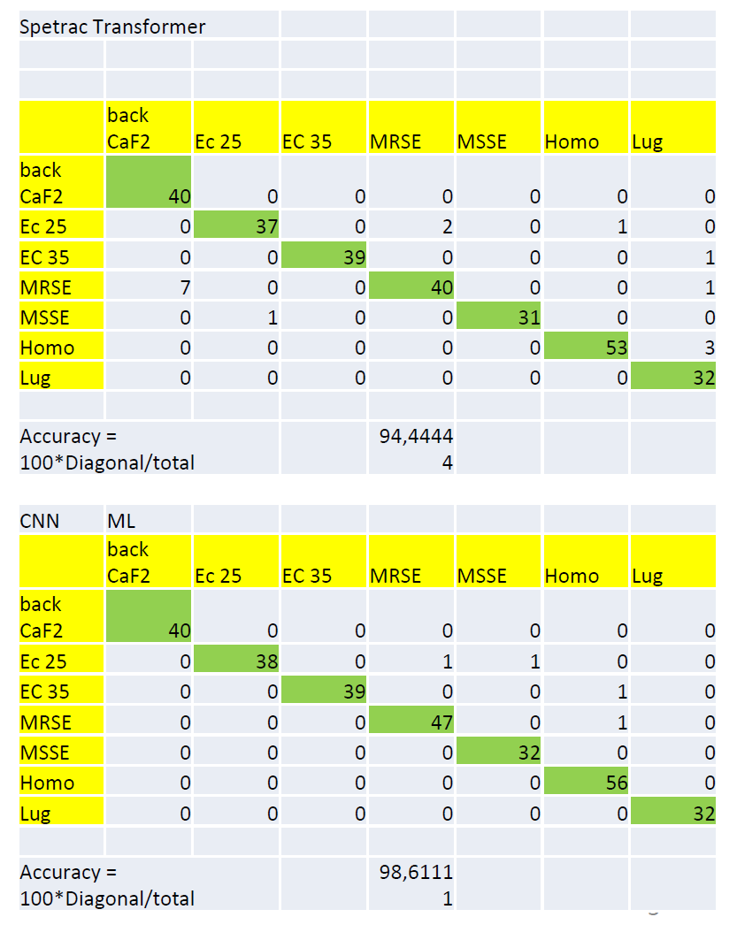
Fig. S26. ML of bacteria data

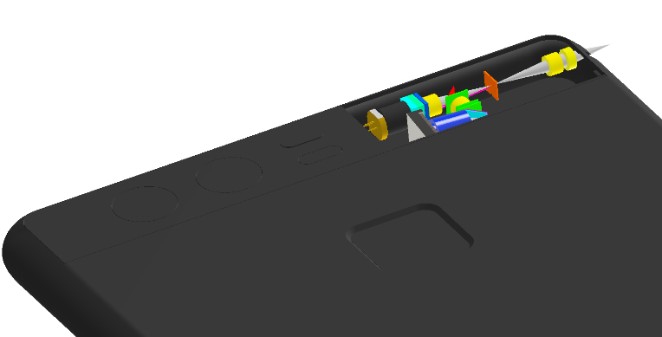
Fig. S27. The optomechanical design of miniaturized Raman spectrometer with spectral resolution 18cm-1 in the range 400-2000cm-1 operated from laser wavelength 785nm.

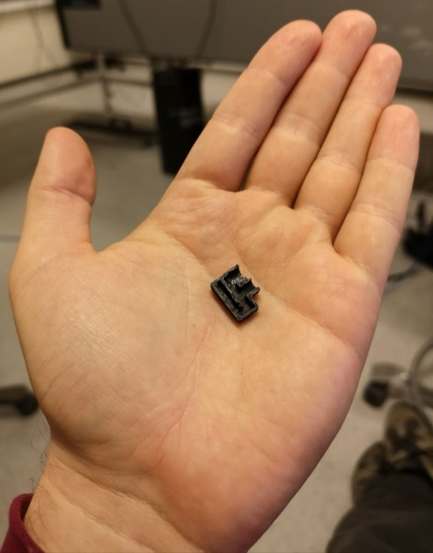
Fig. S28. Photograph of the prototype of miniaturized Raman spectrometer with spectral resolution 18cm-1 in the range 400-2000cm-1 operated from laser wavelength 785nm.

Tables

Table S1. Methanol quantification from 785nm

Parameter | Value
RMSECV | 0.511
RMSEP | 0.4411
R² prediction | 0.998
LOD min | 0.2746
LOD max | 0.7739
LOQ min | 0.8238
LOQ max | 2.3217

Table S2. Methanol quantification from 675nm

Parameter | Value
RMSECV | 0.1
RMSEP | 0.4411
R² prediction | 1.0
LOD min
  0.0711
LOD max
  0.1607
LOQ min | 0.2134
LOQ max | 0.4822

Table S3. pHCA calibration Raman
pHCA concentration (µM) | 1 | 2 |  | average | std dev
1000 | 47.2105 | 47.2451 |  | 47.2278 | 0.024466
500 | 24.4478 | 24.402 |  | 24.4249 | 0.032385
250 | 12.546 | 12.5231 |  | 12.53455 | 0.016193
125 | 6.278 | 6.2729 |  | 6.27545 | 0.003606
62.5 | 3.10259 | 3.102102 |  | 3.102346 | 0.000345
31.25 | 1.6234 | 1.6227 |  | 1.62305 | 0.000495

Table S4. Serine calibration Raman

g/L | Intensity | Intensity | Intensity
50 | 102 | 103 | 105
25 | 56 | 55.5 | 56
12.5 | 28 | 29 | 28.5
6.25 | 16 | 17 | 16.8
1 | 5 | 5.8 | 5.3

Table S5. MTX quantification by SERS

RMSECV | 8.7
RMSEP | 4.0475
R2 pred | 0.9931
LOD min | 2.9842
LOD max | 6.875
LOQ min | 8.9527
LOQ max | 20.6251

References
- Eilers, P. H. C. Penalties in Chemometrics. in Encyclopedia of Analytical Chemistry 1–12 (Wiley, 2020). doi:10.1002/9780470027318.a9658.
- Eilers, P. H. C. & Boelens, H. F. M. Baseline Correction with Asymmetric Least Squares Smoothing. https://zanran_storage.s3.amazonaws.com/www.science.uva.nl/ContentPages/443199618.pdf (2005).
- Gazzola, S., Hansen, P. C. & Nagy, J. G. IR Tools: a MATLAB package of iterative regularization methods and large-scale test problems. Numer Algorithms 81, 773–811 (2019).
- Olivieri, A. C., Goicoechea, H. C. & Iñón, F. A. MVC1: An integrated MatLab toolbox for first-order multivariate calibration. Chemometrics and Intelligent Laboratory Systems 73, 189–197 (2004).
- Olivieri, A. & Olivieri, A. C. Introduction to Multivariate Calibration A Practical Approach Introduction to Multivariate Calibration Introduction to Multivariate Calibration.

Movie S1.
Demonstration of SORS performance in experiment of measuring whiskey content through the glass bottle

Data S1.
Kinetic Raman experiments that demonstrate real-time calibration based on reference channel for laser excitation wavelengths 675 and 785nm.

Data S2.
Quantification of methanol in water-ethanol solution

Data S3.
Raman spectra and PLS quantification of pHCA, Glucose and salts

Data S4.
Raman spectra and PLS quantification of Serine

Data S5.
Raman spectra of human skin.

Data S6.
SERS spectra, calibration and validation data for MTX quantification.

Data S7.
Raw Raman spectra of bacteria obtained via Raman mapping

