Fig. AF1: Propensity Score Distribution and Common Support for Propensity Score Estimation
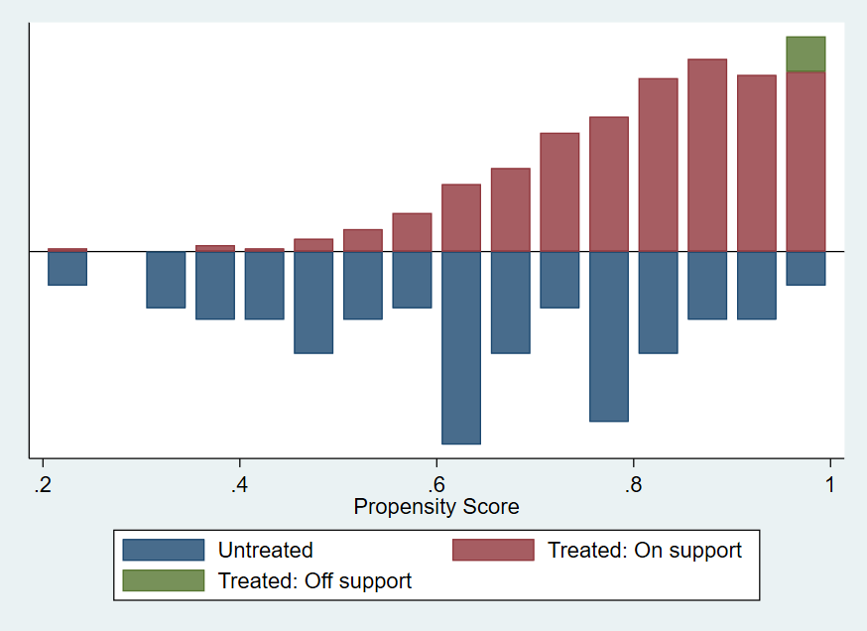
Note: ‘‘Treated: on support’’ indicates the observations in the participant group that have a suitable comparison.
‘‘Treated: off support’’ indicates the observations in the participant group that do not have a suitable comparison.

