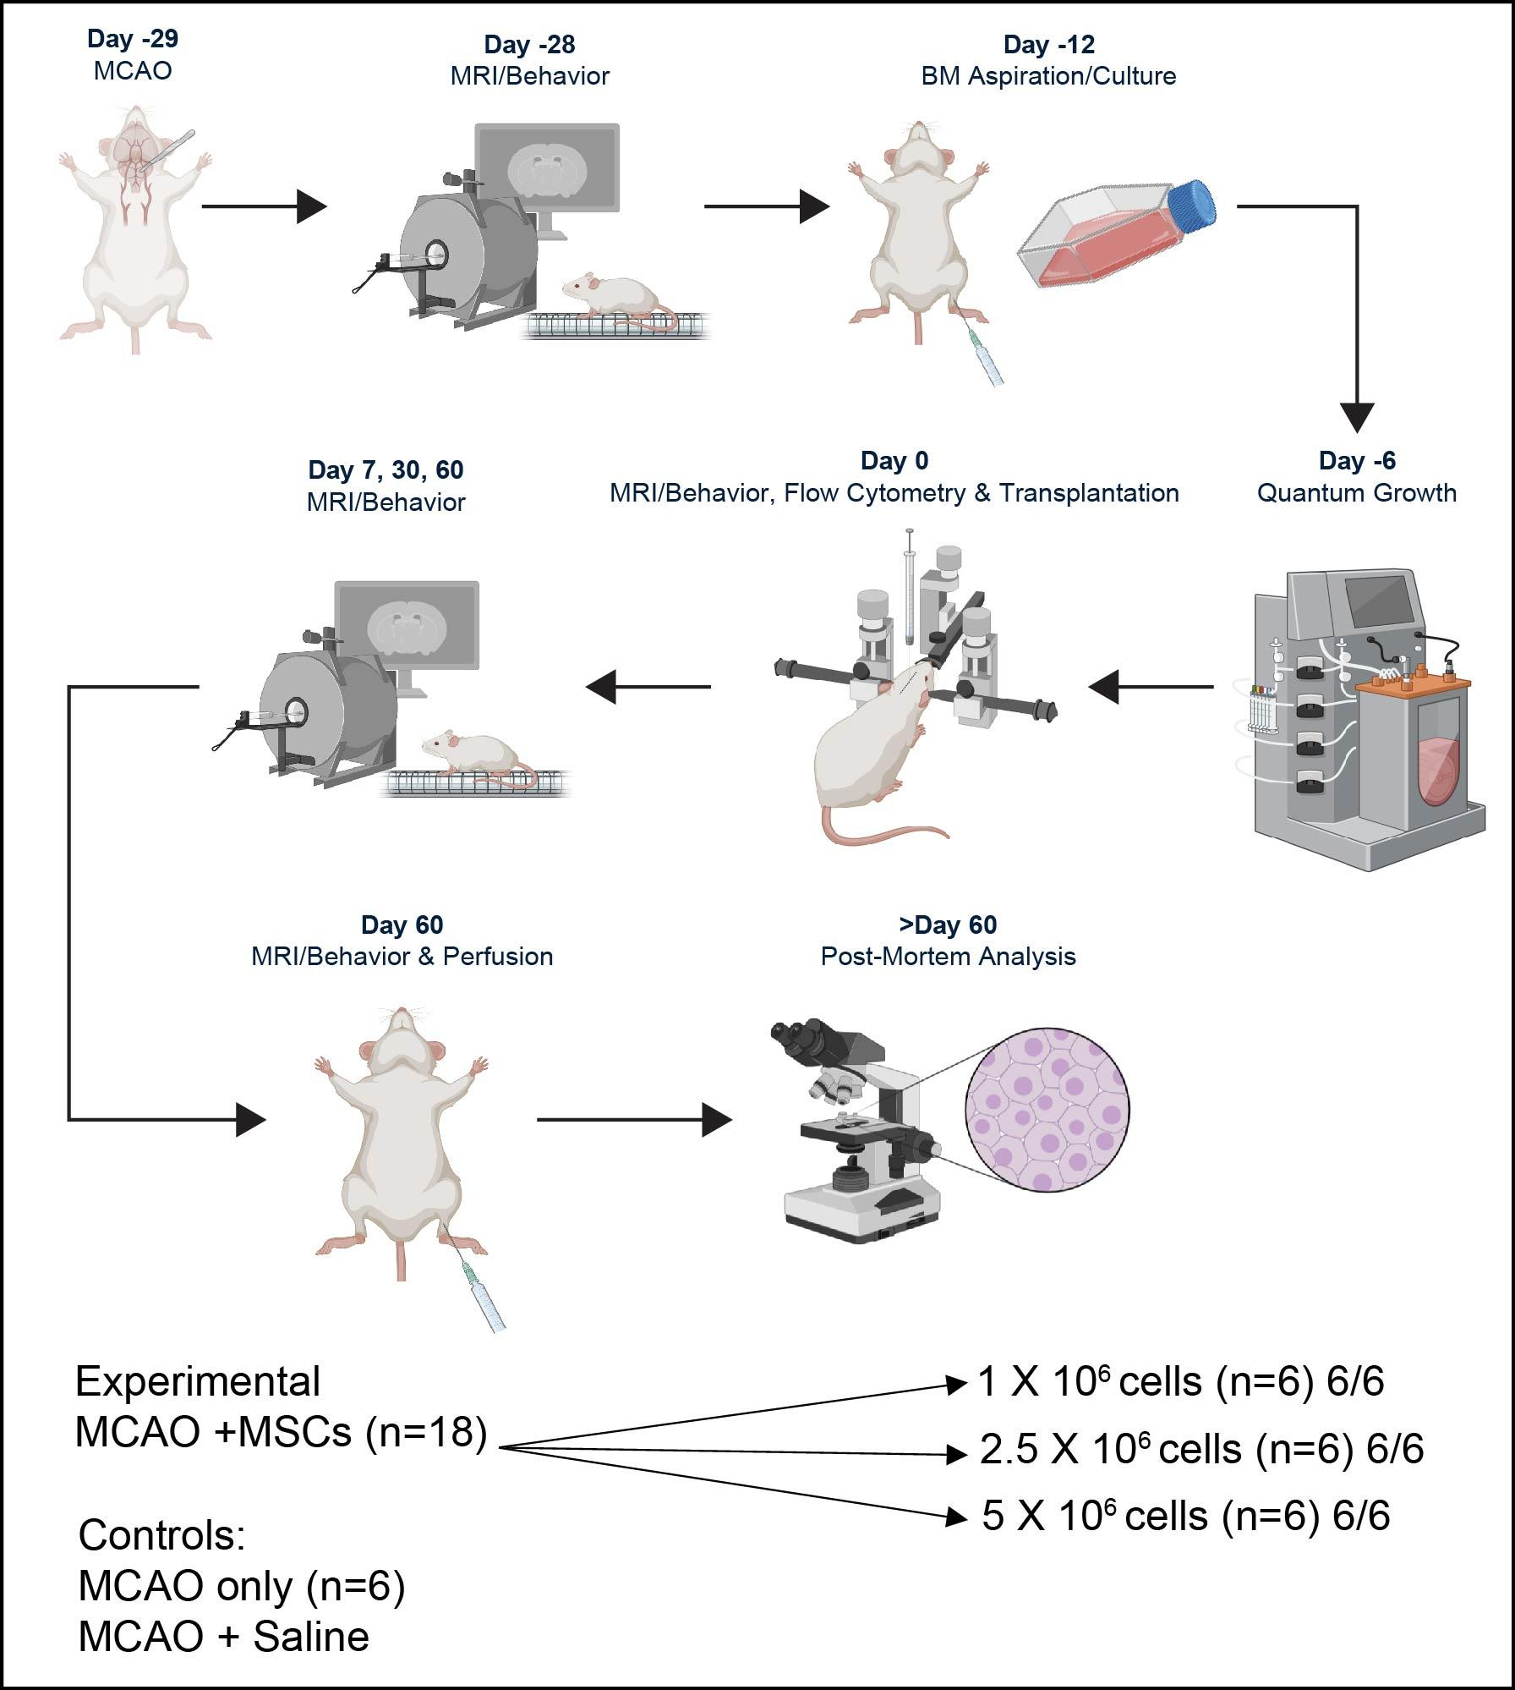
Supplemental Figure #1: Study design overview.

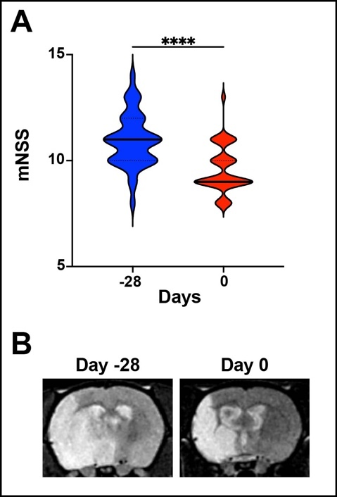
Supplemental Figure 2: Analysis of the chronic stroke model. (A) Pooled analysis of mNSS for all rats used in these studies, highlighting that after a large ischemic cortical and subcortical stroke, there was a significant acute decline in sensorimotor function, with the mean score in infarcted animals being 10.9/16 at one day following MCAO with stabilization to 9.5/16 over the next month prior to treatment. (B) Representative T2-Weighted MR images showing the change in edema associated with the transition from an acute stroke to a chronic stroke.
*P≤0.05 **P≤0.01 ***P≤0.001 ****P≤0.0001

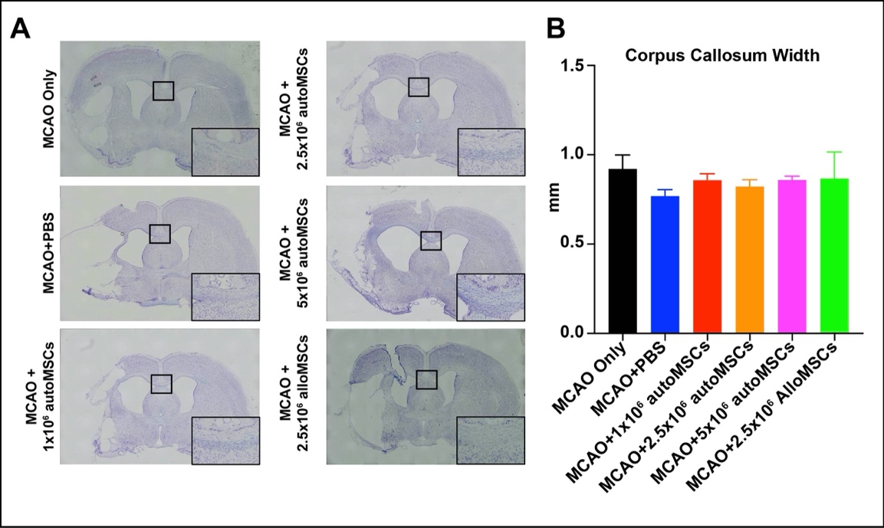
Supplemental Figure 3. No significant changes to corpus callosum width with aMSC treatment. (A) Representative images showing cresyl violet stained brains at bregma -0.26mm from MCAO only, MCAO+PBS, MCAO+1x10⁶, MCAO+2.5x10⁶, MCAO+5x10⁶ autoMSCs, and MCAO+2.5x10⁶ alloMSC groups, highlighting the corpus callosum (black box). (B) Quantification of corpus callosum width reveals a small but significant difference when comparing MCAO only and MCAO+PBS control groups, with no significance between experimental groups.
*P≤0.05 **P≤0.01 ***P≤0.001 ****P≤0.0001

