Supplementary Information

Facile Wet Chemical Synthesis of Dimeric Triangulene Derivatives through Intramolecular Radical-Radical Coupling

Liu et al

Table of Contents

1. Materials, instruments and methods 2
2. Synthetic procedures and characterization data 3
3. X-ray crystallographic analysis 7
5. Theoretical calculation 15
6. NMR and mass spectra 18
7. References 27

1. Materials, instruments and methods
All solvents were obtained commercially and used without further purification except toluene was obtained from a solvent drying system. ¹H NMR and ¹³C NMR spectra were recorded on Bruker 400 MHz Spectrometer and 500 MHz with a Mercury plus 500 spectrometer at 298 K. The ¹H and ¹³C NMR chemical shifts are reported relative to residual solvent signals. Coupling constants (J) are denoted in Hz and chemical shifts (δ) are denoted in ppm. Mudltiplicities are denoted as follows: s = singlet, d = doublet, b = broaden and m = multiplet. 2D-NMR spectra (¹H-¹H COSY) were recorded on Bruker 400 MHz Spectrometer (¹H: 400 MHz). UV-vis spectra were recorded in a quartz cell (light path 10 mm) on a Shimadzu UV2700 UV-visible spectrophotometer. Fluorescence spectra, photoluminescence quantum yields (Ф) and Fluorescence lifetime were recorded on HORIBA Duetta and FluoroMAX+. Electrospray ionization (ESI) mass spectra were recorded with a Waters Synapt G2 mass spectrometer and LTQ XL*, dichloromethane as solvent. The single crystals were measured on Rigaku XtaLAB PRO MM003-DS dual system with a Cu micro-focus source (λ = 1.54184 Å). Circular dichroism (CD) spectra were measured on a Chirascan Series Spectrometer (Applied Photophysics Ltd, UK) at room temperature. Chiral separation was performed using a Shimadzu HPLC System (LC-20AR) equipped with a CHIRALPAK IF® column (250 mm L × 10 mm I. D. for separation) and eluting with hexane/diethylamine (8/1, V/V) at flow rates of 3.0 mL/min.
Theoretical calculations were performed with the Gaussian16 program and the ORCA 5.0.4 program^{1,2}. All molecular geometric optimizations were performed by using ωB97XD exchange-correlation functional in conjunction with 6-31G(d,p) basis set³⁻⁵. Initial guess broken-symmetry (open-shell singlet) wavefunction was found with Guess=Mix, Nosymm and Stable=Opt keywords, and broken-symmetry wavefunction is stable under the perturbations considered in stability test of wavefunction⁶⁻⁷. then the Guess=Read keyword was used to optimize the broken-symmetry state geometry structure at the UωB97XD/6-31G(d,p) level. Frequency calculations were carried out to ensure that these structures were indeed local minima. The structure of transition state was verified by frequency calculations and only one imaginary frequency was found in the transition state. Single point energy was performed at the level of RI-ωB97M-V/def2-TZVPP with ORCA program⁸⁻¹⁰. Molecular thermochemical data, including the Gibbs thermal corrections based on Grimme's quasi-RRHO model and the Gibbs free energy, were calculated by the Shermo 2.3.5 code^{11,12}. Time-dependent density functional theory (TD-DFT) calculations were performed at the level of ωB97XD/6-31G(d,p), dichloromethane (CH₂Cl₂) was used as the solvent in the solvation model based on IEFPCM¹³. Nucleus-independent chemical shift values (NICS(1)_{ZZ}) were calculated using the standard GIAO at the level of ωB97XD/6-31G(d,p)^{14,15}. The anisotropy of the current-induced density (ACID) analysis was realized by the AICD code based on the output file of Gaussian 16, and the maps were finally generated by POV-Ray render^{16,17}. The input file for iso-chemical shielding surface (ICSS) calculation and the 2D ICSS map was made by Multiwfn¹⁸. Spin population calculations based on the Becke atomic charge. Electronic structure analyses were performed with the Multiwfn 3.8 (dev) code. The isosurface maps of spin density were rendered by means of Visual Molecular Dynamics (VMD 1.9.3) software based on the files exported from Multiwfn¹⁹. The CASSCF computations were performed using the PySCF 1.7.6 package. The calculation of the diradical character ($y_{0}$) based on the CASSCF(4,4)/cc-pVDZ level was obtained by the automr program in MOKIT that automatically performs multi-configurational calculations and called Gaussian 16 to transfer molecular orbitals to the PySCF package. Unrestricted natural orbital (UNO) occupation number calculations were done by unrestricted hartree-fock (UHF) and unrestricted density functional theory (UDFT), the diradical character ($y_{0}$) was calculated according to Yamaguchi’s scheme as:
$$y_{0}=1-\frac{2T_{0}}{1+T_{0}^{2}}$$
$$T_{0}=\frac{n_{HONO}-n_{LUNO}}{2}$$
Where $n$ indicates the occupation number of the highest occupied natural orbital (HONO) and the lowest unoccupied natural orbital (LUNO), a molecule with $y_{0}=0$ means a closed-shell structure, whereas a molecule with $y_{0}=1$ means a pure diradical structure. $T$ means Overlap integral^{20,21}.

2. Synthetic procedures and characterization data
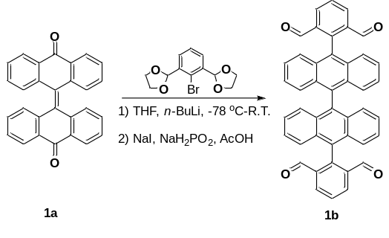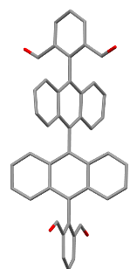
2,2'-[(9,9'-bianthracene)-10,10'-diyl]diisophthalaldehyde(1b): n-BuLi (2.5 M in hexane, 2.30 mL, 5.70 mmol) was slowly added into a solution of 2,2'-(2-bromo-1,3-phenylene)bis(1,3-dioxolane) (1.70 g, 5.64 mmol) in tetrahydrofuran (14 mL) at -78 ºC. The mixture was stirred at -78 ºC for 1.5 h, then compound 10H,10'H-[9,9'-bianthracenylidene]-10,10'-dione 1a (0.22 g, 0.56 mmol)^{[22]} was added to the mixture at once. After the addition, the reaction temperature was slowly raised to room temperature, and the mixture was stirred at room temperature for 2 hours. Next, the reaction was quenched with glacial acetic acid (99%, 2 mL) and the solvents were removed under vacuum. And then, NaI (0.56 g, 3.72 mmol) and sodium hypophosphite monohydrate (0.44 g, 4.96 mmol) were added to the reactant disolved in glacial acetic acid (16 mL), the mixture was refluxed for two hours at 140 ºC. The mixture was cooled to room temperature and extracted first with dichloromethane and water, the organic layer was extracted three times with saturated NaHCO₃ aqueous solution and the solvents were removed under vacuum. The resulting crude product was purified by chromatography on silica gel eluting with petroleum ether: ethyl acetate = 6:1 to get compound 1b (0.22 g, 0.35 mmol, 62.0%) as pale-yellow solid. ¹H NMR (400 MHz, CD₂Cl₂, ppm) δ = 9.47 (s, 4H), 8.47 (d, J = 7.7 Hz, 4H), 7.90 (t, J = 7.7 Hz, 2H), 7.51 – 7.43 (m, 4H), 7.36 (ddd, J = 8.8, 5.9, 3.5 Hz, 4H), 7.22 – 7.14 (m, 8H).¹³C NMR (100 MHz, CD₂Cl₂, ppm) δ =190.47, 136.39, 133.09, 131.79, 130.83, 129.53, 127.22, 126.44, 126.23. HR-ESI-MS: m/z calculated for [C₄₄H₂₆O₄+K]⁺: 657.1468, found: 657.1445.
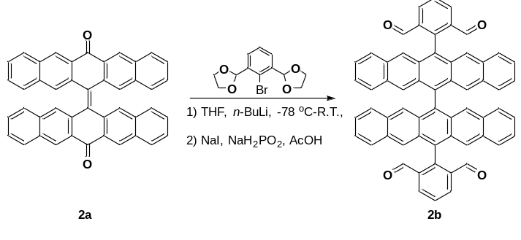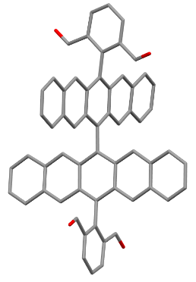
2,2'-[(6,6'-bipentacene)-13,13'-diyl]diisophthalaldehyde (2b): n-BuLi (2.5 M in hexane, 1.34 mL, 3.44 mmol) was slowly added into a solution of 2,2'-(2-bromo-1,3-phenylene)bis(1,3-dioxolane) (1.023 g, 3.4 mmol) in tetrahydrofuran (10 mL) at -78 ºC. The mixture was stirred at -78 ºC for 1.5 h, then compound 13H,13'H-[6,6'-bipentacenylidene]-13,13'-dione 2a (0.2 g, 0.34 mmol)^{[23]} was added to the mixture at once. After the addition, the reaction temperature was slowly raised to room temperature, and the mixture was stirred at room temperature for 2 hours. Next, the reaction was quenched with glacial acetic acid (99%, 2 mL) and the solvents were removed under vacuum. And then, NaI (0.34 g, 2.24 mmol) and sodium hypophosphite monohydrate (0.251 g, 2.86 mmol) were added to the reactant disolved in glacial acetic acid (15 mL), the mixture was refluxed for two hours at 140 ºC. The mixture was cooled to room temperature and extracted first with dichloromethane and water, the organic layer was extracted three times with saturated NaHCO₃ aqueous solution and the solvents were removed under vacuum. The resulting crude product was purified by chromatography on silica gel eluting with petroleum ether: ethyl acetate = 8: 1 to get compound 2b (0.189 g, 0.23 mmol, 68.0%) as dark purple solid. ¹H NMR (400 MHz, CD₂Cl₂, ppm) δ = 9.61 (s, 4H), 8.63 (d, J = 7.7 Hz, 4H), 8.14 (s, 4H), 8.06 (t, J = 7.7 Hz, 2H), 7.83 (s, 4H), 7.65 (d, J = 8.8 Hz, 4H), 7.29 (d, J = 8.8 Hz, 4H), 7.16 (dd, J = 8.7, 6.2 Hz, 4H), 7.03 (dd, J = 8.8, 6.2 Hz, 4H).¹³C NMR (100 MHz, CD₂Cl₂, ppm) δ = 190.66, 145.97, 136.91, 135.81, 133.53, 132.37, 131.73, 130.74, 126.30, 125.88, 125.08. HR-ESI-MS: m/z calculated for [C₆₀H₃₄O₄]⁺: 818.2457, found: 818.2445.
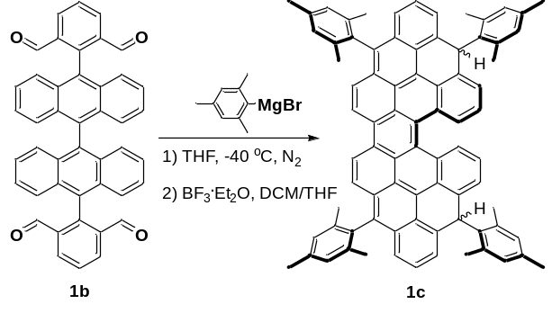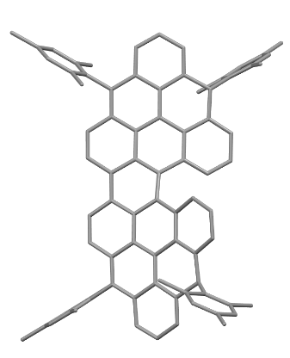
Compound 1c: The compound of 1b (0.10 g, 0.16 mmol) was dissolved in tetrahydrofuran (10 mL), and then 2-mesitylmagnesium bromide (1.0 M in tetrahydrofuran, 4 mL, 4 mmol) was added dropwise at 0 ºC. The mixture was stirred at 40 ºC for 24 hours. After cooling to room temperature, the reaction was quenched by NH₄Cl (aq., 8.0 mL) and extracted by ethyl acetate (20.0 mL x 3). The organic layer was dried over Na₂SO₄, filtered and concentrated under reduced pressure. The residue was dissolved by dichloromethane (15.0 mL) and cooled to 0 ºC, and then BF₃·Et₂O (2.0 mL) was added slowly. The mixture was stirred at room temperature for 8 hours and quenched by methanol (3.0 mL). The mixture was concentrated to dryness and purified by chromatography on silica gel eluting with petroleum ether: dichloromethane = 5: 1 to get product as orange solid, which exist as two isomers, 1c and 1c’. The UV–vis spectra of 1c and 1c’ were almost identical (see Supplementary Figure 9), further confirmed they are isomers.
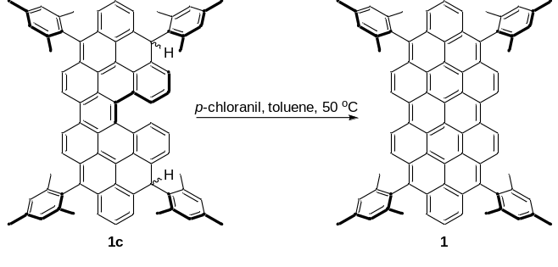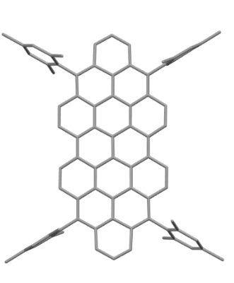
Compound 1: The compound of 1c (0.10 g, 0.10 mmol) was dissolved in toluene (10.0 mL), p-chloranil (0.19 g, 0.784 mmol) was added slowly at 0 ºC. The mixture was stirred at 50 ºC for 8 hours. After reaction finished, the mixture was cooled to room temperature and filtered through diatomite. The mixture was concentrated to dryness and purified by chromatography on silica gel eluting with petroleum ether: dichloromethane = 4: 1 to get compound 1 (0.042 g, 0.041 mmol, 42.0%) as green solid. 1 exhibited ordered molecular packing sustained by herringbone π-stacking, which may explain its considerable ¹H NMR line-broadening (see Supplementary Figure 24). LTQ-ESI-MS: m/z calculated for [C₈₀H₅₈+H]⁺:1019.4617, found: 1019.17.

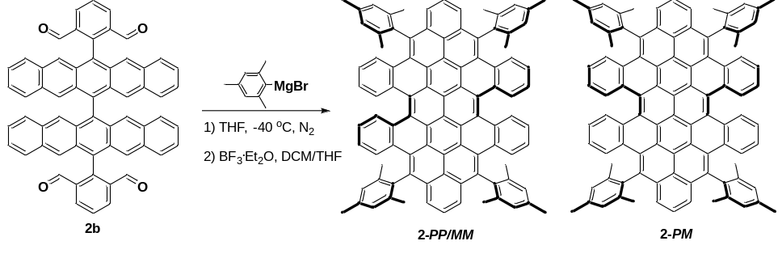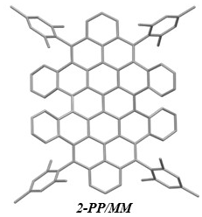
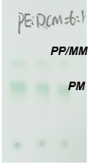
Compound 2: The compound of 2b (0.10 g, 0.12 mmol) was dissolved in tetrahydrofuran, 2-mesitylmagnesium bromide (1.0 M in tetrahydrofuran, 3.0 mL, 3.0 mmol) was added dropwise at 0 ℃. The mixture was stirred at 40 ℃ for 24 hours. After cooling to room temperature, the reaction was quenched by NH₄Cl (aq., 5.0 mL) and extracted by ethyl acetate (20.0 mL x 3). The organic layer was dried over Na₂SO₄, filtered and concentrated under reduced pressure concentrated to dryness.
Method 1: The residue (126 mg, 0.0976 mmol) was dissolved by dichloromethane (10.0 mL) was cooled to 0 ℃, and then, BF₃·Et₂O (1.3 mL) was added into it. The mixture was stirred at room temperature for 8 hours and quenched by methanol (3.0 mL). The mixture was concentrated to dryness and purified by chromatography on silica gel eluting with petroleum ether: dichloromethane = 6: 1 to get compound 2 as two diastereomers (2-PM and 2-PP/MM) in a ratio of about 5:1 (2-PM: 49.49 mg, 0.05 mmol, 41.6%; 2-PP/MM: 9.87 mg, 0.081 mmol, 8.3%).
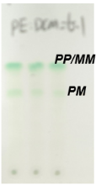
Method 2: The residue (50 mg, 0.039 mmol) was dissolved by tetrahydrofuran (10.0 mL) was cooled to 0 ℃, and then, BF₃·Et₂O (1.3 mL) was added into it. The mixture was stirred at room temperature for 8 hours and quenched by methanol (3.0 mL). The mixture was concentrated to dryness and purified by chromatography on silica gel eluting with petroleum ether: dichloromethane = 6: 1 to get compound 2 as two diastereomers (2-PM and 2-PP/MM) in a ratio of about 1: 4 (2-PM: 5.24 mg, 0.0043 mmol, 11.2%; 2-PP/MM: 20.72 mg, 0.017 mmol, 43.0%). Two diastereomers 2-PM and 2-PP/MM can be separated via standard silica chromatography, while the separations of two atropo-enantiomers 2-PP and 2-MM can be accomplished using chiral high-performance liquid chromatography (HPLC) Due to the poor solubility of 2-PM, we only obtained the well-resolved NMR data of 2-PP/MM. ¹H NMR (500 MHz, THF-d₈, ppm) δ = 8.95 (dd, J = 8.3, 1.4 Hz, 4H), 8.28–8.24 (dd, J = 8.5, 1.2 Hz, 4H), 8.23 (m, 4H), 8.18 (t, J = 9.2,6.3, 2H), 7.43 (s, 4H), 7.36 (s, 4H), 7.31 (ddd, J = 8.1, 6.8, 1.2 Hz, 4H), 7.17 (ddd, J = 8.5, 6.9, 1.5 Hz, 4H), 2.63 (s, 12H), 2.20 (s, 12H), 2.17 (s, 12H). LTQ-ESI-MS: m/z calculated for [C₉₆H₆₆+H]⁺:1219.5243, found: 1219.68 (for 2-PM) and 1218.67 (for 2-PP/MM).

3. X-ray crystallographic analysis
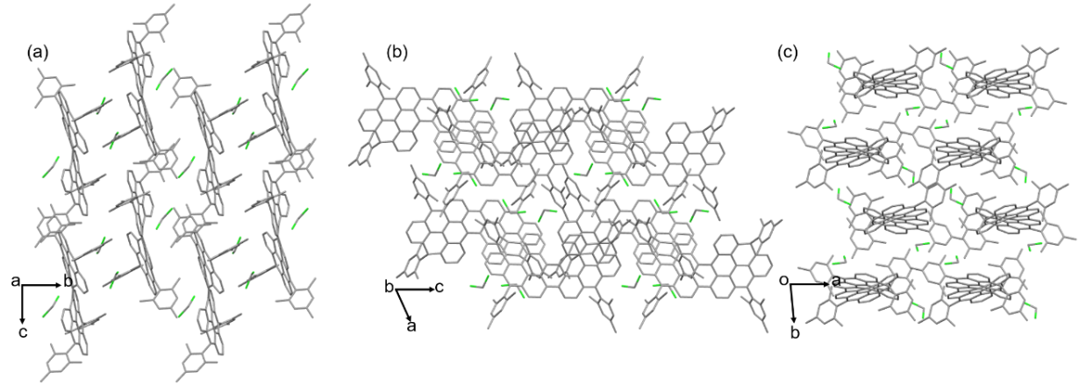
Supplementary Figure 1. Molecular packing of 1c in single crystal.
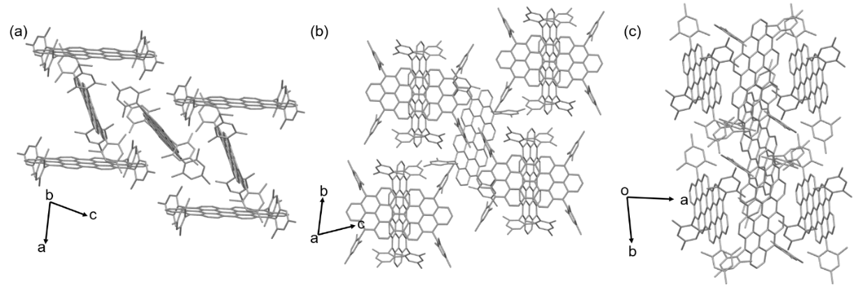
Supplementary Figure 2. Molecular packing of 1 in single crystal.
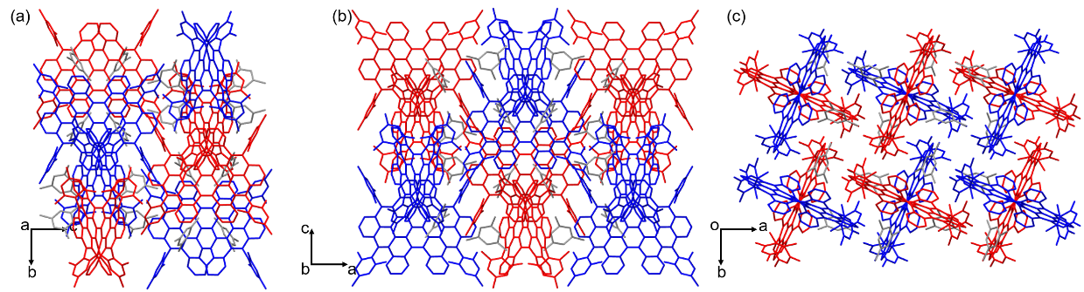
Supplementary Figure 3. Molecular packing of 2-PP/MM in single crystal, (red: PP, Blue: MM).

Supplementary Table 1. Crystal data and structure refinement for 1b.
Compound | 1b
Empirical formula | C₄₄H₂₆O₄
Formula weight | 618.65
Temperature / K | 172.99(10)
Crystal system | orthorhombic
Space group | Pbcn
a / Å | 7.7417(3)
b / Å | 29.5787(8)
c / Å | 13.1710(4)
α / ° | 90
β / ° | 90
γ / ° | 90
Volume / Å³ | 3016.02(17)
Z | 4
ρcalcg / cm³ | 1.362
μ / mm⁻¹ | 0.688
F (000) | 1288.0
Crystal size / mm³ | 0.26 × 0.22 × 0.18
Radiation | CuKα (λ = 1.54184)
2Θ range for data collection / ° | 5.976 to 134.158
Index ranges | -9 ≤ h ≤ 9, -35 ≤ k ≤ 35, -15 ≤ l ≤ 8
Reflections collected | 30369
Independent reflections | 2697 [Rint = 0.0895, Rsigma = 0.0491]
Data / restraints / parameters | 2697/0/221
Goodness-of-fit on F² | 1.045
Final R indexes [I>=2σ (I)] | R1 = 0.0465, wR2 = 0.1240
Final R indexes | R1 = 0.0616, wR2 = 0.1341
Largest diff. peak / hole / e Å⁻³ | 0.36/-0.21
CCDC | 2264625

Supplementary Table 2. Crystal data and structure refinement for 2b.
Compound | 2b
Empirical formula | C₆₂H₃₈C_{l4}O₄
Formula weight | 988.72
Temperature / K | 173.00(10)
Crystal system | orthorhombic
Space group | Pbcn
a / Å | 26.961(2)
b / Å | 10.4991(6)
c / Å | 17.6666(12)
α / ° | 90
β / ° | 90
γ / ° | 90
Volume / Å³ | 5000.8(6)
Z | 4
ρcalcg / cm³ | 1.313
μ / mm⁻¹ | 2.542
F (000) | 2040.0
Crystal size / mm³ | 0.34 × 0.26 × 0.18
Radiation | CuKα (λ = 1.54184)
2Θ range for data collection / ° | 10.538 to 134.14
Index ranges | -28 ≤ h ≤ 32, -10 ≤ k ≤ 12, -20 ≤ l ≤ 21
Reflections collected | 54218
Independent reflections | 4451 [Rint = 0.1084, Rsigma = 0.0563]
Data / restraints / parameters | 4451/2/317
Goodness-of-fit on F² | 1.036
Final R indexes [I>=2σ (I)] | R1 = 0.1887, wR2 = 0.3654
Final R indexes | R1 = 0.2010, wR2 = 0.3711
Largest diff. peak / hole / e Å⁻³ | 1.31/-0.96
CCDC | 2264627

Supplementary Table 3. Crystal data and structure refinement for 1c.
Compound | 1c
Empirical formula | C₈₂H₆₆C_{l4}
Formula weight | 1193.14
Temperature / K | 172(1)
Crystal system | triclinic
Space group | P-1
a / Å | 13.6473(8)
b / Å | 15.2085(4)
c / Å | 16.9424(6)
α / ° | 88.218(2)
β / ° | 66.842(4)
γ / ° | 85.464(3)
Volume / Å³ | 3223.0(3)
Z | 2
ρcalcg / cm³ | 1.229
μ / mm⁻¹ | 2.009
F (000) | 1252.0
Crystal size / mm³ | 0.36 × 0.32 × 0.28
Radiation | CuKα (λ = 1.54184)
2Θ range for data collection / ° | 7.064 to 134.152
Index ranges | -16 ≤ h ≤ 16, -18 ≤ k ≤ 18, -20 ≤ l ≤ 20
Reflections collected | 77240
Independent reflections | 11475 [Rint = 0.1183, Rsigma = 0.0775]
Data / restraints / parameters | 11475/0/787
Goodness-of-fit on F² | 1.042
Final R indexes [I>=2σ (I)] | R1 = 0.1044, wR2 = 0.2999
Final R indexes | R1 = 0.1243, wR2 = 0.3139
Largest diff. peak / hole / e Å⁻³ | 0.86/-0.80
CCDC | 2264626

Supplementary Table 4. Crystal data and structure refinement for 1.
Compound | 1
Empirical formula | C₁₂₃H₁₀₀O₃
Formula weight | 1626.02
Temperature / K | 173.00(10)
Crystal system | triclinic
Space group | P-1
a / Å | 13.9818(15)
b / Å | 18.042(2)
c / Å | 20.665(3)
α / ° | 64.904(14)
β / ° | 72.494(12)
γ / ° | 80.159(10)
Volume / Å³ | 4496.4(12)
Z | 2
ρcalcg / cm³ | 1.201
μ / mm⁻¹ | 0.535
F (000) | 1724.0
Crystal size / mm³ | 0.18 × 0.16 × 0.12
Radiation | CuKα (λ = 1.54184)
2Θ range for data collection / ° | 8.778 to 134.158
Index ranges | -16 ≤ h ≤ 16, -21 ≤ k ≤ 19, -23 ≤ l ≤ 24
Reflections collected | 52233
Independent reflections | 15923 [Rint = 0.1059, Rsigma = 0.1257]
Data / restraints / parameters | 15923/24/1155
Goodness-of-fit on F² | 1.017
Final R indexes [I>=2σ (I)] | R1 = 0.1241, wR2 = 0.2662
Final R indexes | R1 = 0.2366, wR2 = 0.3217
Largest diff. peak / hole / e Å⁻³ | 0.77/-0.32
CCDC | 2264629

Supplementary Table 5. Crystal data and structure refinement for 2-PP/MM.
Compound | 2-PP/MM
Empirical formula | C₅₇H₄₅
Formula weight | 729.93
Temperature / K | 172.99(10)
Crystal system | tetragonal
Space group | I41/a
a / Å | 26.02330(10)
b / Å | 26.02330(10)
c / Å | 25.5307(2)
α / ° | 90
β / ° | 90
γ / ° | 90
Volume / Å³ | 17289.70(19)
Z | 16
ρcalcg / cm³ | 1.122
μ / mm⁻¹ | 0.477
F (000) | 6192.0
Crystal size / mm³ | 0.37 × 0.26 × 0.24
Radiation | Cu Kα (λ = 1.54184)
2Θ range for data collection / ° | 8.35 to 134.138
Index ranges | -31 ≤ h ≤ 31, -31 ≤ k ≤ 31, -30 ≤ l ≤ 30
Reflections collected | 179430
Independent reflections | 7650 [Rint = 0.0614, Rsigma = 0.0193]
Data / restraints / parameters | 7650/400/572
Goodness-of-fit on F² | 0.952
Final R indexes [I>=2σ (I)] | R1 = 0.1103, wR2 = 0.2886
Final R indexes | R1 = 0.1182, wR2 = 0.2946
Largest diff. peak / hole / e Å⁻³ | 1.62/-0.47
CCDC | 2264628

4. Optical properties of 1, 2-PP/MM, 2-PM and the interconversion of 2-PP/MM→2-PM
Supplementary Table 6. Optical properties of 1, 2-PP/MM, 2-PM.
Compound | λ_{Abs,max}（nm） | λ_{Em,max} (nm) | Φ (%)ª | Time (ns) | Stokes shift (nm) | ε (10⁵ M⁻¹ cm⁻¹)
1 | 754 | 810 | 12.31 | 3.68 | 56 | 0.35, 0.50, 0.3, 0.91
2-PP/MM | 723 | 763 | 9.62 | 1.72 | 40 | 0.22, 0.12, 0.56
2-PM | 693 | 723 | 32.95 | 4.38 | 30 | 0.17, 0.12, 0.49
ªFluorescence quantum yield (Φ) was estimated by the absolute integrating sphere method.
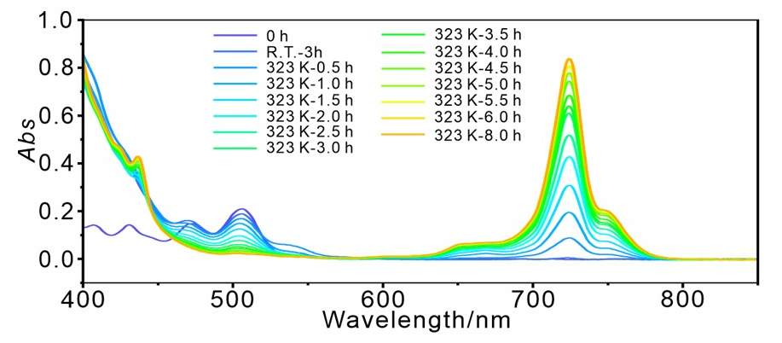
Supplementary Figure 4. Time-dependent UV–vis spectroscopy of 1c→1.
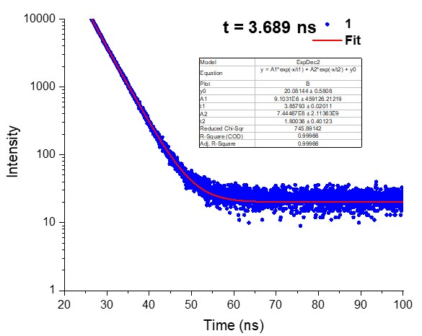
Supplementary Figure 5. Time-resolved fluorescence decay profile of 1 in DCM.
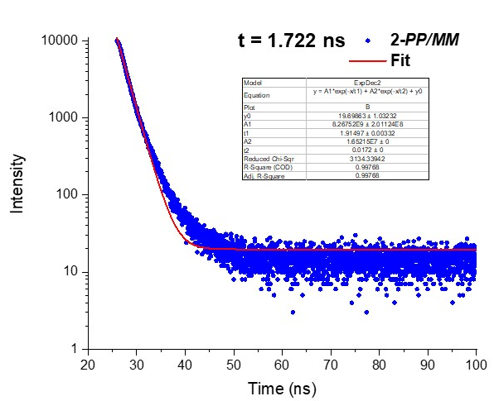
Supplementary Figure 6. Time-resolved fluorescence decay profile of 2-PP/MM in DCM.
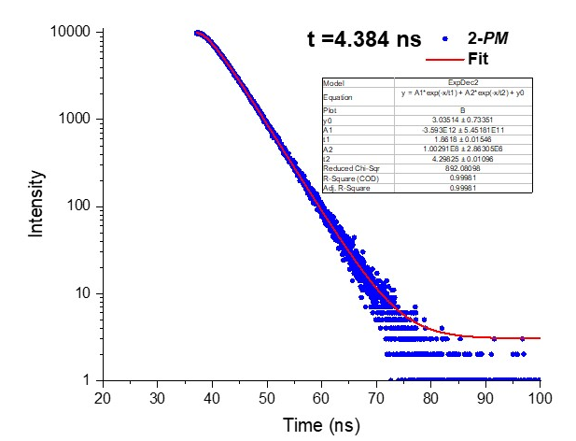
Supplementary Figure 7. Time-resolved fluorescence decay profile of 2-PM in DCM.
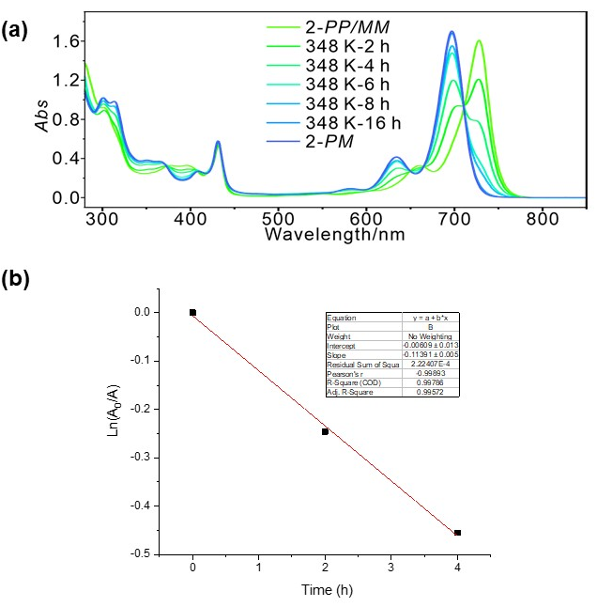
Supplementary Figure 8. (a)Time-dependent-UV–vis spectroscopy of 2-PP/MM→2-PM. (b) Monoexponential increase of the absorbance at 697nm in toluene of the freshly generated PM with time at 348 K. R²=0.9979.
First order kinetic equation $\ln{\frac{[A_{0}]}{[A]}}=kt$ k = -3.164 ×10⁻⁵ s⁻¹
Eyring equation $k=\frac{K_{B}T}{h}e^{-\frac{{ΔG}_{T}⧧}{RT}}$ ΔG_{T}$⧧$ = 27.656 kcal.mol⁻¹
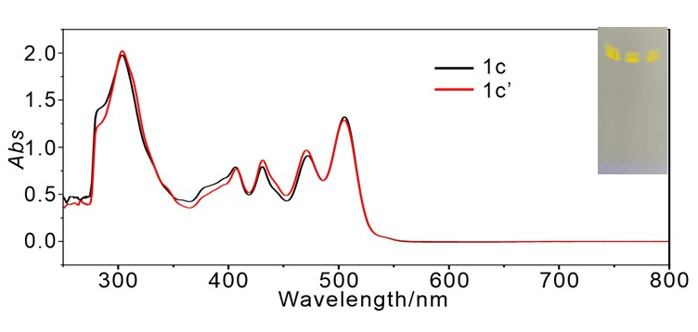
Supplementary Figure 9. Absorption spectra of the two isomers of 1c and 1c’. Inserted was the thin layer chromatography (TLC) of the two isomers of 1c and 1c’.
Supplementary Table 7. Thermal correction to Gibbs free energy (${G_{corr}\left(T\right)}_{Quasi-RRHO}$), electronic energy ($ε_{ele}$), relative Gibbs free energy ($ΔG$) of enantiomeric interconversion pathways of 2-PP/MM→2-PM.ª
Thermo data | 2-PP/MM | 2-TS | 2-PM
$${G_{corr}\left(T\right)}_{Quasi-RRHO}$$ | 1.230834 | 1.229924 | 1.231282
$$ε_{ele}$$ | -3698.2206634 | -3698.1778023 | -3698.2335672
$$G(T)$$ | -3696.9898290 | -3696.9478787 | -3697.0022852
$ΔG$ (kcal mol⁻¹) | 0 | 26.32 | -7.82
ªGibbs free energy $G\left(T\right)=ε_{ele}+{G_{corr}\left(T\right)}_{Quasi-RRHO}$, T = 298.15 K, P = 1 atm.

5. Theoretical calculation
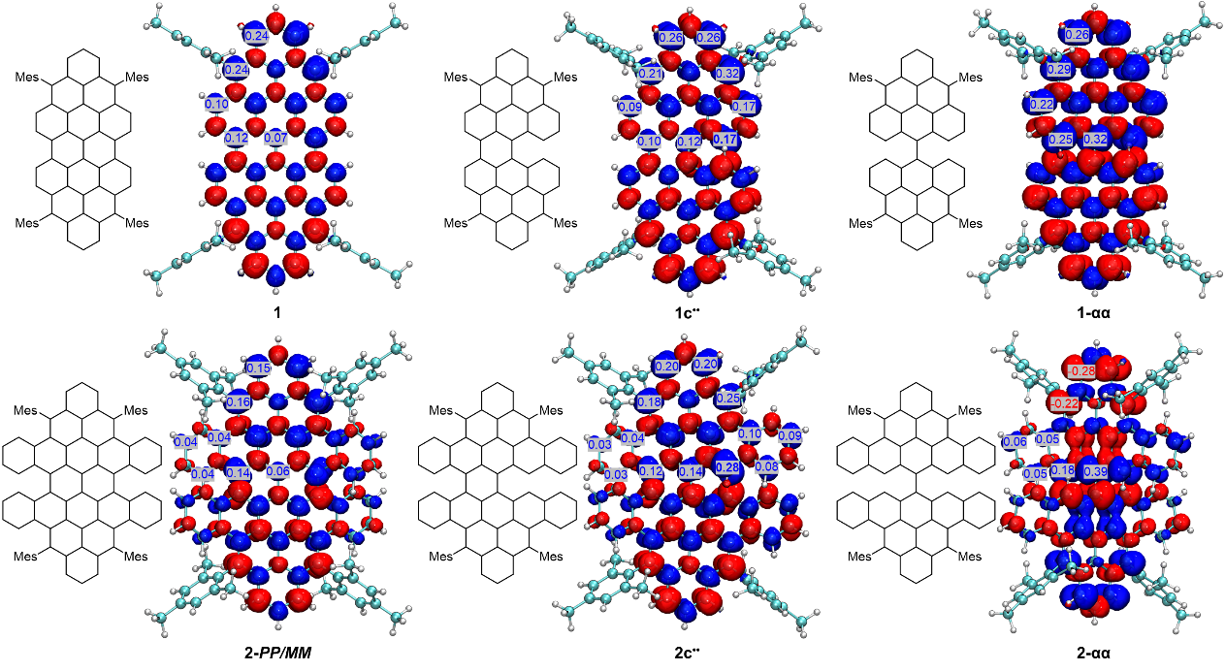
Supplementary Figure 10. Spin density and spin population of 1, 1c••,1-αα, 2-PP/MM, 2c•• and 2-αα in broken-symmetry state based on Becke atomic charge at the level of ωB97XD/6-31G(d,p). Isovalue = 0.002 au.
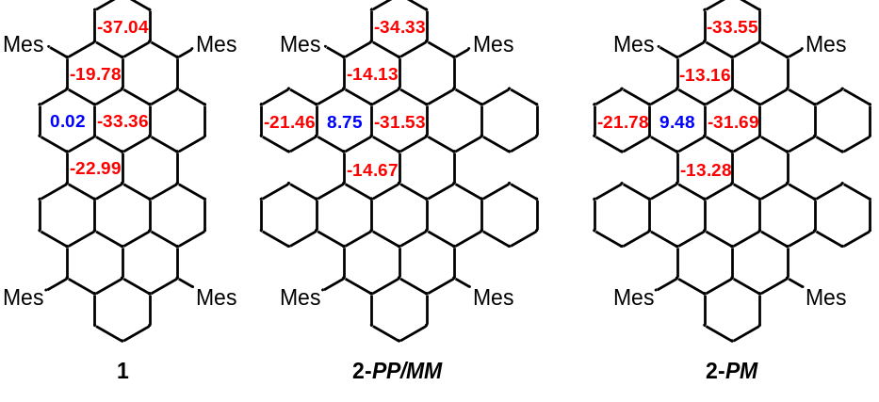
Supplementary Figure 11. Nucleus independent chemical shift (NICS): Calculated NICS(1)_{ZZ} values of 1, 2-PP/MM and 2-PM at the level of ωB97XD/6-31G(d,p). Here NICS(1)_{ZZ} value was the average of NICS(1)_{ZZ} value and NICS(-1)_{ZZ} value. Red negative values and blue positive values represent aromaticity and antiaromaticity, respectively.
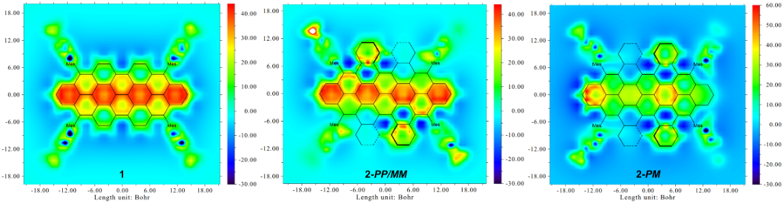
Supplementary Figure 12. Iso-chemical shielding surface (ICSS): Calculated magnetic shielding tensor of 1, 2-PP/MM and 2-PM at the level of ωB97XD/6-31G(d,p) and plotted 2D ICSS color-filled maps. The deep red represents the larger magnetic shielding value and the stronger aromaticity, and the deep blue represents the larger magnetic deshielding value and the stronger antiaromatic, respectively.
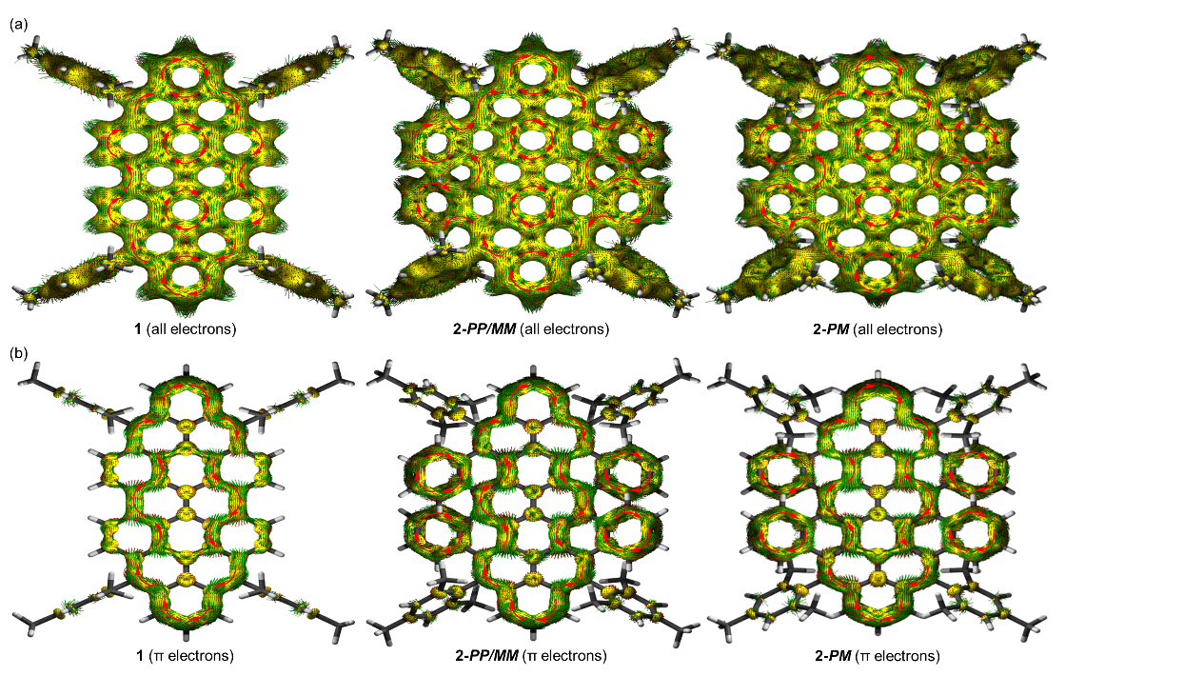
Supplementary Figure 13. Anisotropy of current-induced density (ACID): Calculated current density tensor of 1, 2-PP/MM and 2-PM at the level of ωB97XD/6-31G(d,p) and plotted ACID isosurface maps (a) formed by all-electrons, (b) formed by π-electrons. The external magnetic field is perpendicular to the ring plane and points outward. The small green arrows represent direction and magnitude of the ring current at various positions on the ACID isosurface and the large red arrows represent the diatropic ring current.

Supplementary Table 8. Diradical character (y₀) values of 1 and 2-PP/MM at the level of CASSCF, UHF and UDFT.
Mol
y₀  Method | 1 | 2-PP/MM
CASSCF (4,4)/cc-pVDZ | 0.258 | 0.071
UHF/cc-pVDZ | 0.708 | 0.598
UHF/6-31G(d,p) | 0.717 | 0.601
UωB97XD/6-31G(d,p) | 0.405 | 0.085
UCAM-B3LYP/6-31G(d,p) | 0.373 | 0.082

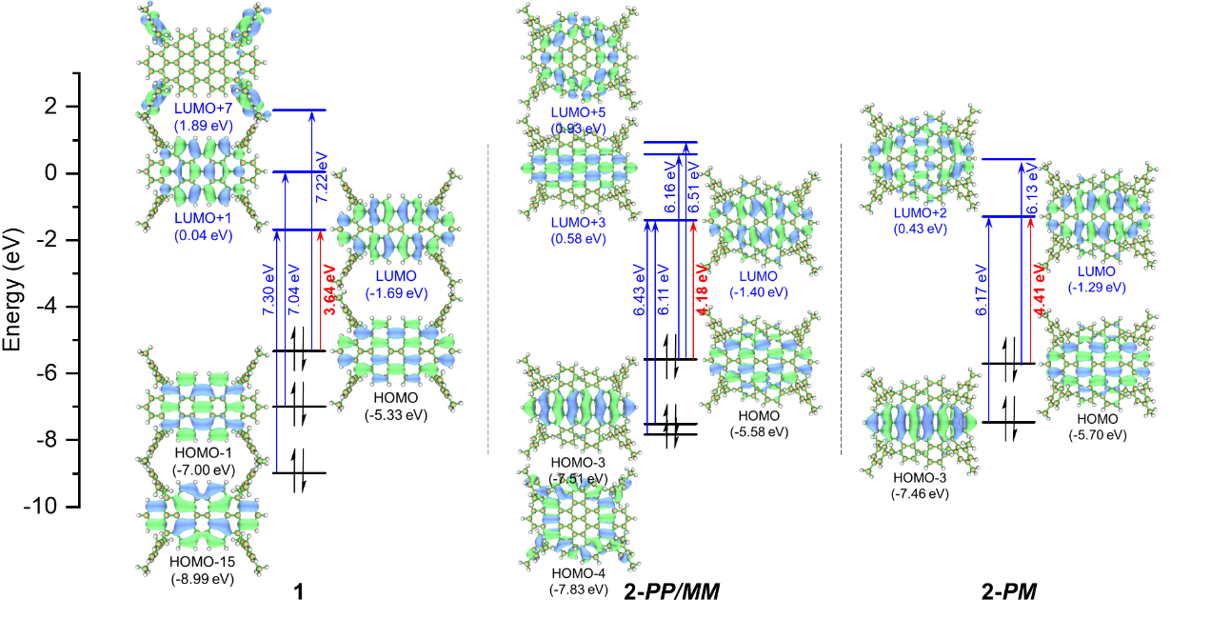
Supplementary Figure 14. Molecular orbitals (MO) energy levels, isosurface and major MO transitions in excited states of 1, 2-PP/MM and 2-PM.
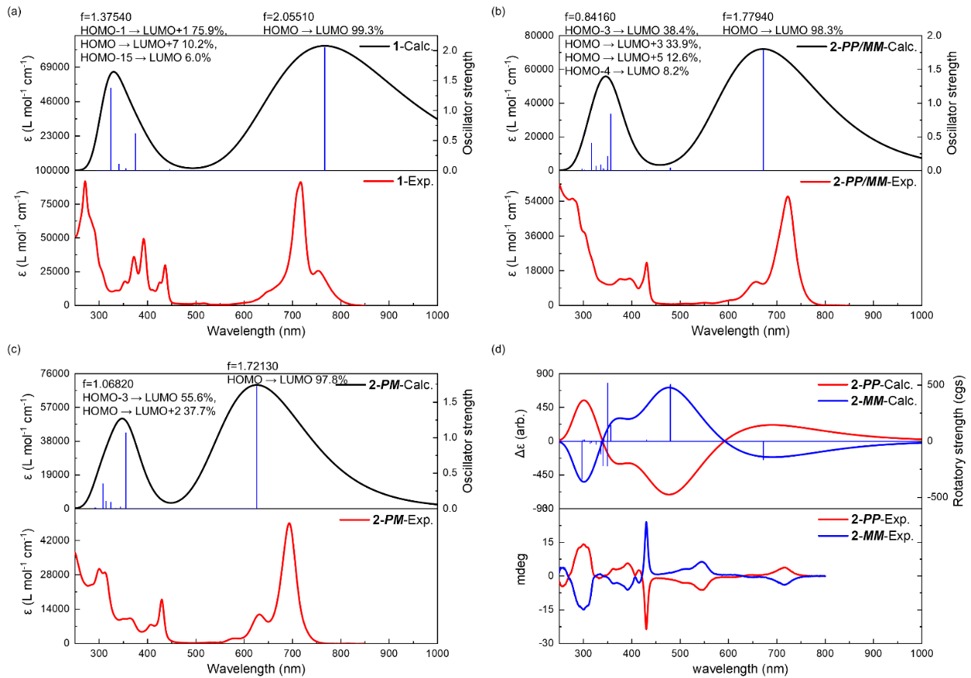
Supplementary Figure 15. Theoretical (black solid curve) and experimental (red solid curve) UV-Vis spectra of (a) 1, (b) 2-PP/MM, (c) 2-PM. The blue vertical line represents the oscillator strength. Theoretical and experimental ECD spectra of (d) 2-PP and 2-MM. The red and blue solid curves represent the PP and MM conformations, respectively, the blue vertical line represents the rotatory strength.

6. NMR and mass spectra
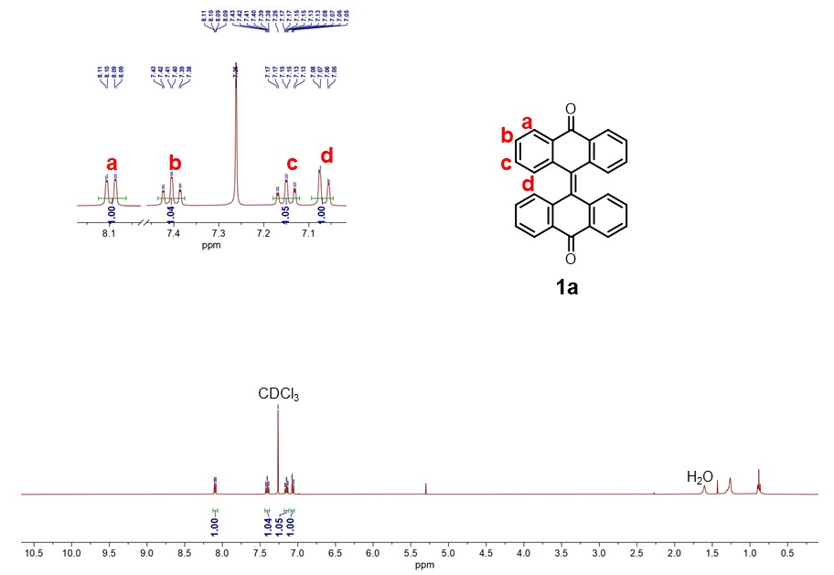
Supplementary Figure 16. The ¹H NMR (400 MHz, CDCl₃, 298 K) spectrum of 1a.

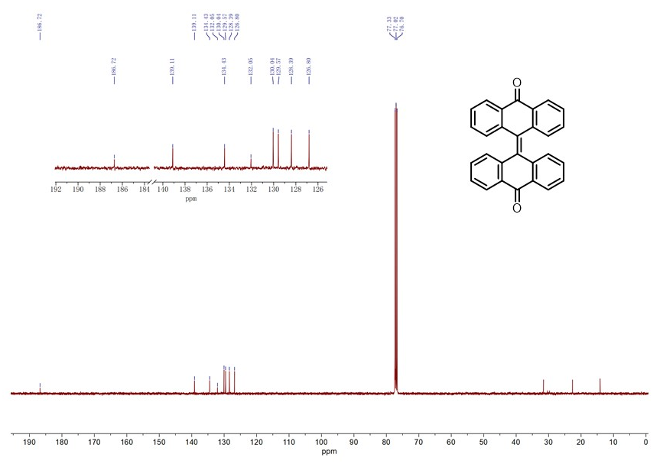
Supplementary Figure 17. The ¹³C NMR (100 MHz, CDCl₃, 298 K) spectrum of 1a.

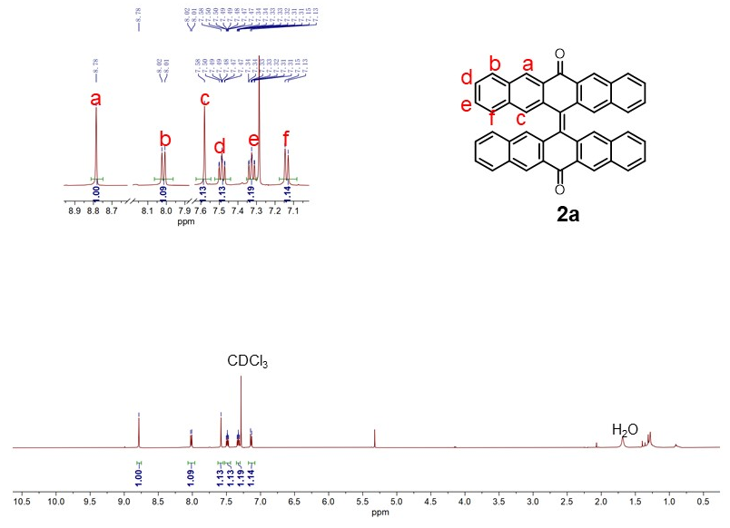
Supplementary Figure 18. The ¹H NMR (400 MHz, CDCl₃, 298 K) spectrum of 2a.

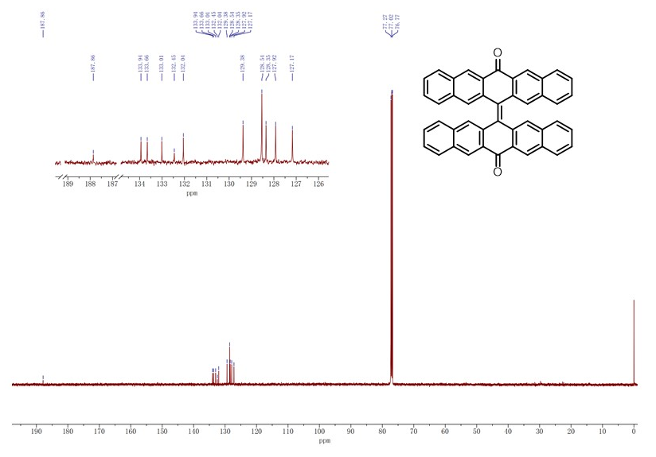
Supplementary Figure 19. The ¹³C NMR (100 MHz, CDCl₃, 298 K) spectrum of 2a.
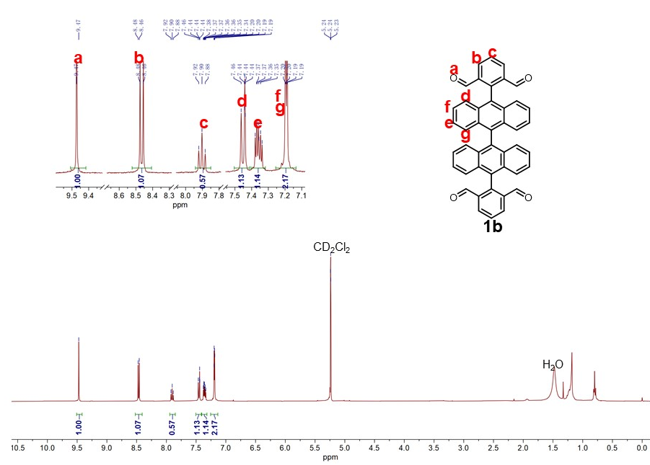
Supplementary Figure 20. The ¹H NMR (400 MHz, CD₂Cl₂, 298 K) spectrum of 1b.
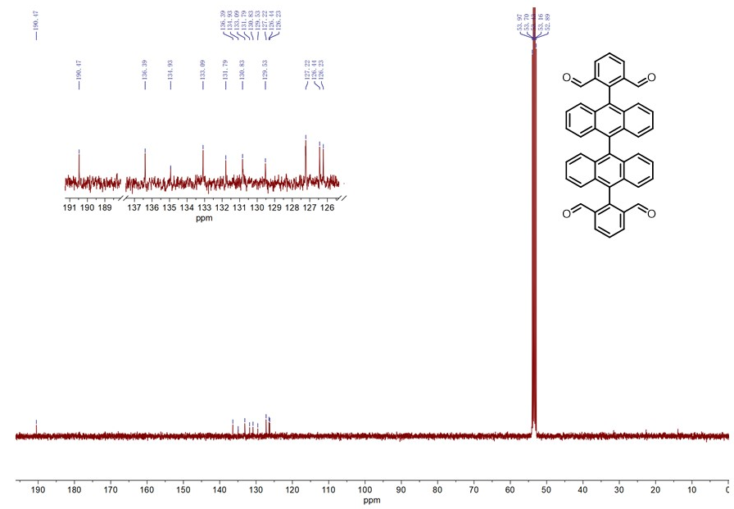
Supplementary Figure 21. The ¹³C NMR (100 MHz, CD₂Cl₂, 298 K) spectrum of 1b.

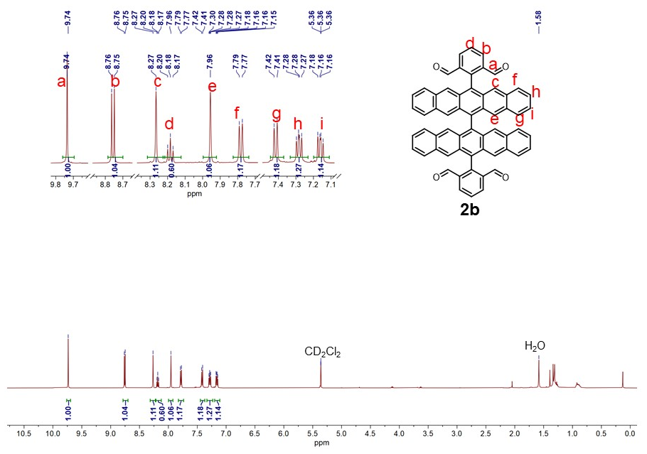
Supplementary Figure 22. The ¹H NMR (400 MHz, CD₂Cl₂, 298 K) spectrum of 2b.
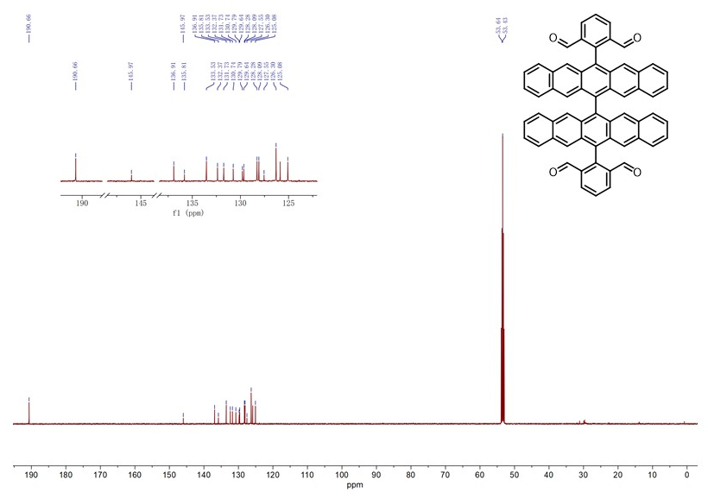
Supplementary Figure 23. The ¹³C NMR (100 MHz, CD₂Cl₂, 298 K) spectrum of 2b.

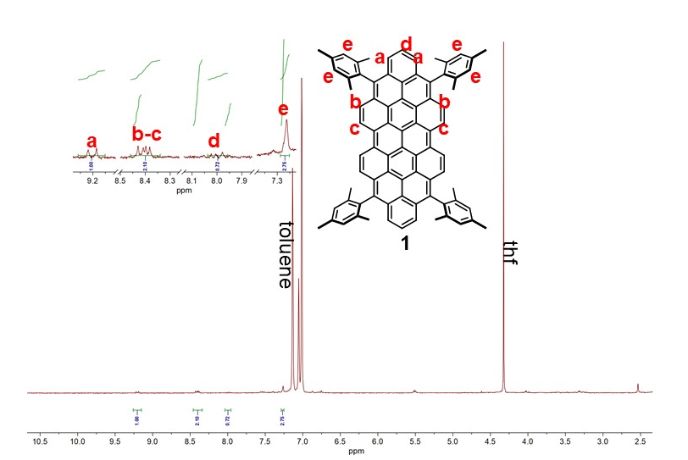
Supplementary Figure 24. The ¹H NMR (400 MHz, toluene-d₈, 298 K) spectrum of 1.
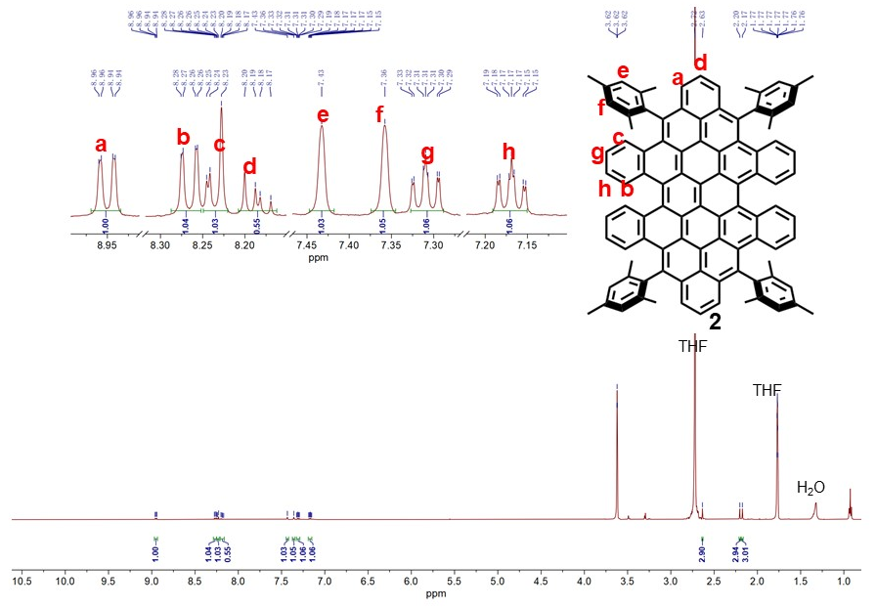
Supplementary Figure 25. The ¹H NMR (500 MHz, THF-d₈, 298 K) spectrum of 2-PP/MM.
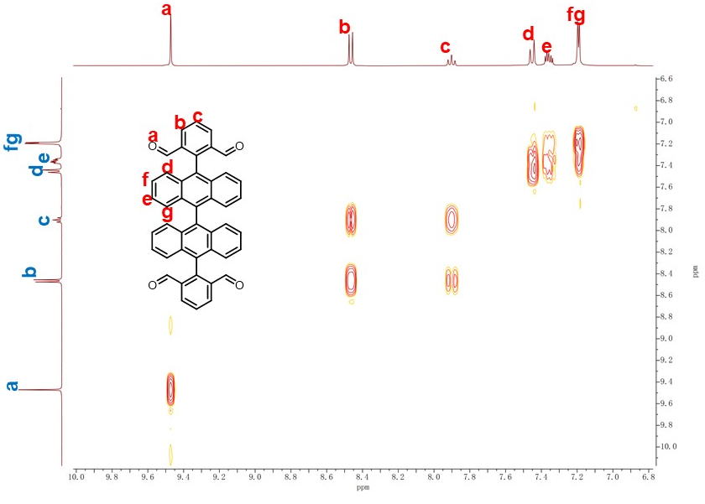
Supplementary Figure 26. The partial 2D COSY NMR (400 MHz, CD₂Cl₂, 298 K) spectrum of 1b.
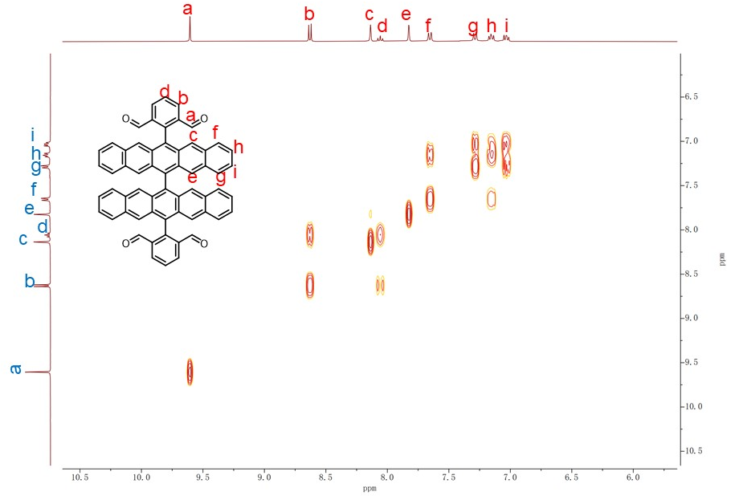
Supplementary Figure 27. The partial 2D COSY NMR (400 MHz, CD₂Cl₂, 298 K) spectrum of 2b.
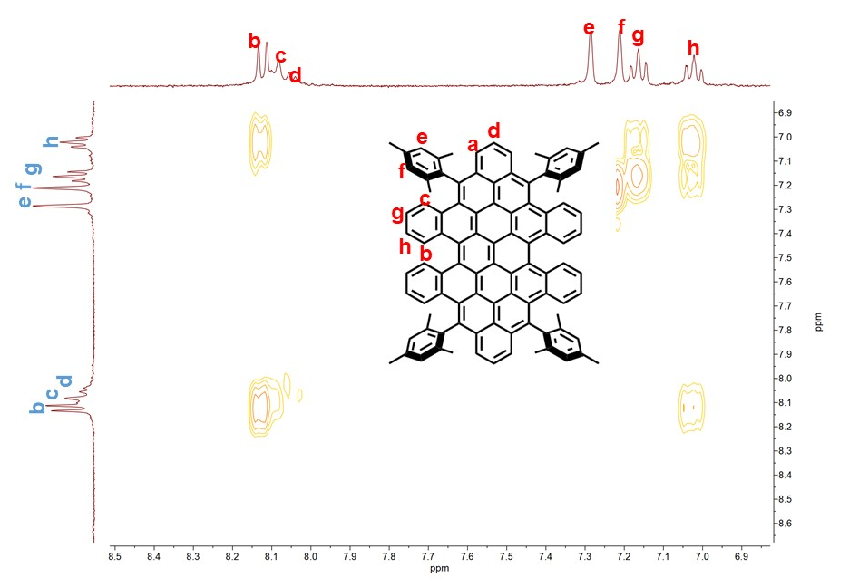
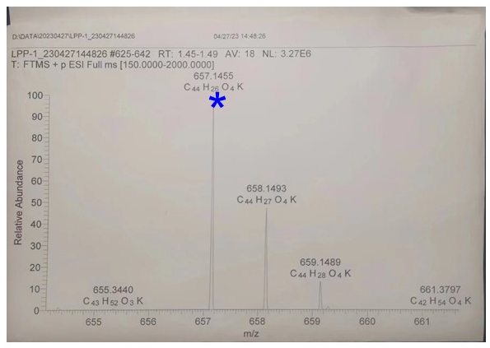
Supplementary Figure 28. The partial 2D COSY NMR (400 MHz, CD₂Cl₂, 298 K) spectrum of 2-PP/MM.
Supplementary Figure 29. HRMS spectrum (ESI) of 1b.
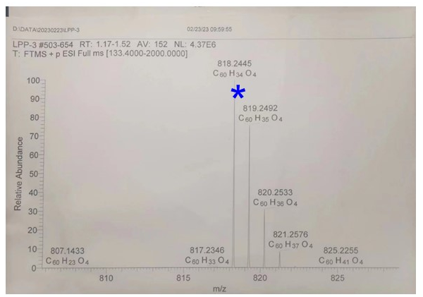
Supplementary Figure 30. HRMS spectrum (ESI) of 2b.
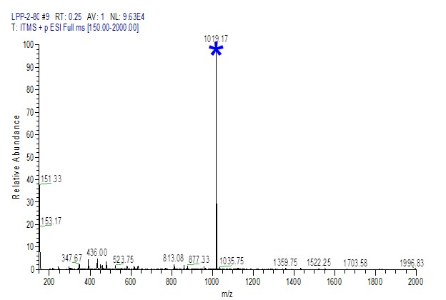
Supplementary Figure 31. The partial ESI-LTQ-XL* MS spectra of 1.
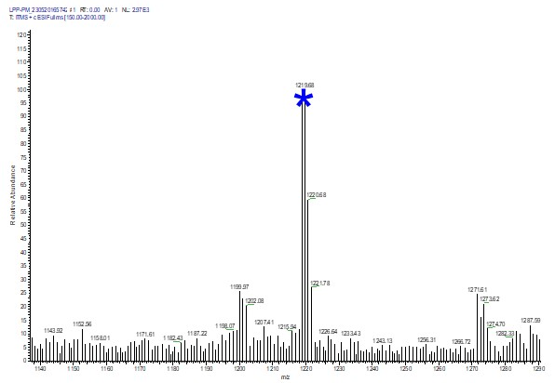
Supplementary Figure 32. The partial ESI-LTQ-XL* MS spectra of 2-PM.
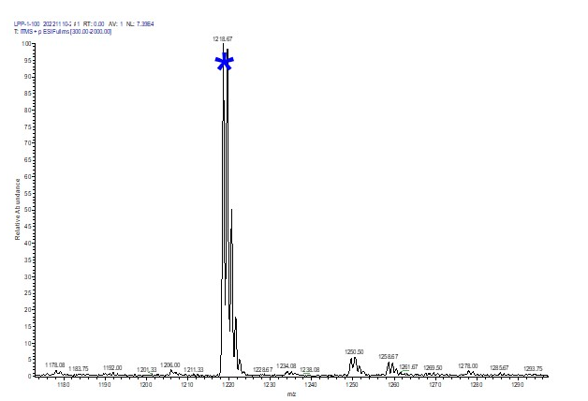
Supplementary Figure 33. The partial ESI-LTQ-XL* MS spectra of 2-PP/MM.

7. References
- Gaussian 16, Revision A.03, Frisch, M. J.et al. Gaussian, Inc., Wallingford CT, 2016.
- Neese, F. Software update: The ORCA program system-Version 5.0. WIREs Comput. Mol. Sci. 12, e1606 (2022).
- Chai, J.-D. & Head-Gordon, M. Long-range corrected hybrid density functionals with damped atom–atom dispersion corrections. Phys. Chem. Chem. Phys. 10, 6615−6620 (2008).
- Hehre, W. J. & Ditchfield, R. Self-Consistent Molecular Orbital Methods. XII. Further Extensions of Gaussian-Type Basis Sets for Use in Molecular Orbital Studies of Organic Molecules. J. Chem. Phys. 56, 2257−2261 (1972).
- Hariharan, P. C. & Pople, J. A. The influence of polarization functions on molecular orbital hydrogenation energies. Theoret. Chim. Acta. 28, 213−222 (1973).
- Seeger, R. & Pople, J. A. Self‐consistent molecular orbital methods. XVIII. Constraints and stability in Hartree–Fock theory. J. Chem. Phys. 66, 3045−3050 (1977).
- Bauernschmitt, R. & Ahlrichs, R. Stability Analysis for Solutions of the Closed Shell Kohn-Sham Equation. J. Chem. Phys. 104, 9047−9052 (1996).
- Mardirossian, N. & Head-Gordon, M. ωB97M-V: A combinatorially optimized, range-separated hybrid, meta-GGA density functional with VV10 nonlocal correlation. J. Chem. Phys. 144, 214110 (2016).
- Weigend, F. & Ahlrichs, R. Balanced basis sets of split valence, triple zeta valence and quadruple zeta valence quality for H to Rn: Design and assessment of accuracyPhys. Chem. Chem. Phys. 7, 3297−3305 (2005).
- Weigend, F. Accurate Coulomb-fitting basis sets for H to Rn. Phys. Chem. Chem. Phys. 8, 1057−1065 (2006).
- Grimme, S. Supramolecular binding thermodynamics by dispersion-corrected density functional theory. Chem. Eur. J. 18, 9955−9964 (2012).
- Lu, T. & Chen, Q. Shermo: A general code for calculating molecular thermochemistry properties. Theor. Chem. 1200, 113249 (2021).
- Miertuš, S., Scrocco, E. & Tomasi, J. Electrostatic interaction of a solute with a continuum. A direct utilizaion of AB initio molecular potentials for the prevision of solvent effects. Chem. Phys. 55, 117−129 (1981).
- Chen, Z., Wannere, C. S., Corminboeuf, C., Puchta, R. & Schleyer, P. Nucleus-independent chemical shifts (NICS) as an aromaticity criterion. Chem. Rev. 105, 3842−3888 (2005).
- Fallah-Bagher-Shaidaei, H., Wannere, C. S., Corminboeuf, C., Puchta, R. & Schleyer, P. v. R. Which NICS Aromaticity Index for Planar π Rings Is Best? Org. Lett. 8, 863−866 (2006).
- Geuenich, D., Hess, K., Kohler, F. & Herges, R. Anisotropy of the induced current density (ACID), a general method to quantify and visualize electronic delocalization. Chem. Rev. 105, 3758−3772 (2005).
- Povray, Persistence of vision raytracer, POV-Ray 3.7, http://www.povray.org/ (accessed on Nov 20, 2019).
- Liu, Z., Lu, T. & Chen, Q. An sp-hybridized all-carboatomic ring, cyclo[18]carbon: Bonding character, electron delocalization, and aromaticity. Carbon 165, 468-475 (2020).
- Humphrey, W., Dalke, A. & Schulten, K. VMD: Visual molecular dynamics. J. Mol. Graph. 14, 33−38 (1996).
- Dunning, T. H. Jr. Gaussian basis sets for use in correlated molecular calculations. I. The atoms boron through neon and hydrogen. J. Chem. Phys. 90, 1007−1023 (1989).
- Yamaguchi, K. The electronic structures of biradicals in the unrestricted Hartree-Fock approximation. Chem. Phys. Lett. 33, 330−335 (1975).
- Agranat, I. & Tapuhi, Y. Dynamic Stereochemistry in Overcrowded Ethylenes. Conformational Behavior of Bianthrones. J. Org. Chem. 44, 1941−1948 (1979).
- Tanaka, K. et al. Effect of alkyl substituents: 5,15-bis(trimethylsilylethynyl)-vs.5,15-bis(triisopropylsilylethynyl)-tetrabenzoporphyrins and their metal complexes. RSC Adv. 3, 15310−15315 (2013).

