SUPPLUMENTAL MATERIAL

Simultaneous Detection of Common Founder Mutations using a Cost-Effective Deep Sequencing Panel
Sapir Shalom^{1,2}, Mor Hanany¹, Avital Eilat¹, Itay Chowers¹, Tamar Ben-Yosef³, Samer Khateb¹, Eyal Banin¹, Dror Sharon¹
1- Department of Ophthalmology, Hadassah Medical Center, Faculty of Medicine, The Hebrew University of Jerusalem, 91120 Jerusalem, Israel.
2- Department of Military Medicine and "Tzameret", Faculty of Medicine, Hebrew University of Jerusalem and Medical Corps, Israel Defense Forces, Jerusalem, Israel.
3- Rappaport Faculty of Medicine, Technion - Israel Institute of Technology, Haifa, Israel.

Corresponding author:
Dror Sharon, PhD., Department of Ophthalmology, Hadassah-Hebrew University Medical Center, Jerusalem, Israel, 91120; Phone: +972 2 6777112; Fax: +972 2 6448917; E-mail: dror.sharon1@mail.huji.ac.il

Keywords: NGS, panel sequencing, Inherited retinal diseases, primers

Supp Figure S1

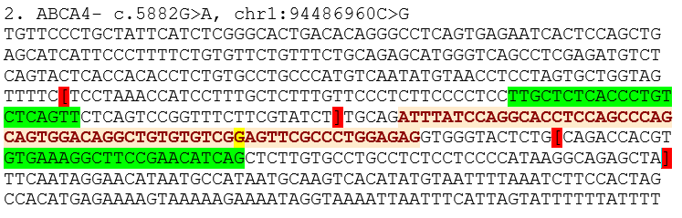
An example of a sequence that was used as an input in FastPCR. In this figure one of the founder mutations from the panel is presented (marked in yellow). The brackets (marked in red) are used to define the preferred primer location. The software designs the primers in the areas bounded by the brackets. The selected primers are marked in green.

