Vinyl-Methyl Substituted Silica Aerogel-Like Hybrids as Effective Oil/Organic Solvent Sorbents
Selay Sert Çok¹, Fatoș Koç^{1,2}, Adél Len^{3,4}, Nilay Gizli¹, Zoltán Imre Dudás^{3,*}
¹Ege University, Faculty of Engineering, Chemical Engineering Department, İzmir 35100, Turkey
²Ege University, Graduate School of Natural and Applied Sciences, Chemical Engineering Department, İzmir, 35100, Turkey
³Centre for Energy Research, Neutron Spectroscopy Department, 1121 Budapest, Hungary
⁴Universiry of Pécs, Faculty of Engineering and Information Technology, Structural Diagnostics and Analysis Research Team, 7624 Pécs, Boszorkány street 2, Hungary

SUPPLEMENTARY DOCUMENT
This document contains the physical appearances of the samples (Figure S1), SEM images of each series at different magnification rates (Figure S2-6), a video that demonstrates the hydrophobic behavior of the materials in VT series whose contact angle measurements couldn’t be performed (Figure S8).
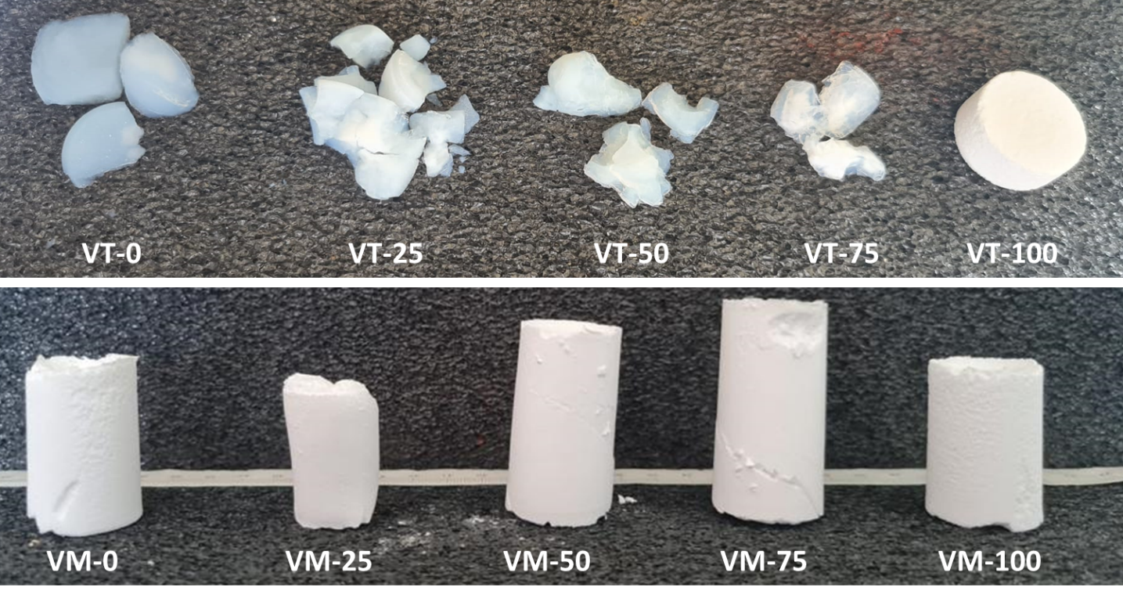
Figure S1. Physical appearances of the samples in VM series after drying.

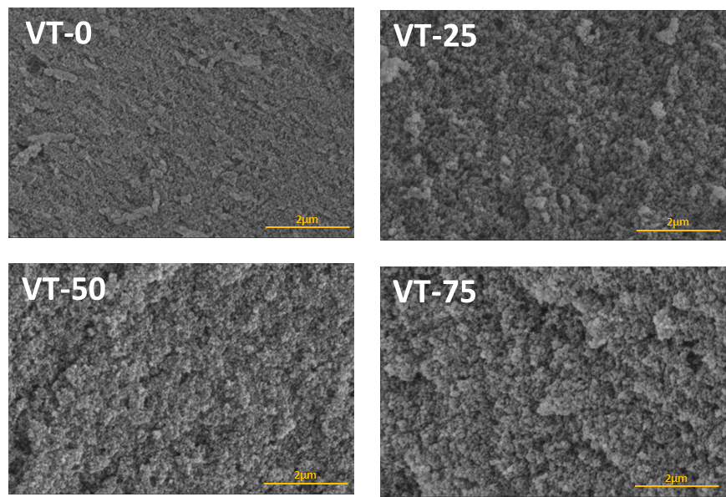
Figure S2. SEM images of samples VT0-75 with 50.000 magnification rate.
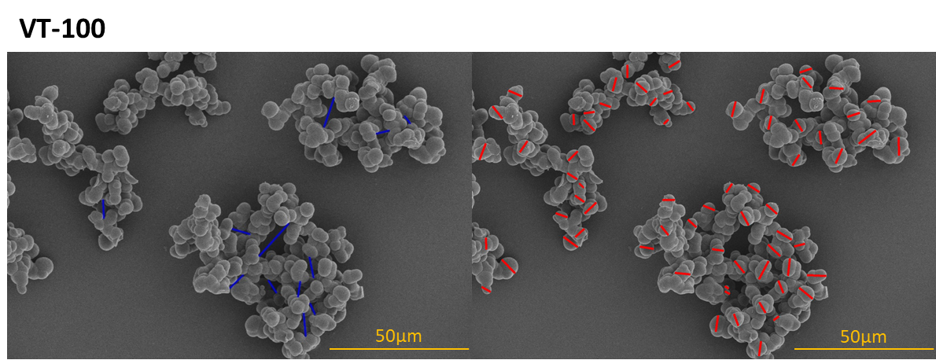
Figure S3. SEM images of sample VT-100 with particle and pore size analysis by using ImageJ (blue lines indicate the pores and red lines indicate the particle diameter).

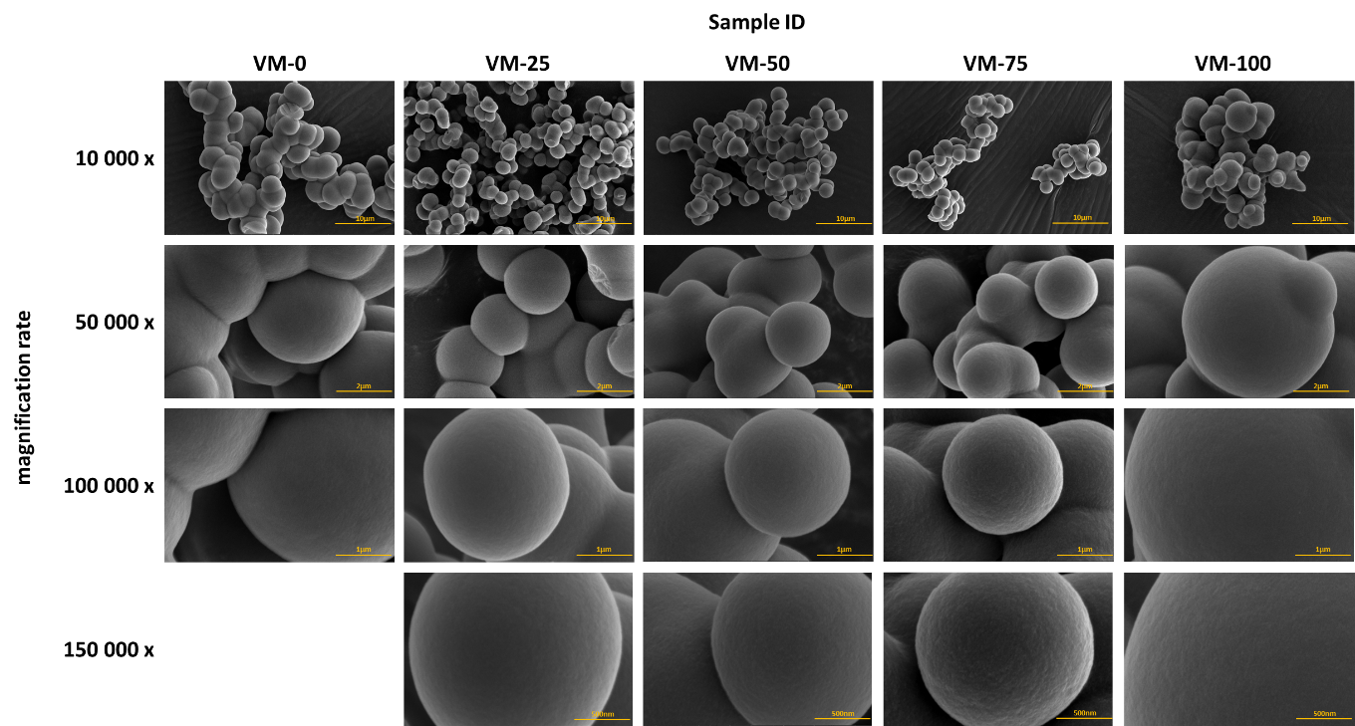
Figure S4. SEM images of samples VM series with different magnification rate.
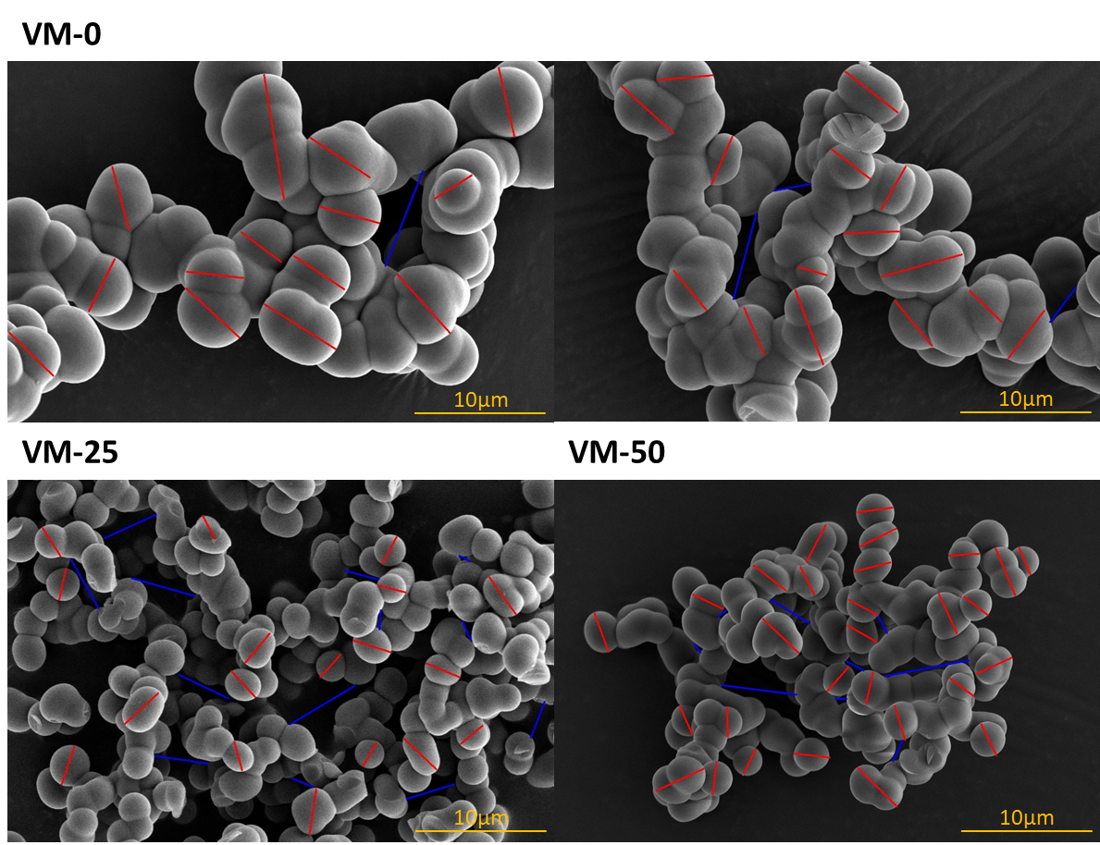
Figure S5. SEM images of samples VM series (0-50) with particle and pore size analysis by using ImageJ (blue lines indicate the pores and red lines indicate the particle diameter).
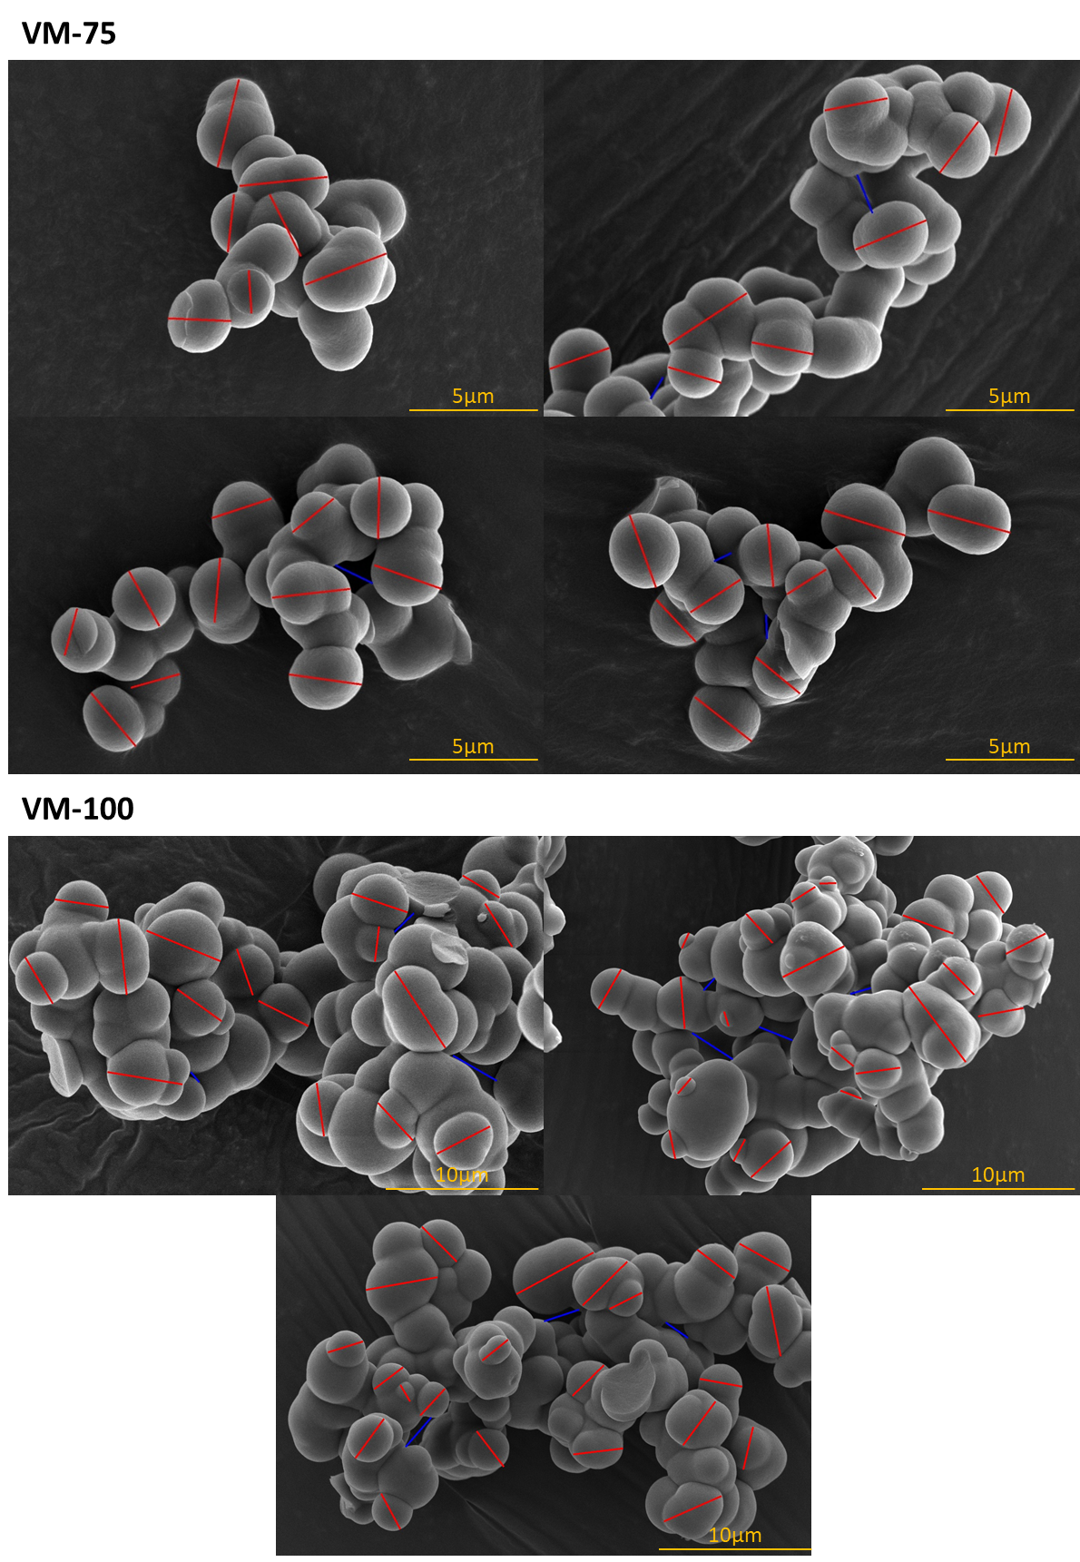
Figure S6. SEM images of samples VM series (75-100) with particle and pore size analysis by using ImageJ (blue lines indicate the pores and red lines indicate the particle diameter).
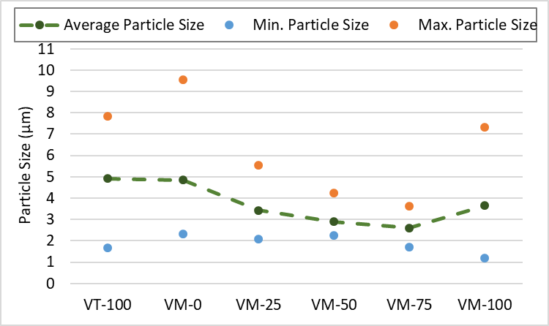
Figure S7. The particle size range of the samples VT-100 and VM series.
Table S1. The pore size analysis of the samples VT-100 and VM series with the help of SEM images by using ImageJ
 | Pore size (µm)
 | VT-100 | VM-0 | VM-25 | VM-50 | VM-75 | VM-100
1 | 5.49 | 6.86 | 2.73 | 3.61 | 1.55 | 3.94
2 | 4.08 | 2.93 | 3.05 | 0.85 | 0.75 | 2.11
3 | 5.99 | 3.38 | 4.43 | 1.60 | 0.95 | 1.02
4 | 4.64 | 7.79 | 5.08 | 1.60 | 0.00 | 3.04
5 | 3.48 |  | 4.25 | 0.95 | 1.62 | 2.89
6 | 8.66 |  | 5.83 | 5.86 | 0.97 | 2.11
7 | 5.00 |  | 4.17 | 6.61 |  | 3.78
8 | 15.63 |  | 0.98 | 1.82 |  | 1.29
9 | 9.64 |  | 3.87 | 0.94 |  | 2.81
10 | 6.99 |  | 4.43 |  |  | 1.67
11 | 7.10 |  | 1.82
12 |  |  | 1.58
13 |  |  | 1.63
Average (µm) | 6.97 | 5.24 | 3.37 | 2.65 | 0.98 | 2.47

Table S2. The particle size analysis of the samples VT-100 and VM series with the help of SEM images by using ImageJ
 | Particle size (µm)
 | VT-100 | VM-0 | VM-25 | VM-50 | VM-75 | VM-100
1 | 5.33 | 6.18 | 2.97 | 2.47 | 2.48 | 3.54
2 | 5.74 | 6.45 | 3.56 | 2.31 | 3.52 | 3.84
3 | 6.19 | 5.17 | 2.39 | 3.28 | 3.38 | 2.29
4 | 4.94 | 4.56 | 2.56 | 2.80 | 2.71 | 3.18
5 | 6.11 | 4.30 | 3.15 | 2.89 | 2.45 | 5.21
6 | 6.40 | 5.44 | 2.41 | 2.60 | 2.70 | 4.96
7 | 4.09 | 4.06 | 2.15 | 2.59 | 2.42 | 3.31
8 | 4.28 | 6.49 | 2.09 | 2.37 | 2.87 | 2.78
9 | 3.92 | 6.10 | 2.37 | 2.30 | 3.06 | 3.33
10 | 4.58 | 5.41 | 2.24 | 2.56 | 3.01 | 3.82
11 | 4.46 | 5.62 | 3.05 | 3.30 | 2.48 | 2.82
12 | 4.45 | 4.73 | 3.57 | 3.20 | 3.32 | 2.82
13 | 5.62 | 9.55 | 2.27 | 2.63 | 2.81 | 1.49
14 | 4.12 | 4.43 | 2.83 | 2.65 | 3.30 | 3.91
15 | 5.07 | 4.50 | 3.46 | 3.40 | 1.80 | 3.65
16 | 4.13 | 3.39 | 2.68 | 2.41 | 2.27 | 4.40
17 | 6.38 | 5.53 | 2.81 | 3.06 | 1.69 | 3.37
18 | 4.46 | 4.67 | 4.43 | 2.75 | 3.44 | 3.40
19 | 4.56 | 5.01 | 4.50 | 2.81 | 2.46 | 6.81
20 | 4.93 | 3.85 | 3.39 | 2.39 | 2.79 | 4.21
21 | 4.53 | 4.77 | 5.53 | 3.88 | 2.51 | 3.37
22 | 6.04 | 2.32 | 4.67 | 3.11 | 1.89 | 5.68
23 | 5.49 | 3.87 | 5.01 | 2.64 | 2.07 | 4.84
24 | 6.96 | 4.02 | 3.85 | 2.24 | 1.97 | 3.52
25 | 6.33 | 4.31 | 4.77 | 4.23 | 2.34 | 1.19
26 | 5.72 | 4.62 | 2.32 | 2.52 | 2.24 | 1.91
27 | 1.66 | 3.84 | 3.87 | 4.10 | 2.52 | 7.33
28 | 2.09 | 4.02 | 4.02 | 3.95 | 2.22 | 3.48
29 | 2.48 | 3.50 | 4.31 | 3.02 | 2.50 | 3.60
30 | 4.64 | 3.25 | 4.62 | 2.31 | 2.98 | 4.16
31 | 7.49 |  | 3.84 |  | 2.49 | 1.75
32 | 4.25 |  | 4.02 |  | 2.15 | 2.19
33 | 2.31 |  | 3.50 |  | 2.45 | 5.35
34 | 4.84 |  |  |  | 2.45 | 3.44
35 | 5.84 |  |  |  | 2.66 | 4.03
36 | 5.78 |  |  |  | 3.64 | 4.18
37 | 5.00 |  |  |  |  | 4.64
38 | 5.21 |  |  |  |  | 7.14
39 | 5.72 |  |  |  |  | 4.25
40 | 5.54 |  |  |  |  | 4.35
41 | 3.95 |  |  |  |  | 4.17
42 | 4.26 |  |  |  |  | 5.92
43 | 4.03 |  |  |  |  | 2.87
44 | 5.24 |  |  |  |  | 2.57
45 | 5.17 |  |  |  |  | 4.89
46 | 2.38 |  |  |  |  | 3.13
47 | 3.48 |  |  |  |  | 3.77
48 | 3.47 |  |  |  |  | 5.49
49 | 3.80 |  |  |  |  | 3.47
50 | 4.78 |  |  |  |  | 2.83
51 | 4.59 |  |  |  |  | 1.58
52 | 5.83 |  |  |  |  | 2.28
53 | 5.25 |  |  |  |  | 4.17
54 | 5.94 |  |  |  |  | 2.28
55 | 4.81 |  |  |  |  | 3.06
56 | 4.75 |  |  |  |  | 1.31
57 | 4.92 |  |  |  |  | 3.45
58 | 4.86 |  |  |  |  | 1.31
59 | 5.12 |  |  |  |  | 3.59
60 | 7.83
61 | 4.79
62 | 4.61
63 | 4.74
64 | 4.98
65 | 5.12
66 | 6.74
67 | 3.75
68 | 6.92
69 | 4.35
70 | 6.40

Video S1. The demonstration of the hydrophobic behavior of the materials in VT.

Table S3. Physicochemical properties of pollutants and volume based capacities of the samples for different oil/organic solvents
 | Properties | Pollutants
 | Properties | Vegetable oils |  | Petroleum products |  |  | Organic Solvents
 | Properties | Sunflower oil | Olive oil | Kerosene | Diesel oil | Gasoline | Toluene | Hexane | Heptane
 | density, g/cm³ | 0.918 | 0.917 | 0.810 | 0.850 | 0.740 | 0.880 | 0.661 | 0.684
 | viscosity, cP at 300 K | 42.970 | 84.000 | 1.640 | - | - | 0.550 | 0.297 | 0.376
 | surface tension, mN/m | 37.040 | 32.000 | 23.000 | 28.890 | 21.600 | 18.000 | 14.900 | 15.200
 |  | Pollutants / Capacities (cm³/g)
Series ID | Sample ID | Sunflower oil | Olive oil | Kerosene | Diesel oil | Gasoline | Toluene | Hexane | Heptane
VM series | VM-0 | 10.96 | 12.09 | 9.07 | 9.48 | 8.49 | 9.75 | 9.91 | 10.22
VM series | VM-25 | 9.64 | 10.51 | 9.09 | 9.71 | 8.70 | 9.82 | 9.68 | 10.28
VM series | VM-50 | 11.32 | 12.64 | 9.22 | 10.38 | 9.39 | 10.42 | 10.05 | 10.47
VM series | VM-75 | 7.20 | 7.45 | 6.77 | 7.84 | 7.47 | 7.47 | 7.61 | 8.26
VM series | VM-100 | 8.67 | 9.07 | 9.52 | 8.91 | 9.62 | 9.86 | 9.80 | 9.88
VT series | VT-0 | 7.07 | 8.50 | 8.35 | 9.39 | 11.86 | 9.01 | 10.14 | 9.44
VT series | VT-25 | 12.24 | 13.49 | 8.64 | 8.99 | 12.36 | 9.52 | 11.57 | 9.31
VT series | VT-50 | 1.45 | 3.92 | 9.00 | 5.91 | 7.36 | 4.43 | 9.18 | 9.39
VT series | VT-75 | 1.96 | 3.97 | 5.81 | 6.31 | 7.86 | 5.34 | 10.71 | 9.62
VT series | VT-100 | 10.98 | 11.87 | 10.32 | 9.46 | 13.57 | 9.69 | 11.69 | 9.96

