Supporting Information:

Enhancement in selectivity of trivalent Am over Cm by modulating donor centres of aza-macrocyclic ligands: An implication of their differences in bonding

Saparya Chattaraj^{a,c}, Arunasis Bhattacharyya^{b,c*}
ªHealth Physics Division, Health, Safety and Environment Group, Bhabha Atomic Research Centre, Mumbai – 400 085, India
^{b}Radiochemistry Division, Radiochemistry and Isotope Group, Bhabha Atomic Research Centre, Mumbai – 400 085, India,
^{c}Homi Bhabha National Institute, Anushaktinagar, Mumbai-400 094, India

*Corresponding Author: Tel.: +91 22 25596335, E-mail: arun12@barc.gov.in
Keywords: minor actinide separation, soft donor, bonding, f-orbital, relativistic DFT

Table S1. Spin contamination in the complexes
Systems | Exact | Calculated | Error (%)
AmL1 | 12 | 12.01683 | 0.14
CmL1 | 15.75 | 15.75791 | 0.05
AmL2 | 12 | 12.02086 | 0.17
CmL2 | 15.75 | 15.75924 | 0.06

Table S2. Natural and AIM charges on metal and donor centres on the complexes and ligands respectively
Natural Charges | Ring O/S | COO | PyN | Ring N | Am/Cm | LMCT | AIM Charges | Ring O/S | COO | PyN | Ring N | Am/Cm | LMCT
AmL1 | -0.56 | -0.86 | -0.52 | -0.43 | 1.99 | 1.01 | AmL1 | -1.06 | -1.20 | -1.10 | -0.93 | 2.18 | 0.82
 | -0.55 | -0.86 | -0.52 | -0.43 |  |  |  | -1.05 | -1.20 | -1.10 | -0.93
 | -0.56 |  |  |  |  |  |  | -1.06
 | -0.55 |  |  |  |  |  |  | -1.05
Average | -0.55 | -0.86 | -0.52 | -0.43 | 1.99 |  | Average | -1.05 | -1.20 | -1.10 | -0.93 | 2.18
CmL1 | -0.56 | -0.88 | -0.54 | -0.43 | 2.05 | 0.95 | CmL1 | -1.06 | -1.20 | -1.11 | -0.92 | 2.20 | 0.80
 | -0.55 | -0.88 | -0.54 | -0.43 |  |  |  | -1.05 | -1.20 | -1.11 | -0.92
 | -0.56 |  |  |  |  |  |  | -1.06
 | -0.55 |  |  |  |  |  |  | -1.05
Average | -0.55 | -0.88 | -0.54 | -0.43 | 2.05 |  | Average | -1.05 | -1.20 | -1.11 | -0.92 | 2.20
AmL2 | 0.12 | -0.86 | -0.52 | -0.43 | 1.58 | 1.42 | AmL2 | -0.10 | -1.20 | -1.09 | -0.91 | 2.05 | 0.95
 | 0.17 | -0.86 | -0.52 | -0.43 |  |  |  | -0.05 | -1.21 | -1.09 | -0.91
 | 0.17 |  |  |  |  |  |  | -0.05
 | 0.12 |  |  |  |  |  |  | -0.10
Average | 0.14 | -0.86 | -0.52 | -0.43 | 1.58 |  | Average | -0.07 | -1.20 | -1.09 | -0.91 | 2.05
CmL2 | 0.11 | -0.87 | -0.53 | -0.43 | 1.67 | 1.33 | CmL2 | -0.12 | -1.21 | -1.10 | -0.93 | 2.06 | 0.94
 | 0.16 | -0.87 | -0.53 | -0.43 |  |  |  | -0.05 | -1.21 | -1.10 | -0.93
 | 0.11 |  |  |  |  |  |  | -0.12
 | 0.16 |  |  |  |  |  |  | -0.05
Average | 0.14 | -0.87 | -0.53 | -0.43 | 1.67 |  | Average | -0.08 | -1.21 | -1.10 | -0.93 | 2.06
L1 | -0.52 | -0.76 | -0.43 | -0.41 |  |  | L1 | -1.04 | -1.22 | -0.99 | -0.91
 | -0.54 | -0.74 | -0.45 | -0.40 |  |  |  | -1.03 | -1.22 | -1.01 | -0.90
 | -0.52 | -0.75 |  |  |  |  |  | -1.02 | -1.22
 | -0.53 | -0.76 |  |  |  |  |  | -1.02 | -1.23
Average | -0.53 | -0.75 | -0.44 | -0.40 |  |  | Average | -1.03 | -1.22 | -1.00 | -0.90
L2 | 0.06 | -0.76 | -0.43 | -0.42 |  |  | L2 | -0.07 | -1.22 | -0.99 | -0.91
 | 0.08 | -0.74 | -0.45 | -0.40 |  |  |  | -0.04 | -1.22 | -1.02 | -0.89
 | 0.09 | -0.74 |  |  |  |  |  | -0.03 | -1.23
 | 0.11 | -0.76 |  |  |  |  |  | -0.02 | -1.23
Average | 0.09 | -0.75 | -0.44 | -0.41 |  |  | Average | -0.04 | -1.23 | -1.00 | -0.90

Table S3. Electron densities at the bond critical point of metal-donor bonds in the complexes
System | Electron Density at BCP
System | M-OS1 | M-OS2 | M-OS3 | M-OS4 | M-COO1 | M-COO2 | M-PyN1 | M-PyN2 | M-RingN1 | M-RingN2
0SAm | 0.023 | 0.019 | 0.023 | 0.019 | 0.081 | 0.081 | 0.043 | 0.043 | 0.019 | 0.019
0SCm | 0.024 | 0.018 | 0.024 | 0.018 | 0.079 | 0.079 | 0.044 | 0.044 | 0.020 | 0.020
4SAm | 0.028 | 0.027 | 0.027 | 0.028 | 0.082 | 0.082 | 0.043 | 0.043 | 0.010 | 0.010
4SCm | 0.026 | 0.026 | 0.026 | 0.026 | 0.080 | 0.080 | 0.044 | 0.044 | 0.011 | 0.011

Table S4. Average (a) delocalisation indices and (b) Wiberg bond indices of the metal-donor bonds in the complexes
(a) | Average Delocalisation Indices
System | M-OS1 | M-OS2 | M-COO | M-PyN | M-RingN
AmL1 | 0.138 | 0.116 | 0.477 | 0.258 | 0.116
CmL1 | 0.143 | 0.099 | 0.441 | 0.252 | 0.121
AmL2 | 0.231 | 0.216 | 0.481 | 0.258 | 0.061
CmL2 | 0.211 | 0.203 | 0.450 | 0.256 | 0.068
(b) | Average Wiberg Bond Indices
System | M-OS1 | M-OS2 | M-COO | M-PyN | M-RingN
AmL1 | 0.112 | 0.108 | 0.312 | 0.178 | 0.108
CmL1 | 0.111 | 0.095 | 0.268 | 0.163 | 0.110
AmL2 | 0.287 | 0.285 | 0.330 | 0.192 | 0.088
CmL2 | 0.263 | 0.265 | 0.284 | 0.176 | 0.092

Fig-S1. α&β-Density of states (DOS) plots for all the complexes

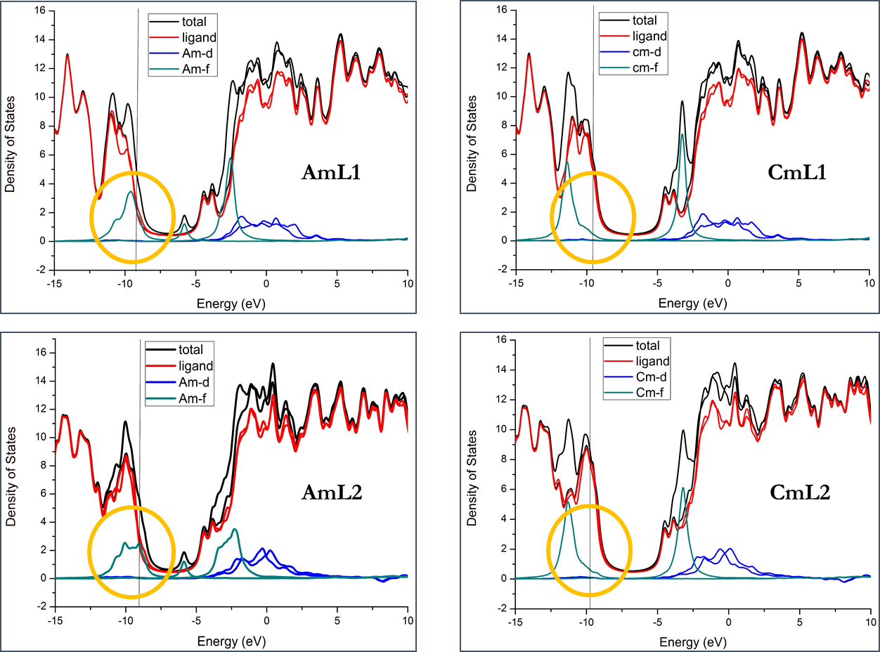

Table S5. Optimised Cartesian coordinates of AmL2 complex
C -4.0924510 0.8213057 -0.6891026
N -3.3139543 0.4515685 0.5090963
C -3.5240031 2.0542365 -1.3881200
C -3.7130301 1.2786082 1.6691577
C -2.5643283 1.6061231 2.6132252
C -0.1938879 3.0846487 3.0555714
C 1.2393056 3.2563678 2.5687792
C 0.1951988 3.0850978 -3.0550349
C -1.2379229 3.2573103 -2.5682035
N 3.3141824 0.4502818 -0.5090007
C 3.7135991 1.2773661 -1.6689129
C 2.5650400 1.6055149 -2.6129337
C 3.5248979 2.0525457 1.3884946
C 4.0928278 0.8194980 0.6892638
C -3.4348773 -0.9849885 0.8213879
C 3.4345520 -0.9862717 -0.8215305
C 2.8639943 -1.8781258 0.2582847
C -2.8647229 -1.8768925 -0.2585987
C 1.1725332 -2.3225356 1.7951938
C 1.8023857 -3.4862601 2.2355991
C 3.0095567 -3.8522318 1.6462411
C 3.5509215 -3.0302836 0.6578032
C -3.5520993 -3.0287355 -0.6582495
C -3.0110824 -3.8507430 -1.6468291
C -1.8037789 -3.4851604 -2.2361588
C -1.1734498 -2.3217564 -1.7955857
Am 0.0000814 0.3039593 0.0000258
H -4.4914517 -1.2708876 0.9965268
H -2.8792156 -1.1717181 1.7533181
H 4.4910261 -1.2725528 -0.9966485
H 2.8788727 -1.1726359 -1.7535239
H 1.3294442 -4.0632951 3.0291840
H 3.5332210 -4.7556286 1.9608647
H 4.5075612 -3.2717672 0.1937785
H -4.5087985 -3.2699400 -0.1942024
H -3.5350865 -4.7539107 -1.9615449
H -1.3310548 -4.0622926 -3.0298027
N -1.6786264 -1.5411569 -0.8137155
N 1.6780214 -1.5420008 0.8134312
C -0.1327078 -1.8670401 2.4243211
O -0.6139203 -0.7616212 1.9041776
O -0.6449157 -2.5071179 3.3354315
C 0.1321415 -1.8668726 -2.4244306
O 0.6137451 -0.7616562 -1.9042200
O 0.6444207 -2.5073852 -3.3351972
H -5.1559802 1.0073068 -0.4394596
H -4.1843513 2.3593540 -2.2116999
H -3.4128179 2.9004563 -0.6938833
H 5.1564348 1.0050994 0.4396530
H 4.0803886 -0.0266989 1.3908902
H 4.1853646 2.3572300 2.2121400
H 3.4140849 2.8989402 0.6944113
H 2.0878265 0.7009850 -3.0142617
H 2.9315273 2.2369630 -3.4342667
H 4.1399302 2.2182760 -1.2922803
H 4.5156031 0.7789598 -2.2482920
H -2.9305478 2.2375818 3.4346696
H -2.0874797 0.7013298 3.0143938
H -4.5152293 0.7804202 2.2484538
H -4.1389869 2.2197552 1.2926948
H -1.2961054 3.9525010 -1.7176851
H -1.8569870 3.6532070 -3.3861244
H 0.2475018 2.3254364 -3.8472176
H 0.5744217 4.0359714 -3.4536878
H -4.0803623 -0.0247766 -1.3908726
H 1.8585278 3.6518500 3.3867809
H 1.2977803 3.9516975 1.7183948
H -0.5727267 4.0356009 3.4544015
H -0.2465010 2.3248601 3.8476120
S -1.2939141 2.5494020 1.6852303
S 1.8857136 1.6211085 2.0695711
S -1.8850111 1.6222259 -2.0692980
S 1.2950047 2.5491565 -1.6847890
Table S6. Optimised Cartesian coordinates of CmL2 complex
C 4.0079231 -0.7244260 -0.8231150
N 3.2613026 -0.4084327 0.4121562
C 3.4762374 -1.9729871 -1.5216409
C 3.7175785 -1.2705360 1.5281217
C 2.6067652 -1.6859899 2.4818136
C 0.2821032 -3.2297567 2.9293422
C -1.1802403 -3.3092842 2.5118019
C -0.2763135 -3.2301807 -2.9293269
C 1.1861658 -3.3071594 -2.5117801
N -3.2604525 -0.4141497 -0.4120738
C -3.7152447 -1.2770825 -1.5280021
C -2.6037352 -1.6905772 -2.4817360
C -3.4726567 -1.9790555 1.5217446
C -4.0064901 -0.7314080 0.8232252
C 3.3907705 1.0195115 0.7686534
C -3.3924254 1.0135612 -0.7686040
C -2.7770407 1.9312066 0.2634329
C 2.7737522 1.9360763 -0.2633697
C -1.0473393 2.3494900 1.7684482
C -1.6253738 3.5488015 2.1831611
C -2.8257746 3.9444283 1.5972723
C -3.4149957 3.1182213 0.6396890
C 3.4095810 3.1242512 -0.6395627
C 2.8188759 3.9494602 -1.5970920
C 1.6191769 3.5517250 -2.1829894
C 1.0432874 2.3513598 -1.7683394
Cm 0.0003371 -0.3200739 0.0000151
H 4.4529650 1.3033138 0.9079548
H 2.8756949 1.1742905 1.7295452
H -4.4551142 1.2954928 -0.9079284
H -2.8776002 1.1692313 -1.7294857
H -1.1224046 4.1292339 2.9554291
H -3.3101313 4.8753004 1.8944257
H -4.3696425 3.3833622 0.1846556
H 4.3637502 3.3910776 -0.1845127
H 3.3015721 4.8812077 -1.8942037
H 1.1151548 4.1313125 -2.9552052
N 1.5938670 1.5719663 -0.8108296
N -1.5965113 1.5691756 0.8108808
C 0.2432963 1.8451075 2.3953136
O 0.6203603 0.6699704 1.9505867
O 0.8338765 2.5198734 3.2315318
C -0.2464997 1.8447587 -2.3951637
O -0.6214451 0.6689002 -1.9505541
O -0.8383607 2.5185977 -3.2312250
H 5.0878322 -0.8616858 -0.6151128
H 4.1327431 -2.2425036 -2.3604215
H 3.4186596 -2.8298288 -0.8342224
H -5.0861734 -0.8705005 0.6152677
H -3.9295322 0.1243382 1.5088170
H -4.1286798 -2.2496810 2.3605456
H -3.4136339 -2.8358069 0.8343360
H -2.1008168 -0.8220438 -2.9276176
H -3.0174030 -2.3371012 -3.2681525
H -4.1712522 -2.1827675 -1.1030494
H -4.5094443 -0.7723683 -2.1112370
H 3.0215441 -2.3317707 3.2682556
H 2.1022864 -0.8183455 2.9276625
H 4.5108516 -0.7643969 2.1113825
H 4.1752179 -2.1754155 1.1032070
H 1.3196782 -3.9328463 -1.6168331
H 1.7755133 -3.7416851 -3.3322399
H -0.4048631 -2.5284881 -3.7647783
H -0.6266352 -4.2210450 -3.2488107
H 3.9295418 0.1311848 -1.5087148
H -1.7688233 -3.7448473 3.3322607
H -1.3126651 -3.9351920 1.6168483
H 0.6341633 -4.2200154 3.2487924
H 0.4094249 -2.5278669 3.7648157
S 1.3540711 -2.6543919 1.5504008
S 1.8029459 -1.6205980 -2.1676533
S -1.3492868 -2.6567466 -1.5503657
S -1.7999540 -1.6237936 2.1677066

