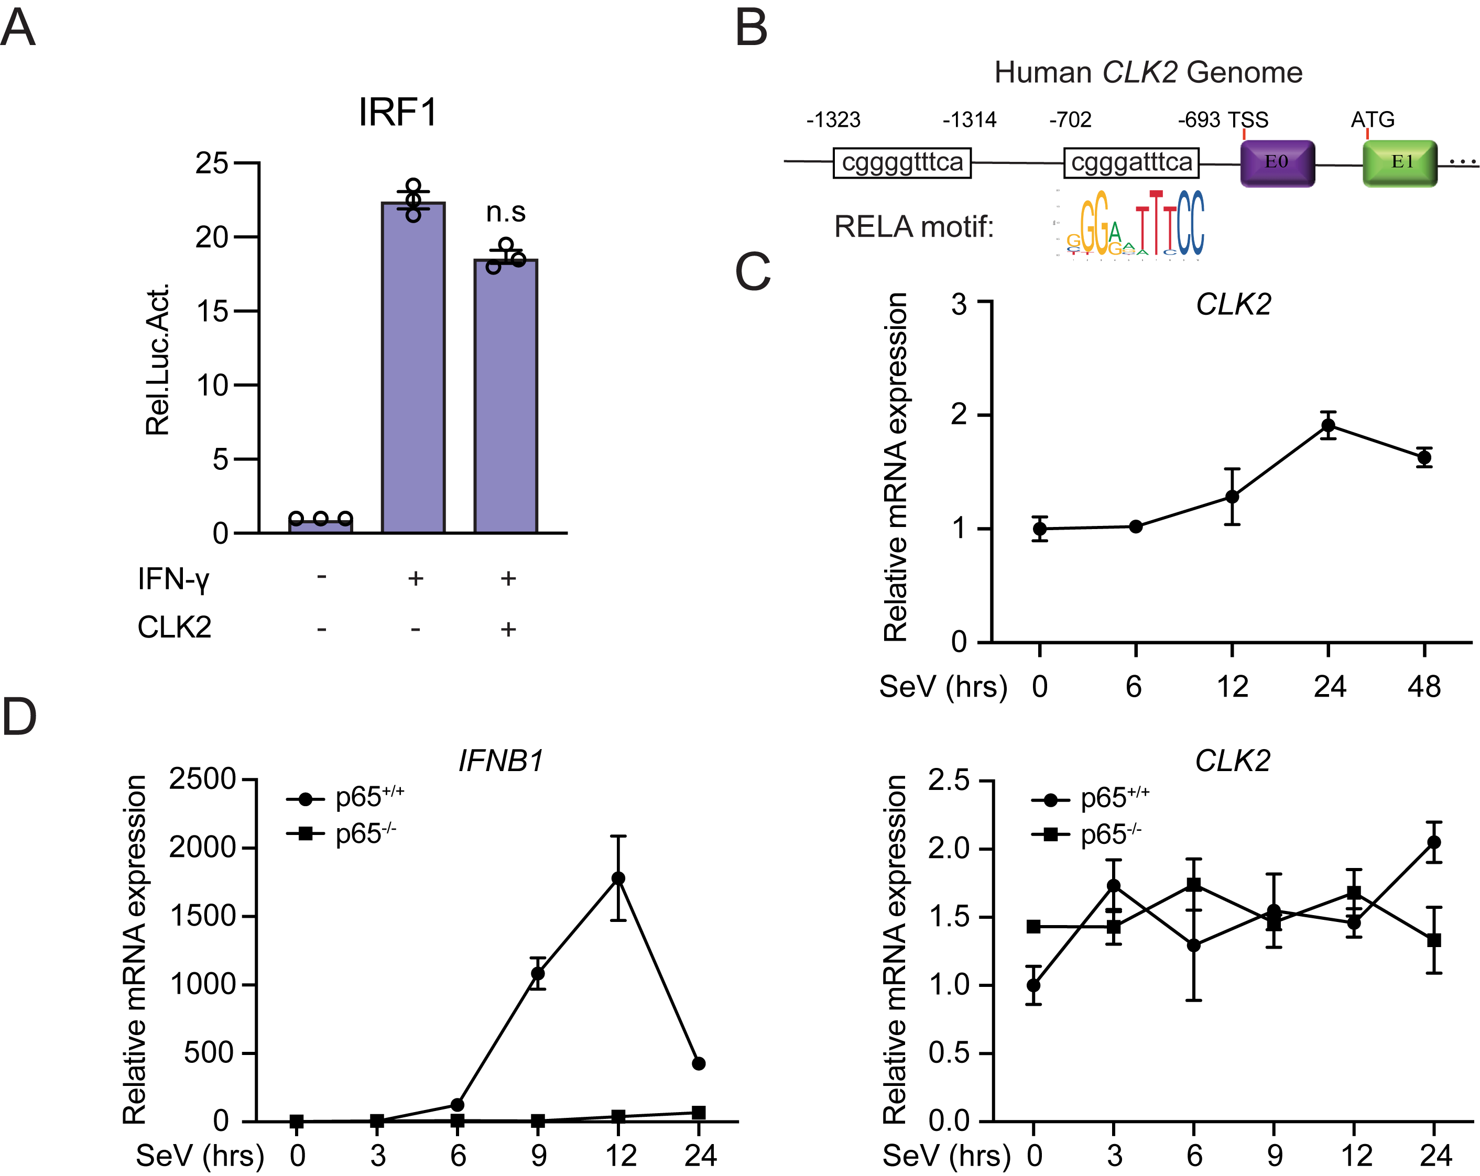
Supplementary Figure 1. CLK2 negatively regulates the transcriptional activation of NF-κB signaling. (a) The IRF1 promoter activity after exposed to IFN-γ (100 ng/ml) for 12 hours in the presence or absence of CLK2 (800 ng) expression plasmids. (b) A schematic of RELA motif in human CLK2 gene promoter. (c) The mRNA level of CLK2 in HEK293T cells after SeV infection at the indicated time points by real-time PCR analysis (n=3). (d) The mRNA level of IFNB1 and CLK2 in p65^{+/+} and p65^{-/-} HEK293T cells after SeV infection at the indicated time points by real-time PCR analysis (n=3). Data are representative of three independent experiments. Data are presented as the mean ± SEM (n=3 for a, c and d). Statistical significance was analyzed by ANOVA (n.s, no significance). Source data (a-d) are provided as a Source Data file.

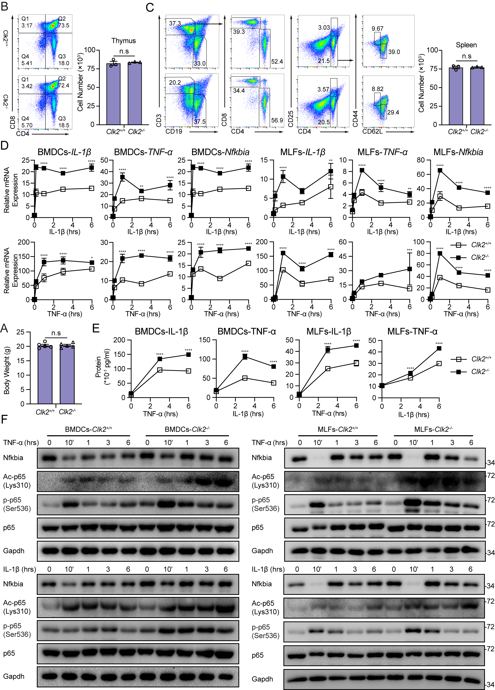
Supplementary Figure 2. Clk2 deficiency enhances NF-κB-mediated inflammatory response. (a) body weight of Clk2^{+/+} and Clk2^{-/-} male mice at age 7 weeks (n=5). (b and c) Flow cytometry analysis and quantitation of immune bccells in thymus (b), spleen (c) from Clk2^{+/+} and Clk2^{-/-} mice (n=3). (d) The real-time PCR analysis of IL-1β, TNF-α and Nfkbia mRNA level in Clk2^{+/+} and Clk2^{-/-} BMDCs and MLFs cells stimulated with TNF-α (50 ng/ml) and IL-1β (50 ng/ml) for indicated time points (n=3). (e) The ELISA analysis of IL-1β and TNF-α protein level in Clk2^{+/+} and Clk2^{-/-} BMDCs and MLFs cells stimulated with TNF-α and IL-1β for indicated time points (n=3). (f) Western blot analysis of Nfkbia, Ac-p65^{K310}, p-p65^{S536}, p65 and Gapdh in Clk2^{+/+} and Clk2^{-/-} BMDCs and MLFs cells stimulated with TNF-α and IL-1β for indicated time points. Data are representative of three independent experiments. Data are presented as the mean ± SEM. Statistical significance was analyzed by Student’s t-test (a-c) or ANOVA (d, e) (n.s, no significance, *p < 0.05, **p < 0.01, ***p < 0.001, ****p < 0.0001). Source data (a-f) are provided as a Source Data file.

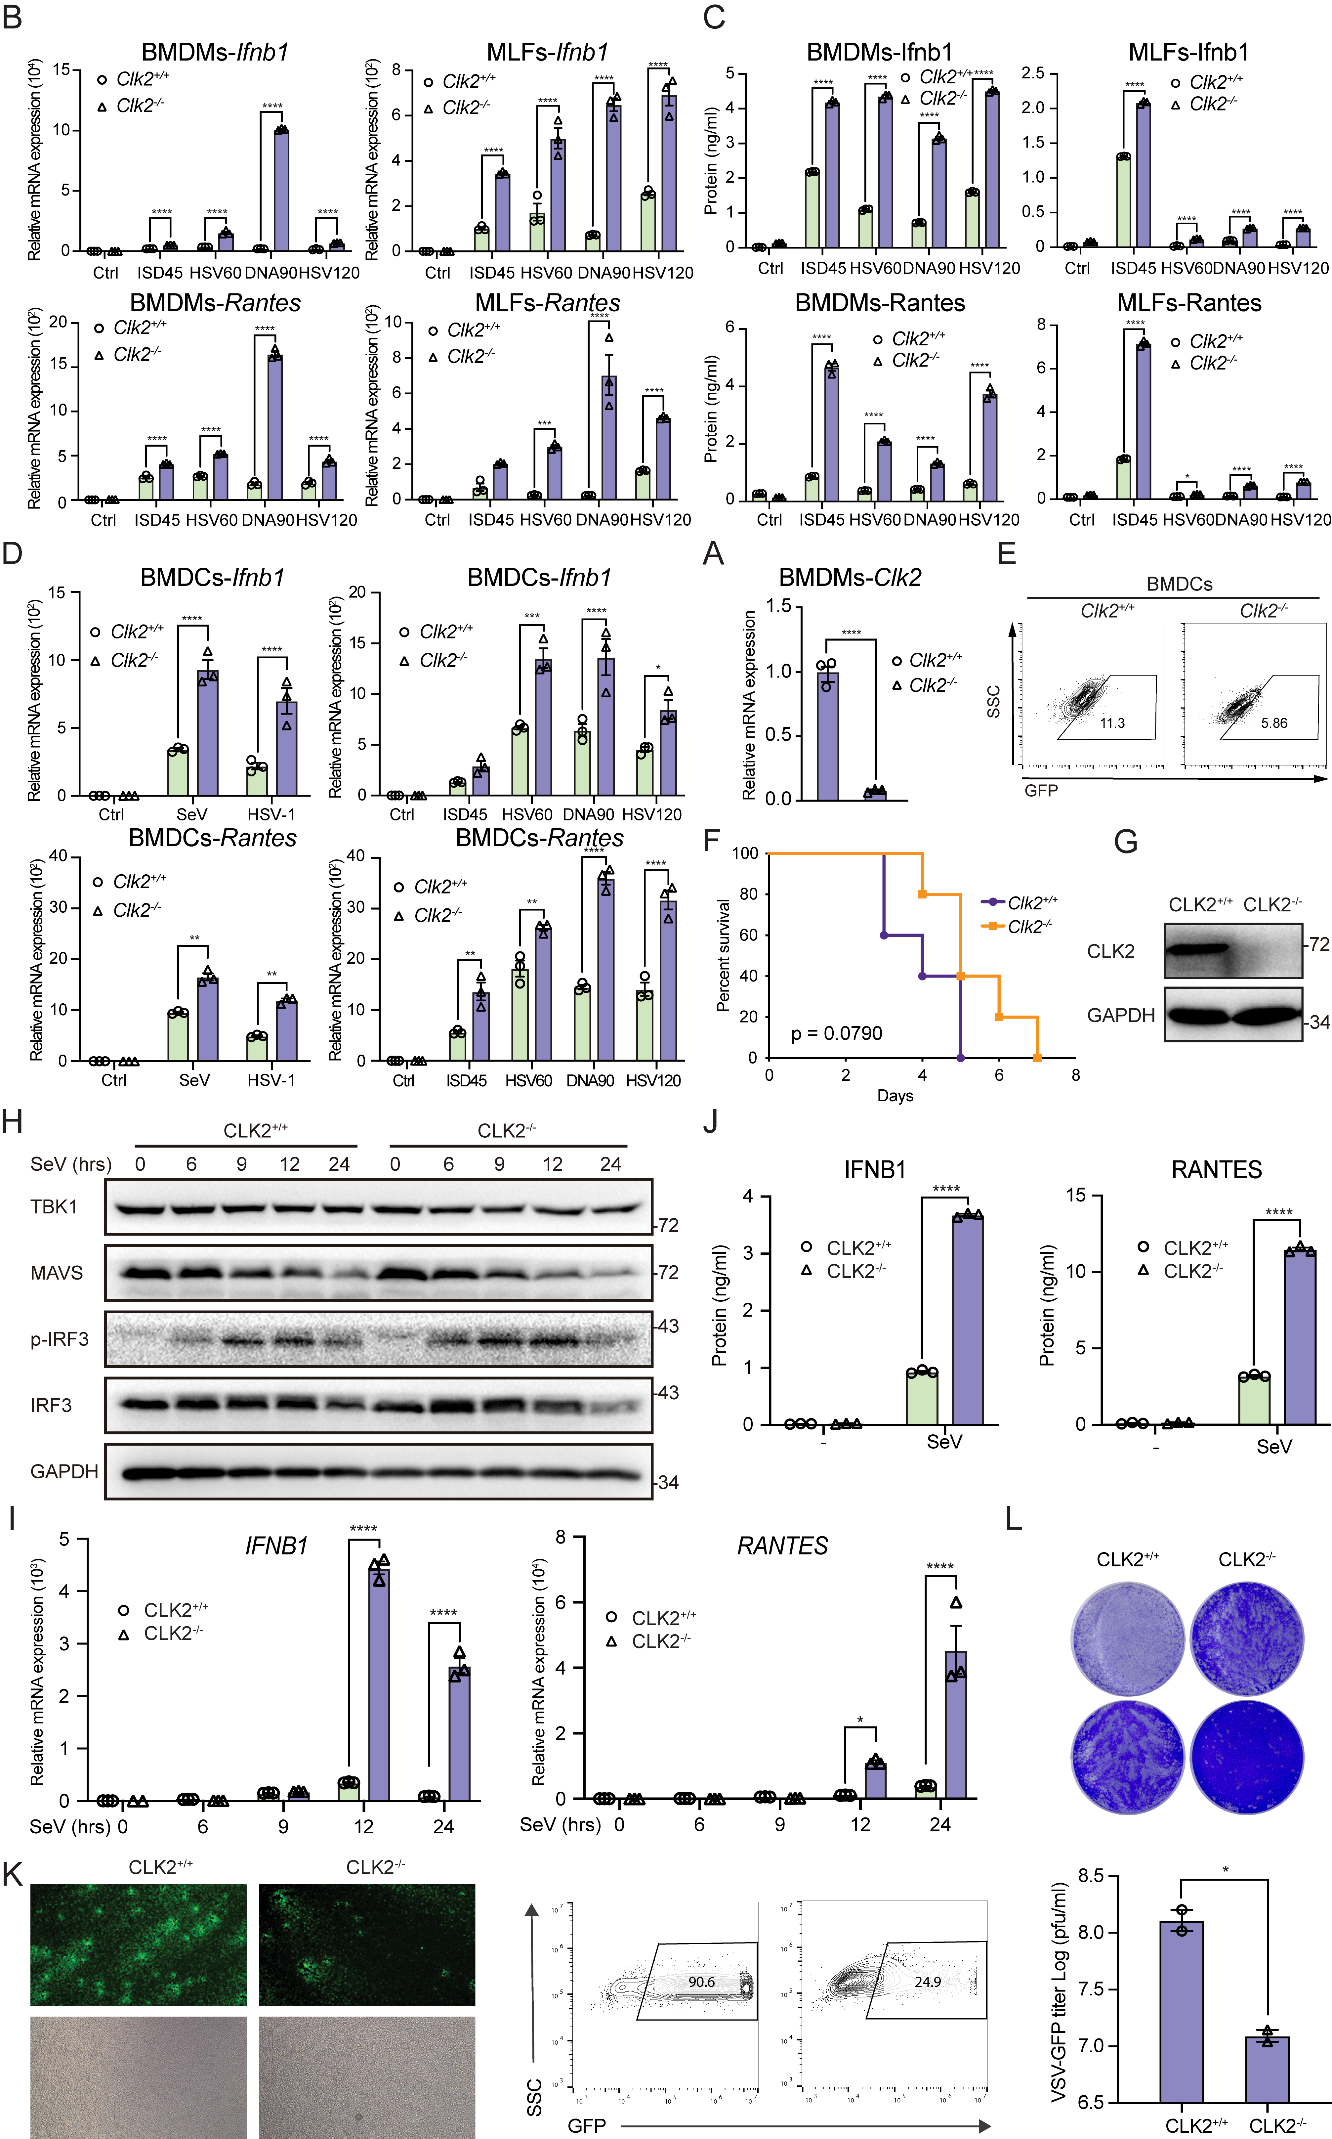
Supplementary Figure 3. CLK2 deficiency enhances virus-induced IFN-β production and antiviral response. (a) identification of Clk2 deficient mice at the mRNA level in BMDMs (n=3). (b) The real-time PCR analysis of Ifnb1 and Rantes mRNA level in Clk2^{+/+} and Clk2^{-/-} BMDMs and MLFs cells transfected with ISD45, HSV60, DNA90, and HSV120 for 6 hours (n=3). (c) The ELISA analysis of Ifnb1 and Rantes protein level in Clk2^{+/+} and Clk2^{-/-} BMDMs and MLFs cells transfected with ISD45, HSV60, DNA90 and HSV120 for 6 hours (n=3). (d) The real-time PCR analysis of Ifnb1 and Rantes mRNA level in Clk2^{+/+} and Clk2^{-/-} BMDCs cells infected with SeV for 12 hours or HSV-1 for 6 hours or transfected with ISD45, HSV60, DNA90 and HSV120 for 6 hours (n=3). (e) The Clk2^{+/+} and Clk2^{-/-} BMDCs cells were infected with VSV-GFP at a MOI of 2 for 12 hours before flow cytometry analysis. (f) Survival assays (Kaplan-Meier curve) of Clk2^{+/+} and Clk2^{-/-} mice at 6 weeks infected with HSV-1 (2.4×10⁶ pfu) via tail vein and intraperitoneal injection. The survival of the mice was monitored for 8 days (n=5). (g) Identification of CLK2 deletion at protein levels in HEK293T cells by Western blot. (h) Western blot analysis of phosphorylated IRF3 and total TBK1, MAVS, IRF3 and GAPDH in CLK2^{+/+} and CLK2^{−/−} HEK293T cells infected with SeV at indicated time. (i) The real-time PCR analysis of IFNB1 and RANTES mRNA level in CLK2^{+/+} and CLK2^{-/-} HEK293T cells infected with SeV at the indicated time points (n=3). (j) The ELISA analysis of IFNB1 and RANTES protein level in the supernatant of CLK2^{+/+} and CLK2^{-/-} HEK293T cells infected with SeV for 24 hours (n=3). (k) The effects of CLK2 deficiency on VSV-GFP infection for 12 hours before phase-contrast and fluorescence microscopy as well as flow cytometry analysis in CLK2^{+/+} and CLK2^{-/-} HEK293T cells. (l) The CLK2^{+/+} and CLK2^{-/-} HEK293T cells were infected with VSV-GFP for 1 hour and followed by continuing culturing for 24 hours with replaced fresh medium, then the supernatants were subjected to plague assays using Vero cells (n=2). Data are representative of three independent experiments. Data are presented as the mean ± SEM. Statistical significance was analyzed by Student’s t-test (a, l) or ANOVA (b-d, i-j) (*p < 0.05, **p < 0.01, ***p < 0.001, ****p < 0.0001). Source data (a-l) are provided as a Source Data file.

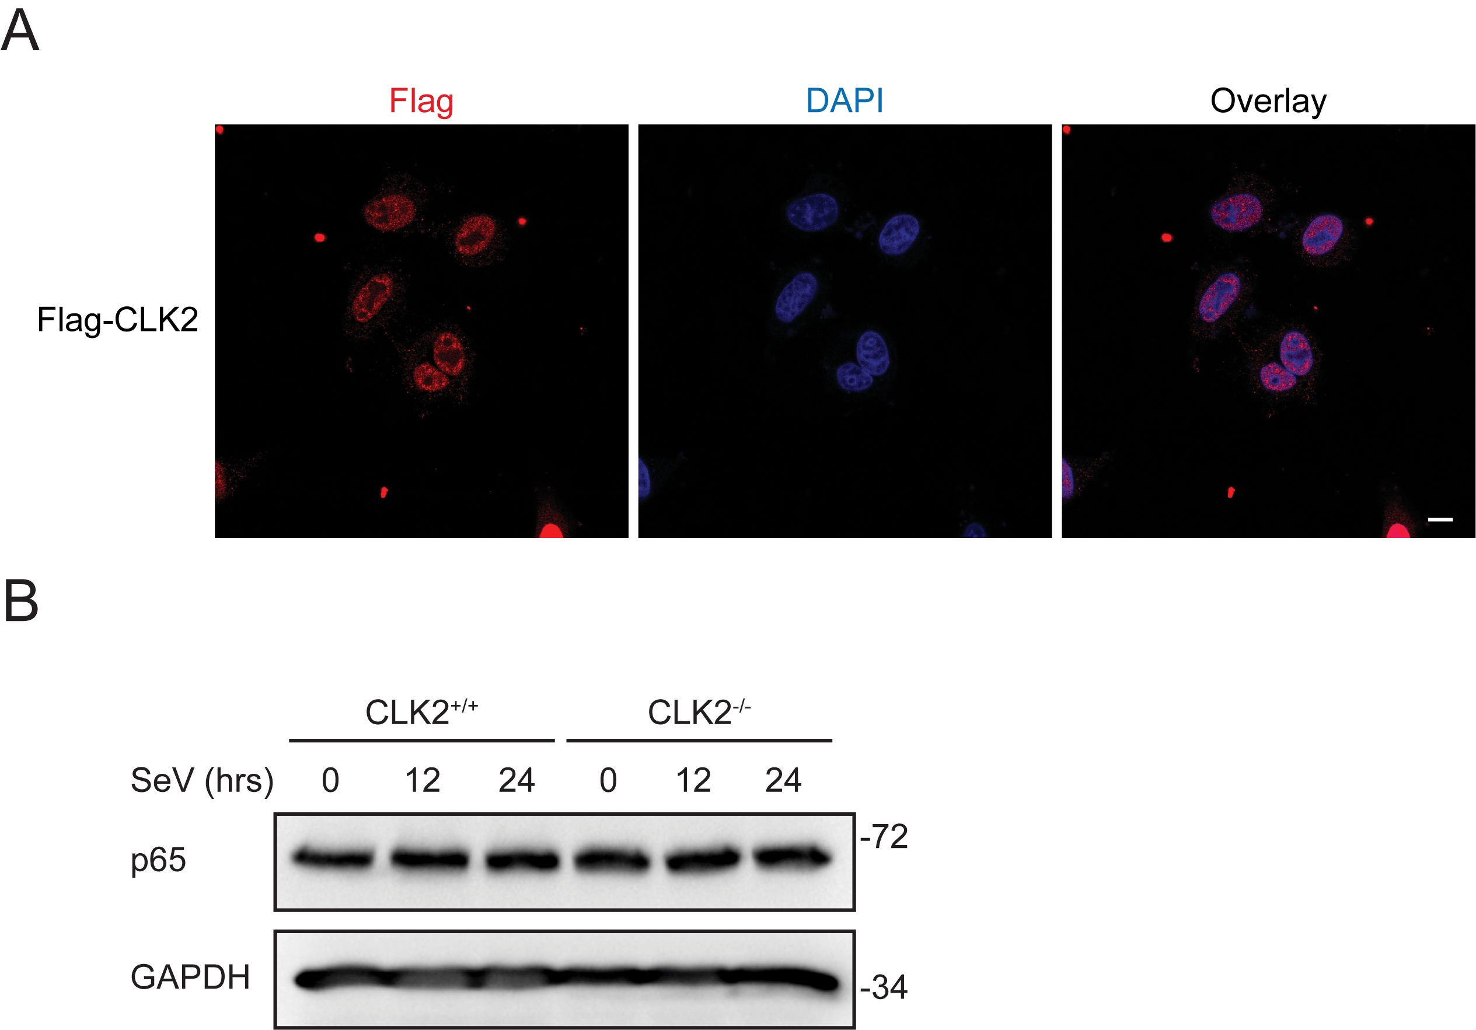
Supplementary Figure 4. CLK2 interacts with and phosphorylates p65 to reverse its nuclear location. (a) Immunofluorescence analysis of the localization exogenous Flag-CLK2 HEK293T cells. Images were obtained by fluorescence microscopy. Scale bar is 10 µm. (b) The Western blot analysis of p65 protein level in the CLK2^{+/+} and CLK2^{-/-} HEK293T cells infected with SeV at the indicated time points. Data are representative of three independent experiments. Source data (a-b) are provided as a Source Data file.

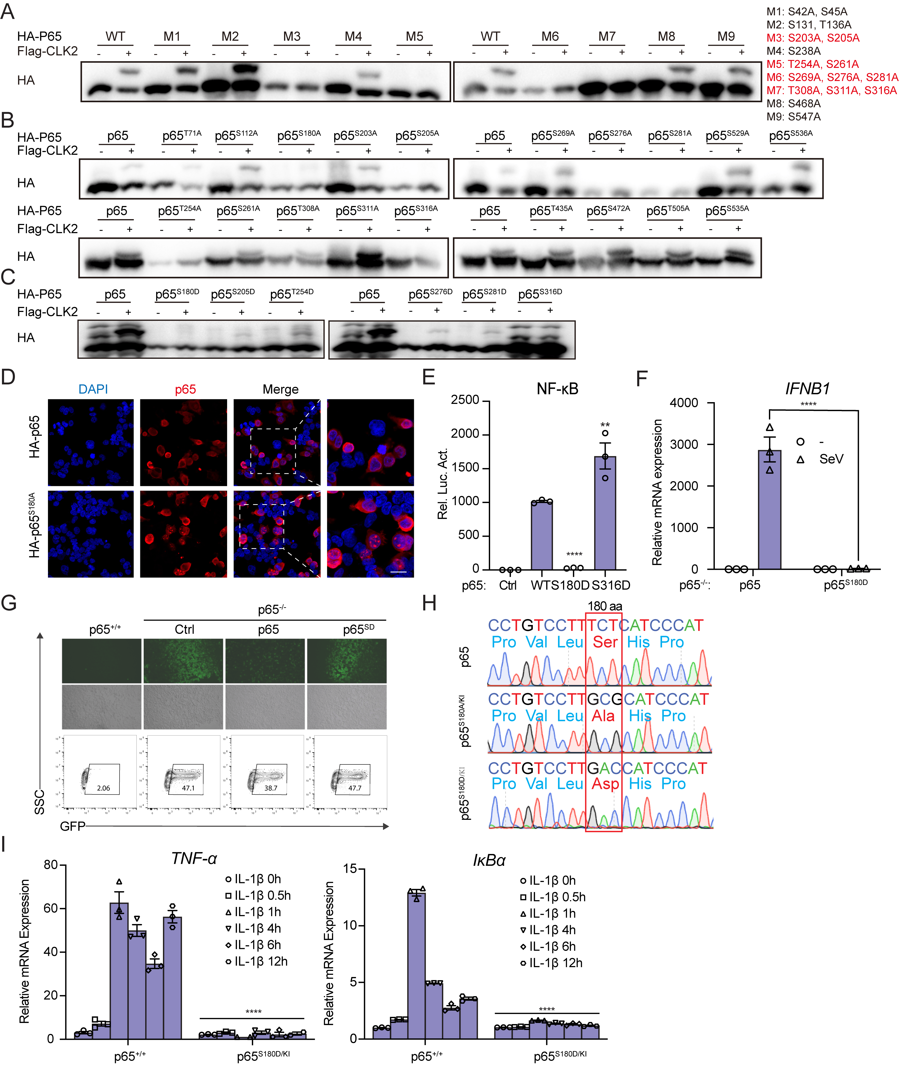
Supplementary Figure 5. Phosphorylation of p65 at Ser-180 by CLK2 totally inhibits transcriptional ability of activated NF-κB. (a-c) Phos-tag SDS-PAGE analyzing the potential phosphorylated residues of p65 by CLK2 using indicated p65 mutants in HEK293T cells. The upper shifted band represents phosphorylated p65 protein. (d) Immunofluorescence analysis of the exogenous HA-p65^{S180A} and wild-type p65 localization in HEK293T cells. Scale bar is 40 µm. (e) Luciferase reporter experiments analyzing NF-κB activity in HEK293T cells transfected with plasmids encoding p65, p65^{S180D}, and p65^{S316D} for 24 hours (n=3). (f) The real-time PCR analysis of SeV induced IFNB1 mRNA level in the presence of p65 and p65^{S180D} in p65^{-/-} HEK293T cells (n=3). (g) The indicated cells were infected with VSV-GFP at a MOI of 0.01 for 12 hours before phase-contrast and fluorescence microscopy and flow cytometry analysis. (h) Identification of p65 knock-in cell lines by sequencing. (i) The real-time PCR analysis of IκBα and TNF-α mRNA level in the indicated cells exposed with 20 ng/ml IL-1β for 0. 0.5, 1, 4, 6, 12 hours (n=3). Data are representative of three independent experiments. Data are presented as the mean ± SEM. Statistical significance was analyzed by ANOVA (*p < 0.05, **p < 0.01, ***p < 0.001). Source data (a-i) are provided as a Source Data file.

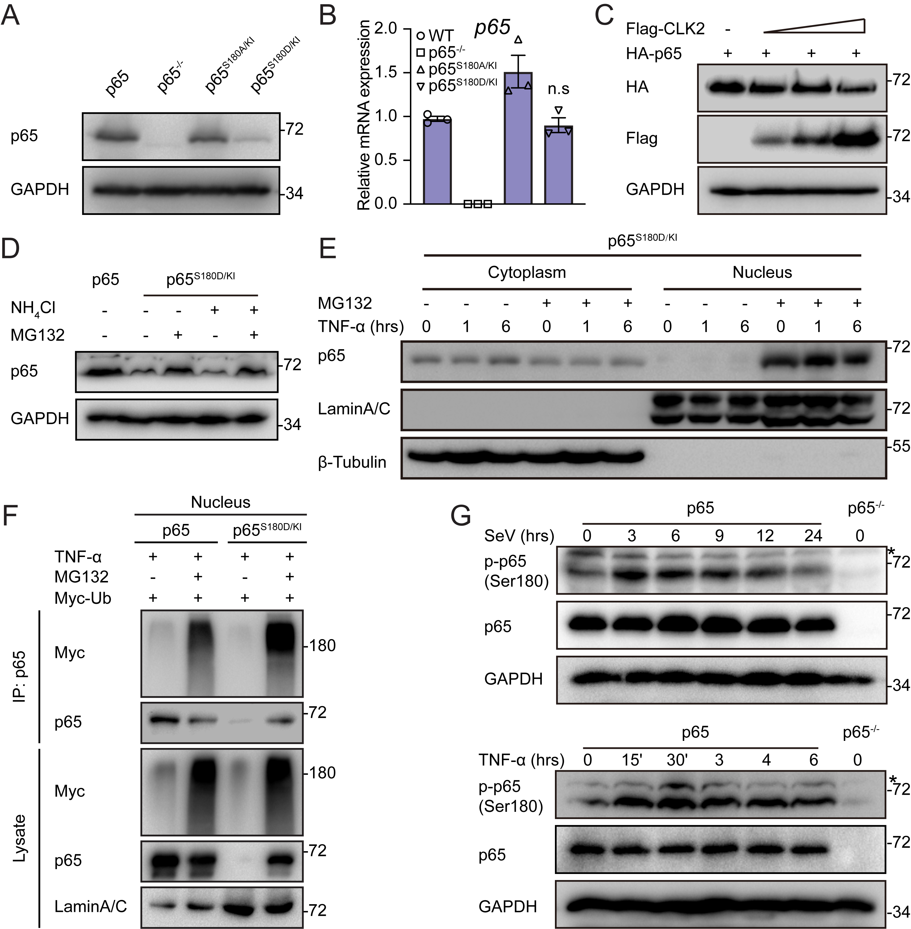
Supplementary Figure 6. Ser-180 phosphorylation of p65 result in its degradation and nuclear export. (a) Western blot and real-time PCR analysis of p65 protein and mRNA level in p65^{+/+}, p65^{-/-}, p65^{S180A/KI} or p65^{S180D/KI} HEK293T cells. (b) Real-time PCR analysis of p65 protein and mRNA level in p65^{+/+}, p65^{-/-}, p65^{S180A/KI} or p65^{S180D/KI} HEK293T cells. (c) Western blot analysis of p65 protein level in the presence of increased CLK2 expression. (d) Western blot analysis of p65 protein level in the presence of MG132 and NH₄Cl in p65^{+/+} and p65^{S180D/KI} HEK293T cells. (e) The cytoplasm and nucleus were fractionated in p65^{S180D/KI} HEK293T cells stimulated with TNF-α at the indicated time points and exposed with or without MG132 before immunoblotting assay with anti-p65, anti-Tubulin and anti-LaminA/C antibodies. (f) Nucleus was fractionated in p65^{S180D/KI} and p65^{+/+} HEK293T cells in the presence of TNF-α with or without MG132, followed by coimmunoprecipitation between p65 and Myc-Ub, and were analysed by Western blot. (g) Western blot analysis of Ser-180 phosphorylated p65 and total p65 and GAPDH in the p65^{+/+} and p65^{−/−} HEK293T cells stimulated with SeV and TNF-α at indicated time. Data are representative of three independent experiments. Data are presented as the mean ± SEM. Statistical significance was analyzed by ANOVA (n.s, no significance). Source data (a-g) are provided as a Source Data file.

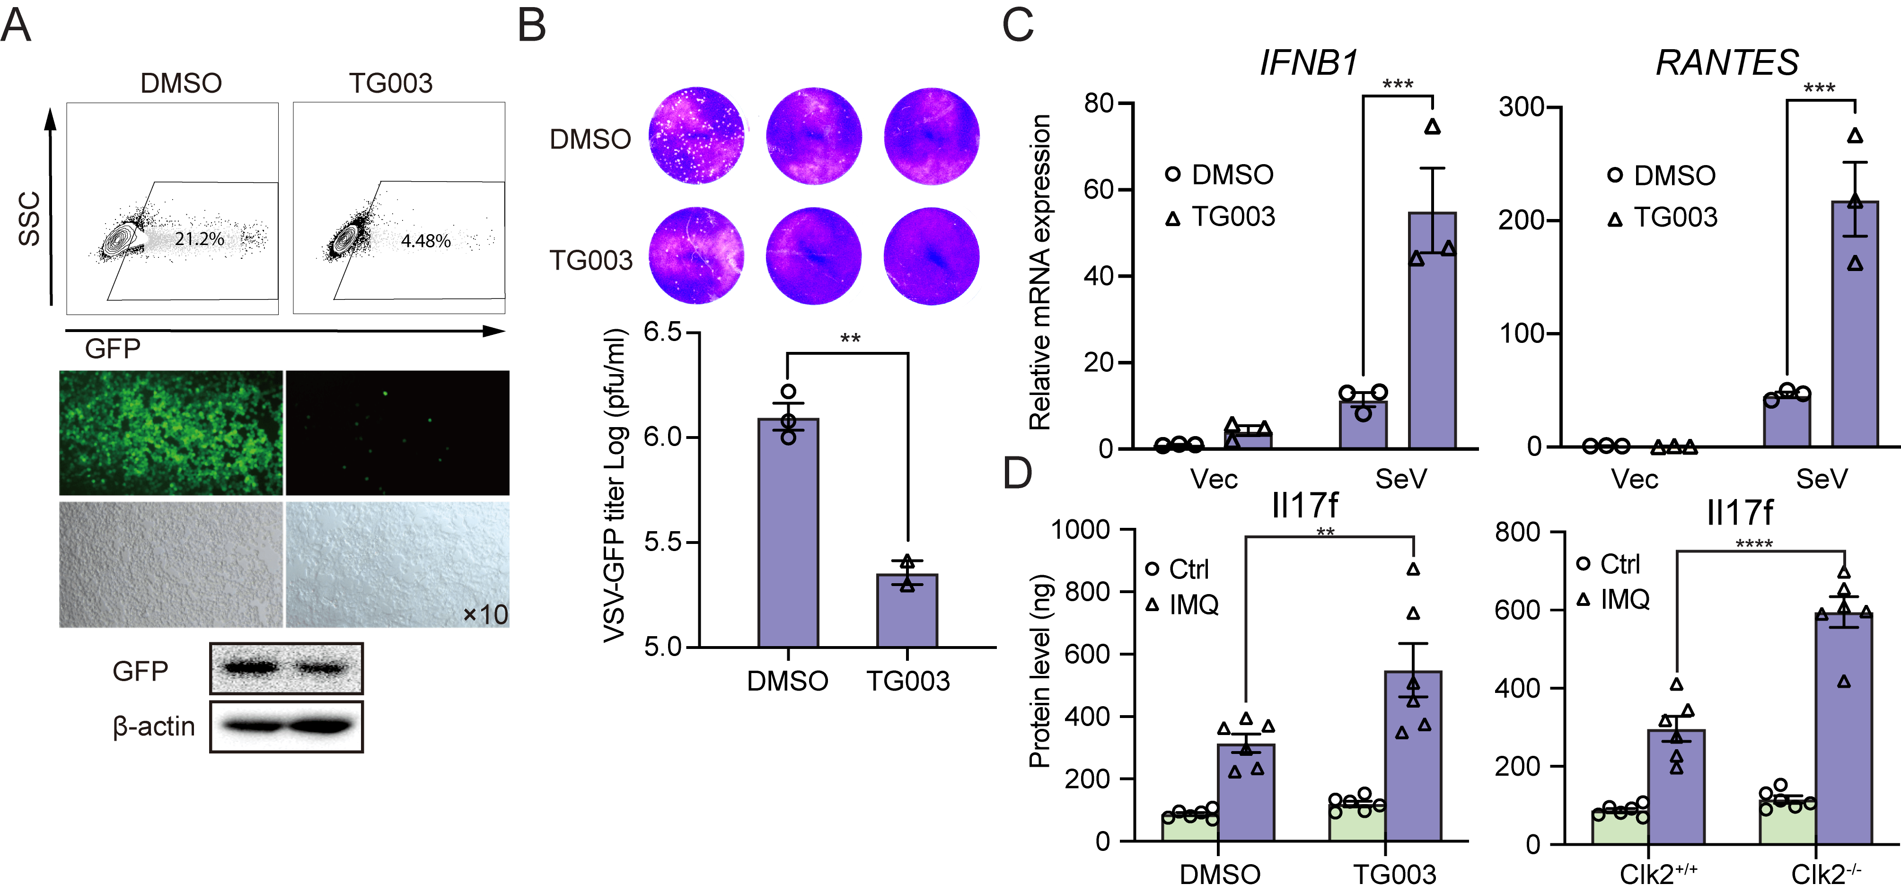

Supplementary Figure 7. CLK2 inhibitor TG003 exhibits power in vitro and in vivo. (a) The HEK293T cells were infected with VSV-GFP in the presence or absence of TG003 (20 µM) at a MOI of 0.01 for 12 hours before phase-contrast and fluorescence microscopy and flow cytometry analysis. (b) The HEK293T cells were infected with VSV-GFP in the presence or absence of TG003 (20 µM) at a MOI of 0.01 for 1 hours before replacing new medium and continue culturing for 24 hours, then the supernatants were diluted and added to Vero cells for plague assay (n=3). (c) The real-time PCR analysis of IFNB1 and RANTES mRNA level in the presence or absence of TG003 in HEK293T cells infected with SeV for 12 hours (n=3). (d) The ELISA analysis of Il-17f protein level after treatment with IMQ 6 days in Clk2-deficient mice or intraperitoneal injection with TG003. Data are representative of three independent experiments. Data are presented as the mean ± SEM. Statistical significance was analyzed by Student’s t-test (b) or ANOVA (c, d) (**p < 0.01, ***p < 0.001). Source data (a-d) are provided as a Source Data file.

