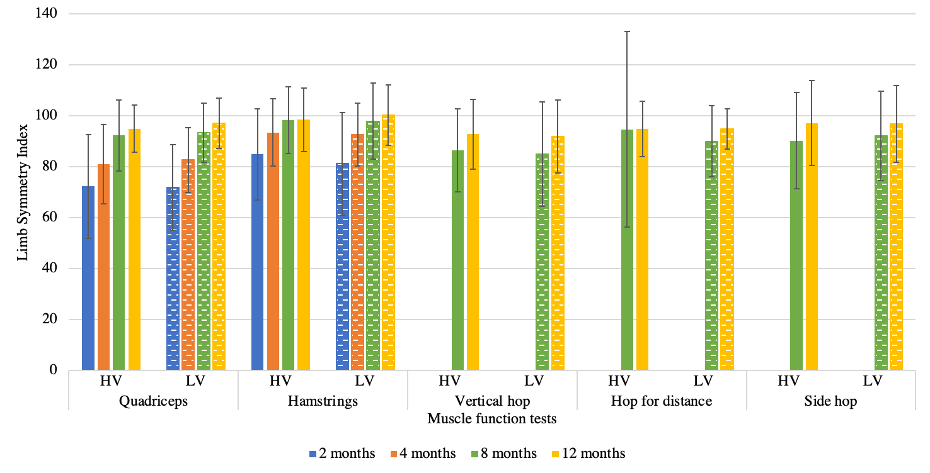Appendix Figure 3. Prospective muscle function test during the first year of rehabilitation after ACL reconstruction. Solid bars represent high-volume clinics and dashed bars represent low-volume clinics. Standard deviation is presented for each bar with whiskers. HV, high-volume clinics; LV, low-volume clinics.

