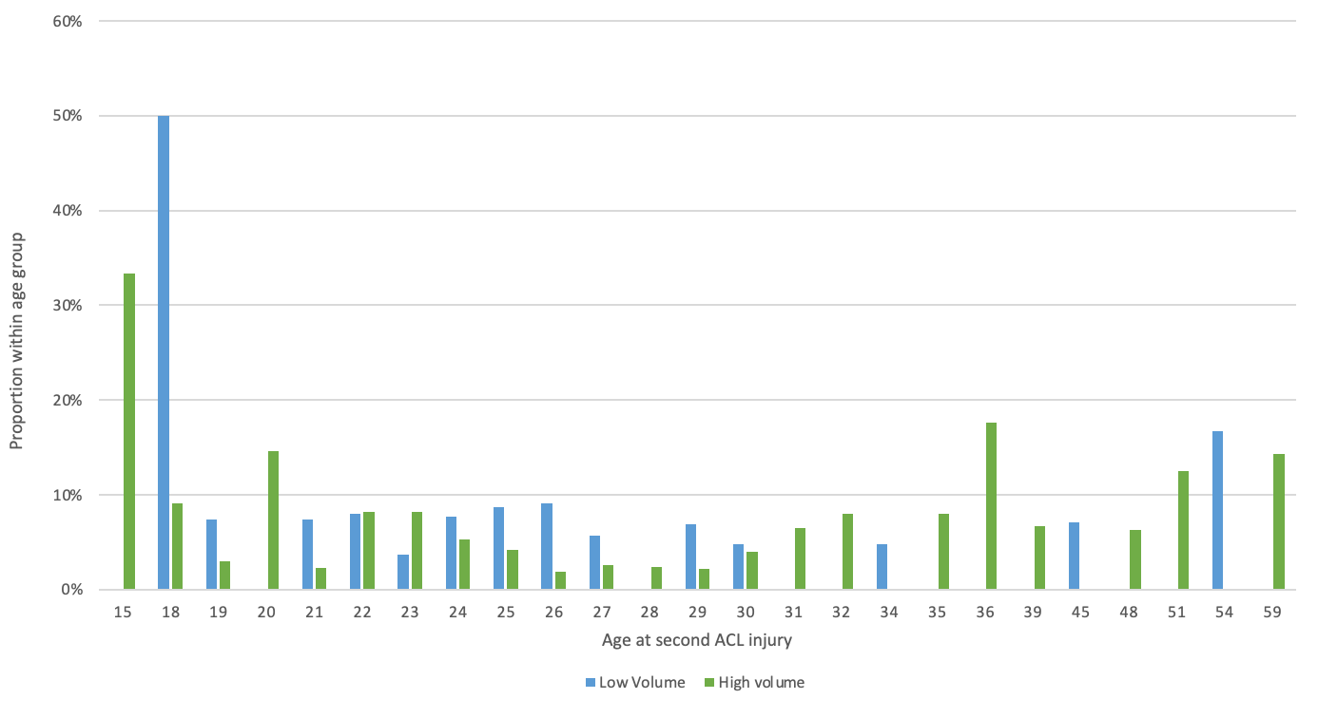Appendix Figure 2. Second ACL injury during the first 2 years stratified by age.

