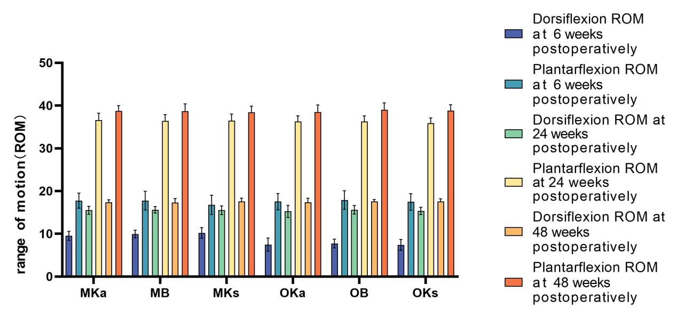
Chart1：Comparison of ROM in the six groups
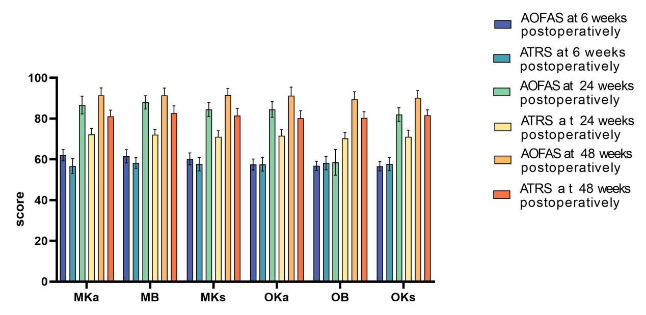
Chart2：Comparison of clinical scores in the six groups
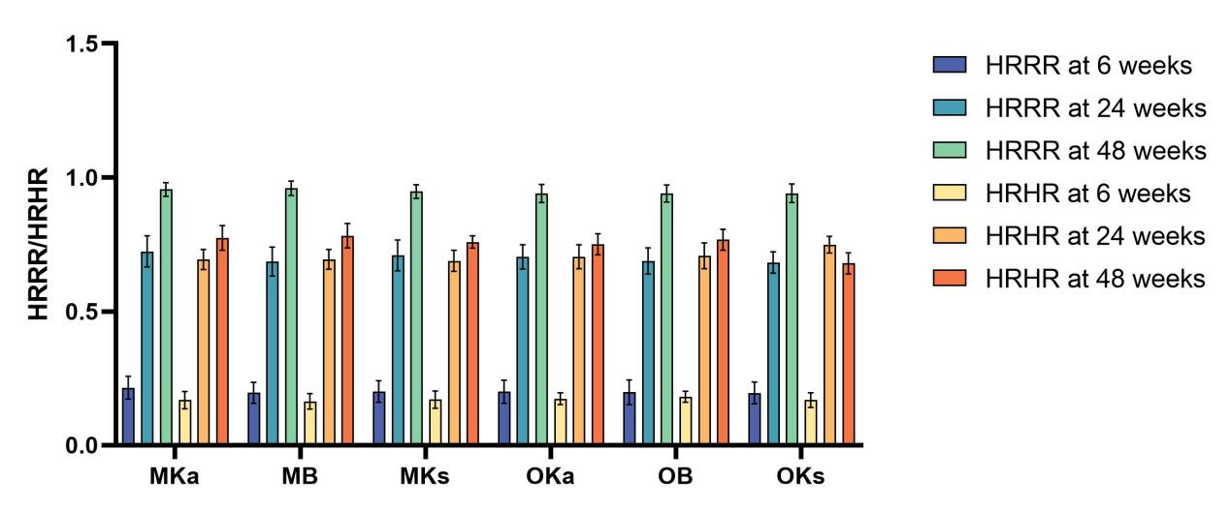
Chart3：Comparison of HRRR/HRHR in the six group

