Supplementary figure 1. Differential expression of lncRNAs in GSE95223. (A) Volcano plot shows the differential expression of lncRNAs between sepsis group and control group in GSE95223. (B) Heat map shows the differential expression of lncRNAs between sepsis group and control group in GSE95223.
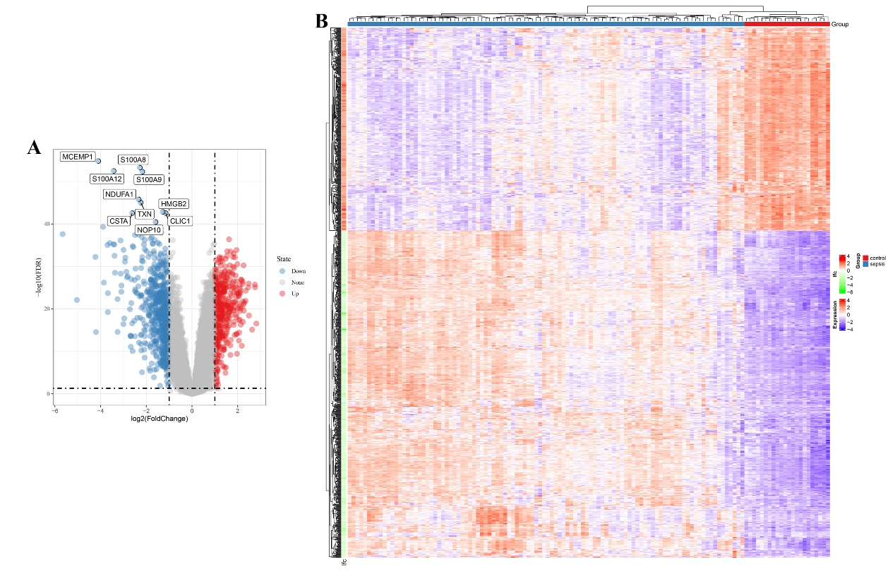

Supplementary table 1. The sequences of primers.
Gene symbol | Primer | Sequences (5’-3’)
PRKCQ-AS1 | Forward primer | AGGGACATTTCCATTCTAAGG
PRKCQ-AS1 | Reverse primer | GGCAATATAAATGCACAGCA
Bax | Forward primer | TACTTTGCCAGCAAACTGG
Bax | Reverse primer | ATGGTTCTGATCAGTTCCG
Bcl-2 | Forward primer | GGATGCCTTTGTGGAACTG
Bcl-2 | Reverse primer | GTCTTCAGAGACAGCCAGG
caspase1 | Forward primer | TGGAGACATCCCACAATGG
caspase1 | Reverse primer | TCTCTTCACTTCCTTGCGG
NLRP3 | Forward primer | AACACTCTCGGAGACAAGG
NLRP3 | Reverse primer | TGCAGTTGTCTAATTCCAACAC
IL-1β | Forward primer | ATTGCTCAAGTGTCTGAAGC
IL-1β | Reverse primer | ACAAGTCATCCTCATTGCCA
GAPDH | Forward primer | CATTTCCTGGTATGACAACGA
GAPDH | Reverse primer | GGGTCTTACTCCTTGGAGG
β-actin | Forward primer | GGATTACAGCTCACCATGG
β-actin | Reverse primer | ATAGGAATCCTTCTGACCCA

