Early and long-term antibody kinetics of asymptomatic and mild disease COVID-19 patients

Supplementary information

Supplementary Table 1: Patients’ risk factors and symptoms by cluster
 | CLUSTER 1 | CLUSTER 2 | P-Value
N | 53 | 65
Women | 28 | 31 | 0.583
Cancer | 3 | 2 | 0.493
Diabetes | 6 | 4 | 0.320
Hypertension | 3 | 3 | 0.799
Heart disease | 2 | 3 | 0.823
Immune deficiency | 2 | 3 | 0.823
Asthma | 1 | 6 | 0.095
Chronic lung disease (non-asthma) | 0 | 0
Chronic liver disease | 0 | 0
Chronic kidney disease | 1 | 1 | 0.885
Hematologic disease/disorder | 0 | 0
Chronic neurological impairment | 1 | 3 | 0.420
Organ or bone marrow recipient | 3 | 3 | 0.799
Smoking | 4 | 11 | 0.131
BMI>30 | 16 | 16 | 0.502
AGE>60 | 11 | 4 | 0.018
Fever ≥ 38˚c | 39 | 7 | < 0.001
Dry cough | 46 | 11 | < 0.001
Sore throat | 16 | 17 | 0.631
Runny nose | 19 | 14 | 0.086
Shortness of breath | 12 | 8 | 0.139
Abdominal pain | 12 | 8 | 0.139
Headache | 42 | 16 | < 0.001
Problem in smell sensation | 23 | 19 | 0.112
Problem in taste sensation | 12 | 10 | 0.318
Chills | 20 | 6 | < 0.001
Vomiting | 6 | 10 | 0.525
Nausea | 8 | 19 | 0.002
Diarrhea | 11 | 7 | 0.136
Rash | 5 | 4 | 0.508
Conjunctivitis | 8 | 8 | 0.663
Muscle aches | 29 | 18 | 0.003
Joint ache | 20 | 7 | 0.001
Loss of appetite | 10 | 20 | 0.005
Nose bleed | 13 | 12 | 0.427
Fatigue | 37 | 19 | < 0.001
Seizures | 0 | 0
Altered consciousness | 3 | 4 | 0.911

Supplementary Table 2: Statistical results of the DT model performance
 | Infection | Inflammation | Recovery
n | 91 | 266 | 641
TP | 67 | 187 | 551
TN | 905 | 627 | 271
FP | 2 | 105 | 86
FN | 24 | 79 | 90
Precision % | 97.1 | 64.0 | 86.5
Sensitivity (Recall) % | 73.6 | 70.3 | 86.0
Specificity % | 99.8 | 85.7 | 75.9
AUC | 0.96 | 0.88 | 0.91
Precision = (TP)/ (TP+FP), Sensitivity = (TP)/ (TP+FN), Specificity = (TN)/ (TN+FP) where
TP, true positive, TN, true negative, FP, false positive, and FN, false negative

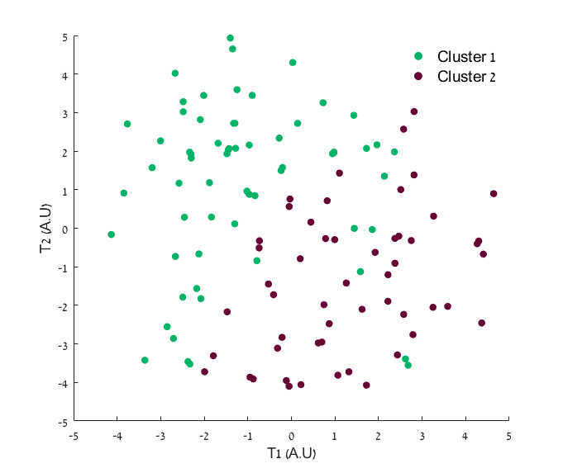
Supplementary Fig. 1: Mild symptoms cohort classification results: t-stochastic neighbor embedding (t-SNE) plot based on HAMMIG distance metrics in data transformation binary results (N=118).

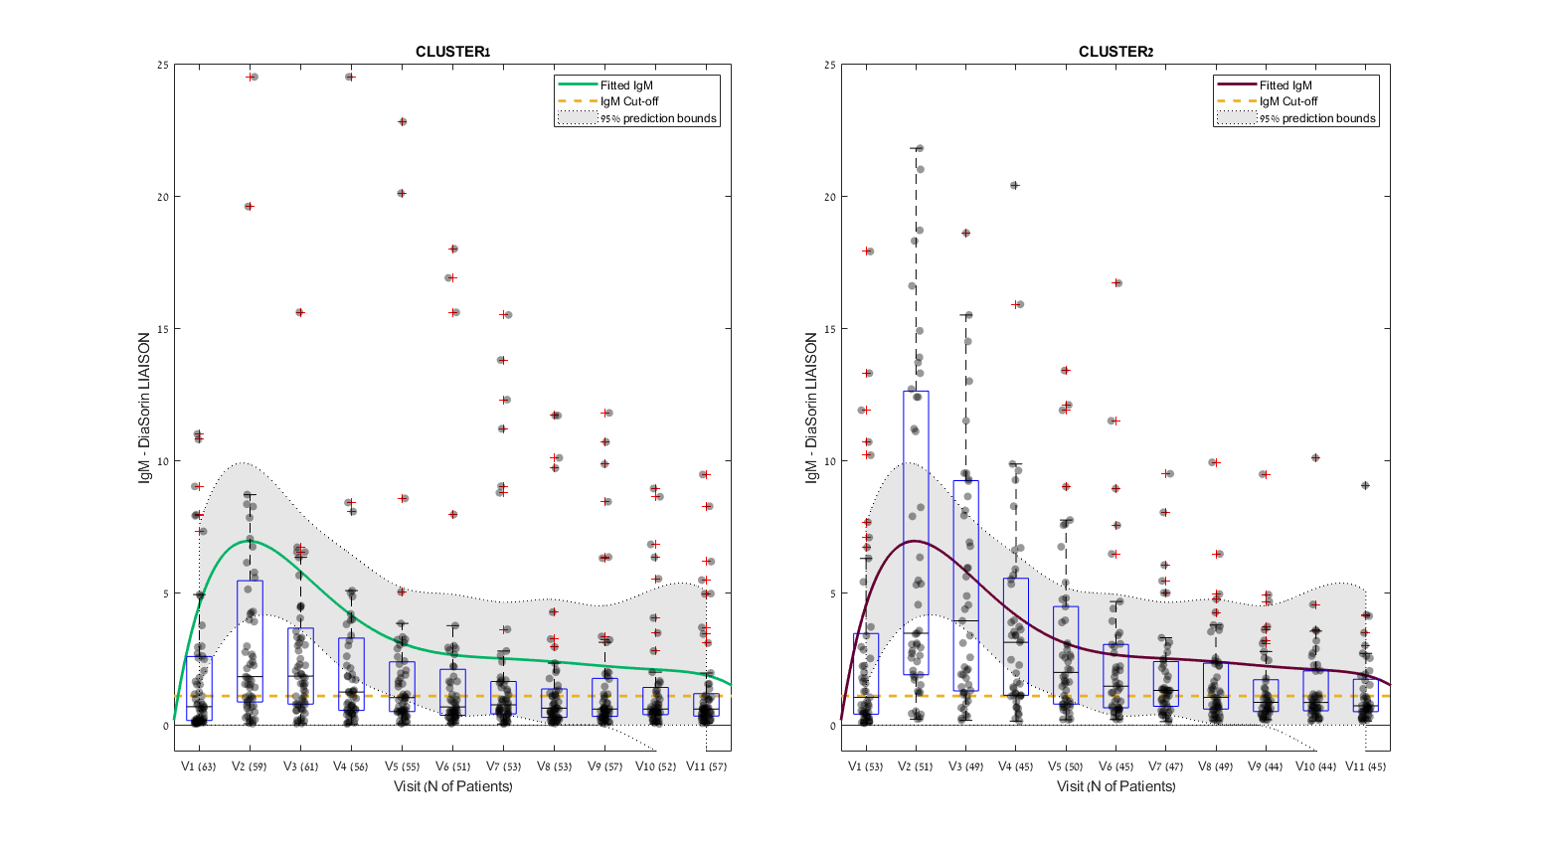
Supplementary Fig. 2: Longitudinal profile of neutralizing serum IgM antibodies in mild COVID-19 patients during the study period. Experimental data were fitted by a quadratic polynomial regression model, and presented with a confidence interval of 95%. The boxplot’s central mark indicates the median, and the bottom and top edges of the box indicate the 25th and 75th percentiles, respectively. + symbols indicate outliers.
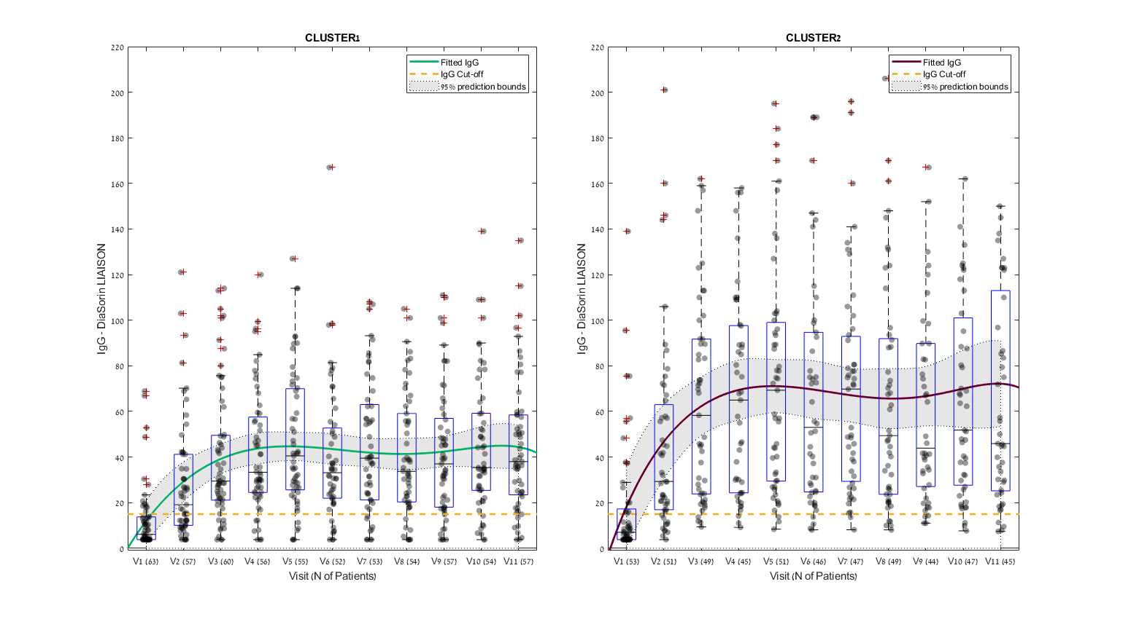
Supplementary Fig. 3: Longitudinal profile of neutralizing serum IgG-S antibodies in mild COVID-19 patients during the study period. Experimental data were fitted by a quadratic polynomial regression model, and presented with a confidence interval of 95%. The boxplot’s central mark indicates the median, and the bottom and top edges of the box indicate the 25th and 75th percentiles, respectively. + symbols indicate outliers.
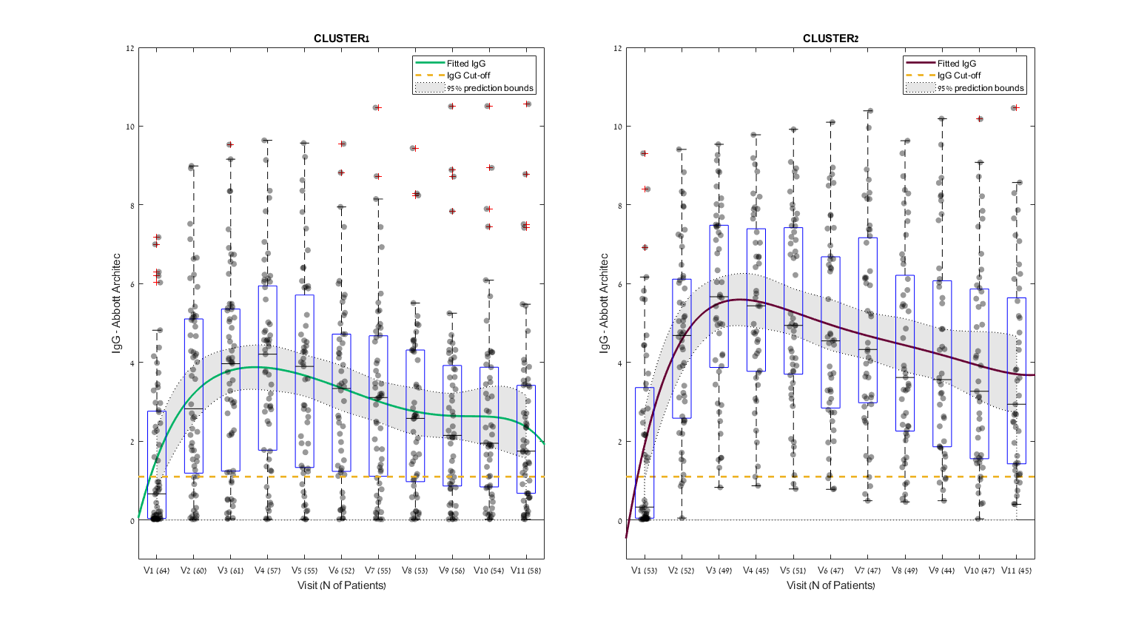
Supplementary Fig. 4: Longitudinal profile of the neutralizing serum IgG-N antibody in mild COVID-19 patients during the study period. Experimental data were fitted by a quadratic polynomial regression model, and presented with a confidence interval of 95%. The boxplot’s central mark indicates the median, and the bottom and top edges of the box indicate the 25th and 75th percentiles, respectively. + symbols indicate outliers.

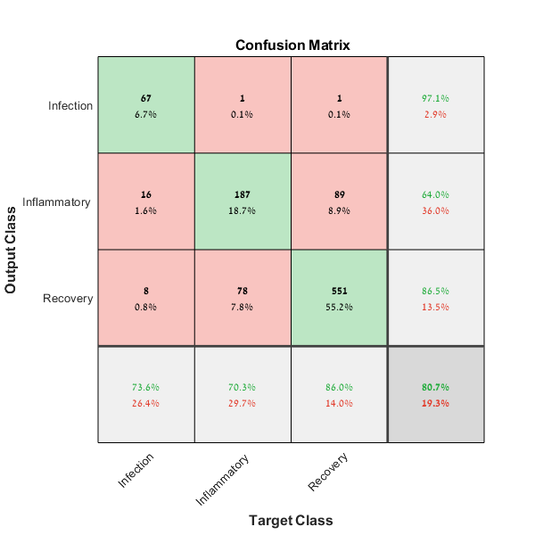
Supplementary Fig. 5: Confusion matrix for the classification tree model: performance of COVID 19 disease course classification (see also Supplementary Table 2). The green squares correspond to TP and TN values, and the red squares represent FP and FN values. The overall correct classification rate is 80.7%.

