Supplementary Figures
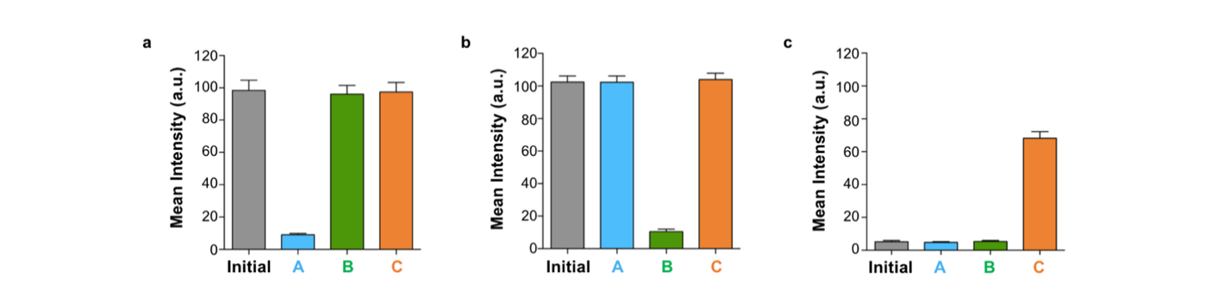
Figure S1. The mean Rhod2 fluorescence intensity inside GUVs (n = 9) in Fig. 1b, which were used for the calculation of the transport efficiency in Fig. 1c. a, Mean Rhod2 fluorescence intensity inside GUVs loaded with [Ca²⁺-Rhod2] before and after addition of ionophore A, B or C in the presence of 1 µM external NiCl₂. b, Mean Rhod2 fluorescence intensity inside GUVs loaded with [Ca²⁺-Rhod2] before and after addition of ionophore A, B or C in the presence of 1 µM external CuCl₂. c, Mean Rhod2 fluorescence intensity inside GUVs loaded with Rhod2 before and after addition of ionophore A, B or C in the presence of 100 µM external CaCl₂. Ionophore A, B and C were used at 20 µM, 5 µM and 1 µM, respectively.
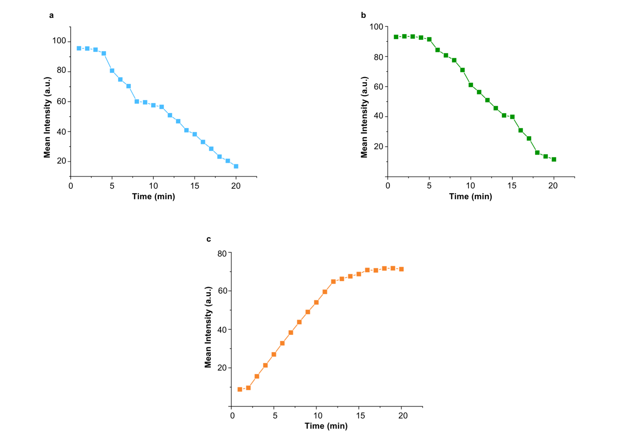Figure S2. Timeline of metal transport into GUVs with ionophores in Fig. 1b. Mean fluorescence intensity of GUVs loaded with [Ca²⁺-Rhod2] after addition of a, ionophore A in the presence of external NiCl₂; b, ionophore B in the presence of external CuCl₂. c, Mean fluorescence intensity of GUVs loaded with Rhod2 after addition of ionophore C in the presence of external CaCl₂.

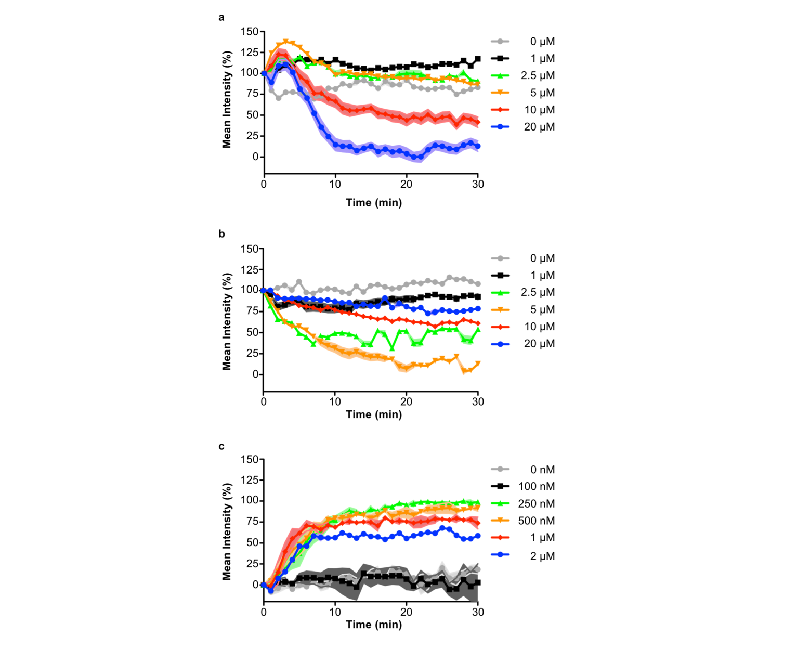Figure S3. Plate reader measurements of metal transport into GUVs with ionophores in bulk. Mean fluorescence intensity of GUVs loaded with [Ca²⁺-Rhod2] after addition of a, different concentrations of ionophore A in the presence of external NiCl₂; b, different concentrations of ionophore B in the presence of external CuCl₂. c, Mean fluorescence intensity of GUVs loaded with 100 µM CaCl₂ in the presence of external 2 µM Rhod2 after addition of different concentrations of ionophore C. n = 3.
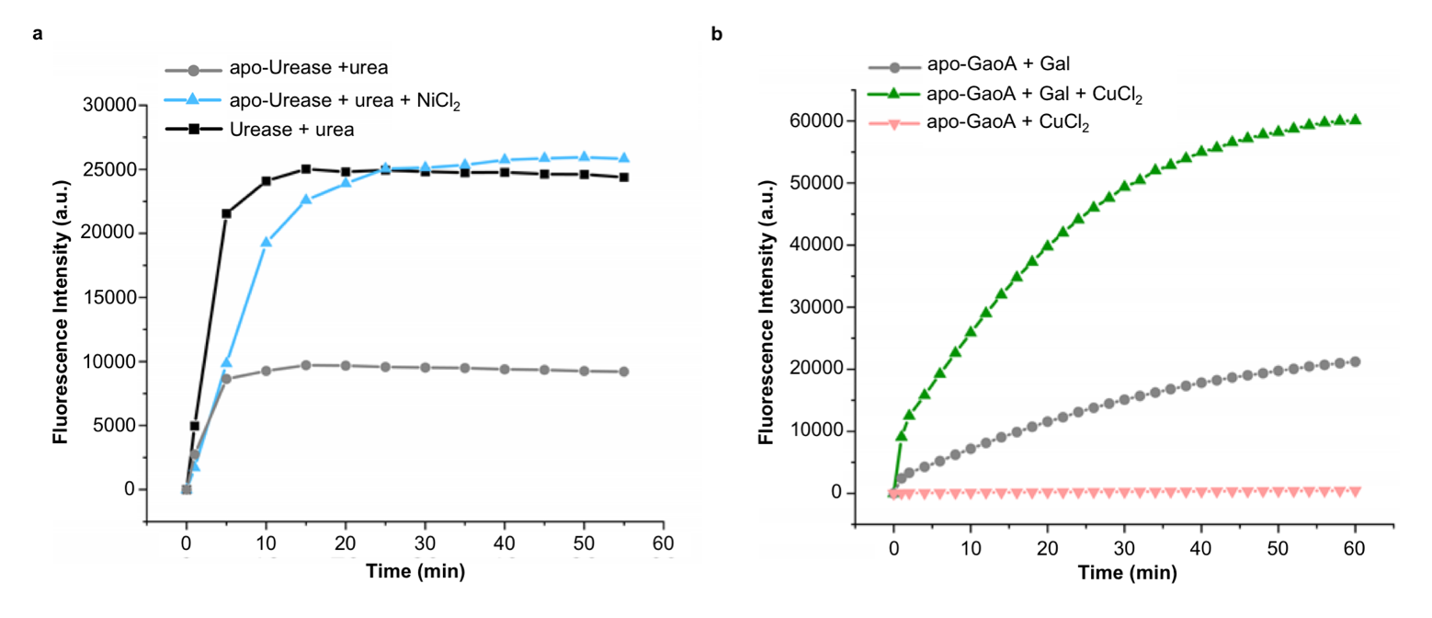
Figure S4. a, Fluorescence of urease sensor in the presence of apo-urease in the presence and absence of NiCl₂ upon addition of urea. b, Fluorescence of GaoA sensor in the presence of apo-GaoA in the presence and absence of CuCl₂ upon addition of galactose.
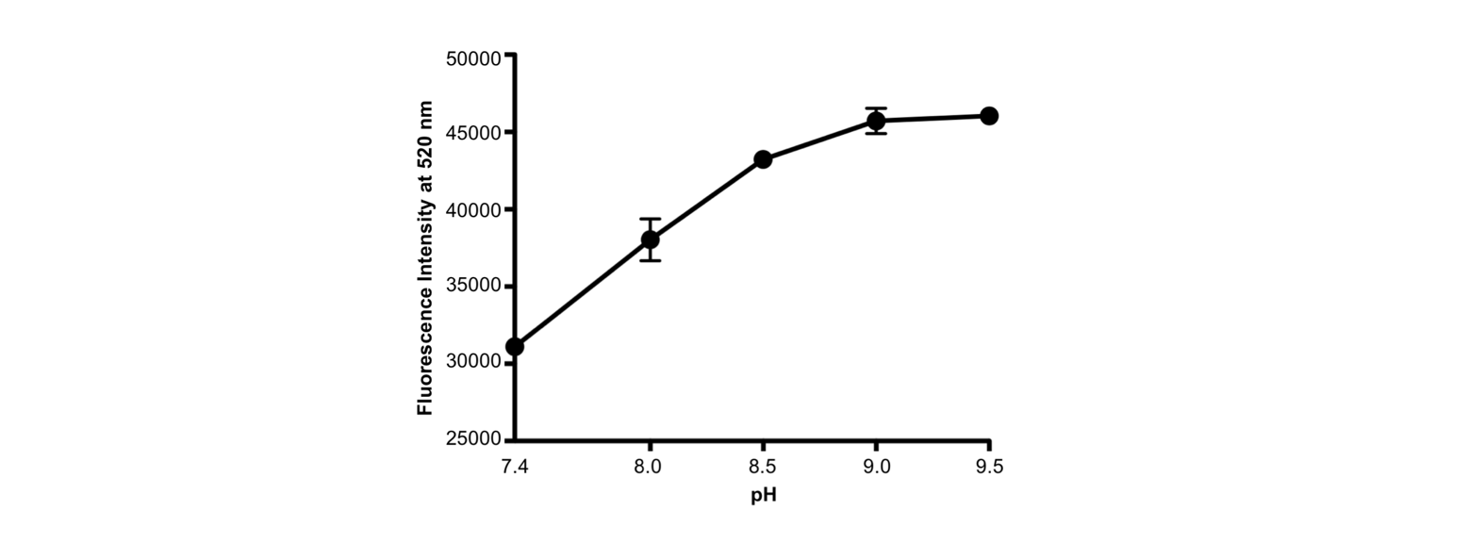Figure S5. pH dependent fluorescence of the urease sensor as measured in solution. Urease sensor in Buffer A was divided into five aliquots, the pH was adjusted and the fluorescence intensity measured (λex = 488 nm; λem = 510-600 nm same as CLSM settings). The urease sensors changed its fluorescence upto pH 9.

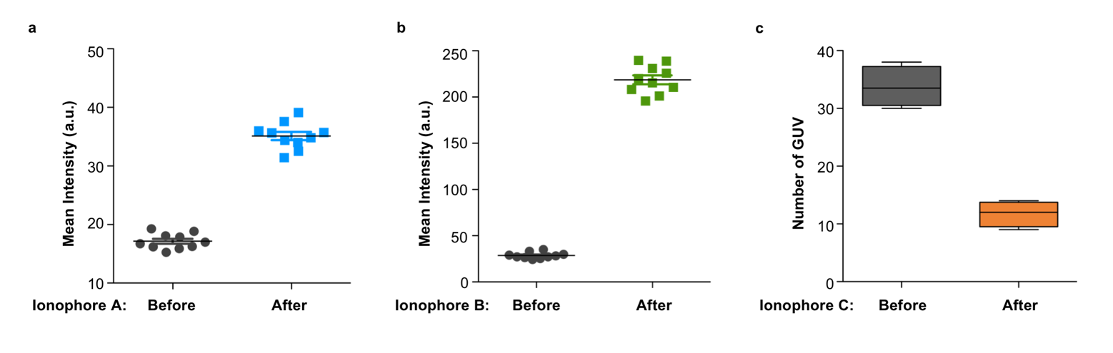Figure S6. a, Mean fluorescence intensity of the urease sensor inside GUVs (n = 10) before and after addition of ionophore A in Fig, 2a. b, Mean fluorescence intensity of GaoA sensor inside GUVs (n = 10) before and after addition of ionophore B in Fig. 2c. c, Number of GUVs before and after addition of ionophore C in Fig. 2e. (n = 10)

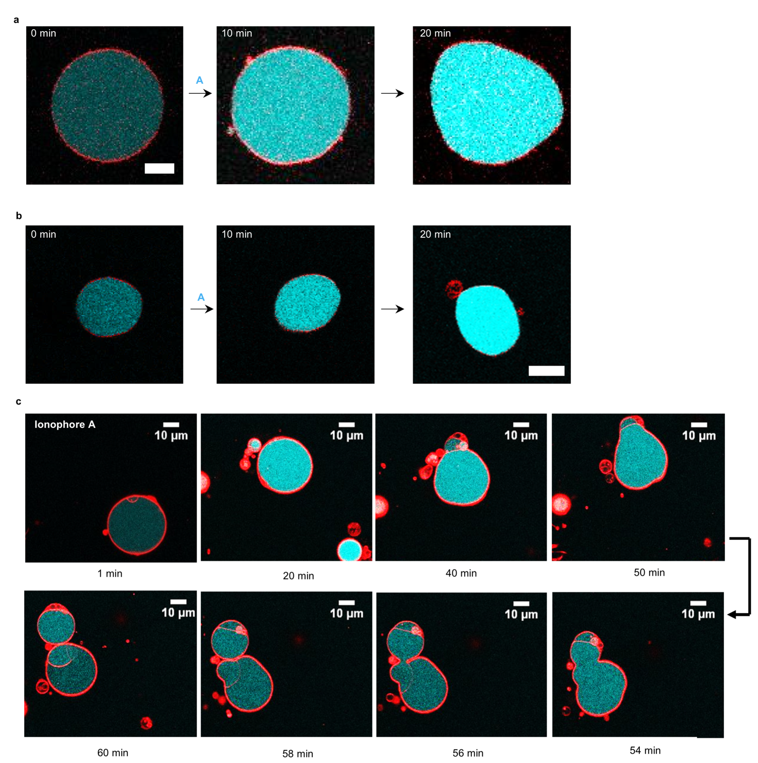Figure S7. Representative CLSM images of apo-urease loaded GUVs before and after addition of ionophore A in the presence of external NiCl₂: a, b, The intracellular activation of apo-urease resulted in the increase in intracellular pH, accompanied by the deformation of the GUV shape. Scale bar is 10 µm. c, In some GUVs, the intracellular activation of apo-urease also induced incomplete cell division.

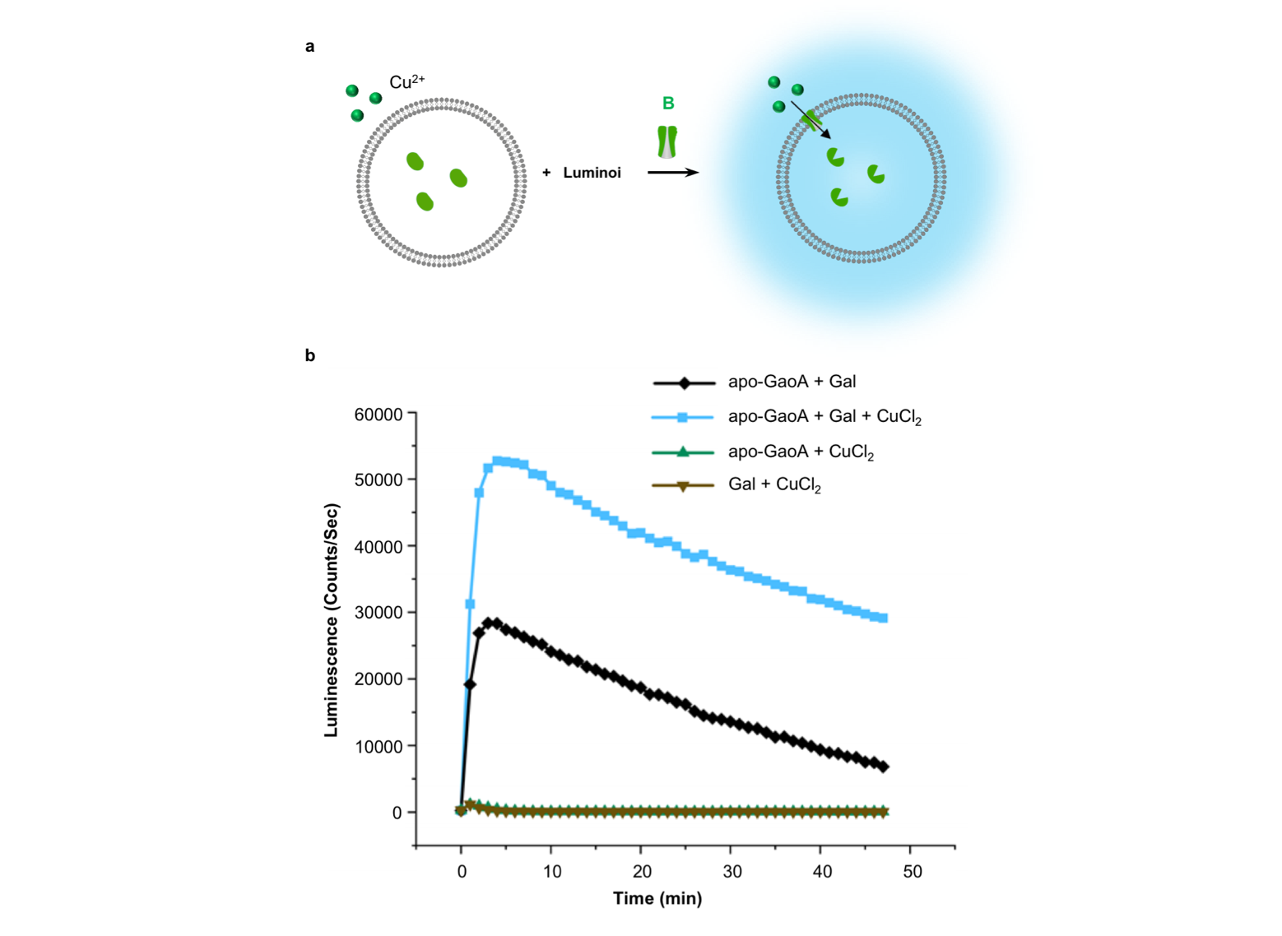
Figure S8. Activation of apo-GaoA inside GUVs with ionophore B shown with luminescence. a, Schematic representation of apo-GaoA and HRP loaded GUVs in the presence of luminol and external CuCl₂. The addition of ionophore B results in the generation of hydrogen peroxide, which reacts with luminol catalyzed by HRP and generates luminescence. b, Time-course of chemiluminescence intensities from the GUVs with apo-GaoA and galactose in the presence of external luminol, CuCl₂, and ionophore B. Luminescence intensity produced by apo-GaoA with galactose and CuCl₂ (blue line) is clearly higher than that produced by apo-GaoA with only galactose (black line), apo-GaoA with only CuCl₂ (green line), or no apo-GaoA with galactose and CuCl₂ (brown line). Measurements were started upon addition of luminol.

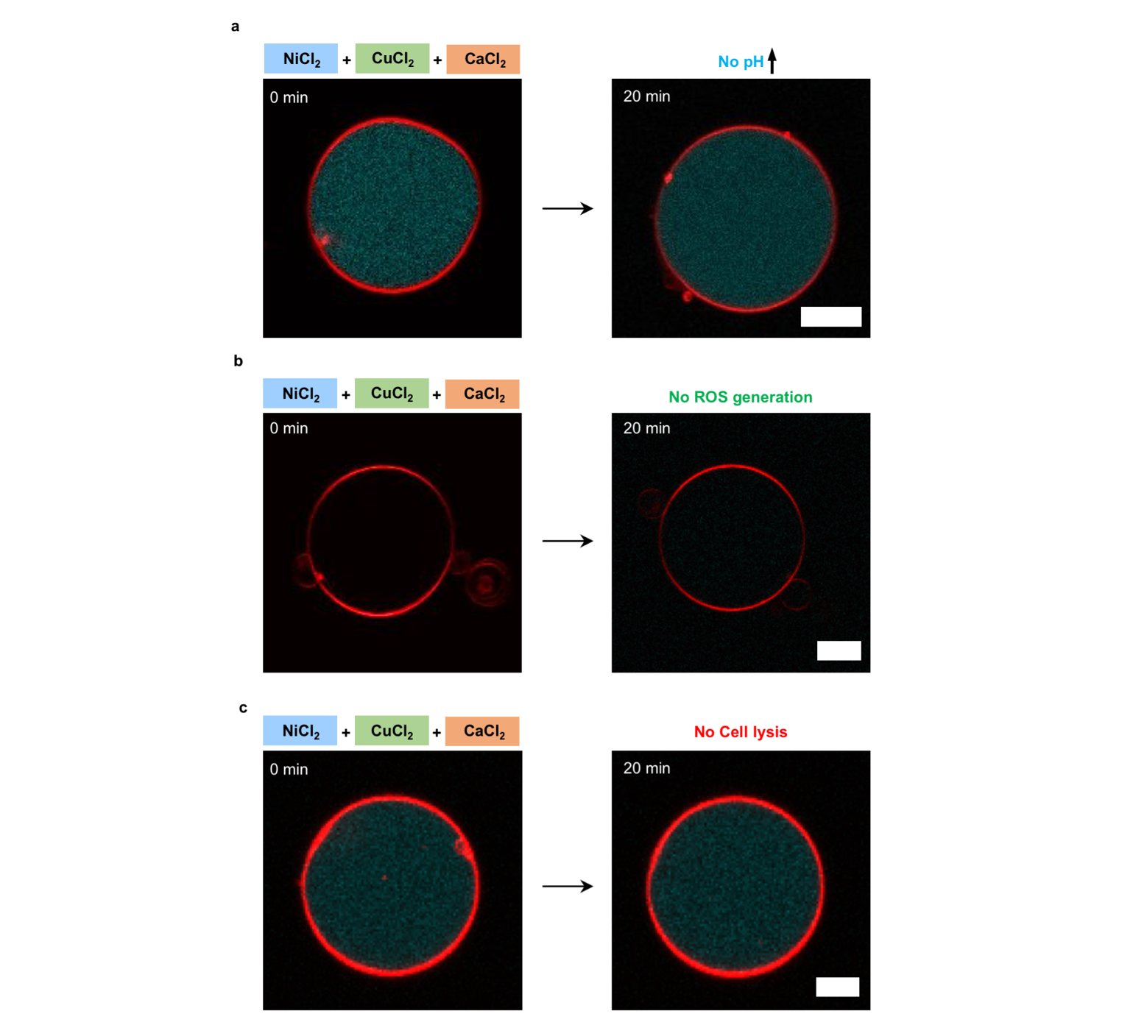
Figure S9. No activation of apo-enzymes in the presence of external metal ions. Representative CLSM images of GUVs loaded with all components, including three apo-metalloenzymes, substrates and sensors in the presence of external NiCl₂, CuCl₂, CaCl₂ after 20 min. The fluorescence of a, the urease sensor (shown in cyan) and b, the GaoA sensor (shown in green) did not increase and c, the GUVs didn’t lyse. Scale bars are 10 µm.

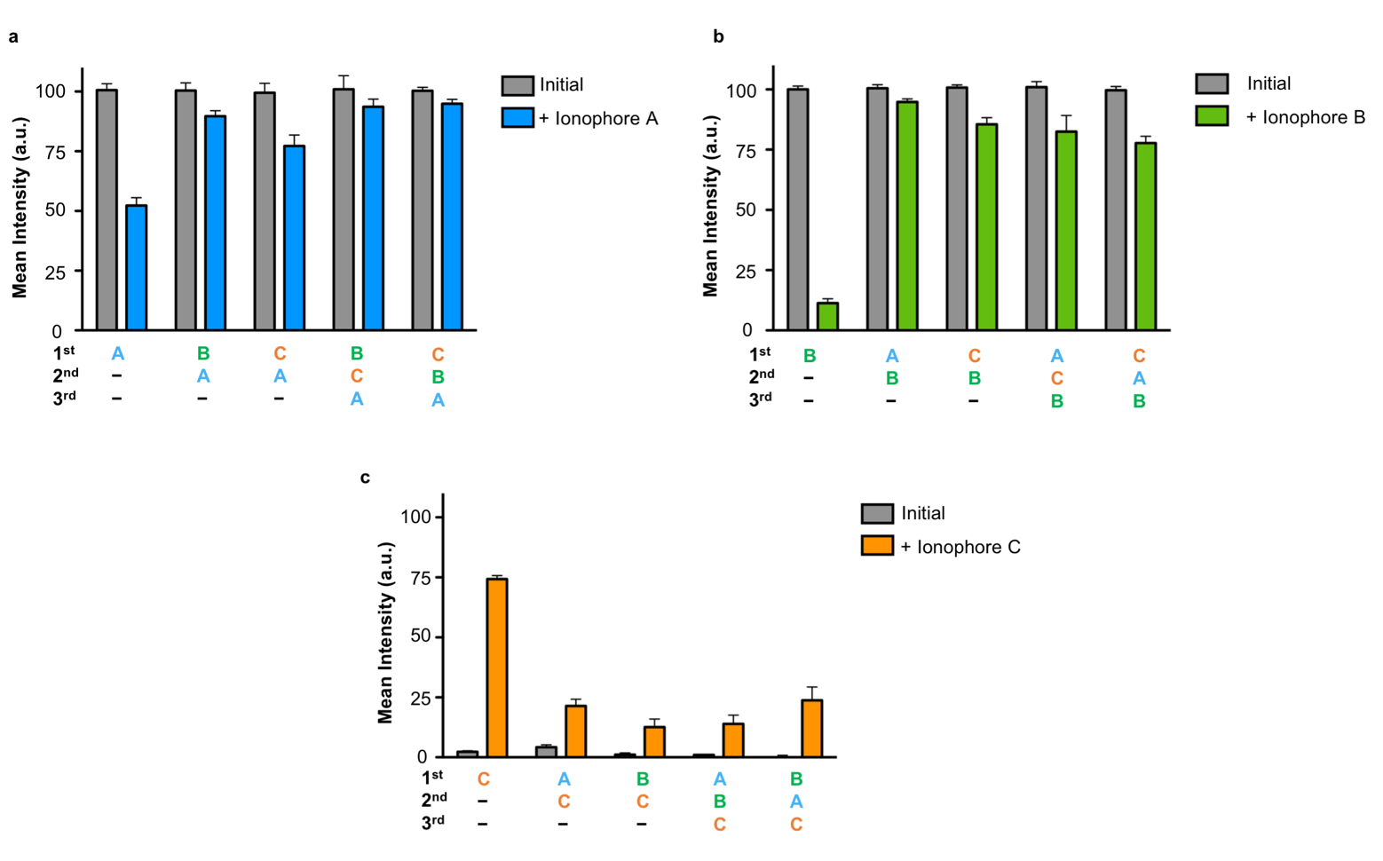Figure S10. The mean Rhod2 fluorescence intensity inside GUVs in Fig. 4, a, c, e, which were used for the calculation of the transport efficiency in Fig. 4b, d, f. a, Mean Rhod2 fluorescence intensity inside GUVs loaded with [Ca²⁺-Rhod2] before and after addition of multiple ionophores with 20 min intervals in the presence of external NiCl₂. b, Mean Rhod2 fluorescence intensity inside GUVs loaded with [Ca²⁺-Rhod2] before and after addition of multiple ionophores with 20 min intervals in the presence of external CuCl₂. c, Mean Rhod2 fluorescence intensity inside GUVs loaded with Rhod2 before and after addition of multiple ionophores with 20 min intervals in the presence of external CaCl₂.

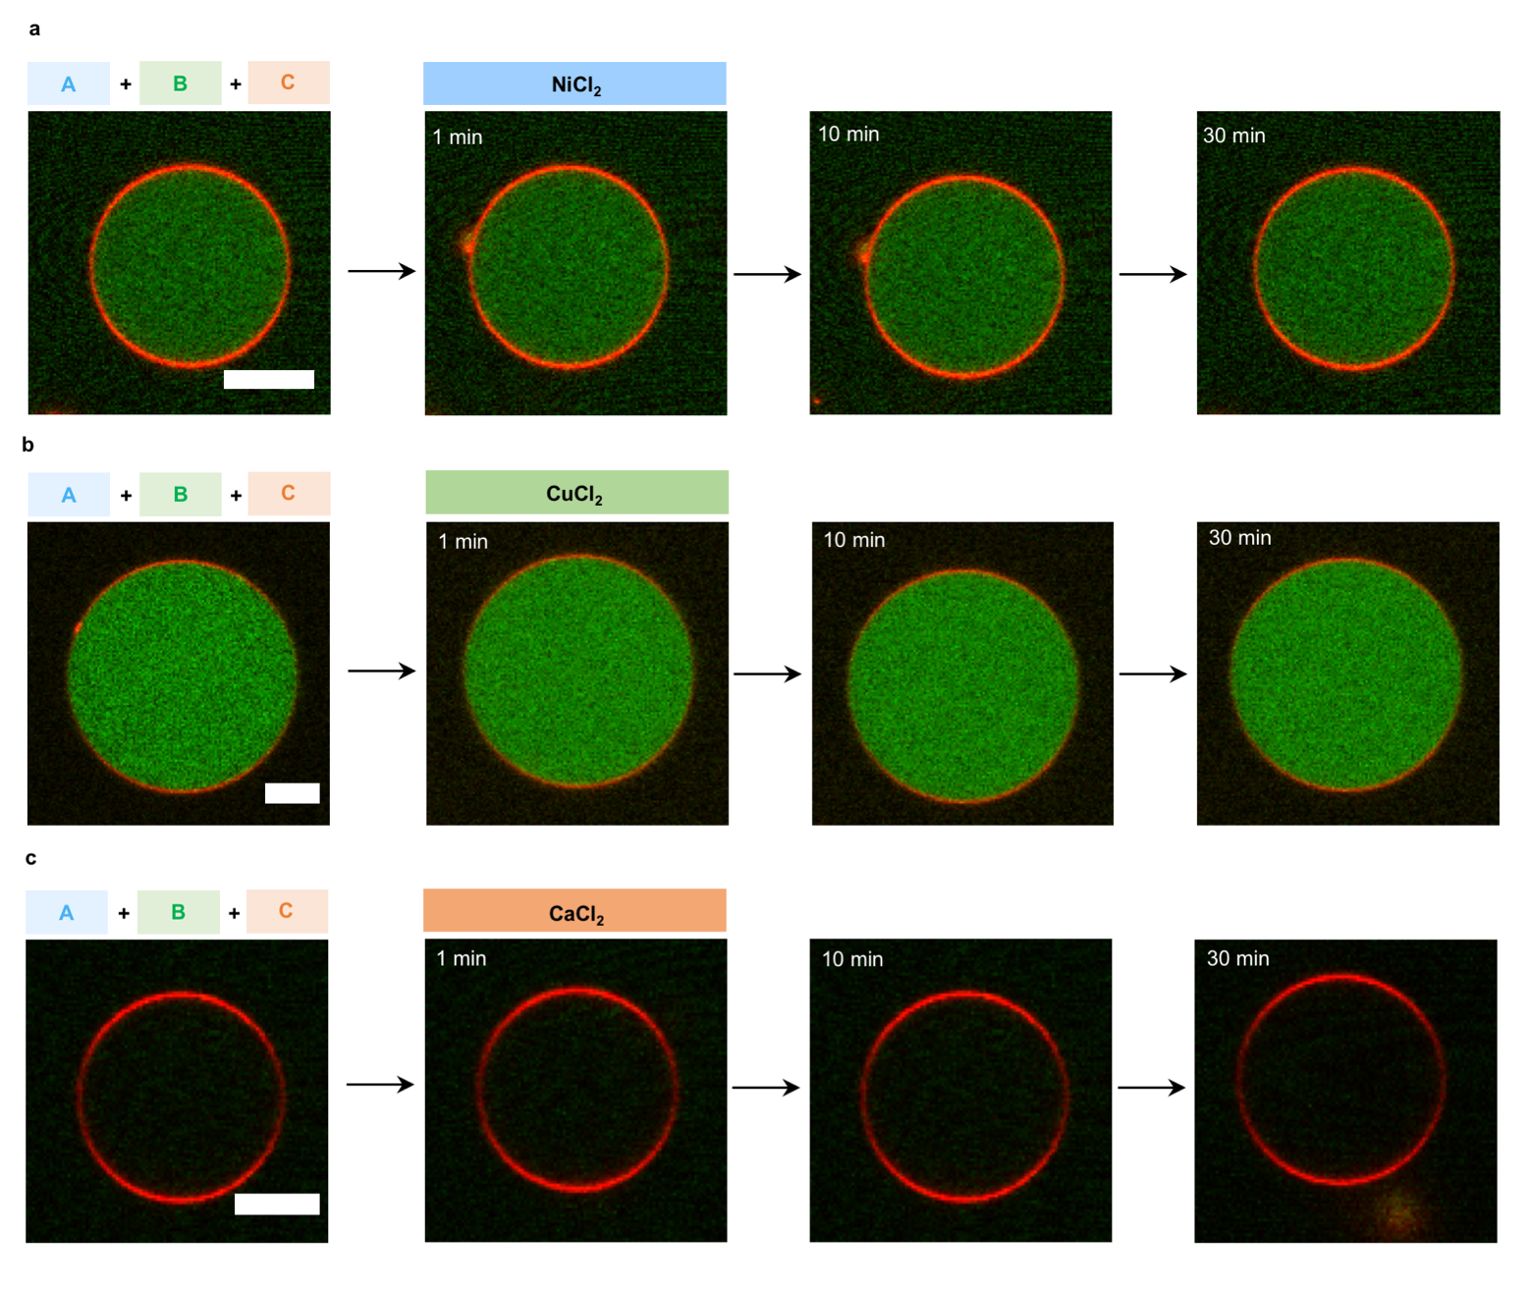
Figure S11. Adding all three ionophores at once induced no change of Rhod2 fluorescence in the presence of external metal ions. Representative CLSM images of [Ca²⁺-Rhod2] loaded GUVs before and after addition all three ionophores in the presence of a, Ni²⁺, or b, Cu²⁺ at different time points. c, Representative CLSM images of Rhod2 loaded GUV before and after addition all three ionophores in the presence of Ca²⁺. Scale bars are 10µm.
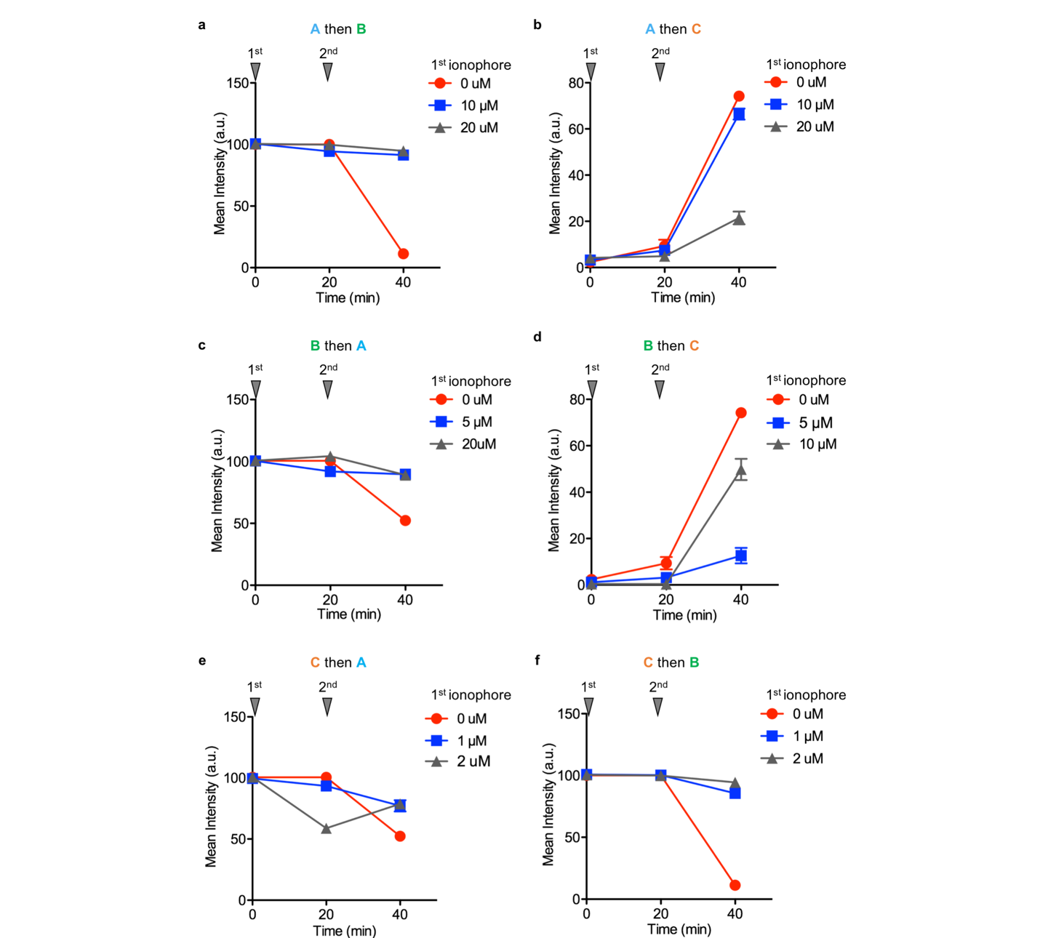Figure S12. Mean [Ca²⁺-Rhod2] fluorescence intensity inside GUVs in CLSM images, which were used to calculate transport efficiency in Fig. 4g. GUVs were first incubated with different concentration of ionophore A and 20 min later with a, ionophore B in the presence of external CuCl₂ or b, ionophore C in the presence of external CaCl₂. GUVs were first incubated with different concentration of ionophore B and 20 min later with a, ionophore A in the presence of external NiCl₂ or b, ionophore C in the presence of external CaCl₂. GUVs were first incubated with different concentration of ionophore C and 20 min later with a, ionophore A in the presence of external NiCl₂ or b, ionophore B in the presence of external CuCl₂. GUVs in a, c, e and f were loaded with [Ca²⁺-Rhod2] and in b and d with Rhod2. n = 10.

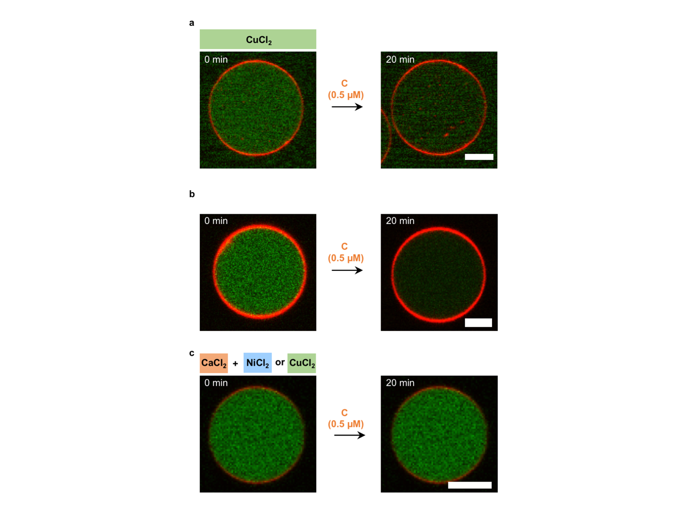
Figure S13. The diffusion out of GUVs depends on concentration gradient between the inside and the outside. Representative CLSM images of GUV loaded with [Ca²⁺-Rhod2] before and after addition of 0.5 µM ionophore C a, in the presence of external CuCl₂; b, in the absence of external metal ion; c, in the presence of external CaCl₂ and NiCl₂ or CuCl₂. In (a) and (b) Ca²⁺ ions diffuse out of the GUV, resulting in a lower internal fluorescence. In (c) the internal and external Ca²⁺ concentrations were equal resulting in no change of [Ca²⁺-Rhod2] fluorescence inside the GUV. Scale bars are 10 µm.

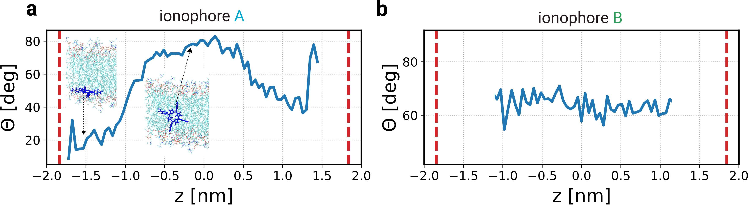
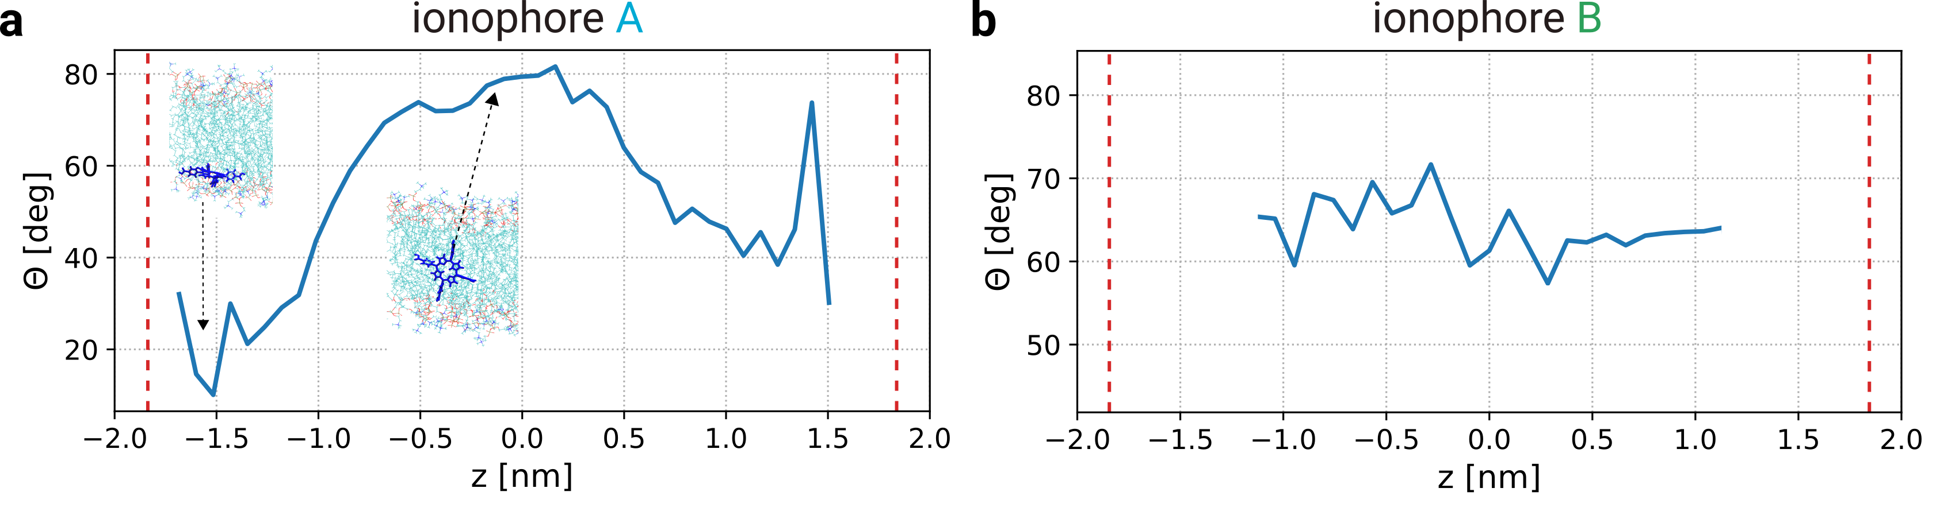
Figure S14. Orientation of the ionophores inside the membrane. a, The angle between the vector perpendicular to the ring part of ionophore A and b, ionophore B with the membrane normal (z-axis) as a function of the position of the ionophore inside the membrane. The average z-positions of the COM of lipids head group in the two leaflets are represented by red dashed lines.

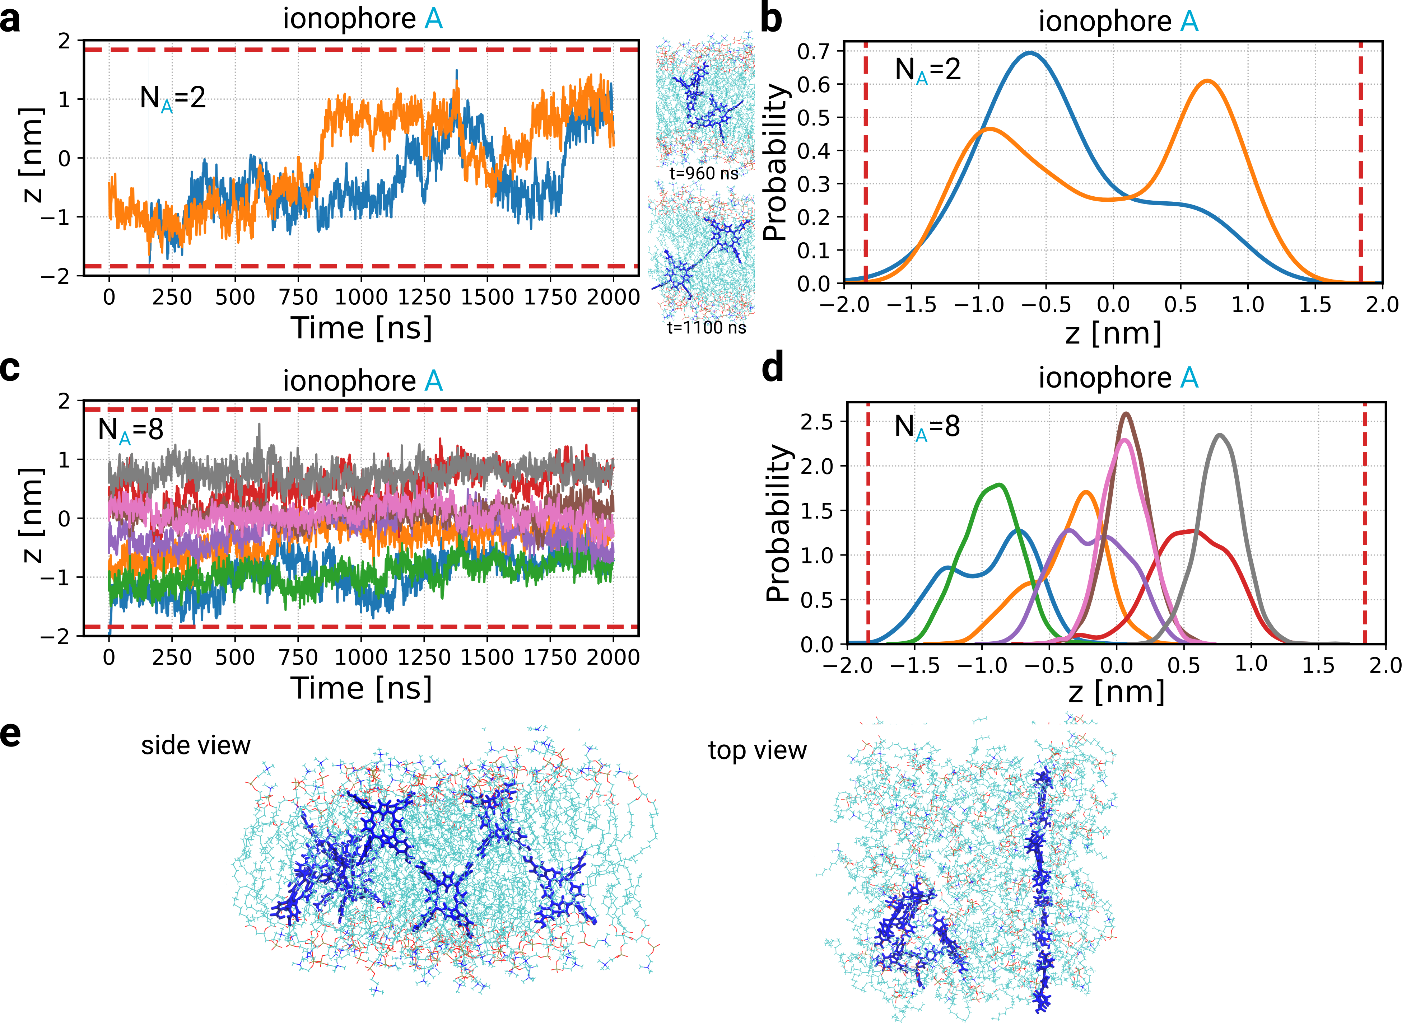
Figure S15. Multiple ionophores in the membrane. N_{A}=2, N_{A}=8. a, The time-dependent position of the z-coordinate of ionophores B, defined along the membrane normal of the COM of a single ionophore A when N_{A}=2, b, The probability distribution of COM values for N_{A}=2. The corresponding plots for the system with N_{A}=8 are shown in c and d. e, The snapshots of the top and side view of the system with N_{A}=8, showing different interactions and forms of clusters. Two ionophores construct parallel clusters and four ionophores create a network-like cluster, in which the ionophores interact through their side chains. The average z-positions of the COM of lipids head group in the two leaflets are represented by red dashed lines. The position of the center of the membrane is at z=0 and the approximate average positions of the lipids head group in the two leaflets are represented by red dashed lines.

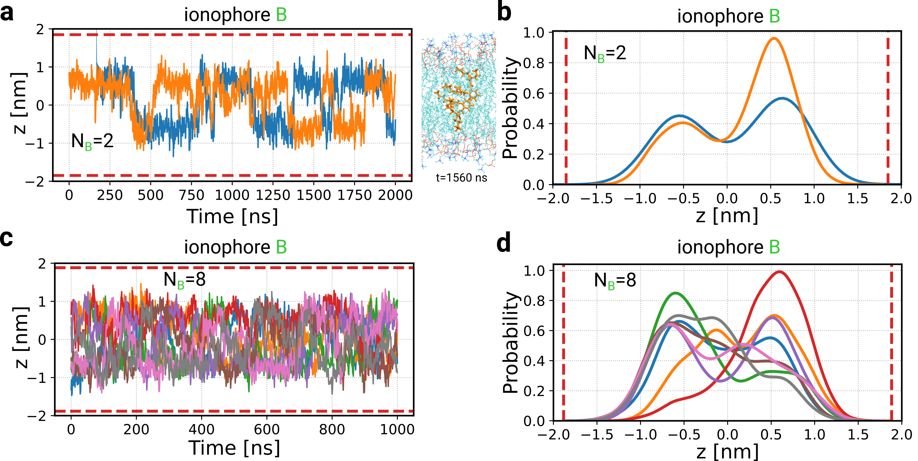
Figure S16. Multiple ionophores in the membrane. N_{B}=2, N_{B}=8. a, The time-dependent position of the z-coordinate of ionophores B, defined along the membrane normal of the COM of a single ionophore A when N_{B}=2, b, The probability distribution of COM values for N_{B}=2. The corresponding plots for the system with N_{B}=8 are shown in c and d. The average z-positions of the COM of lipids head group in the two leaflets are represented by red dashed lines. The position of the center of the membrane is at z=0 and the approximate average positions of the lipids head group in the two leaflets are represented by red dashed lines.

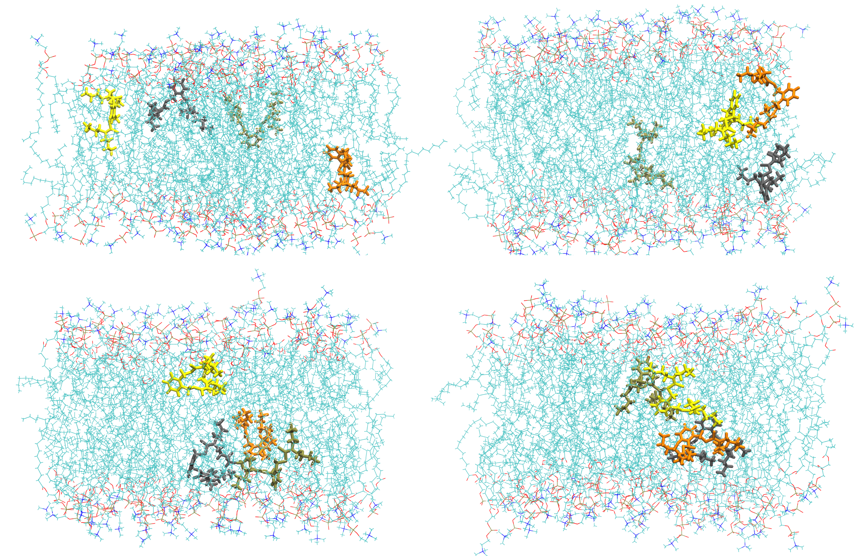
Figure S17. Snapshots of the ionophores B in N_{B}=8. The snapshots of ionophore B shows different configurations and interactions between them and building of transient clusters.
Figure S18. Permeability of GUVs after sequential addition of ionophores due to a partial activation of apo-PLA₂ with ionophore C transported Ca²⁺. a, Representative CLSM images of GUVs loaded with sulfo-Cy5 and apo-PLA₂ in the presence and absence of ionophore C with external CaCl₂. b, Mean fluorescence intensity of the sulfo-Cy5 inside the GUVs (n = 10) loaded with apo-PLA₂ before and after addition of multiple ionophores shown in (a and Fig. 6). Scale bar is 10 µm.

