Supplementary Information

Modular Self-Assembly of a Low-Symmetry Helicene Racemate into Robust yet Facilely Recyclable Porous Crystals

Guoli Zhang¹, Jian Zhang¹, Yu Tao², Fuwei Gan¹, Geyu Lin¹, Juncong Liang¹, Chengshuo Shen^{3,}*, Yuebiao Zhang², Huibin Qiu^{1,}*

¹School of Chemistry and Chemical Engineering, Zhangjiang Institute for Advanced Study, Frontiers Science Center for Transformative Molecules, State Key Laboratory of Metal Matrix Composites, Shanghai Jiao Tong University, Shanghai 200240, China.
²Shanghai Key Laboratory of High Resolution Electron Microscopy, School of Physical Science and Technology, ShanghaiTech University, Shanghai 201210, China.
³School of Chemistry and Chemical Engineering, Key Laboratory of Surface & Interface Science of Polymer Materials of Zhejiang Province, Zhejiang Sci-Tech University, 310018, Hangzhou, China.

Table of Contents
1. Supplementary Methods S2
2. Characterization of Single Crystals and Powder of D6H S4
3. Adsorption Experiments S17
4. Theoretical Calculations S34
Supplementary References S49

1. Supplementary Methods
1.1 General Information
All the synthetic experiments were performed using standard Schlenk techniques unless otherwise stated. Starting materials and reagents were of AR grade quality and were purchased from commercial sources and used without further purification unless otherwise noted.
NMR spectra were recorded on a Bruker Avance III HD 500 Spectrometer. Chemical shifts were determined using residual signals of the deuterated solvents and were reported in parts per million (ppm). High-resolution mass spectrometry (HR-MS) data were recorded on a Bruker time of flight mass spectrometer (autoflex speed TOF/TOF) using matrix-assisted laser desorption/ionization (MALDI) mode. Single crystal data were recorded on a Bruker D8 Venture single crystal X-ray diffractometer with graphite-monochromatic Cu Kα (λ = 1.54178 Å) radiation. Powder X-ray diffraction (PXRD) patterns were collected by a Bruker D8 Advance X-ray diffractometer using Cu Kα (λ = 1.54178 Å) radiation. Variable-temperature powder X-ray diffraction (PXRD) was collected by a Bruker D8 Advance X-ray diffractometer using Co Kα (λ = 1.79021 Å) radiation. Differential scanning calorimetry (DSC) were performed with a DSC 2500 analyzer under nitrogen atmosphere with a temperature changing rate of 10 °C /min. Thermogravimetric analyses (TGA) were performed with an SDT-Q600 analyzer under nitrogen atmosphere with a heating rate of 10 °C /min. Vapor-phase adsorption isotherms were measured with a Belsorp-MAXIIG surface area and porosity analyzer (MicrotracBELe) and a Belsorp-Aqua3 moisture sorption analyzer (MicrotracBELe). Optical microscope photos were taken by a LEICA DM 4000 optical microscope with a CCD camera. Scanning electron microscopy (SEM) micrographs were obtained on a TESCAN MAIA3 microscope operated at 5.0 kV. The adsorption isotherms were collected by a BELSORP-MAX volumetric analyzer.

1.2 Synthesis of D6H
D6H was synthesized according to the literature¹. Typically, 0.176 g of 2-ethynyl[6]helicene (0.5 mmol) and 0.191 g of phencyclone (0.5 mmol) were dissolved in 10 mL of xylene under argon. The mixture was then stirred at 140 °C for 6 hours. During the reaction, the solution color turned from blackish green to yellow with heavy white precipitate. Subsequently, the suspension was cooled to room temperature and the solvent was removed at reduced pressure. The residue was washed with ethanol and ether, and then dried to afford D6H as white solid (0.35 g, 95%). ¹H NMR (500 MHz, CS₂, 298 K): δ 8.39 (d, J = 8.4 Hz, 1H), 8.35 (d, J = 8.4 Hz, 1H), 8.09 (s, 2H), 8.07 (d, J = 8.0 Hz, 1H), 8.04 (d, J = 8.0 Hz, 1H), 8.01 (d, J = 8.4 Hz, 1H), 7.96 (d, J = 8.4 Hz, 1H), 7.92 (s, 1H), 7.90 - 7.85 (m, 2H), 7.81 (d, J = 8.4 Hz, 1H), 7.80 - 7.73 (m, 3H), 7.71 - 7.65 (m, 3H), 7.49 - 7.33 (m, 6H), 7.28 (d, J = 7.8 Hz, 1H), 7.20 - 7.04 (m, 4H), 6.95 - 6.8- (m, 4H), 6.54 (broad, 1H), 6.49 (dd, J = 7.8 Hz, J = 1.6 Hz, 1H), 6.24 (s, 1H). ¹³C{1H} NMR spectrum could not be recorded due to the fast epimerization between different conformers. MALDI-HR-MS for C₅₆H₃₄^{·+} (M^{·+}): m/z = 706.2655 (calculated), 706.2423 (found).
P-D6H: Starting with 35.2 mg of P-2-ethynyl[6]helicenes (0.1 mmol), 52.2 mg of P-D6H (yield: 74%) was obtained.
M-D6H: Starting with 35.2 mg of M-2-ethynyl[6]helicenes (0.1 mmol), 48.6 mg of M-D6H (yield: 68%) was obtained.

2. Characterization of Single Crystals and Powder of D6H
Crystallization of enantiopure D6H by solvent diffusion. Single crystals of enantiopure (P and M) D6H were grown in a carbon disulfide (CS₂) solution with the diffusion of a vapor of n-pentane. 3.0 mg of P-D6H and M-D6H were respectively dissolved in 1 mL of CS₂, and then crystalized in a vapor of n-pentane for 3 days. The crystals were washed with n-pentane and then dried.
Crystallization of D6H after melting. 10.0 mg of D6H was encapsulated in a glass tube with nitrogen atmosphere. The tube was heated at 300 °C for 6 hours, then cooled in a muffle furnace to 250 °C with a slow rate of 0.1 °C/min.

Supplementary Table 1 | Crystallographic data and structure refinement for the crystal of racemic D6H obtained by solvent diffusion (CCDC 2224852).
Empirical formula | C₅₆H₃₄
Formula weight | 706.83
Temperature (K) | 172.99
Crystal system | Trigonal
Space group | R-3
a (Å) | 49.9332(6)
b (Å) | 49.9332(6)
c (Å) | 10.5479(2)
α (°) | 90
β (°) | 90
γ (°) | 120
Volume (Å³) | 22775.9(7)
Z | 18
ρ_{calc.} (g·cm⁻³) | 0.928
μ (mm⁻¹) | 0.400
F(000) | 6660.0
Crystal size (mm³) | 0.1 × 0.03 × 0.02
Radiation | Cu Kα (λ = 1.54178)
2Θ range for data collection (°) | 6.132 to 127.784
Index ranges | −58 ≤ h ≤ 58, −58 ≤ k ≤ 58, −12 ≤ l ≤ 12
Reflections collected | 72124
Independent reflection | 8379 [R_{int} = 0.0599, R_{σ} = 0.0245]
Data/restraints/parameters | 8379/1/505
Goodness-of-fit on F² | 1.031
Final R indexes [I ≥ 2σ(I)] | R₁ = 0.0358, wR₂ = 0.0888
Final R indexes [all data] | R₁ = 0.0454, wR₂ = 0.0940
Largest diff. peak/hole (e·Å⁻³) | 0.14/−0.19

Note: CH₂Cl₂ and n-pentane molecules possibly exist in a disordered form, which were removed by solvent mask using Olex2.

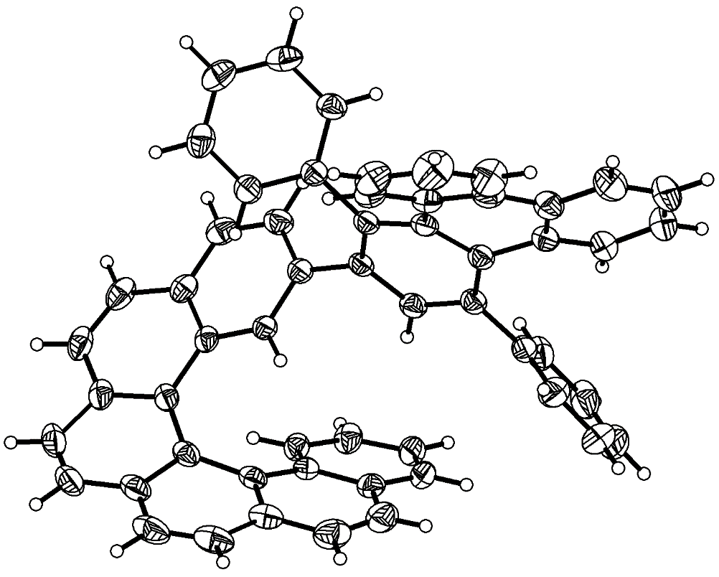
Supplementary Fig. 1 | X-ray crystallographic structure of racemic D6H (only M enantiomer is shown). The single crystal was obtained by solvent diffusion. Thermal ellipsoids are shown at a 50% probability level.

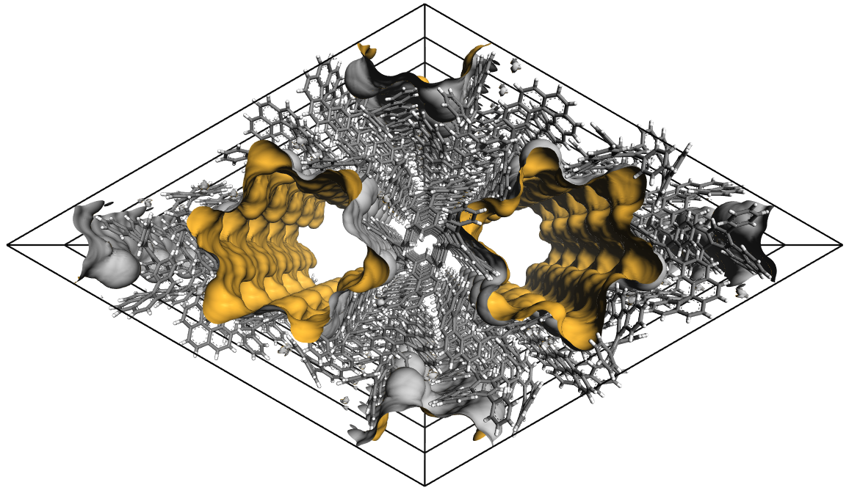
Supplementary Fig. 2 | Solvent-accessible void space generated with a probe of 1.84 Å for a crystal of racemic D6H obtained by solvent diffusion.

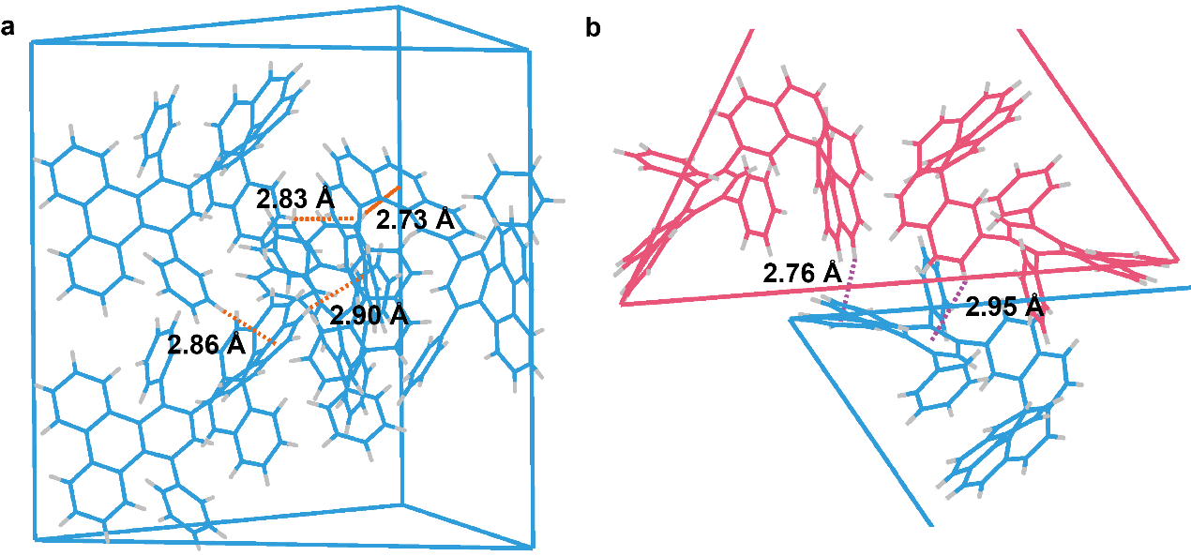
Supplementary Fig. 3 | Intermolecular interactions in a crystal of racemic D6H obtained by solvent diffusion. a, Intermolecular interactions between homochiral molecules. b, Intermolecular interactions between heterochiral molecules.

Supplementary Table 2 | Crystallographic data and structure refinement for the crystal of M-D6H (CCDC 2268959).
Empirical formula | C_{56.5}H₃₄S
Formula weight | 744.965
Temperature (K) | 233.0
Crystal system | Triclinic
Space group | P1
a (Å) | 10.9914(9)
b (Å) | 13.2868(11)
c (Å) | 14.8616(13)
α (°) | 66.908(4)
β (°) | 80.808(5)
γ (°) | 89.602(5)
Volume (Å³) | 1967.1(3)
Z | 2
ρ_{calc.} (g·cm⁻³) | 1.258
μ (mm⁻¹) | 1.024
F(000) | 780.9
Crystal size (mm³) | 0.2 × 0.2 × 0.05
Radiation | Cu K_{α} (λ = 1.54178)
2Θ range for data collection (°) | 6.56 to 138.52
Index ranges | −12 ≤ h ≤ 13, −16 ≤ k ≤ 16, −17 ≤ l ≤ 17
Reflections collected | 20620
Independent reflection | 12602 [R_{int} = 0.1343, R_{σ} = 0.1811]
Data/restraints/parameters | 12602/15/1037
Goodness-of-fit on F² | 1.119
Final R indexes [I ≥ 2σ(I)] | R₁ = 0.1089, wR₂ = 0.2850
Final R indexes [all data] | R₁ = 0.1773, wR₂ = 0.3409
Largest diff. peak/hole (e·Å⁻³) | 1.19/−0.69

- Explanation for the Alert B
PLAT340_ALERT_3_B Low Bond Precision on C−C Bonds 0.01208 Ang.
—— The Alert_3_B was majorly caused by the low quality of the single crystal. However, this would not affect the structural determination in this study.

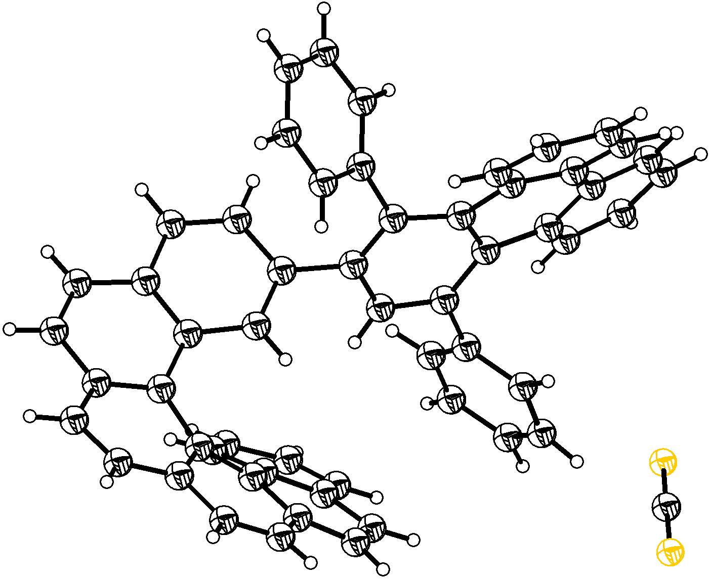
Supplementary Fig. 4 | X-ray crystallographic structure of M-D6H. The single crystal was obtained by solvent diffusion. Thermal ellipsoids are shown at a 50% probability level.
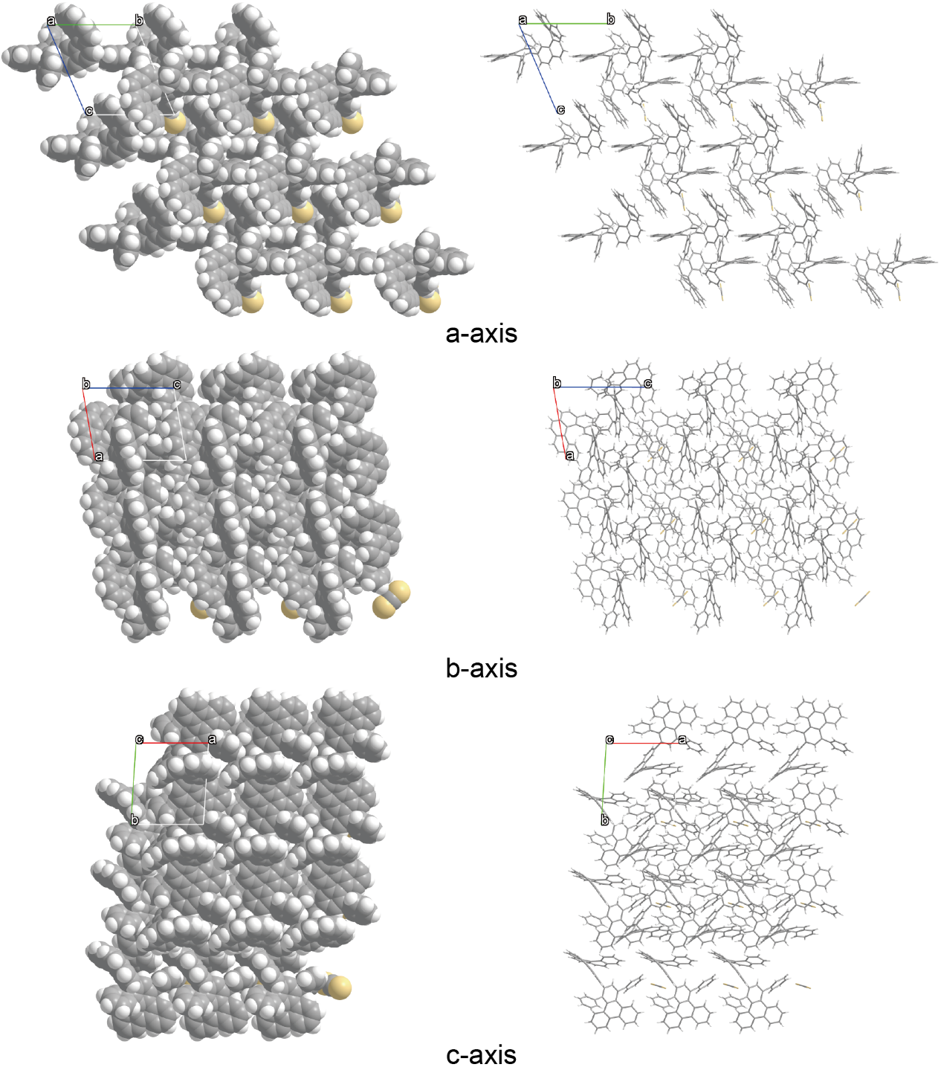
Supplementary Fig. 5 | Molecular packing of M-D6H in the crystal.

Supplementary Fig. 6 | TGA curve of the crystals of racemic D6H obtained by solvent diffusion.

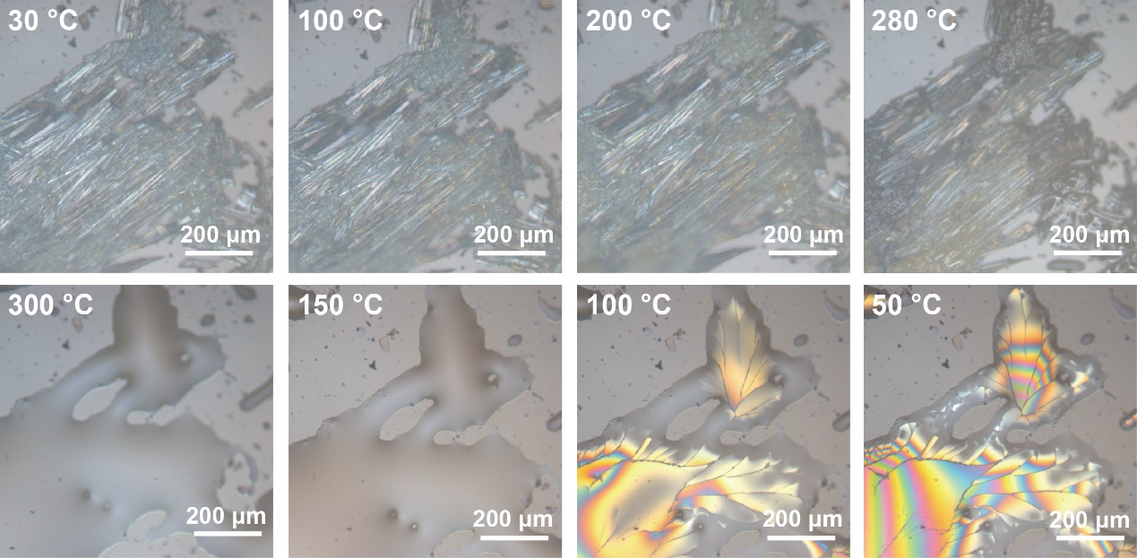
Supplementary Fig. 7 | Optical microscope images of the crystals of racemic D6H obtained by solvent diffusion upon heating from 30 °C to 300 °C, then cooling to 50 °C in the air.

Supplementary Table 3 | Crystallographic data and structure refinement for the crystal of racemic D6H obtained after melting (CCDC 2224863).
Empirical formula | C₅₆H₃₄
Formula weight | 706.83
Temperature (K) | 173.0
Crystal system | Monoclinic
Space group | P2₁/n
a (Å) | 10.7749(2)
b (Å) | 12.9241(2)
c (Å) | 27.1691(5)
α (°) | 90
β (°) | 97.3170(10)
γ (°) | 90
Volume (Å³) | 3752.65(11)
Z | 4
ρ_{calc.} (g·cm⁻³) | 1.251
μ (mm⁻¹) | 0.539
F(000) | 1480.0
Crystal size (mm³) | 0.1 × 0.1 × 0.1
Radiation | Cu K_{α} (λ = 1.54178)
2Θ range for data collection (°) | 6.56 to 136.69
Index ranges | −12 ≤ h ≤ 11, −15 ≤ k ≤ 15, −29 ≤ l ≤ 32
Reflections collected | 39092
Independent reflection | 6848 [R_{int} = 0.0495, R_{σ} = 0.0296]
Data/restraints/parameters | 6848/0/505
Goodness-of-fit on F² | 1.020
Final R indexes [I ≥ 2σ(I)] | R₁ = 0.0351, wR₂ = 0.0834
Final R indexes [all data] | R₁ = 0.0459, wR₂ = 0.0889
Largest diff. peak/hole (e·Å⁻³) | 0.15/−0.17

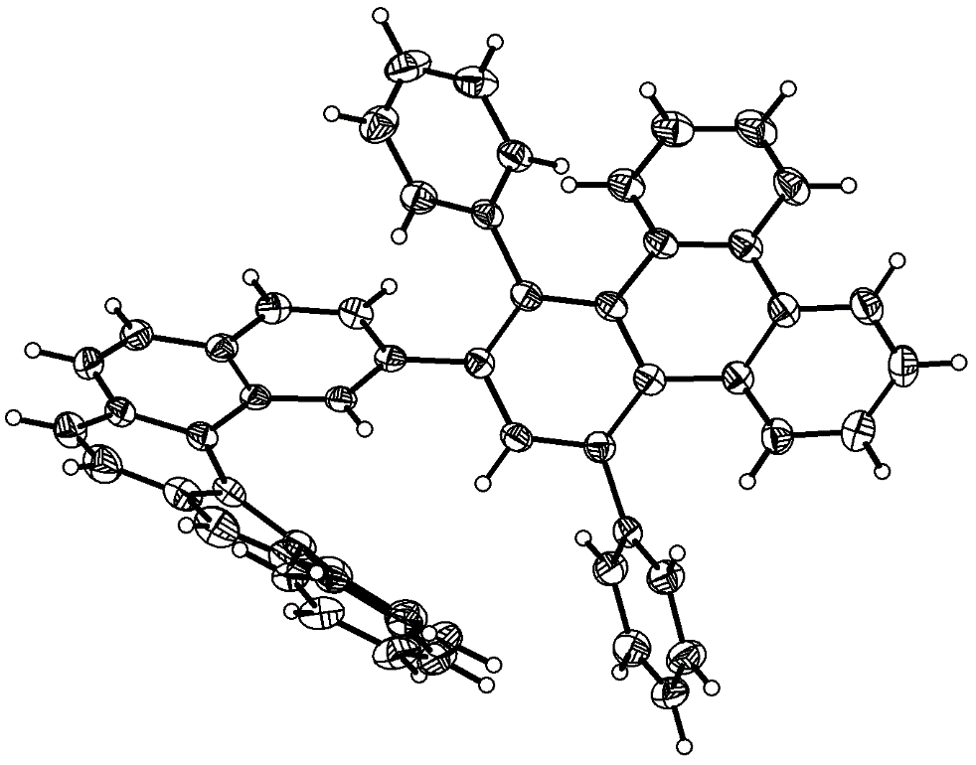
Supplementary Fig. 8 | X-ray crystallographic structure of racemic D6H (only M enantiomer is shown). The crystal was obtained by melting and cooling. Thermal ellipsoids are shown at a 50% probability level.

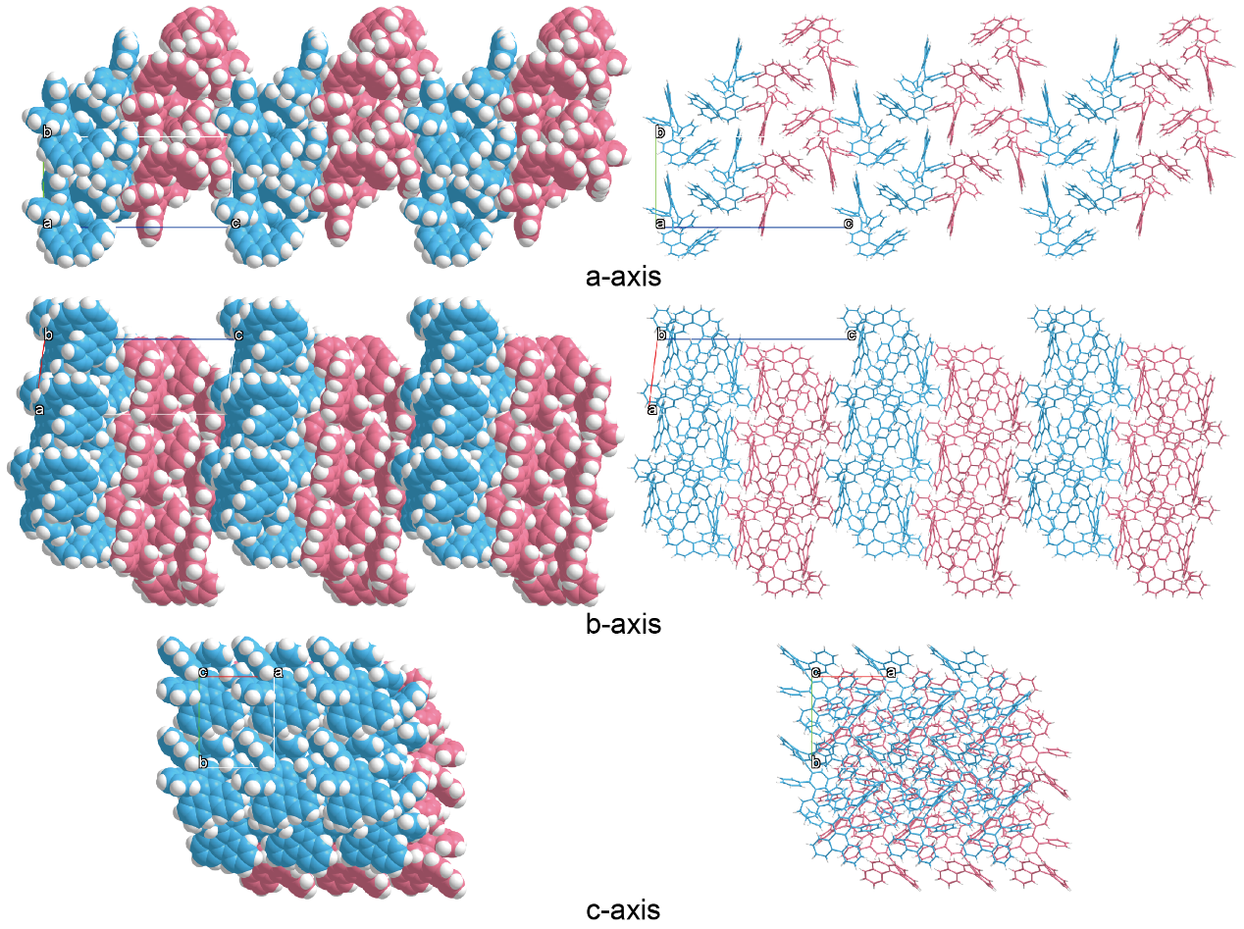
Supplementary Fig. 9 | Molecular packing of racemic D6H in the crystal obtained after melting.

Supplementary Fig. 10 | TGA curve of the crystals of racemic D6H obtained after melting.

Supplementary Fig. 11 | DSC curves of the crystals of racemic D6H obtained after melting.

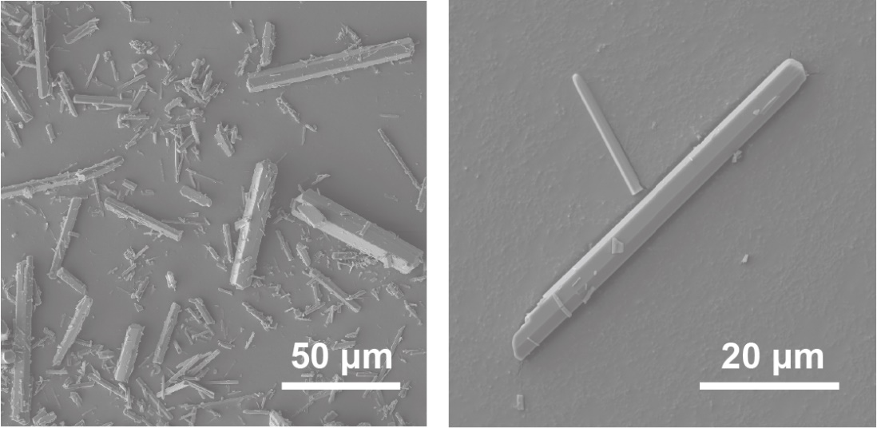
Supplementary Fig. 12 | SEM images of the crystals of racemic D6H obtained by solvent diffusion.

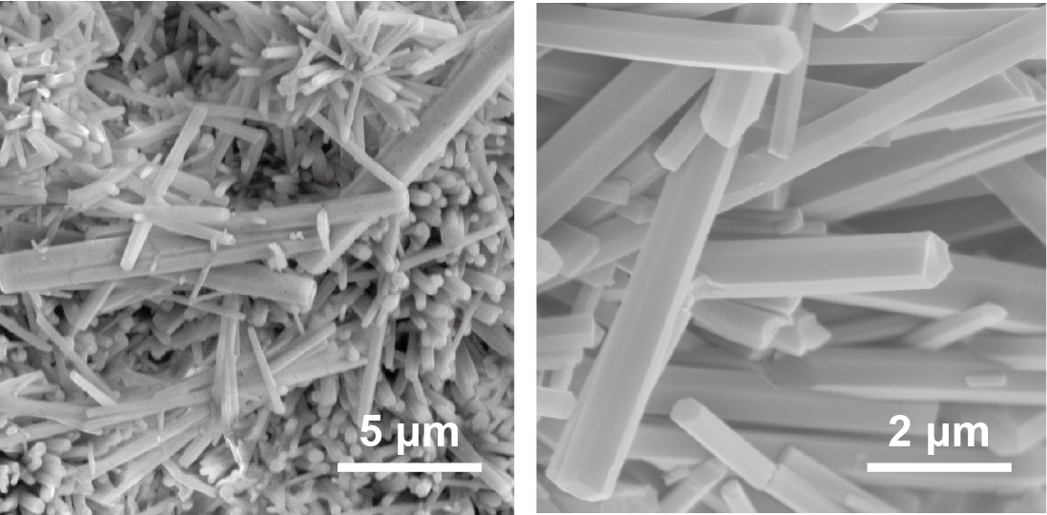
Supplementary Fig. 13 | SEM images of powder of racemic D6H dried from DCM.

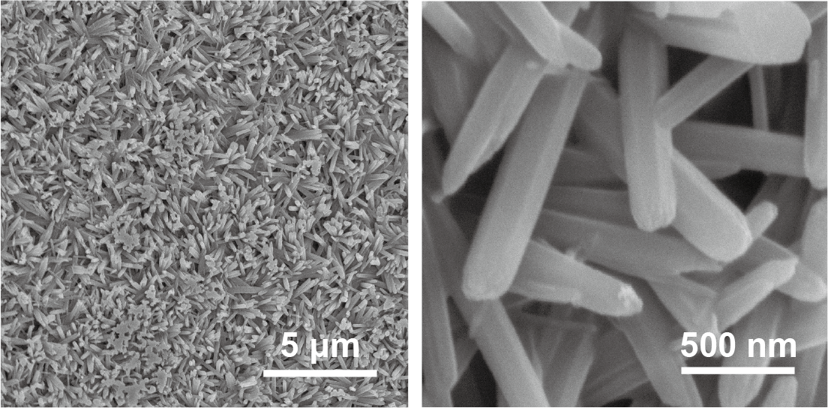
Supplementary Fig. 14 | SEM images of powder of racemic D6H dried from CHCl₃.
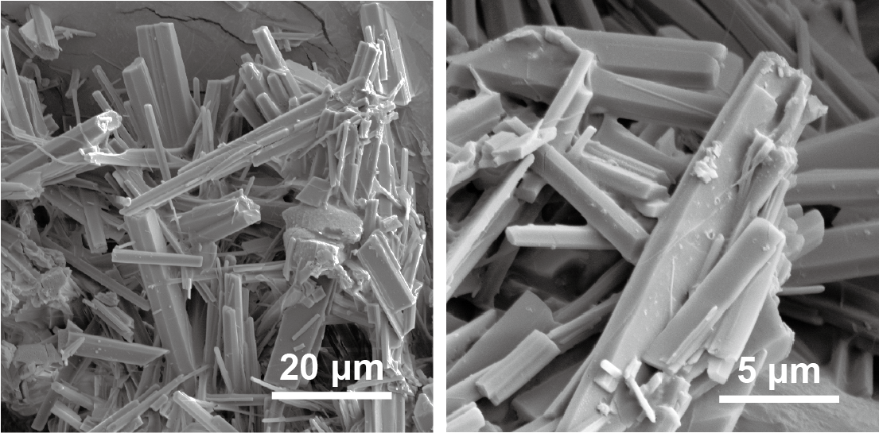
Supplementary Fig. 15 | SEM images of powder of racemic D6H dried from toluene.

3. Adsorption Experiments
Adsorption of various solvents. The powder of racemic D6H dried from DCM was activated by heating the powder at 150 °C under vacuum for 24 h. Subsequently, 10 mg of activated powder of racemic D6H was added into a small glass tube and then the tube was placed in a glass bottle containing 30 mL of target solvent, including THF, diisopropyl ether (DIPE), methyl tert-butyl ether (MTBE), dioxane (DOX), CCH₃, carbon tetrachloride (CCl₄), 1,2-dichloroethane (C₂H₄Cl₂), methanol (MeOH) and cyclohexane (CYH). The whole bottle was heated around the boiling point of the corresponding solvent for 2 days. The samples were eventually exposed in the air at room temperature overnight and the absorption capacity was finally estimated by NMR and TGA.
Cyclic adsorption-desorption experiments. Typically, 40 mg of activated powder of racemic D6H was added into a small glass tube and then the tube was placed in a glass bottle containing 30 mL of THF. The whole bottle was heated at 60 °C for 24 h, and 1 mg of sample was taken out for NMR test. The rest sample was desorbed by heating at 150 °C under vacuum for 24 h, and then placed back in the glass bottle for subsequent adsorption. Repeatedly, the adsorption-desorption experiment was conducted for 10 cycles.
Competitive adsorption experiments. 30 mL of THF, 30 mL of 2-methyltetrahydrofuran (MTHF), and a mixture of 15 mL of THF with 15 mL MTHF were loaded respectively into three glass bottles. The glass tubes with 10 mg of activated powder of racemic D6H were placed in each bottle. The glass bottles were heated at 75 °C for 2 days.
30 mL of DIPE, 30 mL of n-hexane (NH), and a mixture of 15 mL of DIPE with 15 mL NH were loaded respectively into three glass bottles. The glass tubes with 10 mg of activated powder of racemic D6H were placed in each bottle. The glass bottles were heated at 70 °C for 2 days.
30 mL of DOX, 30 mL of CYH, and a mixture of 15 mL of DOX with 15 mL CYH were loaded respectively into three glass bottles. The glass tubes with 10 mg of activated powder of racemic D6H were placed in each bottle. The glass bottles were heated at 90 °C for 2 days. All the absorption capacity was finally estimated by NMR.

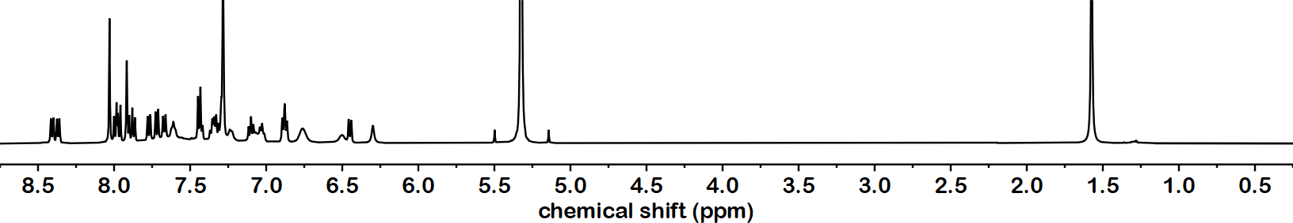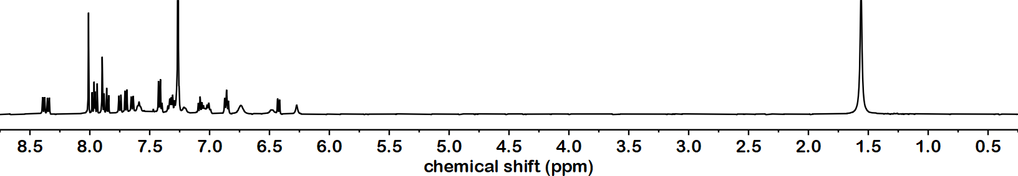
DCM
Supplementary Fig. 16 | ¹H NMR spectrum of powder of racemic D6H dried from DCM before and after activation (500 MHz, CDCl₃, 298 K).

Supplementary Fig. 17 | DSC curves of the activated powder of racemic D6H.

Supplementary Fig. 18 | PXRD patterns of powder of racemic D6H powder dried from DCM before and after activation.

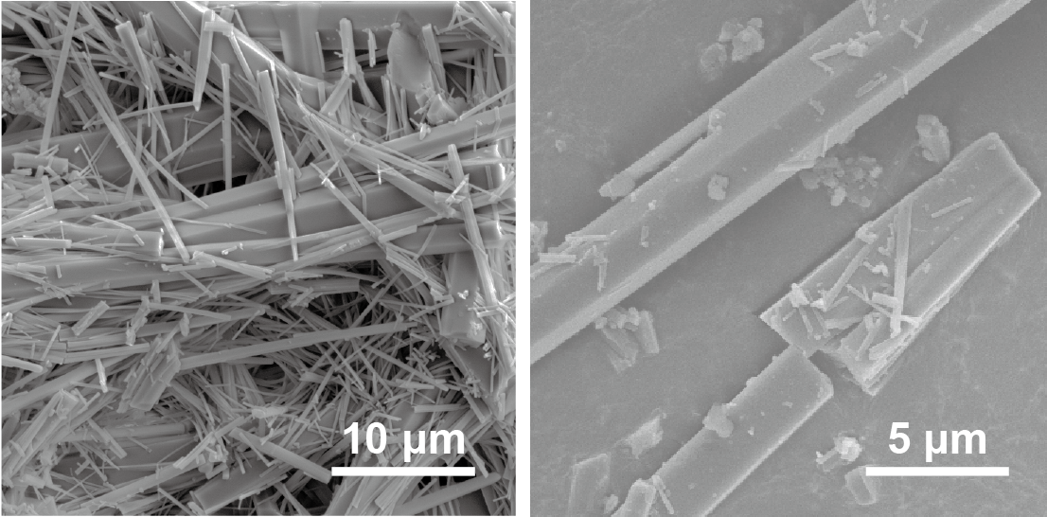
Supplementary Fig. 19 | SEM images of the activated powder of racemic D6H.

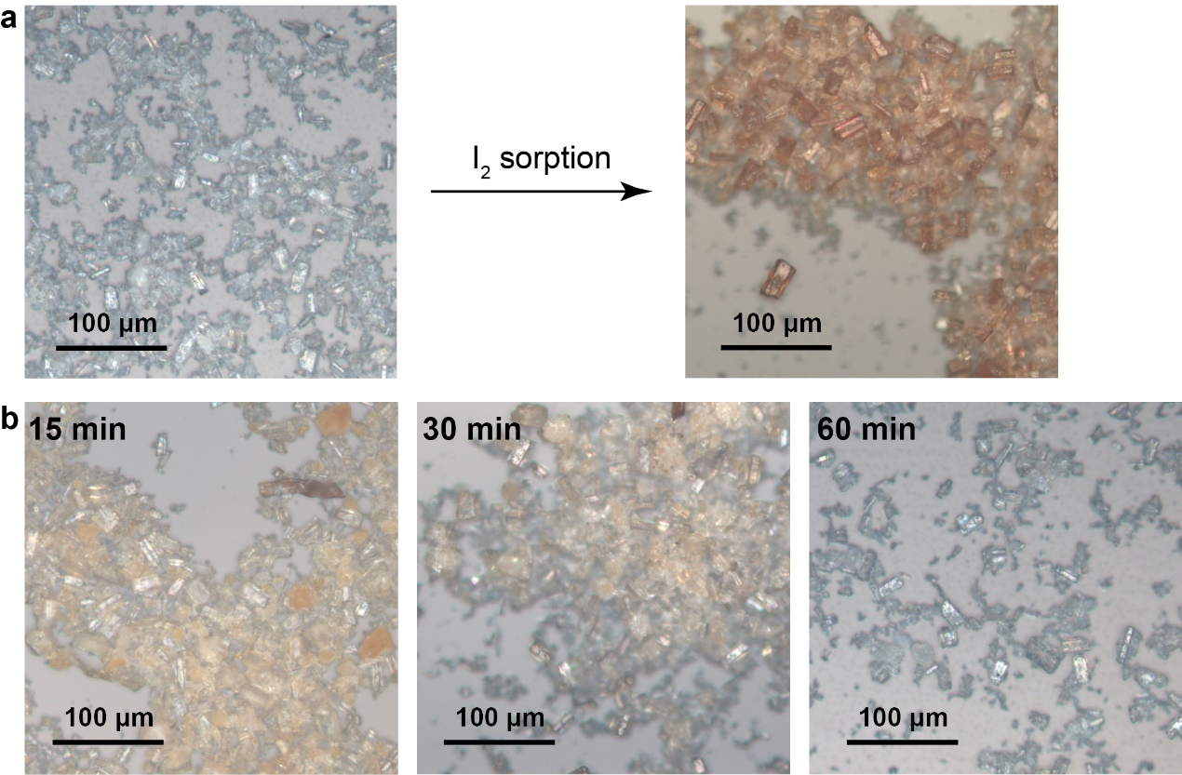
Supplementary Fig. 20 | Adsorption and desorption of iodine by the activated powder of racemic D6H. a, Optical microscope images of the activated powder of racemic D6H before and after being soaked in an ethanol solution of iodine (0.1 mol/L). b, Optical microscope images showing the desorption of iodine from the activated powder of racemic D6H.

Supplementary Fig. 21 | TGA curves of the activated powder of racemic D6H before and after the adsorption of DIPE, MTBE, DOX, CCl₄ and C₂H₄Cl₂.

Supplementary Table 4 | Adsorption capacity of the activated powder of racemic D6H toward various solvents (analyzed by TGA).
Solvent | Weight loss of solvent* | Mole ratio  (D6H : solvent) | Adsorption capacity  (cm³_{STP}/g)
THF | 7.18% | 1 : 0.76 | 24.07
DIPE | 9.30% | 1 : 0.71 | 22.52
MTBE | 6.02% | 1 : 0.49 | 15.50
DOX | 4.68% | 1 : 0.40 | 12.50
CHCl₃ | 10.87% | 1 : 0.70 | 22.30
CCl₄ | 10.52% | 1 : 0.53 | 16.67
C₂H₄Cl₂ | 7.51% | 1 : 0.58 | 18.24
*The weight loss was calculated according to the value at 285 °C.

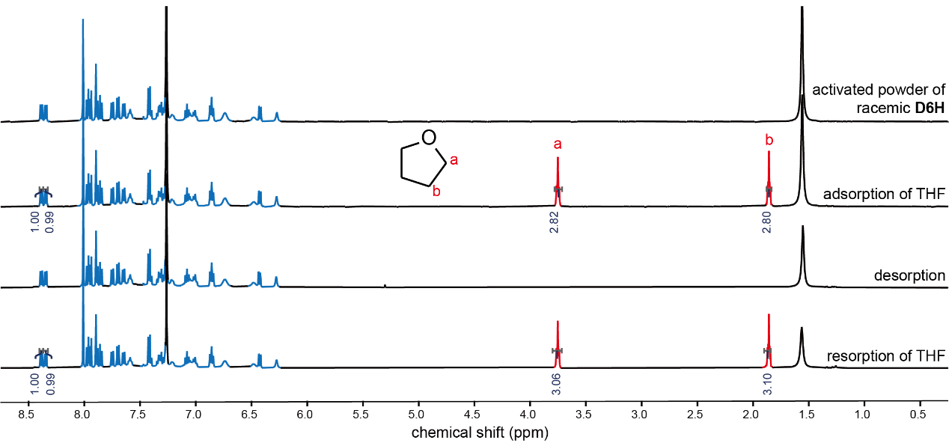
Supplementary Fig. 22 | ¹H NMR spectrum of the activated powder of racemic D6H upon adsorption and desorption of THF (500 MHz, CDCl₃, 298 K).

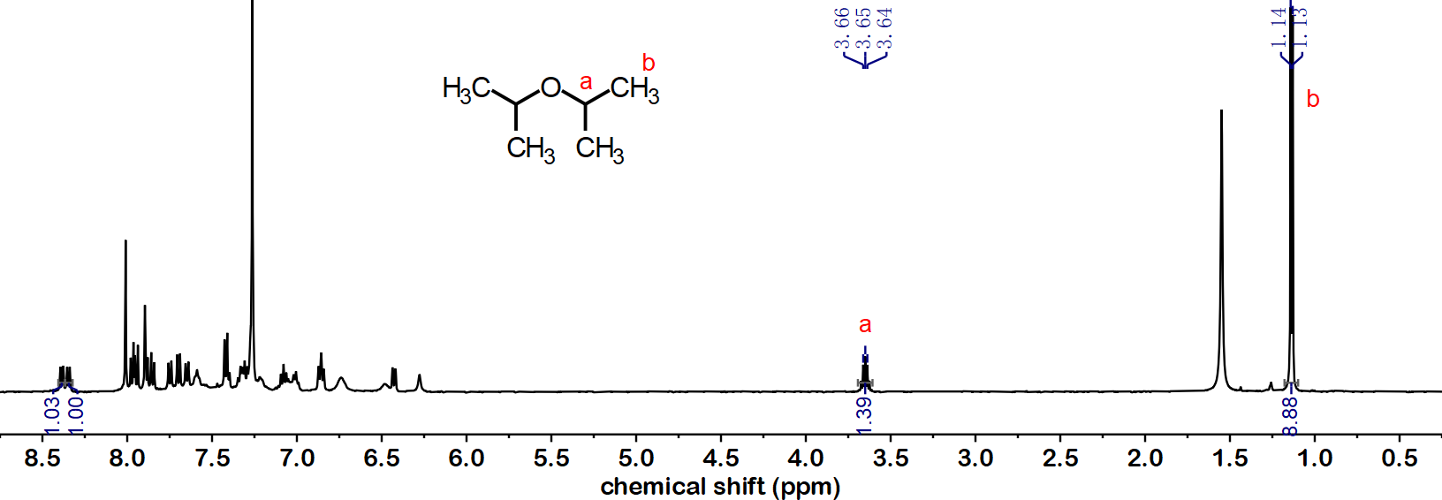
Supplementary Fig. 23 | ¹H NMR spectrum of the activated powder of racemic D6H after adsorption of DIPE (500 MHz, CDCl₃, 298 K).

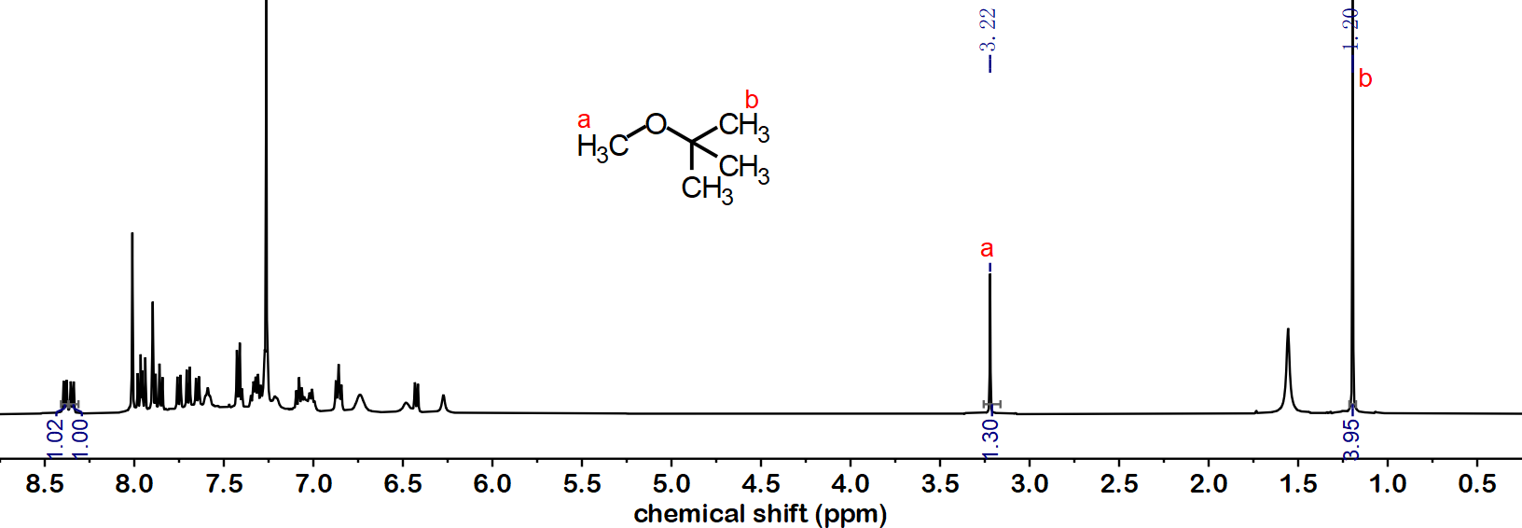
Supplementary Fig. 24 | ¹H NMR spectrum of the activated powder of racemic D6H after adsorption of MTBE (500 MHz, CDCl₃, 298 K).

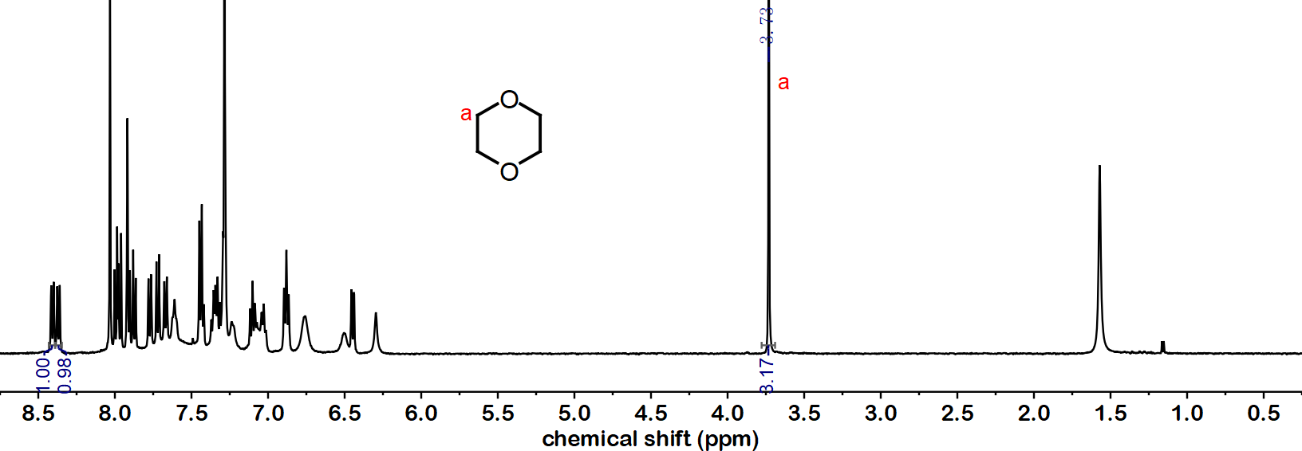
Supplementary Fig. 25 | ¹H NMR spectrum of the activated powder of racemic D6H after adsorption of DOX (500 MHz, CDCl₃, 298 K).

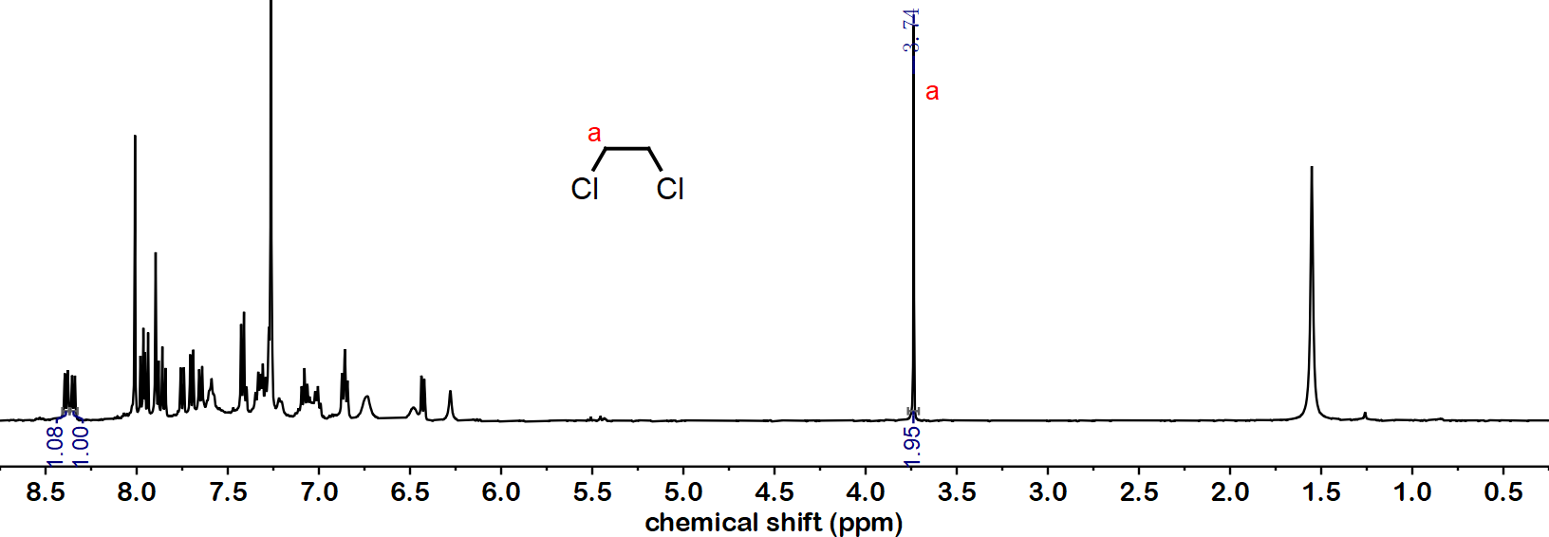
Supplementary Fig. 26 | ¹H NMR spectrum of the activated powder of racemic D6H after adsorption of C₂H₄Cl₂ (500 MHz, CDCl₃, 298 K).

Supplementary Table 5 | Adsorption capacity of the activated powder of racemic D6H toward various solvents (analyzed by NMR).
Solvent | Mole ratio (D6H : THF) | Adsorption capacity (cm³_{STP}/g)
THF | 1 : 0.71 | 22.49
DIPE | 1 : 0.70 | 22.17
MTBE | 1 : 0.44 | 13.94
DOX | 1 : 0.39 | 12.36
C₂H₄Cl₂ | 1 : 0.49 | 15.52

Supplementary Fig. 27 | PXRD patterns of the activated powder of racemic D6H upon adsorption and desorption of THF.

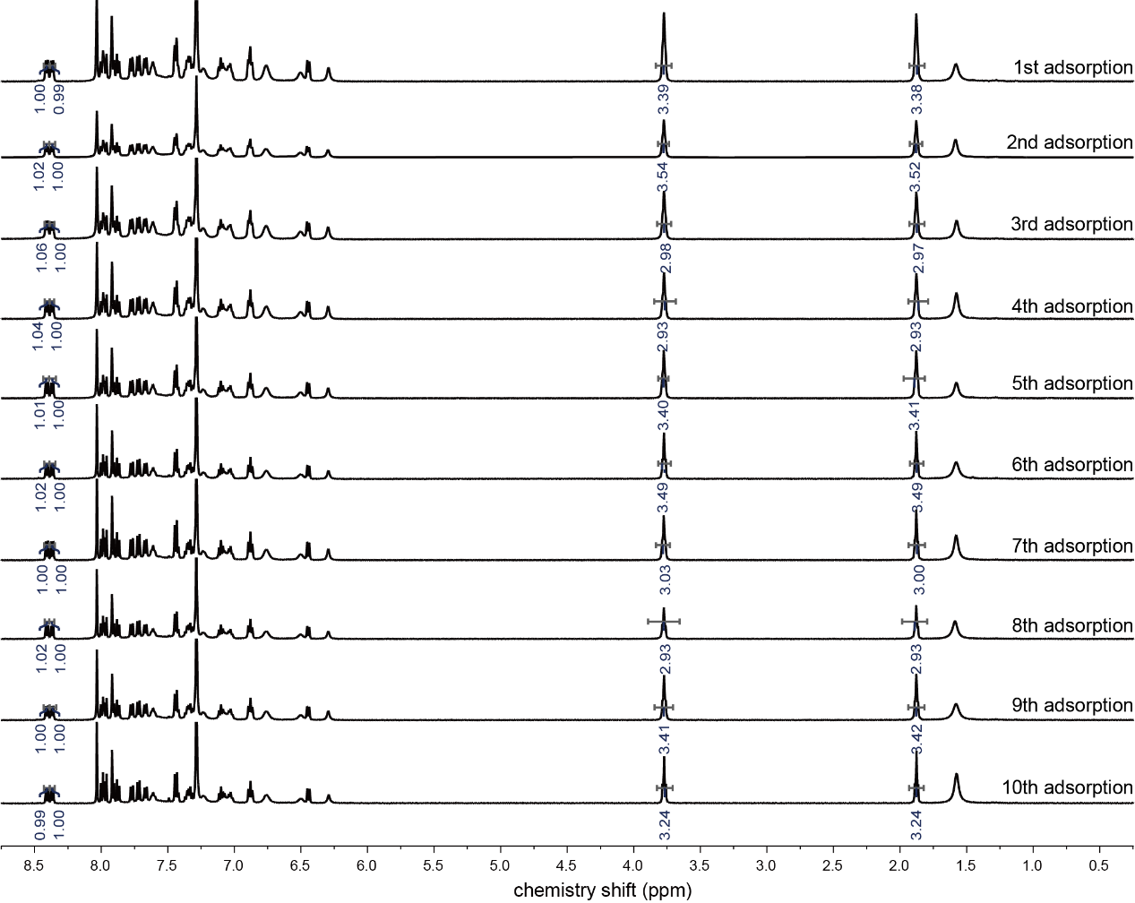
Supplementary Fig. 28 | ¹H NMR spectra showing the adsorption of THF by the activated powder of racemic D6H after various adsorption-desorption cycles (500 MHz, CDCl₃, 298 K).

Supplementary Table 6 | Adsorption capacity of the activated powder of racemic D6H after various adsorption-desorption cycles (analyzed by NMR).
Number of cycles | Mole ratio (D6H : THF) | Adsorption capacity (cm³_{STP}/g)
1 | 1 : 0.85 | 26.92
2 | 1 : 0.88 | 27.87
3 | 1 : 0.75 | 23.75
4 | 1 : 0.73 | 23.12
5 | 1 : 0.85 | 26.92
6 | 1 : 0.87 | 27.55
7 | 1 : 0.76 | 24.07
8 | 1 : 0.73 | 23.12
9 | 1 : 0.85 | 26.91
10 | 1 : 0.81 | 25.64

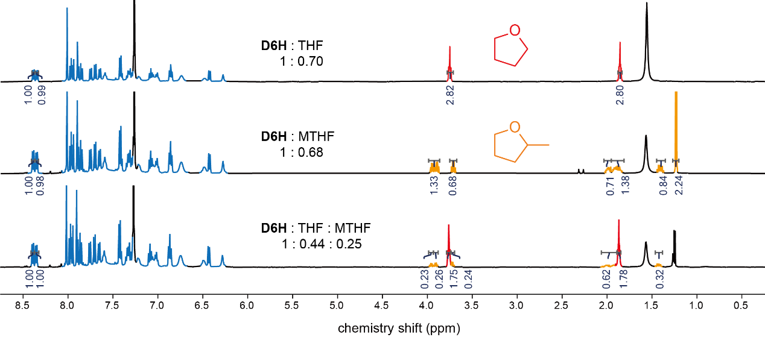
Supplementary Fig. 29 | ¹H NMR spectra of the activated powder of racemic D6H after adsorption of THF, MTHF and a blend vapor of THF with MTHF.

Supplementary Table 7 | Adsorption capacity of the activated powder of racemic D6H toward THF, MTHF and a blend vapor of THF with MTHF (analyzed by NMR).
Solvent |  | Mole ratio (D6H : THF) | Adsorption capacity (cm³_{STP}/g)
THF |  | 1 : 0.70 | 22.17
MTHF |  | 1 : 0.68 | 21.54
Blend vapor | THF | 1 : 0.44 | 13.94
Blend vapor | MTHF | 1 : 0.25 | 7.92

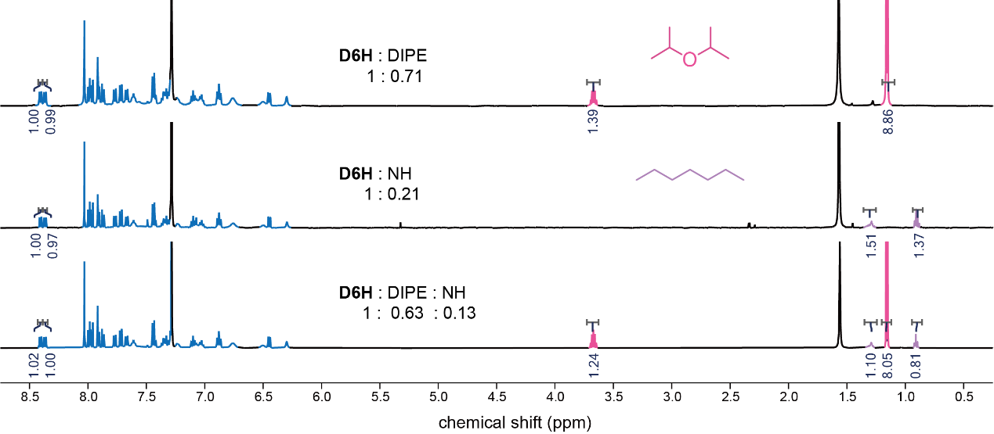
Supplementary Fig. 30 | ¹H NMR spectra of the activated powder of racemic D6H after adsorption of DIPE, NH and a blend vapor of DIPE with NH.

Supplementary Table 8 | Adsorption capacity of the activated powder of racemic D6H toward DIPE, NH and a blend vapor of DIPE with NH (analyzed by NMR).
Solvent |  | Mole ratio (D6H : THF) | Adsorption capacity (cm³_{STP}/g)
DIPE |  | 1 : 0.71 | 22.49
NH |  | 1 : 0.21 | 6.65
Blend vapor | DIPE | 1 : 0.63 | 19.95
Blend vapor | NH | 1 : 0.13 | 4.12

Supplementary Table 9 | Adsorption capacity of the activated powder of racemic D6H toward DOX, CYH, and a blend vapor of DOX and CYH (analyzed by NMR).
Solvent |  | Mole ratio (D6H : THF) | Adsorption capacity (cm³_{STP}/g)
DOX |  | 1 : 0.39 | 12.36
CYH |  | 1 : 0.05 | 1.58
Blend vapor | DOX | 1 : 0.29 | 9.19
Blend vapor | CYH | 1 : 0.01 | 0.32

Supplementary Table 10 | Crystallographic data and structure refinement for THF⸦D6H (CCDC 2259036).
Empirical formula | C₆₀H₄₂O
Formula weight | 779.001
Temperature (K) | 173.0
Crystal system | Trigonal
Space group | R-3
a (Å) | 49.9555(10)
b (Å) | 49.9555(10)
c (Å) | 10.5017(3)
α (°) | 90
β (°) | 90
γ (°) | 120
Volume (Å³) | 22696.4(9)
Z | 18
ρ_{calc.} (g·cm⁻³) | 1.026
μ (mm⁻¹) | 0.454
F(000) | 7401.7
Crystal size (mm³) | 0.5 × 0.1 × 0.1
Radiation | Cu Kα (λ = 1.54178)
2Θ range for data collection (°) | 7.08 to 130
Index ranges | −55 ≤ h ≤ 58, −58 ≤ k ≤ 58, −12 ≤ l ≤ 12
Reflections collected | 33801
Independent reflection | 7502 [R_{int} = 0.1080, R_{σ} = 0.0812]
Data/restraints/parameters | 7502/0/550
Goodness-of-fit on F² | 1.004
Final R indexes [I ≥ 2σ(I)] | R₁ = 0.0683, wR₂ = 0.1927
Final R indexes [all data] | R₁ = 0.0926, wR₂ = 0.2118
Largest diff. peak/hole (e·Å⁻³) | 0.57/−0.40
Note: In each asymmetric unit, only one THF molecules could be found and identified, and the other possible existing THF and n-pentane molecules in a disordered fashion was removed by solvent mask using Olex2.

- Explanation for the Alert A and Alert B
PLAT029_ALERT_3_A Diffrn measured fraction theta full value low 0.874
PLAT911_ALERT_3_B Missing FCF Refl Between Thmin & STh/L = 0.588 1092
—— The Alert_3_A and Alert_3_B were majorly caused by the low quality of the single crystal and the volatilization of THF molecules confined in the pores. However, this would not affect the structural determination in this study.

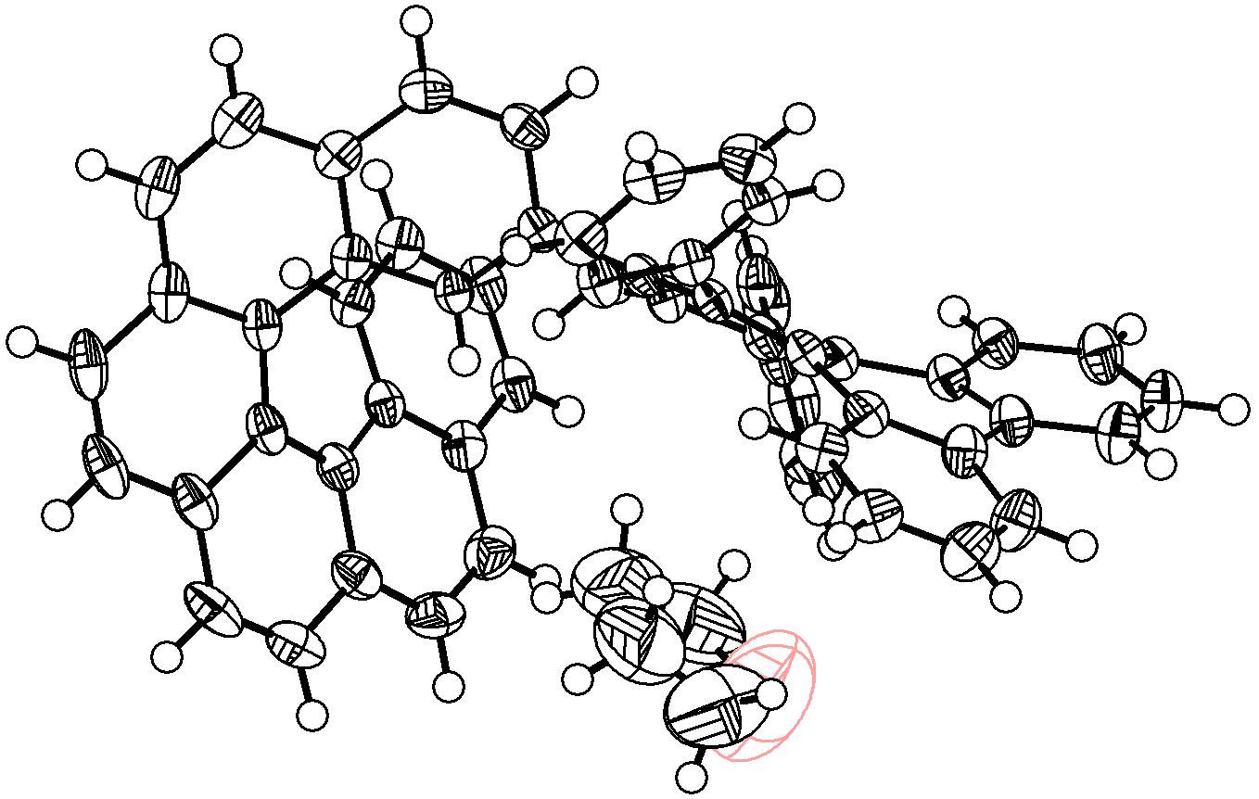
Supplementary Fig. 31 | X-ray crystallographic structure of THF⸦D6H (only M enantiomer is shown). Thermal ellipsoids are shown at a 50% probability level. The identification for the oxygen atom of THF is assisted by theoretical calculations (See theoretical calculation part).

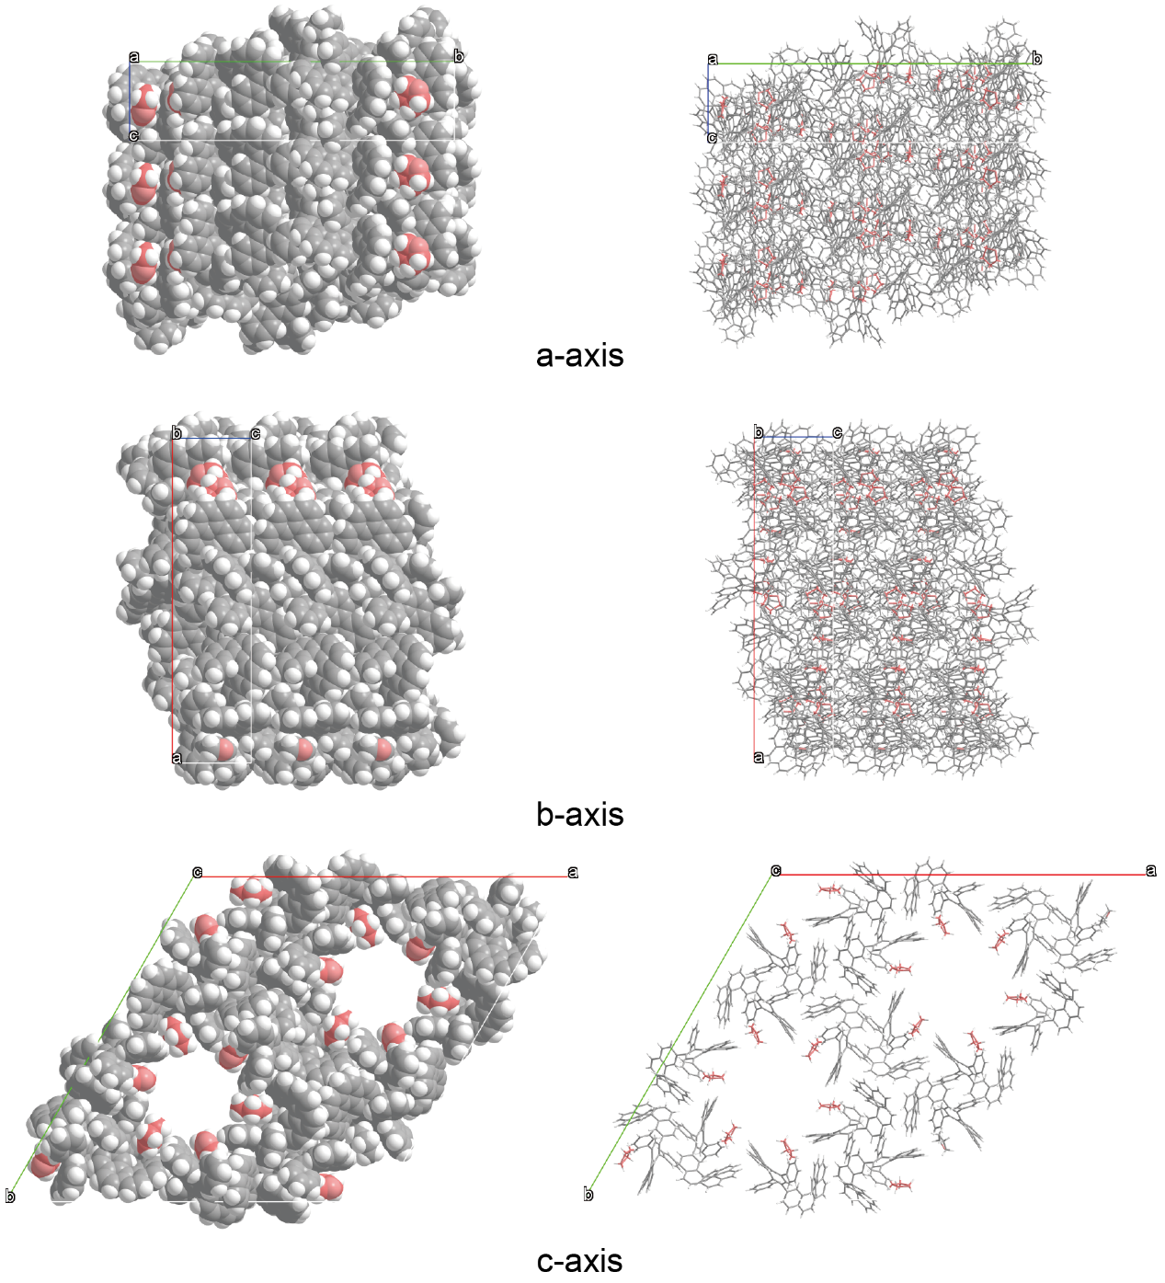
Supplementary Fig. 32 | Molecular packing of THF and D6H in the crystal. The C atoms of THF are marked in red.

Supplementary Table 11 | Crystallographic data and structure refinement for CHCl₃⸦D6H (CCDC 2255046).
Empirical formula | C₅₇H₃₅Cl₃
Formula weight | 826.20
Temperature (K) | 233.0
Crystal system | Trigonal
Space group | R-3
a (Å) | 50.275(3)
b (Å) | 50.275(3)
c (Å) | 10.5646(6)
α (°) | 90
β (°) | 90
γ (°) | 120
Volume (Å³) | 23125(3)
Z | 18
ρ_{calc.} (g·cm⁻³) | 1.068
μ (mm⁻¹) | 1.858
F(000) | 7704.0
Crystal size (mm³) | 0.1 × 0.02 × 0.02
Radiation | Cu Kα (λ = 1.54178)
2Θ range for data collection (°) | 3.514 to 135.82
Index ranges | −60 ≤ h ≤ 59, −60 ≤ k ≤ 56, −11 ≤ l ≤ 12
Reflections collected | 95432
Independent reflection | 9342 [R_{int} = 0.1362, R_{σ} = 0.0619]
Data/restraints/parameters | 9342/42/542
Goodness-of-fit on F² | 0.984
Final R indexes [I ≥ 2σ(I)] | R₁ = 0.0823, wR₂ = 0.2292
Final R indexes [all data] | R₁ = 0.1304, wR₂ = 0.2767
Largest diff. peak/hole (e·Å⁻³) | 0.40/−0.50
Note: In each asymmetric unit, only one CHCl₃ molecules could be found and identified, and the other possible existing CHCl₃ and n-pentane molecules in a disordered fashion was removed by solvent mask using Olex2.

- Explanation for the Alert B
PLAT260_ALERT_2_B Large Average Ueq of Residue Including Cl1 0.695
—— The Alert_2_B was majorly caused by the low quality of the single crystal and the volatilization of CHCl₃ molecules confined in the pores. However, this would not affect the structural determination in this study.

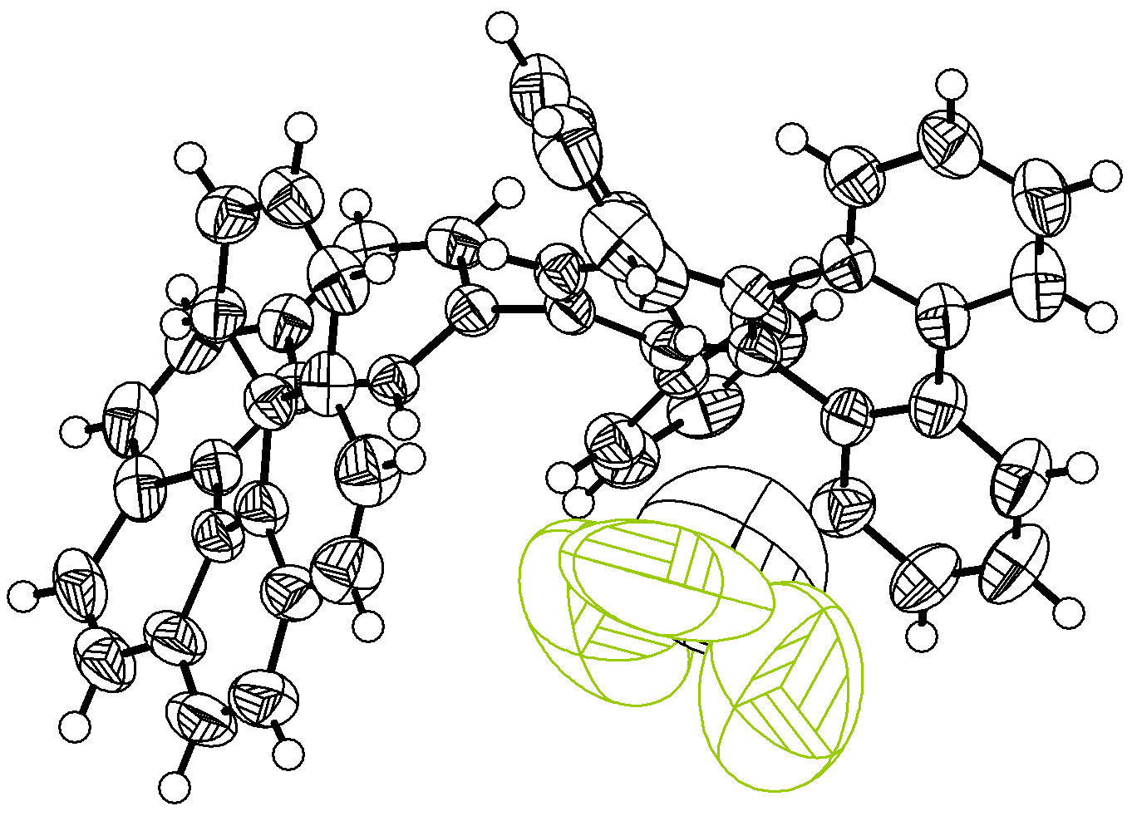
Supplementary Fig. 33 | X-ray crystallographic structure of CHCl₃⸦D6H (only P enantiomer is shown). Thermal ellipsoids are shown at a 50% probability level.

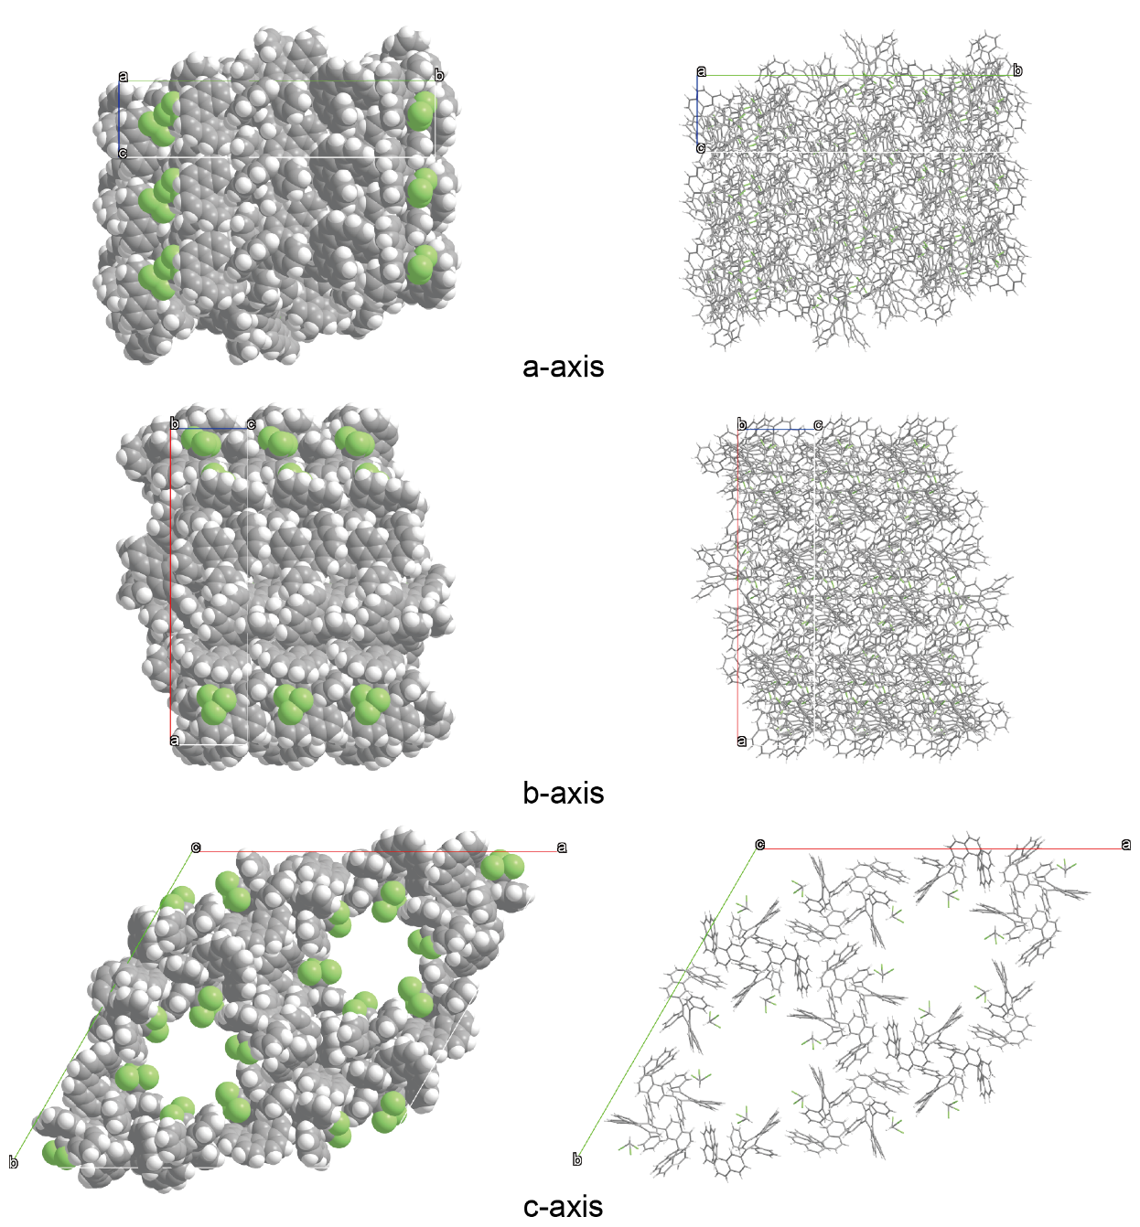
Supplementary Fig. 34 | Molecular packing of CHCl₃ and D6H in the crystal.

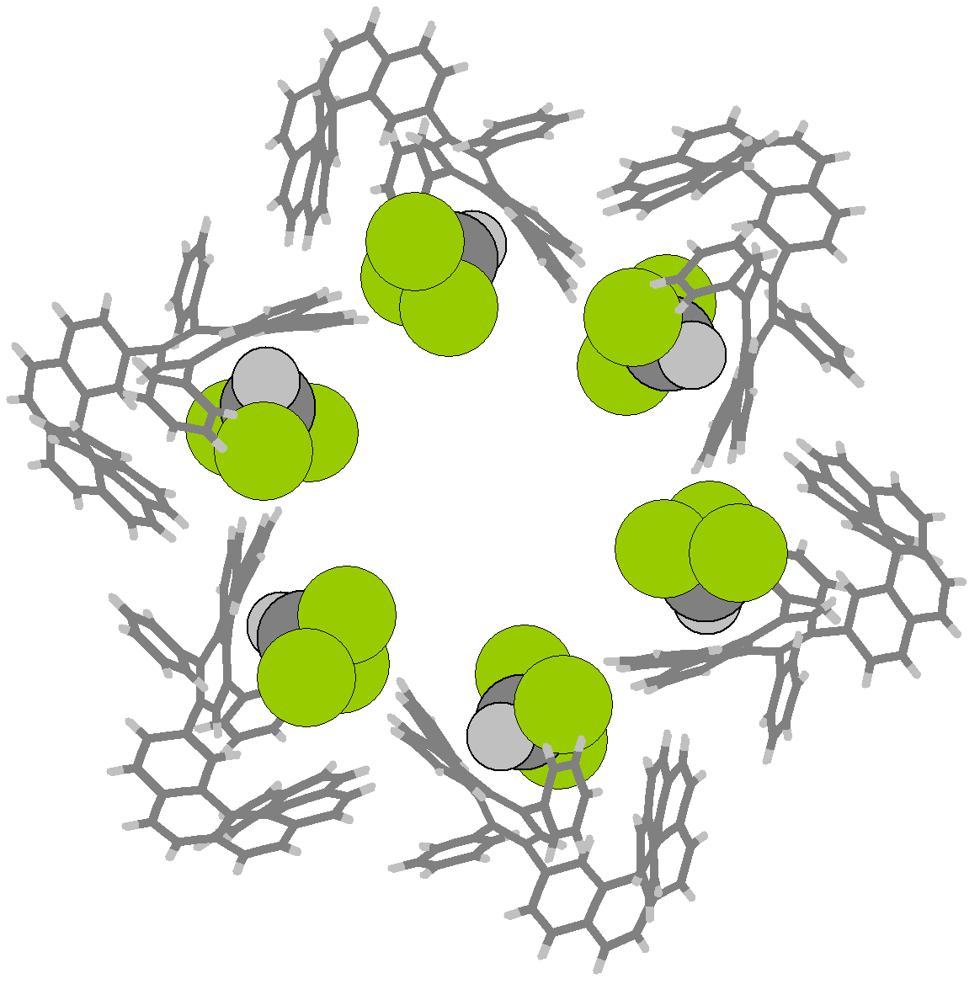
Supplementary Fig. 35 | Cross-section of a channel containing six CHCl₃ molecules.

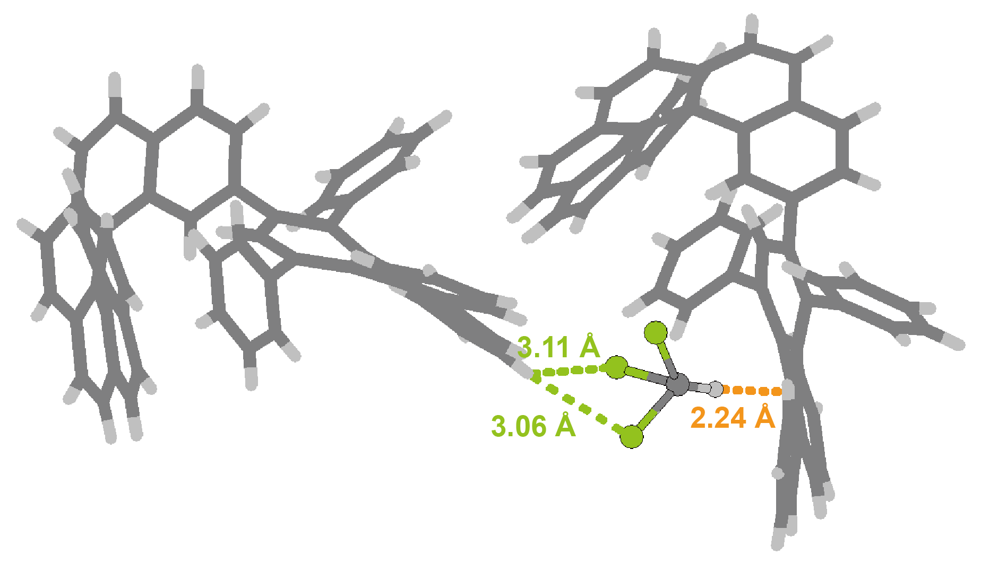
Supplementary Fig. 36 | Intermolecular interactions between the adsorbed CHCl₃ and D6H molecules.

3 Theoretical calculations
Density functional theory (DFT) calculations were carried out using CP2K 8.2 program². For D6H framework without any adsorbed small molecules, the geometry optimization was performed on both structure and cell at the PBE0-D3(BJ)^{3,4}/DZVP-MOLOPT-SR-GTH⁵ level of theory using primitive cell of the X-ray single crystal structure as the first guess. For the geometry optimizations of D6H frameworks with adsorbed THF or CHCl₃ molecules, the cell parameters for the first guesses were set as same as the optimized D6H structure, and were fixed at the subsequent structure optimizations.

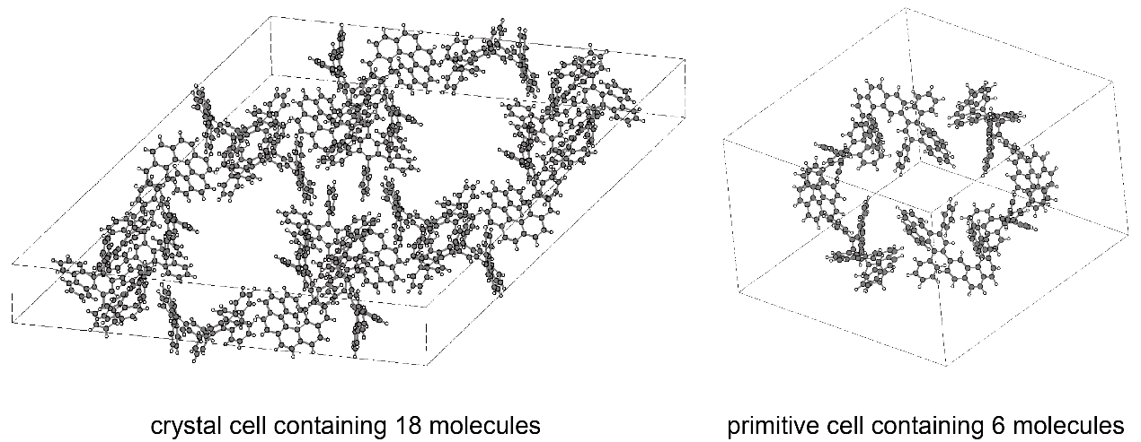
Supplementary Fig. 37 | A crystal cell of D6H containing 18 molecules and a primitive cell for theoretical calculation containing 6 molecules.

For the calculation of noncovalent interaction (NCI) analysis, we firstly selected the relevant molecules from the optimized framework structures (for example, two neighboring D6H molecules), and then calculated the single point for on the structures without geometry optimization to give the electronic structure information. The single point calculations were carried out using Gaussian 16 program⁶ at the PBE0-D3(BJ)^{3,4}/def2-TZVPP⁷ level of theory. Subsequently, the calculations of noncovalent interaction (NCI) analysis⁸ were performed using Multiwfn 3.8-dev program^{9,10}. Cutoff of the electron density ρ was set to 0.05. The NCI map with the isosurface of the reduced density gradient (RDG) mapped by the electron density multiplied by the sign of the second Hessian eigenvalue function (sign(λ₂)ρ) were visualized by using VMD program¹¹. Isosurface value was set to 0.6 with a color scale of −0.04 < sign(λ₂)ρ < 0.02.
When solving the single-crystal structures of THF⸦D6H, we found a regular five-membered ring formed by five Q peaks which could be assigned to a THF molecule (Supplementary Fig. 38, Q peaks are marked in yellow). However, we could not distinguish which Q peak should be the oxygen atom. Therefore, we made theoretical calculations by building five initial guesses with oxygen on each Q peak respectively (namely, THF⸦D6H_1, THF⸦D6H_2, THF⸦D6H_3, THF⸦D6H_4 and THF⸦D6H_5) (Supplementary Fig. 39). The initial guesses were optimized at the PBE0-D3(BJ) /DZVP-MOLOPT-SR-GTH level. The result indicated that the configuration THF⸦D6H_1 gave the lowest electron energy (Supplementary Table 12), thus appeared to be the most plausible configuration for the single crystal structure.
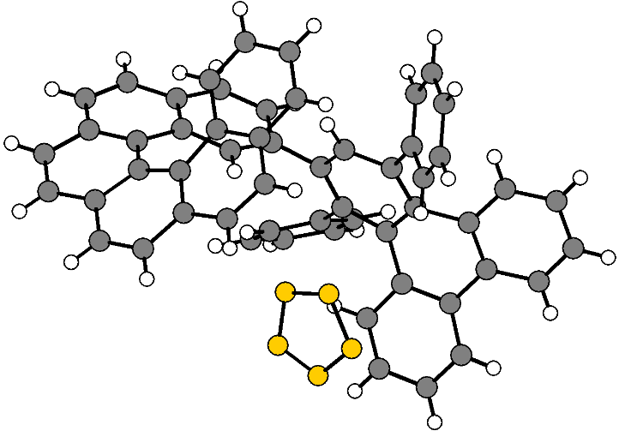
Supplementary Fig. 38 | Intermediate structure of the single crystal refinement for THF⸦D6H. In the smallest symmetry unit, there are a D6H molecule and a THF molecule appearing as a pentagon without hydrogen atoms (marked in yellow).

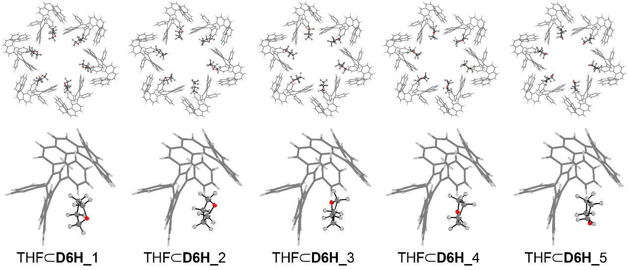
Supplementary Fig. 39 | Five possible configurations of THF⸦D6H depending on the position of the oxygen atoms

Supplementary Table 12 | Calculation results for the electron energies of configurations of THF⸦D6H.
Configuration | Electron energy (Hartree) | Electron energy* (kcal/mol)
THF⸦D6H_1 | -2294.02952 | 0
THF⸦D6H_2 | -2294.02708 | 1.5311
THF⸦D6H_3 | -2293.99997 | 18.5426
THF⸦D6H_4 | -2294.02798 | 0.9663
THF⸦D6H_5 | -2294.02686 | 1.6691
*The electron energy of THF⸦D6H_1 is set as 0 kcal/mol.
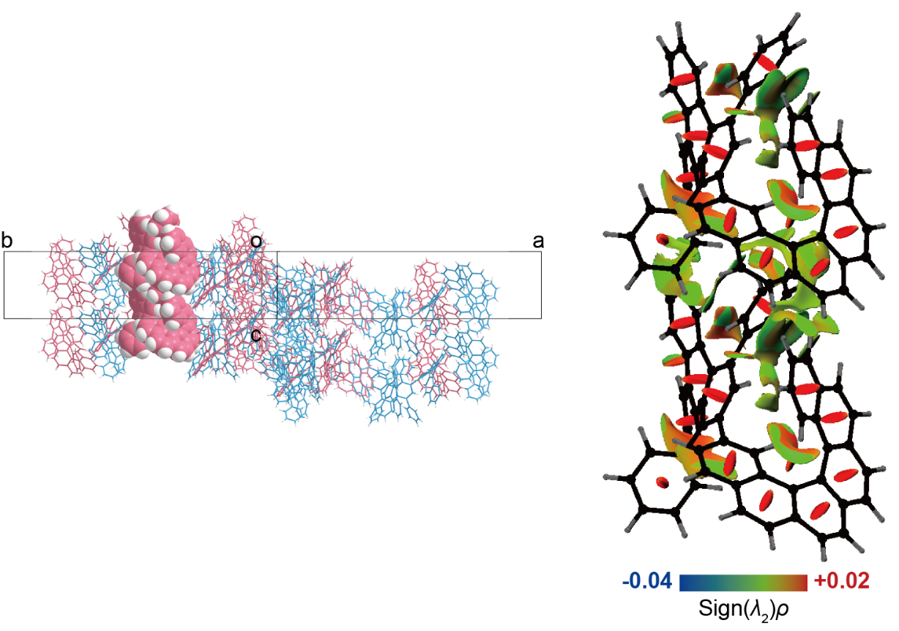
Supplementary Fig. 40 | NCI maps for the intermolecular interactions between homochiral D6H molecules arranged in parallel along the c-axis, and their relative positions marked in space-fill representation (left).

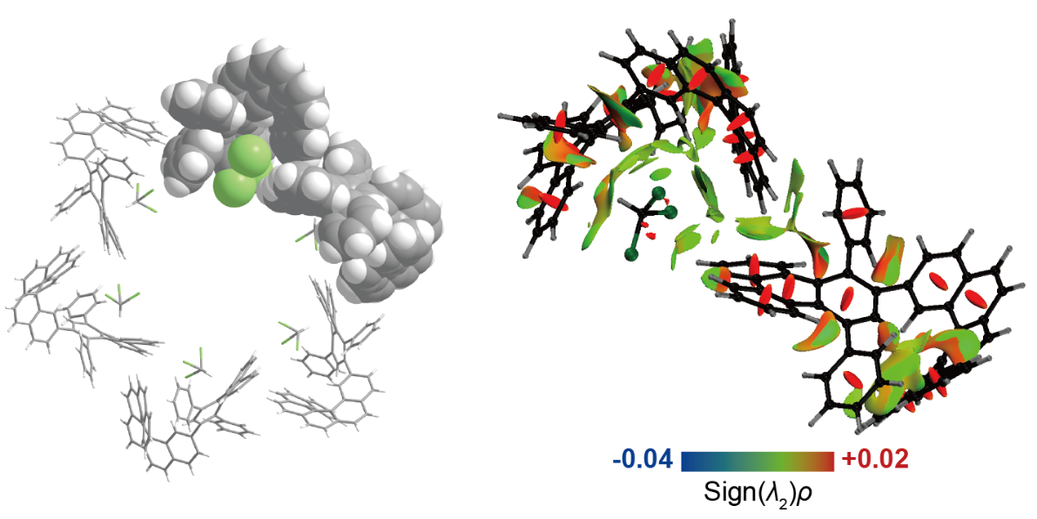
Supplementary Fig. 41 | NCI maps for the intermolecular interactions between CHCl₃ and two D6H molecules nearby and their relative positions marked in space-fill representation (left).

Cartesian Coordinates of the Optimized Geometries
D6H (six molecules surrounding the channel)
Molecule I
C -2.79799 14.69900 1.86900
C -2.96399 13.74801 2.89100
C -1.58299 14.80602 1.09700
C -3.93600 15.46299 1.50500
C -4.15498 13.57400 3.55700
H -2.15099 13.08799 3.13801
C -0.35900 14.10400 1.41400
C -1.66362 15.48129 -0.13606
C -5.13499 15.31100 2.22900
C -3.89200 16.29400 0.35200
C -4.18898 12.54000 4.61700
C -5.25501 14.38398 3.23201
C 0.09698 13.72799 2.72801
C 0.44400 13.71501 0.31500
C -2.81064 16.25327 -0.46405
C -0.65363 15.31228 -1.11406
H -5.98001 15.91800 1.94600
H -4.75901 16.88999 0.09900
C -4.86498 11.32600 4.49400
C -3.43085 12.78642 5.75700
H -6.19401 14.26098 3.75001
C -0.26400 14.42001 3.94700
C 1.02400 12.66798 2.83400
C 1.43198 12.71301 0.46600
C 0.28437 14.35029 -0.93706
H -2.79864 16.80929 -1.39006
H -0.71463 15.87028 -2.03806
C -4.71600 10.35900 5.52000
C -5.82301 11.12798 3.38601
C -3.42985 11.93242 6.84500
H -2.84585 13.69442 5.80200
C -0.87202 15.68700 3.96001
C 0.06916 13.84442 5.20000
C 1.64802 12.14100 1.67800
C 1.36900 12.13700 4.11000
H 1.99137 12.40428 -0.40306
H 0.94935 14.07428 -1.73706
C -5.00599 8.94098 5.31101
C -4.16883 10.73142 6.76800
C -7.13399 10.75598 3.69401
C -5.49102 11.36901 2.05400
C -2.56885 12.32343 7.97801
H -1.05201 16.19400 3.03000
C -1.21184 16.31041 5.13601
C 0.86101 12.66701 5.24700
C -0.31287 14.48242 6.39201
H 2.34799 11.32702 1.79300
H 2.04599 11.29600 4.13501
C -4.95801 8.37499 4.02701
C -5.14699 8.07700 6.41600
C -4.51286 9.91443 7.93100
H -7.41001 10.59200 4.72400
C -8.08201 10.61399 2.69400
H -4.48001 11.63799 1.79100
C -6.45099 11.26600 1.06100
C -2.67084 13.60643 8.50800
C -1.58186 11.46942 8.47201
H -1.66184 17.29144 5.10700
C -0.96583 15.68641 6.36200
H 1.09715 12.25542 6.21600
H -0.06886 14.01542 7.33500
H -4.76199 9.01000 3.17900
C -5.10200 7.01901 3.83000
C -5.33399 6.70499 6.19001
C -5.05784 8.62541 7.75401
C -4.50684 10.45642 9.22501
H -9.08501 10.30900 2.95000
C -7.74601 10.88101 1.37500
H -6.18600 11.48301 0.03700
H -3.42886 14.27342 8.12501
C -1.81184 14.03242 9.50801
H -1.49184 10.47442 8.06201
C -0.72484 11.89743 9.47400
H -1.25684 16.16043 7.28601
H -5.00899 6.61000 2.83500
C -5.32701 6.17900 4.91901
H -5.44199 6.03801 7.03100
C -5.50085 7.91140 8.87701
H -4.16984 11.46540 9.37701
C -4.98222 9.75514 10.30806
H -8.48598 10.78799 0.59500
H -1.90484 15.03145 9.90199
C -0.83322 13.18115 9.99406
H 0.03614 11.22942 9.85001
H -5.45501 5.11700 4.77300
H -5.92784 6.92941 8.74801
C -5.45022 8.45513 10.13806
H -5.01920 10.23614 11.27406
H -0.15320 13.51414 10.76406
H -5.79522 7.88414 10.98606

Molecule II
C 11.08301 10.59501 2.38800
C 9.88401 10.13002 1.82100
C 12.01798 9.72100 3.05701
C 11.27999 11.99900 2.42500
C 8.94398 10.97300 1.27600
H 9.65600 9.07901 1.85200
C 11.92799 8.27699 3.04001
C 12.94800 10.32200 3.93000
C 10.33300 12.84802 1.81800
C 12.36800 12.54301 3.16000
C 7.72799 10.34801 0.70600
C 9.18300 12.35699 1.25900
C 11.39099 7.46500 1.97800
C 12.37600 7.60701 4.20400
C 13.13400 11.73099 3.93000
C 13.63102 9.54400 4.89600
H 10.51602 13.91100 1.84100
H 12.52101 13.61399 3.16000
C 6.46698 10.42900 1.29400
C 7.90238 9.57730 -0.43706
H 8.45500 13.02899 0.82900
C 11.35898 7.85800 0.58500
C 10.94298 6.16401 2.29500
C 11.98899 6.26899 4.45701
C 13.24299 8.26401 5.10900
H 13.90700 12.13900 4.56400
H 14.37000 10.01700 5.52801
C 5.40500 9.67900 0.72800
C 6.22802 11.39001 2.39100
C 6.83936 8.99530 -1.10506
H 8.90036 9.45527 -0.83406
C 12.08700 8.94799 0.07800
C 10.62537 7.07628 -0.33906
C 11.21301 5.60099 3.56501
C 10.24101 5.38799 1.32900
H 12.30600 5.80600 5.37900
H 13.61302 7.70700 5.95400
C 4.19200 9.34800 1.47400
C 5.54135 9.12928 -0.56406
C 5.19401 12.31899 2.25400
C 7.04001 11.45499 3.52301
C 7.17836 8.20028 -2.30106
H 12.72999 9.50400 0.73500
C 12.02538 9.30028 -1.24606
C 10.03402 5.85499 0.07600
C 10.54838 7.46929 -1.68606
H 10.85199 4.60600 3.77801
H 9.87701 4.41801 1.63600
C 4.19901 9.29701 2.87800
C 3.04699 8.88400 0.79600
C 4.31637 8.85230 -1.31506
H 4.57500 12.29599 1.36900
C 4.96801 13.27599 3.22901
H 7.83199 10.73600 3.65901
C 6.83700 12.43900 4.47600
C 7.98335 8.75528 -3.29106
C 6.79137 6.86429 -2.42206
H 12.61236 10.13329 -1.60406
C 11.21738 8.57927 -2.13005
H 9.48437 5.28427 -0.65305
H 9.96337 6.87327 -2.37106
H 5.09701 9.56300 3.41000
C 3.10301 8.86199 3.59000
C 1.92600 8.48501 1.54000
C 3.07535 8.79629 -0.64806
C 4.31436 8.84328 -2.71706
H 4.15299 13.97400 3.11301
C 5.79898 13.34600 4.33900
H 7.49200 12.49400 5.33300
H 8.29037 9.78728 -3.19906
C 8.39621 8.00287 -4.37806
H 6.17237 6.42327 -1.65606
C 7.20421 6.11385 -3.51206
H 11.14436 8.87027 -3.16605
H 3.15901 8.78601 4.66600
C 1.94101 8.48501 2.91600
H 1.04800 8.12802 1.02700
C 1.90036 8.65929 -1.40106
H 5.23837 8.96428 -3.25206
C 3.14737 8.74627 -3.44206
H 5.63617 14.10142 5.09200
H 9.02421 8.45185 -5.13206
C 8.01021 6.67587 -4.49406
H 6.90122 5.08087 -3.59706
H 1.07202 8.15700 3.46600
H 0.94735 8.62528 -0.89805
C 1.93137 8.61627 -2.77706
H 3.18721 8.81085 -4.51906
H 8.34121 6.08187 -5.33406
H 1.01336 8.50928 -3.33306

Molecule III
C 14.24302 -3.49501 3.51700
C 13.48699 -2.54198 4.22200
C 13.75499 -4.82600 3.24301
C 15.45800 -3.05500 2.93400
C 13.90502 -1.24200 4.39300
H 12.51898 -2.81200 4.60401
C 12.55099 -5.38100 3.82401
C 14.38684 -5.54041 2.20500
C 15.89898 -1.73599 3.16000
C 16.16700 -3.90799 2.04500
C 13.01401 -0.34400 5.16200
C 15.14299 -0.83899 3.86700
C 12.00300 -5.07001 5.11901
C 11.82601 -6.28901 3.01501
C 15.61485 -5.08242 1.65400
C 13.75483 -6.66442 1.61900
H 16.83701 -1.43200 2.72400
H 17.10499 -3.57001 1.62600
C 12.27198 0.68898 4.59001
C 12.86700 -0.62102 6.51801
H 15.48499 0.17700 3.99901
C 12.78299 -4.60698 6.24700
C 10.62800 -5.30900 5.33500
C 10.47301 -6.58500 3.30400
C 12.46186 -6.92843 1.92400
H 16.09786 -5.69942 0.91100
H 14.27484 -7.22241 0.85400
C 11.35200 1.39601 5.40300
C 12.55699 1.11698 3.20401
C 12.11701 0.18200 7.36000
H 13.38198 -1.47500 6.93101
C 14.18698 -4.66899 6.28801
C 12.11800 -4.13199 7.40600
C 9.86700 -6.03200 4.38701
C 9.99698 -4.85400 6.52901
H 9.93483 -7.24043 2.63701
H 11.89984 -7.65643 1.36400
C 10.24601 2.17400 4.84601
C 11.41700 1.27799 6.81000
C 12.85900 2.46000 2.96700
C 12.61099 0.22099 2.13700
C 12.04699 -0.24201 8.77201
H 14.71799 -5.11201 5.46600
C 14.89600 -4.20999 7.37100
C 10.70500 -4.23201 7.49901
C 12.86002 -3.63800 8.49100
H 8.81700 -6.19398 4.57900
H 8.93401 -5.01999 6.62500
C 9.72700 1.88200 3.57400
C 9.55599 3.10100 5.65101
C 10.86499 2.37201 7.60900
H 12.84699 3.15801 3.79000
C 13.18899 2.89702 1.69500
H 12.36200 -0.81699 2.29200
C 12.97999 0.65401 0.87500
C 13.22198 -0.51900 9.46501
C 10.82500 -0.46901 9.40601
H 15.97300 -4.29098 7.37500
C 14.23001 -3.65299 8.46600
H 10.23000 -3.86201 8.39501
H 12.33302 -3.25899 9.35500
H 10.19000 1.11098 2.98001
C 8.60499 2.51801 3.08900
C 8.44199 3.77000 5.12201
C 9.99500 3.31101 7.01700
C 11.33699 2.63401 8.90300
H 13.40200 3.94301 1.52900
C 13.26199 1.99201 0.64600
H 13.04400 -0.05600 0.06400
H 14.17101 -0.34998 8.97800
C 13.18365 -1.00828 10.75806
H 9.90800 -0.26398 8.87300
C 10.78863 -0.95828 10.70006
H 14.78500 -3.26600 9.30600
H 8.20200 2.23399 2.12800
C 7.97600 3.49801 3.85600
H 7.90900 4.47998 5.73401
C 9.58000 4.42300 7.76300
H 12.06201 1.97701 9.34800
C 10.94815 3.75041 9.60801
H 13.53736 2.32528 -0.34006
H 14.10471 -1.22041 11.27606
C 11.96579 -1.23387 11.38407
H 9.83862 -1.13126 11.18306
H 7.10601 4.01299 3.47800
H 8.92299 5.15001 7.31400
C 10.03215 4.63542 9.04601
H 11.38678 3.94713 10.57206
H 11.93279 -1.62886 12.38906
H 9.69515 5.49844 9.60000

Molecule IV
C 3.98799 -12.69298 7.99100
C 4.15300 -11.74201 6.97001
C 2.77201 -12.80098 8.76400
C 5.12599 -13.45699 8.35601
C 5.34501 -11.56798 6.30400
H 3.34000 -11.08199 6.72300
C 1.54799 -12.09798 8.44600
C 2.85362 -13.47528 9.99706
C 6.32400 -13.30500 7.63201
C 5.08199 -14.28800 9.50801
C 5.37901 -10.53399 5.24400
C 6.44400 -12.37799 6.62900
C 1.09301 -11.72200 7.13300
C 0.74600 -11.70899 9.54601
C 4.00063 -14.24829 10.32506
C 1.84364 -13.30628 10.97506
H 7.17000 -13.91201 7.91501
H 5.94800 -14.88398 9.76100
C 6.05502 -9.31999 5.36600
C 4.61983 -10.78042 4.10401
H 7.38299 -12.25499 6.11100
C 1.45298 -12.41500 5.91301
C 0.16598 -10.66199 7.02700
C -0.24199 -10.70702 9.39501
C 0.90562 -12.34427 10.79806
H 3.98865 -14.80426 11.25006
H 1.90462 -13.86428 11.89907
C 5.90601 -8.35299 4.34100
C 7.01300 -9.12199 6.47400
C 4.61984 -9.92643 3.01600
H 4.03482 -11.68741 4.05900
C 2.06200 -13.68199 5.90100
C 1.12085 -11.83842 4.66100
C -0.45799 -10.13498 8.18300
C -0.17900 -10.13099 5.75100
H -0.80137 -10.39827 10.26306
H 0.24064 -12.06828 11.59807
C 6.19601 -6.93499 4.55000
C 5.35885 -8.72542 3.09300
C 8.32401 -8.74998 6.16700
C 6.68099 -9.36399 7.80601
C 3.75884 -10.31743 1.88200
H 2.24200 -14.18900 6.83100
C 2.40085 -14.30441 4.72500
C 0.33000 -10.66099 4.61400
C 1.50286 -12.47642 3.46900
H -1.15699 -9.32098 8.06800
H -0.85600 -9.29000 5.72600
C 6.14801 -6.37000 5.83400
C 6.33698 -6.07101 3.44601
C 5.70285 -7.90844 1.93001
H 8.60000 -8.58600 5.13700
C 9.27200 -8.60799 7.16700
H 5.67101 -9.63300 8.06901
C 7.64099 -9.25998 8.79900
C 3.86085 -11.60042 1.35200
C 2.77184 -9.46342 1.38800
H 2.85184 -15.28542 4.75400
C 2.15484 -13.68041 3.49900
H 0.09385 -10.24843 3.64501
H 1.25884 -12.00943 2.52600
H 5.95199 -7.00398 6.68200
C 6.29201 -5.01400 6.03100
C 6.52400 -4.69899 3.67100
C 6.24785 -6.61940 2.10700
C 5.69685 -8.45041 0.63600
H 10.27600 -8.30300 6.91101
C 8.93598 -8.87499 8.48601
H 7.37699 -9.47801 9.82301
H 4.61884 -12.26742 1.73500
C 3.00283 -12.02641 0.35200
H 2.68085 -8.46842 1.79900
C 1.91484 -9.89243 0.38700
H 2.44584 -14.15542 2.57500
H 6.19902 -4.60501 7.02700
C 6.51700 -4.17301 4.94200
H 6.63201 -4.03201 2.83000
C 6.69084 -5.90541 0.98400
H 5.36084 -9.45941 0.48400
C 6.17221 -7.74915 -0.44705
H 9.67599 -8.78200 9.26501
H 3.09583 -13.02541 -0.04200
C 2.02422 -11.17514 -0.13306
H 1.15386 -9.22443 0.01000
H 6.64500 -3.11101 5.08900
H 7.11786 -4.92342 1.11300
C 6.64021 -6.44913 -0.27706
H 6.20922 -8.23012 -1.41306
H 1.34420 -11.50912 -0.90306
H 6.98521 -5.87714 -1.12506

Molecule V
C -9.89399 -8.58899 7.47300
C -8.69502 -8.12399 8.04101
C -10.82799 -7.71500 6.80400
C -10.09000 -9.99300 7.43601
C -7.75399 -8.96700 8.58500
H -8.46701 -7.07301 8.00901
C -10.73800 -6.27100 6.82100
C -11.75800 -8.31601 5.93101
C -9.14400 -10.84200 8.04300
C -11.17800 -10.53701 6.70101
C -6.53898 -8.34201 9.15501
C -7.99301 -10.35100 8.60201
C -10.20201 -5.45901 7.88301
C -11.18701 -5.60200 5.65701
C -11.94400 -9.72601 5.93101
C -12.44100 -7.53800 4.96501
H -9.32600 -11.90601 8.02001
H -11.33101 -11.60800 6.70101
C -5.27700 -8.42300 8.56701
C -6.71236 -7.57027 10.29806
H -7.26601 -11.02299 9.03201
C -10.17000 -5.85201 9.27601
C -9.75301 -4.15798 7.56600
C -10.79899 -4.26401 5.40400
C -12.05301 -6.25801 4.75200
H -12.71701 -10.13400 5.29701
H -13.18001 -8.01200 4.33300
C -4.21501 -7.67401 9.13301
C -5.03801 -9.38500 7.47001
C -5.64935 -6.98928 10.96606
H -7.71037 -7.44927 10.69506
C -10.89801 -6.94301 9.78301
C -9.43537 -5.07128 10.20006
C -10.02299 -3.59499 6.29600
C -9.05099 -3.38301 8.53201
H -11.11702 -3.80101 4.48201
H -12.42299 -5.70199 3.90700
C -3.00201 -7.34200 8.38701
C -4.35136 -7.12328 10.42506
C -4.00402 -10.31299 7.60701
C -5.85000 -9.44998 6.33900
C -5.98837 -6.19428 12.16206
H -11.54101 -7.49800 9.12601
C -10.83637 -7.29428 11.10707
C -8.84400 -3.84898 9.78501
C -9.35835 -5.46428 11.54706
H -9.66201 -2.60099 6.08300
H -8.68699 -2.41298 8.22500
C -3.00898 -7.29099 6.98300
C -1.85801 -6.87698 9.06500
C -3.12637 -6.84727 11.17606
H -3.38501 -10.29000 8.49201
C -3.77900 -11.26999 6.63200
H -6.64200 -8.73000 6.20200
C -5.64800 -10.43300 5.38501
C -6.79337 -6.74927 13.15207
C -5.60237 -4.85828 12.28307
H -11.42238 -8.12730 11.46407
C -10.02836 -6.57428 11.99106
H -8.29436 -3.27929 10.51406
H -8.77335 -4.86827 12.23206
H -3.90703 -7.55799 6.45201
C -1.91299 -6.85600 6.27100
C -0.73701 -6.47899 8.32000
C -1.88536 -6.78928 10.50906
C -3.12436 -6.83829 12.57806
H -2.96402 -11.96898 6.74800
C -4.60900 -11.34100 5.52200
H -6.30200 -10.48900 4.52800
H -7.10039 -7.78128 13.06007
C -7.20722 -5.99787 14.23907
H -4.98237 -4.41630 11.51707
C -6.01519 -4.10786 13.37306
H -9.95437 -6.86528 13.02706
H -1.96999 -6.78100 5.19500
C -0.75200 -6.47901 6.94501
H 0.14199 -6.12099 8.83300
C -0.71136 -6.65329 11.26206
H -4.04836 -6.95928 13.11307
C -1.95737 -6.74126 13.30306
H -4.44616 -12.09543 4.76901
H -7.83434 -6.44687 14.99307
C -6.82121 -4.67086 14.35607
H -5.71221 -3.07485 13.45806
H 0.11701 -6.14999 6.39400
H 0.24163 -6.61929 10.75906
C -0.74137 -6.61127 12.63806
H -1.99721 -6.80586 14.38007
H -7.15222 -4.07686 15.19507
H 0.17662 -6.50328 13.19407

Molecule VI
C -13.05300 5.50101 6.34401
C -12.29801 4.54701 5.63900
C -12.56501 6.83199 6.61800
C -14.26900 5.06102 6.92700
C -12.71499 3.24802 5.46800
H -11.32900 4.81701 5.25700
C -11.36200 7.38700 6.03700
C -13.19786 7.54542 7.65601
C -14.70899 3.74199 6.70101
C -14.97699 5.91301 7.81600
C -11.82400 2.35002 4.69800
C -13.95301 2.84400 5.99301
C -10.81301 7.07499 4.74200
C -10.63598 8.29500 6.84600
C -14.42584 7.08842 8.20700
C -12.56485 8.67042 8.24200
H -15.64799 3.43802 7.13700
H -15.91601 5.57501 8.23500
C -11.08200 1.31701 5.27100
C -11.67701 2.62701 3.34200
H -14.29500 1.82900 5.86101
C -11.59400 6.61202 3.61300
C -9.43799 7.31401 4.52600
C -9.28399 8.59101 6.55600
C -11.27285 8.93342 7.93701
H -14.90785 7.70442 8.95101
H -13.08486 9.22743 9.00801
C -10.16200 0.60999 4.45800
C -11.36800 0.88902 6.65700
C -10.92702 1.82400 2.50100
H -12.19300 3.48102 2.93000
C -12.99700 6.67499 3.57300
C -10.92802 6.13700 2.45501
C -8.67799 8.03800 5.47400
C -8.80800 6.86000 3.33200
H -8.74484 9.24643 7.22400
H -10.71086 9.66242 8.49701
C -9.05700 -0.16800 5.01500
C -10.22701 0.72800 3.05100
C -11.66901 -0.45401 6.89400
C -11.42100 1.78501 7.72301
C -10.85800 2.24801 1.08800
H -13.52900 7.11699 4.39500
C -13.70702 6.21599 2.49001
C -9.51500 6.23700 2.36200
C -11.67100 5.64402 1.37000
H -7.62801 8.20000 5.28100
H -7.74499 7.02601 3.23500
C -8.53701 0.12399 6.28701
C -8.36601 -1.09500 4.20901
C -9.67500 -0.36601 2.25201
H -11.65801 -1.15201 6.07101
C -11.99900 -0.89098 8.16600
H -11.17201 2.82299 7.56801
C -11.79001 1.35201 8.98601
C -12.03199 2.52499 0.39500
C -9.63501 2.47500 0.45500
H -14.78302 6.29599 2.48700
C -13.04100 5.65899 1.39500
H -9.04101 5.86800 1.46600
H -11.14400 5.26500 0.50500
H -9.00001 0.89401 6.88100
C -7.41500 -0.51201 6.77101
C -7.25100 -1.76300 4.73800
C -8.80501 -1.30502 2.84400
C -10.14800 -0.62800 0.95700
H -12.21199 -1.93600 8.33201
C -12.07299 0.01402 9.21500
H -11.85401 2.06199 9.79701
H -12.98099 2.35599 0.88300
C -11.99363 3.01428 -0.89706
H -8.71800 2.27000 0.98800
C -9.59863 2.96429 -0.83906
H -13.59601 5.27100 0.55500
H -7.01199 -0.22800 7.73200
C -6.78501 -1.49100 6.00401
H -6.71799 -2.47300 4.12700
C -8.39000 -2.41699 2.09700
H -10.87299 0.02900 0.51300
C -9.75817 -1.74542 0.25300
H -12.34736 -0.31928 10.20106
H -12.91463 3.22628 -1.41506
C -10.77579 3.23985 -1.52406
H -8.64863 3.13729 -1.32206
H -5.91502 -2.00500 6.38201
H -7.73300 -3.14399 2.54700
C -8.84216 -2.62942 0.81500
H -10.19780 -1.94113 -0.71106
H -10.74281 3.63487 -2.52806
H -8.50618 -3.49241 0.26100

THF⸦D6H_1
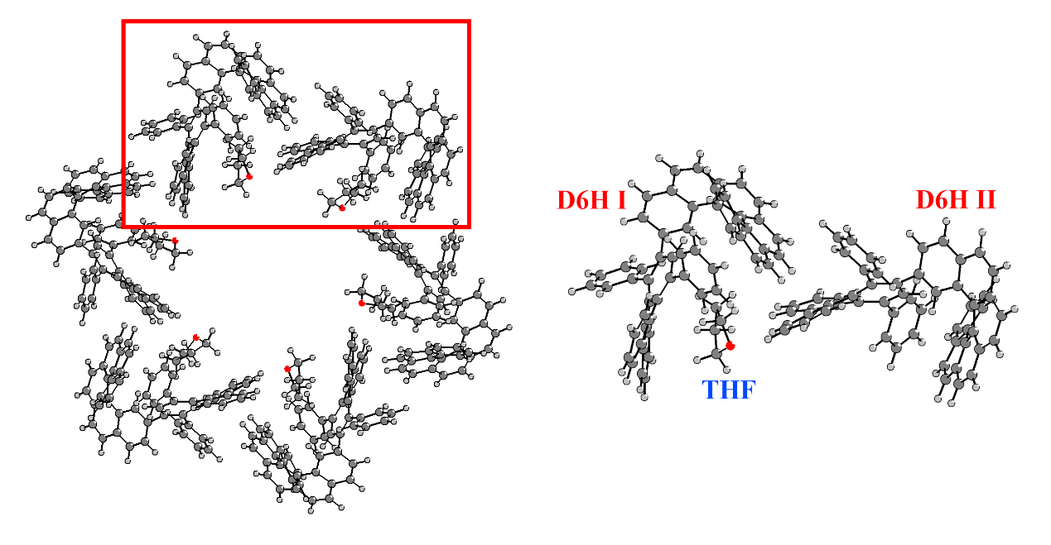
THF
C -1.42629 7.32953 4.30514
H -2.38331 7.08796 4.77251
H -0.94861 6.40465 3.98722
C -1.60556 8.35961 3.19255
O -0.56738 7.95600 5.25695
H -0.84458 8.22947 2.42653
H -2.57455 8.27348 2.70647
C -1.41681 9.70678 3.91389
C -1.03055 9.30271 5.33933
H -2.32133 10.31226 3.91019
H -0.62599 10.29242 3.44982
H -0.23130 9.90703 5.76274
H -1.89766 9.35169 6.00144

D6H I
C -4.16169 12.56712 4.77637
C -4.11515 13.60169 3.71874
C -4.84444 11.35867 4.63911
C -3.39696 12.79969 5.91634
C -2.91308 13.77519 3.07188
C -5.21384 14.40210 3.36924
C -4.68886 10.37312 5.64578
C -5.80289 11.17668 3.52817
H -2.80307 13.70041 5.96820
C -3.40209 11.93224 6.99424
H -2.10289 13.11870 3.33833
C -2.73478 14.71709 2.04416
C -5.08258 15.32188 2.36167
H -6.16051 14.27513 3.87327
C -4.13983 10.73371 6.89692
C -4.94486 8.95176 5.41013
C -7.11450 10.80627 3.83285
C -5.46715 11.42083 2.19758
C -2.53555 12.28895 8.13521
C -1.50782 14.82064 1.28745
C -3.87153 15.47363 1.65698
H -5.92793 15.92360 2.06216
C -4.45498 9.88765 8.04543
C -4.98843 8.05047 6.49424
C -4.94387 8.41938 4.11083
H -7.38939 10.63007 4.86189
C -8.06270 10.67776 2.83149
H -4.45344 11.68197 1.93833
C -6.42572 11.32467 1.20236
C -2.60611 13.56518 8.68671
C -1.57133 11.40287 8.61764
C -1.57137 15.49940 0.05258
C -0.29129 14.10843 1.61813
C -3.81078 16.30241 0.50369
C -4.90561 8.56842 7.84637
C -4.50064 10.41771 9.34335
C -5.09792 6.67583 6.23927
H -4.83619 9.08263 3.26990
C -5.01877 7.06280 3.88540
H -9.06761 10.37535 3.08450
C -7.72434 10.95085 1.51365
H -6.15630 11.54241 0.17967
H -3.34719 14.25679 8.31308
C -1.73657 13.95421 9.69377
H -1.50355 10.41079 8.19508
C -0.70135 11.79401 9.62318
C -2.71424 16.27280 -0.29329
C -0.54623 15.33143 -0.91060
C 0.15218 13.72199 2.93470
C 0.52253 13.71890 0.52594
H -4.67655 16.89284 0.23563
C -5.28359 7.80278 8.95851
H -4.23758 11.44721 9.50824
C -4.93415 9.66946 10.41514
H -5.10987 5.98605 7.06844
C -5.12549 6.17881 4.95656
H -4.95318 6.67991 2.87764
H -8.46568 10.87177 0.73397
H -1.80317 14.94976 10.10471
C -0.77644 13.07142 10.16587
H 0.04412 11.10149 9.98463
H -2.68693 16.83479 -1.21510
H -0.59437 15.89234 -1.83304
C 0.38676 14.36705 -0.72483
C -0.20043 14.41856 4.15428
C 1.06191 12.64699 3.04260
C 1.48876 12.69500 0.67948
H -5.61694 6.78754 8.81594
C -5.28708 8.33468 10.22869
H -5.02038 10.13662 11.38494
H -5.19758 5.11685 4.76936
H -0.08666 13.37658 10.93969
H 1.06451 14.09310 -1.51646
C 0.13117 13.84111 5.40720
C -0.80089 15.68991 4.16756
C 1.67763 12.10665 1.88843
C 1.40167 12.11339 4.31829
H 2.04682 12.37968 -0.19005
H -5.58287 7.72120 11.06718
C -0.25020 14.48074 6.59850
C 0.91019 12.65487 5.45629
H -0.98205 16.19879 3.23821
C -1.13664 16.31564 5.34435
H 2.35327 11.27221 2.00445
H 2.06096 11.25765 4.34164
H -0.01605 14.00831 7.54160
C -0.89750 15.68843 6.57054
H 1.14774 12.24339 6.42564
H -1.58231 17.29939 5.31382
H -1.18999 16.16201 7.49451

D6H II
C 7.71809 10.37352 0.80288
C 8.93911 10.98763 1.37121
C 6.46167 10.46590 1.40170
C 7.88074 9.59169 -0.33765
C 9.88012 10.13151 1.89570
C 9.17601 12.37102 1.38219
C 5.39476 9.70553 0.86079
C 6.23563 11.43514 2.49514
H 8.87505 9.45803 -0.73784
C 6.80724 9.01279 -0.99130
H 9.64894 9.08038 1.90551
C 11.07872 10.58496 2.47281
C 10.32760 12.85192 1.94857
H 8.44445 13.05049 0.97066
C 5.51905 9.14934 -0.43240
C 4.20643 9.34386 1.63484
C 5.20225 12.36463 2.35921
C 7.05088 11.49975 3.62388
C 7.11853 8.19754 -2.18230
C 12.01236 9.69716 3.12751
C 11.27517 11.98913 2.53484
H 10.50937 13.91562 1.99031
C 4.28945 8.83838 -1.15781
C 3.08584 8.77976 0.99019
C 4.22463 9.34895 3.03886
H 4.57422 12.33375 1.48161
C 4.98809 13.32967 3.32946
H 7.83739 10.77472 3.76082
C 6.85529 12.48633 4.57622
C 7.92953 8.71852 -3.18670
C 6.69503 6.87165 -2.28354
C 12.95277 10.28467 3.99928
C 11.90923 8.25336 3.10001
C 12.36911 12.51914 3.27180
C 3.07724 8.68731 -0.45713
C 4.24814 8.87074 -2.55964
C 2.01409 8.30979 1.76309
H 5.09969 9.70774 3.55296
C 3.17368 8.85211 3.77761
C 5.82391 13.40257 4.43488
H 7.51173 12.53895 5.43195
H 8.26383 9.74305 -3.11114
C 8.31448 7.93903 -4.26645
H 6.06782 6.45442 -1.50910
C 7.08229 6.09292 -3.36270
C 13.14614 11.69404 4.01592
C 13.64006 9.49143 4.95078
C 11.35985 7.44817 2.03754
C 12.36004 7.57129 4.25695
H 12.52131 13.58994 3.28786
C 1.89443 8.47537 -1.17961
H 5.14835 9.06368 -3.11522
C 3.06687 8.72090 -3.25180
H 1.16793 7.85805 1.26967
C 2.04216 8.35050 3.13825
H 3.24432 8.81303 4.85467
H 5.67241 14.16569 5.18226
H 8.94840 8.35915 -5.03202
C 7.89560 6.61992 -4.35905
H 6.75215 5.06688 -3.42718
H 13.92927 12.09172 4.64429
H 14.38593 9.95433 5.58106
C 13.24602 8.21162 5.15592
C 11.33501 7.83905 0.64341
C 10.89288 6.15393 2.35593
C 11.94600 6.24145 4.51321
H 0.96443 8.34696 -0.64970
C 1.88447 8.47679 -2.55656
H 3.06794 8.82114 -4.32709
H 1.21711 7.97220 3.72543
H 8.20709 6.00478 -5.19113
H 13.62198 7.64420 5.99137
C 10.59895 7.05899 -0.28554
C 12.06863 8.92594 0.13608
C 11.14833 5.58986 3.62862
C 10.18902 5.38149 1.38859
H 12.25690 5.77432 5.43632
H 0.95851 8.31028 -3.08734
C 10.52370 7.45485 -1.63134
C 9.99937 5.84086 0.13055
H 12.71131 9.48301 0.79348
C 12.00966 9.27782 -1.19126
H 10.76075 4.60560 3.84550
H 9.80791 4.41951 1.69958
H 9.93167 6.86450 -2.31577
C 11.19745 8.56247 -2.07587
H 9.44959 5.26973 -0.60225
H 12.60075 10.10946 -1.54660
H 11.12261 8.85650 -3.11101
H 4.17569 14.03042 3.21407

CHCl₃⸦D6H
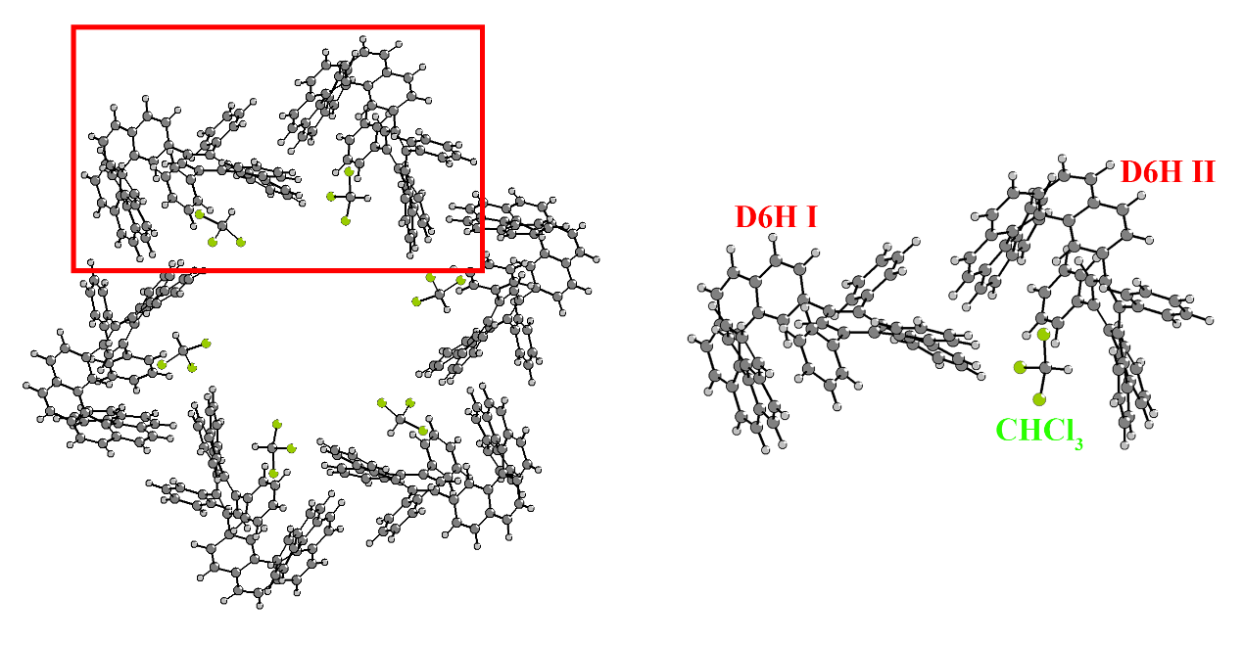
CHCl₃
C 2.79385 8.03638 2.15272
H 3.73799 7.84940 1.65587
Cl 2.63532 6.86084 3.45971
Cl 1.50247 7.81696 0.96037
Cl 2.81739 9.68038 2.77056

D6H I
C -6.44941 11.26858 5.34445
C -5.18994 11.11948 4.76489
C -7.66313 11.62818 4.57664
C -6.61836 10.99745 6.69907
C -4.12442 10.65078 5.57220
C -4.96367 11.57378 3.37630
C -8.61676 10.65054 4.41350
C -7.87845 12.90493 4.03362
C -5.55035 10.72821 7.53741
H -7.61525 11.03042 7.11310
C -4.25595 10.64636 6.98027
C -2.92151 10.03500 5.01114
C -3.93638 12.48663 3.12811
C -5.78895 11.19073 2.31974
H -8.40261 9.67331 4.80951
C -9.80918 10.86627 3.69907
H -7.13640 13.67975 4.15493
C -9.02134 13.14924 3.31921
C -5.87319 10.46344 8.95310
C -3.02921 10.67722 7.77629
C -1.79248 9.81564 5.82856
C -2.94068 9.44697 3.73431
H -3.30054 12.80322 3.94106
C -3.74079 13.00200 1.85720
H -6.57078 10.46645 2.48351
C -5.61559 11.73628 1.05879
C -9.98409 12.14222 3.10392
C -10.75680 9.80977 3.42548
H -9.18506 14.11744 2.87072
C -6.71694 11.33094 9.64090
C -5.42323 9.31230 9.60174
C -1.80031 10.31037 7.19167
C -3.00988 11.24228 9.06055
C -0.70686 9.09082 5.31541
H -3.82841 9.52760 3.13012
C -1.87701 8.70791 3.26569
H -2.93212 13.69595 1.68200
C -4.59122 12.64077 0.82172
H -6.28355 11.45213 0.25899
C -11.07189 12.36724 2.21732
C -10.67131 8.48325 3.99659
C -11.69167 10.03310 2.39331
H -7.06495 12.22583 9.14615
C -7.11913 11.05310 10.93754
H -4.76905 8.63223 9.07708
C -5.81919 9.03892 10.90125
C -0.62103 10.44008 7.93936
H -3.92221 11.60312 9.49964
C -1.83660 11.40257 9.76343
H 0.15242 8.90618 5.94084
C -0.73777 8.55015 4.05123
H -1.94672 8.21707 2.30629
H -4.45427 13.05583 -0.16455
H -11.20698 13.35250 1.79159
C -11.86433 11.33278 1.84130
C -10.12280 8.14141 5.28352
C -11.12835 7.41630 3.18605
C -12.39231 8.94456 1.81671
H -7.78226 11.73203 11.45022
C -6.67764 9.90211 11.57230
H -5.45983 8.14908 11.39761
H 0.32316 10.16634 7.49571
C -0.63538 10.96198 9.21338
H -1.85680 11.89859 10.72269
H 0.09750 7.96985 3.69270
H -12.64263 11.47533 1.10624
C -10.10162 9.03440 6.42136
C -9.64485 6.82695 5.47657
C -10.71684 6.08759 3.45573
C -12.01256 7.67740 2.11194
H -13.13773 9.14087 1.05919
H -7.00971 9.67100 12.57401
H 0.28455 11.05383 9.76991
C -10.84363 10.22803 6.47514
C -9.35403 8.67562 7.57133
C -9.90911 5.82189 4.51481
C -8.91852 6.49393 6.65445
H -11.03278 5.30362 2.78310
H -12.39857 6.84141 1.55183
H -11.49166 10.48462 5.65648
C -10.78248 11.06284 7.56415
C -9.28122 9.55696 8.66410
C -8.73087 7.40244 7.63935
H -9.51723 4.82949 4.68131
H -8.51155 5.49590 6.72727
H -11.37736 11.96457 7.57598
C -9.96298 10.74530 8.65177
H -8.68219 9.27964 9.51948
H -8.15533 7.16780 8.52105
H -9.88882 11.41468 9.49412

D6H II
C 5.38729 11.71026 0.78027
C 6.06838 10.64767 1.37277
C 5.36035 13.07814 1.34593
C 4.62251 11.48539 -0.36050
C 5.92334 9.35444 0.81297
C 7.01879 10.91076 2.47432
C 4.16974 13.51536 1.87767
C 6.47548 13.93126 1.34697
C 4.62857 10.27204 -1.02657
H 4.02975 12.29768 -0.75438
C 5.37356 9.20415 -0.48136
C 6.19410 8.13188 1.57013
C 8.33461 10.46055 2.34738
C 6.67403 11.66393 3.59596
H 3.34656 12.82279 1.89494
C 4.01858 14.79070 2.45128
H 7.41534 13.59836 0.93290
C 6.37090 15.17621 1.90874
C 3.77441 10.17324 -2.22617
C 5.71274 7.99160 -1.22586
C 6.27587 6.89059 0.90381
C 6.14829 8.12900 2.97519
H 8.61809 9.89039 1.47563
C 9.27936 10.75577 3.31671
H 5.65741 11.99832 3.72738
C 7.62925 11.99085 4.54379
C 5.17010 15.61800 2.50051
C 2.80502 15.20765 3.11623
H 7.22885 15.83050 1.94306
C 3.83317 11.16863 -3.19732
C 2.83959 9.14741 -2.37471
C 6.20380 6.86001 -0.54420
C 5.73886 7.98354 -2.62877
C 6.38480 5.71419 1.65967
H 5.99661 9.05722 3.49960
C 6.22045 6.95723 3.69566
H 10.28832 10.38653 3.20785
C 8.93299 11.53706 4.41012
H 7.35229 12.60228 5.38999
C 5.13538 16.83787 3.22901
C 1.57850 14.44012 3.10933
C 2.89201 16.31990 3.97920
H 4.55720 11.96310 -3.09069
C 2.97178 11.15535 -4.28268
H 2.78519 8.37054 -1.62696
C 1.98361 9.13020 -3.46431
C 6.61483 5.74113 -1.28303
H 5.44492 8.86205 -3.17392
C 6.18721 6.89189 -3.33834
H 6.43082 4.76121 1.15637
C 6.36706 5.74021 3.03459
H 6.12006 6.98212 4.77060
H 9.67107 11.78706 5.15611
H 6.01289 17.47050 3.23593
C 4.04900 17.14778 3.97946
C 1.12331 13.56644 2.05869
C 0.77592 14.52245 4.27270
C 1.87507 16.56234 4.93583
H 3.02533 11.94161 -5.01920
C 2.03779 10.13958 -4.41844
H 1.26860 8.32772 -3.57453
H 6.99652 4.87406 -0.76761
C 6.59235 5.74517 -2.65969
H 6.24970 6.94878 -4.41512
H 6.41957 4.81837 3.59165
H 4.04373 18.03134 4.60055
C 1.46387 13.72794 0.66199
C 0.22385 12.53138 2.39534
C -0.19299 13.52498 4.54428
C 0.93202 15.61479 5.15938
H 1.93659 17.44488 5.55664
H 1.34871 10.14091 -5.25046
H 6.91438 4.87320 -3.20779
C 2.05407 14.89528 0.14489
C 1.13688 12.69781 -0.25566
C -0.38445 12.50041 3.67353
C -0.10202 11.52620 1.44185
H -0.74703 13.58322 5.46975
H 0.26409 15.68976 6.00186
H 2.23198 15.73113 0.79738
C 2.38376 15.00481 -1.18401
C 1.50817 12.81708 -1.60621
C 0.38348 11.57690 0.18009
H -1.05618 11.68807 3.90815
H -0.73812 10.71535 1.76569
H 2.82287 15.92225 -1.54827
C 2.14609 13.94131 -2.06027
H 1.27689 12.00855 -2.28460
H 0.16730 10.80264 -0.53926
H 2.43256 14.01316 -3.09751

Supplementary References
1 Shen, C. S. et al. Oxidative cyclo-rearrangement of helicenes into chiral nanographenes. Nat. Commun. 12, 2786–2793 (2021).
2 Kuehne, T. D. et al. CP2K: An electronic structure and molecular dynamics software package - Quickstep: Efficient and accurate electronic structure calculations J. Chem. Phys. 152, 194103 (2020).
3 Adamo, C. & Barone, V. Toward reliable density functional methods without adjustable parameters: The PBE0 model. J. Chem. Phys. 110, 6158–6170 (1999).
4 Grimme, S., Antony, J., Ehrlich, S. & Krieg, H. A consistent and accurate ab initio parametrization of density functional dispersion correction (DFT-D) for the 94 elements H-Pu. J. Chem. Phys. 132, 154104 (2010).
5 VandeVondele, J. & Hutter, J. Gaussian basis sets for accurate calculations on molecular systems in gas and condensed phases. J. Chem. Phys. 127, 114105 (2007).
6 Frisch, M. J. et al. Gaussian, Inc., Gaussian 16, Revision A.03. Wallingford CT (2016).
7 Weigend, F. & Ahlrichs, R. Balanced basis sets of split valence, triple zeta valence and quadruple zeta valence quality for H to Rn: Design and assessment of accuracy. Phys. Chem. Chem. Phys. 7, 3297–3305 (2005).
8 Johnson, E. R. et al. Revealing noncovalent interactions. J. Am. Chem. Soc. 132, 6498–6506 (2010).
9 Lu, T. & Chen, F. Multiwfn: A multifunctional wavefunction analyzer. J. Comput. Chem. 33, 580–592 (2012).
10 Lu, T. & Chen, Q. Van der waals potential: An important complement to molecular electrostatic potential in studying intermolecular interactions. J. Mol. Model. 26, 315 (2020).
11 Humphrey, W., Dalke, A. & Schulten, K. VMD - Visual molecular dynamics. J. Molec. Graphics 14, 33–38 (1996).

