Supplementary TableS2: Physio-chemical properties of ligands reported as inhibitors
Pubchem ID | MW | #Heavy atoms | #Aromatic heavy atoms | Fraction Csp3 | #Rotatable bonds | #H-bond acceptors | #H-bond donors | MR | TPSA | iLOGP
1.01E+08 | 472.7 | 34 | 0 | 0.9 | 1 | 4 | 3 | 137.82 | 77.76 | 3.55
44715635 | 482.57 | 35 | 5 | 0.61 | 6 | 7 | 0 | 128.17 | 92.04 | 3.68
44584640 | 650.84 | 47 | 6 | 0.69 | 5 | 8 | 5 | 182.67 | 144.52 | 3.68
21573751 | 427.66 | 31 | 0 | 0.93 | 0 | 3 | 1 | 132.13 | 32.7 | 4.56
14492795 | 422.51 | 31 | 12 | 0.35 | 6 | 5 | 2 | 123.48 | 75.99 | 4.36
12444386 | 504.7 | 6 | 0 | 0.9 | 2 | 6 | 5 | 140.14 | 118.22 | 2.65
12303065 | 432.64 | 31 | 0 | 1 | 0 | 4 | 2 | 123.23 | 58.92 | 4.3
10414856 | 538.46 | 40 | 32 | 0 | 3 | 10 | 6 | 146.97 | 181.8 | 2.62
6427057 | 875.09 | 62 | 0 | 0.81 | 8 | 14 | 3 | 230.77 | 170.06 | 6.65
6321424 | 875.09 | 62 | 0 | 0.81 | 8 | 14 | 3 | 230.77 | 170.06 | 6.51
5291488 | 448.38 | 32 | 16 | 0.29 | 4 | 11 | 7 | 108.13 | 190.28 | 1.83
5281800 | 624.59 | 44 | 12 | 0.48 | 11 | 15 | 9 | 148.42 | 245.29 | 2.15
5281669 | 534.42 | 38 | 16 | 0.29 | 8 | 14 | 7 | 124.45 | 233.65 | 1.58
5281600 | 538.46 | 40 | 32 | 0 | 3 | 10 | 6 | 146.97 | 181.8 | 3.06
5281599 | 538.46 | 40 | 32 | 0 | 3 | 10 | 6 | 146.97 | 181.8 | 3.02
5280637 | 448.38 | 32 | 16 | 0.29 | 4 | 11 | 7 | 108.13 | 190.28 | 1.76
3035446 | 416.64 | 30 | 0 | 1 | 0 | 3 | 1 | 122.07 | 38.69 | 4.55
471393 | 442.37 | 32 | 18 | 0.14 | 4 | 10 | 7 | 109.78 | 177.14 | 1.91
451674 | 552.76 | 38 | 0 | 0.9 | 4 | 7 | 3 | 148.27 | 129.51 | 2.97
442985 | 413.64 | 30 | 0 | 0.93 | 0 | 3 | 2 | 127.23 | 41.49 | 4.32
442416 | 466.44 | 33 | 6 | 0.5 | 7 | 11 | 6 | 108.82 | 175.37 | 0.7
441688 | 611.53 | 43 | 16 | 0.44 | 7 | 16 | 11 | 140.42 | 272.59 | -1.7
320066 | 433.33 | 30 | 24 | 0.08 | 2 | 2 | 2 | 119.99 | 40.46 | 3.55
259846 | 426.72 | 31 | 0 | 0.93 | 1 | 1 | 1 | 135.14 | 20.23 | 4.76
99474 | 414.62 | 30 | 0 | 0.93 | 0 | 3 | 1 | 121.59 | 38.69 | 4.52
97283 | 378.38 | 28 | 16 | 0.29 | 2 | 6 | 1 | 101.81 | 90.65 | 2.97
94225 | 468.75 | 34 | 0 | 0.91 | 2 | 2 | 0 | 144.62 | 26.3 | 5.21
92157 | 468.75 | 34 | 0 | 0.91 | 3 | 2 | 0 | 144.88 | 26.3 | 5.17
92097 | 426.72 | 31 | 0 | 0.93 | 0 | 1 | 1 | 134.88 | 20.23 | 4.82
91472 | 426.72 | 31 | 0 | 0.97 | 0 | 1 | 0 | 134.39 | 17.07 | 4.5
73659 | 472.7 | 34 | 0 | 0.9 | 1 | 4 | 3 | 137.82 | 77.76 | 3.65
73641 | 488.7 | 35 | 0 | 0.9 | 2 | 5 | 4 | 138.98 | 97.99 | 2.88
73568 | 634.45 | 45 | 18 | 0.22 | 3 | 18 | 11 | 141.85 | 310.66 | 1.48
73419 | 430.67 | 31 | 0 | 1 | 0 | 4 | 3 | 130.41 | 67.51 | 4.01
73299 | 472.7 | 34 | 0 | 0.9 | 2 | 4 | 3 | 137.82 | 77.76 | 3.4
73145 | 426.72 | 31 | 0 | 0.93 | 0 | 1 | 1 | 134.88 | 20.23 | 4.76
64945 | 456.7 | 33 | 0 | 0.9 | 1 | 3 | 2 | 136.91 | 57.53 | 3.95
10494 | 456.7 | 33 | 0 | 0.9 | 1 | 3 | 2 | 136.65 | 57.53 | 3.94
10219 | 480.64 | 35 | 12 | 0.59 | 7 | 6 | 1 | 147.05 | 52.19 | 4.89

Table S3 2D interaction of Agasthisflavone and Amentoflavone with SARS CoV M^{Pro,} MERS CoV2 M^{Pro} and seven proteins of SARS CoV2.

Protein | Agathisflavone (2D protein-ligand interaction/Binding affinity) | Amentoflavone (2D protein-ligand interaction/Binding affinity)
SARS CoV2 M^{Pro} | 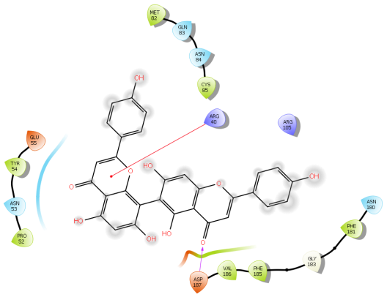  -8.2kcal/mol | 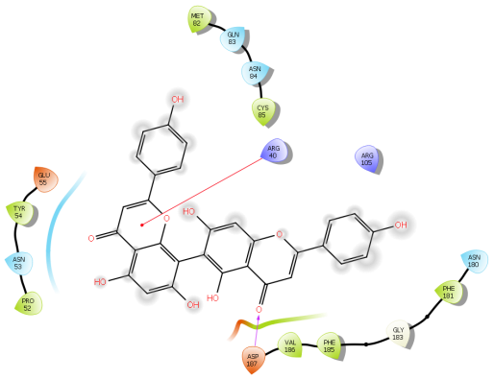-7.5kcal/mol
RdRp | 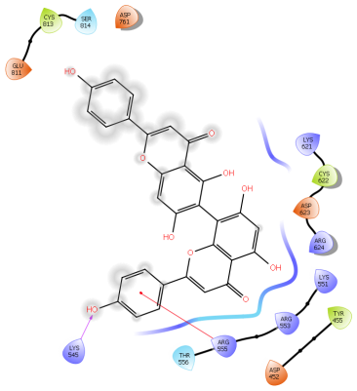  -8.9 kcal/mol | 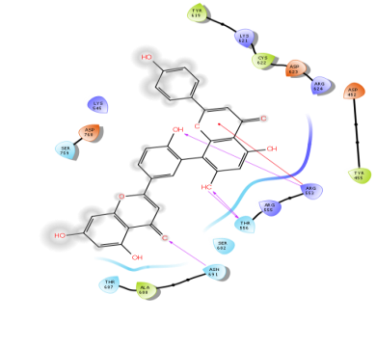  -9.3 kcal/mol
NSP3 | 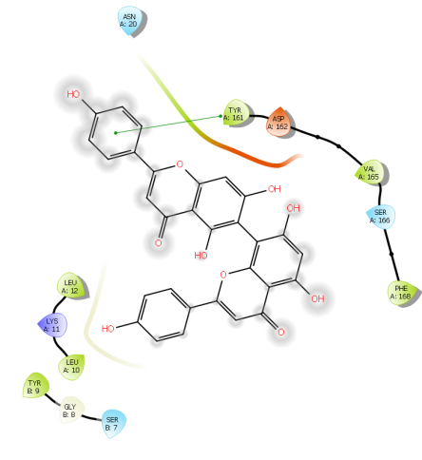  -6.6 kcal/mol | 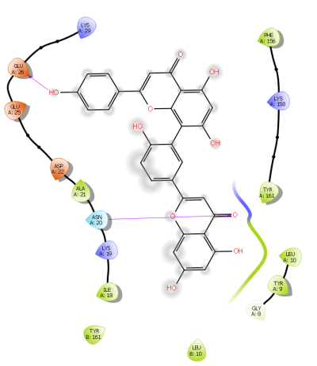  -7.4 kcal/mol
NSP9 | 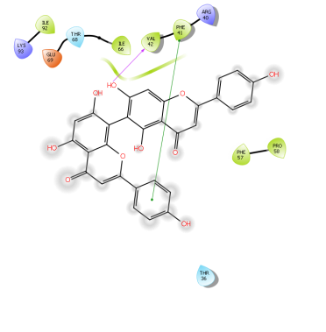  -8.1 kcal/mol | 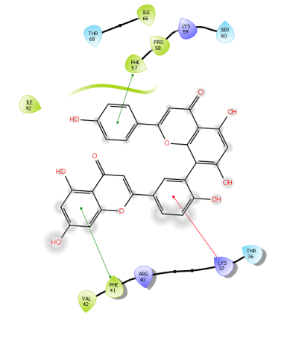  -8.3 kcal/mol
NSP16 - NSP10 | 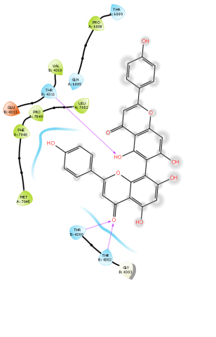  -7.3 kcal/mol | 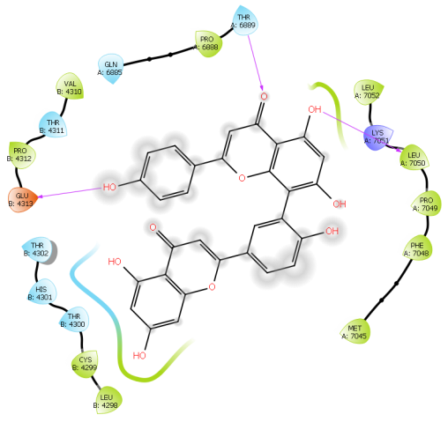  -8.5 kcal/mol
NSP15 | 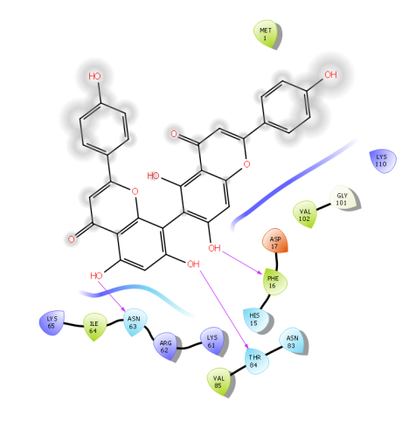  -8.2kcal/mol | 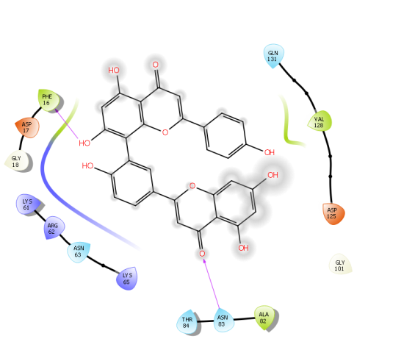  -8.4kcal/mol
Spike glycoprotein | 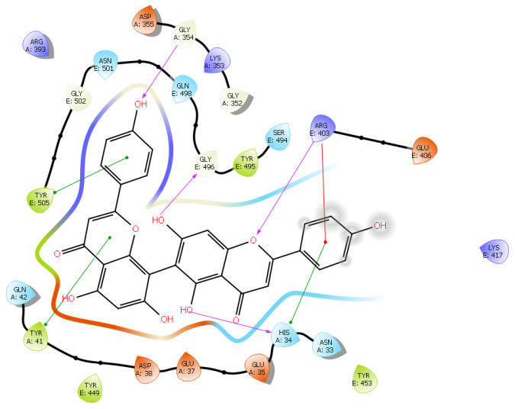  -8.2kcal/mol | 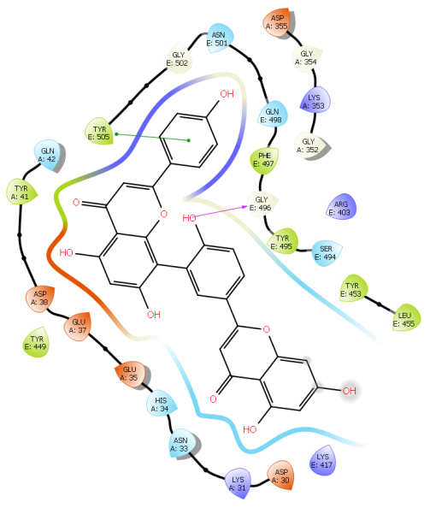  -8.2 kcal/mol

Table S4 2D interaction of Hydroxychloroquine, Chloroquine and Ivermectin against seven target proteins of SARS CoV2
Protein | Hydroxycholoroquine ((2D protein-ligand interaction/Binding affinity) | Chloroquine (2D protein-ligand interaction/Binding affinity) | Ivermectin (2D protein-ligand interaction/Binding affinity)
SARS CoV2 M^{Pro} | 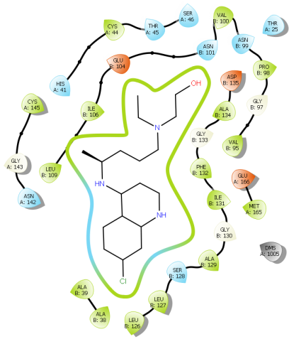 | 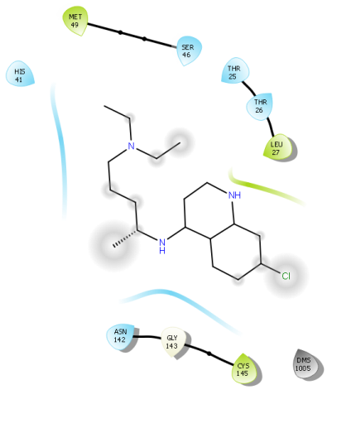 | 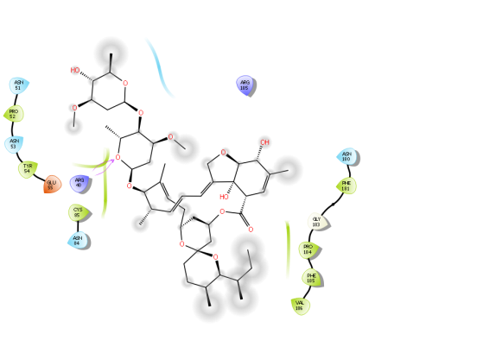
 | -5.5kcal/mol | -4.9kcal/mol | -7.3kcal/mol
RdRp | 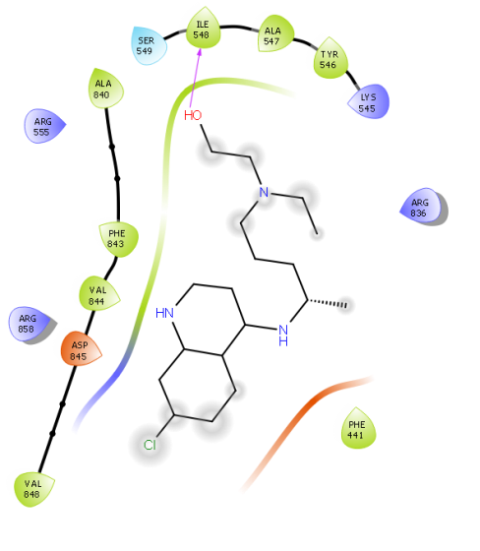 | 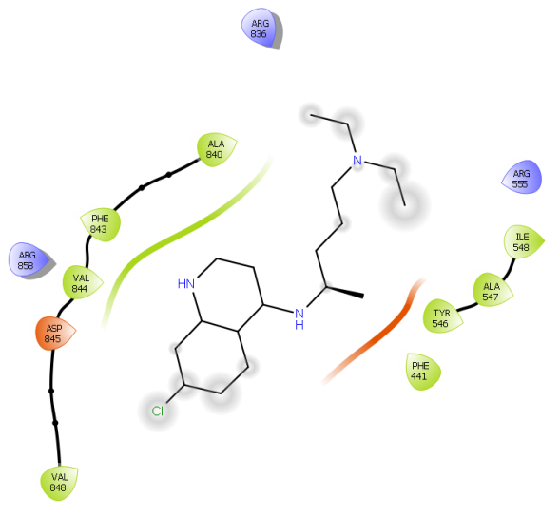 | 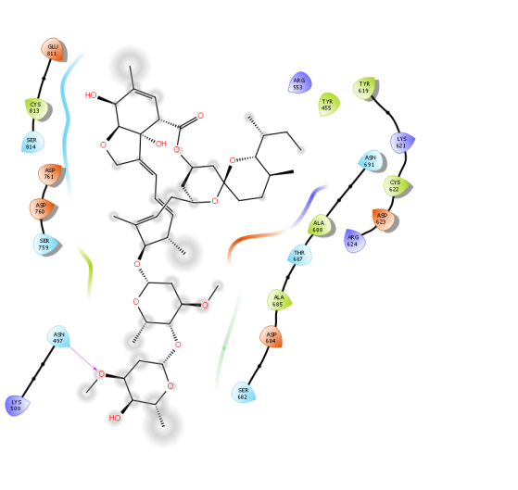
 | -5.6kcal/mol | -5.4kcal/mol | -9.4kcal/mol
NSP3 | 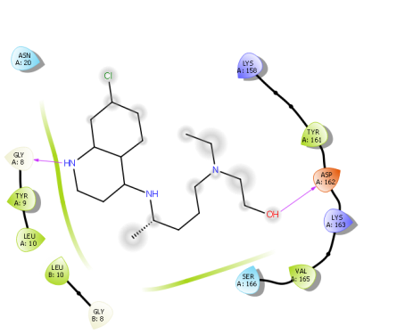 | 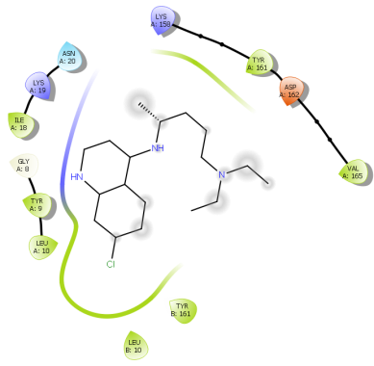 | 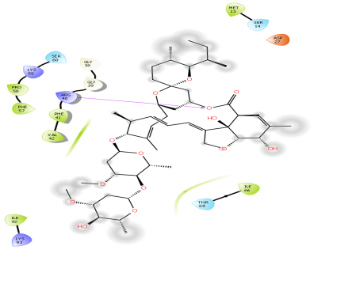
 | -4.5kcal/mol | -4.2kcal/mol | -6.7kcal/mol
NSP9 | 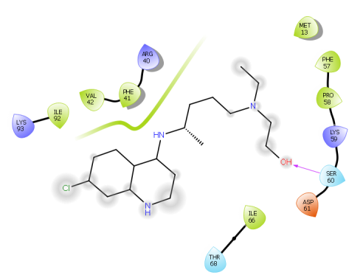 | 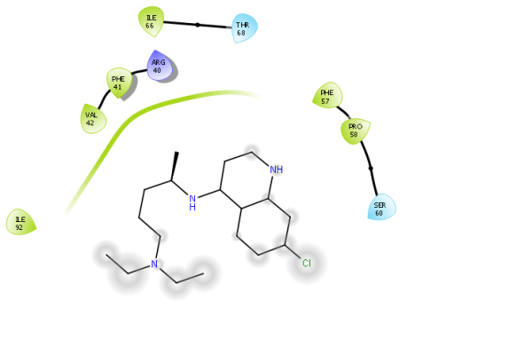 | 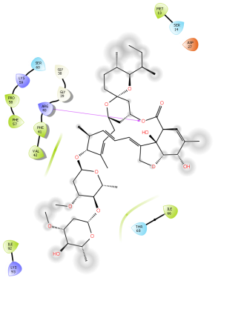
 | -5.7kcal/mol | -5.2kcal/mol | -7.5 kcal/mol
NSP16-NSP10 | 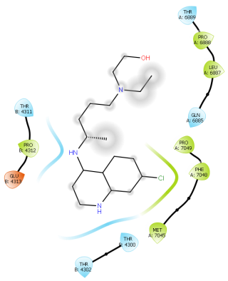 | 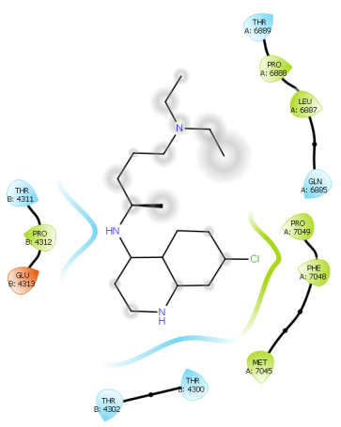 | 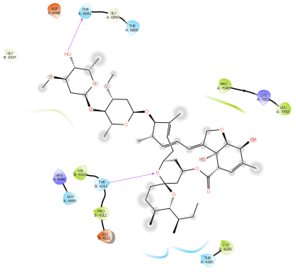
 | -5.7kcal/mol | -5.3kcal/mol | -1.9kcal/mol
NSP15 | 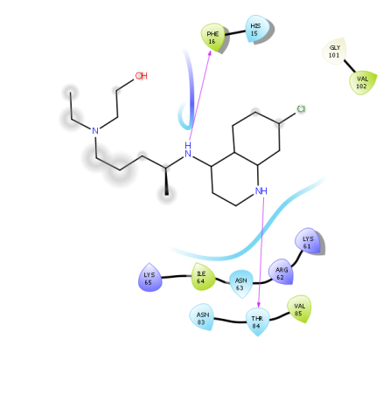 | 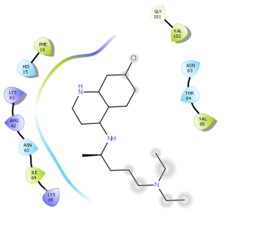 | 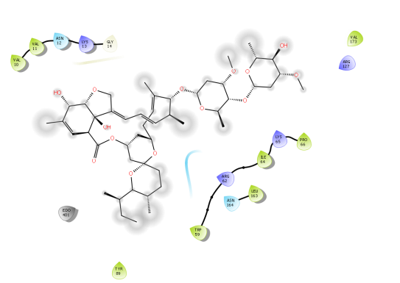
 | -5.5 kcal/mol | -5.4kcal/mol | -6.4 kcal/mol
Spike glycoprotein | 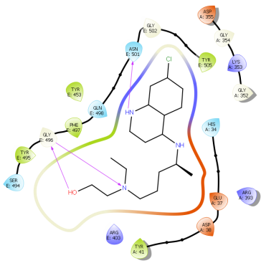 | 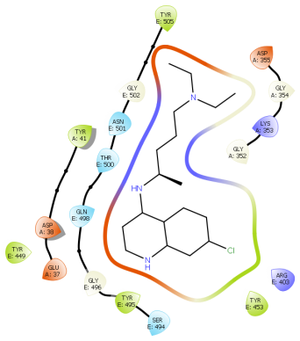 | 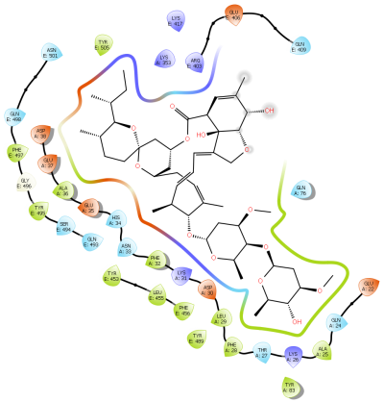
 | -5.3kcal/mol | -5.2kcal/mol | -8.2kcal/mol

Table S5 2D interaction of cyanin with SARS CoV M^{Pro,} MERS CoV2 M^{Pro} and seven proteins of SARS CoV2
Protein | Protein-ligand interaction | Residues exhibiting H Bond interactions
SARS COV Main Protease | 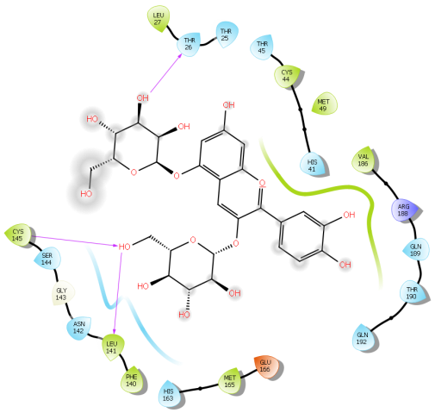  -8.2 kcal/mol | T26, L141,C145
SARS COV2 Main Protease | 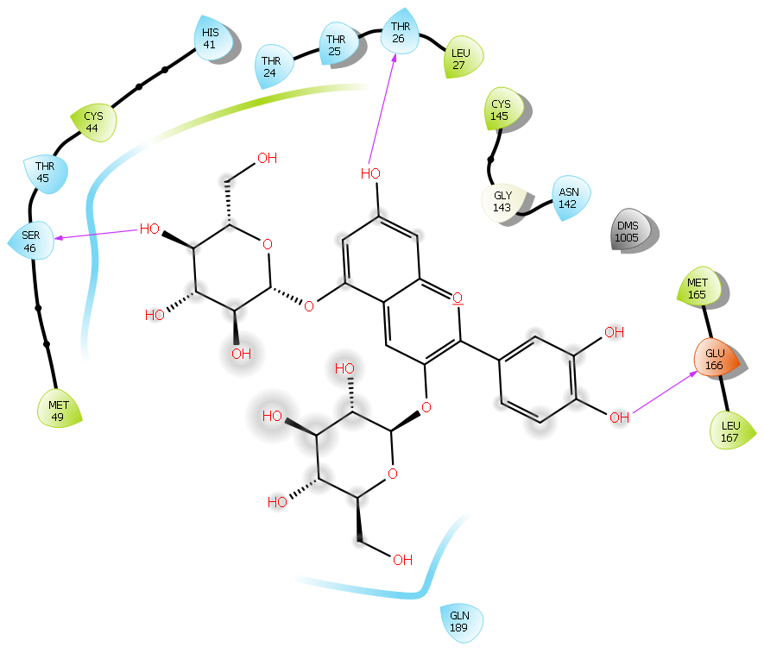-8.3 kcal/mol | T26, S45, D166
MERS COV Main Protease | 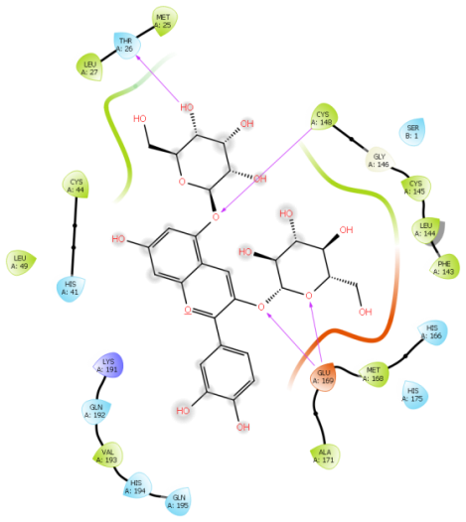  -7.7 kcal/mol | T26, C149, D169

