Additional File
S1 Table. Budget impact analysis
Vaccine option | Year 1
Vaccine option | Cost of vaccine | Cost of vaccine administration | Cost of treatment | Total Cost
No vaccine |  |  | 15,632.12 | 15,632.12
School-based | 3,072,015.71 | 607,701.67 | 10,929.26 | 3,690,646.64
Community-based | 3,321,240.43 | 223,940.85 | 14,370.37 | 3,559,551.64
Community-based + 1 time catch up at 15 years old | 6,281,667.44 | 423,553.18 | 7,278.79 | 6,712,499.41
Community-based + 1 time catch up at 20 years old | 6,212,695.70 | 421,679.80 | 9,121.87 | 6,643,497.37
School-based + 1 time catch up at 21 years old | 5,944,092.09 | 801,356.79 | 6,002.62 | 6,751,451.50
Vaccine option | Year 2
Vaccine option | Cost of vaccine | Cost of vaccine administration | Cost of treatment | Total Cost
No vaccine |  |  | 14,553.17 | 14,553.17
School-based | 2,859,981.59 | 565,757.39 | 10,174.91 | 3,435,913.88
Community-based | 3,092,004.52 | 208,484.19 | 13,378.51 | 3,313,867.22
Community-based + 1 time catch up at 15 years old | 5,848,099.40 | 394,319.05 | 6,776.40 | 6,249,194.84
Community-based + 1 time catch up at 20 years old | 5,783,888.17 | 392,574.97 | 8,492.27 | 6,184,955.40
School-based + 1 time catch up at 21 years old | 5,533,823.89 | 746,046.21 | 5,588.31 | 6,285,458.42
Vaccine option | Year 3
Vaccine option | Cost of vaccine | Cost of vaccine administration | Cost of treatment | Total Cost
No vaccine |  |  | 13,917.75 | 13,917.75
School-based | 2,735,108.27 | 541,055.13 | 9,730.65 | 3,285,894.04
Community-based | 2,957,000.55 | 199,381.30 | 12,794.37 | 3,169,176.22
Community-based + 1 time catch up at 15 years old | 5,592,758.03 | 377,102.18 | 6,480.53 | 5,976,340.74
Community-based + 1 time catch up at 20 years old | 5,531,350.41 | 375,434.25 | 8,121.48 | 5,914,906.14
School Base + 1 time catch up at 21 year old | 5,292,204.52 | 713,472.13 | 5,344.31 | 6,011,020.96
Vaccine option | Year 4
Vaccine option | Cost of vaccine | Cost of vaccine administration | Cost of treatment | Total Cost
No vaccine |  |  | 13,576.01 | 13,576.01
School-based | 2,667,949.95 | 527,769.97 | 9,491.72 | 3,205,211.64
Community-based | 2,884,393.86 | 194,485.65 | 12,480.21 | 3,091,359.73
Community-based + 1 time catch up at 15 years old | 5,455,432.50 | 367,842.75 | 6,321.40 | 5,829,596.65
Community-based + 1 time catch up at 20 years old | 5,395,532.69 | 366,215.77 | 7,922.06 | 5,769,670.53
School-based + 1 time catch up at 21 years old | 5,162,258.83 | 695,953.41 | 5,213.09 | 5,863,425.33
Vaccine option | Year 5
Vaccine option | Cost of vaccine | Cost of vaccine administration | Cost of treatment | Total Cost
No vaccine |  |  | 13,586.83 | 13,586.83
School-based | 2,670,077.00 | 528,190.74 | 9,499.29 | 3,207,767.02
Community-based | 2,886,693.46 | 194,640.71 | 12,490.16 | 3,093,824.34
Community-based + 1 time catch up at 15 years old | 5,459,781.89 | 368,136.01 | 6,326.44 | 5,834,244.35
Community-based + 1 time catch up at 20 years old | 5,399,834.33 | 366,507.74 | 7,928.38 | 5,774,270.44
School-based + 1 time catch up at 21 years old | 5,166,374.48 | 696,508.27 | 5,217.24 | 5,868,099.99

S2 Table Age- specific incidence estimates of typhoid fever used in the model

Supplementary Fig 1: Cohort Model
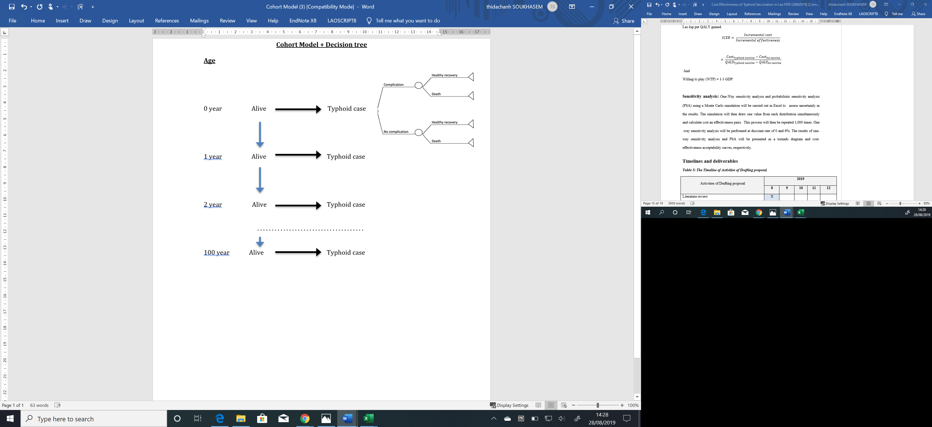

Supplementary Fig 2: Decision Tree Model

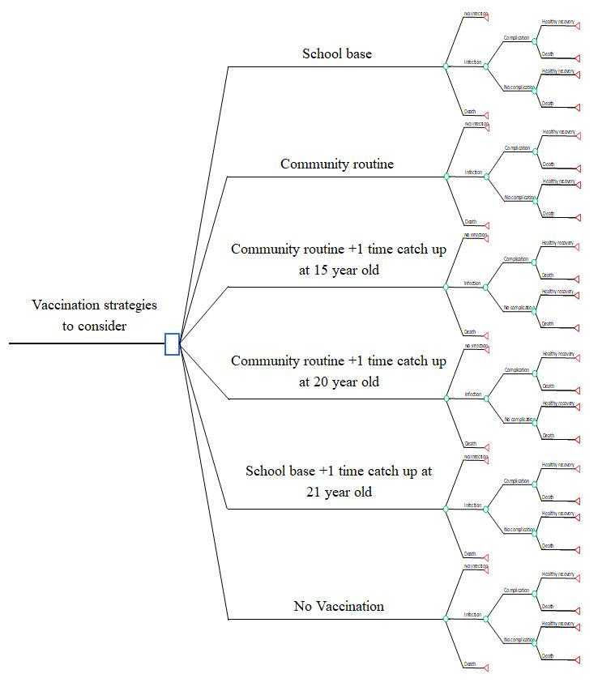

CHEERS Checklist
Topic | No. | Item | Location where item is reported
Title
Title | 1 | Identify the study as an economic evaluation and specify the interventions being compared. | Title
Abstract
Abstract | 2 | Provide a structured summary that highlights context, key methods, results, and alternative analyses. | Abstract
Introduction
Background and objectives | 3 | Give the context for the study, the study question, and its practical relevance for decision making in policy or practice. | Introduction
Methods
Health economic analysis plan | 4 | Indicate whether a health economic analysis plan was developed and where available. | Methodology, First Paragraph
Study population | 5 | Describe characteristics of the study population (such as age range, demographics, socioeconomic, or clinical characteristics). | Methodology, Second Paragraph
Setting and location | 6 | Provide relevant contextual information that may influence findings. | Methodology, Second Paragraph
Comparators | 7 | Describe the interventions or strategies being compared and why chosen. | Methodology, Second Paragraph
Perspective | 8 | State the perspective(s) adopted by the study and why chosen. | Methodology, Third Paragraph
Time horizon | 9 | State the time horizon for the study and why appropriate. | Methodology, Sixth Paragraph
Discount rate | 10 | Report the discount rate(s) and reason chosen. | Methodology, Sixth Paragraph
Selection of outcomes | 11 | Describe what outcomes were used as the measure(s) of benefit(s) and harm(s). | Methodology, Fifth Paragraph
Measurement of outcomes | 12 | Describe how outcomes used to capture benefit(s) and harm(s) were measured. | Methodology, Direct Medical Costs Data Collection
Valuation of outcomes | 13 | Describe the population and methods used to measure and value outcomes. | Methodology, Direct Medical Costs Data Collection
Measurement and valuation of resources and costs | 14 | Describe how costs were valued. | Methodology, Costs, Utility and Analysis
Currency, price date, and conversion | 15 | Report the dates of the estimated resource quantities and unit costs, plus the currency and year of conversion. | Methodology, Direct Medical Costs Data Collection, Last Paragraph
Rationale and description of model | 16 | If modelling is used, describe in detail and why used. Report if the model is publicly available and where it can be accessed. | Methodology, Modelling approach, First and Second Paragraph
Analytics and assumptions | 17 | Describe any methods for analysing or statistically transforming data, any extrapolation methods, and approaches for validating any model used. | Methodology, Modelling approach, Third Paragraph
Characterising heterogeneity | 18 | Describe any methods used for estimating how the results of the study vary for subgroups. | Methodology, Sensitivity analysis
Characterising distributional effects | 19 | Describe how impacts are distributed across different individuals or adjustments made to reflect priority populations. | Methodology, Sensitivity analysis
Characterising uncertainty | 20 | Describe methods to characterise any sources of uncertainty in the analysis. | Methodology, Sensitivity analysis, Last paragraph
Approach to engagement with patients and others affected by the study | 21 | Describe any approaches to engage patients or service recipients, the general public, communities, or stakeholders (such as clinicians or payers) in the design of the study. | Not applicable
Results
Study parameters | 22 | Report all analytic inputs (such as values, ranges, references) including uncertainty or distributional assumptions. | Results, Table 1
Summary of main results | 23 | Report the mean values for the main categories of costs and outcomes of interest and summarise them in the most appropriate overall measure. | Results, Table 2 and Table 3
Effect of uncertainty | 24 | Describe how uncertainty about analytic judgments, inputs, or projections affect findings. Report the effect of choice of discount rate and time horizon, if applicable. | Results, Figure 1 and 2
Effect of engagement with patients and others affected by the study | 25 | Report on any difference patient/service recipient, general public, community, or stakeholder involvement made to the approach or findings of the study | Not applicable
Discussion
Study findings, limitations, generalisability, and current knowledge | 26 | Report key findings, limitations, ethical or equity considerations not captured, and how these could affect patients, policy, or practice. | Discussion
Other relevant information
Source of funding | 27 | Describe how the study was funded and any role of the funder in the identification, design, conduct, and reporting of the analysis | Funding
Conflicts of interest | 28 | Report authors conflicts of interest according to journal or International Committee of Medical Journal Editors requirements. | COI

