Supplementary Data

The combination of Ephedrae herba and coixol from Coicis semen attenuate adiposity via glucocorticoid receptor regulation

Supplementary Table 1: Primer sequence used in this study.
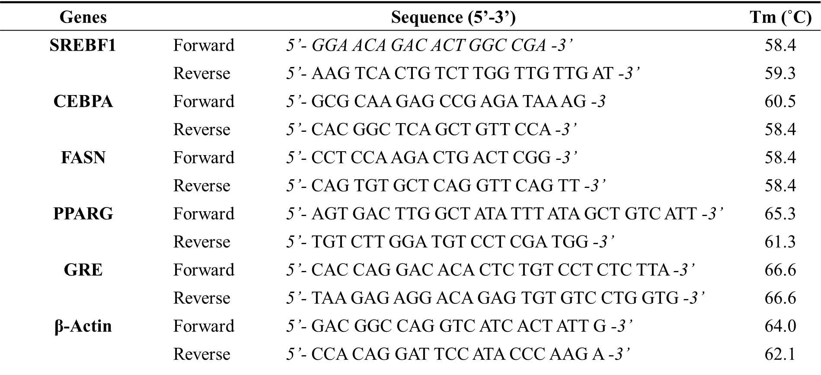

Figure S1 Validation of selected gene expression profiles from GSE59034. Total 32 samples (16 obese patients and 16 non-obese counterparts) were included. (A) Boxplot of selected samples. (B) Venn diagram of DEGs between two groups. (C) Adjusted p-value histogram of all analyzed genes. (D) UMAP plot of all 32 samples. (E) Volcano plot visualizing the distribution of DEGs in obese group by their fold change and p-value (adjusted p-value < 0.05 and |log2FC| > 1).
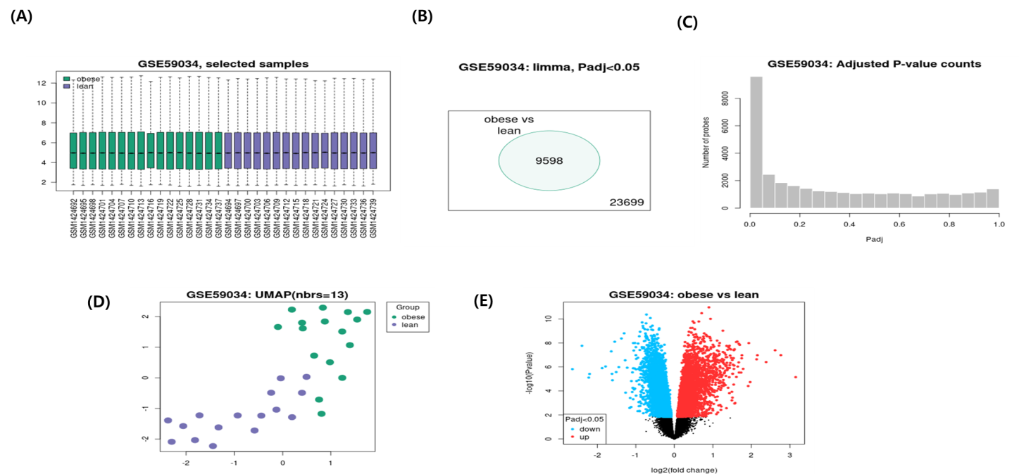

Figure S2 Venn diagram visualizing the distribution of up- or down-regulated DEGs overlapping with potential targets of EH and CS.
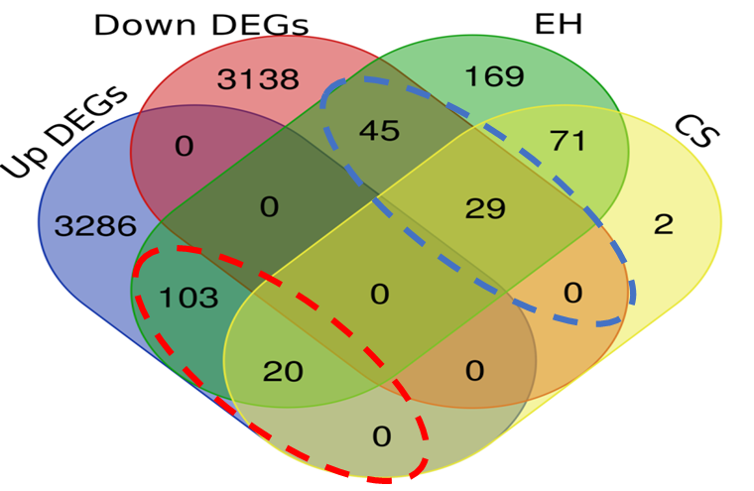

Figure S3 Total protein-protein interaction network of EH-CS combination divided by (A) up-regulated or (B) down-regulated gene lists.
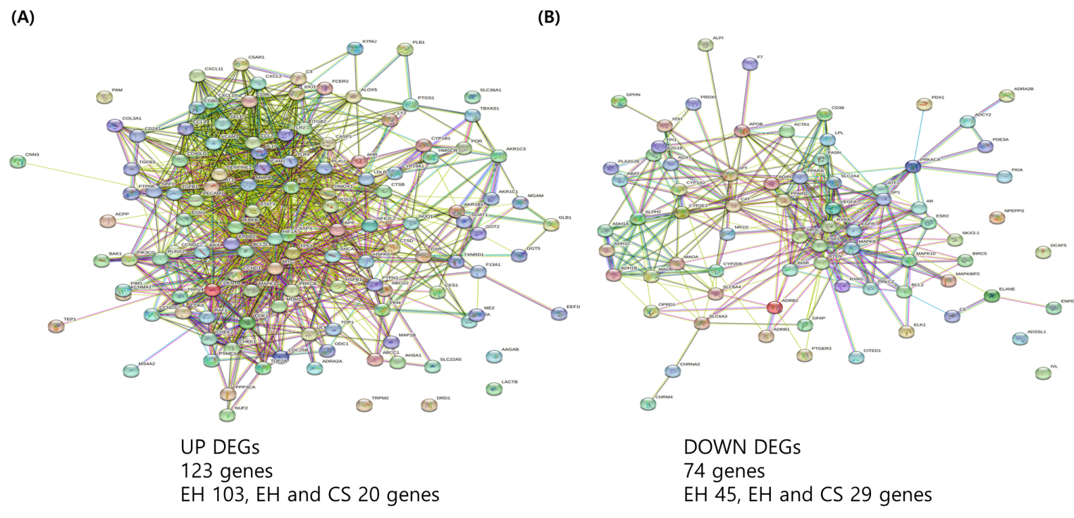

Figure S4 Functional cluster analysis of all up-regulated DEGs for EH-CS combination.
