Supporting Information
Structure-guided design of pyridinyl-indole 4R-tau PET radiotracers: Development of [¹⁸F]OXD-2314 for human use
Anton Lindberg¹, Junchao Tong¹, N. Scott Mason², Daniel Sohn³, Johan Sandell⁴, Peter Ström⁴, Jeffrey S. Stehouwer², Brian J. Lopresti², Jenny Viklund,³ Samuel Svensson^{3,4,*},
Chester A. Mathis^{2,*}, and Neil Vasdev^{1,5,*}

¹Azrieli Centre for Neuro-Radiochemistry, Brain Health Imaging Centre, Centre for Addiction and Mental Health, Toronto, Canada.
²Department of Radiology, University of Pittsburgh, USA.
³Oxiant Discovery, SE-15136 Södertälje, Sweden.
⁴Novandi Chemistry AB, SE-15136 Södertälje, Sweden
⁵Department of Psychiatry, University of Toronto, Canada
*Co-Corresponding authors : samuel.svensson@oxiantdiscovery.com; mathis@pitt.edu; neil.vasdev@utoronto.ca
Table of contents.
Radiosynthesis and rat PET imaging of [¹⁸F]OXD-2188 and [¹⁸F]OXD-2189 3
In silico calculations for predicting BBB permeability of [¹⁸F]OXD-2314 4
Mouse pharmacology assay for OXD-2115 and OXD-2314 5
In vitro pharmacology screening 8
Radiometabolite analysis in rats 11
Dosimetry analysis in rats 13
Radiometabolite analysis in NHP 15
Chemistry methods 17
¹³C- and ¹H-NMR spectra for compounds 1-8 including OXD-2314 24

Radiosynthesis and rat PET imaging of [¹⁸F]OXD-2188 and [¹⁸F]OXD-2189
Radiochemistry. [¹⁸F]OXD-2188 and [¹⁸F]OXD-2189 were radiolabeled using the same methodology as for [¹⁸F]OXD-2115.¹ [¹⁸F]OXD-2188 and [¹⁸F]OXD-2189 were synthesized in radiochemical purity above 95%, molar activity of 60.1 and 58.4 GBq/μmol, respectively, and radiochemical yield of 9% (not decay-corrected).
PET imaging. Three adult rats (two females and one male) were used in baseline PET imaging of [¹⁸F]OXD-2188 and [¹⁸F]OXD-2189 (16-23 MBq injected, with the male rat being scanned twice on two consecutive days). PET-CT imaging in normal rats showed initial uptake of only ~1.0 SUV for both [¹⁸F]OXD-2188 (n=2) and [¹⁸F]OXD-2189 (n=2) with rapid clearance of radioactivity from the brain (Figure S1).
Figure S1. Time-activity curves and representative PET summation images from 0-120 min from PET-CT scans of [¹⁸F]OXD-2188 and [¹⁸F]OXD-2189 in rats.

In silico calculations for predicting BBB permeability of [¹⁸F]OXD-2314.
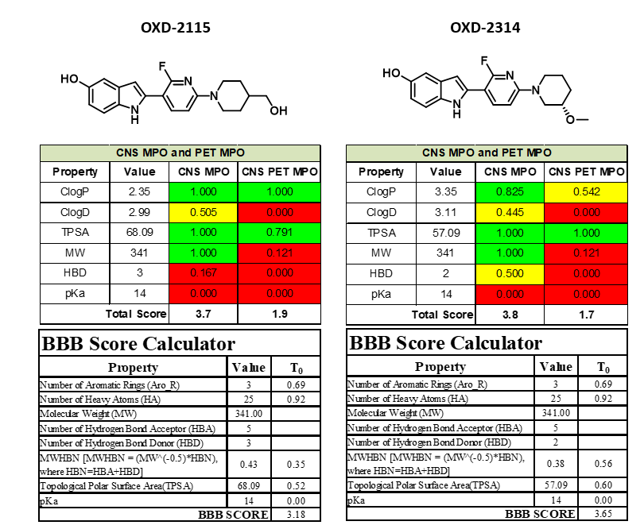
Figure S2. In silico evaluation of CBD-2115 and OXD-2314 using CNS MPO, CNS PET MPO and BBB score.

Mouse pharmacology assay for OXD-2115 and OXD-2314.

Figure S3. Mouse pharmacology. Brain concentration of OXD-2314 in mouse following i.v. administration.

Figure S4. Mouse pharmacology. Plasma concentration of OXD-2314 in mouse following i.v. administration.

Figure S5. Mouse pharmacology. Plasma concentration of OXD-2115 in mouse following i.v. administration.

Figure S6. Mouse pharmacology. Brain concentration of OXD-2115 in mouse following i.v. administration.
Table S1. Mouse pharmacology. Ratio of brain and plasma concentrations of OXD-2314 (brain:plasma) following i.v. administration. Area under the curve (AUC).
 | TOTAL |  | FREE
 | AUC | brain:plasma | AUC | brain:plasma
Plasma | 267 |  | 0.160
Brain | 458 | 1.7 | 0.092 | 0.6

Table S2. Mouse pharmacology. Ratio of brain and plasma concentrations of OXD-2115 following i.v. administration.
 | TOTAL |  | FREE
 | AUC | brain:plasma | AUC | brain:plasma
Plasma | 151 |  | 14
Brain | 15 | 0.1 | 0.030 | 0.002

In vitro pharmacology screening performed by Eurofins.
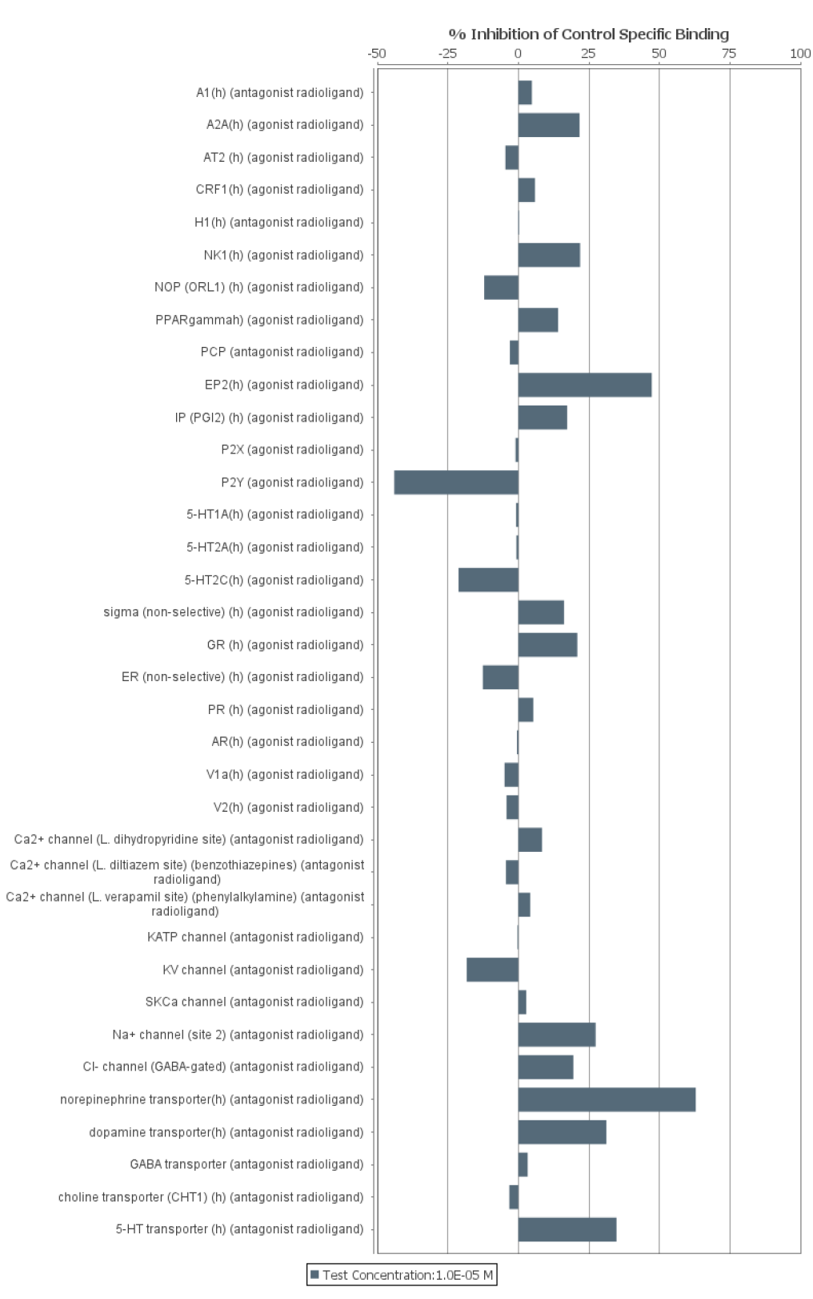
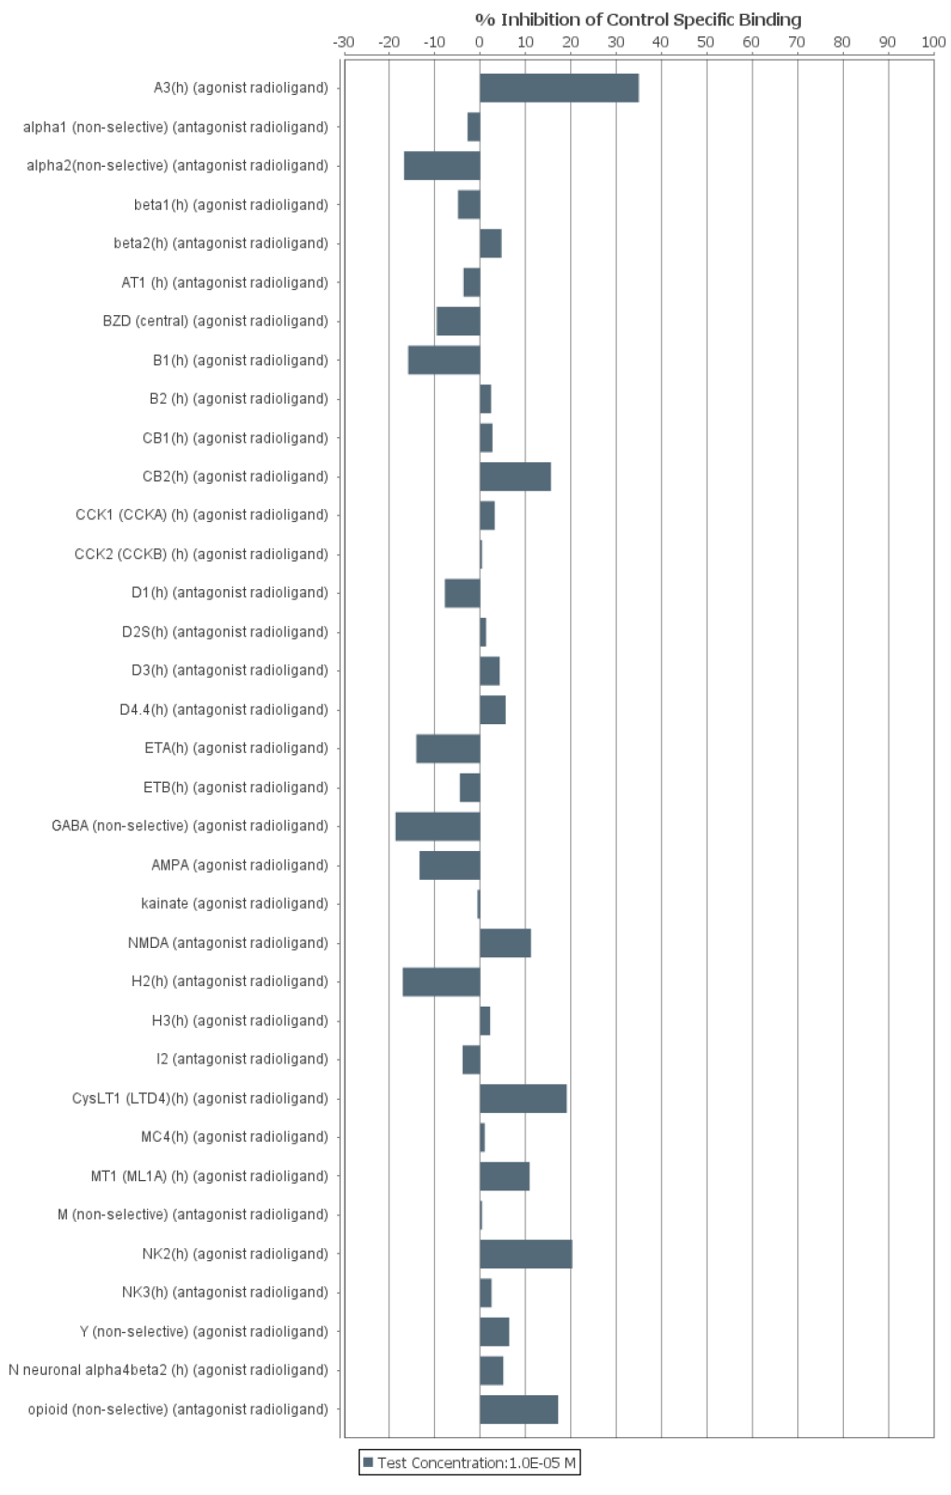
Figure S7. In vitro pharmacology of OXD-2314. %Inhibition of radioligand binding to CNS receptors by OXD-2314 at 10µM.
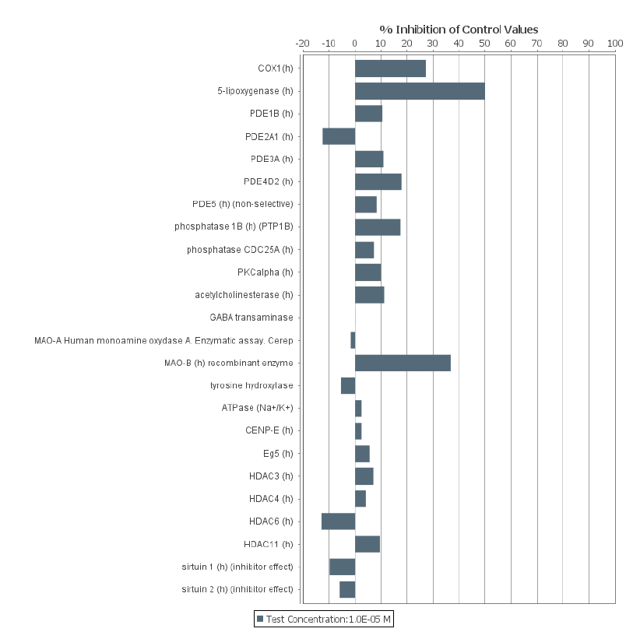
Figure S8. In vitro pharmacology of OXD-2314. CNS enzyme inhibition by OXD-2314 at 10µM.

Radiometabolite analysis in rats.
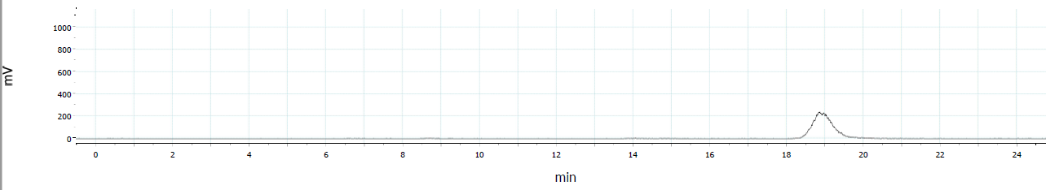
Figure S9. Basline HPLC chromatogram of standard [¹⁸F]OXD-2314 for metabolite studies in rat. UV signal top.
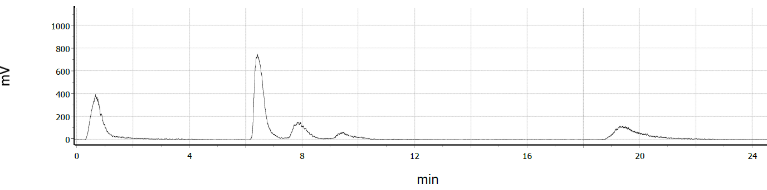
Figure S10. Radiometabolite study. HPLC chromatogram of blood plasma from female rat following i.v. administration of [¹⁸F]OXD-2314. t=30 min post-injection.
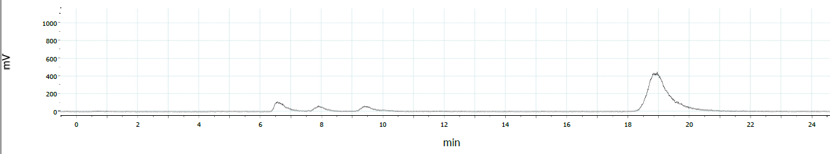
Figure S11. Radiometabolite study. HPLC chromatogram of brain homogenate sample from female rat following i.v. administration of [¹⁸F]OXD-2314. t=30 min post injection
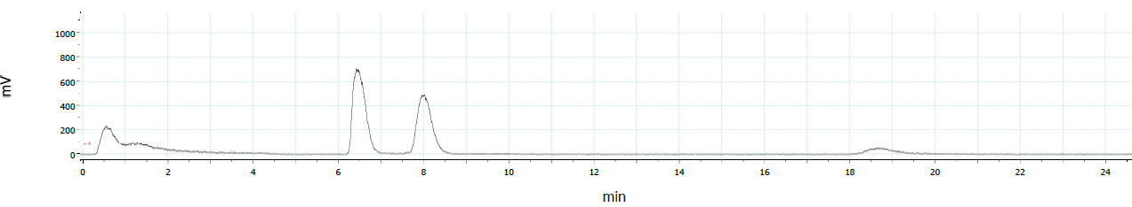
Figure S12. Radiometabolite study. HPLC chromatogram of blood plasma from male rat following i.v. administration of [¹⁸F]OXD-2314. t=30 min post injection
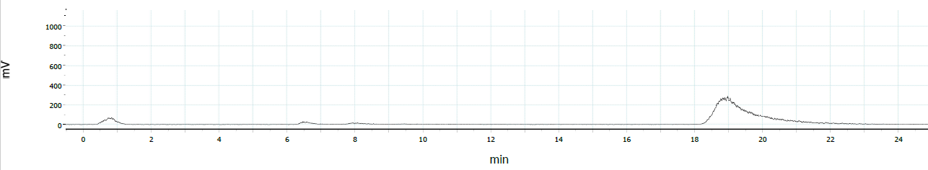
Figure S13. Radiometabolite study. HPLC chromatogram of brain homogenate sample from male rat following iv. administration of [¹⁸F]OXD-2314. t=30 min post injection
Figure S14. Radiometabolite analysis in plasma and brain. Representative column-switch HPLC chromatograms are shown for female rat plasma (A) and brain (B), with the parent [¹⁸F]OXD-2314 and four radiometabolites (M1-M4) indicated. (C) shows the parent fraction (%) in plasma and brain of male (n=2) and female (n=3) rats at 30 min (T30) and 60 min (T60) post-radiotracer injection. Note that the rats were not perfused with saline prior to death, thereby likely resulting in the trapping of radiometabolites contained in blood in the brains of the rats.

Dosimetry analysis in rats.
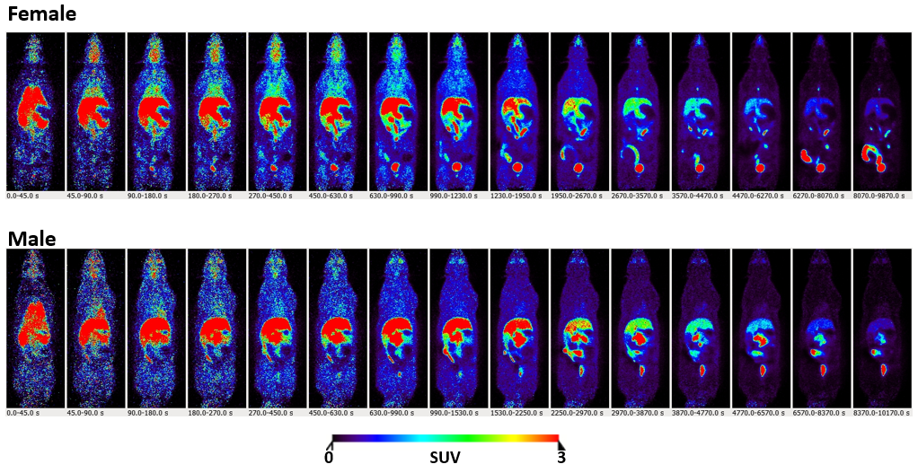
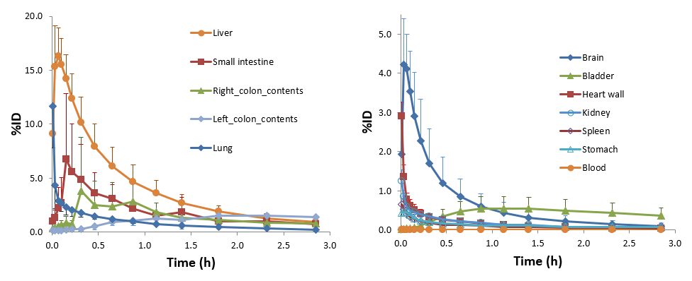
Figure S15. Representative full body images of 15-time frames from female and male rat PET scans of [¹⁸F]OXD-2314 and organ TACs from rat full-body PET scans of [¹⁸F]OXD-2314.

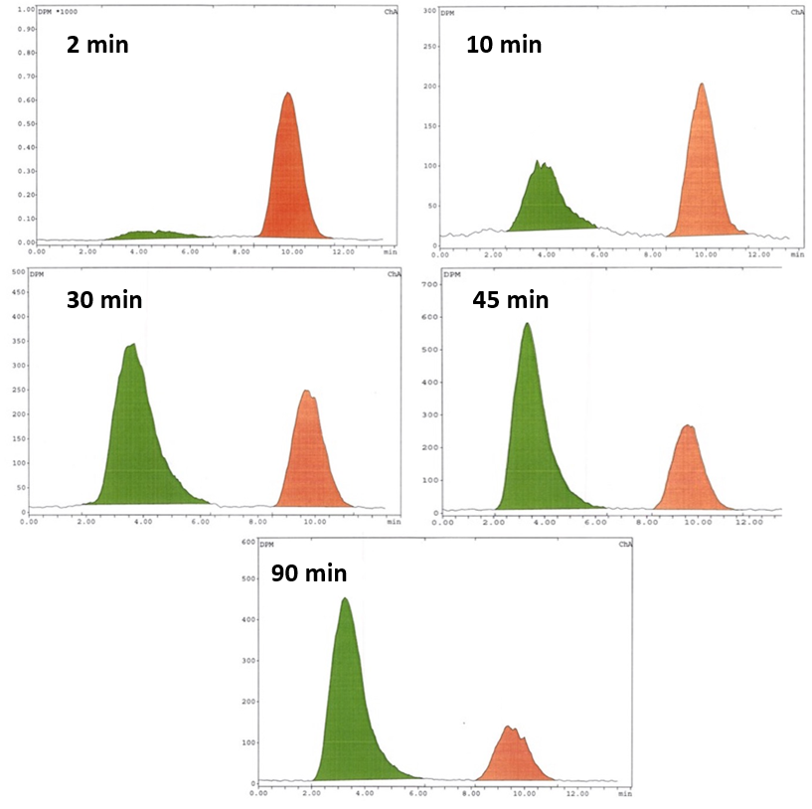
Figure S16. Radiometabolite study. HPLC chromatogram of venous plasma samples from male NHP following i.v. administration of [¹⁸F]OXD-2314 taken at 2, 10, 30, 45 and 90 min post injection. Unchanged parent [¹⁸F]OXD-2314 shown in orange (R_{t} 8-12 min), radiometabolite fraction shown in green(R_{t} 2-6 min).

Figure S17. Radiometabolite study. Fraction of unmetabolized [¹⁸F]OXD-2314 in venous male NHP plasma over 90 min post i.v. injection.

Chemistry Methods.
All reagents and solvents used were analytical grade and commercially available. Anhydrous reactions were routinely used for reactions. Reactions were typically run under inert atmosphere of nitrogen (N₂). ¹H and ¹³C NMR spectra were recorded on a Bruker Avance III 400MHz or an Agilent DD2 500MHz. High-resolution mass spectra (HRMS) were acquired using a JEOL AccuTOF Plus 4G with Direct Analysis in Real Time (DART) ion source. Microwave heating was performed in a Biotage Initiator 2.0. Flash column chromatography was performed using Silica gel 60 (0.040-0.063 mm) in a filter funnel or by using a Teledyne ISCO CombiFlash Rf with varying sizes (4 - 120 g) of Silicycle silica columns. TLC plates were Merck Silica gel 60 F254.
2-Fluoro-6-[(3S)-3-methoxypiperidin-1-yl]pyridine (1). (S)-3-Methoxypiperidine HCl (1.0 g, 6.6 mmol) was slurried in dioxane (8 mL) and 2,6-difluoropyridine (660 µL, 1.1 eq) was added followed by Hunig’s base (3.0 ml, 2.6 eq). The reaction was heated to 100 °C for 5 h.
The cooled reaction mixture was taken into ethyl acetate, washed with water, treated with brine, dried using MgSO₄ and filtered. The solvent was removed in vacuo. The crude was purified by flash column chromatography (40 g silica, applied with hexane, eluted with 5-20% ethyl acetate/ hexane over 5 min) to give 2-fluoro-6-[(3S)-3-methoxypiperidin-1-yl]pyridine (1.03 g, 75% yield, TLC 10% ethyl acetate/ hexane Rf 0.14). ¹H NMR (500 MHz, dmso-d6) δ 7.59 (ddd, J = 9.2, 8.3, 7.7 Hz, 1H), 6.69 – 6.60 (m, 1H), 6.16 (ddd, J = 7.7, 2.9, 0.4 Hz, 1H), 3.86 (dq, J = 11.0, 1.3 Hz, 1H), 3.64 (dddt, J = 13.2, 5.6, 3.9, 0.9 Hz, 1H), 3.25 (s, 3H), 3.24 – 3.15 (m, 3H), 1.95 – 1.84 (m, 1H), 1.68 (dddd, J = 13.3, 7.2, 6.0, 3.5 Hz, 1H), 1.52 – 1.43 (m, 1H), 1.39 (dtt, J = 13.2, 9.2, 3.7 Hz, 1H). ¹³C NMR (126 MHz, dmso-d6) δ 163.41, 161.56, 158.28, 158.15, 142.90, 142.83, 103.56, 103.52, 94.90, 94.61, 74.64, 55.93, 48.37, 45.00, 29.95, 22.09. HRMS (DART+) m/z calculated for 211.12482, found 211.12447
3-Bromo-2-fluoro-6-[(3S)-3-methoxypiperidin-1-yl]pyridine (2). 2-Fluoro-6-[(3S)-3-methoxypiperidin-1-yl]pyridine (1.03 g, 4.9 mmol) was dissolved in acetonitrile (20 mL), cooled on an ice-bath and NBS (0.87 g, 1 eq) was added in 2 portions. The reaction was allowed to stir at 0 °C for 5 min then stirred at rt for 30 min. Diethylether was added to the mixture, the solution was washed with water, treated with brine, dried using MgSO₄ and filtered. The solvent was removed in vacuo. The crude was purified by flash column chromatography (40 g silica, applied with hexane/ DCM, eluted with 5-20% ethyl acetate/ hexane over 5 min) to give 3-bromo-2-fluoro-6-[(3S)-3-methoxypiperidin-1-yl]pyridine (1.35 g, 96% yield, TLC 20% ethyl acetate/ hexane Rf 0.19). ¹H NMR (500 MHz, dmso-d6) δ 7.75 (dd, J = 9.6, 8.7 Hz, 1H), 6.67 (dd, J = 8.8, 1.9 Hz, 1H), 3.78 (ddt, J = 12.9, 3.2, 1.1 Hz, 1H), 3.57 (ddd, J = 13.3, 6.7, 3.8 Hz, 1H), 3.33 – 3.25 (m, 2H), 3.24 – 3.19 (m, 1H), 1.87 (dqd, J = 11.3, 3.8, 1.9 Hz, 1H), 1.72 – 1.61 (m, 1H), 1.54 – 1.46 (m, 1H), 1.43 – 1.34 (m, 1H). ¹³C NMR (126 MHz, dmso-d6) δ 158.61, 157.07, 156.95, 156.78, 144.96, 144.94, 106.04, 106.01, 85.85, 85.54, 74.51, 55.98, 48.40, 45.16, 29.70, 21.85. HRMS (DART+) m/z calculated for 289.03349, found 289.03367
t-Butyl 5-[(t-butyldimethylsilyl)oxy]-2-{2-fluoro-6-[(3S)-3-methoxypiperidin-1-yl]pyridin-3-yl}-1H-indole-1-carboxylate (3). 3-Bromo-2-fluoro-6-[(3S)-3-methoxypiperidin-1-yl]pyridine (580 mg, 2 mmol) and {1-[(t-butoxy)carbonyl]-5-[(t-butyldimethylsilyl)oxy]-1H-indol-2-yl}boronic acid (1.1 g, 1.4 eq) were dissolved in dioxane (12 mL) in a 20 mL microwave vial (Biotage). The solution was bubbled with N₂ for 5 min, then Pd(dppf)Cl₂ DCM (82 mg, 5 mol%) was added followed by 2 M K₂CO₃ (3 mL, 3 eq). The solution was again bubbled with N₂ for 5 min, capped then put in a pre-heated oil bath. The reaction was run at 90 °C for 1 h. The aqueous was removed from the cooled reaction then was diluted with ethyl acetate, dried using MgSO₄ and filtered. The solvent was removed in vacuo. The purification was done by flash column chromatography (40 g silica, applied with DCM, eluted with 5-15% ethyl acetate/ hexane over 6 min) to give t-butyl 5-[(t-butyldimethylsilyl)oxy]-2-{2-fluoro-6-[(3S)-3-methoxypiperidin-1-yl]pyridin-3-yl}-1H-indole-1-carboxylate (1.17 g, 98% yield, TLC 20% ethyl acetate/ hexane Rf 0.35). ¹H NMR (500 MHz, dmso-d6) δ 7.92 (dt, J = 8.9, 0.7 Hz, 1H), 7.66 (dd, J = 10.2, 8.3 Hz, 1H), 7.01 (dd, J = 2.4, 0.5 Hz, 1H), 6.83 (dd, J = 8.9, 2.5 Hz, 1H), 6.76 (dd, J = 8.4, 2.1 Hz, 1H), 6.59 (d, J = 0.7 Hz, 1H), 3.89 (dd, J = 13.1, 3.3 Hz, 1H), 3.67 (ddd, J = 13.2, 6.4, 3.8 Hz, 1H), 3.62 – 3.52 (m, 4H), 3.39 – 3.31 (m, 2H), 3.27 (s, 3H), 3.24 (tt, J = 7.4, 3.4 Hz, 1H), 1.92 (ddt, J = 11.4, 7.4, 3.8 Hz, 1H), 1.78 – 1.65 (m, 5H), 1.53 (dtd, J = 12.5, 8.3, 3.9 Hz, 1H), 1.45 – 1.36 (m, 1H), 1.34 (s, 9H), 0.95 (s, 9H). ¹³C NMR (126 MHz, dmso-d6) δ 150.88, 149.35, 142.06, 133.99, 131.56, 129.63, 117.46, 115.44, 110.20, 109.68, 102.72, 102.44, 102.19, 83.27, 74.16, 67.01, 55.57, 48.08, 44.84, 29.53, 27.18, 25.63, 25.12, 21.57, 17.98, -4.53. HRMS (DART+) m/z calculated for 556.29880, found 556.29868
t-Butyl 2-{2-fluoro-6-[(3S)-3-methoxypiperidin-1-yl]pyridin-3-yl}-5-hydroxy-1H-indole-1-carboxylate (4). t-Butyl 5-[(t-butyldimethylsilyl)oxy]-2-{2-fluoro-6-[(3S)-3-methoxypiperidin-1-yl]pyridin-3-yl}-1H-indole-1-carboxylate (1.1 g, 2.0 mmol) was dissolved in THF (20 mL), cooled on an ice-bath and a 1 M tetrabutylammonium fluoride solution (2.2 mL, 1.1 eq) was added. The reaction stirred 10 min at 0 °C. The reaction was diluted with ethyl acetate, treated with brine, dried MgSO₄ and filtered. The solvent was removed in vacuo. The purification was done by flash column chromatography (40 g silica, applied with DCM, eluted with 30-45% ethyl acetate/ hexane over 5 min) to give t-butyl 2-{2-fluoro-6-[(3S)-3-methoxypiperidin-1-yl]pyridin-3-yl}-5-hydroxy-1H-indole-1-carboxylate (0.84 g, 98% yield, TLC Rf 45% ethyl acetate/ hexane Rf 0.28). ¹H NMR (500 MHz, dmso-d6) δ 9.18 (s, 1H), 7.87 (dt, J = 8.8, 0.7 Hz, 1H), 7.63 (dd, J = 10.2, 8.3 Hz, 1H), 6.89 (dd, J = 2.5, 0.5 Hz, 1H), 6.77 (dd, J = 8.9, 2.5 Hz, 1H), 6.72 (dd, J = 8.4, 2.1 Hz, 1H), 6.53 (d, J = 0.7 Hz, 1H), 3.88 (dd, J = 13.1, 3.3 Hz, 1H), 3.65 (ddd, J = 13.2, 6.3, 3.8 Hz, 1H), 3.36 – 3.28 (m, 3H), 3.22 (tt, J = 7.4, 3.4 Hz, 1H), 1.94 – 1.85 (m, 1H), 1.69 (dtt, J = 13.4, 6.9, 3.5 Hz, 1H), 1.52 (tdd, J = 12.5, 7.7, 3.9 Hz, 1H), 1.45 – 1.35 (m, 1H), 1.33 (s, 8H). ¹³C NMR (126 MHz, dmso-d6) δ 170.31, 159.27, 157.41, 157.17, 157.04, 153.33, 149.45, 142.00, 141.97, 133.62, 133.58, 130.25, 129.71, 115.39, 113.35, 109.69, 104.99, 102.73, 102.67, 102.64, 102.49, 83.11, 82.96, 74.17, 59.75, 55.56, 48.11, 44.85, 30.96, 29.53, 27.20, 22.07, 21.57, 20.74, 20.04, 14.07, 13.95, 13.92. HRMS (DART+) m/z calculated for 442.21252, found 442.21266
2-{2-Fluoro-6-[(3S)-3-methoxypiperidin-1-yl]pyridin-3-yl}-1H-indol-5-ol (OXD-2314) In a 20mL microwave vial, t-butyl 2-{2-fluoro-6-[(3S)-3-methoxypiperidin-1-yl]pyridin-3-yl}-5-hydroxy-1H-indole-1-carboxylate (0.84 g, 1.9 mml) was dissolved in methanol (15 mL). The reaction was subjected to the microwave for 45 min at 150 °C. The solvent was removed, the remains were stirred with DCM and the solid was filtered to give 2-{2-fluoro-6-[(3S)-3-methoxypiperidin-1-yl]pyridin-3-yl}-1H-indol-5-ol (300 mg, 47% yield, TLC Rf 40% ethyl acetate/ hexane Rf 0.15). ¹H NMR (400 MHz, dmso-d6) δ 11.00 (s, 1H), 8.69 (s, 1H), 8.12 (dd, J = 10.7, 8.6 Hz, 1H), 7.23 (dt, J = 8.6, 0.7 Hz, 1H), 6.91 (dd, J = 8.6, 2.1 Hz, 1H), 6.87 (d, J = 2.3 Hz, 1H), 6.65 (dd, J = 8.6, 2.3 Hz, 1H), 6.60 – 6.53 (m, 1H), 3.97 (d, J = 12.1 Hz, 1H), 3.75 (ddd, J = 13.0, 6.3, 3.7 Hz, 1H), 3.36 (s, 7H), 2.08 – 1.91 (m, 1H), 1.79 (ddt, J = 13.4, 6.8, 3.4 Hz, 1H), 1.67 – 1.42 (m, 2H). ¹³C NMR (126 MHz, dmso-d6) δ 159.19, 157.31, 156.35, 156.22, 151.28, 139.53, 132.14, 132.08, 131.47, 129.80, 111.96, 111.78, 104.28, 103.94, 101.65, 101.42, 99.69, 74.65, 56.00, 48.43, 45.10, 29.87, 22.08. ¹⁹F NMR (377 MHz, DMSO) δ -67.79, -67.82). HRMS (DART+) m/z calculated for 342.16123, found 342.16119
2-[(3S)-3-Methoxypiperidin-1-yl]-6-nitropyridine (5). 2-Chloro-6-nitropyridine (0.63 g, 4 mmol) and (S)-3-methoxypiperidine HCl (0.9 g, 1.5 eq) were slurried in dioxane (6 mL) followed by the addition of Hunig’s base (2.9 mL, 1.5 eq). The reaction was heated to 100 °C for 19 h. The cooled reaction mixture was taken into ethyl acetate, washed with water, treated with brine, dried using MgSO₄ and filtered. The solvent was removed in vacuo. The crude was purified by flash column chromatography (40 g silica, applied with hexane, eluted with 15-30% ethyl acetate/ hexane over 8 min) to give 2-[(3S)-3-methoxypiperidin-1-yl]-6-nitropyridine (0.63 g, TLC 30% ethyl acetate/ hexane Rf 0.22). ¹H NMR (500 MHz, dmso-d6) δ 7.78 (dd, J = 8.6, 7.5 Hz, 1H), 7.34 (d, J = 7.5 Hz, 1H), 7.25 (d, J = 8.6 Hz, 1H), 3.86 (ddt, J = 13.4, 3.4, 1.0 Hz, 1H), 3.66 (ddd, J = 13.3, 6.9, 3.7 Hz, 1H), 3.50 – 3.41 (m, 2H), 3.30 – 3.26 (m, 1H), 3.25 (s, 3H), 1.92 – 1.84 (m, 1H), 1.70 (dtd, J = 17.0, 7.3, 3.7 Hz, 1H), 1.58 – 1.49 (m, 1H), 1.45 – 1.36 (m, 1H). ¹³C NMR (126 MHz, dmso-d6) δ 157.77, 155.75, 141.11, 113.09, 104.84, 74.72, 74.57, 56.67, 55.95, 55.33, 48.07, 44.96, 29.71, 21.88. HRMS (DART+) m/z calculated for 238.11862, found 238.11834
3-Bromo-6-[(3S)-3-methoxypiperidin-1-yl]-2-nitropyridine (6). 2-[(3S)-3-Methoxypiperidin-1-yl]-6-nitropyridine (0.61 g, 2.6 mmol) was dissolved in acetonitrile (15 mL), cooled on an ice-bath and NBS (0.65 g, 1 eq) was added. The reaction was allowed to stir at 0 °C for 5 min then stirred at rt for 60 min. The reaction was taken into ethyl acetate, treated with brine, treated with brine, dried using MgSO₄ and filtered. The solvent was removed in vacuo. The crude was purified by flash column chromatography (40 g silica, applied with hexane/ DCM, eluted with 15-30% ethyl acetate/ hexane over 6 min) to give 3-bromo-6-[(3S)-3-methoxypiperidin-1-yl]-2-nitropyridine (0.74 g, TLC 60% ethyl acetate/ hexane Rf 0.30). ¹H NMR (400 MHz, CDCl₃) δ 7.70 (d, J = 9.0 Hz, 1H), 6.72 (d, J = 9.0 Hz, 1H), 3.85 (ddt, J = 13.2, 3.4, 1.1 Hz, 1H), 3.68 (ddd, J = 13.3, 6.6, 3.8 Hz, 1H), 3.52 – 3.31 (m, 6H), 2.05 – 1.94 (m, 1H), 1.88 (ddp, J = 14.2, 7.3, 3.6 Hz, 1H), 1.69 (ddp, J = 12.8, 8.7, 3.9 Hz, 1H), 1.61 – 1.48 (m, 1H). ¹³C NMR (126 MHz, CDCl₃) δ 156.28, 144.12, 110.93, 93.14, 74.58, 56.40, 48.46, 45.43, 29.58, 21.80. HRMS (DART+) m/z calculated for 316.02913, found 316.02855
t-Butyl 5-[(t-butyldimethylsilyl)oxy]-2-{6-[(3S)-3-methoxypiperidin-1-yl]-2-nitropyridin-3-yl}-1H-indole-1-carboxylate (7). 3-Bromo-6-[(3S)-3-methoxypiperidin-1-yl]-2-nitropyridine (316 mg, 1 mmol) and {1-[(t-butoxy)carbonyl]-5-[(t-butyldimethylsilyl)oxy]-1H-indol-2-yl}boronic acid (550 mg, 1.4 eq) were dissolved in dioxane (6 mL) in a 20 ml microwave vial (Biotage). The solution was bubbled with N₂ for 2 min, then Pd(dppf)Cl₂ DCM (41 mg, 5 mol%) was added followed by 2 M K₂CO₃ (31.5mL, 3 eq). The solution was again bubbled with N₂ for 5 min, capped then put in a pre-heated oil bath. The reaction was run at 90 °C for 1 h. The aqueous was removed from the cooled reaction then was diluted with ethyl acetate, dried using MgSO₄ and filtered. The solvent was removed in vacuo. The purification was performed by flash column chromatography (40 g silica, applied with DCM, eluted with 10-20% ethyl acetate/ hexane over 6 min) to give t-butyl 5-[(t-butyldimethylsilyl)oxy]-2-{6-[(3S)-3-methoxypiperidin-1-yl]-2-nitropyridin-3-yl}-1H-indole-1-carboxylate (334 mg, 57% yield, TLC 20% ethyl acetate/ hexane Rf 0.16). ¹H NMR (500 MHz, dmso-d6) δ 7.97 (dt, J = 9.0, 0.7 Hz, 1H), 7.77 (d, J = 8.7 Hz, 1H), 7.27 (d, J = 8.7 Hz, 1H), 7.04 – 6.99 (m, 1H), 6.85 (dd, J = 9.0, 2.5 Hz, 1H), 6.57 (d, J = 0.7 Hz, 1H), 3.85 (dd, J = 13.5, 3.1 Hz, 1H), 3.66 (ddd, J = 13.0, 7.0, 3.7 Hz, 1H), 3.58 (dd, J = 13.3, 6.9 Hz, 2H), 3.29 (td, J = 6.6, 3.1 Hz, 1H), 3.27 (s, 3H), 1.90 (ddt, J = 12.3, 8.0, 3.9 Hz, 1H), 1.76 – 1.67 (m, 1H), 1.60 (ddd, J = 12.1, 9.8, 5.8 Hz, 1H), 1.48 – 1.37 (m, 1H), 1.28 (s, 12H), 0.95 (s, 12H), 0.18 (s, 6H). ¹³C NMR (126 MHz, dmso-d6) δ 157.00, 154.26, 151.41, 149.57, 143.55, 134.78, 131.73, 130.17, 118.18, 116.45, 111.10, 110.83, 110.76, 110.46, 83.81, 74.56, 56.04, 48.16, 45.19, 29.72, 27.60, 26.08, 21.82, 18.42, -4.08. HRMS (DART+) m/z calculated for 583.29598, found 583.29561
t-Butyl 5-hydroxy-2-{6-[(3S)-3-methoxypiperidin-1-yl]-2-nitropyridin-3-yl}-1H-indole-1-carboxylate (8). t-Butyl 5-[(t-butyldimethylsilyl)oxy]-2-{6-[(3S)-3-methoxypiperidin-1-yl]-2-nitropyridin-3-yl}-1H-indole-1-carboxylate (236 g, 0.40 mmol) was dissolved in THF (7 mL), cooled on an ice-bath and a 1 M TBAF solution (450 µL, 1.1 eq) was added. The reaction stirred 10 min at 0 °C. The reaction was diluted with ethyl acetate, treated with brine, dried MgSO₄ and filtered. The solvent was removed in vacuo. The purification was performed by flash column chromatography (12 g silica, applied with DCM, eluted with 25-40% ethyl acetate/ hexane over 5 min) to give t-butyl 5-hydroxy-2-{6-[(3S)-3-methoxypiperidin-1-yl]-2-nitropyridin-3-yl}-1H-indole-1-carboxylate (142 mg, 75% yield, TLC Rf 40% ethyl acetate/ hexane Rf 0.16). ¹H NMR (400 MHz, CDCl₃) δ 8.03 (d, J = 8.9 Hz, 1H), 7.56 (d, J = 8.6 Hz, 1H), 6.91 (d, J = 2.5 Hz, 1H), 6.88 – 6.81 (m, 2H), 6.35 (d, J = 0.7 Hz, 1H), 3.95 (dd, J = 13.3, 3.3 Hz, 1H), 3.76 (ddd, J = 13.4, 6.5, 3.8 Hz, 1H), 3.56 (dd, J = 13.3, 7.2 Hz, 1H), 3.42 (s, 4H), 3.37 (tt, J = 7.2, 3.5 Hz, 1H), 2.00 (dq, J = 11.6, 3.6 Hz, 1H), 1.88 (dtt, J = 13.9, 7.1, 3.6 Hz, 1H), 1.69 (dtd, J = 12.5, 8.2, 3.7 Hz, 1H), 1.55 (ddt, J = 15.2, 8.8, 4.1 Hz, 1H), 1.39 (s, 9H). ¹³C NMR (101 MHz, CDCl₃) δ 156.82, 151.78, 149.82, 142.77, 134.69, 131.55, 130.02, 116.72, 113.52, 111.46, 110.10, 109.35, 105.52, 83.70, 77.36, 77.04, 76.72, 74.81, 56.41, 48.38, 45.46, 29.85, 27.80, 21.99. HRMS (DART+) m/z calculated for 469.20816, found 469.20799

¹³C- and ¹H-NMR spectra for compounds 1-8 including OXD-2314

2-Fluoro-6-[(3S)-3-methoxypiperidin-1-yl]pyridine (1)
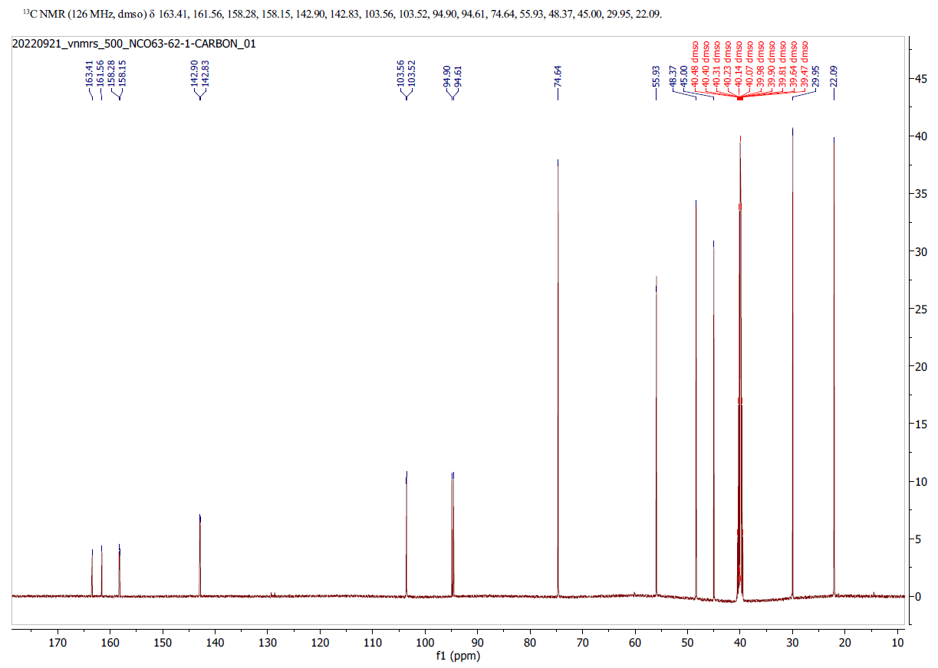

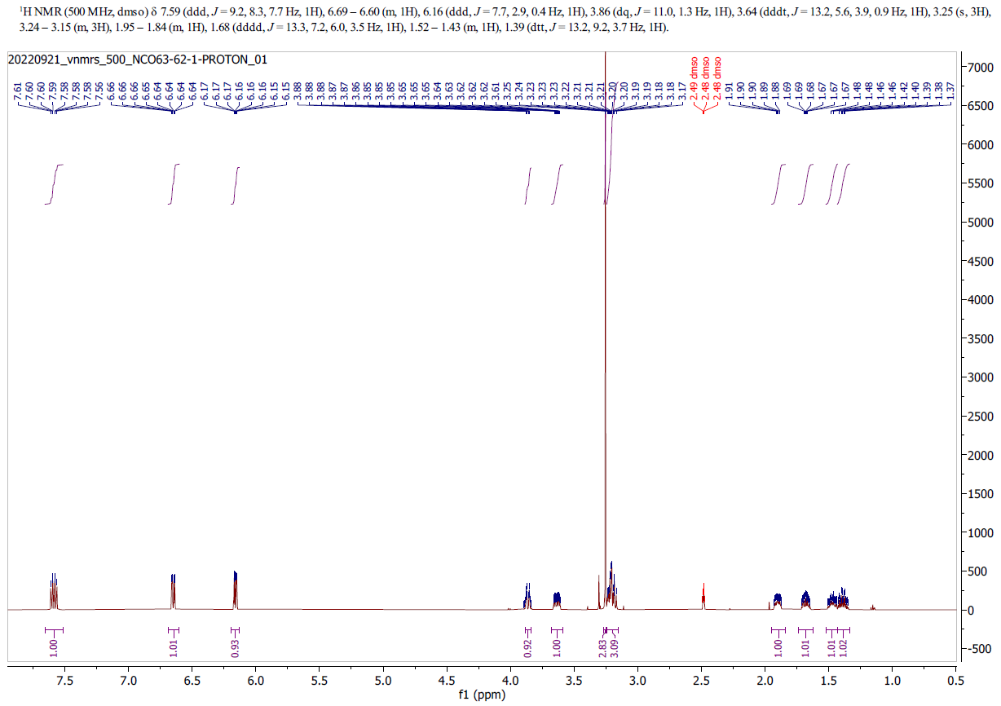

3-Bromo-2-fluoro-6-[(3S)-3-methoxypiperidin-1-yl]pyridine (2)
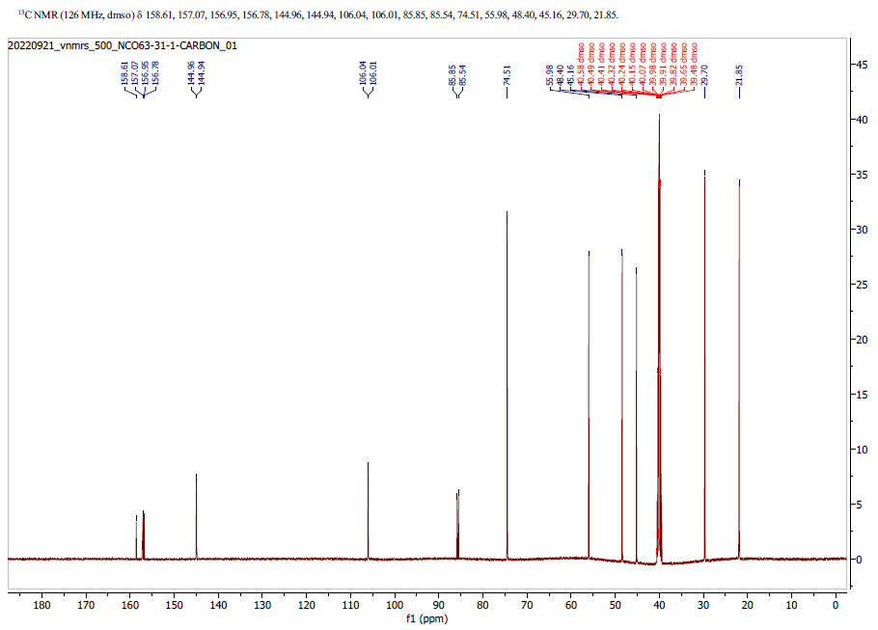
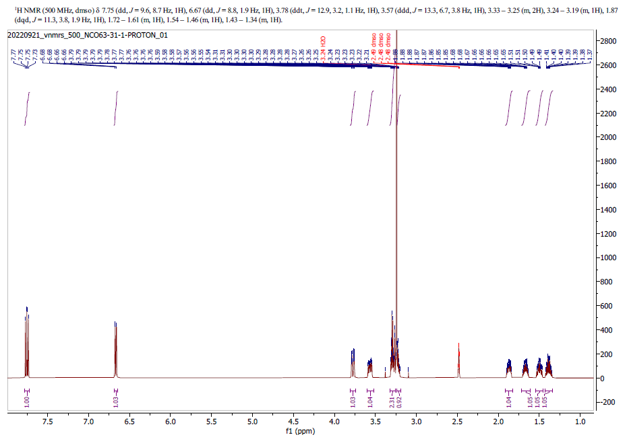

t-Butyl 5-[(t-butyldimethylsilyl)oxy]-2-{2-fluoro-6-[(3S)-3-methoxypiperidin-1-yl]pyridin-3-yl}-1H-indole-1-carboxylate (3)
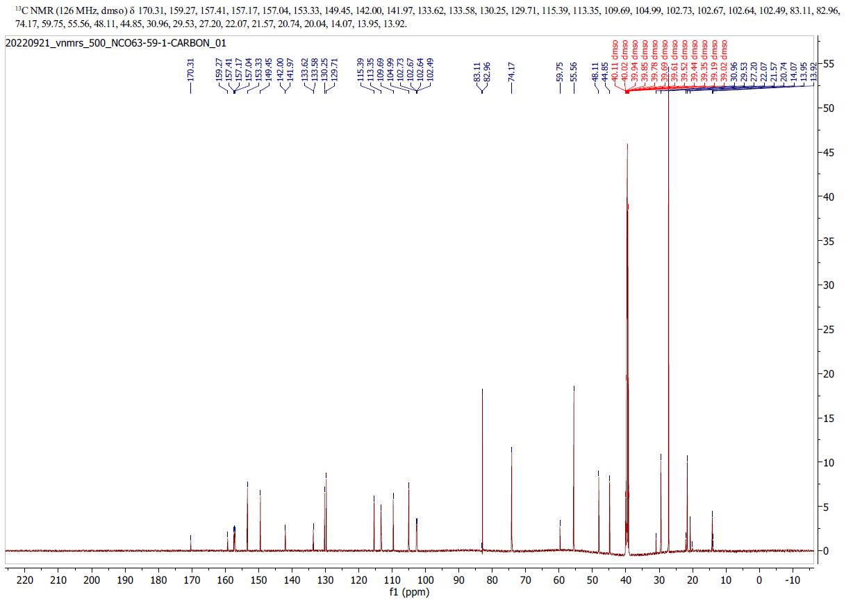
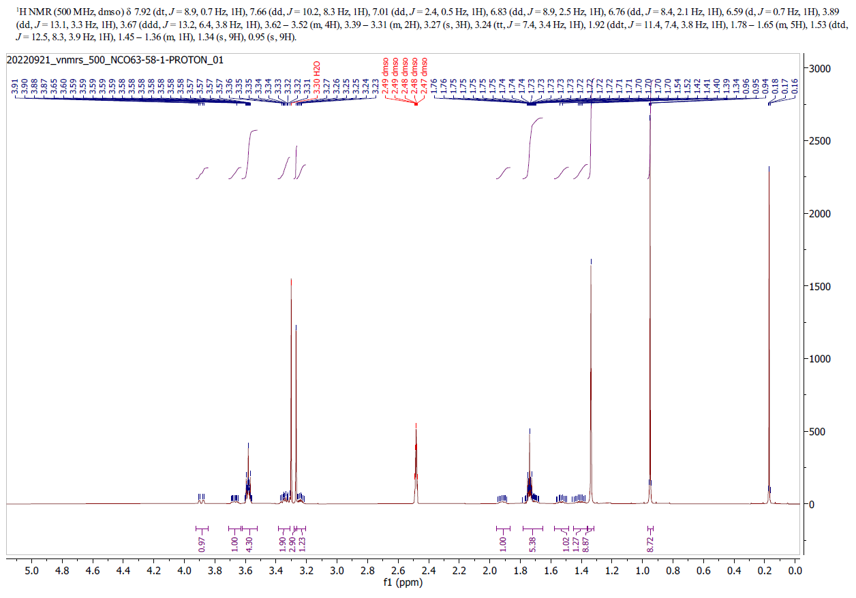

t-Butyl 2-{2-fluoro-6-[(3S)-3-methoxypiperidin-1-yl]pyridin-3-yl}-5-hydroxy-1H-indole-1-carboxylate (4)
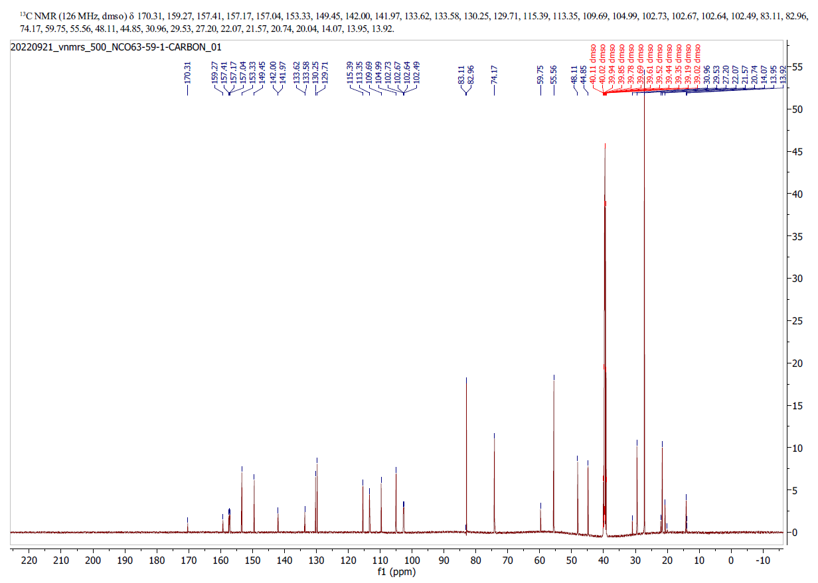
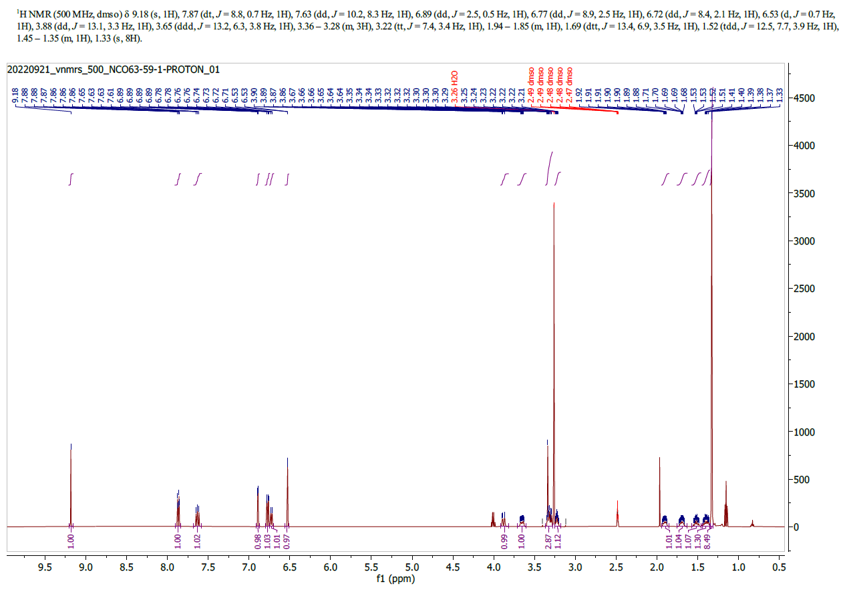

2-{2-Fluoro-6-[(3S)-3-methoxypiperidin-1-yl]pyridin-3-yl}-1H-indol-5-ol (OXD-2314)

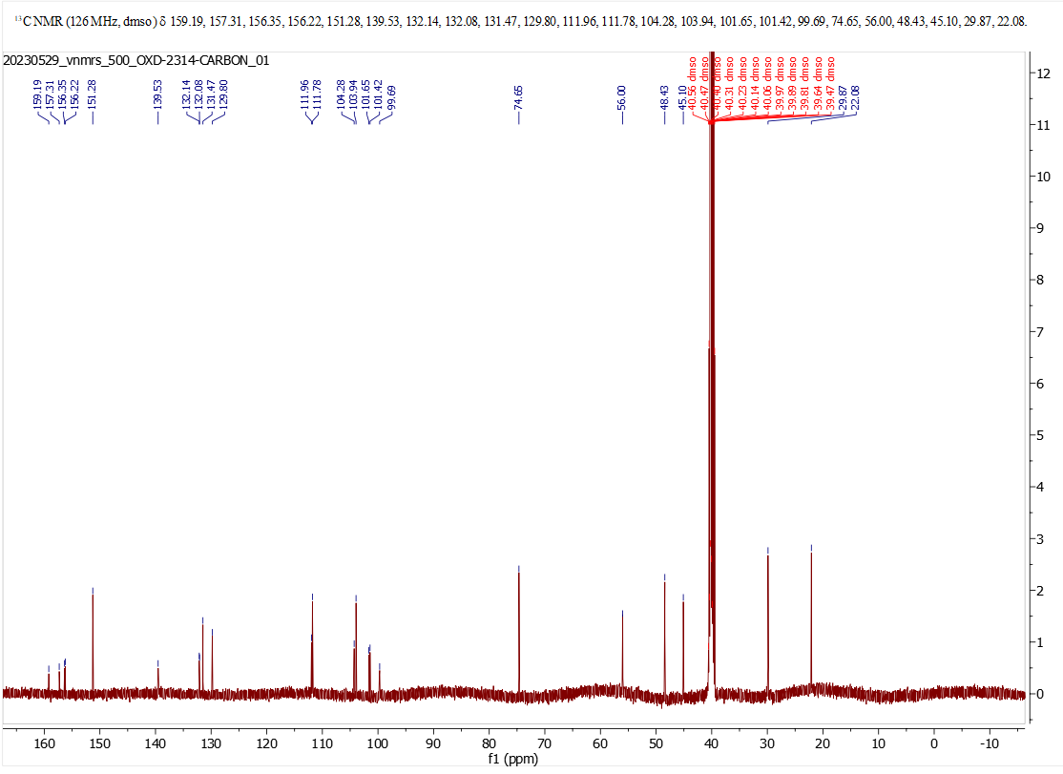
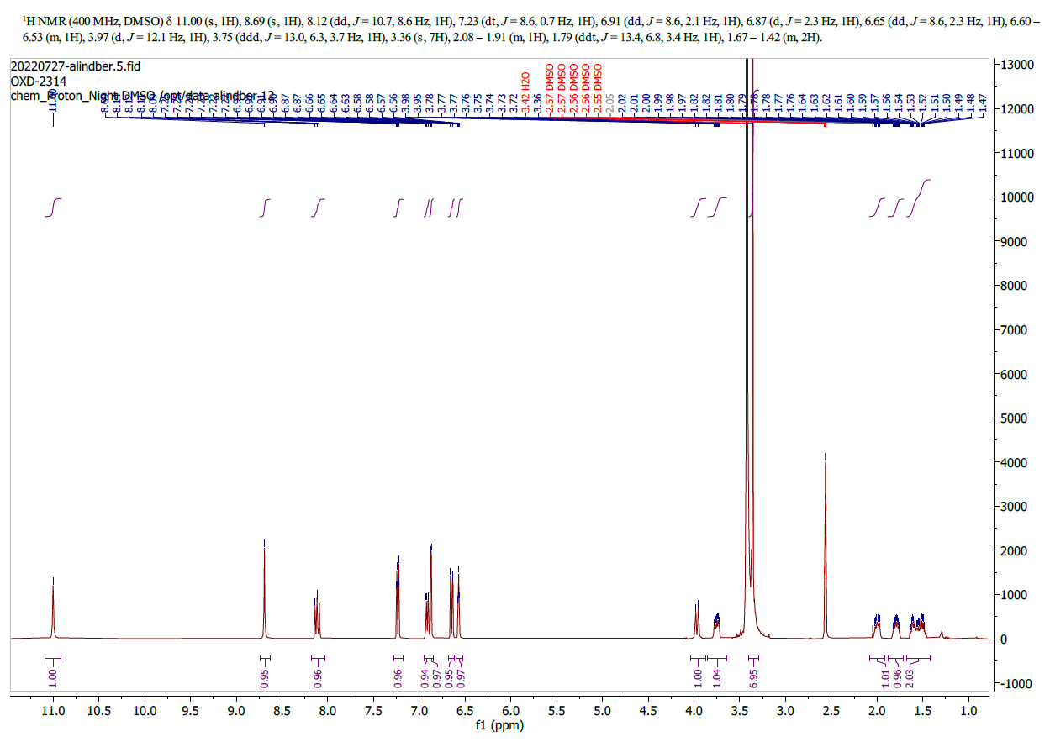
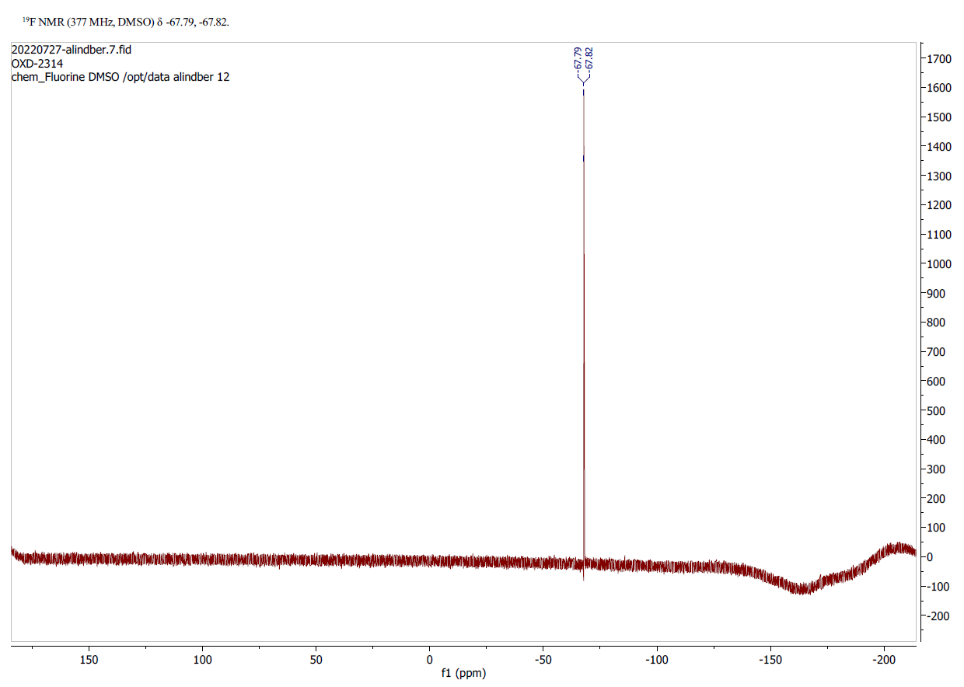

2-[(3S)-3-Methoxypiperidin-1-yl]-6-nitropyridine (5)
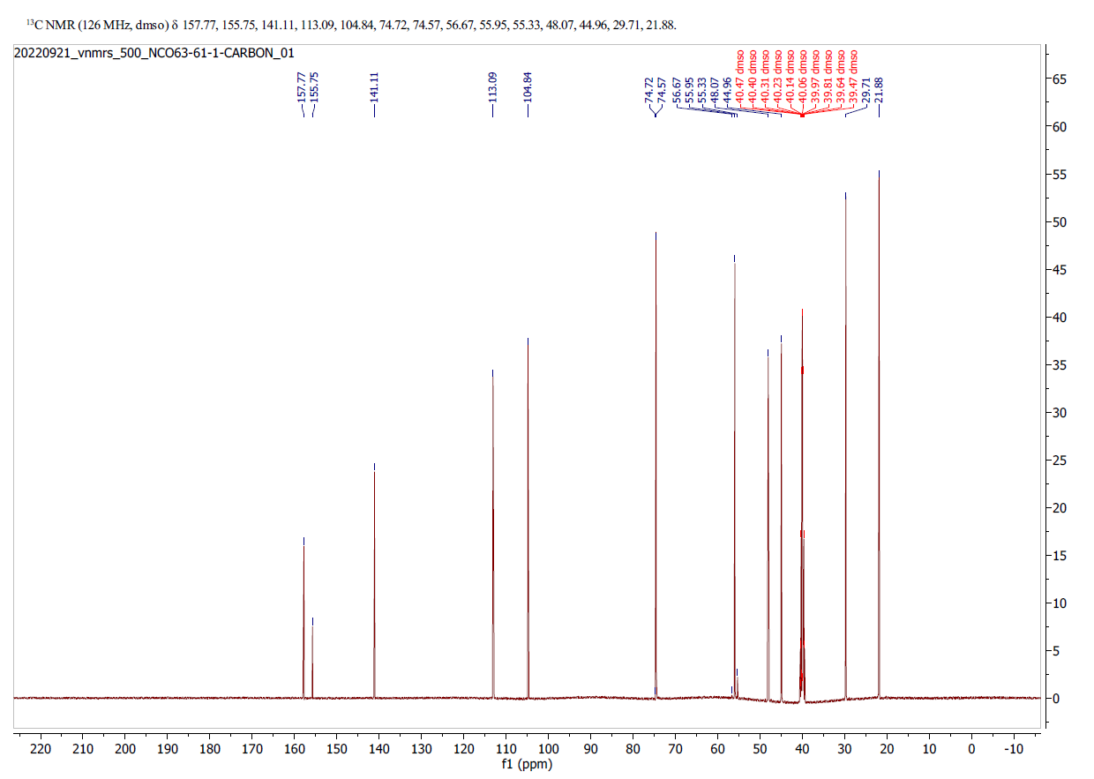

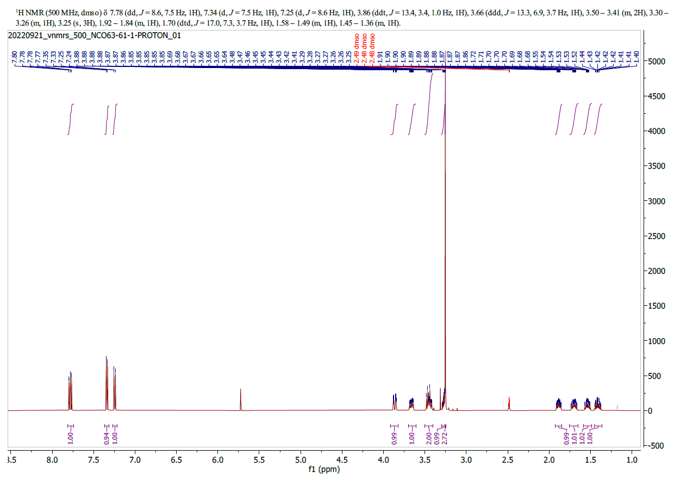

3-Bromo-6-[(3S)-3-methoxypiperidin-1-yl]-2-nitropyridine (6)
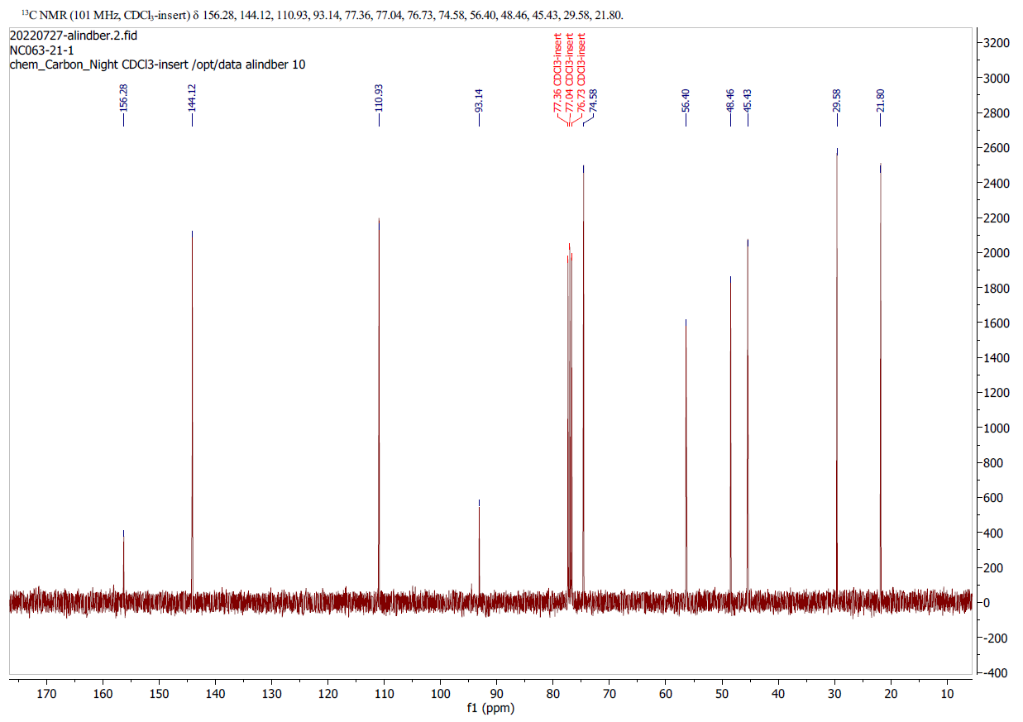
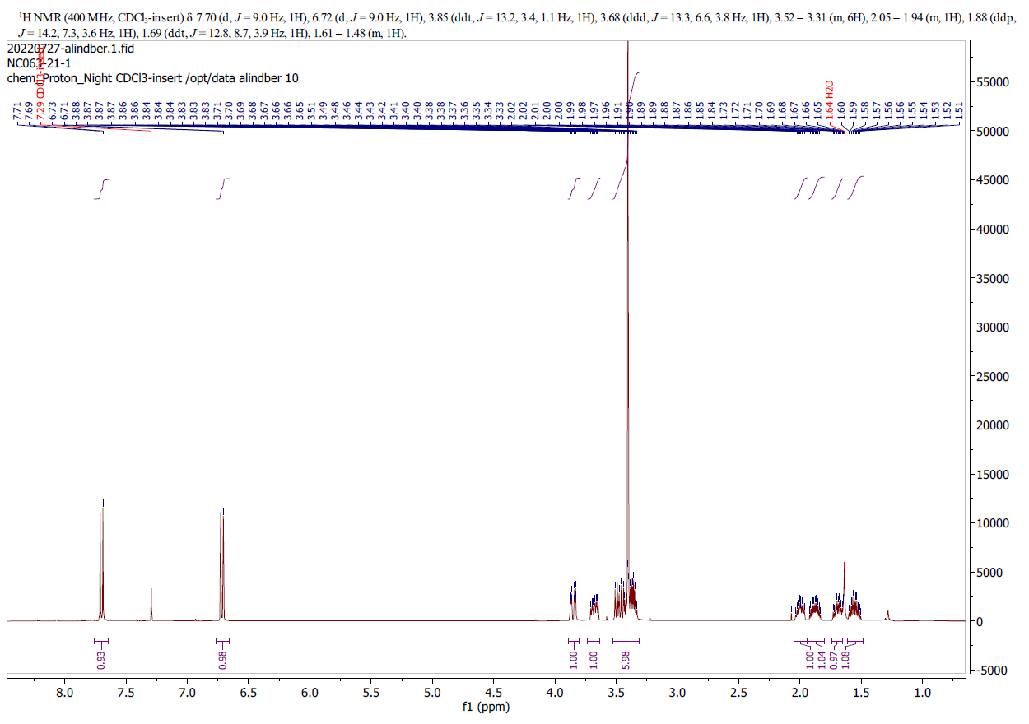

t-Butyl 5-[(t-butyldimethylsilyl)oxy]-2-{6-[(3S)-3-methoxypiperidin-1-yl]-2-nitropyridin-3-yl}-1H-indole-1-carboxylate (7)
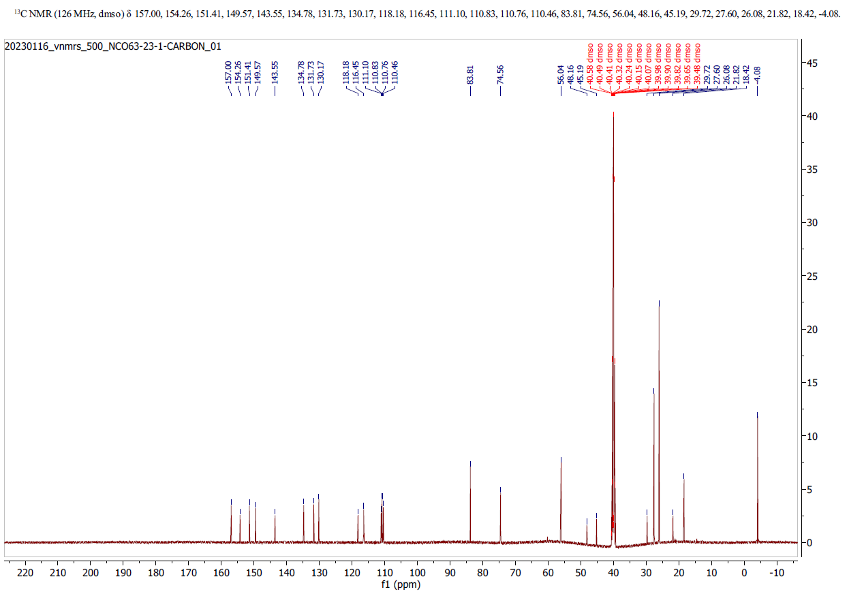
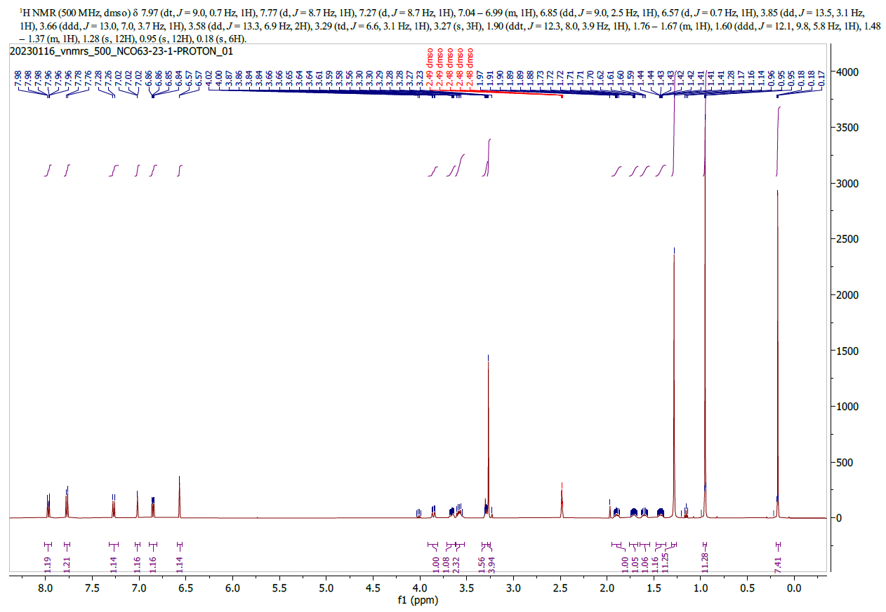

t-Butyl 5-hydroxy-2-{6-[(3S)-3-methoxypiperidin-1-yl]-2-nitropyridin-3-yl}-1H-indole-1-carboxylate (8)
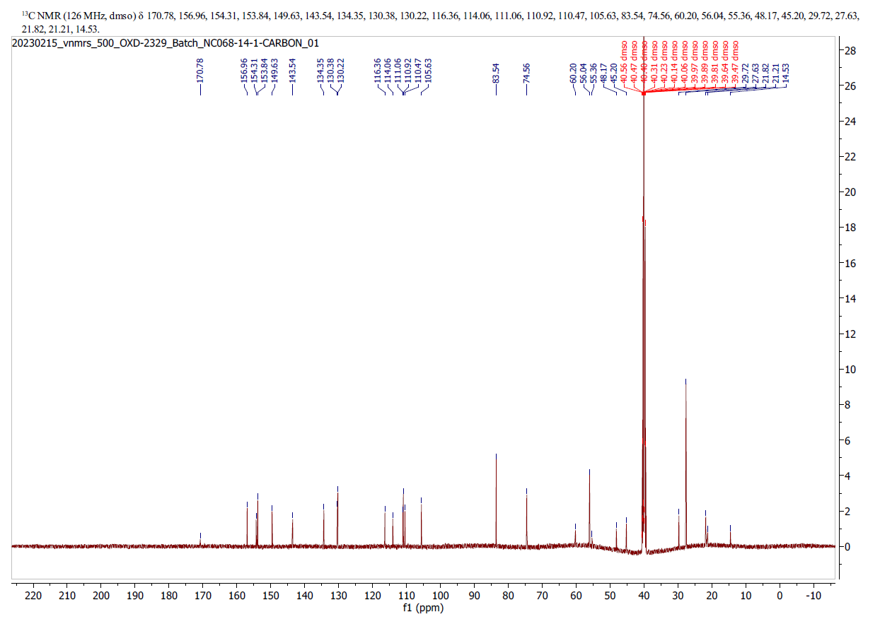
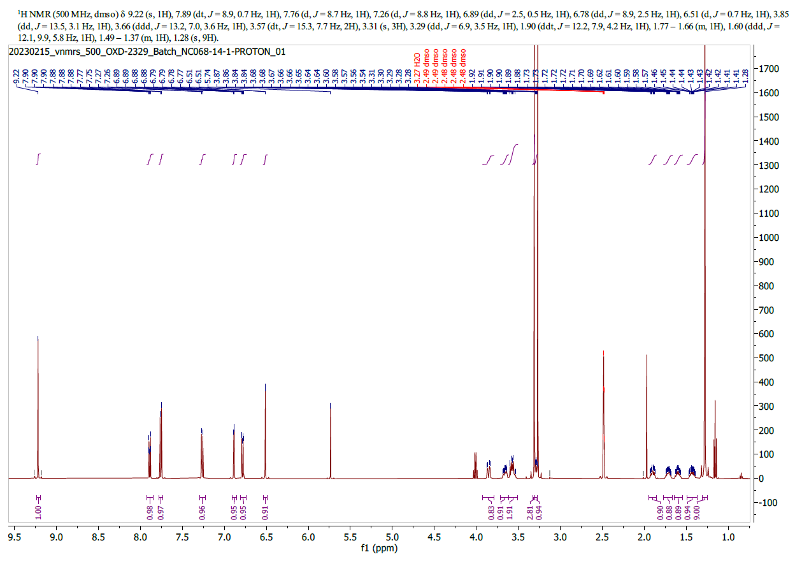

1 Lindberg, A. et al. Radiosynthesis, In Vitro and In Vivo Evaluation of [¹⁸F]CBD-2115 as a First-in-Class Radiotracer for Imaging 4R-Tauopathies. ACS Chemical Neuroscience 12, 596-602 (2021). https://doi.org:10.1021/acschemneuro.0c00801

