Supplemental Information

High-efficiency, low-speckle contrast white laser lighting via multi-stage scattering and photon recycling

Xiaoxin Wang,^{1,*} Charles J. Carver,² Nicholas R. Shade,¹ Eric R. Fossum,¹ Xia Zhou,^{2,} and Jifeng Liu^{1,*}

[1] Thayer school of Engineering, Dartmouth College, 15 Thayer Drive, Hanover, NH 03755 USA
[2] Department of Electrical Engineering and Computer Science, Columbia University, Mudd Building, 500 W 120th St, New York, NY 10027, USA

*Corresponding authors: Xiaoxin.Wang@dartmouth.edu; Jifeng.Liu@dartmouth.edu

- Specifications of the RGB Laser Diodes

In the simulation, three grid laser sources in red, green and blue (RGB) are defined with the Gaussian distribution and beam divergence angles parallel to (θ//) and perpendicular to (θ┴) the junction from the laser specifications. The number of tracing rays for each laser is 640000, resulting in 1920000 rays in total. The details of LD specifications are as follows:
- Blue laser is PLT5450 (Osram), emission wavelength λ_{peak}= 450 nm, θ// = 6.5°, θ┴=22°.
- Green laser is PLT3520D (Osram), λ_{peak}= 520 nm, θ// = 6.2°, θ┴=22.5°.
- Red lasers are L638P700m (Thorlab, λ_{peak}= 640 nm, θ// = 9°, θ┴=35°) and HL6545MG (Opnext, λ_{peak}= 670 nm, θ// = 10°, θ┴=17°).

- Simulated Optical Irradiance Distribution for a Conical Reflective Cavity

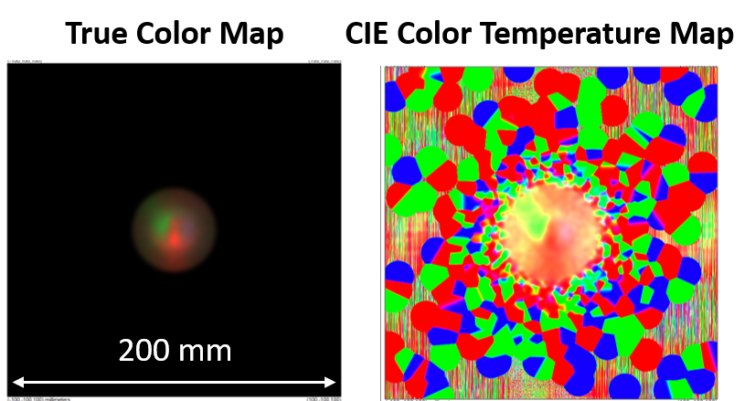

Fig. S1 Simulated true color map (left) and CIE color temperature map (right) of a conical cavity structure. The color mixing is clearly not ideal.

- Effect of Mixing Rod Length from Modeling

Fig. S2(a) summarizes the simulated extraction efficiency η_{ex} as a function of the rod length for 8.5°, 19.3° and extended reflective cavities. In the cases of perfect-mirror interior surfaces (R=100%) and a high anisotropy factor (g=0.99), η_{ex} decreases with increasing the rod length. Particularly, η_{ex} decreases much faster in the 8.5° cavity from 80% to 75% when L increases from 20 mm to 80 mm, indicating more light is trapped in the longer mixing rod and the cavity with a small output opening. Η_{ex} is relatively higher for the 19.3° cavity (80.6% ~ 81.6%), while η_{ex} of the extended cavity lies between those of the 8.5° and 19.3° cavity and more closer to that of the 19.3° cavity.
In the cases of R=95%, the power loss in the packaging is the sum of the light trapping and optical absorption loss α_{s}. Each internal reflection at the cavity inner surface induces additional absorption loss in the interior surfaces of the cavity. The η_{ex} difference between the R=95% curve and the corresponding R=100% curve indicate the accumulated absorption loss due to such multiple reflections. Clearly, α_{s} decreases with the increment in the rod length L for the three types of reflective cavities, and the trend is more obvious for the 8.5° cavity. At L=10 mm, α_{s} is 13%, 7%, 10% for the 8.5°, 19.3° and extended cavity, respectively, while at L =80 mm, the corresponding α_{s} is 7%, 4.5% and 6%, respectively. In other words, light scattered out of the shorter mixing rod from the rod diffusers will undergo more rounds of reflection and suffer more reflective losses on the imperfect surfaces; the light scattered from the longer mixing rod may have fewer bounces before escaping the pyramidal cavity with a larger sidewall angle. More bounces within the cavity enable good color mixing, yet it leads to relatively low light extraction and high absorption loss. Hence, there is a tradeoff between and mixing uniformity and η_{ex}. This trade-off can be balanced by optimizing the reflective cavity structure and mixing rod parameters.
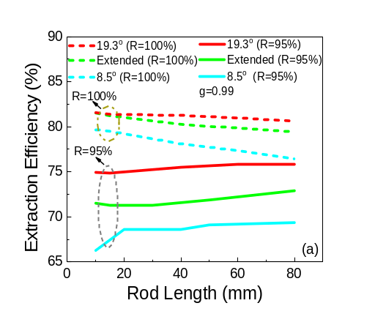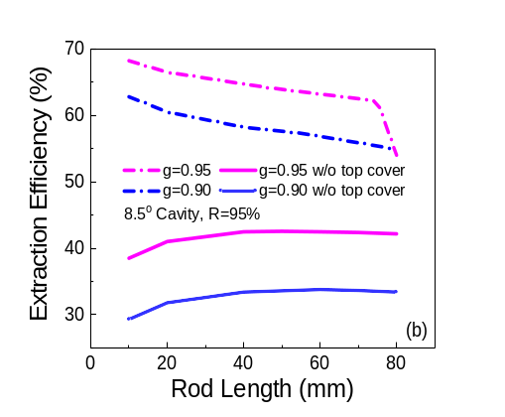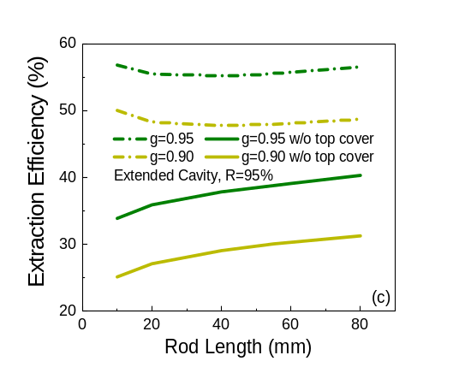

Fig. S2 Simulated white laser extraction efficiency η_{pk} as a function of the rod length for (a) 8.5°, 19.3° and extended reflective cavities, R=95% and 100%, and g=0.99; (b) 8.5° cavity, R=95%, and g=0.90 and g=0.95;
(c) Extended cavity, R=95%, and g=0.90 and g=0.95.

Fig.S2(b)(c) show the extraction efficiency η_{ex} curves of 8.5° cavity and extended cavity in the cases of smaller anisotropy factors (g=0.90 and g=0.95) and R=95%, respectively. The leakage scenarios are also evaluated by removing the top cover to mimic the optical loss at the input. By comparing with the measured extraction efficiency of the reflectors with different diffuser configures, it is concluded that it is concluded that $g\sim 0.90$for D6060 diffuser and $g≥0.95$. Furthermore, Fig.S2(b) confirms that the measured η_{ex} of the 8.5° cavity is reduced by the poor input sealing, consistent with the observations of the input optical leakage.

- Optical Components of the Laser Mixing Cavity.

Thin metal plates are used to prepare the truncated-pyramidal cavities, and the interior surface is glued with 3MTM enhanced specular reflector film (R>95%)(see Fig. S3). The light guiding and mixing rods were purchased from Snapvent Plastics with a diameter of 20 mm. The acrylic rod was then cut into segments with various lengths, and the lateral surface of each segment was ground with a 500 grid sand-paper to improve the illumination uniformity of LD lighting. The rod bottom diffusers and the output diffuser are high efficiency beam shaping diffusers DiffsTEKTM D6060 or 3030 obtained from Fusion Optix. Itermatix ChromaLit CL-827 phosphor plate is purchased to evaluate PC-LD lighting in the same packaging platform. RGB lasers are PLT5450 (Osram, λ_{peak}=450 nm, P_{max}=150 mW), PLT3520D (Osram, λ_{peak}= 520 nm, P_{max}=150 mW), and L638P700m (Thorlab, λ_{peak}= 640 nm, P_{max}=150 mW) or HL6545MG (Opnext, λ_{peak}= 670 nm, P_{max}=150 mW). A Newport Si photodiode 818S is used to detect the optical power of laser beams, and Model 401025 Digital light meter from Extech Instruments is used to measure the luminous intensity. The spectra measurement are carried out with Thorlab compact CCD spectrometer CCS200. The color quality is then analyzed with a ColorCalculator software by Osram.

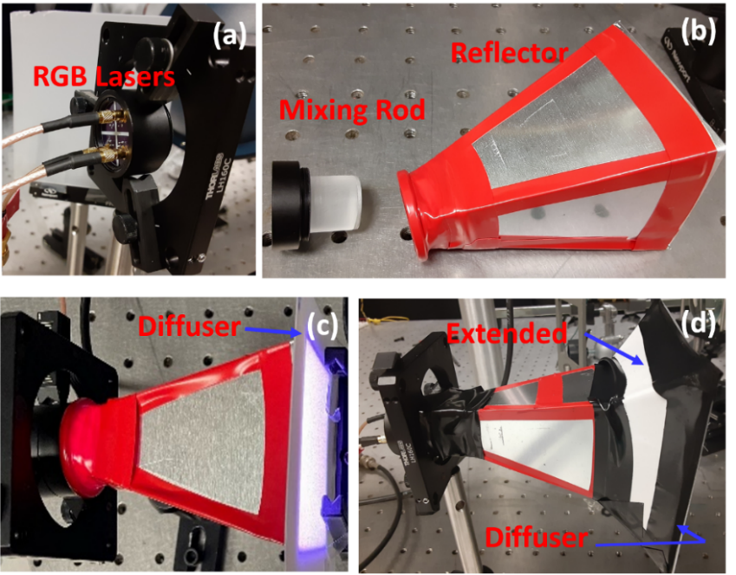

Fig. S3 Images of (a) RGB laser clusters on a heat sink, (b) mixing rod with two diffusers attached at the bottom and a pyramidal 8.5° cavity, (c) a complete 8.5° cavity packaging attached an output diffuser, with the LDs turned on. Uniform white light can be seen at the output port, and (d) a complete extended cavity packaging sealed with an output diffuser.

Fig. S3 (a)(b) show the components of RGB LD clusters installed on a heat sink, a mixing rod with two layers of diffusers attached to the bottom, and a highly reflective pyramidal cavity. Fig.3 (c) is a complete 8.5°cavity packaging with an output diffuser attached, while Fig.3 (d) is a complete extended cavity packaging sealed with an output diffuser. This lighting packaging is easy to assemble and dissemble, which is convenient to measure the optical power of laser sources and identify the role of each component. It is also feasible to convert the CM-LD packaging to PC-LD setup by simply replacing the output diffuser with a phosphor plate (Fig. 11).

- Four LD Mixing in the Extended Cavity.

The extended cavity demonstrated in this work is insensitive to the positions of LDs due to multiple scattering and reflection. Therefore, it is fully scalable to larger number of LDs for synergistic laser lighting and wavelength division multiplexing (WDM) in visible light communication (VLC). An example of 4 LD mixing is shown here, with peak emission at 450, 250, 640 and 670 nm, respectively. Fig. S4 shows ray-tracing modelled color mixing at a power ratio of P _{R670}:P_{R640}:P_{G520}:P_{B460}=1:4.1:3:0.95 in an extended cavity with a 20 mm-long mixing rod, two D3030 rod diffusers, and one D3030 output diffuser at an interior surface reflectivity of R=100%. The color mixing works well with a luminous efficiency (in reference to the input optical power) of LEO=197 lm/W_{o}.

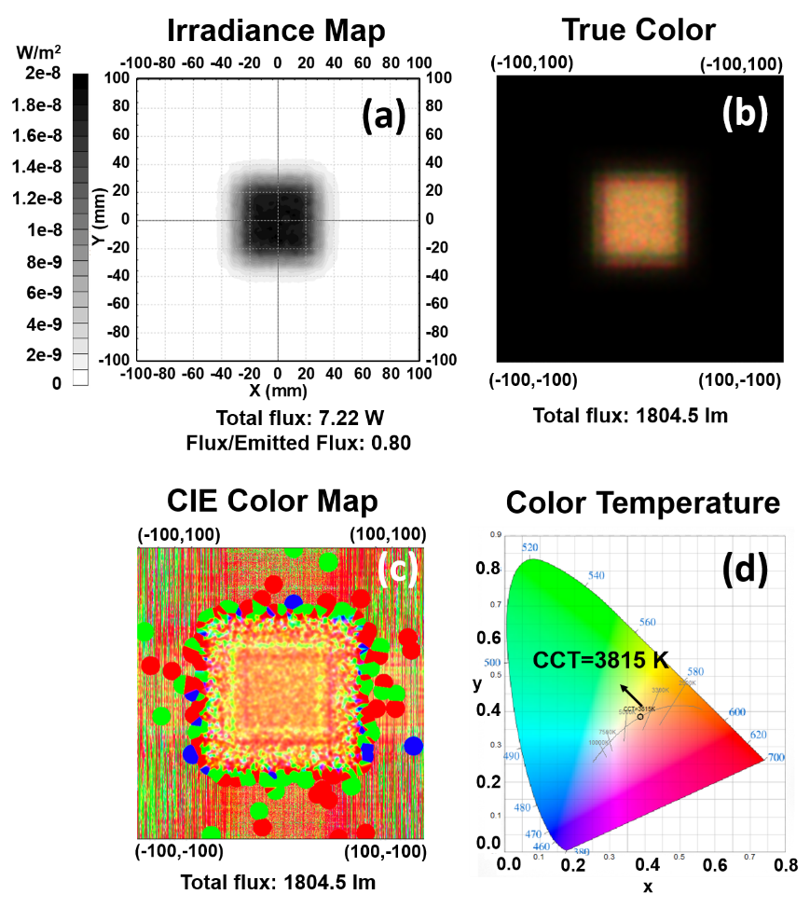
Fig. S4 Ray-tracing modeling results for a 20 mm long rod inserted into the extended reflective cavity (ideal reflectivity R=100%) with two D3030 rod diffusers and one D3030 output diffuser. The four laser power ratios are P _{R670}:P_{R630}:P_{G520}:P_{B460}=1: 4.1: 3: 0.95. (a) Irradiance map; (b) True color map; (c) CIE Color map, and (d) Color temperature.

Fig. S5 shows the preliminary experimental results of 4-LD white laser mixing with a 20 mm mixing rod, two D3030 rod diffusers and one D6060 output diffuser in an extended cavity. Note that due to the power efficiency limitations of the green and 640 nm red LDs that induced significant heating, the laser power ratio did not reach the optimum as modelled in Fig. S4. The actual power ratio was P _{R670}:P_{R630}:P_{G520}:P_{B460}=97mW:56mW:18 mW:14 mW=1:0.58:0.17:0.15. This notably impacted the measured LEO and CRI. Despite of these limitations, successfully 4 LD white color mixing is preliminarily demonstrated with a color temperature of 3920 K and a speckle contrast of 5.1%, proving the concept that the extended cavity package is scalable to multiple LDs for simultaneous white lighting and WDM in VLC. The LEO is measured to be 79±8 lm/W_{o}, and a slightly improved version (with 40 mm mixing rod, two D3030 rod diffusers and one D3030 output diffuser) reached 93±10 lm/W_{o} as shown in Table 4 in the main text. Future development in amber/orange lasers will greatly improve the LEO and CRI.

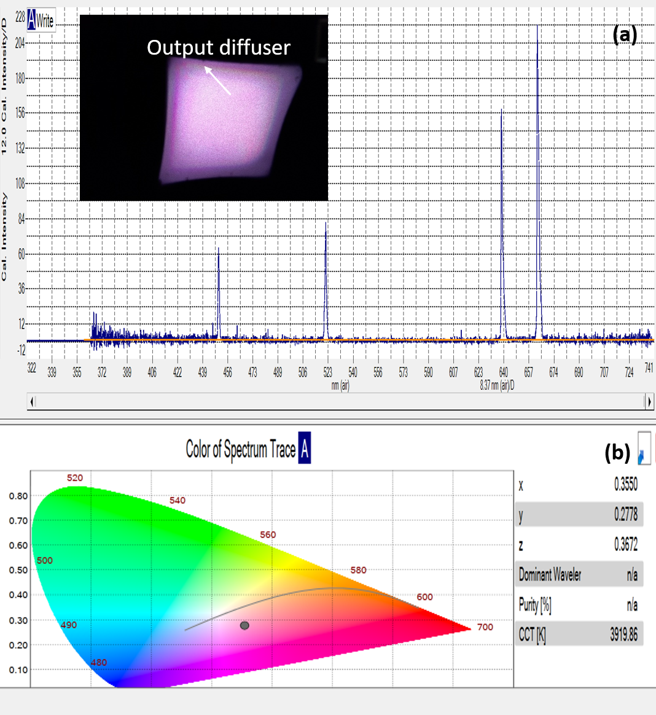

Fig. S5 (a) The actual laser spectrum in the experiment using the designed set up in Fig. S4. Note that due to the power limitation of the green and 640 nm red lasers, the laser power ratio did not reach the optimum. The inset shows a photo of the mixed white light coming from the output diffuser (b) the color temperature measurement indicates a color temperature of 3920 K.

ColorCalculator software by OSRAM Sylvania, Inc. https://www.osram.us/cb/tools-and-resources/applications/led-colorcalculator/index.jsp

