Supplementary Material
Removal of phosphorus by modified bentonite:polyvinylidene fluoride membrane - Study of adsorption performance and mechanism

Xavier, Gabriela Tuono Martins ^{a,b}; Nunes, Renan Silva ª; Urzedo, Alessandro Lamarca ª; Tng, Keng Han ^{b}; Le-Clech, Pierre ^{b}; Labuto, Geórgia ^{c}; Mandelli, Dalmo ª; Fadini, Pedro Sergio ^{d}; Carvalho, Wagner Alves ^{a,*}.
ª Center for Natural and Human Sciences, Federal University of ABC (UFABC), Santo André, Brazil.
^{b} UNESCO Centre for Membrane Science and Technology, School of Chemical Engineering, The University of New South Wales (UNSW), Sydney, Australia.
^{c} Department of Chemistry, Federal University of São Paulo (UNIFESP), Diadema, Brazil.
^{d} Department of Chemistry, Federal University of São Carlos (UFSCar), São Carlos, Brazil
*Corresponding author: wagner.carvalho@ufabc.edu.br; +55(19)99829-8929

Figure S.1 - Cross-sectional SEM image of 0.5 MB:PVDF and 0.75 MB:PVDF membranes, respectively.
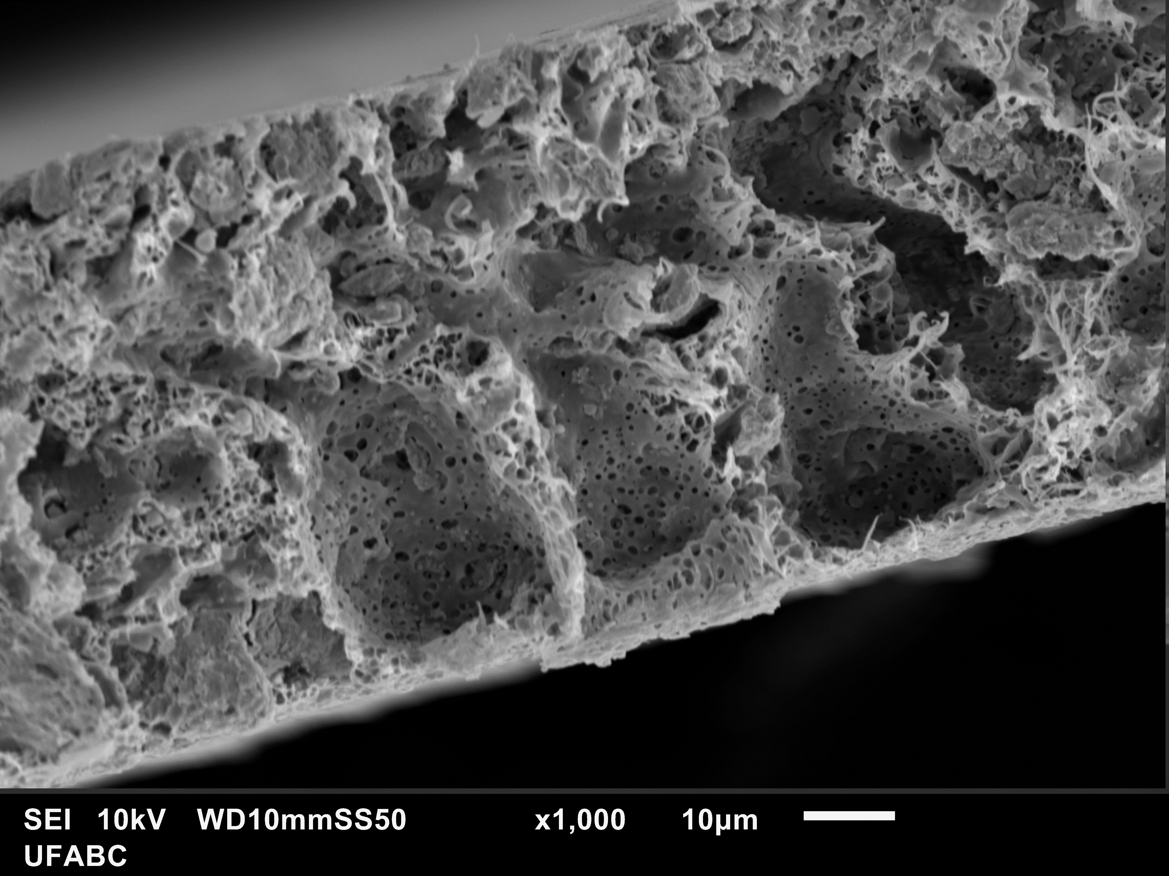

Figure S.2 – Diagram of Fe(III) speciation in NaCL 0.7 mol L⁻¹and H₃PO₄ dissociation.
