List of Supplemental Figures
SFigure 1. The seasonal VIMF (vector, units: kg m⁻¹ s⁻¹) and its divergence (shading, unit: 10^{–5} kg m⁻¹ s⁻¹) anomalies during (a) pSON, (b) pDJF, (c) pMAM, (d) pJJA, (e) cSON corresponds for pSON EM and pSON EN teleconnections. For the divergence of VIMF, only areas where anomalies are statistically significant at 90% are plotted.
SFigure 2. The seasonal 200-hPa velocity potential (shading; units: 10⁶ m² s⁻¹) and divergent wind (arrow, unit: m s⁻¹) anomalies during (a) pSON, (b) pDJF, (c) pMAM, (d) pJJA, (e) cSON corresponds for pSON EM and pSON EN teleconnections. For velocity potential, only areas where anomalies are statistically significant at 90% are plotted.
SFigure 3. Same as SFigure 1 but for pSON LM and pSON LN teleconnections.
SFigure 4. Same as SFigure 2 but for pSON LM and pSON LN teleconnections.
SFigure 5. The seasonal VIMF (vector, units: kg m⁻¹ s⁻¹) and its divergence (shading, unit: 10^{–5} kg m⁻¹ s⁻¹) anomalies during (a) pSON, (b) pDJF, (c) pMAM, (d) pJJA, (e) cSON corresponds for pMAM EM and pMAM EN teleconnections. For the divergence of VIMF, only areas where anomalies are statistically significant at 90% are plotted.
SFigure 6. The seasonal 200-hPa velocity potential (shading; units: 10⁶ m² s⁻¹) and divergent wind (arrow, unit: m s⁻¹) anomalies during (a) pSON, (b) pDJF, (c) pMAM, (d) pJJA, (e) cSON corresponds for pMAM EM and pMAM EN teleconnections. For velocity potential, only areas where anomalies are statistically significant at 90% are plotted.
SFigure 7. Same as SFigure 5 but for pMAM LM and pMAM LN teleconnections.
SFigure 8. Same as SFigure 6 but for pMAM LM and pMAM LN teleconnections.

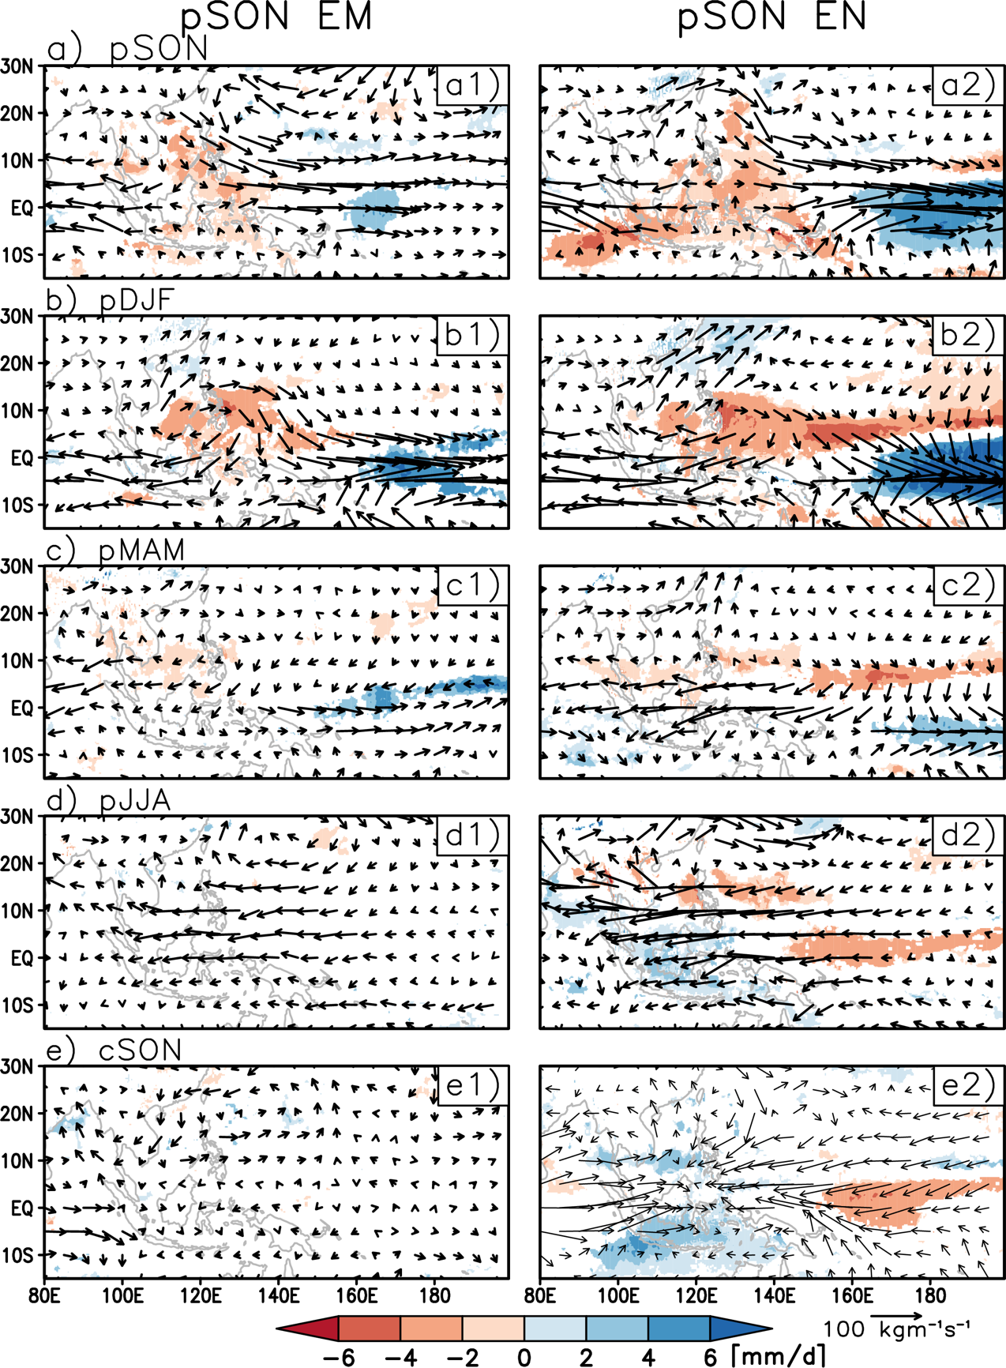
SFigure 1. The seasonal VIMF (vector, units: kg m⁻¹ s⁻¹) and its divergence (shading, unit: 10^{–5} kg m⁻¹ s⁻¹) anomalies during (a) pSON, (b) pDJF, (c) pMAM, (d) pJJA, (e) cSON corresponds for pSON EM and pSON EN teleconnections. For the divergence of VIMF, only areas where anomalies are statistically significant at 90% are plotted.
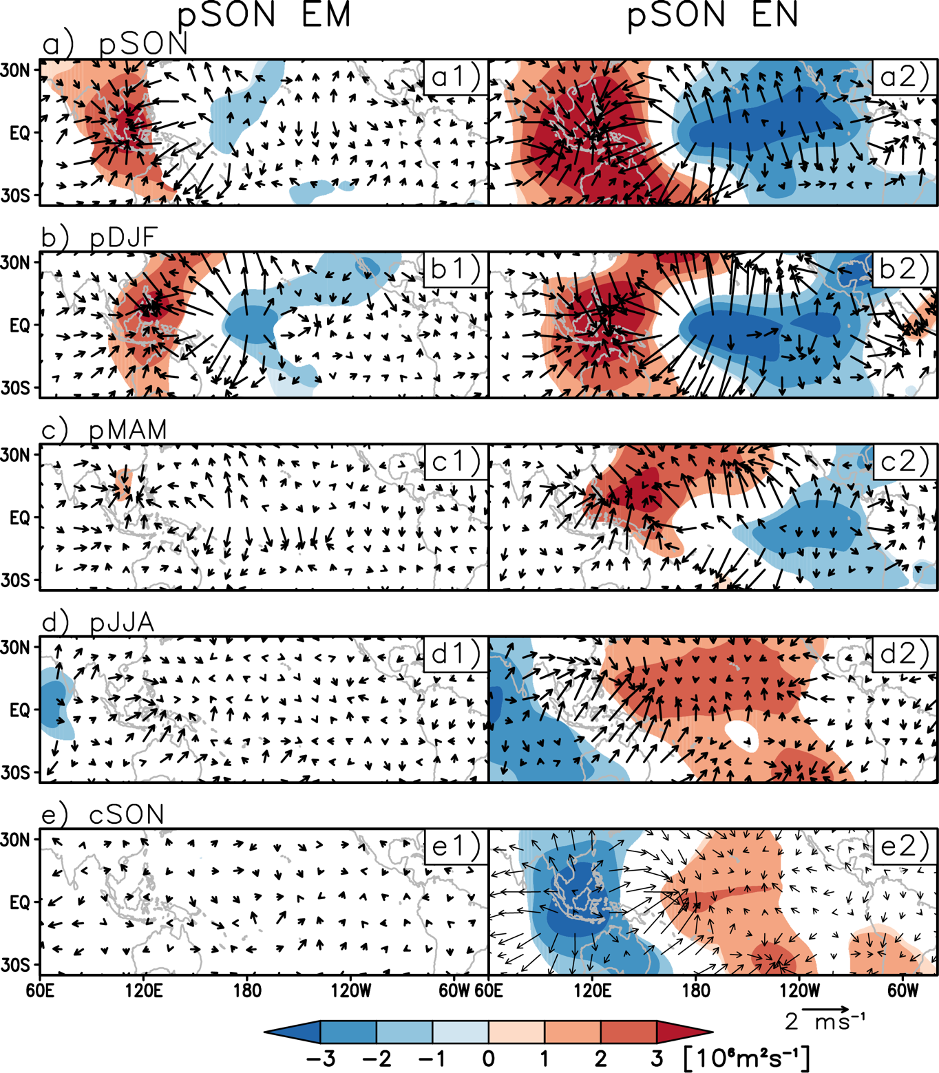
SFigure 2. The seasonal 200-hPa velocity potential (shading; units: 10⁶ m² s⁻¹) and divergent wind (arrow, unit: m s⁻¹) anomalies during (a) pSON, (b) pDJF, (c) pMAM, (d) pJJA, (e) cSON corresponds for pSON EM and pSON EN teleconnections. For velocity potential, only areas where anomalies are statistically significant at 90% are plotted.

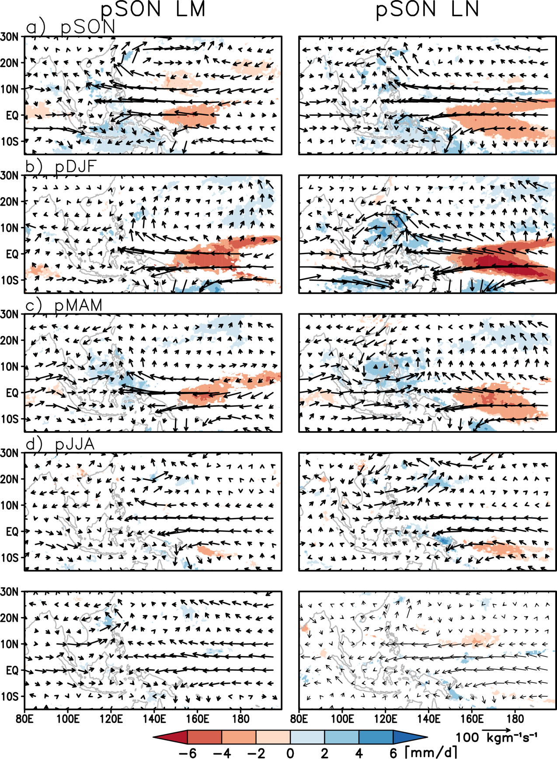
SFigure 3. Same as SFigure 1 but for pSON LM and pSON LN teleconnections.
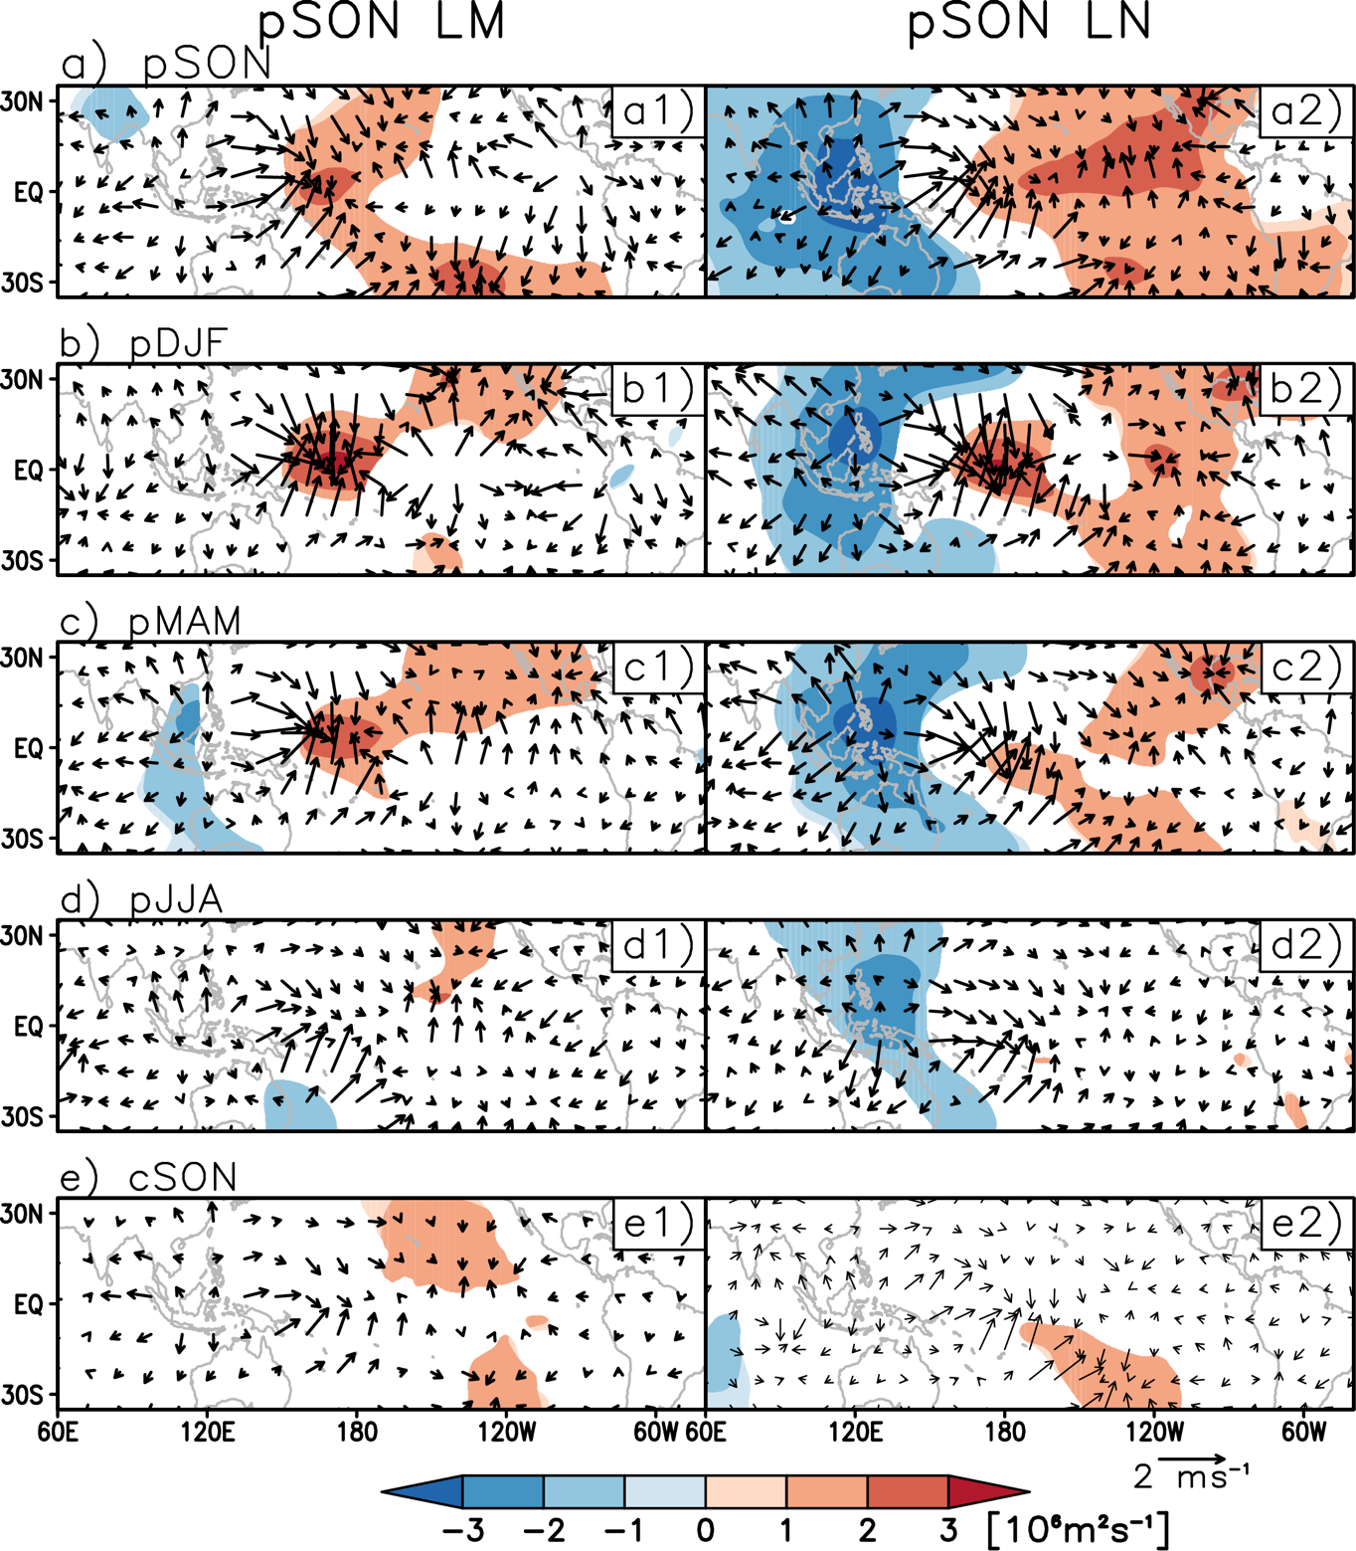
SFigure 4. Same as SFigure 2 but for pSON LM and pSON LN teleconnections.

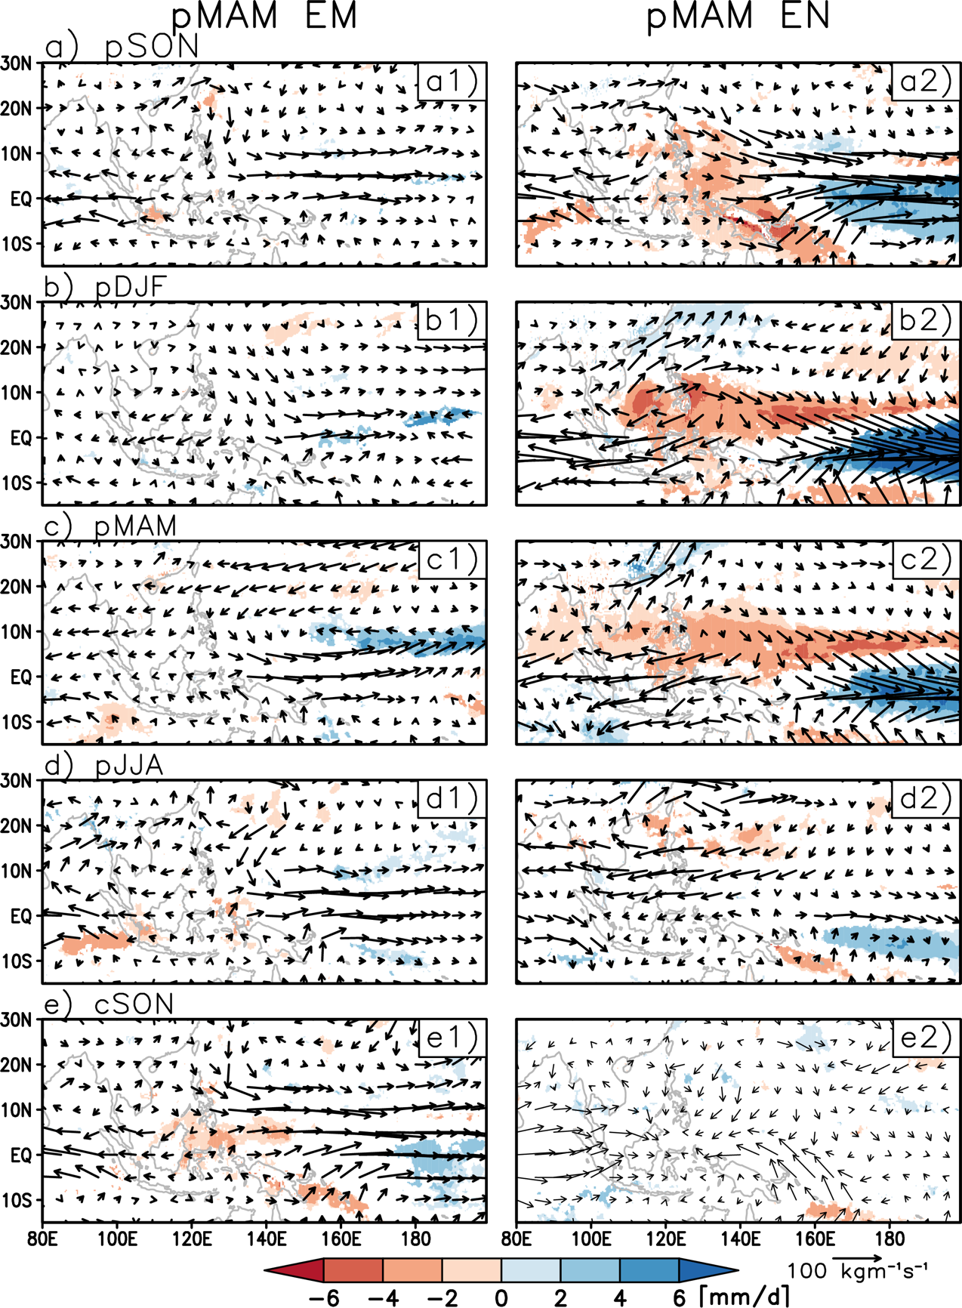
SFigure 5. The seasonal VIMF (vector, units: kg m⁻¹ s⁻¹) and its divergence (shading, unit: 10^{–5} kg m⁻¹ s⁻¹) anomalies during (a) pSON, (b) pDJF, (c) pMAM, (d) pJJA, (e) cSON corresponds for pMAM EM and pMAM EN teleconnections. For the divergence of VIMF, only areas where anomalies are statistically significant at 90% are plotted.
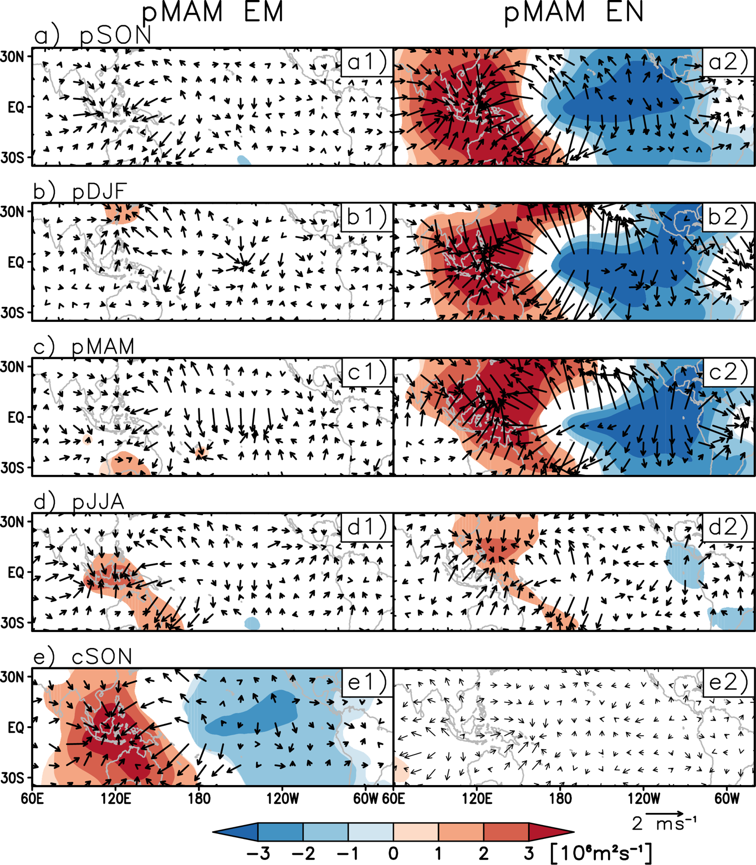
SFigure 6. The seasonal 200-hPa velocity potential (shading; units: 10⁶ m² s⁻¹) and divergent wind (arrow, unit: m s⁻¹) anomalies during (a) pSON, (b) pDJF, (c) pMAM, (d) pJJA, (e) cSON corresponds for pMAM EM and pMAM EN teleconnections. For velocity potential, only areas where anomalies are statistically significant at 90% are plotted.

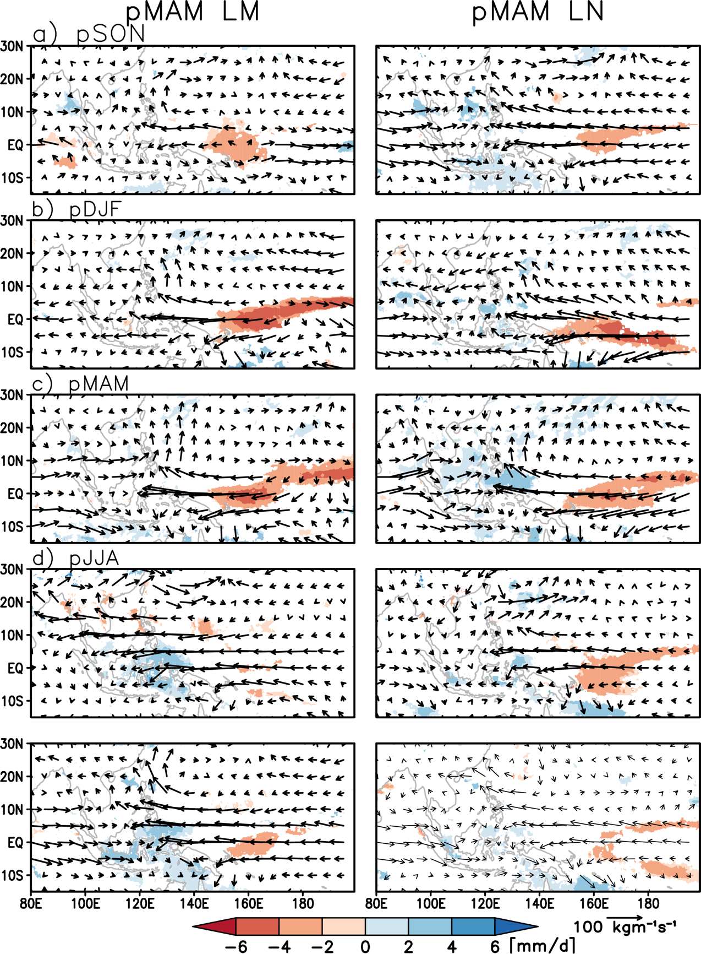
SFigure 7. Same as SFigure 5 but for pMAM LM and pMAM LN teleconnections.

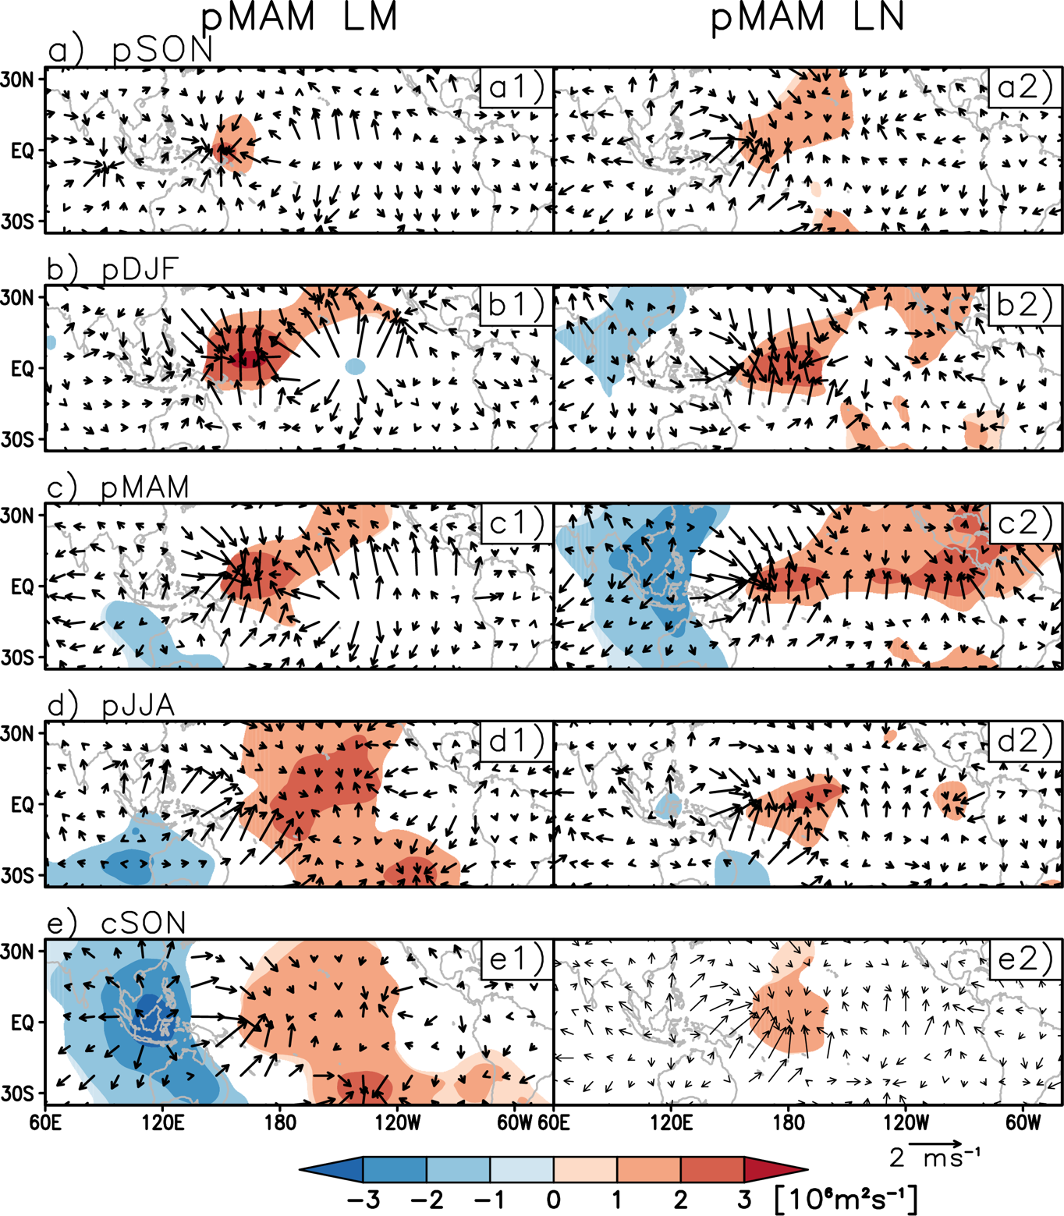
SFigure 8. Same as SFigure 6 but for pMAM LM and pMAM LN teleconnections.

