

_______________________________________________________________________________
Department of Chemical Engineering / DEQUI
Campus Alto Paraopeba / CAP

Ouro Branco, July 07, 2022

Dear Editor,

The authors confirm that all elements of the submission are in compliance with the journal publishing ethics policy. We also emphasize that this is an original work, which was not published in any journal and which is not under consideration for publication anywhere else. All authors mutually agree that Clean Technologies and Environmental Policy the most suitable journal for publishing this paper. We truly hope that this manuscript could be considered suitable for publication.
Sincerely yours,

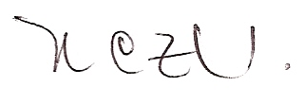
Dr. Renata Carolina Zanetti Lofrano (corresponding author)

