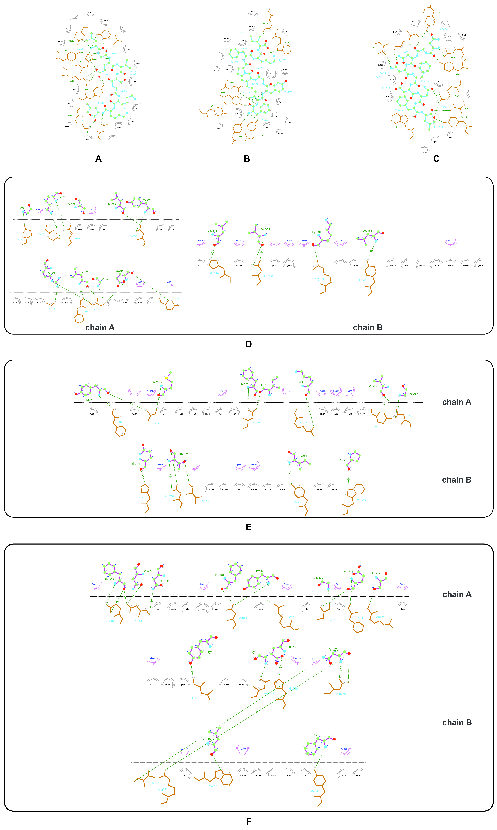
Figure S1. LIGPLOT+ results of epitope-HLA molecular docking. The molecules involved in binding in each epitope-HLA docked complex is represented. The complexes presented are as follows: A2-class I T-cell epitope of Ep1 (A), A2-class I T-cell epitope of Ep2 (B), A2-class I T-cell epitope of Ep3 (C), D15-class II T-cell epitope of Ep1 (D), D15-class II T-cell epitope of Ep2 (E), D15-class II T-cell epitope of Ep3 (F). The A2 and D15 are HLA-A*02:01 and HLA-DRB1*15:01, respectively.

