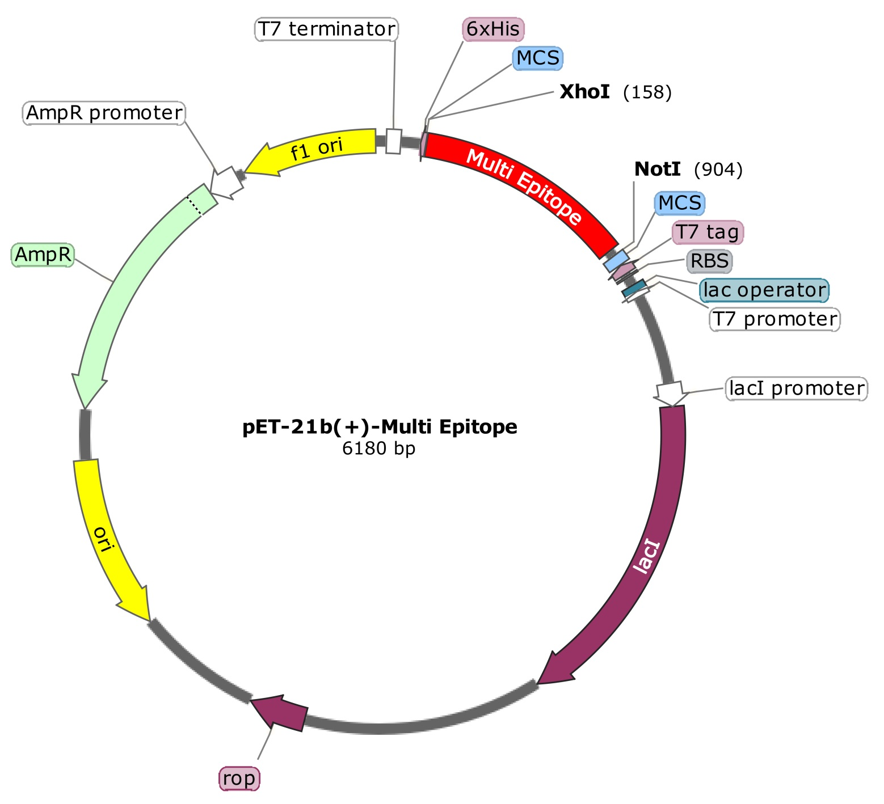

Figure S2. In silico cloning of the multi-epitope. The multi-epitope sequence was inserted between the XhoI and NotI enzymes into the pET21b (+) vector using SnapGene software. The resulting recombinant plasmid has a length of 6180 bp. The multi-epitope is highlighted in red.

