Therapeutic Potential of Lactoferrin-Coated Iron Oxide Nanoparticles for Targeted Hyperthermia in Gastric Cancer

Komal Attri^{1,4}, Bhupendrakumar Chudasama^{2,4}*, Roop L. Mahajan^{3,4*}, Diptiman Choudhury^{1,4}*

¹School of Chemistry and Biochemistry, Thapar Institute of Engineering and Technology, Patiala-147004, Punjab, India.
²School of Physics and Material Sciences, Thapar Institute of Engineering and Technology, Patiala-147004, Punjab, India
³Department of Mechanical Engineering, Virginia Tech, Blacksburg, VA 24061, United States; Institute for Critical Technology and Applied Science, Virginia Tech, Blacksburg, VA 24061, United States.
⁴TIET-VT Centre of Excellence for Emerging Materials, Thapar Institute of Engineering and Technology, Patiala-147004 Punjab, India.
*Corresponding E-mail: diptiman@thapar.edu, mahajanr@vt.edu, bnchudasama@thapar.edu
*Corresponding Phone: +91-8196949843 / +1-5402312597 / +91-9781966136

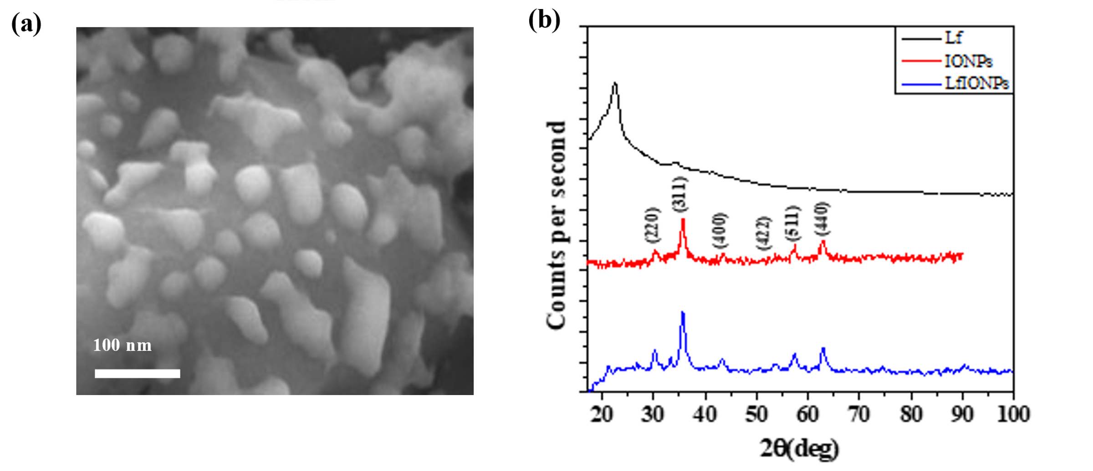
Fig. S1: (a) Fe-SEM micrograph of Lf-IONPs on a scale of 100 nm (b) XRD graph shows the X-Ray diffraction pattern which gives deep knowledge about the chemical composition, crystallographic structure and physical properties of a materials including FeCl₃, FeSO₄, IONPs, Lf and Lf-IONPs when subjected to the Cu K α irradiation.

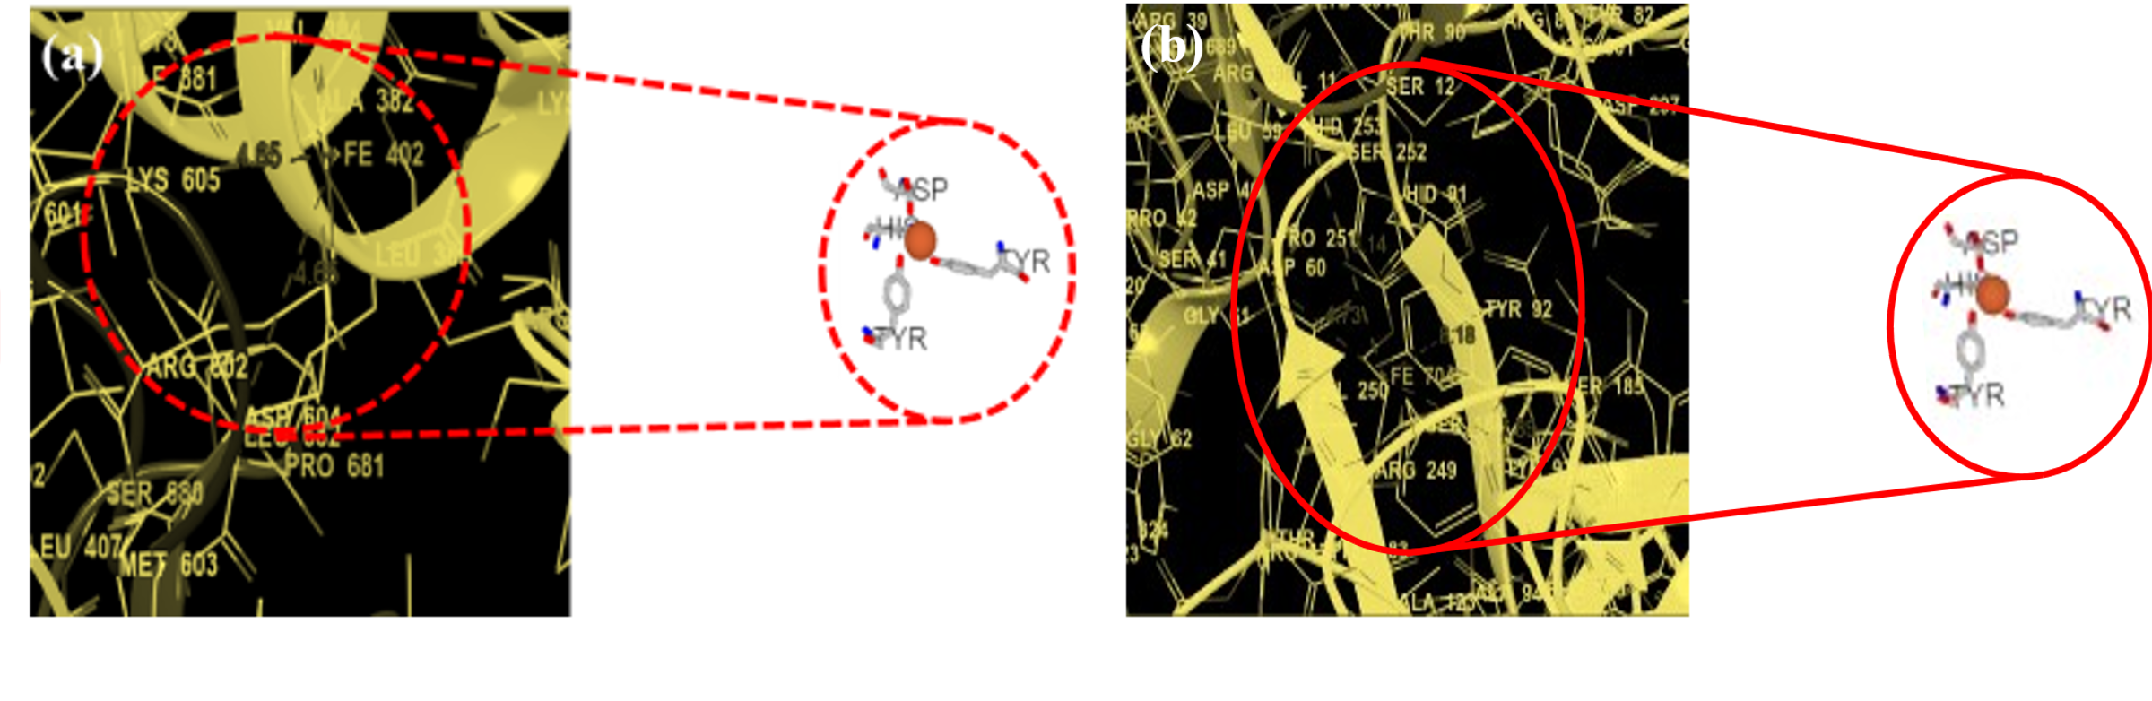
Fig. S2 Metal ion binding residues showing binding of Fe⁺³ with amino acids on the chain of the lactoferrin protein (a) Binding of Fe⁺³ with amino acids 60D, 92Y, 192Y, 253H and they were at a distance of 4.73 Å, 8.18 Å, 7.89 Å, 6.14 Å respectively (b) Binding of Fe⁺³ with amino acids 604D, 605K with a distance of about 4.65 Å, 4.65 Å respectively.
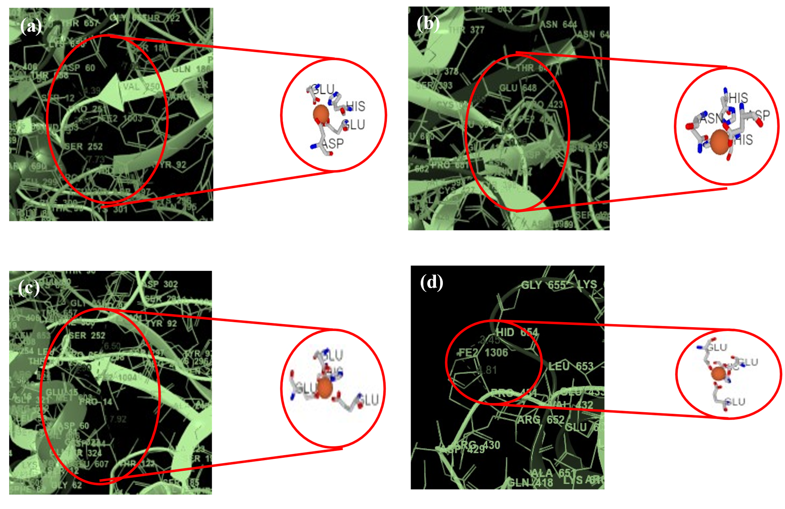
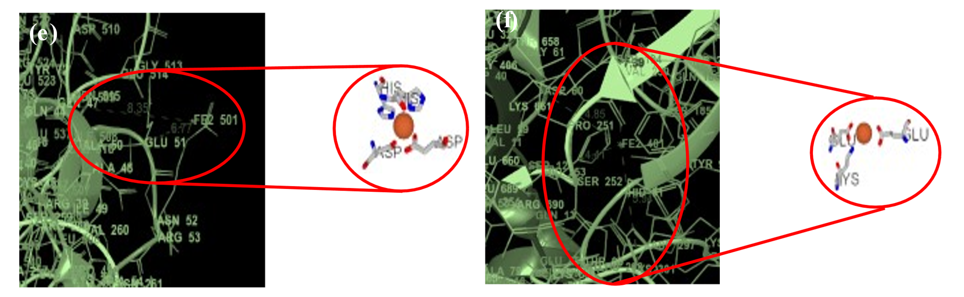Fig. S3 Metal ion binding residues showing binding of Fe⁺² with amino acids on the chain of the lactoferrin protein (a) Binding of Fe⁺² with amino acids 393S, 413E, 597H, 644N and distance was found out to be 6.59 Å, 4.99 Å, 3.06 Å, 5.23 Å respectively (b) Binding of Fe⁺² with amino acids 60D, 122T, 253H, 301K and their distance were as such 4.39 Å, 7.05 Å, 3.84 Å,7.73 Å respectively (c) Binding of Fe⁺² with amino acids 60D, 122T, 253H, 301K which showed distance of 4.45 Å, 7.92 Å, 3.90 Å, 6.50 Å respectively (d) Binding of Fe⁺² with amino acids 431P, 654H with a distance of 4.81 Å, 3.45 Å respectively (e) Binding of Fe⁺² with amino acids 60D, 122T, 253H, 301K and showed distance of about 4.85 Å, 7.39 Å, 4.41 Å, 5.94 Å respectively (f) 47Q, 51E with a distance of 8.35 Å, 6.77 Å respectively.

P value for checking the statistical significance of data
Time | Lf | IONPs | Lf-IONPs
6h | 0.013236 | 0.011081 | 0.003126
12h | 0.007966 | 0.00749 | 0.005609
24h | 0.007763 | 0.073926 | 0.003126
36h | 0.001935 | 0.001685 | 0.004992
48h | 0.003772 | 0.051658 | 0.004813

Table S1. Table shows the p values calculated for % variation in scratch diameter after treatment with 7.5 µM of FeCl₃, FeSO₄, lactoferrin, IONPs and lactoferrin-IONPs. The statistical significance of data is considered when the p < 0.05.

