Supplementary Information

Key innovation triggers widespread radiation of the genus Medicago

Supplementary Fig. 1 Tree topology estimated based on the whole genome SNPs using FastTree. Numbers on nodes indicate bootstrap values < 100.
Supplementary Fig. 2 Tree topology estimated using the coalescent method of ASTRAL based on the CDS dataset of 7,669 low-copy nuclear genes. Numbers on nodes indicate bootstrap values < 100.
Supplementary Fig. 3 Tree topology estimated using the concatenation method of RAxML based on the C₁₂ dataset of 7,669 low-copy nuclear genes. Numbers on nodes indicate bootstrap values < 100.
Supplementary Fig. 4 Tree topology estimated using the coalescent method of ASTRAL based on the C₁₂ dataset of 7,669 low-copy nuclear genes. Numbers on nodes indicate bootstrap values < 100.
Supplementary Fig. 5 Tree topology estimated using the concatenation method of RAxML based on the C₃ dataset of 7,669 low-copy nuclear genes. Numbers on nodes indicate bootstrap values < 100.
Supplementary Fig. 6 Tree topology estimated using the coalescent method ASTRAL based on the C₃ dataset of 7,669 low-copy nuclear genes. Numbers on nodes indicate bootstrap values < 100.
Supplementary Fig. 7 Tree topology estimated using the concatenation method of RAxML based on the 4D-sites dataset of 7,669 low-copy nuclear genes. Numbers on nodes indicate bootstrap values < 100.
Supplementary Fig. 8 Tree topology estimated using the coalescent method of ASTRAL based on the 4D-sites dataset of 7,669 low-copy nuclear genes. Numbers on nodes indicate bootstrap values < 100.
Supplementary Fig. 9 Divergence times of Medicago and its relatives estimated from the concatenated CDS dataset of 7,669 low-copy nuclear genes using r8s. The numbers at nodes indicate divergence times (Ma).
Supplementary Fig. 10 Divergence times of Medicago and its relatives estimated from the concatenated CDS dataset of 7,669 low-copy nuclear genes using RelTime. The numbers at nodes indicate divergence times (Ma). Horizontal bars indicate 95% credible intervals of the divergence time estimates.
Supplementary Fig. 11 Diversification rates of Medicago estimated by BAMM. (a) Phylorate plot showing net diversification rate on a scale from low to high values (blue to red) along each branch of the Medicago phylogeny. (b) Speciation rate through time, with color density shading to denote confidence on evolutionary rate. (c) Extinction rate through time, with color density shading to denote confidence on evolutionary rate. (d) Net diversification rate through time, with color density shading to denote confidence on evolutionary rate.
Supplementary Fig. 12 Plots showing the net diversification rates of Medicago through time (a, b) and temperature (c, d) estimated by RPANDA. Black curve in (b) is the diversity-through-time (DDT) curve using the deterministic approach by RPANDA.
Supplementary Fig. 13 Ancestral state reconstruction and evolutionary rate of pod spiral estimated by BAMM. (a) Ancestral state reconstruction of pod spiral. Color of circles at the nodes indicate corresponding degree of pod spiral. (b) Phylorate plot showing evolutionary rate of pod spiral on a scale from low to high values (blue to red) along each branch of the Medicago and its relatives. Red circles along branches represent major pod spiral shifts. (c-e) Evolutionary rate of pod spiral through time in branches of the Medicago and its relatives (c), Medicago (d), and non-Medicago (e), with color density shading to denote confidence on evolutionary rate.
Supplementary Fig. 14 Ancestral state reconstruction and evolutionary rate of pod spine estimated by BAMM. (a) Ancestral state reconstruction of pod spine. Color of circles at the nodes indicate whether the pod is spiny. (b) Phylorate plot showing evolutionary rate of pod spine on a scale from low to high values (blue to red) along each branch of the Medicago and its relatives. Red circles along branches represent major pod spine shifts. (c-e) Evolutionary rate of pod spine through time in branches of the Medicago and its relatives (c), Medicago (d), and non-Medicago (e), with color density shading to denote confidence on evolutionary rate.
Supplementary Fig. 15 Ancestral state reconstruction and evolutionary rate of biotype estimated by BAMM. (a) Ancestral state reconstruction of biotype. Color of circles at the nodes indicate corresponding biotype. (b) Phylorate plot showing evolutionary rate of biotype on a scale from low to high values (blue to red) along each branch of the Medicago. Red circles along branches represent major biotype shifts. (c) Evolutionary rate of biotype through time in branches of the Medicago, with color density shading to denote confidence on evolutionary rate.
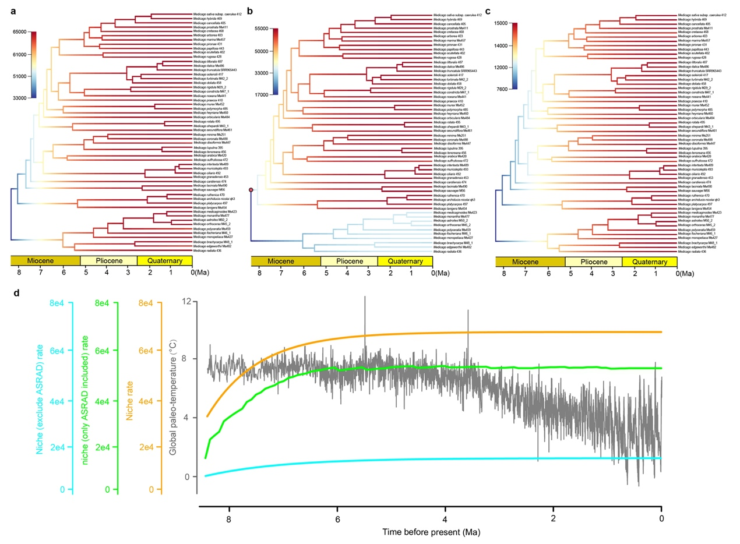
Supplementary Fig. 16 Niche evolution estimated by BAMM. (a-c) Phylorate plot showing rates for all niches, ASRAD, and niches excluding ASRAD on a scale from low to high values (blue to red) along each branch of the Medicago. Red circle along branches in (b) represent a major ASRAD shift. (d) Rates for all niches (orange), ASRAD (fluorescent green), and niches excluding ASRAD (cyan) through time, with color density shading to denote confidence on evolutionary rate. The gray broken line in the background shows the fluctuation of global temperature using the dataset from ref. 82.

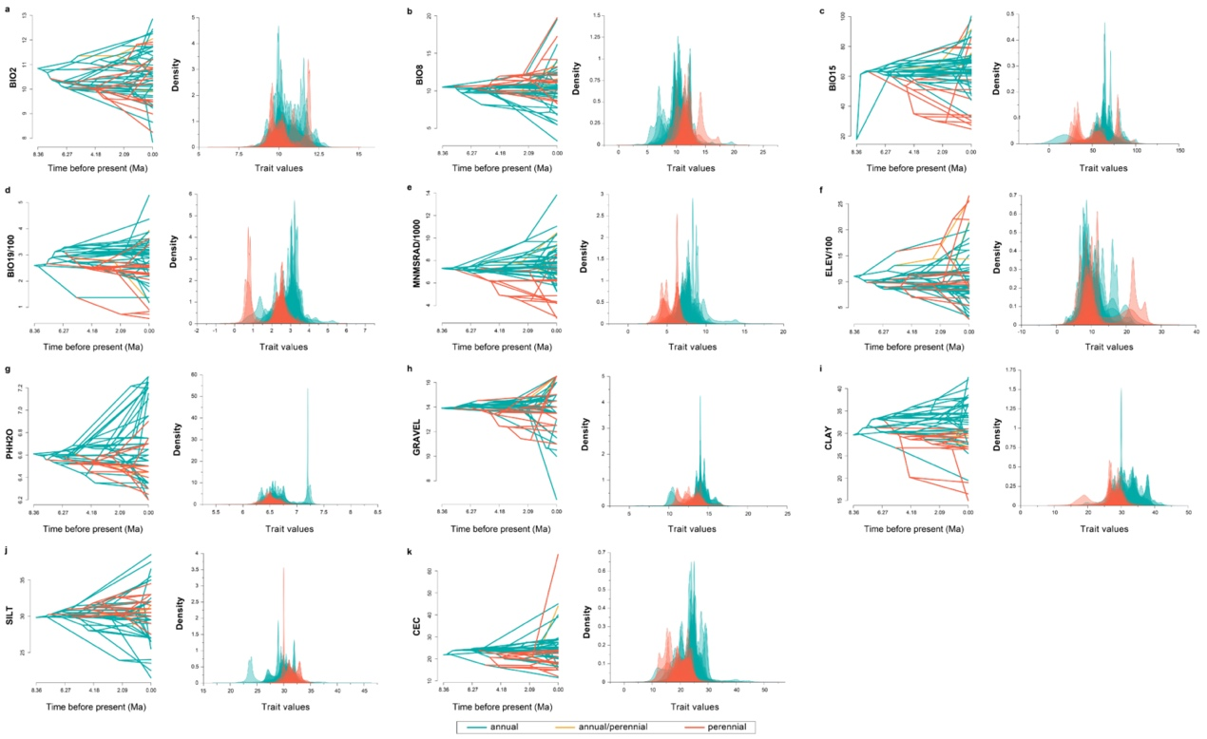
Supplementary Fig. 17 Reconstruction of ancestral niches for the annuals and perennials. (a-k) Left figures: Traitgrams showing the inferred evolution of ecological-niche factors (BIO2 (mean diurnal range (mean of monthly (max temp - min temp))), BIO8 (mean temperature of wettest quarter), BIO15 (precipitation seasonality), BIO19 (precipitation of coldest quarter), MNMSRAD (minimum monthly solar radiation), ELEV (elevation), PHH2O (soil pH), GRAVEL (volume proportion gravel in the soil), CLAY (proportion of clay), SILT (proportion of silt), and CEC (cation exchange capacity in the soil)) based on present taxa and over the dated phylogenetic tree of the Medicago clade in a space defined by the phenotype (y axis). Right figures: Posterior distributions of ancestral traits estimated for correspondent nodes in the tree.
Supplementary Fig. 18. ILS detection among Medicago species. (a) Simplified nuclear (left) and plastome (right) topologies of the 15 Medicago subclades (M1-M15) (see Methods for details). Numbers on nodes indicate bootstrap values < 100. I, II, III, and IV indicate four focal internal nodes that accounted for the most incongruence between the two trees. (b) ILS analysis. For each focal internal node, frequencies of the three alternative topologies (q1-q3) for both empirical observation and simulation with ILS by Phybase, and their correlation are shown. P-value is estimated by chi-square test using the topology frequency.
Supplementary Fig. 19. The likely hybrid events among the 15 Medicago subclades inferred by PhyloNetworks based on the simplified nuclear topologies (see Methods for details). The blue lines represent the predicted hybrid events and the numbers on the blue line represent the proportion of mixture. (a-d) Representing hmax (the maximum allowed number of hybridizations) from 0-3. Each network has a loglik attribute, which is its pseudo deviance: a multiple of the negative log-likelihood up to a constant (the constant is such that the score is 0 if the network fits the data perfectly). The lower the better. Then when hmax = 3, the network fits the data better (-loglik = 354.2).
Supplementary Fig. 20. Supplementary Data 1: ancestral niche reconstruction of the 15 selected variables. Median and HPD limits for the sigma parameter of each branch and for the ancestral trait estimated for every node. Numbers correspond with the numbers on the figure bellow.
Supplementary Table 1. Summary statistics of genome resequencing data and DNA sequence variants for 182 individuals.

Resequencing | Total data | 1.84T
Resequencing | Median Mapping rate | 83.31%
Resequencing | Median coverage | 43.20%
Resequencing | Median depth | 12.6×
Indels | Total | 32,015,838
Snps | Total | 10,083,088
Snps | Nonsynonymous | 3,177,537(31.51%)
Snps | Synonymous | 2,886,747(28.63%)
Snps | Upstream_gene | 1,132,584(11.23%)
Snps | Downstream_gene | 1,014,146(10.06%)
Snps | Intron | 1,667,323(16.54%)
Snps | Splicing | 335,033(3.32%)
Snps | Intergenic | 204,751(2.03%)

Supplementary Table 2. The 70 plastome protein-coding genes (CDS) shared across 181 individuals included in phylogenetic analysis.

atpA |  | psaA |  | rps2
atpB |  | psaB |  | rps3
atpE |  | psaC |  | rps4
atpF |  | psaJ |  | rps7
atpH |  |  |  | rps8
atpI |  | psbA |  | rps11
 |  | psbB |  | rps12
ndhA |  | psbC |  | rps14
ndhB |  | psbD |  | rps15
ndhC |  | psbE |  | rps18
ndhD |  | psbF |  | rps19
ndhE |  | psbH
ndhF |  | psbI |  | rpoA
ndhG |  | psbJ |  | rpoB
ndhH |  | psbK |  | rpoC1
ndhI |  | psbL |  | rpoC2
ndhJ |  | psbM
ndhK |  | psbT |  | ycf1
 |  | psbZ |  | ycf2
petA |  |  |  | ycf3
petB |  | rpl2 |  | ccsA
petD |  | rpl14 |  | cemA
petG |  | rpl16 |  | clpP1
petL |  | rpl20 |  | matK
petN |  | rpl36 |  | pbf1
 |  |  |  | rbcL

Supplementary Table 3. Biogeographic models tested in this study.

Model | LnL | numparams | d | e | j | AICc | AICc_wt
DEC | -488.5 | 2 | 0.010 | 0.010 | 0 | 981.2 | 3.6e-64
DEC+J | -481 | 3 | 1.15 | 1.88 | 1.63 | 968.3 | 2.2e-61
DIVALIKE | -391.4 | 2 | 0.099 | 0.18 | 0 | 787 | 5.3e-22
DIVALIKE+J | -359.4 | 3 | 0.071 | 1.0e-12 | 0.0052 | 725 | 1.5e-08
BAYAREALIKE | -345.6 | 2 | 0.040 | 0.12 | 0 | 695.3 | 0.044
BAYAREALIKE+J | -341.4 | 3 | 0.037 | 0.098 | 0.010 | 689.1 | 0.96

Supplementary Table 4. Stochastic mapping statistics and data from BioGeoBears results.

Summary of dispersal events counts (mean)
 | A | B | C | D | E | F
A | － | 5.64 | 7.74 | 3.06 | 9.94 | 4.08
B | 1 | － | 1.52 | 0.86 | 2.22 | 1.66
C | 1.5 | 2.16 | － | 0.98 | 2.5 | 1.96
D | 3.78 | 5.84 | 10.7 | － | 11.22 | 6.1
E | 1.02 | 1.96 | 2.38 | 1.5 | － | 1.22
F | 0.48 | 1.04 | 1.72 | 1.36 | 1.16 | －
Range expansion event counts (mean)
 | A | B | C | D | E | F
A | － | 6.76 | 7.8 | 3.88 | 10.4 | 4.34
B | 1.44 | － | 1.52 | 0.98 | 2.24 | 1.88
C | 1.5 | 2.48 | － | 1.34 | 2.5 | 2.08
D | 3.86 | 6.16 | 10.76 | － | 11.36 | 6.42
E | 1.52 | 2.02 | 2.38 | 1.66 | － | 1.34
F | 0.48 | 1.2 | 1.74 | 1.44 | 1.2 | －
Founder event counts (mean)
 | A | B | C | D | E | F
A | － | 1.12 | 0.060 | 0.82 | 0.46 | 0.26
B | 0.44 | － | 0 | 0.12 | 0.020 | 0.22
C | 0 | 0.32 | － | 0.36 | 0 | 0.12
D | 0.080 | 0.32 | 0.060 | － | 0.14 | 0.32
E | 0.50 | 0.060 | 0 | 0.16 | － | 0.12
F | 0 | 0.16 | 0.020 | 0.080 | 0.040 | －
Summary counts of BSMs
 | founder | a | d | e | subset | vicariance | sympatry | ALL_disp | ana_disp | all_ana | all_clado | total_events
means | 6.38 | 0 | 98.3 | 0 | 0 | 0 | 86.62 | 104.7 | 98.3 | 98.3 | 93 | 191.3
 | (3.3%) |  | (51.4%) |  |  |  | (45.3%) | (54.7%) | (51.4%) | (51.4%) | (48.6%)
stdevs | 1.44 | 0 | 7.85 | 0 | 0 | 0 | 1.44 | 7.89 | 7.85 | 7.85 | 0 | 7.85
stdevs | 319 | 0 | 4915 | 0 | 0 | 0 | 4331 | 5234 | 4915 | 4915 | 4650 | 9565

Supplementary Table 5. RPANDA diversification models fit of time-dependence.

Model | λ parameters | μ parameters | AICc
bcst_d0 | 0.2834 |  | 438.1153
bcst_dcst | 0.2852 | -1.0682e-7 | 440.2079
bcst_dexp | 0.2834 | 7.7612e-8, 5.3061e-2 | 442.3385
bcst_dlin | 0.2832 | 1.4811e-5, -2.8541e-6 | 442.3540
bexp_d0 | 0.1873, 0.1261 |  | 430.5739
bexp_dcst | 0.1873, 0.1260 | 4.1478e-7 | 432.7087
bexp_dexp | 0.1873, 0.1260 | -1.5141e-6, -1.0912e-1 | 434.8914
blin_d0 | 0.1541, 0.0440 |  | 429.5023
blin_dcst | 0.1546, 0.0481 | -2.2990e-2 | 431.6354

Supplementary Table 6. RPANDA diversification models fit of temperature-dependence.

Model | λ parameters | μ parameters | AICc
bcst_dexp | 0.2835 | -5.3521e-7, -7.2235e-2 | 442.3540
bcst_dlin | 0.3540 | -0.4056, 0.0573 | 442.1091
bexp_d0 | 0.1091, 0.1734 |  | 432.4018
bexp_dcst | 0.1091, 0.1734 | 1.3361e-6 | 434.5366
bexp_dexp | 0.1274, 0.2049 | -0.6854282, -0.2660295 | 435.9282
blin_d0 | 0.0262, 0.0489 |  | 432.1687
blin_dcst | -0.0100, 0.0622 | 1.1852e-6 | 434.3414

Supplementary Table 7. Niche PCA loadings.

Variables | PC1 loading
ASRAD | -0.999959002
PET | -0.819338886
MNMSRAD | -0.765499944
WI | -0.748234796
BIO1 | -0.748218734
BIO9 | -0.745095221
BIO10 | -0.702400984
BIO5 | -0.702380982
BIO15 | -0.673875586
BIO2 | -0.668640436
PHH2O | -0.638482980
MXMSRAD | -0.638039433
BIO11 | -0.633491597
BIO6 | -0.533483224
BIO19 | -0.474766531
CLAY | -0.454452850
BIO3 | -0.449614464
PAR | -0.360056808
BIO13 | -0.278623355
CEC | -0.263424282
BIO16 | -0.262279908
GRAVEL | -0.116774343
ELEV | -0.001176644
OC | 0.006649836
SILT | 0.034890815
BIO18 | 0.040942739
BIO8 | 0.041094512
BIO12 | 0.123436999
RMSRAD | 0.172220235
AI | 0.300770690
BIO7 | 0.307782252
BIO4 | 0.363677925
SAND | 0.368970694
BIO17 | 0.434347319
BIO14 | 0.435381886
Abbreviations and explanations of environmental variables refer to Supplementary Data 4.

Supplementary Table 8. Key innovation test. Posterior estimates of the rates of speciation (λ), extinction (μ), net diversification (r = λ-μ), and extinction fraction (a = μ/λ) obtained by key innovation test are given as mean and maximum a posteriori (MAP) with 95% credibility interval (CI). Subscript numbers 0 and 1 refer to non-spiral/spineless and spiral/spiny, respectively.

 |  | Posterior rates
 |  | λ₀ | λ₁ | μ₀ | μ₁ | r₀ | r₁ | α₀ | α₁
non-spiral/spiral | Mean | 0.339 | 0.308 | 0.097 | 0.038 | 0.242 | 0.270 | 0.261 | 0.119
 | MAP | 0.304 | 0.300 | 0.003 | 0.001 | 0.236 | 0.265 | 0.012 | 0.004
 | 95% CI lower | 0.173 | 0.223 | 0 | 0 | 0.102 | 0.191 | 0 | 0
 | 95% CI upper | 0.528 | 0.398 | 0.283 | 0.113 | 0.384 | 0.352 | 0.64 | 0.327
spineless/spiny | Mean | 0.309 | 0.260 | 0.049 | 0.047 | 0.260 | 0.213 | 0.149 | 0.169
 | MAP | 0.292 | 0.246 | 0.002 | 0.002 | 0.258 | 0.210 | 0.006 | 0.014
 | 95% CI lower | 0.210 | 0.163 | 0 | 0 | 0.170 | 0.124 | 0 | 0
 | 95% CI upper | 0.413 | 0.367 | 0.145 | 0.140 | 0.350 | 0.305 | 0.402 | 0.454

Supplementary Table 9. The final niche factors used for Medicago species ancestral niche reconstruction in this study.

Abbreviation | Factor description | Unit
Temperature
BIO1* | Annual mean temperature | ℃
BIO2* | Mean diurnal range (mean of monthly (max temp - min temp)) | ℃
BIO8* | Mean temperature of wettest quarter | ℃
Precipitation
BIO12 | Annual precipitation | mm
BIO15 | Precipitation seasonality
BIO19 | Precipitation of coldest quarter | mm
Evapo-transpiration
PET* | Potential evapo-transpiration | mm
Solar radiation
MXMSRAD* | Maximum monthly solar radiation | kJ m-2 day-1
MNMSRAD* | Minimum monthly solar radiation | kJ m-2 day-1
Topography
ELEV | Elevation | m
Soil
PHH2O | Soil pH
GRAVEL | Volume proportion gravel in the soil | %
CLAY | Proportion of clay | %
SILT | Proportion of silt | %
CEC | Cation exchange capacity in the soil | cmol kg-1
Note: “*”: environmental energy factors.

Supplementary Table 10. The 3 calibration points used to calibrate the divergence time following TimeTree (http://www.timetree.org/).

No. | Taxon pair |  | Confidence interval of estimated divergence time
No. | Taxon 1 | Taxon 2 | Confidence interval of estimated divergence time
1 | Medicago | Trigonella | 12.3 - 18.6 Ma
2 | Medicago | Trifolium | 13.0 - 32.9 Ma
3 | Medicago | Cicer | 30.0 – 54.0 Ma

