Molecularly imprinted polymers with ionic liquid as the functional monomer for selective solid-phase extraction of gastrodin.
Congcong Zhaoª, Jin Li^{b} and Zhenyu Zuo*^{a,c}
Congcong Zhao, Email:zhaocongcong9803@163.com；
Jin Li, Email: 2051014@sntcm.edu.cn；
Zhenyu Zuo, Email: zuozhenyu666@sina.cn；
ª Department of Pharmacy, Shaanxi University of Chinese Medicine, Xi’an, 712046, China;
^{b} Northwestern Polytechnical University, Xi’an 712072, China;
^{c} Shaanxi Key Laboratory of Basic and New Herbal Medicament Research, Xi'an 712046, China);
*Corresponding author: Zhenyu Zuo, Email: zuozhenyu666@sina.cn.

Fig.3 Synthesis of dehydroabietic acid [2-(acryloyloxy)ethyl] ester (DAAEE).

Fig.4 Synthesis of [COOHvimBr] ionic liquid.

Fig.5 Synthesis of [C₁₄VIM⁺] [Br⁻] ionic liquid.
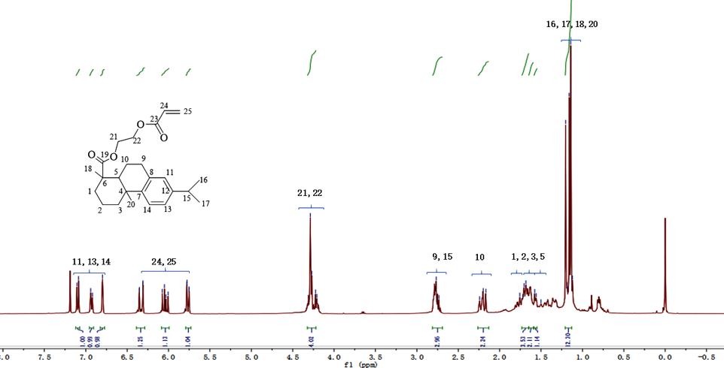
Fig. S1 ¹H-NMR of DAAEE.
¹H-NMR(400MHz;CDCl₃);δ(ppm)=7.10(d,1H),6.93(d,1H),6.80(s,1H),6.39-6.29 (m,1H),6.09-5.99(m,1H),5.77(1H,dd),4.32-4.22(m,4H),2.81-2.69(m,3H),2.26-2.13(m,2H), 1.73-1.65 (m,4H), 1.63 (s,2H), 1.57 (d,1H), 1.21-1.13 (m,12H).
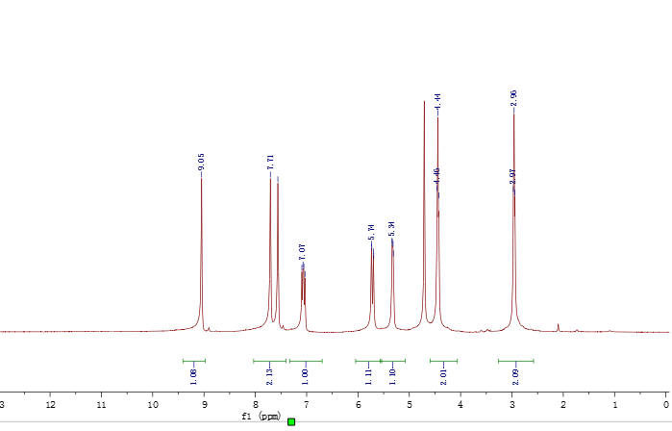
Fig. S2 ¹H-NMR of [COOHvimBr].
¹HNMR(400MHz;D2O-d6;MeSi₄);δ(ppm)=2.9(t,2H),4.44(t,2H),5.34(d,1H),5.74(d, 1H),7.07(m,1H),7.58(s,1H),7.71(s, 1H),9.05(s,1H).
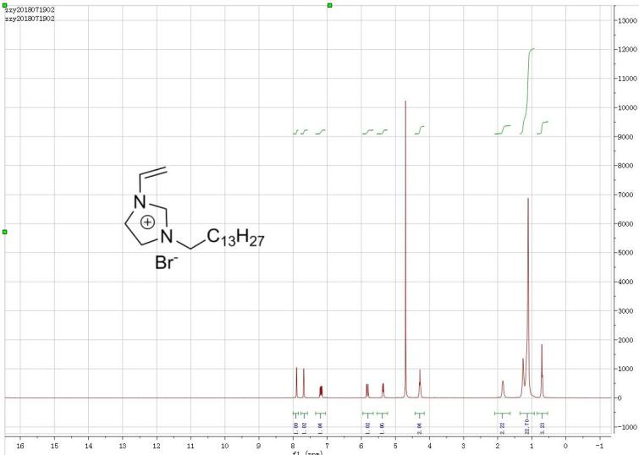
Fig. S3 ¹H-NMR of [C₁₄VIM⁺] [Br⁻].
¹HNMR(400MHz;D₂O);δ(ppm)=7.85(s,1H),7.65(s,1H),7.15(s,1H),5.85(d,1H), 5.45(s,1H), 4.25(s,2H), 1.75(s,2H), 1.15(s,23H),0.80(s,3H).

a b
Fig.7 binding energy of functional monomer and GAS(a) and molar ratio of functional monomer to template molecule(b).

Fig.8 The Ultraviolet and visible spectrophotometry of different functional monomers (a) and GAS in ethanol with addition of different concentrations of [C₁₄VIM＋][Br⁻] (b).
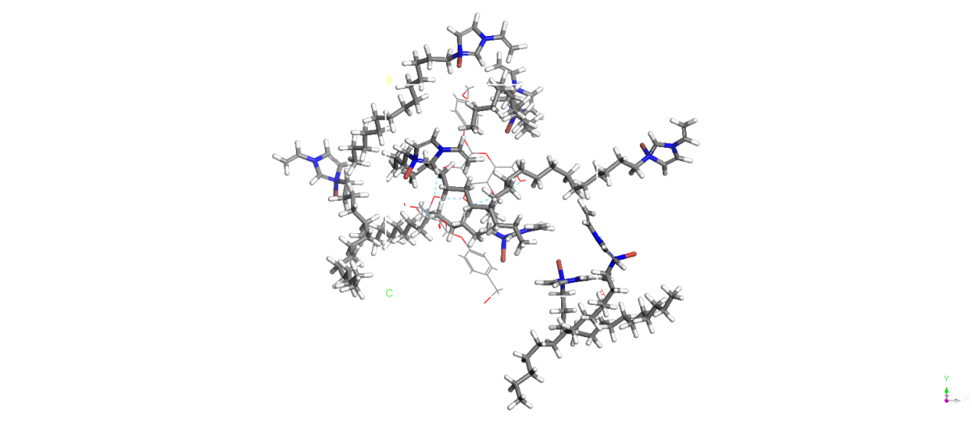 Fig.9 Interaction between [C₁₄VIM⁺] [Br⁻] and GAS.
Fig.10 The FT-IR spectrum of MIP (a), [C₁₄VIM⁺] [Br⁻](b), MIP after the adsorption of GAS(c), GAS(d).
Fig.11 The FT-IR spectrum of silica gel(a), modified silica gel (b)and SNIPs(c).

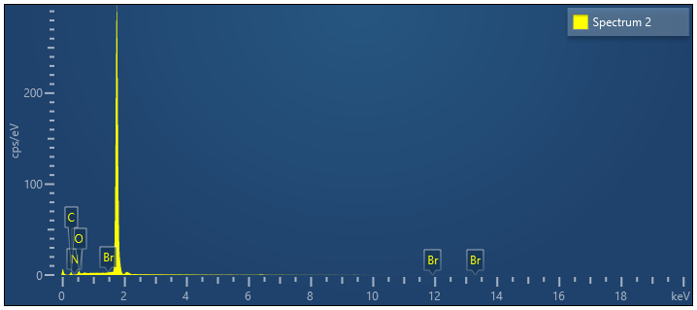
a
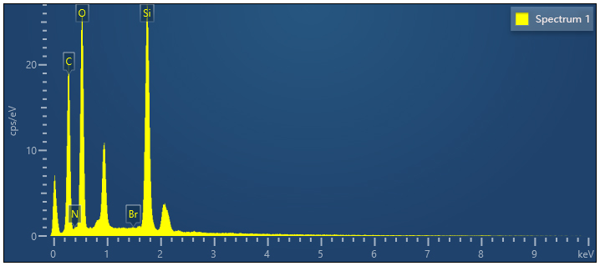
b
Fig.14 EDS energy spectrum of MIPs(a)and SMIPs(b).

Fig.17 Adsorption kinetics curves of MIPs and NIPs.
Tab. S1 simulation parameters of pseudo-first-order dynamics and
pseudo-second- order dynamics
 | Q_{e(exp)}  (mg/g) | the pseudo-first-order model |  |  | the pseudo- second -order model
 | Q_{e(exp)}  (mg/g) | R₁² | K₁  (min⁻¹) | $lnQ_{e}$ (mg/g) | R₂² | K₂(g·mg⁻¹·min⁻¹) | $$lnQ_{e}$$  (mg/g)
MIP | 151.8424 | 0.835 | 0.0222 | 5.6032 | 0.5894 | -0.0042 | 0.3204
NIP | 120.3517 | 0.9065 | 0.0239 | 5.0973 | 0.1468 | -0.0016 | 0.9631

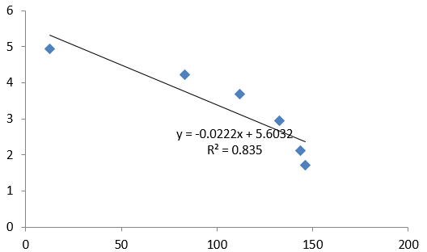
Fig. S4 The pseudo-first-order kinetic model curve of MIPs.
Table S2 Recoveries of GAS at different spiked levels in samples(n=3)
Spiked levels(%) | Recovery (%) | Mean recovery (%) | RSD (%)
80% | 97.75 | 0.99092 | 2.23
80% | 101.64 | 0.99092 | 2.23
80% | 97.89 | 0.99092 | 2.23
100% | 102.15 | 1.004249333 | 1.53
100% | 99.88 | 1.004249333 | 1.53
100% | 99.24 | 1.004249333 | 1.53
120% | 103.43 | 1.001487667 | 2.88
120% | 99.03 | 1.001487667 | 2.88
120% | 97.98 | 1.001487667 | 2.88

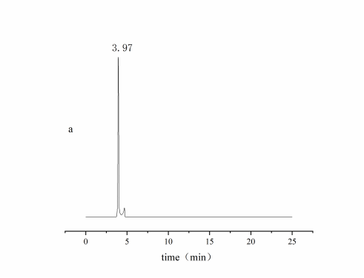

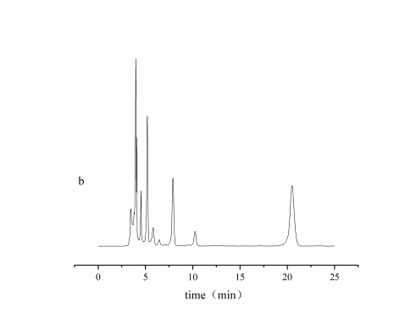
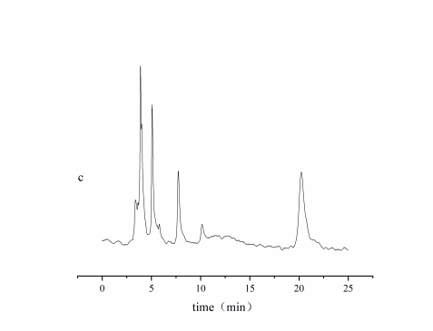
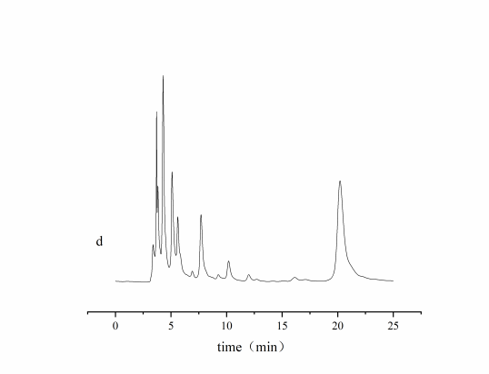
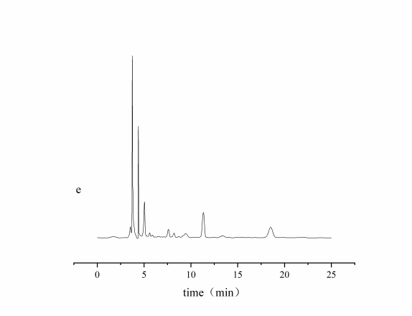
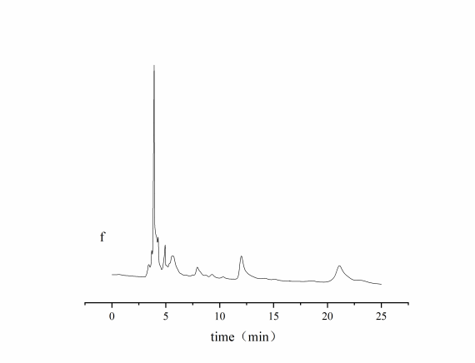
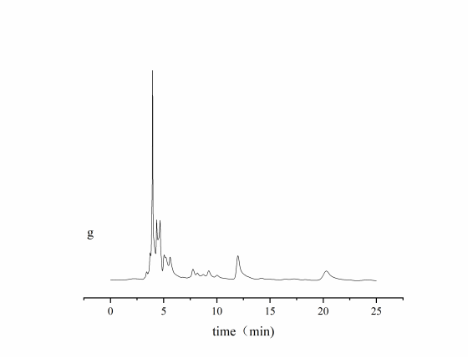
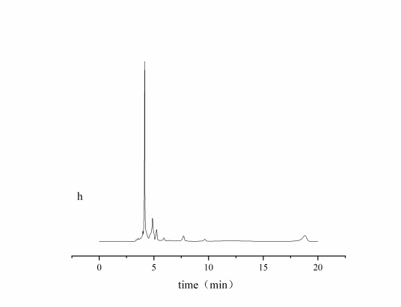
Fig.20 HPLC spectrum of GAS standard (a), Gastrodia elata root extracts before percolating through SPE column (b), methanol acetic acid eluent (c), methanol eluent (d), 70% methanol eluent (e), ethanol eluent (f), 50% ethanol eluent (g), 70% ethanol eluent (h), SMIPs-SPE-70% ethanol eluent (I).

