Relaxation of mitochondrial hyperfusion in the diabetic retina via N6-furfuryladenine confers neuroprotection regardless of glycaemic status.
Aidan Anderson^{1*}, Nada Alfahad¹, Dulani Wimalachandra¹, Kaouthar Bouzinab¹, Paula Rudzinska¹, Heather Wood¹, Isabel Fazey¹, Heping Xu², Timothy J. Lyons^{3,4}, Nicholas M. Barnes⁵, Parth Narendran⁶, Janet M. Lord¹, Saaeha Rauz^{1,7}, Ian G. Ganley⁸, Tim M. Curtis², Graham R. Wallace¹ and Jose R. Hombrebueno^{1#*}.

¹Institute of Inflammation and Ageing, University of Birmingham, Birmingham, UK
²Wellcome-Wolfson Institute for Experimental Medicine, Queen’s University Belfast, UK
³Division of Endocrinology and Diabetes, Medical University of South Carolina, Charleston, SC, USA.
⁴ Diabetes Free South Carolina, Columbia, SC, USA
⁵Institute of Clinical Sciences, University of Birmingham, Birmingham, UK
⁶Institute of Immunology and Immunotherapy, University of Birmingham, Birmingham, UK
⁷Birmingham & Midland Eye Centre, Birmingham, UK
⁸MRC Protein Phosphorylation and Ubiquitylation Unit, University of Dundee, UK

#Correspondence to Dr Jose R Hombrebueno; j.m.romero@bham.ac.uk
*Aidan Anderson and Jose R. Hombrebueno contributed equally to this work.
Institute of Inflammation and Ageing, College of Medical and Dental Sciences, University of Birmingham, Edgbaston, Birmingham, B15 2TT, UK. Phone: +44(0) 1213713226
The authors have declared no conflict of interest

Supplemental Fig 1. Neuronal impairment in the human (outer) retina is not associated with the clinical stage of diabetic retinopathy. The density of (A) DAPI⁺ nuclei at the ONL and (B) synaptophysin⁺ processes at the OPL in human retinas from nondiabetic (ND; n = 3), diabetic with no retinopathy (DNR; n = 5-6), and non-proliferative diabetic retinopathy (NPDR; n = 2) individuals.

Supplemental Fig 2. Mitochondrial morphology is not altered in the Ins2^{Akita} outer retina by 3-months of diabetes. (A-B) Morphometric quantification of mitochondrial fusion (Fis1-GFP signal) in the ONL of 3-month diabetic mitophagy reporter mice (mitoQC Ins2^{Akita}) and age-matched non-diabetic siblings (mitoQC WT). The inset rectangle shows a high-magnification view of mitochondrial morphology at the ONL, (B) Mitochondrial interconnectivity index, average mitochondrial length and mitochondrial aspect ratio. Data are presented in box-and-whisker plots. N ≥ 4, eyes/strain and condition. IS, photoreceptor inner segments; ONL, outer nuclear layer; OPL, outer plexiform layer. Scale bars: 40 µm (A), 20 µm (inset).

Supplemental Fig 3. Mitochondria remodels towards hyperfusion in the Ins2^{Akita} outer retina during the progression of diabetes. (A-C) Morphometric quantification of mitochondrial fusion (TOMM20 immunostaining) in the ONL of 3-month and 8-month diabetic Ins2^{Akita} mice and age-matched WT siblings. (C) Mitochondrial interconnectivity index and average mitochondrial length in different treatment groups (N ≥ 6 eyes/strain and condition). (D) Example immunoblot of Mitofusin-2 (Mfn2) and β-actin loading controls in retinal lysates of 8-month diabetic Ins2^{Akita} mice and age-matched WT siblings (N = 2 eyes/strain and condition). Data are presented in box-and-whisker plots. 2-sided unpaired Student’s t-test between mice of same strain and age. *P<0.05, **P<0.01. ONL, outer nuclear layer; OPL, outer plexiform layer. Scale bar: 40 µm.

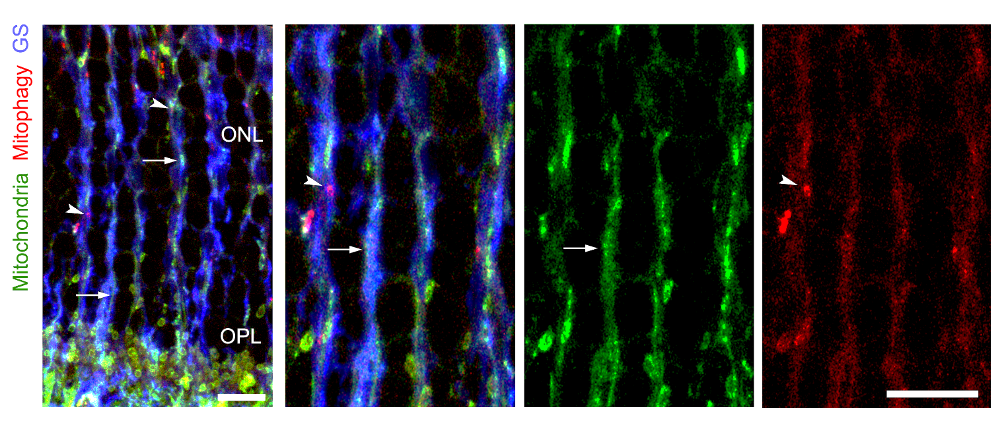
Supplemental Fig 4. Retinal Müller glia are involved in the regulation of mitochondrial turnover at the outer retina. Retinal micrographs of 3-month mitophagy reporter mice (mitoQC) mice processed for glutamine synthase (GS) immunostaining. A substantial fraction of filamentous mitochondria (arrows) and mitolysosomes (arrowheads) are found within GS⁺ Müller glia processes at the outer nuclear layer (ONL). OPL, outer plexiform layer. Scale bar: 20 µm.

Supplemental Fig 5. Exacerbated fusion impairs biogenesis machinery in human MIO-M1 Müller glia under hyperglycaemia. Human MIO-M1 Müller cells were antagonized for mitochondrial fission using a Drp1-inhibitor peptide (P110) under physiological (NG; 5.5mM) or elevated glucose (HG; 30.5mM) conditions, and then evaluated for mitochondrial morphology (Fis1 immunostaining) or mitochondrial biogenesis adaptors (TFAM). (A-B) Representative micrographs of MIO-M1 Müller cultures immunostained and binarized for Fis1 or TFAM in different treatment groups. (C-D) Morphometric analysis of mitochondrial fusion (interconnectivity and average mitochondrial length). (E) Mitochondrial mass (% of Fis1⁺ signal per cell). (F) TFAM expression (mean fluorescence intensity [MFI]). N ≥ 6 technical replicates from at least 2 biological replicates per group. Data are presented in box-and-whisker plots. **P<0.01, ***P<0.001, ****P<0.0001. One-way ANOVA with Bonferroni’s correction for multiple comparisons. TFAM, mitochondrial transcription factor A. Scale bars: 20 µm.

Supplemental Fig 6. Exacerbated fusion impairs mitochondrial bioenergetics in mouse primary Müller glia under hyperglycaemia. Mouse primary Müller cells were antagonized for mitochondrial fission using a Drp1-inhibitor peptide (P110) under physiological (NG; 5.5mM) or elevated glucose (HG; 30.5mM) conditions, and then evaluated for mitochondrial bioenergetics using Seahorse. Representative Seahorse assay of (A) metabolic flux and (B) metabolic potential using Cell Mito Stress Test. (C-F) Quantification of oxygen consumption rate (OCR) indicative of (C) basal respiration, (D) ATP-linked respiration, (E) Maximum respiration and (F) metabolic potential. (C-F) N ≥ 6 technical replicates from at least 2 biological replicates per group. Data are presented in box-and-whisker plots. *P<0.05, **P<0.01. One-way ANOVA with Bonferroni’s correction for multiple comparisons. ECAR, extracellular acidification rate.

Supplemental Fig 7. Glycosylated N6-furfuryladenine (kinetin riboside) but not its precursor (kinetin) amplifies mitophagy in Muller glia independent of mitochondrial uncoupling. Primary Müller cells isolated from mitoQC mice (MitoQC PMCs) or human MIO-M1 cells were treated with putative activators of Pink1 mitophagy including (A) kinetin and its glycosylated metabolite kinetin riboside (KR) or (B) niclosamide or (C) urolithin-A (Uro-A). (D) Quantification of mitophagy in MitoQC PMCs after 24h of treatment. (E) Evaluation of mitochondrial membrane potential (ψm) by JC-1 dye (red, hyperpolarized; green, depolarized mitochondria) in human MIO-M1 cells 24h after treatments. CCCP (100 μM) was added as a mitochondrial uncoupler positive control (2 hours). N ≥ 6 technical replicates from at least 2 biological replicates per group. Data are presented in box-and-whisker plots. ***P<0.001, ****P<0.0001; §§§P<0.001 (niclosamide or Uro-A compared with untreated controls). One-way ANOVA with Dunnett’s multiple comparisons.

Supplemental Fig 8. Kinetin riboside but not its precursor (kinetin) rescues mitochondrial biogenesis machinery in Muller glia under diabetes-mitochondrial hyperfusion. Human MIO-M1 cells were antagonized for mitochondrial fission (P110 peptide) under elevated glucose (HG; 30.5mM) conditions, and treated with different concentrations of kinetin, kinetin riboside (KR), niclosamide, urolithin-A (Uro-A) or DMSO control (0.1%). Following treatment, the expression levels of mitochondrial biogenesis adaptor TFAM was evaluated by immunocytochemistry. N ≥ 6 technical replicates from at least 2 biological replicates per group. Data are presented in box-and-whisker plots. *P<0.001, ****P<0.0001; §§§P<0.001 (niclosamide compared with vehicle-control). One-way ANOVA with Dunnett’s multiple comparisons. TFAM, mitochondrial transcription factor A. Scale bar: 20 µm.

Supplemental Fig 9. Kinetin riboside (KR) rescues mitochondrial biogenesis nucleoids in diabetic Ins2^{Akita} retinas. KR (60 mg/L) or DMSO vehicle-control (0.1%) was supplemented in the drinking water from 4-months to 8-months of diabetes in Ins2^{Akita} mice. Following treatment, the density of TFAM⁺ mitochondrial nucleoids at the outer retina (arrowheads) was evaluated via immunohistochemistry and compared between diabetic and non-diabetic (WT) age-matched groups. N ≥ 4, eyes/strain and condition. *P<0.05, ****P<0.0001. One-way ANOVA with Dunnett’s multiple comparison. IS, photoreceptor inner segments, ONL, outer nuclear layer; OPL, outer plexiform layer, TFAM, mitochondrial transcription factor A. Scale bar: 40 µm.

Supplemental Table 1. Primary antibodies used for western blot (WB), immunohistochemistry (IHC) and immunocytochemistry (IC).

Antigen | Antiserum  (Host) | Dilution | Source (catalogue number)
ATP Synthase (beta) | mouse | 1:1000 (WB) | Thermo (A-21351)
β-actin | mouse | 1:10000 (WB) | Santa Cruz (sc-47778)
β-III tubulin | rabbit | 1:500 (IC) | Abcam (ab18207)
Calbindin | rabbit | 1:1000 (IHC) | Swant (CB-38a)
Cone-arrestin | rabbit | 1:10000 (IHC) | Chemicon (ab15282)
Cox4 | goat | 1:50 (IHC) | R&D systems (AF5814)
Fis1 | rabbit | 1:500 (IHC and IC) | Genetex (GTX111010)
GABA | rabbit | 1:500 (IHC) | Sigma (A2052)
Glutamine synthase | rabbit | 1:10000 (IHC)  1:500 (IC) | Sigma (G2781)
Neurofilament (heavy chain) | rabbit | 1:500 (IC) | Proteintech (21471-1-AP)
Mitofusin-2 | rabbit | 1:1000 (WB) | Cell Signaling (9482S)
M-opsin | rabbit | 1:1000 (IHC) | Chemicon (AB5405)
Synaptophysin | rabbit | 1:500 (IHC) | Abcam (ab14692)
TFAM | rabbit | 1:500 (IHC and IC) | Genetex (GTX112760)
TOMM20 | rabbit | 1:500 (IHC) | Sigma (HPA011562)
Vimentin | rabbit | 1:500 (IHC) | Abcam (ab92547)

