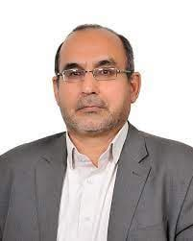

Behrouz Minaei Bidgoli is an Associate Professor and the head of the Computer Engineering School at Iran University of Science and Technology. He led the Data Mining Lab (DML) that does research on various areas in artificial intelligence and data mining, including text mining, web information extraction, and natural language processing.



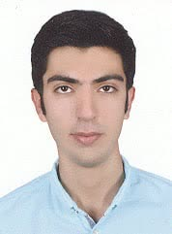
Mohammad Abdous received his M.S. degrees from the University of Science and Technology, in 2016. From 2016 until now he was Researcher at mentioned Institute and worked on the high-level Natural Language Processing tools. Text mining and natural language processing are his interests.

Poorya Piroozfar received his M.S. degree in computer Engineering from the University of Science and Technology, Iran, in 2022. His research interests include Natural Language Processing, Data Mining and Deep Learning. His supervisor is Dr. Behrouz Minaei Bidgoli in University of Science and Technology.

