Supporting Information
Probing the Mechanism of Cation Enhanced CO₂ Reduction in Acidic Media: Water Structure Determining the Hydrogenation Kinetics
Zhi-Ming Zhang¹, Tao Wang^{1,2}*, Yu-Chen Cai¹, Xiao-Yu Li¹, Jin-Yu Ye¹, Yao Zhou³, Na Tian¹, Zhi-You Zhou^{1,2}*, Shi-Gang Sun¹
- State Key Laboratory of Physical Chemistry of Solid Surfaces, College of Chemistry and Chemical Engineering, Xiamen University, Xiamen, China
- Innovation Laboratory for Sciences and Technologies of Energy Materials of Fujian Province (IKKEM), Xiamen, China
- College of Energy, Xiamen University, Xiamen, China
*Correspondence: twangxm@xmu.edu.cn, zhouzy@xmu.edu.cn

Materials and methods
- Reagents, solutions, materials and apparatus
H₂SO₄ (99.99%) were purchased from Merck. Na₂SO₄ (99.99%), Li₂SO₄ (99.99%) and K₂SO₄ (99.99%) were purchased from Sigma. D₂O (99.9 atom % D), H₂O¹⁸ (97 atom % ¹⁸O), NaOH (99.99%), KHCO₃ (99.99%) Cu₂SO₄·5H₂O (99.9%), C₂H₄O₆KNa·4H₂O (99.9%), C₂H₆OS (99.99%), HF (49 wt. % in H₂O), H₂O₂ (30% in water), NH₄F (99.9%), HCHO (37 wt. % in H₂O) and H₃PO₄ (99%) were purchased from Aladdin, ¹³CO₂ (¹³C, 99%) were purchased from Cambridge Isotope Laboratories, Inc. CO₂ (99.999%), Ar (99.999%), H₂(99.999%) and CO (99.999%), compressed air (99.999%) were purchased from Linde. Copper dices (99.99%) were purchased from Macklin. The solutions were prepared from super pure water (18 MΩ cm) purified through a Milli-Q Lab system (Nihon Millipore Ltd.).
- Experiment section
Preparation of Cu thin film working electrodes. The preparation procedure of Cu film working electrodes with prominent signal enhanced effect was modified from a “Seeded growth tactics” ¹ as follows: the reflecting plane of a trapezoidal Si prism (25×25 mm) was polished with diamond suspension and cleaned in water and ethyl alcohol successively by ultrasonic for several times. Then the prism was immerged in a piranha solution (3:1 volumetric ratio of H₂SO₄ and H₂O₂) for 60 min. The reflection plane was then treated by 40% NH₄F for 90 s, and immersed the Si reflecting plane in a mixture of 2% HF and 3.17 mM CuSO₄ at 28°C for 20 s. The plating solution of electroless deposition Cu (31.7 mM CuSO₄·5H₂O, 0.161 M C₂H₄O₆KNa, 0.333 M HCHO, adjusted to pH 12 with NaOH) was deposited dropwise on the reflection plane at 30°C for 3 min, then carefully rinsed with ultrapure water and purged with argon immediately. Scanning electron microscopy (SEM, ZEISS Sigma) was applied to characterize the morphology of the Cu film on Si.
Electrochemical In-situ Attenuated Total Reflection Surface-enhanced Infrared Absorption Spectroscopy (ATR-SEIRAS). A Nicolet 8700 FTIR spectrometer equipped with a liquid-nitrogen-cooled MCT-A detector cooled was employed for the ATR-SEIRAS measurements. All spectral resolution was 8 cm⁻¹ and 200 interferograms were co-added for each spectrum if not otherwise mentioned. All resulting spectra were presented as relative change in reflectivity, as following equation:
$$\frac{\text{∆R}}{\text{R}}\text{=}\frac{\text{(R}\left({\text{E}}_{\text{S}}\right) \text{- R(}{\text{E}}_{\text{R}}\text{))}}{\text{R(}{\text{E}}_{\text{R}}\text{)}}$$
Where $\text{R}\left({\text{E}}_{\text{S}}\right)$ and $\text{R(}{\text{E}}_{\text{R}}\text{)}$ represent the single-beam spectra collected at the sample potential and the reference one, respectively.
The Cu-coated prism was assembled into a homemade cell as the working electrode, IrO₂ loaded on titanium sheet was used as the counter electrodes and a saturated calomel electrode (SCE) near the working electrode via a Luggin capillary was used as reference. All solutions were adjusted to pH = 1 with H₂SO₄ and deoxygenated by Ar at least 30 min, subsequently, bubbled the high-purity CO₂ into solution untiled saturated and continuously purged CO₂ before each test. the reference spectrum was taken at -0.08 V vs RHE. For isotope testing, ¹³CO₂ was bubbled into solution sustainable. All containers were strictly dried by Ar before test in D₂O and H₂O¹⁸ solution, other procedure was similar as described before. CO was continuously purged into 0.1 M KHCO₃ solution at around 2 L min⁻¹ for CO adsorption experiment, and the reference spectrum was taken at 0.24 V vs RHE. The potential was converted to versus the reversible hydrogen electrode (RHE) as follow: E (V vs. RHE) = E (V vs. SCE) + 0.241 V + 0.059 V × pH.
Quantified analysis of products.
Gas chromatography. All gaseous products were analyzed by an online gas chromatograph (GC Fuli 970) equipped with a thermal conductivity detector (TCD) and a flame ionization detector (FID). Electrolysis was performed with CHI 660E electrochemical workstation in a H-type electrochemical cell separated by Nafion117 proton exchange membrane, with a platinum sheet (2 cm²) as the counter electrode and saturated calomel electrode as reference electrode. The working electrode was obtained by classical electropolishing copper sheet (2 cm²) in concentrated H₃PO₄ (85%) ², and rinsed by ultrapure water before each use. The Faradaic efficiency of a gas analyte $g$ was calculated as following equation:
$${FE}_{g}= \frac{N_{g}∙r_{g}∙F }{I} = \frac{N_{g}∙f∙x_{g}∙p∙F }{I∙RT}$$
Where, $N_{g}$, $r_{g}$, $F$ and $I$ are the number of electrons transferred for producing the gas product, the formation rate (mol s⁻¹), the Faraday constant (9.65 × 10⁴ C mol⁻¹) and current. Further, $f$ is the mass flow rate of gas flow of CO₂ (100 sccm). $x_{g}$ is the percent of gas analyte $g$ detected by TCD or FID. $p$ is the standard atmospheric pressure (101.3 kPa). $T$ is the thermodynamic temperature (273 K).$R$ is the gas constant (8.314 J mol⁻¹ K⁻¹).
Nuclear Magnetic Resonance Spectrometer. The solution phase products after electrolysis were characterized by ¹H-nuclear magnetic resonance (¹H-NMR, 500 MHz, Bruker). Dimethyl sulfoxide (DMSO, chemical shift was at 2.71 ppm) in heavy water (D₂O) was used as an inner standard to quantify the products. For each test, 500 μL of the electrolyte and 100 μL 1 mM DMSO in D₂O were mixed. The quantified relationship of liquid analyte and internal standard follows the equation:
$${FE}_{l}= \frac{N_{l}∙n_{l}∙F }{Q} =\frac{N_{l}∙F∙n_{std}∙I_{l}∙H_{std}}{Q∙I_{std}∙H_{l}}$$
where $N_{l}$, $n_{l}$, and $Q$ are the number of electrons transferred for producing the liquid product, the mole of liquid analyte, and the integrated charge, respectively.$H$ and $I$ are the number of H atoms and the integral area of liquid analyte ($l$) and internal standard (std). In this work, formic acid was the main liquid phase product.
The partial current density of product $p$ was calculated according to the equation:
$$j_{p}=j∙{FE}_{p}$$Where, $j$ is the current density normalized to the area of working electrode.
Electrochemical Surface Area (ECSA) of Cu foil. ECSA measurements of Cu foil (2 cm²) was carried out by Pb underpotential deposition (UPD)³ in Ar-saturated 0.1 M HClO₄ + 1 mM Pb(ClO₄)₂. Cu foil was firstly electropolished in 85% H₃PO₄ solution as previously mentioned, then immersed in Ar-saturate 0.1 M HCIO₄ + 1 mM Pb (CIO₄)₂ solution and held at -0.106 V vs RHE for 10 min before exfoliated Pb by applying the potential from -0.106 to 0.22 V at 5 mVs⁻¹. The background current was measured in the absence of Pb. The ECSA of Cu was calculated from the charge (after the background current correction) associated with 2e⁻ oxidation of monolayer of Pb with a conversion factor of 310 µC cm⁻².
Calculation of Turnover frequency (TOF) of CO on Cu.
Area per copper atom on the surface of Cu film (the lattice constant of Cu: 3.61 × 10⁻¹⁰ m):
$$\frac{{\left(3.61{10}^{-10} \right)}^{2}}{2}=6.52×{10}^{-20} m^{2}$$
Number of atoms on the surface of Cu film (ECSA_{Cu}: 2.6 cm²):
$$\frac{2.6×{10}^{-4}}{6.52×{10}^{-20}}=3.99×{10}^{16}$$
TOF of CO production (the Avogadro constant N_{A}: 6.023 × 10²³, the product of CO was obtained from GC):
$${TOF}_{CO}= \frac{n_{co}N_{A}}{3.99×{10}^{16}t}$$

Computational details
Ab initio molecular dynamics (AIMD) were conducted to illustrate the adsorbed CO₂ at electrochemical interface in detail, which were performed by CP2K/Quickstep.⁴ A Nose–Hoover thermostat was applied to keep the temperature at 300 K and the timestep was set to 0.5 fs. With orbital transformation (OT) optimization, iterations in the self-consistent field (SCF) loop of maximum number was 5. In CP2K, the DFT simulations was based on a hybrid Gaussian plane wave (GPW) scheme⁵, the orbitals were performed by atom centered Gaussian-type basis set, and auxiliary plane wave basis set were performed to re-expand the electron density in reciprocal space. Gaussian basis sets with double-ζ polarization function (DZVP-MOLOPT-SR-GTH) were used.⁶ The plane wave energy cutoff was 400 Ry. In the Goedecker-Teter-Hutter (GTH) pseudopotential,^{7,8} 6 electrons of O, 1 electron of H, 4 electrons of C, 11 electrons of Cu, 3 electrons of Li and 9 electrons of Na were regarded as valance electrons, respectively. We carried out the canonical ensemble (NVT) and used the revised version of Perdew−Burke−Ernzerhof (RPBE) functional⁹ to describe the exchange-correlation effect. Besides, the Grimme D3 method¹⁰ was performed as dispersion correction.
The Cu (111) surface was modeled by the four-layer slab of an orthogonal (4×4) super-lattice (8.854 Å × 10.224 Å × 30.0 Å) with the surface area of 0.9 nm². Two adsorbed CO₂ molecules are placed on the both sides of the slab. The thickness of explicit water slab is ~21 Å, which contains 64 water molecules to maintain the water density of 1.0 g cm⁻³ at room temperature. Two Na ion (Na⁺) and two Li ion (Li⁺) are inserted into the water slab, respectively. The ions are placed ~4 Å away from the Cu (111) surface at initial. During the simulation, the middle two layers of Cu (111) slab are frozen, while the two layers at both sides with adsorbed molecules and all the molecules in electrolyte are allowed to be fully relaxed. The water / Cu (111) interface is pre-equilibrated by running AIMD for 5 ps. Then, all AIMD trajectories are sampled for 15-17 ps, which are adopted for statistical analyses. The time step for simulation is 0.5 fs. The VDOS profiles are extracted by the Fourier transformation of the velocity auto-correlation functions in the AIMD trajectories.
The IR frequency were also calculated by Vienna ab initio simulation pack (VASP)¹¹⁻¹⁴ using the same model described above with projector augmented wave (PAW) method^{15,16}. Generalized gradient approximation (GGA) of the revised version of Perdew−Burke−Ernzerhof (RPBE)⁹ functional was adopted for all calculations, employed with the cut-off energy of 400 eV for the plane-wave basis set. The Brillouin zone is sampled with k-points mesh of 3×3×1, according to the Monkhorst-Pack scheme.¹⁷ All geometries were optimized to reach a gradient smaller than 0.03 eV Å with wave functions converged to 1x10⁻⁵ eV.

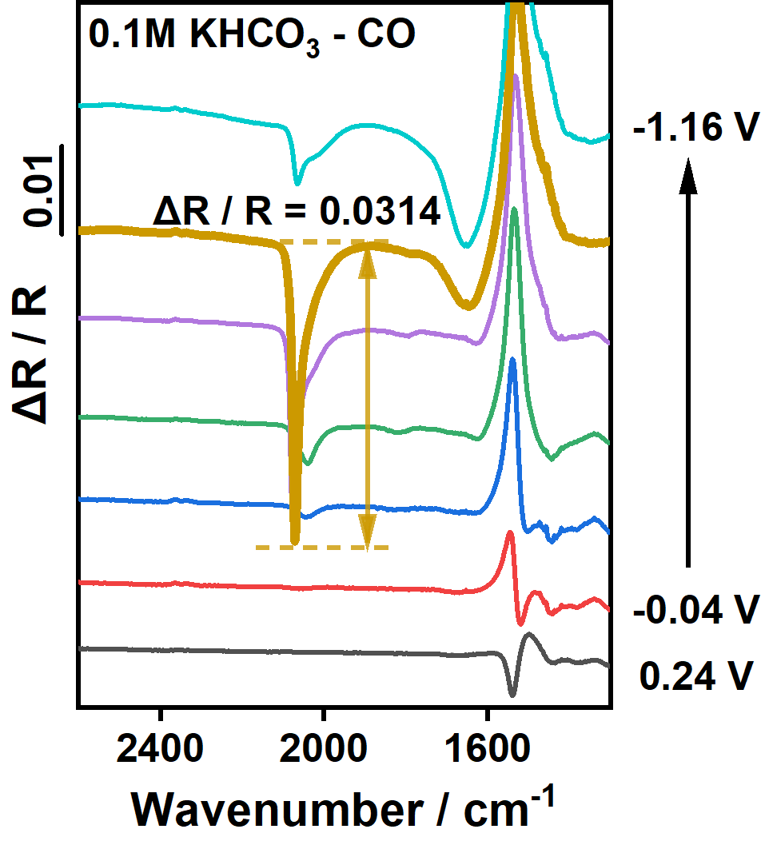
Figure S1. Potential-dependent ATR-SEIRAS of CO adsorbed on the Cu film electrode in 0.1 M KHCO₃. The reference spectrum was taken at 0.16 V vs RHE. Very strong CO band (ΔR/R=0.0314) could be observed due to high enhanced infrared absorption of the chemically deposited Cu film.
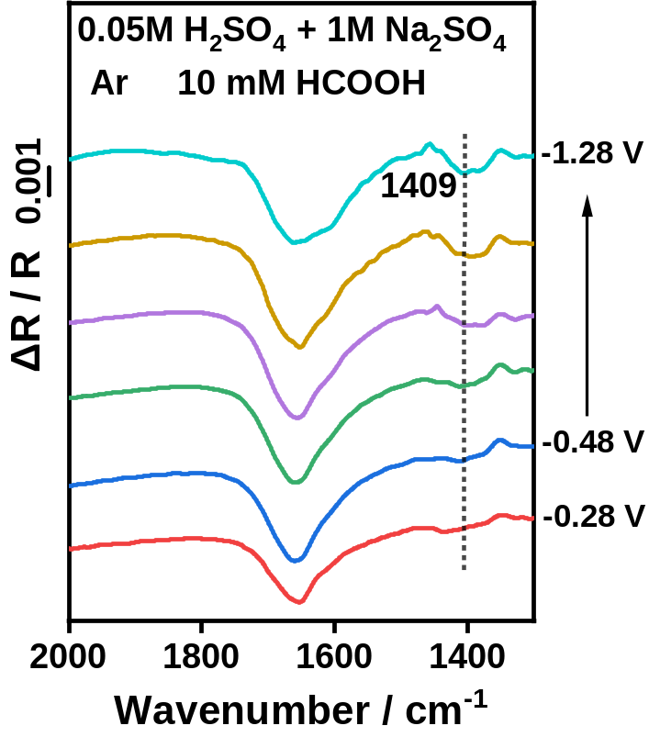
Figure S2. ATR-SEIRAS of the Cu film collected in Ar-saturated 0.05 M H₂SO₄ +1 M Na₂SO₄ with 10 mM HCOOH. The reference spectrum was taken at −0.08 V vs RHE. Adsorbed HCOO⁻ shows a peak at 1409 cm⁻¹.

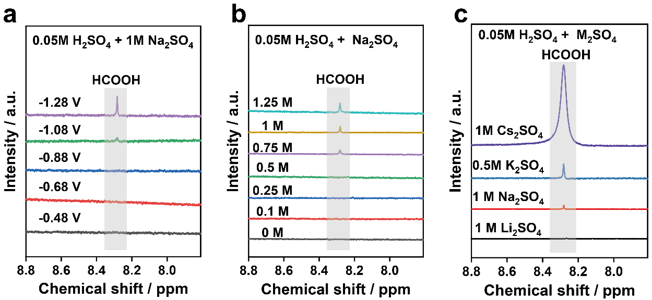

Figure S3. ¹H NMR spectra of the liquid products of HCOOH from CO₂RR. (a) 0.05 M H₂SO₄ + 1 M Na₂SO₄ with different potentials; (b) 0.05 M H₂SO₄ + Na₂SO₄ with different concentrations at −1.28 V vs RHE; (c) Comparison of HCOOH formation in 0.05 M H₂SO₄ solution with Li⁺, Na⁺, K⁺ and Cs⁺ at −1.28 V vs RHE.

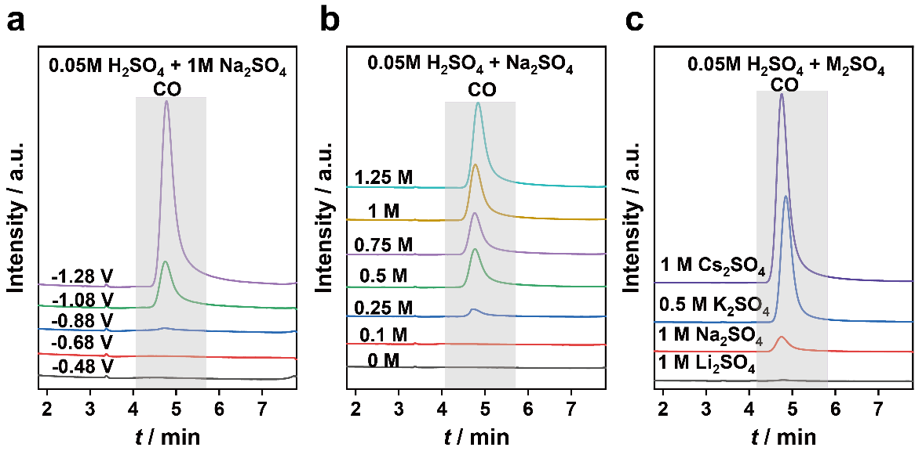
Figure S4. Gas chromatography analysis of CO produced from CO₂RR. (a) 0.05 M H₂SO₄ +1 M Na₂SO₄ with different potentials; (b) 0.05 M H₂SO₄ + Na₂SO₄ with different concentrations at −1.28 V vs RHE; (c) Comparison of CO formation in 0.05 M H₂SO₄ solution with Li⁺, Na⁺, K⁺ and Cs⁺ at −1.28 V vs RHE.

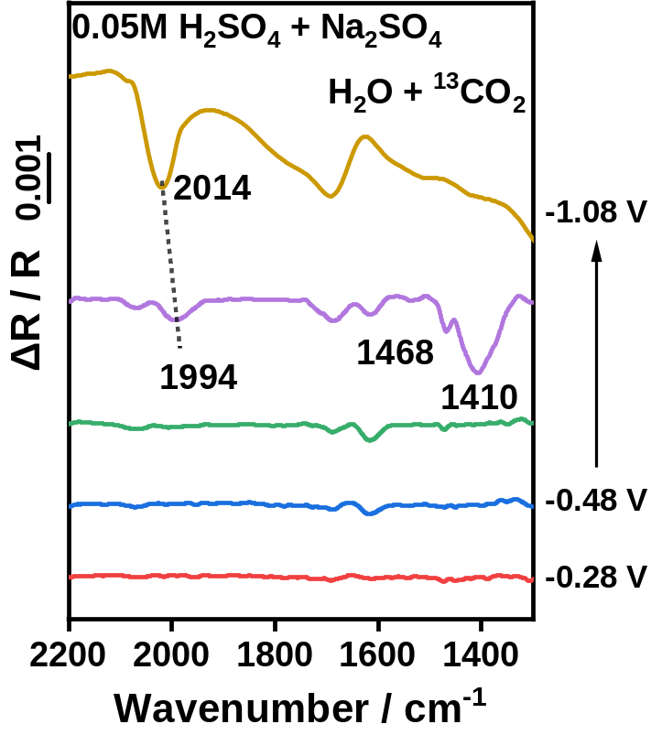
Figure S5. ATR-SEIRAS of ¹³CO₂ reduction in 0.05 M H₂SO₄ + 1 M Na₂SO₄. The reference spectrum was taken at −0.08 V vs RHE.

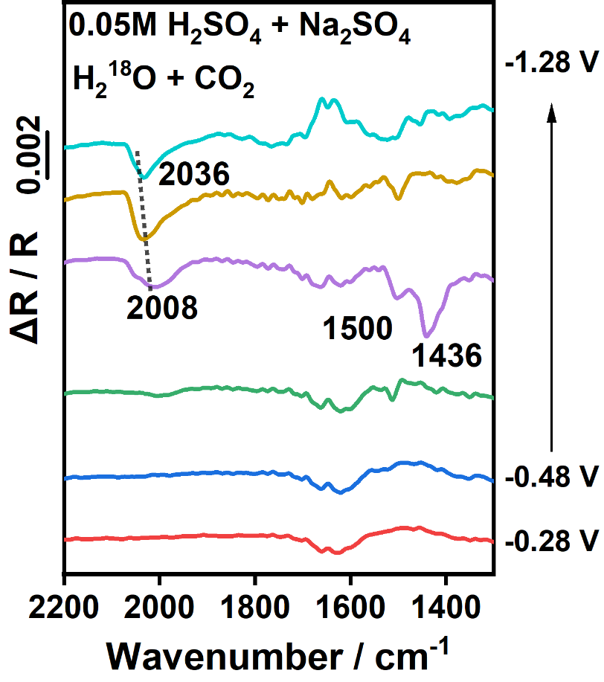
Figure S6. ATR-SEIRAS of CO₂RR in 0.05 M H₂SO₄ + 1 M Na₂SO₄ solution prepared with H₂¹⁸O. The reference spectrum was taken at −0.08 V vs RHE.

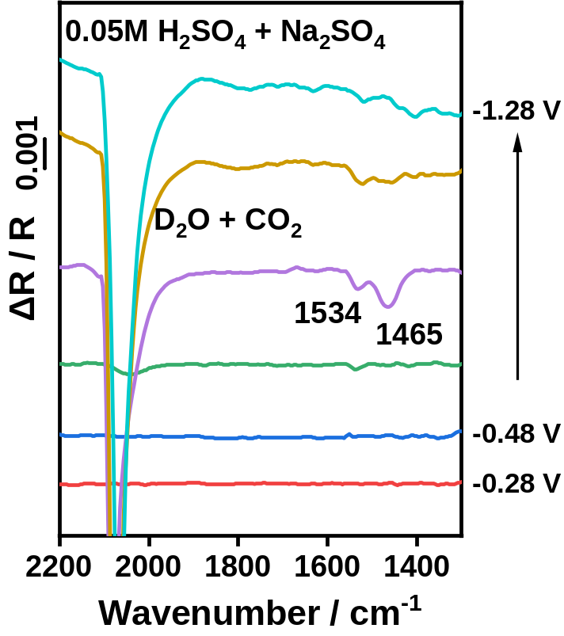
Figure S7. ATR-SEIRAS of CO₂RR in 0.05 M H₂SO₄ + 1 M Na₂SO₄ in D₂O. The reference spectrum was taken at −0.08 V vs RHE.
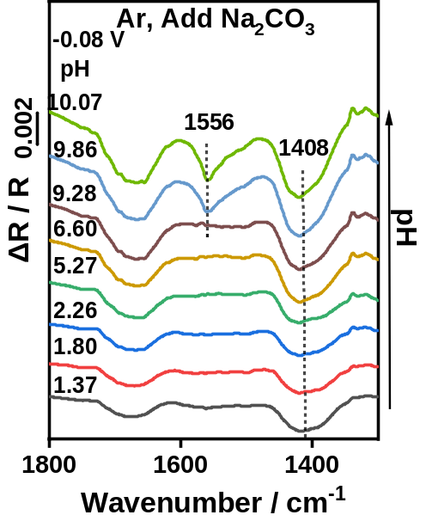
Figure S8. ATR-SEIRAS of Cu film in Na₂CO₃ electrolytes with different pH at -0.08 V (a). Firstly, the spectrum was taken in H₂SO₄ solution with the pH=1 as the reference, then 1 M Na₂CO₃ solution was dropwise added to adjust pH to 10.07. The potential shift was corrected as previously mentioned to precisely control the potential at -0.08 V.

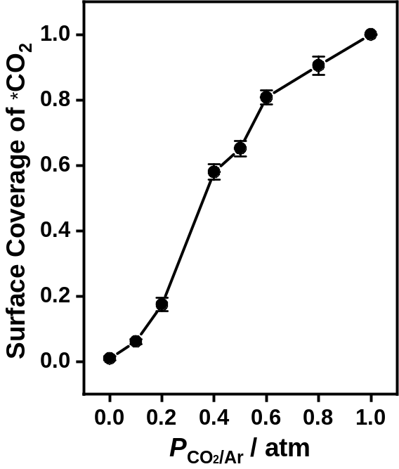
Figure S9. CO₂ partial pressure-dependent band intensity of adsorbed CO₂ (~1466 cm⁻¹). Data were extracted from ATR-SEIRAS of CO₂RR in 0.05 M H₂SO₄ + 1 M Na₂SO₄ at -0.88 V with different CO₂ partial pressure in the CO₂/Ar mixture. Firstly, the spectrum was taken in 200 sccm CO₂ (CO₂-saturated), then Ar was imported to adjust the partial pressure of CO₂, and the total gas flow rate was fixed at 200 sccm (for example 180 sccm CO₂ + 20 sccm Ar corresponded the partial pressure of CO₂ was 0.9). The atmosphere was maintained at least 15 minutes before the test to ensure equilibrium when atmosphere was varied. The reference spectrum was taken at −0.08 V vs RHE.
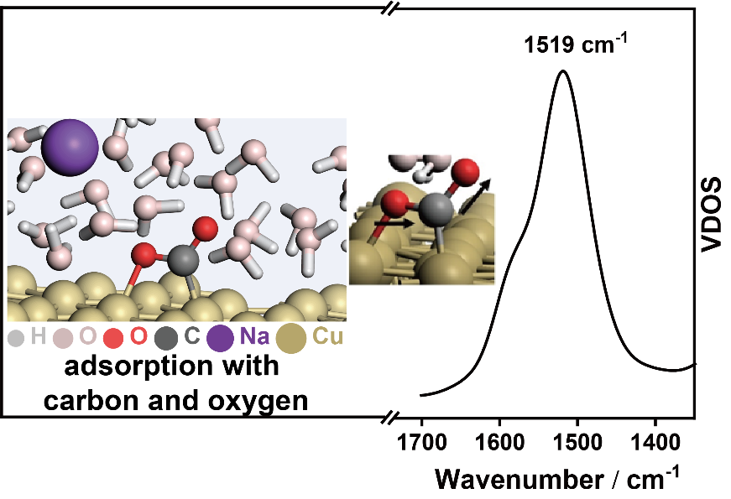
Figure S10. Calculated VDOS profiles of the CO₂ adsorbed at Cu (111)/electrolyte interface via both carbon and oxygen sites. The illustration was the snapshots of AIMD simulation for adsorbed CO₂ at electrocatalytic interface composed of Cu(111), water molecules and sodium cation.

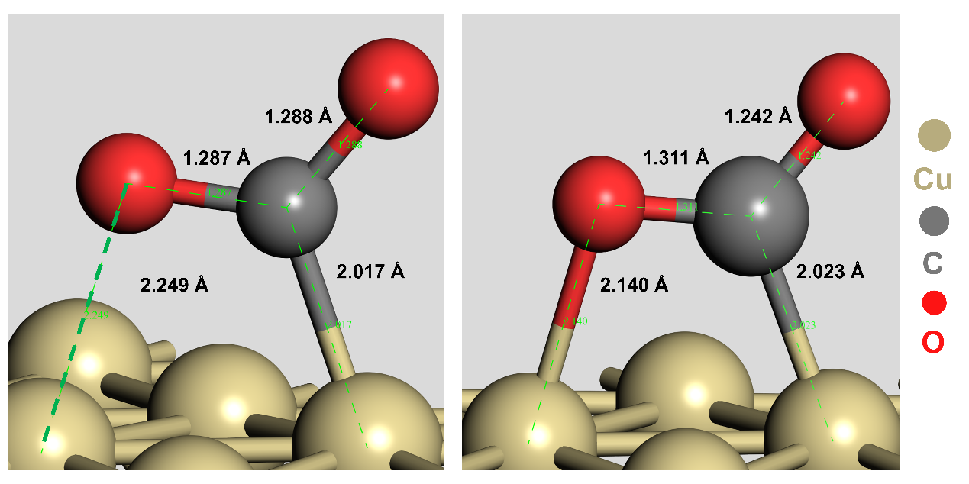
a
b
Figure S11. The optimized equilibrium configurations of adsorbed CO₂ on Cu(111) via (a) carbon atom and (b) both carbon and oxygen atoms by DFT. These configurations are adopted for calculating the IR frequencies. Note that, the explicit water and cations are involved in this model as described in supplementary method, but not be showed in this simplified picture.

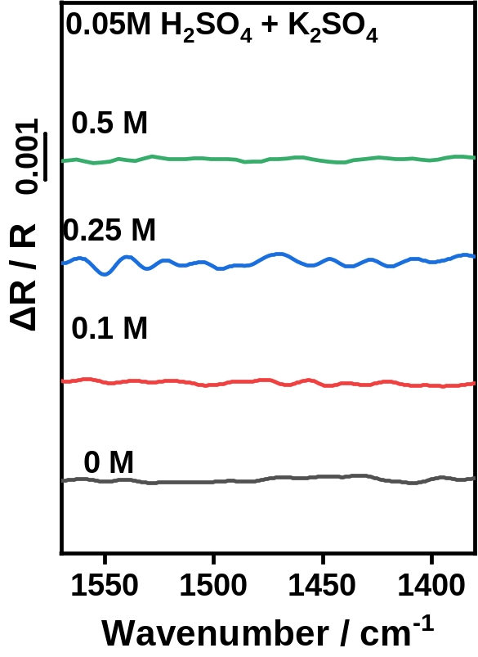
Figure S12. ATR-SEIRAS of Cu film collected at −0.88 V in CO₂-saturated 0.05 M H₂SO₄ solution with different K₂SO₄ concentrations. Reference spectrum was taken at −0.08 V vs RHE.

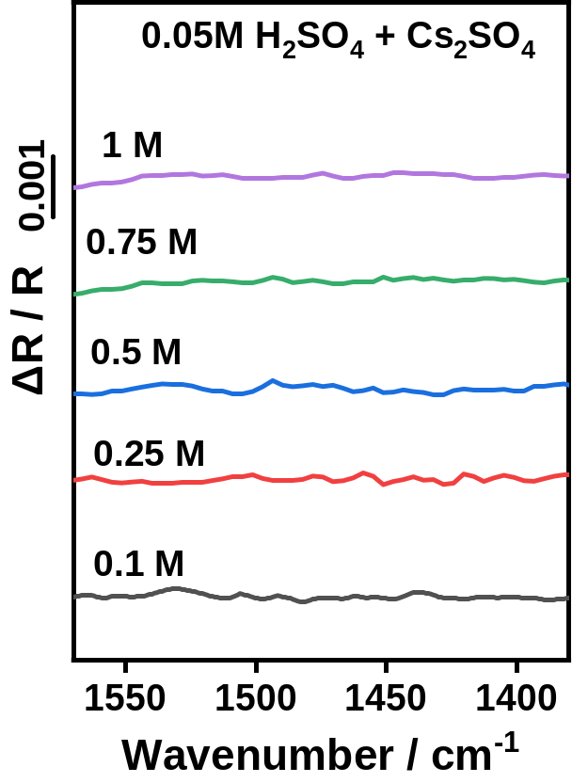
Figure S13. ATR-SEIRAS of Cu film collected at −0.88 V in CO₂-saturated 0.05 M H₂SO₄ solution with different Cs₂SO₄ concentrations. Reference spectrum was taken at −0.08 V vs RHE.

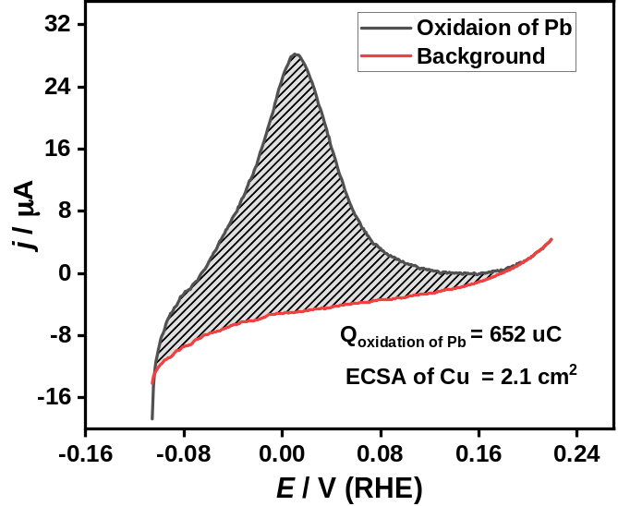
Figure S14. Pb striping curves of Cu foil in Ar-saturated 0.1 M HCIO₄ + 1 mM Pb(CIO₄)₂ (back) and Ar-saturated 0.1 M HCIO₄ (red).

Figure S15. In situ ATR-SEIRAS collected at a small potential interval of 0.02 V in 0.05 M H₂SO₄ + 1 M Li₂SO₄. The reference potential was −0.08 V.

a
b
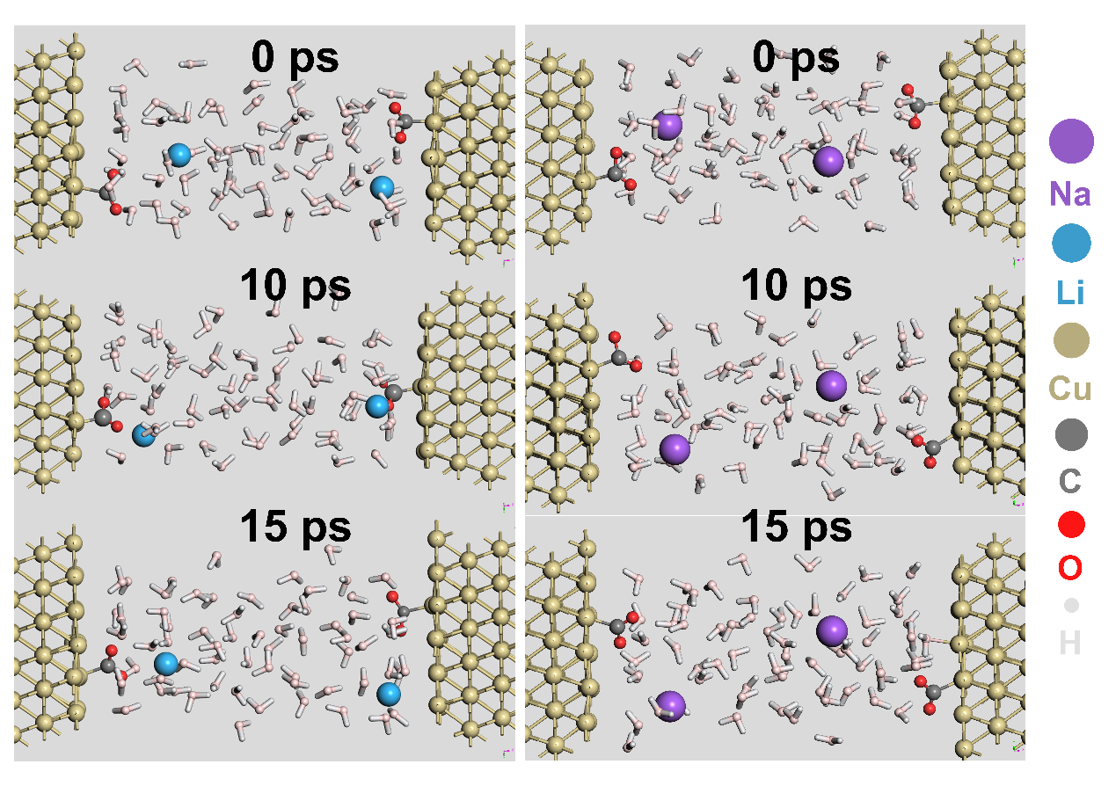
Figure S16. The molecule trajectory of AIMD for (a) Li⁺-electrolyte interface and (b) Na⁺-electrolyte interface.

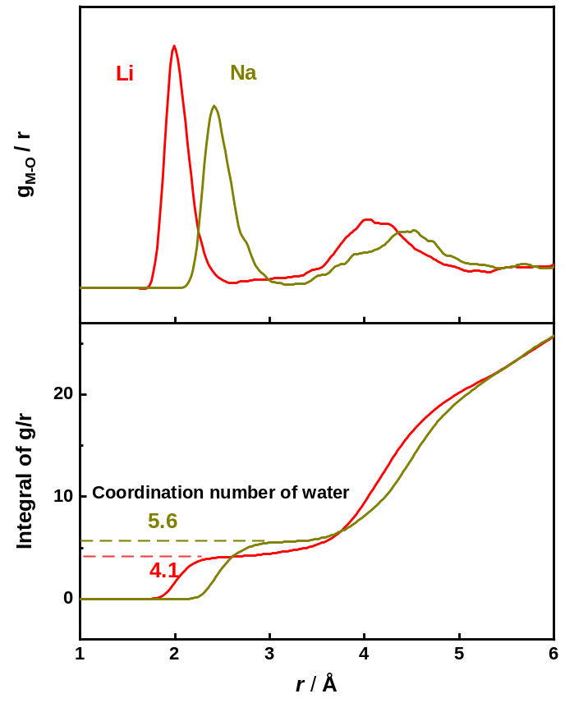
a
b
Figure S17. (a) Radial pair distribution function of the hydrogen atoms of water around the oxygen atoms of CO₂; (b) the integral of the radial pair distribution function, indicating the coordination number of water in hydration shell.

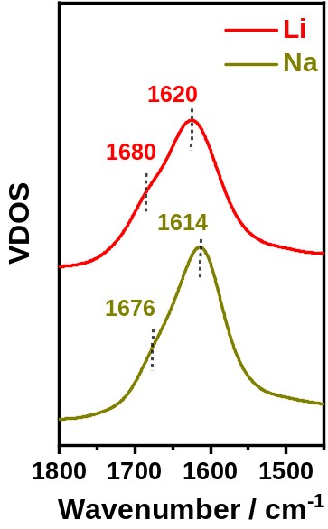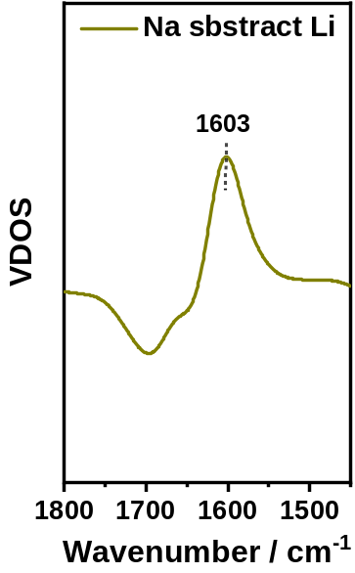
a
b

Figure S18. (a) VDOS of water around the adsorbed CO₂ extracted from the AIMD simulations; (b) Differential spectra calculated from VDOS of Li⁺ and Na⁺. The result reveals the content of free water (~1603 cm⁻¹) around the adsorbed CO₂ with Na⁺ is higher than that with Li⁺.

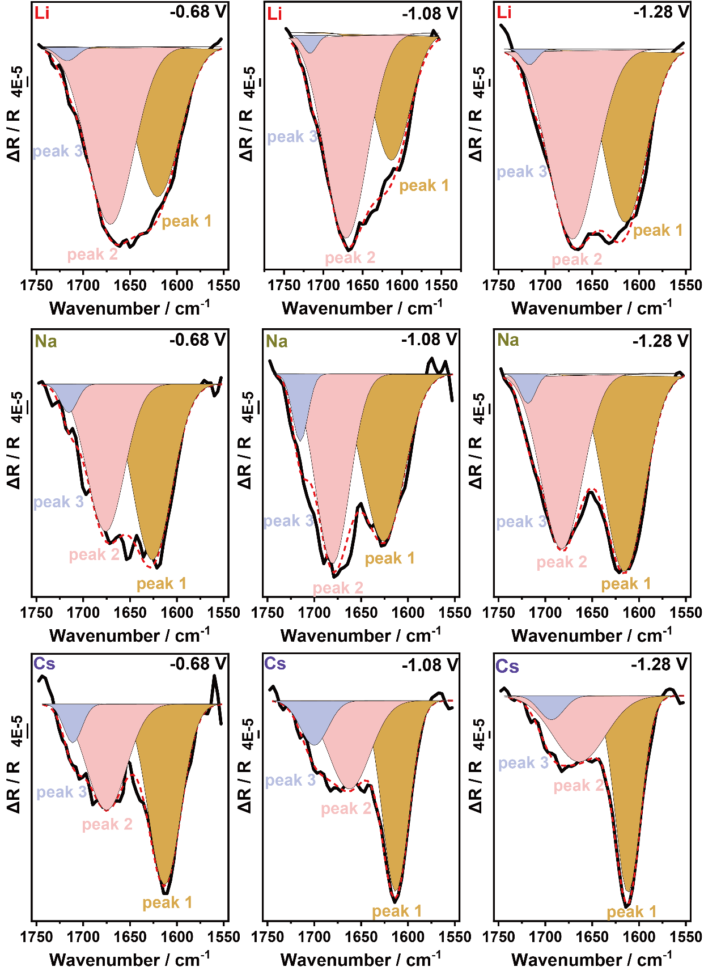
Figure S19. The signal of interfacial water on Cu film in CO₂-saturated 0.05 M H₂SO₄ with 1 M Li₂SO₄, Na₂SO₄ and Cs₂SO₄ at different potential, where the peaks at ~1620 cm⁻¹ (peak 1, brown), ~1680 cm⁻¹ (peak 2, pink) and ~1715 cm⁻¹ (peak 3, gray) were attributed to the free water, H-bonded water and protonated water, respectively.

Table S1. IR frequencies of ν_{s} (C=O) and ν_{as} (C=O) for CO₂ adsorption on Cu, corresponding vibrations of experimental, AIMD and DFT simulation results.

Vibrations | Frequency / cm⁻¹ (Experimental) | Frequency / cm⁻¹  (VDOS from AIMD) | Frequency/cm⁻¹  (DFT) | Frequency after isotope edited / cm⁻¹
 |  |  |  | Experimental |  | DFT
ν_{as} (C=O) of adsorbed CO₂ with carbon on Cu | 1456-1462 | 1458  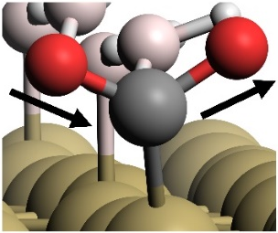 | 1439 | ¹³C-O
 |  |  |  | 1410 |  | 1400
 |  |  |  | C-¹⁸O
 |  |  |  | 1436 |  | 1413
ν_{as}(C=O) of adsorbed CO₂ with carbon and oxygen on Cu | 1530-1543 | 1519  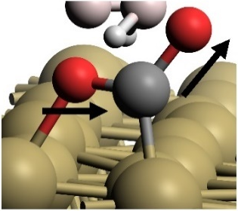 | 1561 | ¹³C-O
 |  |  |  | 1468 | 1520a
 |  |  |  | C-¹⁸O
 |  |  |  | 1500 | 1530

Table S2. Calculation of TOF at -0.88 V in 0.05 M H₂SO₄ + xM M₂SO_{4.}
 | TOF_{CO} s⁻¹
1 M Li₂SO₄ | 0.13
1 M Na₂SO₄ | 0.51
0.5 M K₂SO₄ | 2.31
1 M Cs₂SO₄ | 3.66

Table S3. The corresponding surface potential ion of Li⁺ and Na⁺ on Cu(111).
 | Li⁺ | Na⁺
Fermi /eV | 1.762 | 1.826
φ / V | 1.72 | 1.72
Potential /V | -0.85 | -0.916

Reference
1 Wang, H. F. et al. Seeded growth fabrication of Cu-on-Si electrodes for in situ ATR-SEIRAS applications. Electrochim. Acta 52, 5950-5957 (2007).
2 Salimon, J., Hernandez-Romero, R. M. & Kalaji, M. The Dynamics of the Conversion of Linear to Bridge Bonded CO on Cu. Journal of Electroanalytical Chemistry 538, 99-108 (2002).
3 Siegenthaler, H. & Juttner, K. Voltammetric Investigation of Lead Adsorption on Cu(111) Single-Crystal Substrates. Journal of Electroanalytical Chemistry 163, 327-343 (1984).
4 VandeVondele, J. et al. Quickstep: Fast and Accurate Density Functional Calculations using a Mixed Gaussian and Plane Waves Approach. Computer Physics Communications 167, 103-128 (2005).
5 Lippert, G., Hutter, J. & Parrinello, M. A Hybrid Gaussian and Plane Wave Density Functional Scheme. Molecular Physics 92, 477-487 (1997).
6 VandeVondele, J. & Hutter, J. Gaussian Basis Sets for Accurate Calculations on Molecular Systems in Gas and Condensed Phases. Journal of Chemical Physics 127 (2007).
7 Goedecker, S., Teter, M. & Hutter, J. Separable Dual-Space Gaussian Pseudopotentials. Physical Review B 54, 1703-1710 (1996).
8 Hartwigsen, C., Goedecker, S. & Hutter, J. Relativistic Separable Dual-Space Gaussian Pseudopotentials from H to Rn. Physical Review B 58, 3641-3662 (1998).
9 Hammer, B., Hansen, L. B. & Norskov, J. K. Improved Adsorption Energetics within Density-Functional Theory using Revised Perdew-Burke-Ernzerhof Functionals. Physical Review B 59, 7413-7421 (1999).
10 Grimme, S., Antony, J., Ehrlich, S. & Krieg, H. A Consistent and Accurate Ab Initio Parametrization of Density Functional Dispersion Correction (DFT-D) for the 94 Elements H-Pu. Journal of Chemical Physics 132 (2010).
11 Kresse, G. & Furthmuller, J. Efficient Iterative Schemes for Ab Initio Total-Energy Calculations using a Plane-Wave Basis Set. Physical Review B 54, 11169-11186 (1996).
12 Kresse, G. & Furthmuller, J. Efficiency of Ab-Initio Total Energy Calculations for Metals and Semiconductors using a Plane-Wave Basis Set. Computational Materials Science 6, 15-50 (1996).
13 Kresse, G. & Hafner, J. Ab-Initio Molecular-Dynamics for Open-Shell Transition-Metals. Physical Review B 48, 13115-13118 (1993).
14 Kresse, G. & Hafner, J. Ab-Initio Molecular-Dynamics Simulation of the Liquid-Metal Amorphous-Semiconductor Transition in Germanium. Physical Review B 49, 14251-14269 (1994).
15 Blochl, P. E. Projector Augmented-Wave Method. Physical Review B 50, 17953-17979 (1994).
16 Kresse, G. & Joubert, D. From Ultrasoft Pseudopotentials to the Projector Augmented-Wave Method. Physical Review B 59, 1758-1775 (1999).
17 Monkhorst, H. J. & Pack, J. D. Special Points for Brillouin-Zone Integrations. Physical Review B 13, 5188-5192 (1976).

