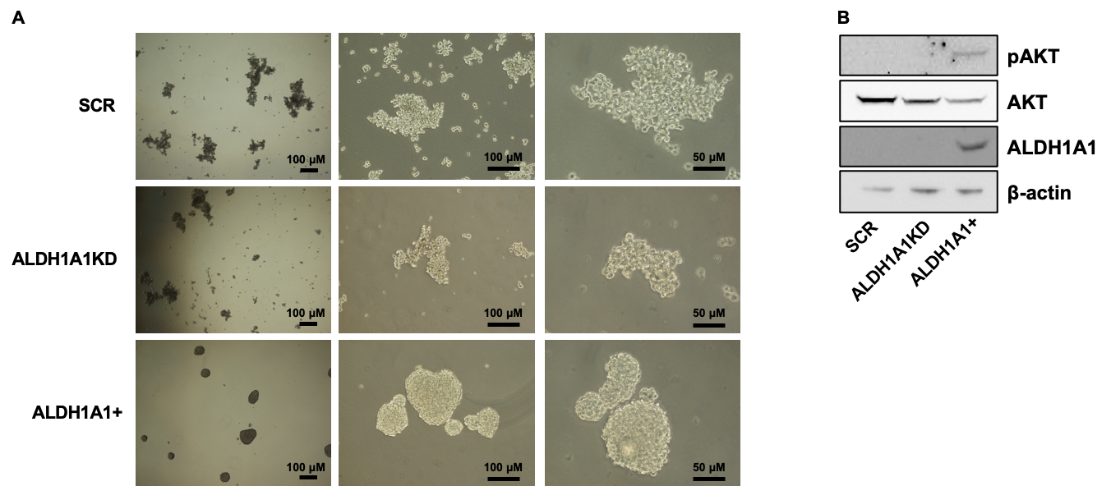
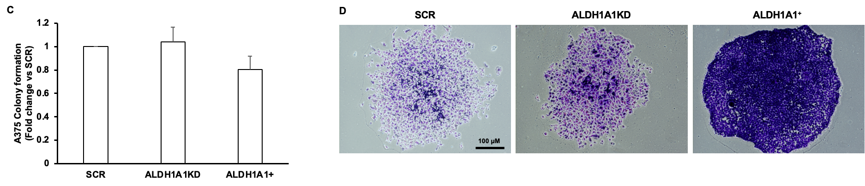
Fig. S1. A375 ALDH1A1 affects in vitro stemness. (A). Representative images of A375 SCR, ALDH1A1KD, ALDH1A1+ tumorspheres (magnification 4x left, 10x center, 20x right) showing morphology of spheroids grown on ultra-low attachment plate. (B). Western blot analysis of stemness markers ALDH1A1 and AKT activation (pAKT) in A375 tumorspheres after 7 days of culture. (C). Quantification of colony formation in A375 SCR, ALDH1A1KD and ALDH1A1+ after 7 days of culture (10 % FBS). Data are reported as fold change vs SCR, assigned to 1. The graph is the mean data of three independent experiments. (D). Representative images of A375 SCR, ALDH1A1KD and ALDH1A1+ clones. After 7 days of experiment, cells were fixed, stained, and photographed.

