Extended data figures

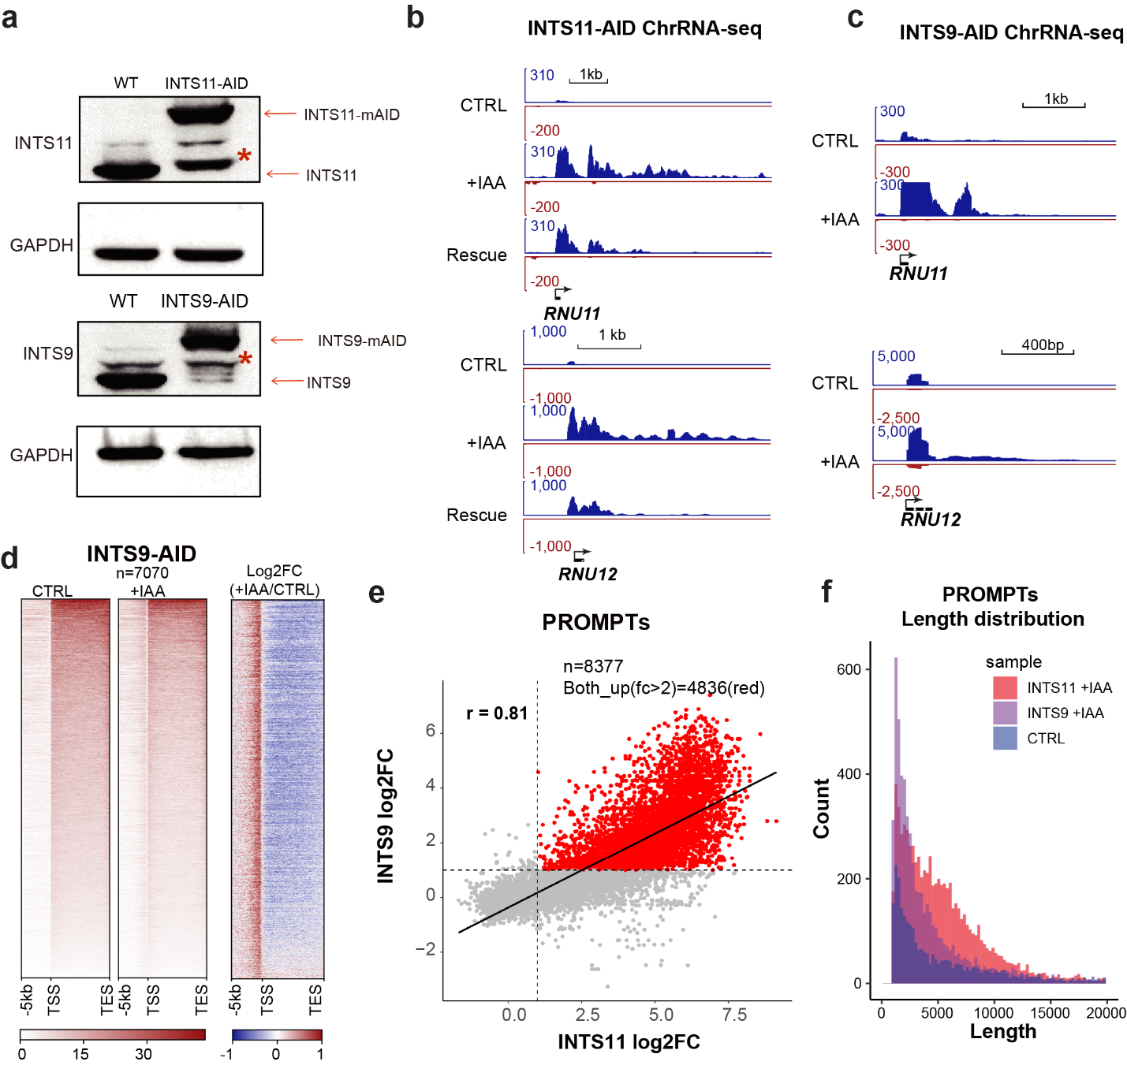
Extended Data Fig. 1 Correlation of PROMPTs accumulation under the INTS11 or INTS9 depletion.
a. Western blot representing the protein levels of INTS11/9 in wild-type and engineered cells. b. IGV tracks of RNU11 and RNU12 loci from chrRNA-seq results treated with DMSO, 1 hour of 500 µM IAA, or rescued with 7 hours of fresh media. c. IGV tracks of RNU11 and RNU12 loci from chromatin RNA-seq results in INTS9-AID cells with 4 hours of 10 µM 5 Ph-IAA treatments. d. Heatmap of 7070 genes and their PROMPTs from chrRNA-seq with or without INTS11 depletion (left). An overlaying heatmap of +IAA / CTRL shown on the right. Up-regulation shown in red, and down-regulation shown in blue. e. The correlation map of Log2 foldchange of PROMPTs after INTS11 or INTS9 depletion calculated with the Spearman method. f. Histogram showing the length distribution of PROMPTs (PROMPTs were identified by PROMPT-finder.) in CTRL, INTS9 deception and INTS11 depletion conditions.

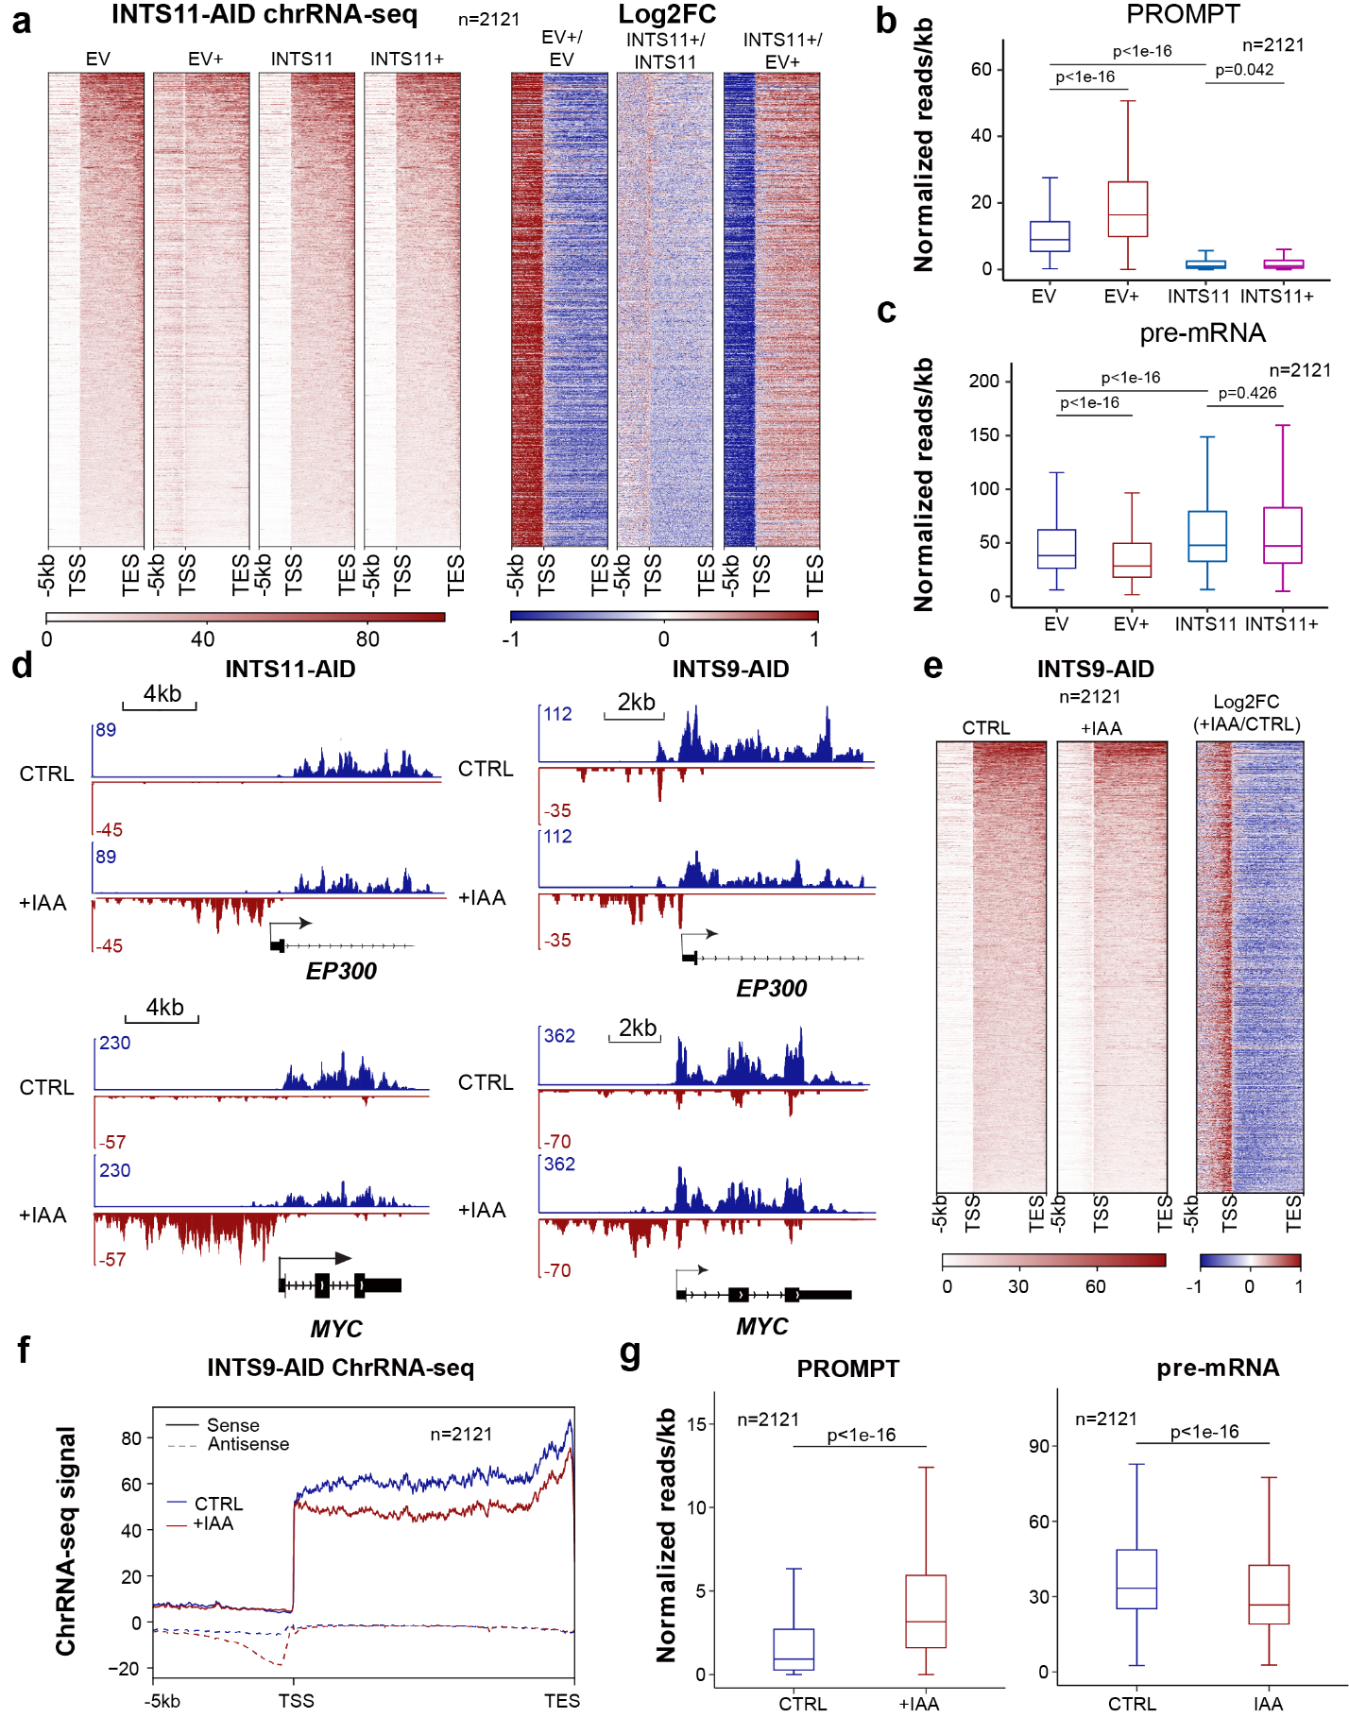
Extended Data Fig. 2 Depletion of Integrator leads to altered transcription pattern in the sense and antisense direction.
a. Heatmap representing highly expressed genes and their PROMPTs from chrRNA-seq results with EV or ectopic expression of INTS11 protein. “+” represents IAA treatments. The corresponding differences by log2 foldchange shown on the right panel. Up-regulation shown in red, and down-regulation shown in blue. b-c. Boxplots representing the transcript levels from PROMPT b and pre-mRNA c for 2121 active genes. d. IGV tracks of EP300 and MYC locus from chromatin RNA-seq results in INTS11 or INTS9 depletion. e. Heatmap representing 2121 genes and PROMPTs from chrRNA-seq before and after INTS9 depletion. f. Metagene analysis of the average density of chromatin RNA-seq signals after INTS9 depletion. g. Boxplots representing the transcript levels from PROMPT (left) and pre-mRNA (right) for 2121active genes with or without INTS9 depletion. Mann-Whitney test was used for all statistical analyses.

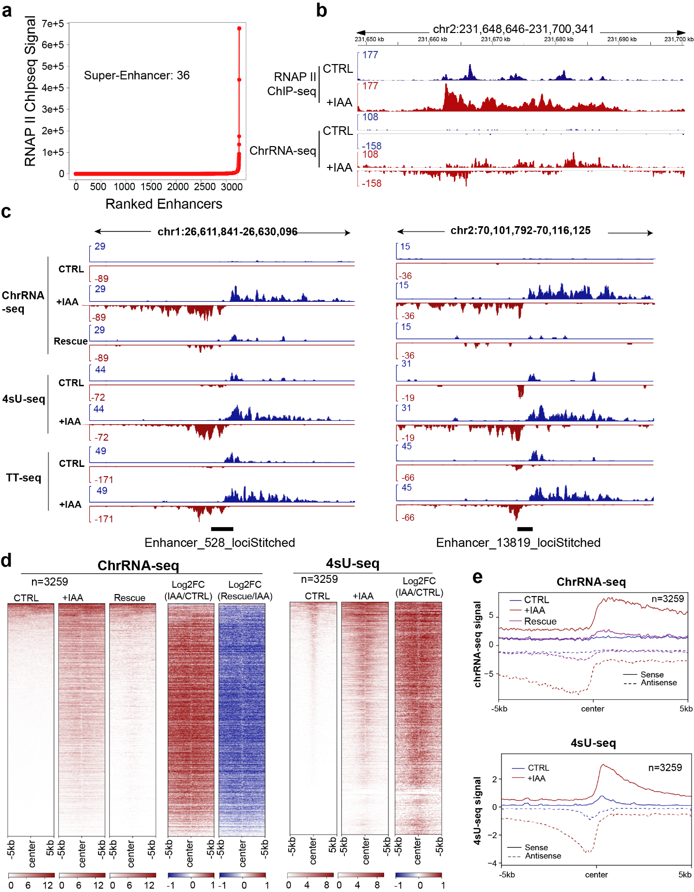

Extended Data Fig. 3 Integrator depletion leads the upregulation of unbiased bi-directional transcription in the enhancer RNA loci.
a. Enhancer and Super-enhancer distribution map calculated by RNAPII ChIP-seq signal in units of reads per million. Enhancers are ranked by the increment of RNAPII ChIP-seq signal. b. IGV tracks of a super-enhancer locus from chrRNA-seq and RNAPII ChIP-seq results before and after INTS11 depletion. c. IGV tracks of chrRNA-seq, 4sU-seq, and TT-seq of two enhancer RNA loci. d. Heatmap of 3,259 enhancer loci. from chrRNA-seq and 4sU-seq results. e. Metagene analysis showing the average occupancy of chrRNA-seq and 4sU-seq signals at 3259 enhancer RNA loci.

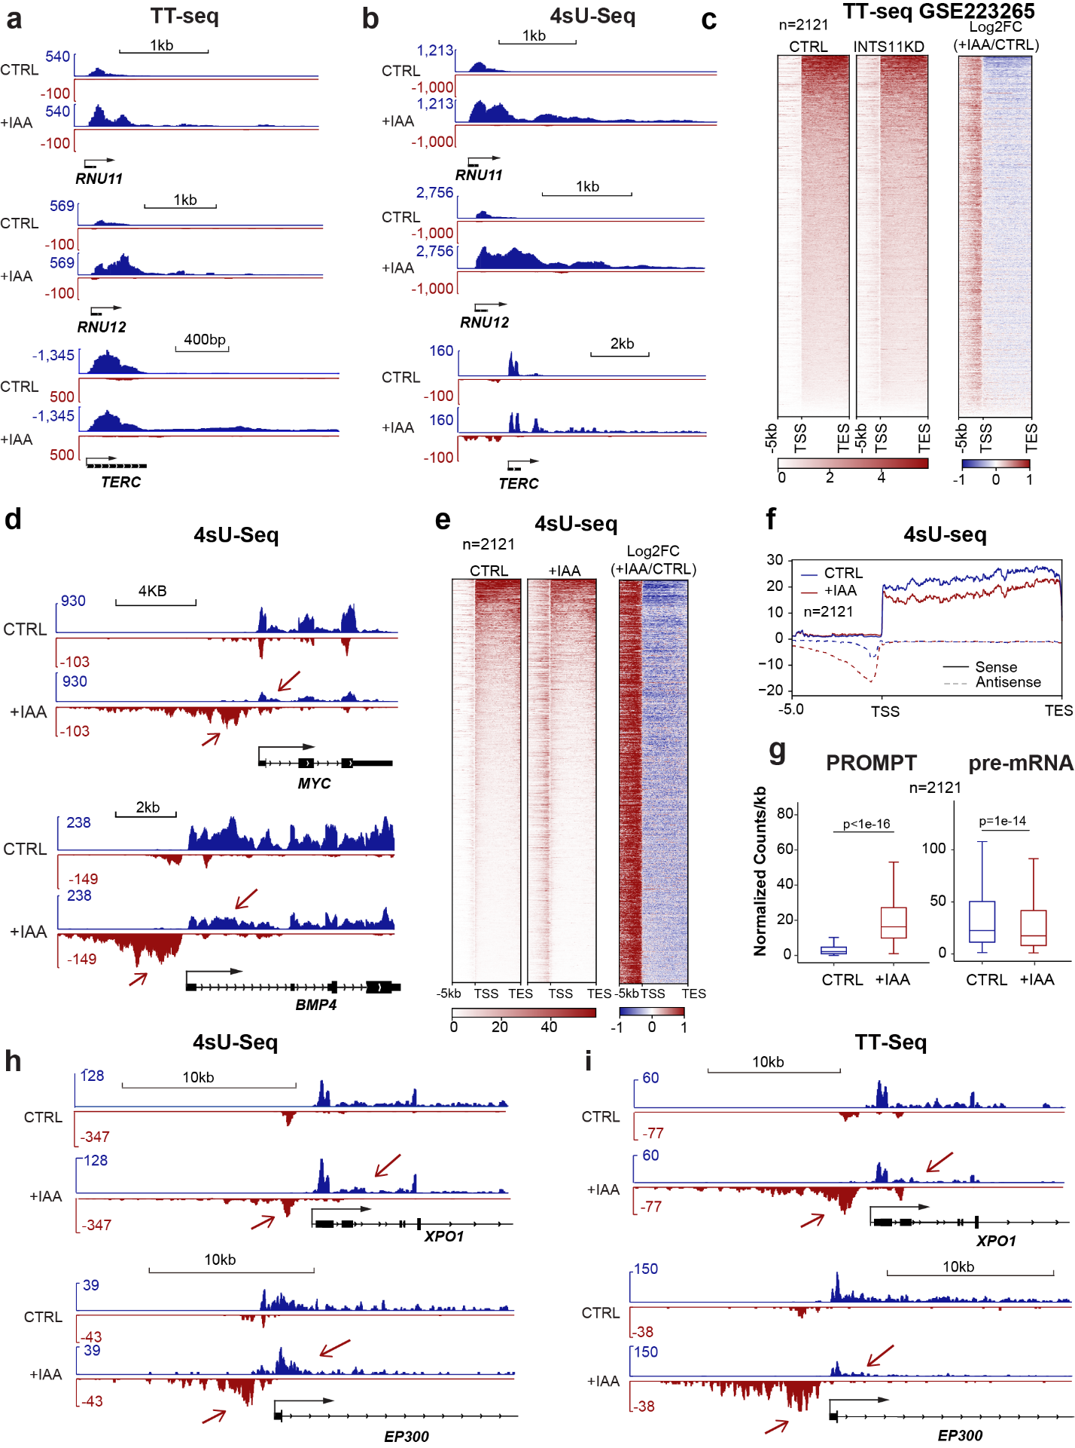
Extended Data Fig. 4 Validation of altered transcriptional change upon INTS11 depletion by 4SU-seq and TT-seq.
a-b. IGV tracks of RNU11, RNU12, and TERC loci from TT-seq and 4sU -seq results before and after INTS11 depletion. c. Heatmap representing the identified 2121 active genes and PROMPTs in GSE223265 TT-seq results (left) and the overlaying heatmap of +IAA / CTRL (right). d. IGV tracks of 4SU-seq representing the PROMPT accumulations at MYC or BMP4 loci. e-f. Heatmap e, and Metagene analysis f, showing accumulated transcripts at PROMPT direction and reduced transcripts at pre-mRNAs direction for 2121 active genes upon INTS11 depletion. g. Quantitative boxplots of transcription distribution at PROMPTs (left) and pre-mRNA (right) from 4SU-seq results. p - value is calculated with Mann-Whitney test. h-i. The IGV track comparison of 4sU-seq h and TT-seq i at XPO1 or EP300 loci upon INTS11 depletion.

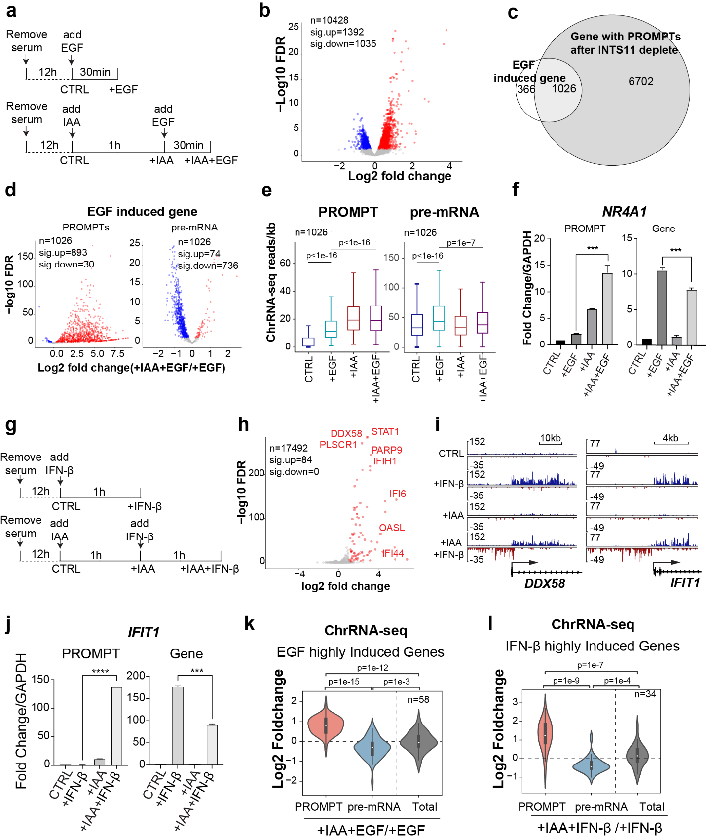
Extended Data Fig. 5 Depletion of INTS11 reduces immediate early responsive gene expression and induces PROMPT accumulation.
a and g. Flow diagram illustrating the EGF / IFN-β induced experiments in INTS11-AID cells. b and h. Selection of immediate responsive genes (FDR<0.05). Volcano plots showing the IEG genes b and IFN-β genes h. c. Venn diagram showing the overlap between EGF-induced IEG genes and genes with PROMPT after INTS11 depletion. d. Volcano plots showing the PROMPT regions with significantly upregulated RNA levels and IEG genes with downregulated pre-mRNA levels upon EGF treatment. In total 1026 IEG genes are included in the analyses. e. Quantitative boxplots of transcription distribution for 1026 EGF-induced IEG genes and their PROMPTs upon INTS11 depletion. f. Quantitative RT-PCR results of the EGF-induced NR4A1 gene and PROMPT locus upon INTS11 depletion. i. IGV tracks of DDX58 and IFIT1 gene loci before and after IFN-β induction with or without INTS11 depletion. j. Quantitative RT-PCR results of the IFN-β induced IFIT1 gene and its PROMPT locus before and after the depletion of INTS11. k-l. IEG genes and their PROMPTs before and after INTS11 depletion. The total represents the combined levels of pre-mRNA and PROMPT fold change for each locus. Mann-Whitney test was used for all statistical analyses. For f and j, unpaired two-tailed student's t-test was used (***) p < 0.001, (****) p < 0.0001. Error bars represent s.e.m. (n = 3 biologically independent experiments).

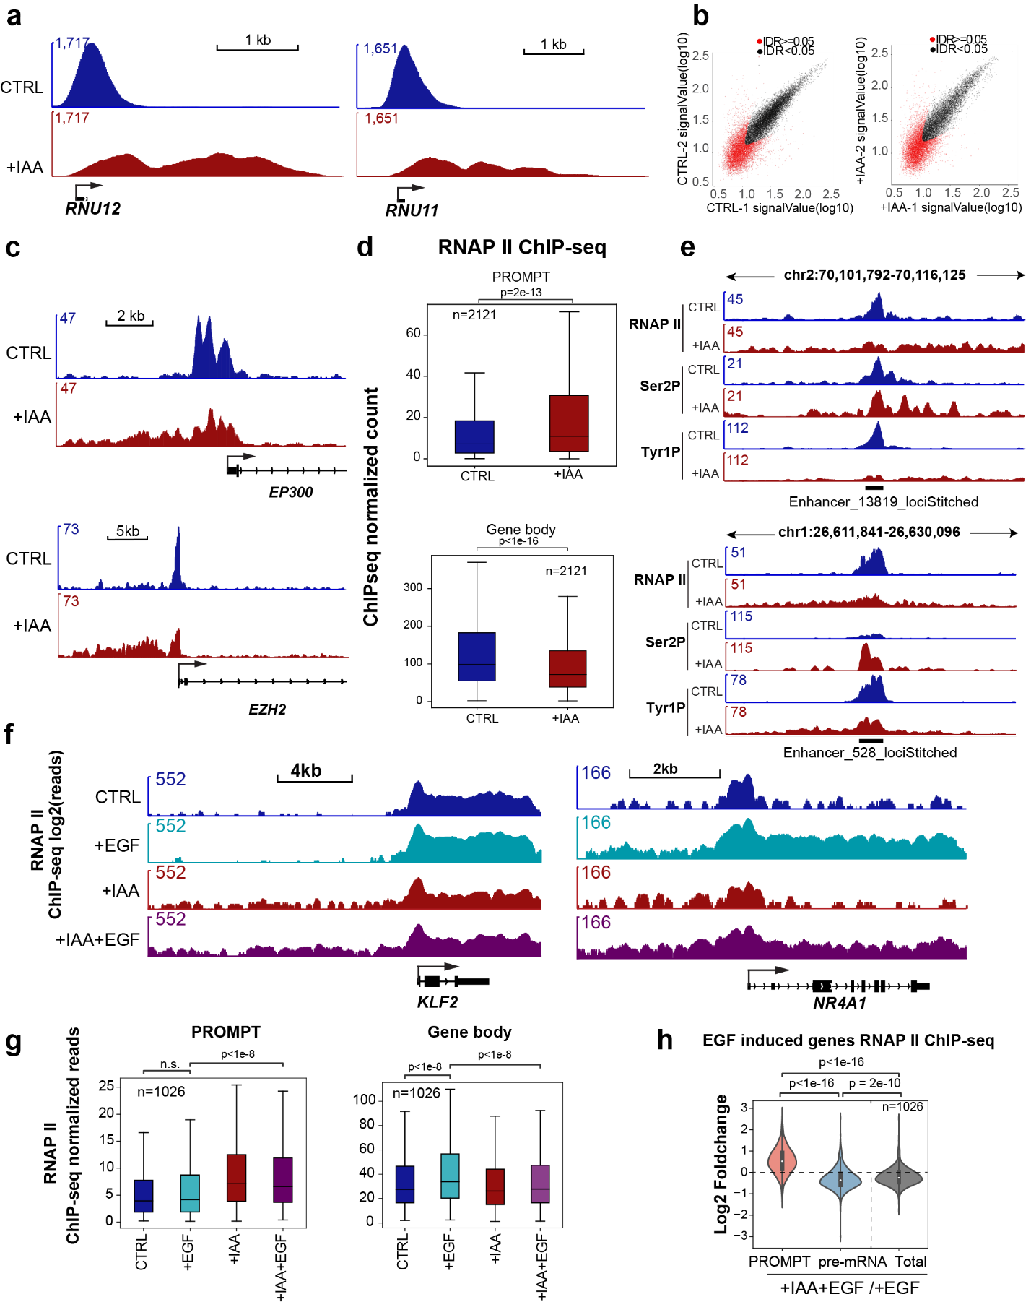
Extended Data Fig. 6 Integrator depletion alters the total RNAP II occupancy at actively transcribed genes.
a. IGV tracks of RNU11 and RNU12 loci from total RNAPII ChIP-seq results after INTS11 depletion. b. Irreproducible discovery rate analysis to test the repeatability of RNAPII ChIP-seq samples. c. IGV tracks of EP300 and EZH2 loci from RNAPII ChIP-seq results upon INTS11 depletion. d. Boxplots of 2121 highly expressed genes RNAPII ChIP-seq signal in PROMPTs (top) and gene bodies (bottom). e. The IGV tracks of total RNAPII, Ser2P, and Tyr1P ChIP-seq results in two enhancers loci upon INTS11 depletion. f. IGV tracks of KLF2 and NR4A1 loci from RNAP II ChIP-seq results upon EGF induction and INTS11 depletion. g. Box plots of RNAPII ChIP-seq signal at the 1026 EGF-induce genes loci (PROMPTs, left; gene bodies, right). h. Violin plot showing the balance of RNAPII occupancies for 1026 EGF induced gene loci after the depletion of INTS11. Mann-Whitney test was used for statistical analyses.

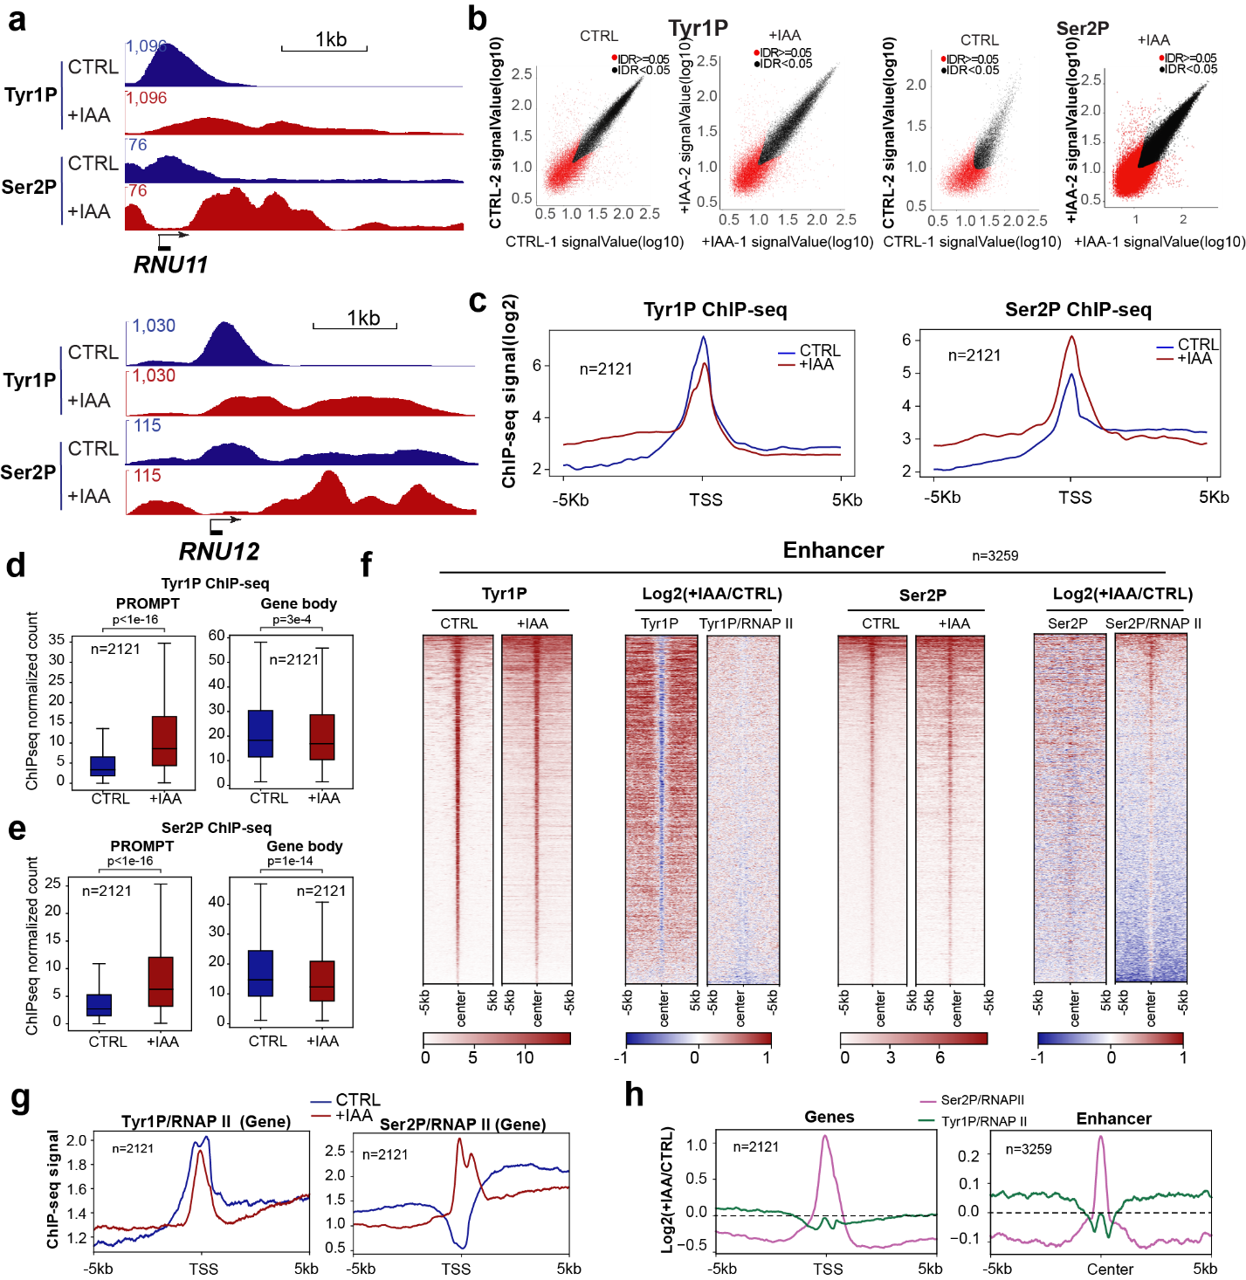
Extended Data Fig. 7 Integrator depletion alters the dynamics of RNAPII-CTD phosphorylation.
a. IGV tracks of RNU11 and RNU12 loci from Tyr1P and Ser2P ChIP-seq results in INTS11-AID cells. (Control samples shown in blue with DMSO treatment, INTS11 KD samples shown in red with IAA treatment). b. Irreproducible discovery rate analyses to test the repeatability of Tyr1P and Ser2P ChIP-seq samples. c. Metagene analysis of Tyr1P and Ser2P ChIP-seq signal (log2) across 2121 highly expressed genes. d-e. Box plots representing the 2121 genes Tyr1P(d) and Ser2P(e) ChIP-seq results in genes and PROMPTs upon INTS11 depletion. Mann-Whitney test was used for statistical analyses. f. Heatmap representing Tyr1P and Ser2P ChIP-seq signal (left) and log2 (+IAA / CTRL) of Ser2P, Tyr1P, Tyr1P / RNAP II and Ser2P / RNAP II (right) at 3259 enhancer sites. g. Metagene analyses of Tyr1P / RNAP II and Ser2P / RNAP II ChIP-seq ratio around 2121 gene TSS sites. h. The comparison of metagene analysis between genes and enhancers.

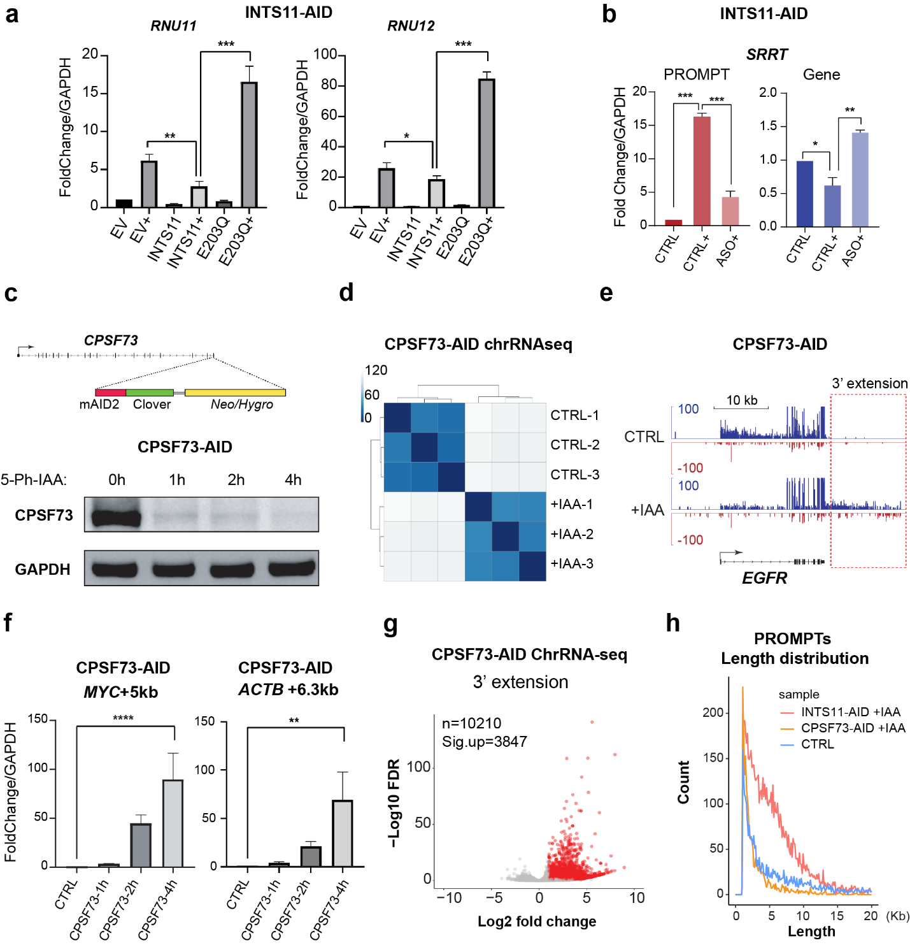
Extended Data Fig. 8 Endonuclease activity of Integrator is specifically required for degrading PROMPTs
a. Quantitative RT-PCR representing the accumulation of 3’ end extension of RNU11 or RNU12 through the ectopic expression of INTS11 or the E203Q mutant. “+” stands for the IAA treatments. b. The accumulation of PROMPTs can be rescued by gapmer ASO specific for the PROMPT of SRRT gene locus, which leads to the recovery of gene expression. (PROMPTs shown in red, gene shown in blue). c. Schematic diagram showing the generation of CPSF73-AID2 cell line (top). Western blot of CPSF73 depletion with the time course after 10 µM of 5-Ph-IAA treatment (bottom). d. CPSF73 ChrRNA-seq results were calculated by Sample-to-sample distances with DESeq2. e. IGV tracks of EGFR locus revealing 3’end extension after CPSF73 depletion. f. Quantitative RT-PCR results representing a 3’extension of MYC or ACTB genes after CPSF73 depletion. g. Volcano plot showing the log2 fold changes of 3847 genes showing significant 3’ extension after CPSF73 depletion (FDR<0.05, FC>1). h. Histogram of PROMPTs (PROMPTs were identified by PROMPT-finder.) length distribution in CTRL, CPSF73 deception, and INTS11 depletion condition. For a, b, and c, unpaired two-tailed student's t-test was used (*) p < 0.05. (**) p < 0.01. (***) p < 0.001. Error bars represent s.e.m. (n = 3 biologically independent experiments).
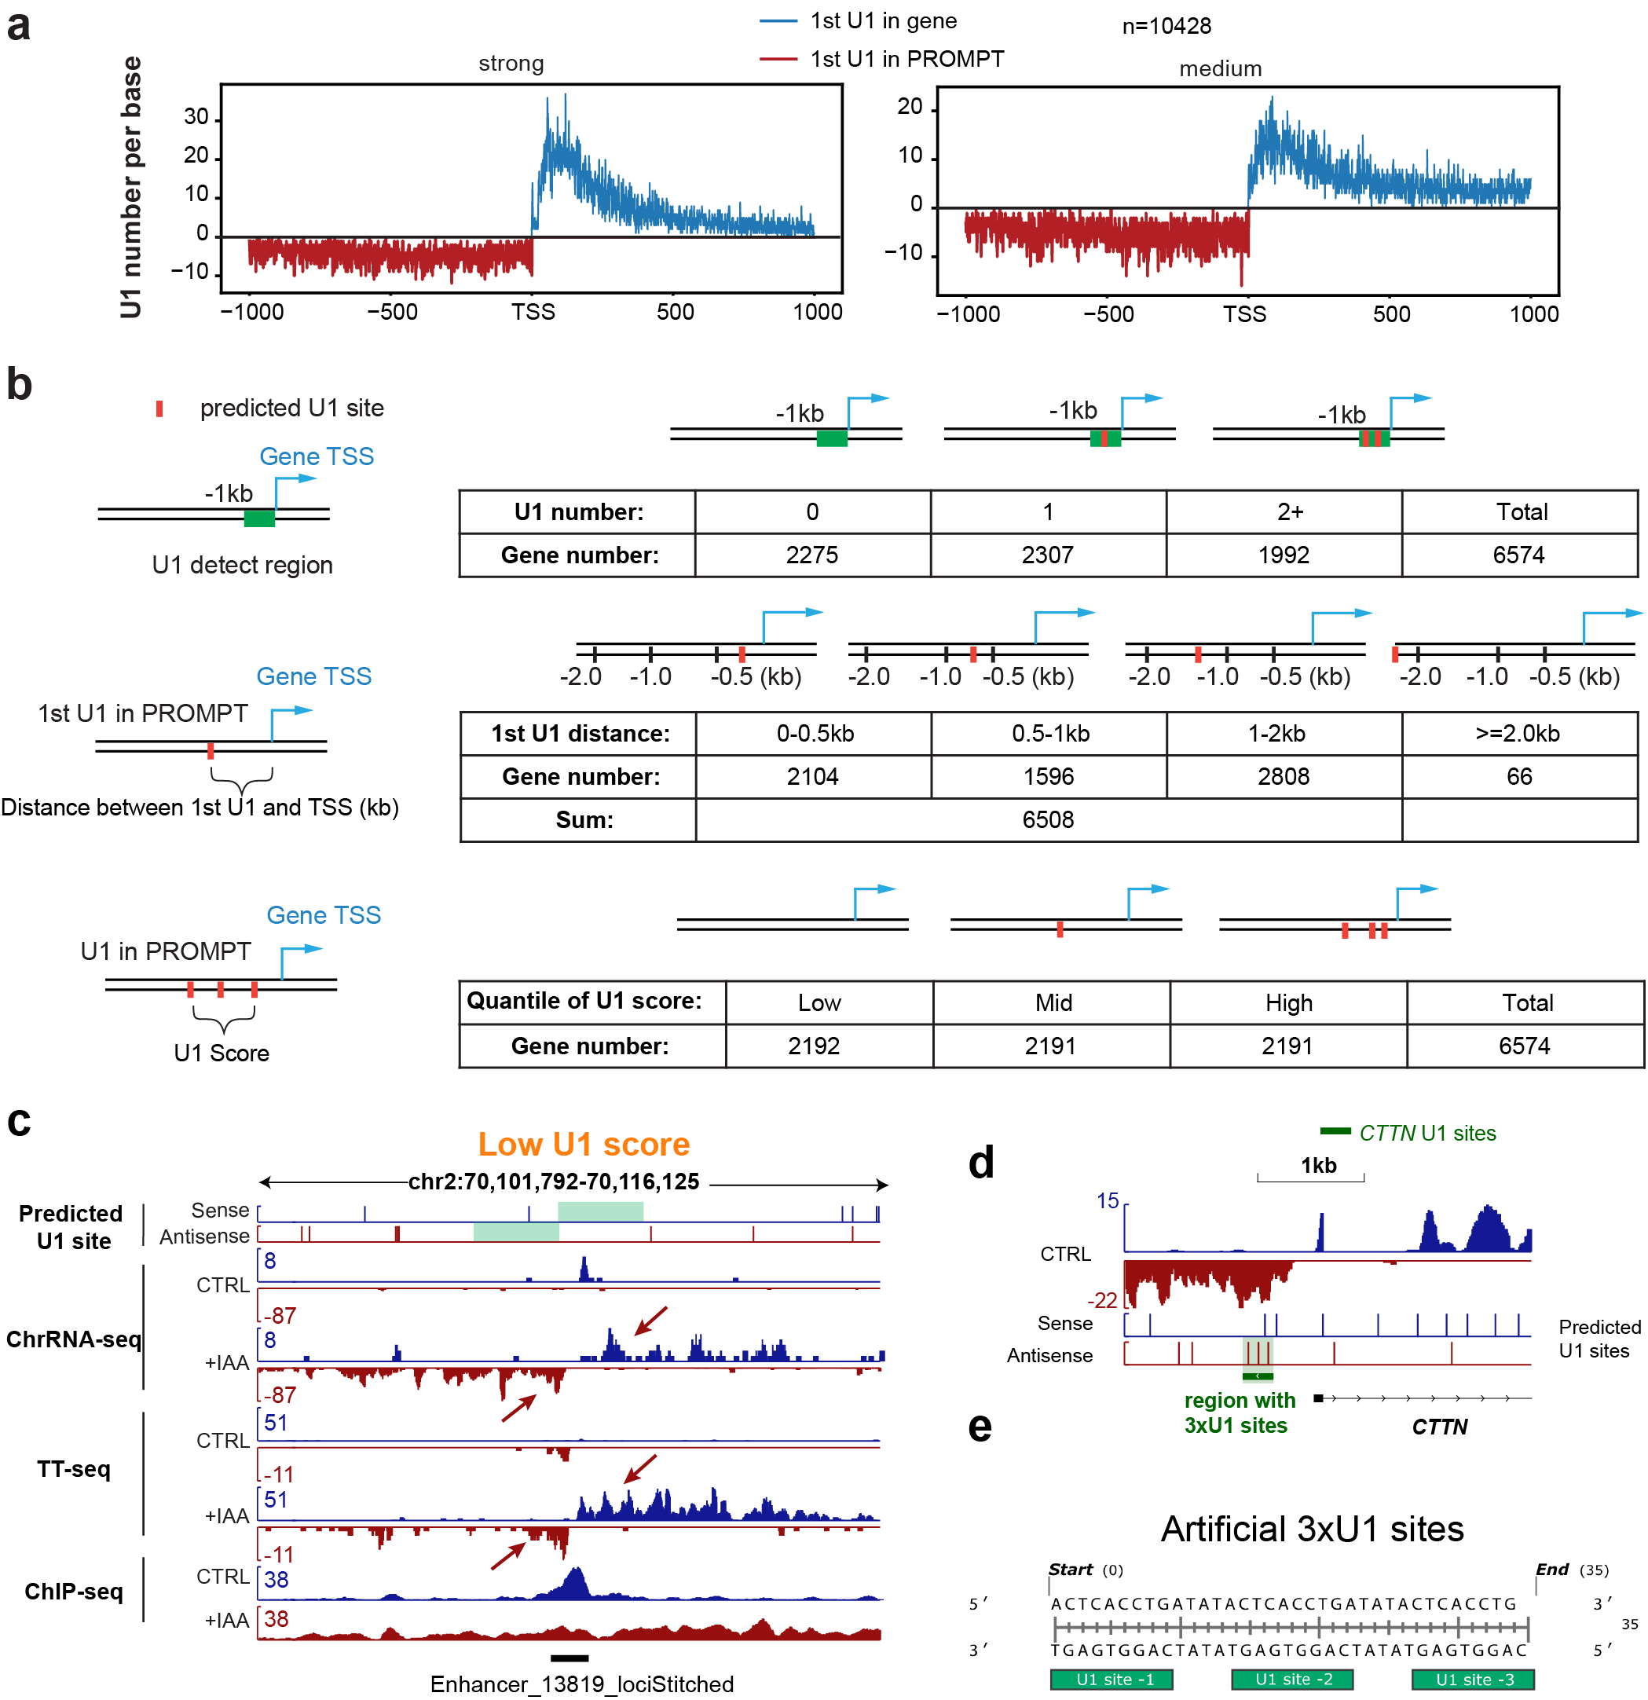
Extended Data Fig. 9 The distribution and characterization of U1 sites in human genome
a. Density of predicted 5’ U1 splice sites within a 1-kb region flanking gene TSS. Strong, medium sites are defined in Methods. b. Definition of U1 sites and distance with TSS. The red bar shows the predicted U1 sites. The green box shown the analyzed region. c. IGV examples of an enhancer locus with low U1 score together with chrRNA-seq, TT-seq, RNAPII ChIP-seq, and predicted U1 site results. d. Schematic diagram of the endogenous 3 x U1 sequence in the CTTN gene PROMPT region. e. The sequence of artificial 3xU1 site sequence. Predicted U1 sites shown as green boxes below.

Supplementary Table 1: List of Plasmids, Cell lines, Antibodies and primers in this study.

