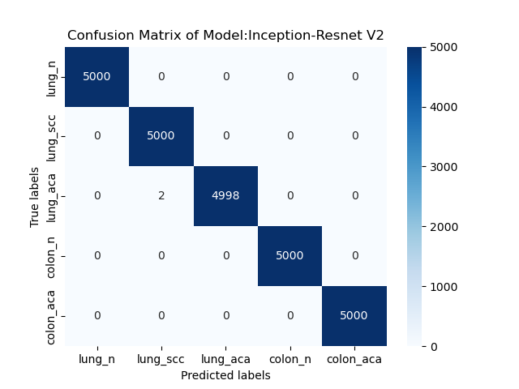
(a)

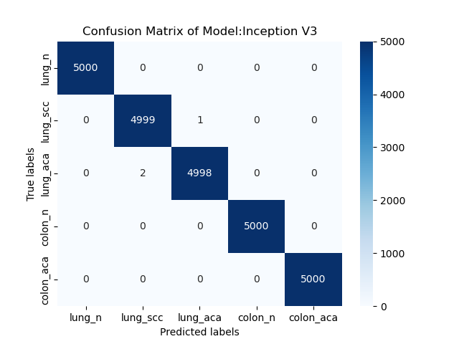
(b)

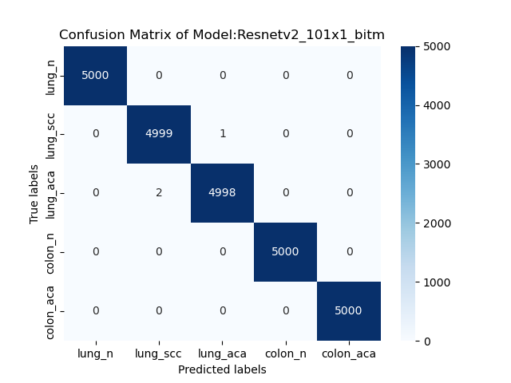
(c)

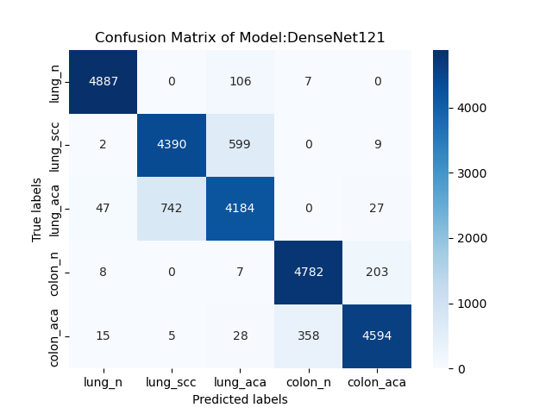
(d)

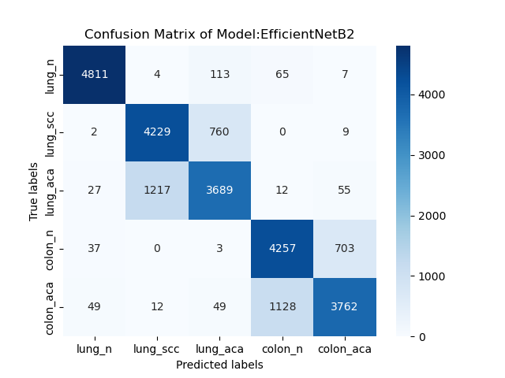
(e)

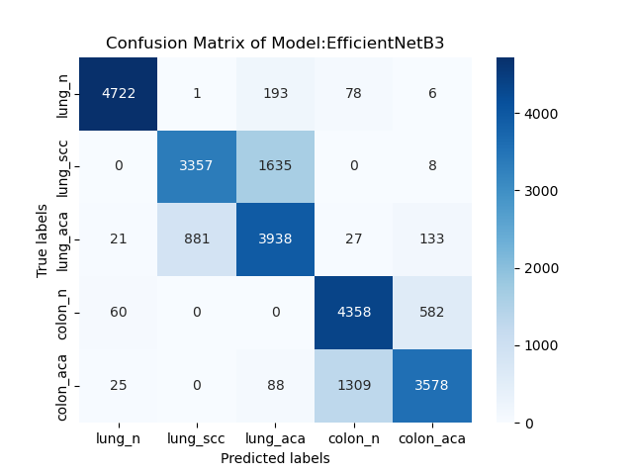
(f)

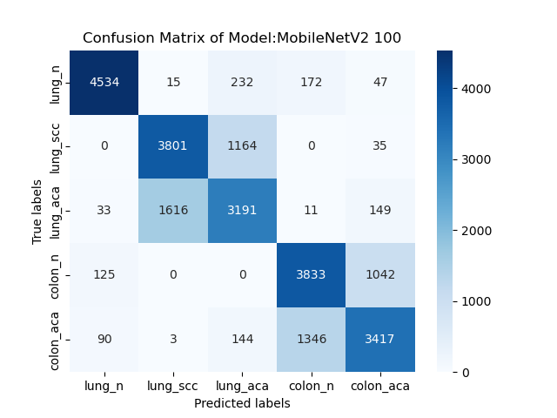
(g)

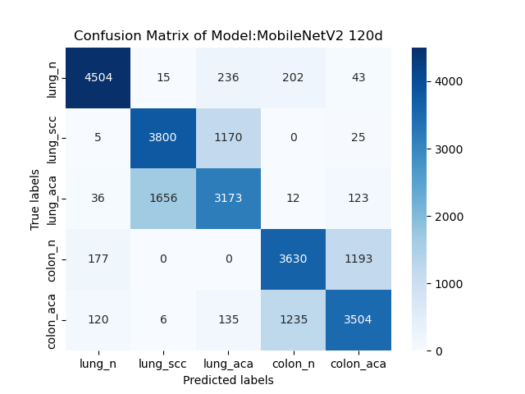
(h)

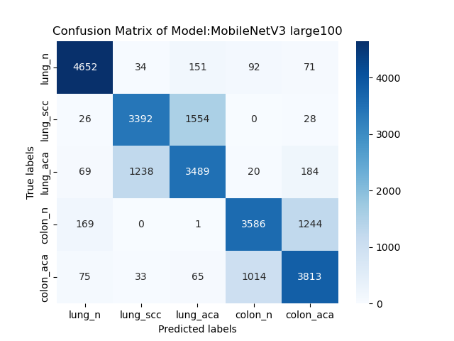
(i)

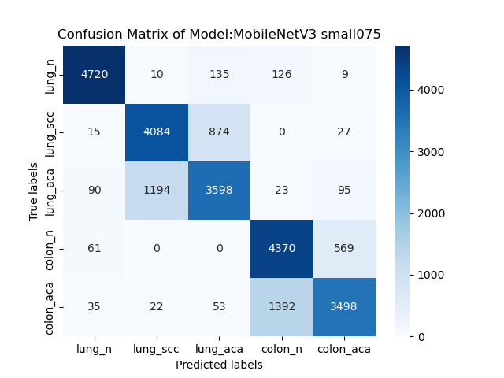
(j)

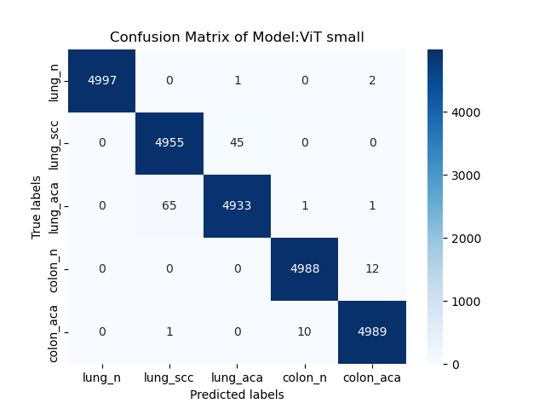
(k)

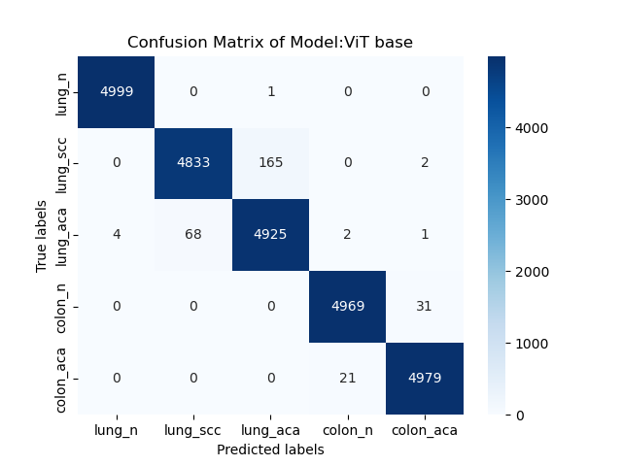
(l)

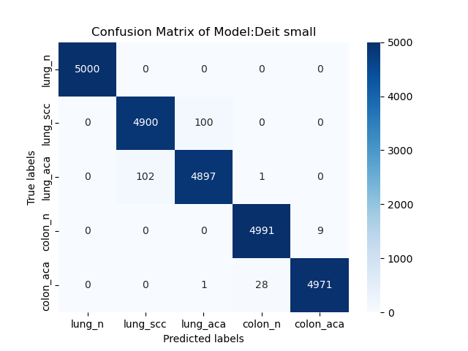
(m)

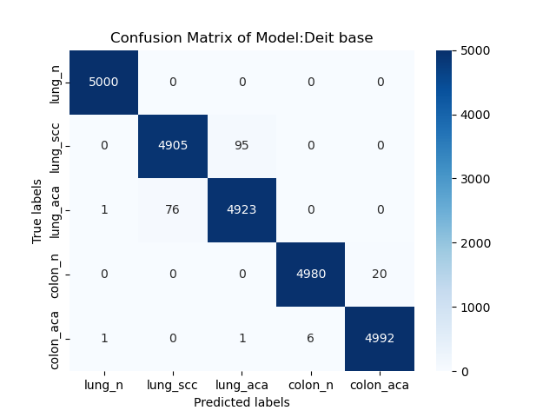
(n)

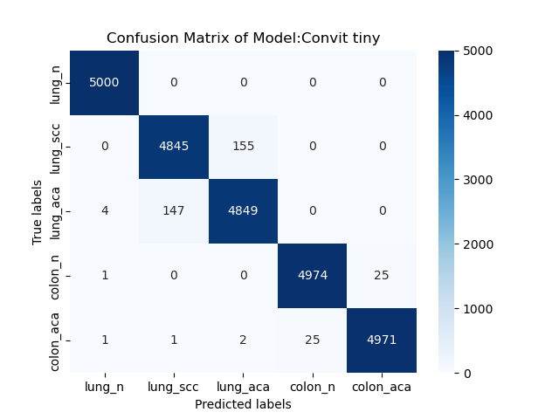
(o)

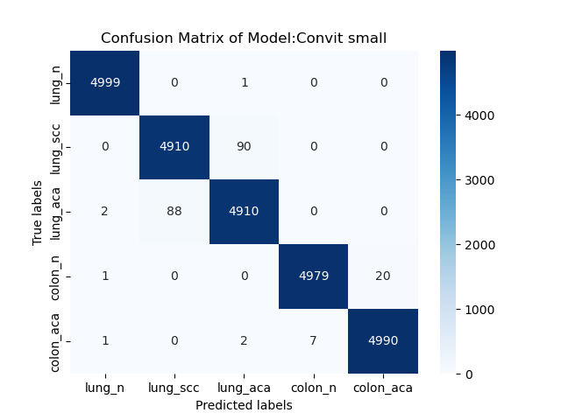
(p)

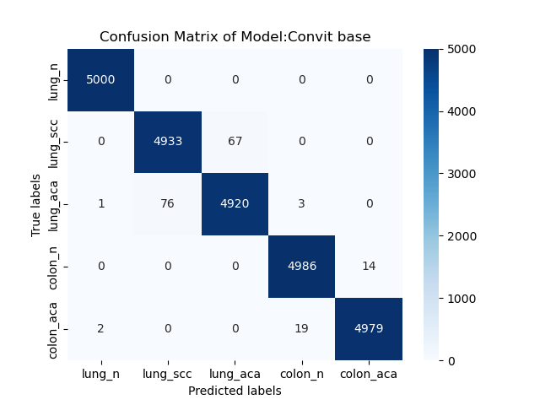
(q)

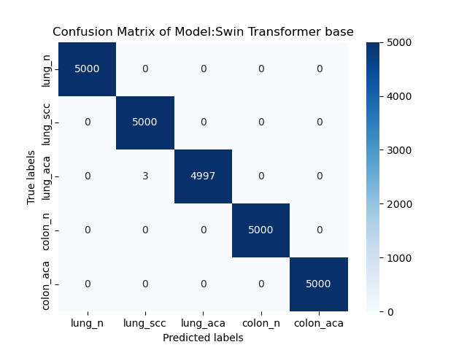
(r)

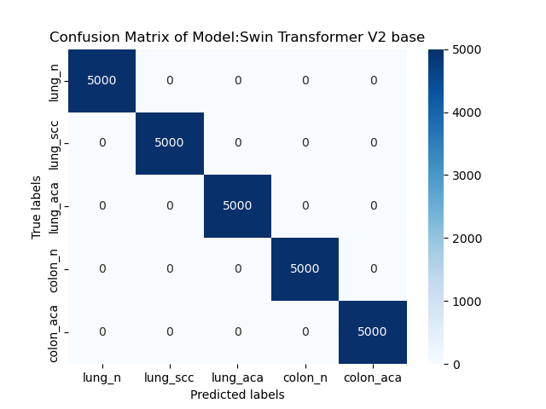
(s)
Figure S1. Confusion matrices of models: (a) Inception-Resnet V2; (b) Inception V3; (c)Resnetv2_101x1_bitm; (d) DenseNet121; (e)EfficientNetB2; (f)EfficientNetB3; (g)MobileNetV2_100; (h)MobileNetV2_100d (i)MobileNetV3_large_100; (j) MobileNetV3_small_075; (k) ViT_small; (l)ViT_base; (m)DeiT_small; (n); DeiT_base(o) ConViT_tiny; (p)ConViT_small; (q)ConViT_base; (r)Swin Transformer base; (s) Swin Transformer V2 base;

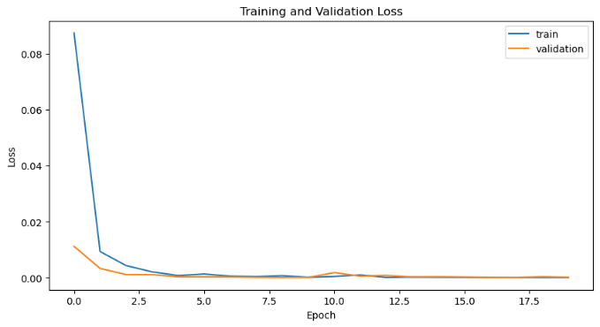
(a)

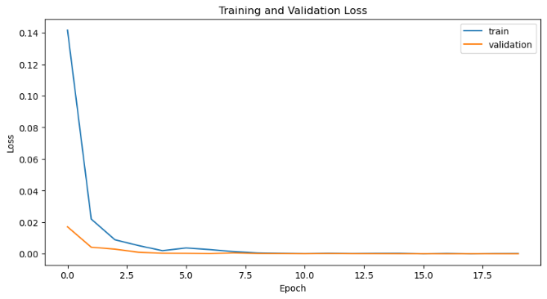
(b)

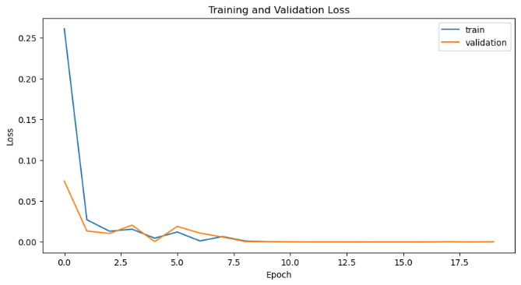
(c)

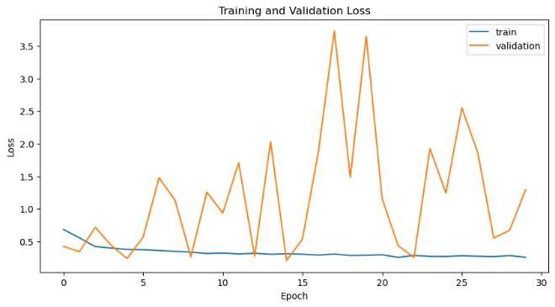
(d)

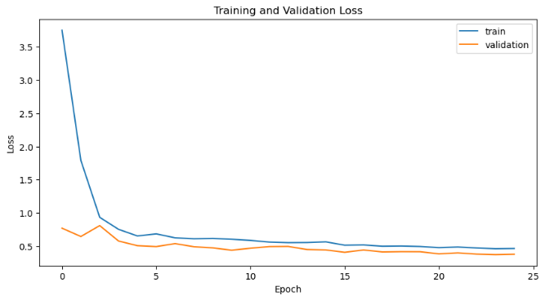
(e)

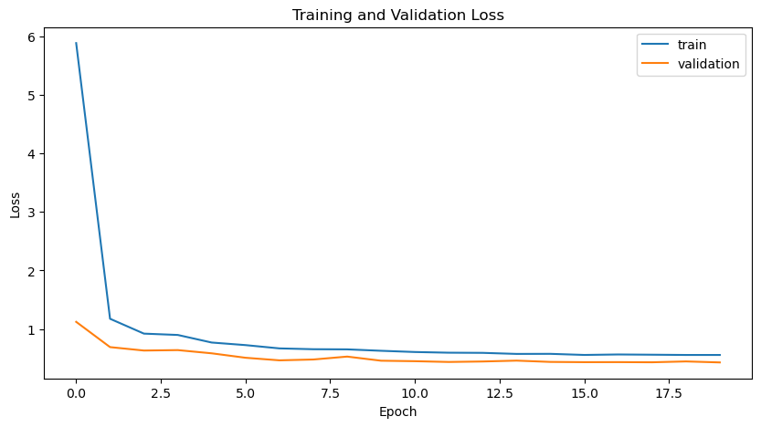
(f)

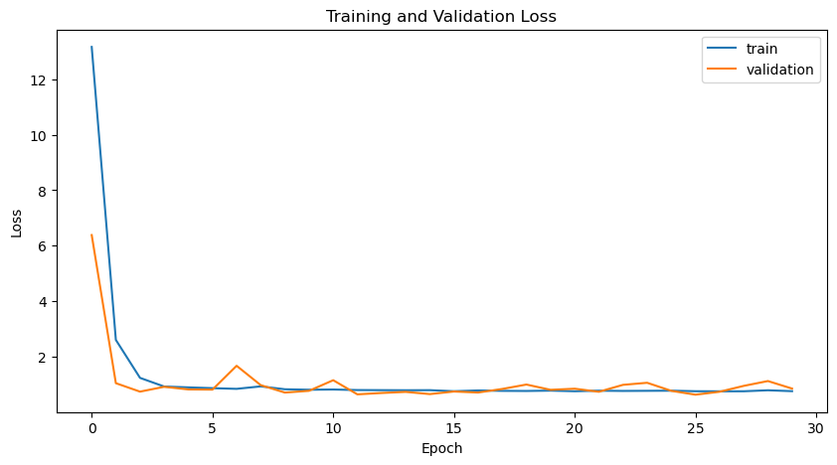
(g)

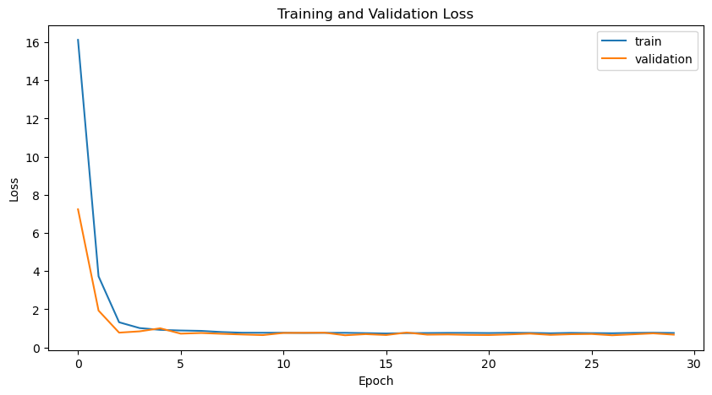
(h)

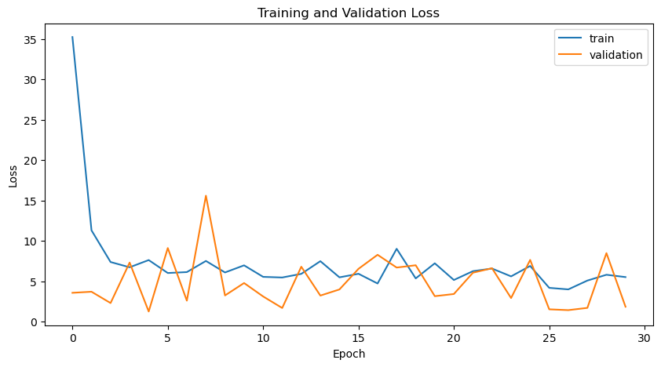
(i)

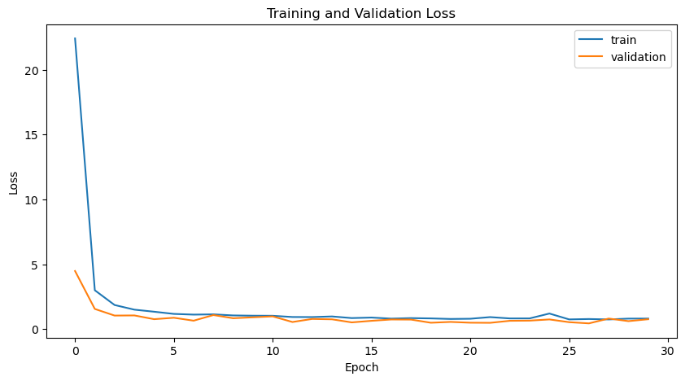
(j)

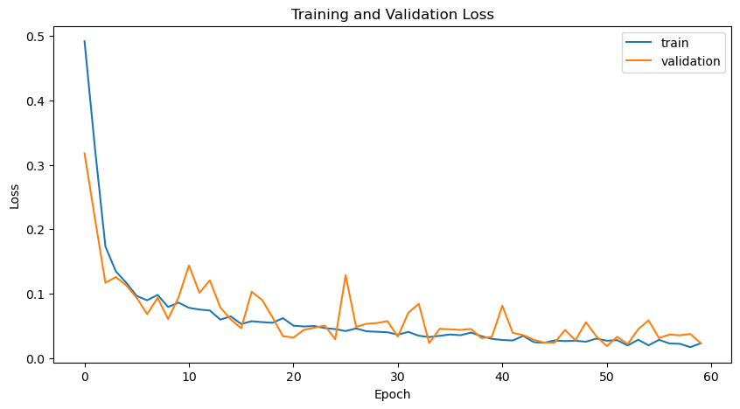
(k)

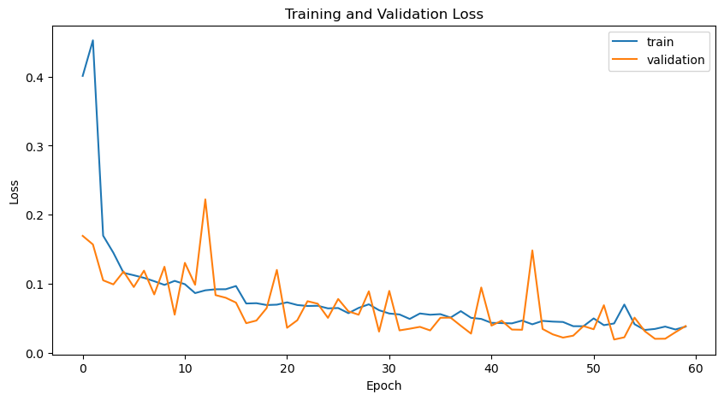
(l)

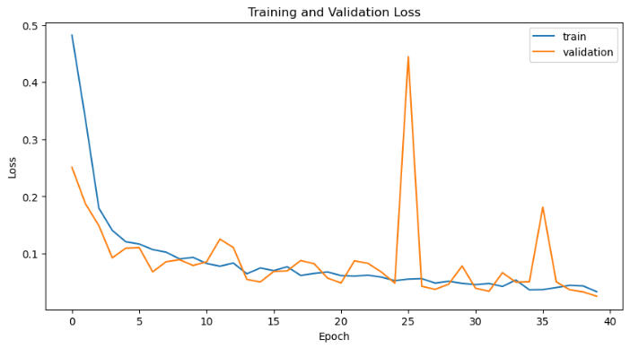
(m)

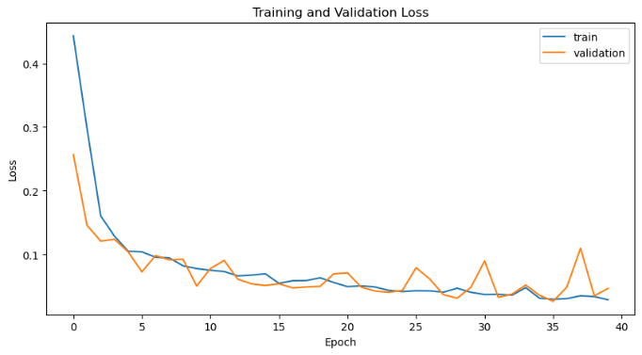
(n)

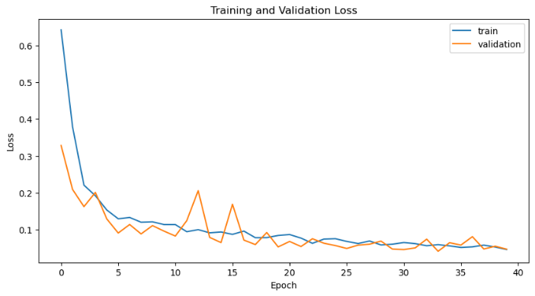
(o)

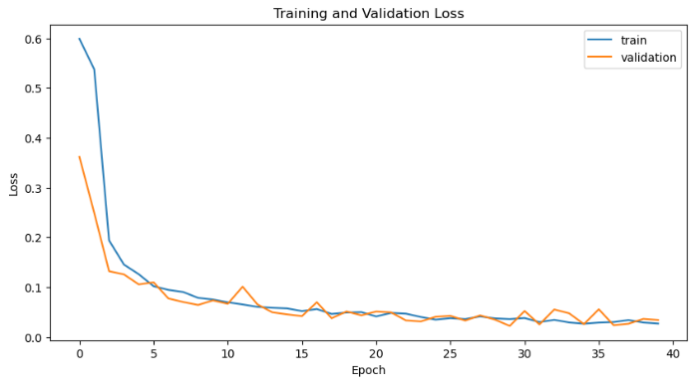
(p)

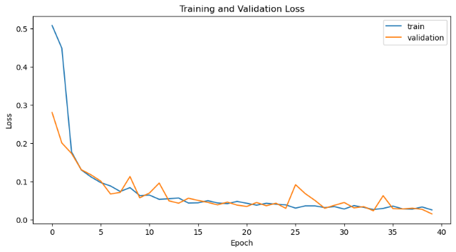
(q)

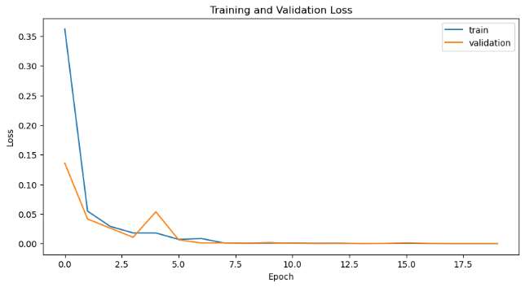
(r)

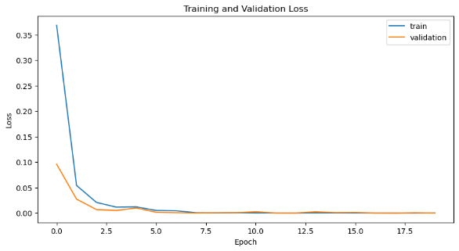
(s)

Figure S2. Training and validation losses of different models. For every model the loss graph is randomly selected from one data split training. (a)Inception-Resnet V2; (b)Inception V3; (c)Resnetv2_101x1_bitm; (d)DenseNet121; (e)EfficientNetB2; (f)EfficientNetB3; (g)MobileNetV2_100; (h)MobileNetV2_100d (i)MobileNetV3_large_100; (j) MobileNetV3_small_075; (k) ViT_small; (l)ViT_base; (m) DeiT_small; (n) DeiT_base; (o) ConViT_tiny; (p) ConViT_small (q)ConViT_base;(r)Swin Transformer base; (s) Swin Transformer V2 base;

