Tribological study of Ni-Cr-5Al₂O₃ thermal spray coating: A comparison of post processing techniques
Mayank Garg¹, Harpreet S Grewal¹, Harpreet Singh Arora ^{1*}
¹Surface Science and Tribology Lab, Department of Mechanical Engineering, Shiv Nadar University, Uttar Pradesh, India 201314
*Corresponding author email: harpreet.arora@snu.edu.in

List of Supplementary Figures

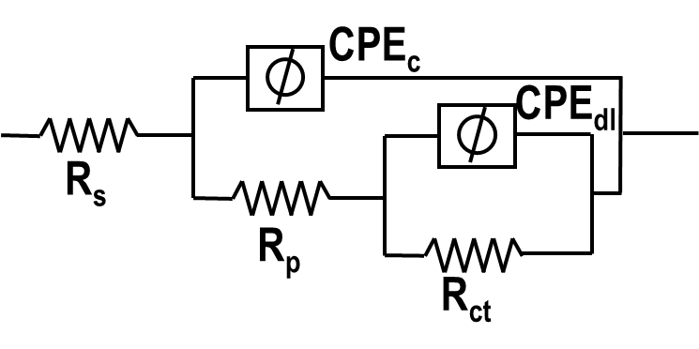
Fig. S1: Electrical equivalent circuit (EEC) diagram for fitting of impedance spectra

