Supporting information for

Core-shell NH₂-UIO-66@iCOFs with built-in “adsorption engines” for improving CO₂ adsorption and conversion
Ping Liu,ª Kaixing Cai,ª Peng Chen,ª Duan-Jian Tao,^{b} and Tianxiang Zhao^{a,}*
ªKey Laboratory of Green Chemical and Clean Energy Technology, School of Chemistry and Chemical Engineering, Guizhou University, Guiyang 550025, P. R. China
^{b}College of Chemistry and Chemical Engineering, Jiangxi Normal University, Nanchang 330022, P. R. China
*Corresponding author: txzhao3@gzu.edu.cn (T. X. Zhao)

1.1 Materials and measurements
2-amino-terephthalic acid (NH₂-BDC), zirconium tetrachloride (ZrCl₄), terephthalaldehyde, acetic acid and ammonium chloride were purchased in energy chemicals. N, N-dimethylformamide (DMF), tetrahydrofuran (THF), acetone Ethanol and methanol were provided by Chengdu Jinshan Chemical Reagent Co., Ltd. CO₂ (99.99%), N₂ (99.999%) were purchased from Sanhe Gases, Guiyang. All reagents were used directly without further processing unless otherwise specified.
Scanning electron microscopy (SEM, Quanta FEG 650) and high-resolution transmission electron microscopy (TEM, FEI G2 F20) were used to investigate the morphology and pore channels of the materials.¹H NMR was characterized on JNM-ECZ-400 spectrometer at 400 MHz. Fourier Transform infrared (FTIR) spectroscopy was used for material characterization on the Nicolet 50 FTIR Advanced spectrometer (Thermo Fisher Scientific, USA). The hybrid material ¹³C MAS NMR was characterized by Bruker 400M. The crystal structure of the material was studied by X-ray diffraction (XRD) (D8 advanced). X-ray photoelectron spectroscopy (XPS) (K-Alpha Plus) was used to determine the surface element composition and bond energy analysis of the hybrid materials. Thermogravimetric analysis (TGA) (TG 209F1Libra) was used to analyze the thermal stability of the materials. Nitrogen adsorption and desorption isotherms at 77 K were measured with BSD-PM2 to study pore properties. The sample was degassed at 393.2 K for 8 h, and the yield of cyclic carbonate was determined by Shimadzu GC-2014 gas chromatography and ¹H NMR.

1.2 Preparation of MOF, COF and M@iCOFs
Preparation of NH₂-UIO-66: 163 mg of NH₂-BDC and 208 mg of ZrCl₄ were dissolved in 35 ml of DMF. 12 ml of acetic acid was added to the mixture. Ultrasonic treatment was continued for about 30 min until the solids were completely dissolved. The mixture was then transferred to a 100 ml teflon-lined autoclave and heated at 120ºC for 24 h. After cooling to room temperature, the precipitate is separated from the reaction mixture by centrifugation and thoroughly cleaned with DMF and ethanol to remove unreacted reactants. Finally, the pink solid was obtained by vacuum drying at 60ºC for 24 h.
Preparation of iCOF: Terephthalaldehyde (250 mg), ammonium chloride (400 mg), and 3 ml DMF were added to 25 ml Shrek tube. Close screw cap of sample bottle and cover with teflon tape. The mixture was then allowed to react at 120ºC for 72 h. The yellow sediment is collected, filtered, and then washed repeatedly with water, methanol, acetone, and chloroform. The resulting powder was dried overnight under a vacuum of 60ºC.
Preparation of M@iCOF: 250 mg terephthaldehyde was added to 3 mL DMF for complete ultrasonic dissolution. Then 50 mg NH₂-UIO-66 was added for another 20 min for further ultrasonic dissolution to make the mixture into a uniform suspension. Then, 400 mg ammonium chloride was added into the above suspension and the ultrasound was continued for 10 min. It was then frozen in a liquid nitrogen bath, degassed 3 times by freezing pump-thawing, then sealed and reacted at 120ºC for 3 days. Yellow precipitates were obtained by filtration, DCM, THF, acetone and methanol washing. The products were further purified by tetrahydrofuran and methanol in a Soxhlet extractor for 24 h and vacuum dried at 60ºC for 24 h before collection, named M@iCOF-400. By changing the dosage of terephthaldehyde and ammonium chloride, M@COFs of different shell thickness was prepared. When the mass ratio of terephthaldehyde to ammonium chloride was 125 mg : 200 mg, 94 mg : 150 mg, 62.5 mg : 100 mg, 31.3 mg: 50 mg, the prepared NH₂-UIO-66@iCOFs were named M@iCOF-200, M@iCOF-150, M@iCOF-100 and M@iCOF-50, respectively.
1.3 Gas adsorption
The adsorption isotherms of CO₂ and N₂ at 273K were determined by BSD-PM2 high pressure gas adsorption apparatus after the polymer was degassing at 120ºC for 8 h. The relative pressure (p/p₀) changed from 0.02 to 1 bar.
1.4 Isosteric heats (Q_{st)} calculation of CO₂ adsorption
The isosteric heats (Q_{st}) were calculated from the isotherms at 273 and 298 K using the Clausius-Clapeyron equation (S1):
(S1)
where R is the gas constant (R=8.314 J·(K·mol)⁻¹), T₁ and T₂ are the adsorption temperature, P₁ and P₂ represent equilibrium pressure (p/p₀).
1.5 CO₂ conversion
Typical preparation of cyclic carbonate: In a 50 mL stainless steel autoclave, 10 mmol of epichlorohydrin and 20 mg of M@iCOF-400 were added. The reactor was purged three times with CO₂ and then injected with 0.1 MPa of CO₂, followed by the reaction at 120ºC for 8 h. After the reaction was completed, the autoclave was cooled to room temperature and the excess CO₂ was slowly discharged out from the reactor. The cyclic carbonate and unreacted epoxide were extracted with ethyl acetate and the yield of cyclic carbonate was determined by centrifugation operation to obtain the supernatant. The yield of cyclic carbonate was calculated using Shimadzu GC-2014 gas chromatography and ¹H NMR.
M@iCOF-400 reusability process: The cycling performance of M@iCOF-400 was tested under optimized conditions using epichlorohydrin as a substrate. At the end of each cycle, the product was extracted with added ethyl acetate followed by centrifugation to separate the catalyst from the organic phase. The separated catalyst was washed with methanol and dried in an oven at 60ºC for six hours, followed by the next catalytic cycle.
1.6 Activation energy calculation procedure
Using the Arrhenius equation (S2), the activation energy of the cycloaddition reaction can be calculated from the relationship between the observed rate constant (k_{obs}) and the absolute temperatures (Figure S1). The detailed calculation process can be referred to our previous work [1].
(S2)

Figure S1. SEM images of various M@iCOFs and iCOF.

Figure S2. (a) CO₂ uptake isotherms in 298 K

Figure S3. First-order kinetic plots ln[ECH] versus time at different temperatures. (a) iCOF; (b) M@iCOF-400; curve fitting of lnk_{obs} against 1/T (c) iCOF (d) M@iCOF-400.

Figure S4. (a) the hot filtration experiment of M@iCOF-400; (b) fourier transform infrared (FTIR) spectra; (c) N₂ adsorption-desorption isotherms; and (d) pore distribution of M@iCOF-400 before and after cycling.

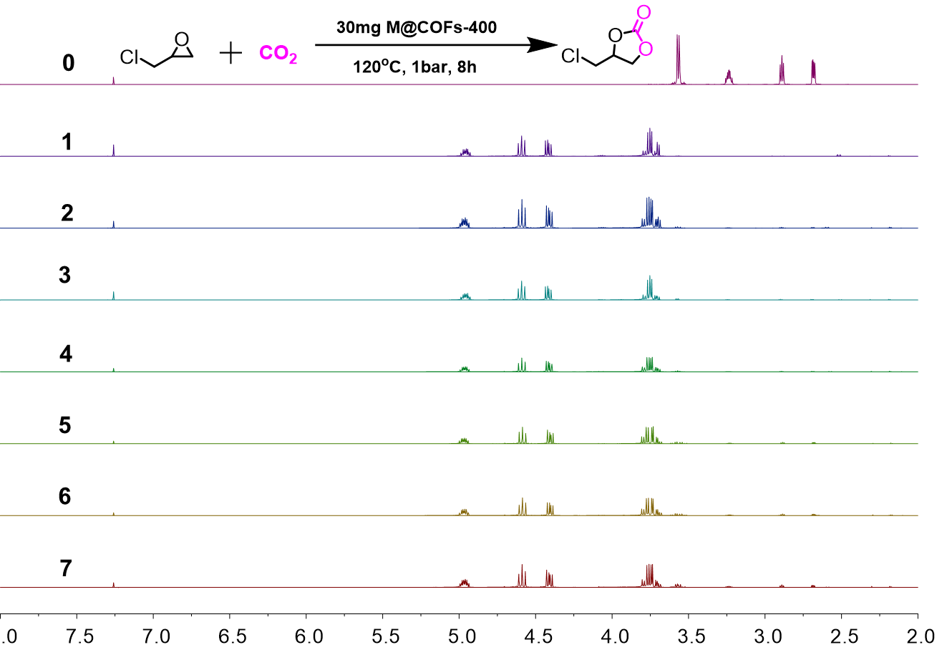
Figure S5. ¹HNMR of seven cycles of the catalyst.

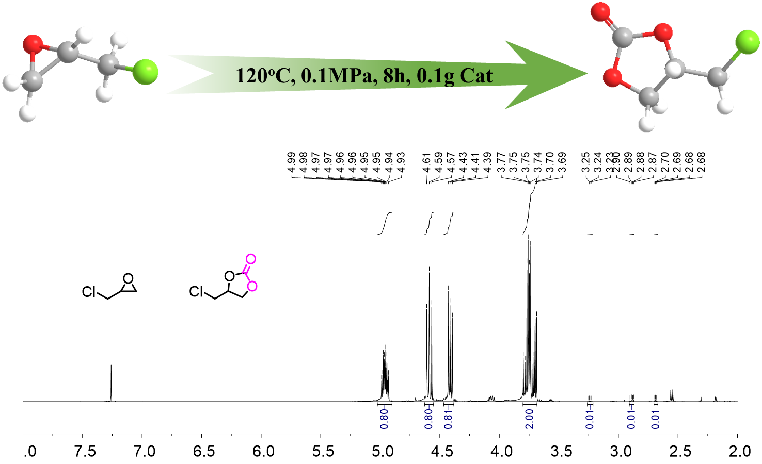
Figure S6. ¹H NMR of the chloropropene carbonate synthesized by gram-scale experiment.

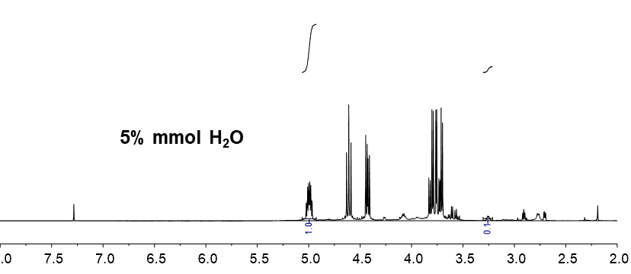
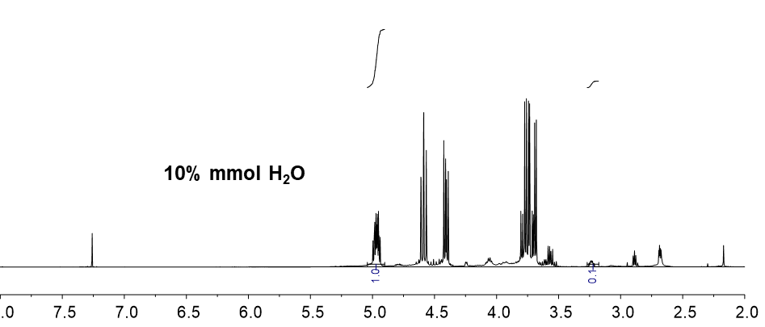
Figure S7. effect of water on the synthesis of M@iCOF-400.

Figure S8. ¹HNMR spectra (in CDCl₃) of the reaction mixture using M@iCOF-400 as a catalyst for the cycloaddition reaction of 1,2-epoxybutane (¹H NMR spectrum was obtained from the crude sample).
Figure S9. ¹HNMR spectra (in CDCl₃) of the reaction mixture using M@iCOF-400 as a catalyst for the cycloaddition reaction of 1,2-epoxyhexane (¹H NMR spectrum was obtained from the crude sample).

Figure S10. ¹HNMR spectra (in CDCl₃) of the reaction mixture using M@iCOF-400 as a catalyst for the cycloaddition reaction of epibromohydrin (¹H NMR spectrum was obtained from the crude sample).
Figure S11. ¹HNMR spectra (in CDCl₃) of the reaction mixture using M@iCOF-400 as a catalyst for the cycloaddition reaction of glycidyl isopropyl ether (¹H NMR spectrum was obtained from the crude sample).

Figure S12. ¹HNMR spectra (in CDCl₃) of the reaction mixture using M@iCOF-400 as a catalyst for the cycloaddition reaction of butyl glycidyl ether (¹H NMR spectrum was obtained from the crude sample).

Figure S13. ¹HNMR spectra (in CDCl₃) of the reaction mixture using M@iCOF-400 as a catalyst for the cycloaddition reaction of allyl glycidyl ether (¹H NMR spectrum was obtained from the crude sample).

Figure S14. ¹HNMR spectra (in CDCl₃) of the reaction mixture using M@iCOF-400 as a catalyst for the cycloaddition reaction of glycidyl phenyl ether (¹H NMR spectrum was obtained from the crude sample).
Figure S15. ¹HNMR spectra (in CDCl₃) of the reaction mixture using M@iCOF-400 as a catalyst for the cycloaddition reaction of benzyl glycidyl ether (¹H NMR spectrum was obtained from the crude sample).

Figure S16. ¹HNMR spectra (in CDCl₃) of the reaction mixture using M@iCOF-400 as a catalyst for the cycloaddition reaction of 1,2-epoxy-4-vinylcyclohexane (¹H NMR spectrum was obtained from the crude sample).

Table S1. Structure parameters of iCOF, NH₂-UIO-66, and M@iCOFs
Sample | S_{BET}(m²∙g^{–1})ª | V_{total}(cm³∙g^{–1})^{b} | V_{micro}(cm³∙g^{–1})^{d} | V_{ultra}(cm³∙g^{–1})^{e}
iCOF | 11 | 0.025^{c} | 0.003
NH₂-UIO-66 | 1003 | 0.547 | 0.501 | 0.493
M@iCOF-50 | 521 | 0.300 | 0.261 | 0.256
M@iCOF-100 | 162 | 0.119 | 0.080 | 0.077
M@iCOF-150 | 61 | 0.067^{c} | 0.029 | -
M@iCOF-200 | 45 | 0.056^{c} | 0.021 | -
M@iCOF-400 | 20 | 0.034^{c} | 0.008 | -
ªThe surface area was calculated by using the BET model. ^{b}The total pore volume was calculated at p/p₀ = 0.99. ^{c}The was calculated by using the BJH method. ^{d}The micropore area (d<2 nm) was calculated by using the non-local density functional theory (NLDFT) method. ^{e}The ultramicropore volume (d<0.7 nm) was calculated by using H-K(Original) model.

Table S2. Comparison of the catalytic activities of catalysts.
Entry | Catalyst | Yield(%)ª | Cl⁻ content(%) | Cl⁻ content (mmol∙g^{–1}) | TON
1 | iCOF | 74 | 3.59 | 1.01 | 365
2 | NH₂-UIO-66 | 13 | - | - | -
3 | M@iCOF-50 | 37 | 1.42 | 0.40 | 462
4 | M@iCOF-100 | 60 | 2.32 | 0.65 | 458
5 | M@iCOF-150 | 75 | 2.41 | 0.68 | 552
6 | M@iCOF-200 | 92 | 2.77 | 0.78 | 589
7 | M@iCOF-400 | 98 | 3.49 | 0.98 | 498
Reaction conditions: epichlorohydrin (10 mmol), catalyst (20 mg), CO₂ (0.1 MPa), 8 h, 120°C. ªDetermined by GC. ^{b}Ionic content was calculated based on the average of three XPS measurements.

Table S3. Comparison of CO₂ adsorption and conversion capacity of different hybrid materials.
Catalyst | Cocatalyst/solvent | T(ºC) | CO₂(MPa) | t(h) | Yield(%) | CO₂ uptake(mmol·g⁻¹)ª | TON | Ref.
Cu₃(BTC)₂@iPOF-TM-Br⁻ (0.27 mmol) | - | 60 | 0.5 | 24 | 95.1 | 10.3 | - | [2]
PPIL@COF^{A}-20 (15 mg) | - | 100 | 2 | 24 | 94 | 1.41 | 922 | [3]
M-41/CN(b)-RF (50 mg) | CH₃CN | 140 | 0.8 | 12 | 77.8 | - | 532 | [4]
polyILs@MIL-101 (100 mg) | CH₃CN | 70 | 0.1 | 24 | 94 | 4.60 | - | [5]
SiO₂@ZIF-67 (50 mg) | n-Bu₄NBr | 80 | 2 | 24 | 96 | - | - | [6]
NH₂-UiO-66@Br-COF-4 | - | - | - | - | - | 3.85 | - | [7]
PIL-HPCOF-320-10-100 (15 mg) | - | 90 | 1 | 24 | 95 | 0.73 | 240 | [8]
iCOF | - | 120 | 0.1 | 8 | 74 | 0.79 | 365 | This wok
M@iCOF-50 (20 mg) | - | 120 | 0.1 | 8 | 37 | 3.33 | 462 | This wok
M@iCOF-200 (20 mg) | - | 120 | 0.1 | 8 | 92 | 2.08 | 589 | This wok
M@iCOF-400 (20 mg) | - | 120 | 0.1 | 8 | 98 | 1.52 | 498 | This wok
ªCO₂ uptake at 273 K (1 bar).

Reference
- K. Cai, P. Liu, Z. Chen, P. Chen, F. Liu, T. Zhao, D. J. Tao, Construction of bifunctional triazine-based imidazolium porous ionomer polymers by a post-crosslinking tactic for efficient CO₂ capture and conversion, Chem. Eng. J. 451 (2023) 138946.
- K. Liu, S. Jiao, H. Zhao, F. Cao, D. Ma, Hybridization of MOFs and ionic POFs: a new strategy for the construction of bifunctional catalysts for CO₂ cycloaddition, Green Chem. 23 (2021) 1766-1771.
- Y. R. Du, G. R. Ding, Y. F. Wang, B. H. Xu, S. J. Zhang, Construction of a PPIL@COF core-shell composite with enhanced catalytic activity for CO₂ conversion, Green Chem. 23 (2021) 2411-2419.
- D. Liu, S. Kang, Y. Xu, P. Duan, S. Chen, Core-shell catalyst with synergistic hydroxyl and nitrogen active sites for CO₂ cycloaddition, J. Environ. Chem. Eng. 9 (2021) 106452.
- M. L. Ding, H. L. Jiang, Incorporation of imidazolium-based poly(ionic liquid)s into a metal-organic framework for CO₂ capture and conversion ACS Catal. 8 (2018) 3194-3201.
- C. Y. Tsai, Y. H. Chen, S. Lee, C. H. Lin, C. H. Chang, W. T. Dai, W. L. Liu, Uniform core-shell microspheres of SiO₂@MOF for CO₂ cycloaddition reactions, Inorg. Chem. 61 (2022) 2724-2732.
- J. J. Wang, L. Z. Wang, Y. Wang, F. Yang, J. W. Li, X. Y. Guan, J. J. Zong, F. Zhou, J. H. Huang, Y. N. Liu, Covalently connected core-shell NH₂-UiO-66@Br-COFs hybrid materials for CO₂ capture and I₂ vapor adsorption, Chem. Eng. J. 438 (2022) 135555.
- Y. R. Du, X. Yang, Y. F. Wang, P. X. Guan, R. Wang, B. H. Xu, Immobilization poly(ionic liquid)s into hierarchical porous covalent organic frameworks as heterogeneous catalyst for cycloaddition of CO₂ with epoxides, Mol. Catal. 520 (2022) 112164.

