Supplementary Materials for
Achieving High Exciton Utilization with Folded π-Molecules
Shidang Xu¹ and Bin Liu^{1,2}*

¹Department of Chemical and Biomolecular Engineering, 4 Engineering Drive 4, National University of Singapore, 117585, Singapore.
²Joint School of National University of Singapore and Tianjin University, International Campus of Tianjin University, Binhai New City, Fuzhou 350207, China.
*Corresponding author. Email: cheliub@nus.edu.sg

Synthesis of 1-12
Synthesis of 1. A mixture of 4-bromobenzonitrile (182 mg, 1.0 mmol), phenothiazine (253 mg, 1.5 mmol), cesium carbonate (1.14 g, 3.5 mmol), palladium(II) acetate (11.2 mg, 0.05 mmol), tri-tertbutyl phosphine (30 mg, 0.15 mmol) and toluene (30 mL) was heated at 40 ºC for 2 h. The reaction mixture was then heated at 110ºC for 24 h. After the mixture was cooled to room temperature, water (80 mL) and chloroform (200 mL) were added. The organic layer was separated and washed with brine, dried over anhydrous MgSO₄ and evaporated to dryness under reduced pressure. The crude product was purified by column chromatography on silica gel using hexane/toluene as eluent to afford 1 as a yellow solid (182 mg, 61% yield). ¹H NMR (400 MHz, Chloroform-d) δ 7.72 (dd, J = 15.4, 8.0 Hz, 2H), 7.60 – 7.52 (m, 2H), 7.46 (t, J = 8.2 Hz, 1H), 7.34 (d, J = 8.9 Hz, 1H). ¹³C NMR (101 MHz, CDCl₃) δ 148.95, 140.98, 133.63, 133.03, 128.92, 127.46, 126.27, 125.91, 119.59, 116.82, 104.05.. ESI-MS, m/z: [M+1]⁺ calcd 301.0790, found 301.0800.
Synthesis of 2. A mixture of 2,3-bis(4-bromophenyl)fumaronitrile (388 mg, 1.0 mmol), phenothiazine (506 mg, 3.0 mmol), cesium carbonate (2.28 g, 7.0 mmol), palladium(II) acetate (22.4 mg, 0.10 mmol), tri-tertbutyl phosphine (60.6 mg, 0.30 mmol) and toluene (60 mL) was heated at 40 ºC for 2 h. The reaction mixture was then heated at 110ºC for 24 h. After the mixture was cooled to room temperature, water (80 mL) and chloroform (200 mL) were added. The organic layer was separated and washed with brine, dried over anhydrous MgSO₄ and evaporated to dryness under reduced pressure. The crude product was purified by column chromatography on silica gel using hexane/toluene as eluent to afford 2 as a yellow solid (306 mg, 48% yield). ¹H NMR (400 MHz, CDCl₃) δ 7.85 – 7.80 (m, 1H), 7.26 (d, J = 2.1 Hz, 1H), 7.25 – 7.22 (m, 3H), 7.16 – 7.10 (m, 4H). ¹³C NMR (100 MHz, CDCl₃) δ 147.09, 141.69, 130.46, 130.40, 128.39, 127.26, 126.59, 125.41, 123.83, 121.90, 119.89, 117.31. ESI-MS, m/z: [M]⁺ calcd 624.1442, found 624.1454.
Synthesis of 3. Bis(4-fluorophenyl)methanone (1.63 g, 7.5 mmol) was added to a solution of potassium tert-butoxide (3.36 g, 30 mmol) in dry dimethylformamide (DMF) (15 mL). After the solution was stirred at room temperature for 10 min, carbazole (1.25 g, 7.5 mmol) in dry DMF (10 mL) was added and the mixture was stirred for 1 h. And then phenothiazine (1.49 g, 7.5 mmol) in dry DMF (10 mL) was added. The mixture was stirred at 100 °C for an additional 6 h. After cooling, the mixture was poured into 400 mL of water, and the white precipitate was filtered and dried. The crude product was purified by column chromatography on silica gel using hexane/toluene as eluent to afford 3 as a yellow solid (1.71 g, 42% yield). ¹H NMR (400 MHz, Chloroform-d) 8.18 (d, J = 7.7 Hz, 1H), 8.08 (d, J = 8.5 Hz, 1H), 7.74 (d, J = 8.5 Hz, 1H), 7.55 (d, J = 8.2 Hz, 1H), 7.47 (t, J = 8.2 Hz, 1H), 7.35 (t, J = 7.4 Hz, 1H). ¹³C NMR (101 MHz, CDCl₃) δ 141.28, 140.32, 136.57, 132.47, 131.59, 127.23, 126.31, 126.19, 123.80, 120.54, 120.46, 109.80. EI-MS, m/z: [M]⁺ calcd 544, found 544.
Synthesis of 4. A 100 mL round-bottom flask equipped with a magnetic stir bar was charged with 2-(4-bromophenyl)- 4,6-diphenyl-1,3,5-triazine (500 mg, 1.29 mmol), phenothiazine (283 mg, 1.42 mmol), potassium carbonate (535 mg, 3.87 mmol) and toluene (15 mL). The solution was stirred at room temperature. After 10 min, a solution of palladium(II) acetate (8.67 mg, 0.04 mmol) and tri-tert-butyl phosphine (29 mg, 0.14 mmol) in toluene (5 mL) was added dropwise over 5 min. The reaction mixture was stirred and heated to 120 °C under reflux for 24 h. After cooling to room temperature, the resulting mixture was treated with water (40 mL) and extracted with chloroform (20 mL × 3). The organic phase was separated, washed twice with brine, dried over anhydrous MgSO₄. Then the solution was concentrated under reduced pressure, and the residue was purified by column chromatography on silica gel (hexane/chloroform = 4/1) to afford 4 (395 mg, 60% yield) as a light yellow solid. ¹H NMR (400 MHz, CDCl₃) δ 7.60 (d, J = 7.8 Hz, 1H), 7.50 (d, J = 6.1 Hz, 1H), 7.45 (d, J = 8.8 Hz, 1H), 7.41 – 7.33 (m, 2H), 7.31 – 7.18 (m, 4H), 7.02 (d, J = 2.6 Hz, 1H), 6.75 (dd, J = 8.8, 2.6 Hz, 1H). ¹³C NMR (101 MHz, CDCl₃) δ 143.33, 142.49, 140.65, 137.41, 136.87, 136.45, 136.17, 131.65, 129.63, 128.98, 128.89, 126.83, 126.44, 126.41, 126.27, 122.24, 113.72, 106.29.
Synthesis of 5. A mixture of 2-bromoanthracene-9,10-dione (287 mg, 1 mmol), phenothiazine (253 mg, 1.5 mmol), cesium carbonate (1.14 g, 3.5 mmol), palladium(II) acetate (11.2 mg, 0.05 mmol), tri-tert butyl phosphine (30.3 mg, 0.15 mmol) and toluene (30 mL) was heated at 40 ºC for 2 h. The reaction mixture was then heated at 110ºC for 24 h. After the mixture was cooled to room temperature, water (80 mL) and chloroform (200 mL) were added. The organic layer was separated and washed with brine, dried over anhydrous MgSO₄ and evaporated to dryness under reduced pressure. The crude product was purified by column chromatography on silica gel using hexane/toluene as eluent to afford 5 as a yellow solid (247 mg, 61% yield). ¹H NMR (400 MHz, Chloroform-d) δ 8.30 (s, 1H), 8.23 (d, J = 7.1 Hz, 1H), 8.16 (d, J = 8.8 Hz, 1H), 7.90 (d, J = 2.7 Hz, 1H), 7.80 – 7.71 (m, 2H), 7.50 (t, J = 7.3 Hz, 4H), 7.44- 7.35 (m, 3H), 7.28 (t, J = 7.6 Hz, 2H). ¹³C NMR (101 MHz, CDCl₃) δ 183.37, 181.77, 150.54, 140.65, 134.98, 134.14, 134.08, 133.90, 133.61, 133.52, 129.51, 129.08, 127.61, 127.04, 127.03, 126.71, 126.62, 126.59, 119.73, 112.40, 77.38, 77.06, 76.75. ESI-MS, m/z: [M+1]⁺ calcd 406.0823, found 406.0909.
Synthesis of 6. A mixture of 2-bromodibenzothiophene 5,5-dioxide (295 mg, 1.0 mmol), phenothiazine (253 mg, 1.5 mmol), caesium carbonate (1.14 g, 3.5 mmol), palladium(II) acetate (11.2 mg, 0.05 mmol), tri-tertbutylphosphine (30.3 mg, 0.15 mmol) and toluene (30 mL) was heated at 40 ºC for 2 h. The reaction mixture was then heated at 110ºC for 24 h. After the mixture was cooled to room temperature, water (80 mL) and chloroform (200 mL) were added. The organic layer was separated and washed with brine, dried over anhydrous MgSO₄ and evaporated to dryness under reduced pressure. The crude product was purified by column chromatography on silica gel using hexane/toluene as eluent to afford 6 as a yellow solid (265 mg, 65% yield). ¹H NMR (400 MHz, Chloroform-d) δ 8.17 (d, J = 8.9 Hz, 1H), 8.07 (d, J = 7.8 Hz, 1H), 7.89 – 7.86 (m, 1H), 7.78 – 7.73 (m, 2H), 7.67 (d, J = 8.8 Hz, 1H), 7.44 (d, J = 7.8 Hz, 1H), 7.42 – 7.28 (m, 2H). ¹³C NMR (101 MHz, CDCl₃) δ 149.34, 141.57, 133.71, 130.69, 128.65, 128.54, 127.40, 125.73, 123.93, 123.71, 123.60, 122.11, 121.65, 112.21, 111.96. ESI-MS, m/z: [M+1]⁺ calcd 414.0544, found 414.0620.
Synthesis of 7. A mixture of 2-bromo-9H-thioxanthen-9-one 10,10-dioxide (322 mg, 1.0 mmol), phenothiazine (253 mg, 1.5 mmol), caesium carbonate (1.14 g, 3.5 mmol), palladium(II) acetate (11.2 mg, 0.05 mmol), tri-tertbutylphosphine (30.3 mg, 0.15 mmol) and toluene (30 mL) was heated at 40 ºC for 2 h. The reaction mixture was then heated at 110 ºC for 24 h. After the mixture was cooled to room temperature, water (80 mL) and chloroform (200 mL) were added. The organic layer was separated and washed with brine, dried over anhydrous MgSO₄ and evaporated to dryness under reduced pressure. The crude product was purified by column chromatography on silica gel using hexane/ethyl actate as eluent to afford 7 as a yellow solid (330 mg, 75% yield). ¹H NMR (400 MHz, Chloroform-d) δ 8.25 (d, J = 7.9 Hz, 1H), 8.16 (d, J = 7.8 Hz, 1H), 7.97 (d, J = 8.8 Hz, 1H), 7.86 (dd, J = 17.1, 9.5 Hz, 2H), 7.75 (t, J = 7.7 Hz, 1H), 7.56 – 7.38 (m, 7H), 7.32 – 7.27 (m, 2H). ¹³C NMR (101 MHz, CDCl₃) δ 178.72, 149.94, 149.90, 141.41, 140.33, 134.50, 132.14, 131.74, 130.96, 129.23, 129.02, 127.73, 126.88, 125.37, 123.30, 119.60, 114.01. ESI-MS, m/z: [M+1]⁺ calcd 441.0493, found 442.0572.
Synthesis of 8. 2-Bromodibenzo[b,d]thiophene 5,5-dioxide (0.94 g, 3.20 mmol, 1 eq.) and 1-methylphenothiazine (0.72 g, 3.50 mmol, 1.1 eq.) were dried under vacuum for 30 min in a 100 mL two-neck round-bottom flask fitted with a reflux condenser. The flask was back-filled with argon and then dry toluene (30 mL) was added. The solution was bubbled with argon for 30 min, then Pd₂(dba)₃∙CHCl₃ (82 mg, 80 μmol, 0.05 eq.) and HPtBu₃BF₄ (46 mg, 160 μmol, 0.1 eq.) were added and the reaction mixture was bubbled with argon for an additional 30 min. NaOtBu (0.46 g, 4.78 mmol, 3 eq.) was added under a high flow of argon and the reaction was heated to 115 °C with stirring for 20 h. After being cooled down to room temperature, the reaction mixture was quenched with water (50 mL) and extracted with CHCl₃ (2 × 70 mL). The combined organic layers were dried with MgSO₄ and filtered. The solvent was removed under reduced pressure and the crude mixture was purified by silica gel chromatography with gradient elution from 10% v/v CHCl₃/hexane switching to 100% CHCl₃ in 25% increasing increments. Removal of solvent under reduced pressure resulted in 8 as a yellow solid (0.92 g, 70 % yield). ¹H NMR (400 MHz, CDCl₃) δ 7.78 (d, J = 7.6 Hz, 1H), 7.61 (dd, J = 18.8, 6.9 Hz, 3H), 7.48 (dt, J = 15.5, 8.5 Hz, 4H), 7.40 – 7.23 (m, 4H), 6.97 (s, 1H), 6.73 (d, J = 8.7 Hz, 1H), 2.43 (s, 3H). ¹³C NMR (101 MHz, CDCl₃) δ 150.67, 140.92, 139.20, 138.94, 137.04, 136.95, 136.63, 133.44, 133.33, 131.64, 130.24, 129.51, 129.45, 128.96, 128.07, 127.46, 127.24, 127.16, 127.02, 123.31, 121.87, 121.25, 114.28, 104.97, 17.99.
Synthesis of 9. Phenothiazine (2.98 g, 15 mmol) was added to a solution of potassium tert-butoxide (3.36 g, 30 mmol) in dry dimethylformamide (DMF) (30 mL). After the solution was stirred at room temperature for 30 min, bis(p-fluorophenyl) sulfone (1.91 g, 7.5 mmol) in dry DMF (30 mL) was added, and then the mixture was stirred at 100°C for an additional 6 h. After cooling, the mixture was poured into 400 mL of water, and the white precipitate was filtered and dried. The crude product was recrystallized from chloroform and ethyl ether to produce yellow crystals (3.4 g) in 74% yield. ¹H NMR (400 MHz, Chloroform-d) δ 7.75 (d, J = 8.7 Hz, 4H), 7.38 (d, J = 6.6 Hz, 4H), 7.26 (d, 4H), 7.18-7.08 (m, J = 19.7, 8.0 Hz, 3H). ¹³C NMR (101 MHz, CDCl₃) δ 181.77, 149.01, 141.39, 134.84, 132.23, 129.43, 128.87, 127.54, 126.11, 125.37, 117.87. ESI-MS, m/z: [M-I-2Br]³⁺ calcd 212.1 635.0892, found 635.0914.
Synthesis of 10. A mixture of dibromobenzophenone (169 mg, 0.5 mmol), phenothiazine (298 mg, 1.5 mmol), cesium carbonate (1.14 g, 3.5 mmol), palladium(II) acetate (11.2 mg, 0.05 mmol), tri-tert butyl phosphine (30.3 mg, 0.15 mmol) and toluene (30 mL) was heated at 40ºC for 2 h. The reaction mixture was then heated at 110ºC for 24 h. After the mixture was cooled to room temperature, water (80 mL) and chloroform (200 mL) were added. The organic layer was separated and washed with brine, dried over anhydrous MgSO₄ and evaporated to dryness under reduced pressure. Then malononitrile (19.8 mg, 0.30 mmol) in dichloromethane (10 mL) and titanium tetrachloride (0.04 mL, 0.35 mmol) were added slowly at 0 ºC. After the reaction mixture was stirred for 30 min, pyridine (0.03 mL, 0.35 mmol) was injected and stirred for another 30 min. Then the mixture was heated at 40 ºC for 4 h. After the mixture was cooled down to room temperature, the reaction was quenched by water (10 mL) and the mixture was extracted with dichloromethane. The collected organic layer was washed with brine (20 mL), dried over Na₂SO₄ and concentrated under reduced pressure. The desired residue was purified by column chromatography using n-hexane/dichloromethane (5/1 to 1/1, v/v) as eluent to give the desired product 13 as a red solid (48.7 mg, 78.0% yield). ¹H NMR (400 MHz, CDCl₃) δ8.14 (d, J = 8.5 Hz, 4H), 7.57 (d, J = 8.5 Hz, 4H), 6.78 – 6.74 (m, 5H), 6.73 (d, J = 1.5 Hz, 2H), 6.71 – 6.64 (m, 5H), 6.05 (dd, J = 7.8, 1.5 Hz, 4H). ¹³C NMR (101 MHz, CDCl₃) δ 172.17, 144.49, 144.03, 135.02, 135.00, 133.27, 133.05, 130.80, 123.41, 122.47, 116.03, 113.94. ESI-MS, m/z: [M+1]⁺ calcd 625.1899, found: 625.1519.
Synthesis of 11. 2,8-Dibromodibenzothiophene (1.09 g, 3.20 mmol, 1 eq.) and 1-methylphenothiazine (1.43 g, 7.00 mmol, 2.2 eq.) were dried under vacuum for 30 min in a two-neck round-bottomed 100 mL flask fitted with a reflux condenser. The flask was back-filled with argon and then dry toluene (30 mL) was added. The solution was bubbled with argon for 30 min, then Pd₂(dba)₃∙CHCl₃ (165 mg, 160 μmol, 0.05 eq.) and HPtBu₃BF₄ (93 mg, 320 μmol, 0.1 eq.) were added and the reaction mixture was bubbled with argon for an additional 30 min. NaOtBu (0.92 g, 9.57 mmol, 3 eq.) was added under a high flow of argon and the reaction was heated to 115 °C (DrySyn kit temperature) with stirring for 20 h. After being cooled down to room temperature, the reaction mixture was quenched with water (50 mL) and extracted with CHCl3 (2 × 70 mL). The combined organic layers were dried with MgSO4 and filtered. The solvent was removed under reduced pressure and the crude mixture was purified by silica gel chromatography with gradient elution from 25% v/v CHCl₃/hexane switching to 100% CHCl₃ in 25% increasing increments. Removal of solvent under reduced pressure resulted in product as a yellow solid. Recrystallization from 20% v/v CHCl₃/hexane mixture gave 11 as a greenish solid (1.48 g, 76% yield). ¹H NMR (400 MHz, CDCl₃) δ 8.88 (d, J = 8.6 Hz, 1H), 8.79 (d, J = 6.5 Hz, 2H), 7.59 (t, J = 7.1 Hz, 3H), 7.46 (s, 1H), 7.21 (d, J = 5.6 Hz, 1H), 7.07 – 6.95 (m, 2H), 6.72 (d, J = 7.9 Hz, 1H), 1.65 (s, 1H), 1.26 (s, 2H). ¹³C NMR (101 MHz, CDCl₃) δ 170.63, 169.45, 145.44, 142.07, 135.23, 132.58, 131.54, 130.13, 127.94, 127.69, 126.51, 126.01, 124.68, 124.03, 122.85, 118.77, 115.26, 28.68.
Synthesis of 12. A mixture of 2,8-dibromodibenzo[b,d]thiophene 5,5-dioxide (374 mg, 1 mmol), phenothiazine (506 mg, 3 mmol), caesium carbonate (2.28 g, 7 mmol), palladium(II) acetate (22.4 mg, 0.10 mmol), tri-tertbutylphosphine (60.6 mg, 0.30 mmol) and toluene (60 mL) was heated at 40 ºC for 2 h. The reaction mixture was then heated at 110ºC for 24 h. After the mixture was cooled to room temperature, water (80 mL) and chloroform (200 mL) were added. The organic layer was separated and washed with brine, dried over anhydrous MgSO₄ and evaporated to dryness under reduced pressure. The crude product was purified by column chromatography on silica gel using hexane/toluene as eluent to afford 12 as a yellow solid (268 mg, 44% yield). ¹³C NMR (101 MHz, CDCl₃) δ 141.55, 138.63, 134.00, 133.62, 131.34, 130.72, 130.56, 130.20, 128.65, 128.54, 127.39, 123.97, 123.65, 122.08, 121.56, 121.05, 112.15, 111.92. ESI-MS, m/z: [M+Na]⁺ calcd 633.0743, found 633.0737.
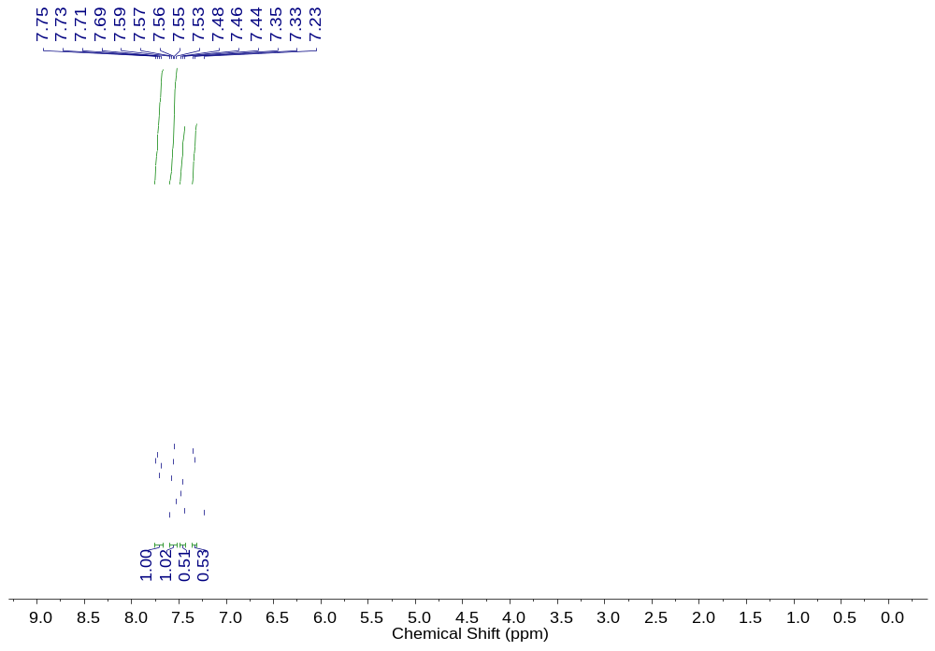
Figure S1. The ¹H NMR spectrum of 1 in in CDCl₃.
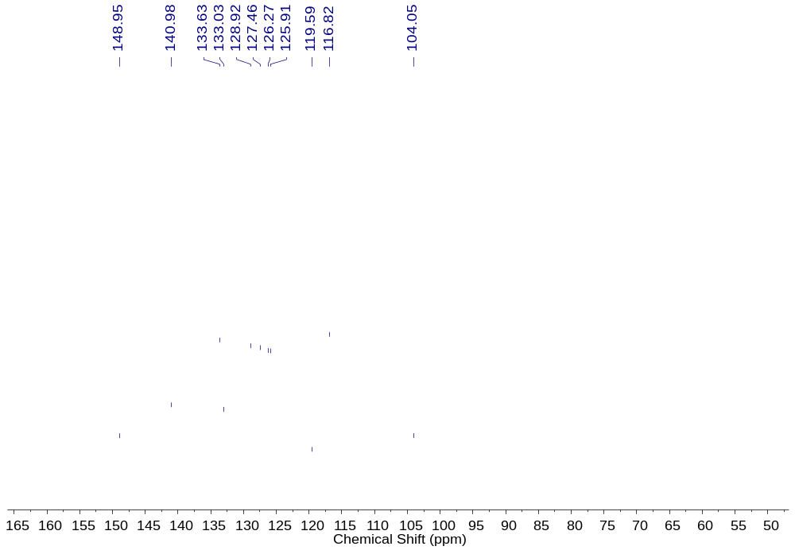
Figure S2. The ¹³C NMR spectrum of 1 in CDCl₃.
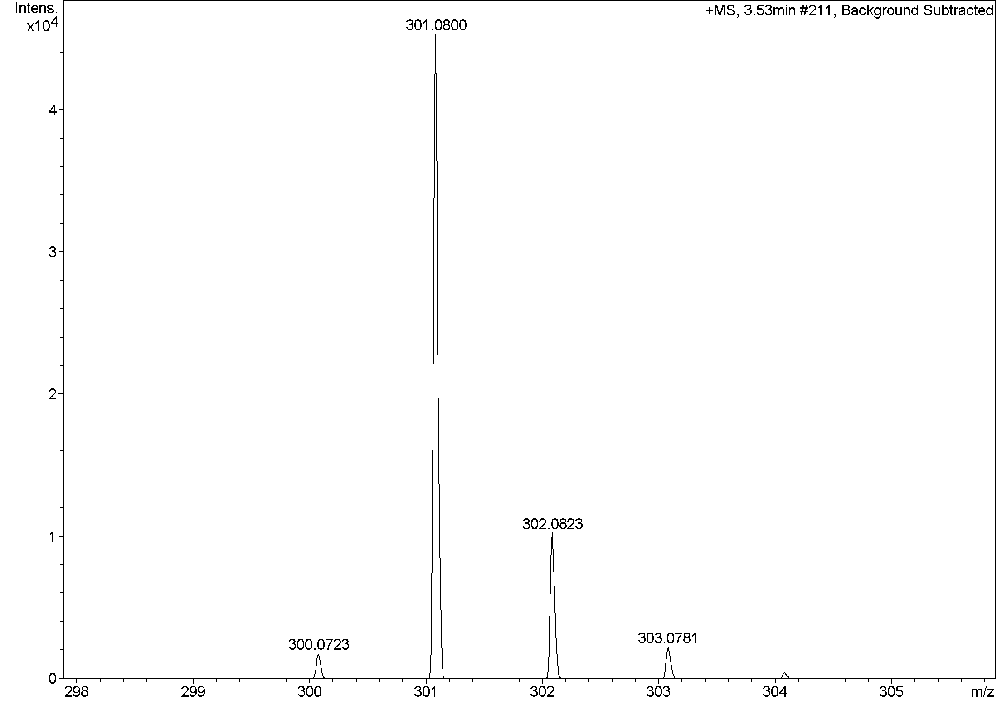
Figure S3. The HRMS spectrum of 1.
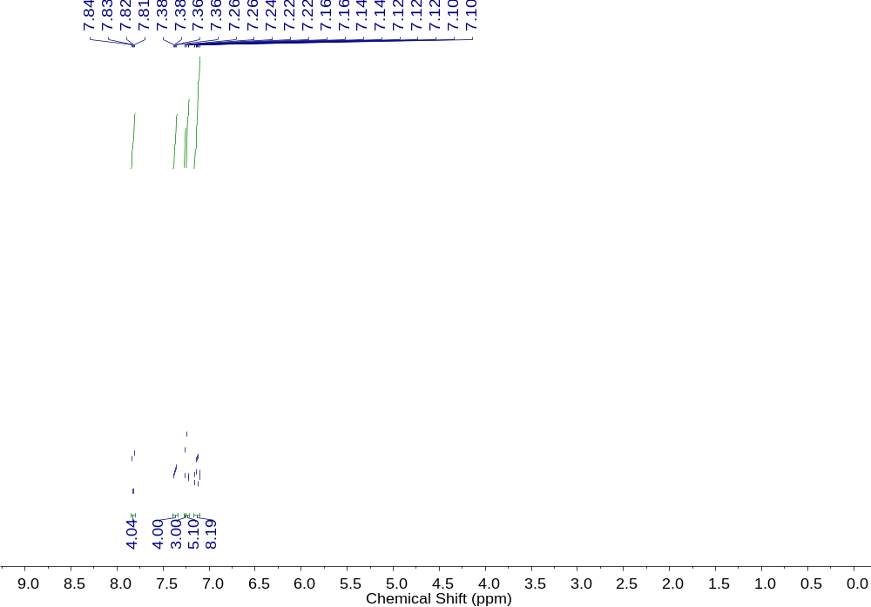
Figure S4. The ¹H NMR spectrum of 2 in CDCl₃.
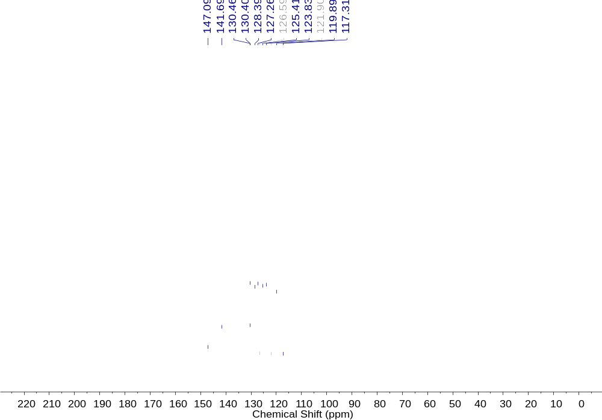
Figure S5. The ¹³C NMR spectrum of 2 in CDCl₃.
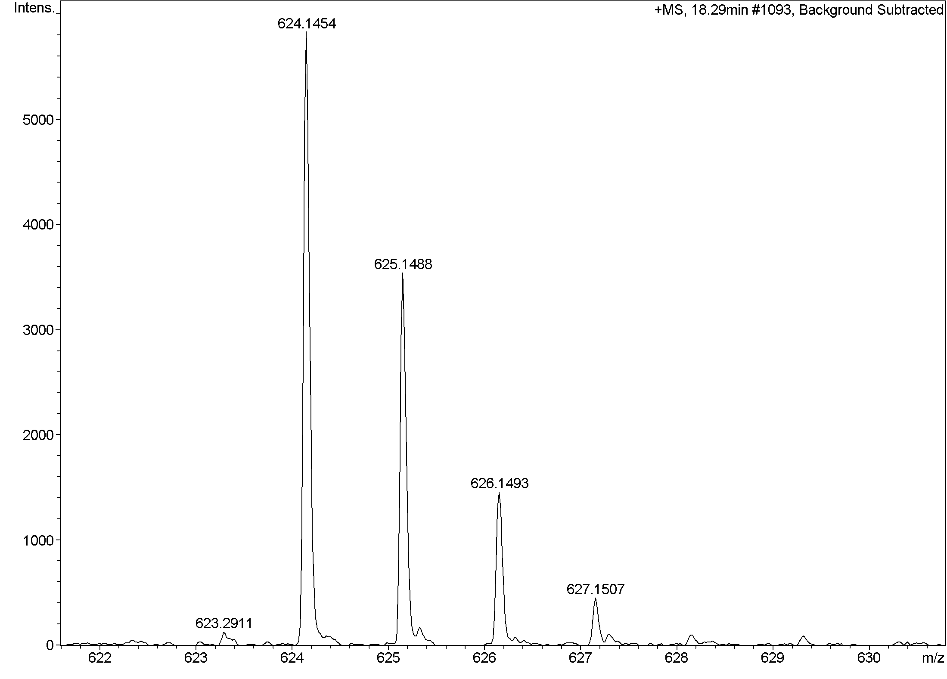
Figure S6. The HRMS spectrum of 2.
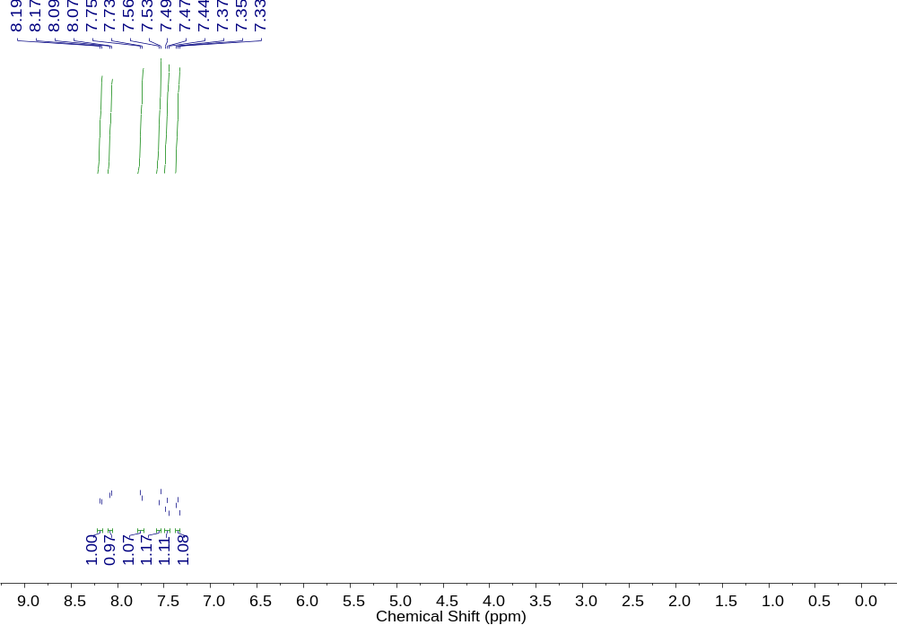
Figure S7. The ¹H NMR spectrum of 3 in CDCl₃.
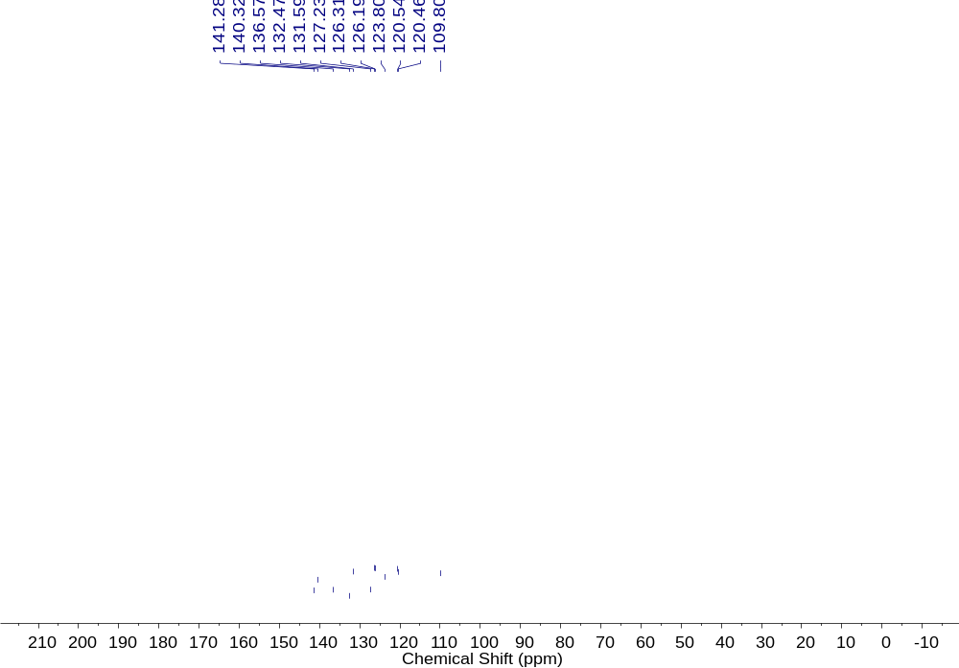
Figure S8. The ¹³C NMR spectrum of 3 in CDCl₃.
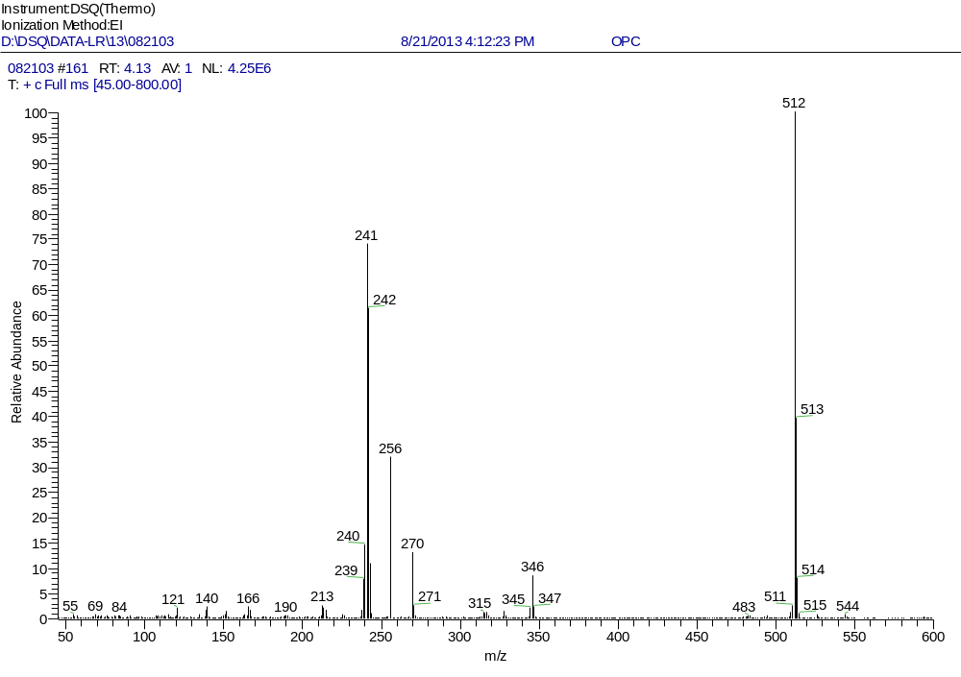
Figure S9. The EIMS spectrum of 3.
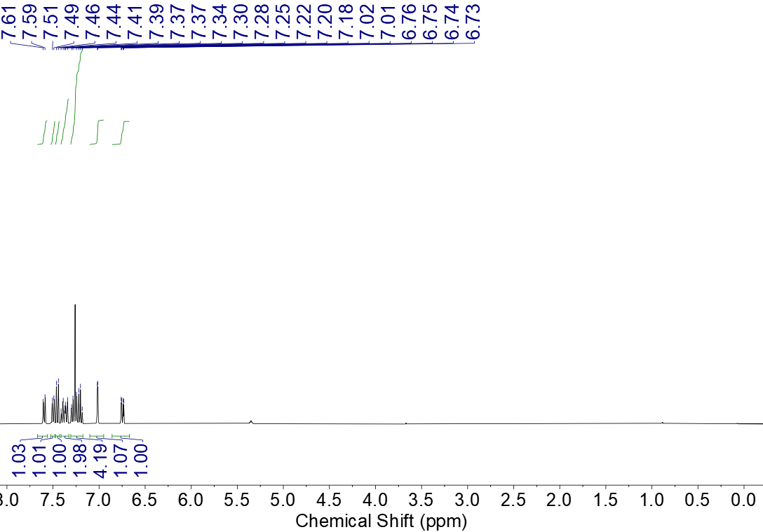
Figure S10. The ¹H NMR spectrum of 4 in CDCl₃.
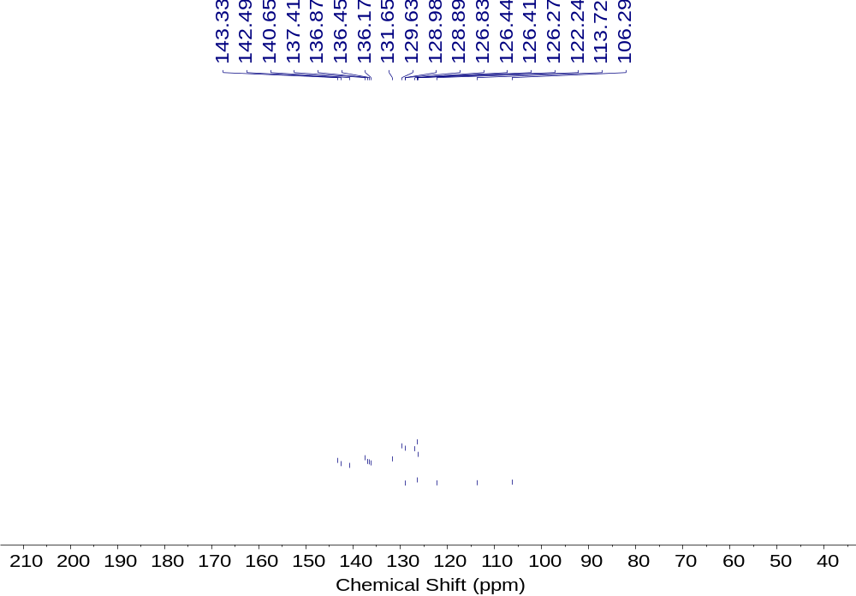
Figure S11. The ¹³C NMR spectrum of 4 in CDCl₃.
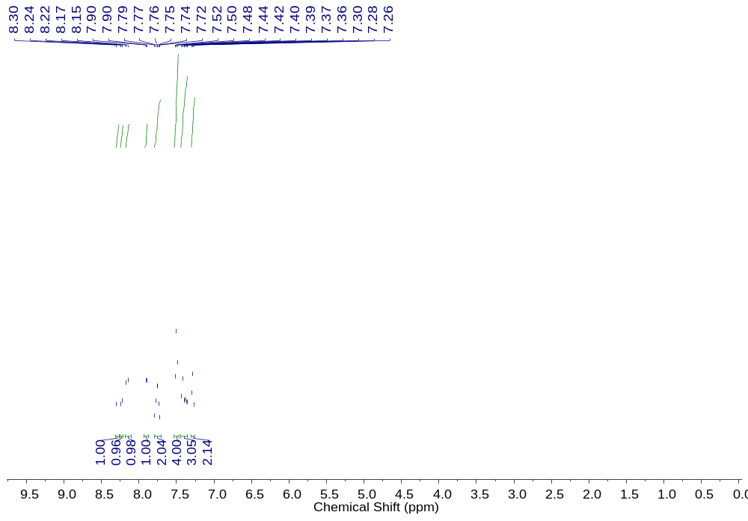
Figure S12. The ¹H NMR spectrum of 5 in CDCl₃.
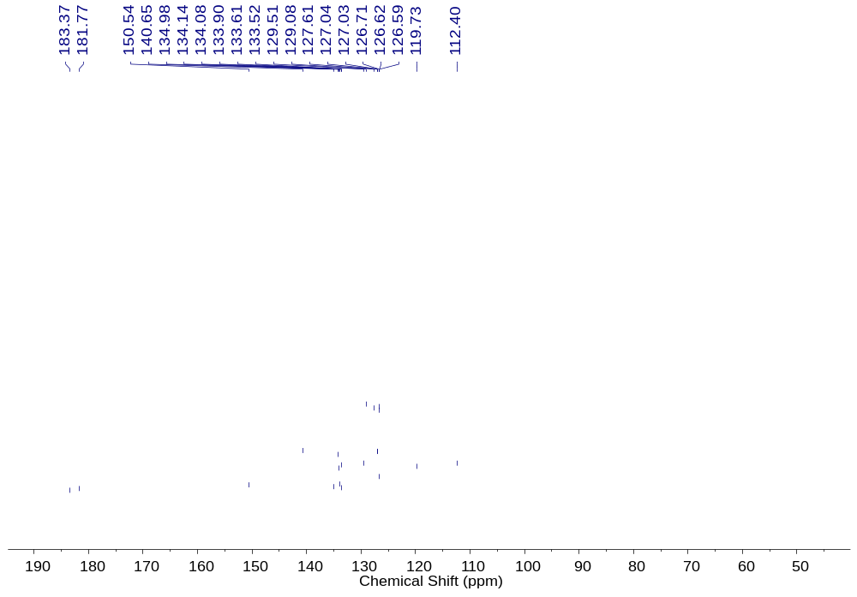
Figure S13. The ¹³C NMR spectrum of 5 in CDCl₃.
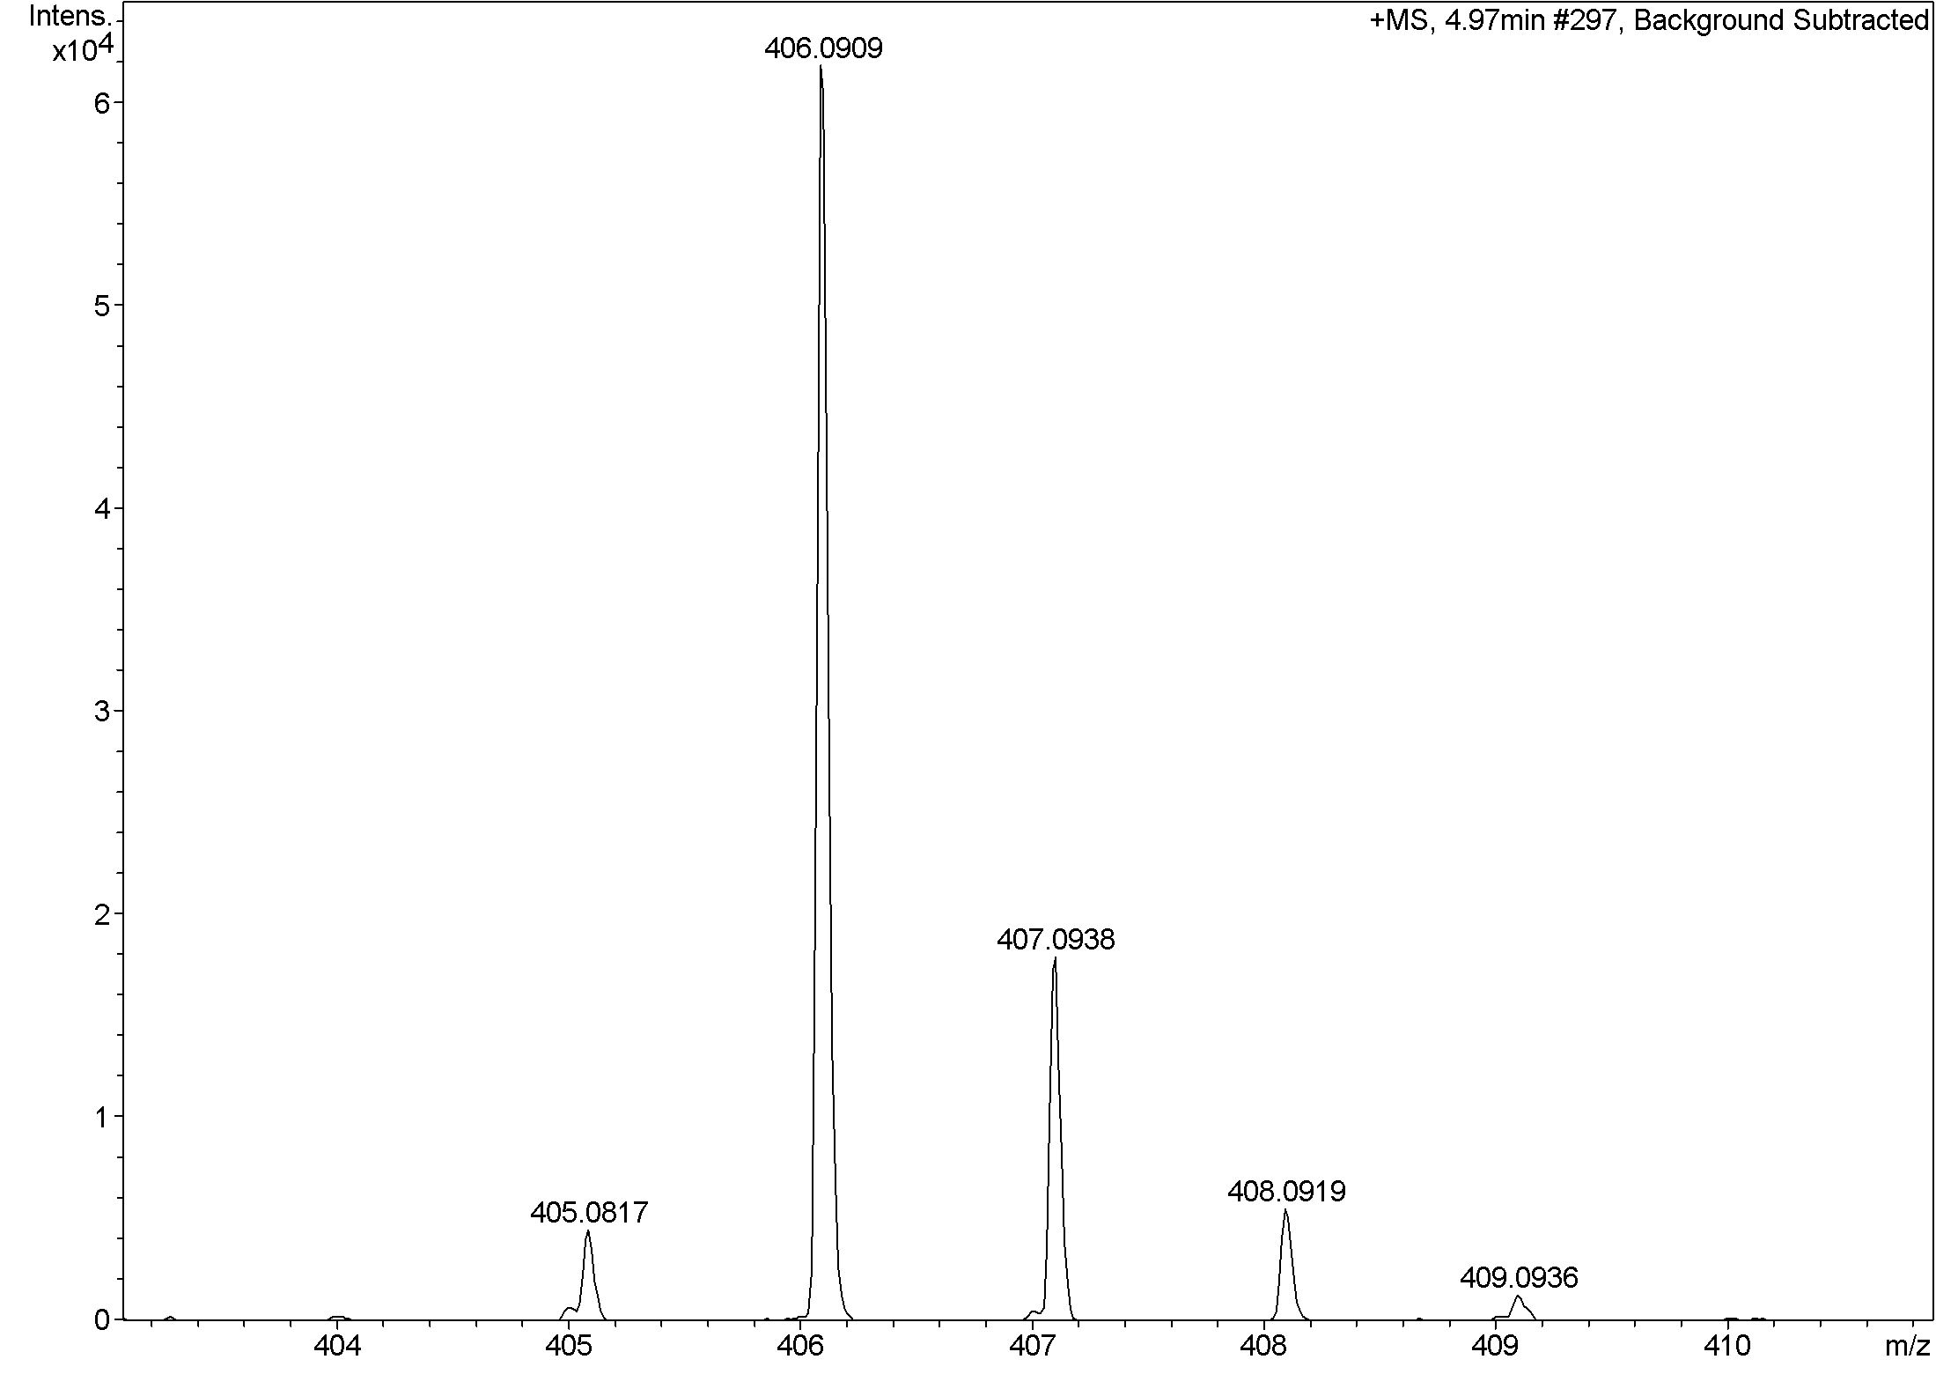
Figure S14. The HRMS spectrum of 5.
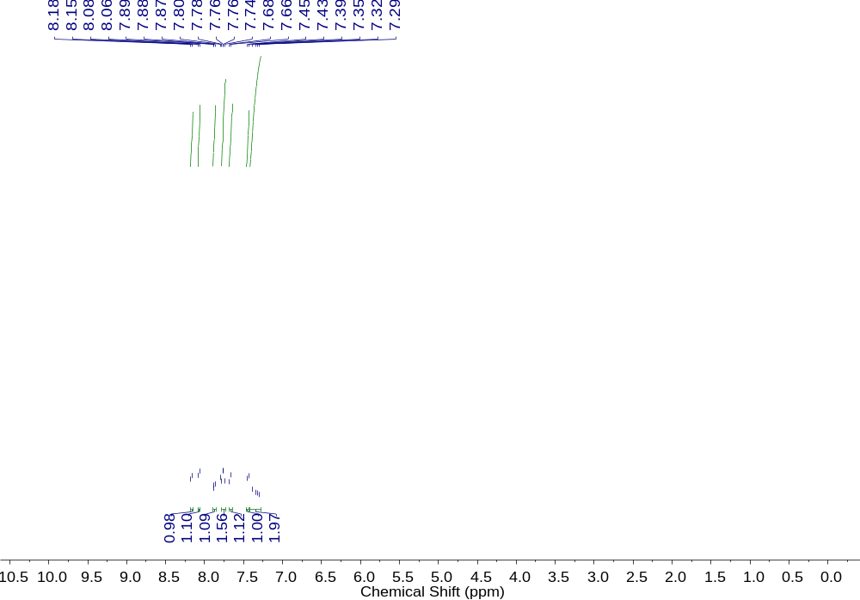
Figure S15. The ¹H NMR spectrum of 6 in CDCl₃.
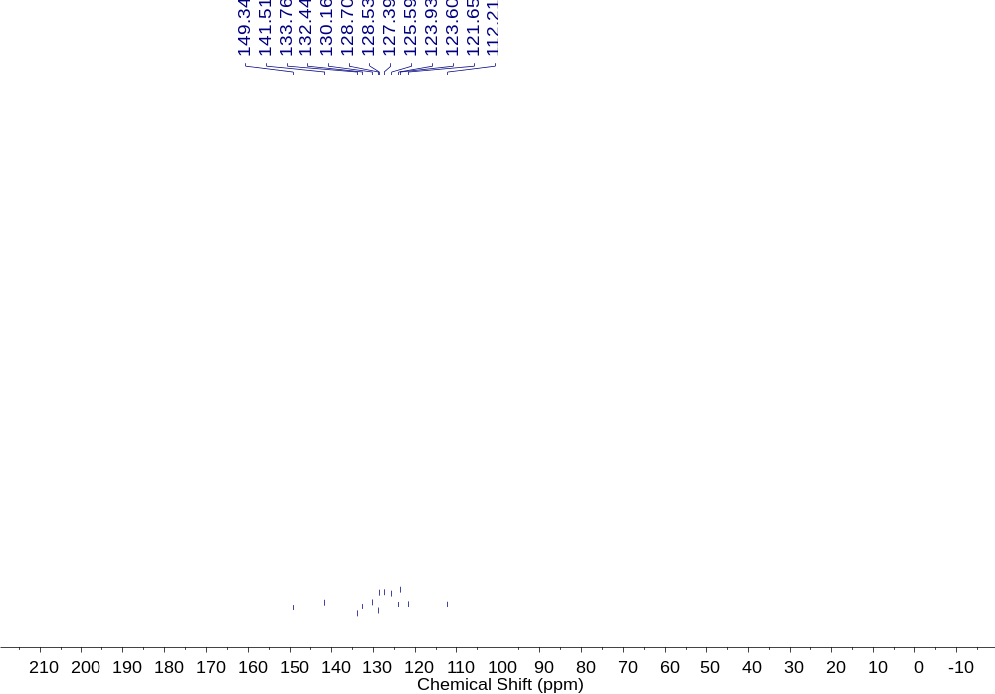
Figure S16. The ¹³C NMR spectrum of 6 in CDCl₃.
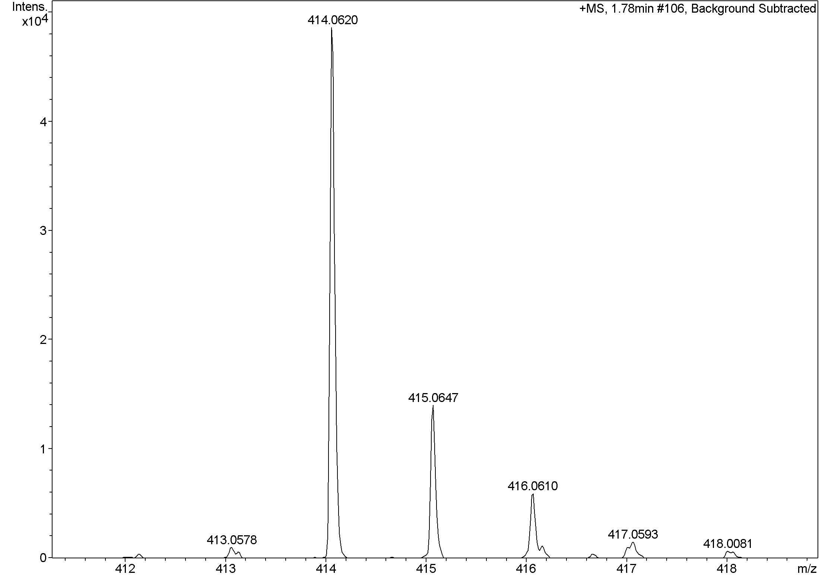
Figure S17. The HRMS spectrum of 6.
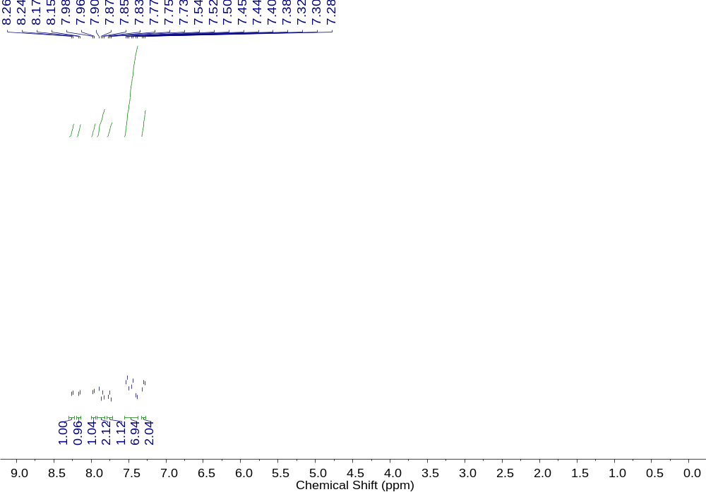
Figure S18. The ¹H NMR spectrum of 7 in CDCl₃.
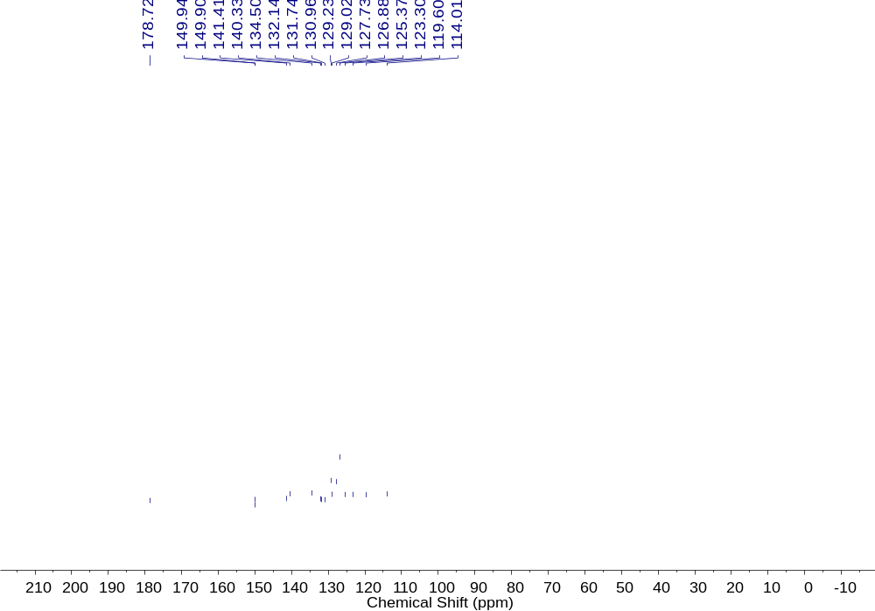
Figure S19. The ¹³C NMR spectrum of 7 in CDCl₃.
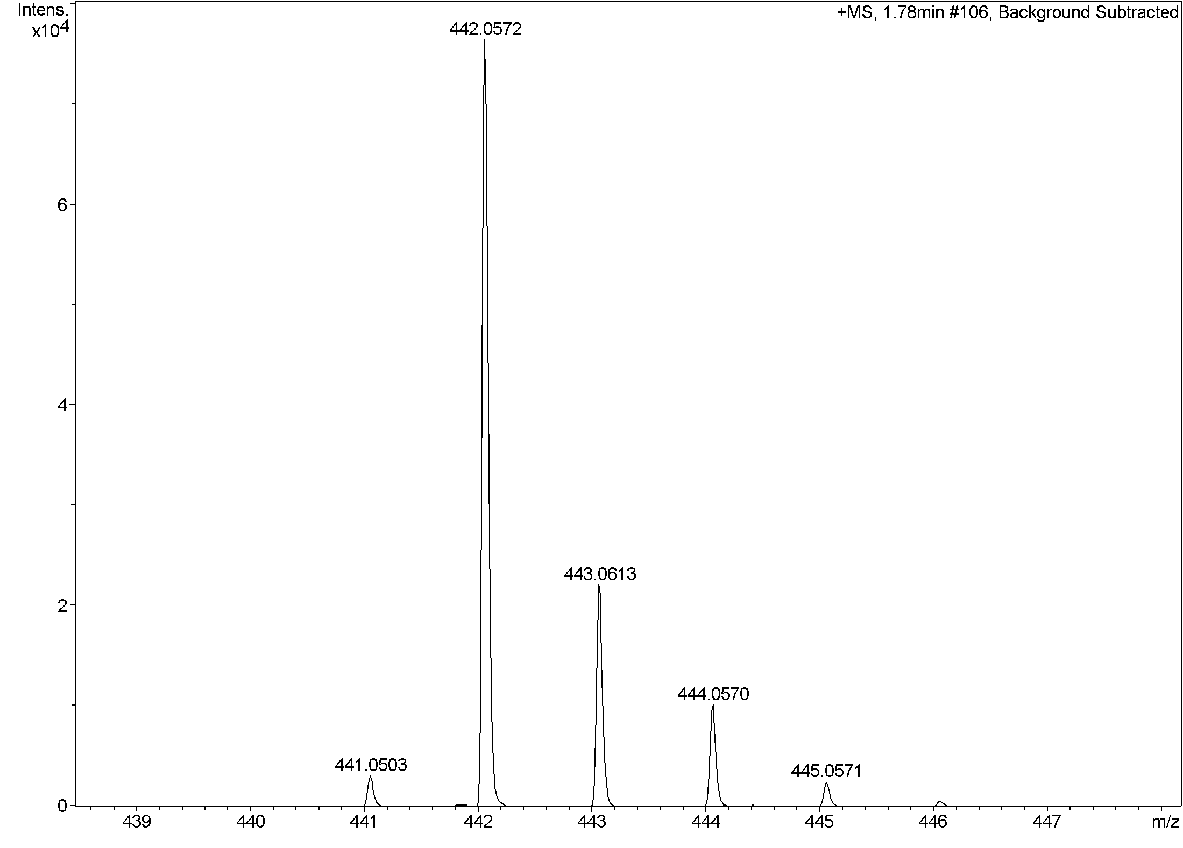
Figure S20. The HRMS spectrum of 7
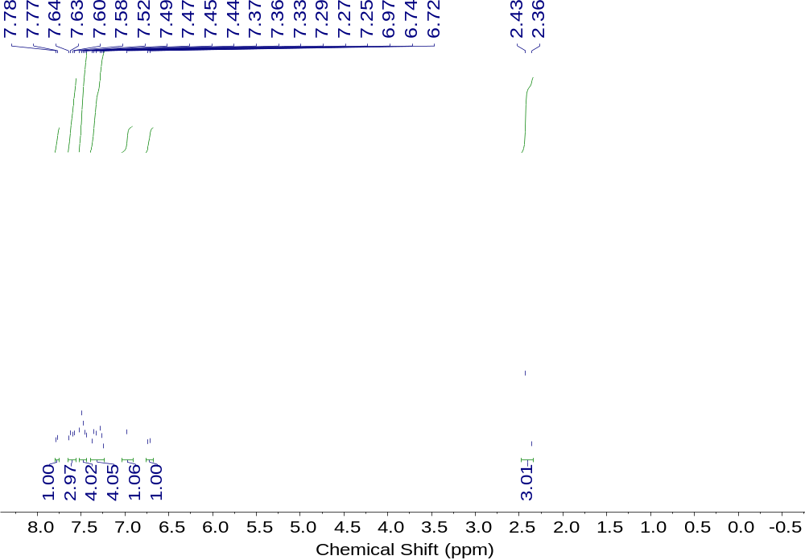
Figure S21. The ¹H NMR spectrum of 8 in CDCl₃.
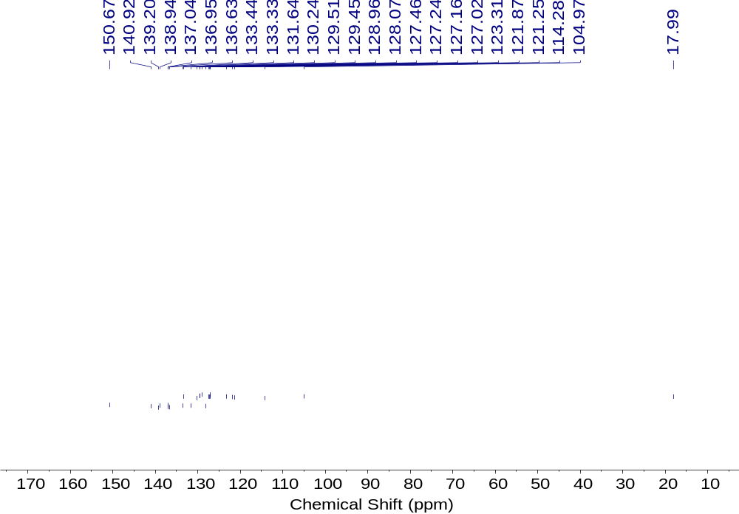
Figure S22. The ¹³C NMR spectrum of 8 in CDCl₃.
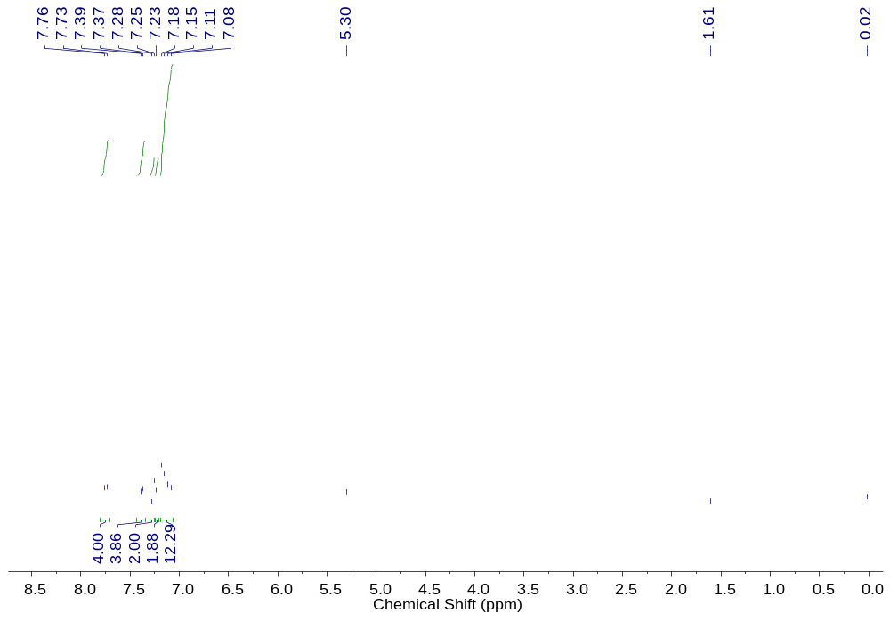
Figure S23. The ¹H NMR spectrum of 9 in CDCl₃.
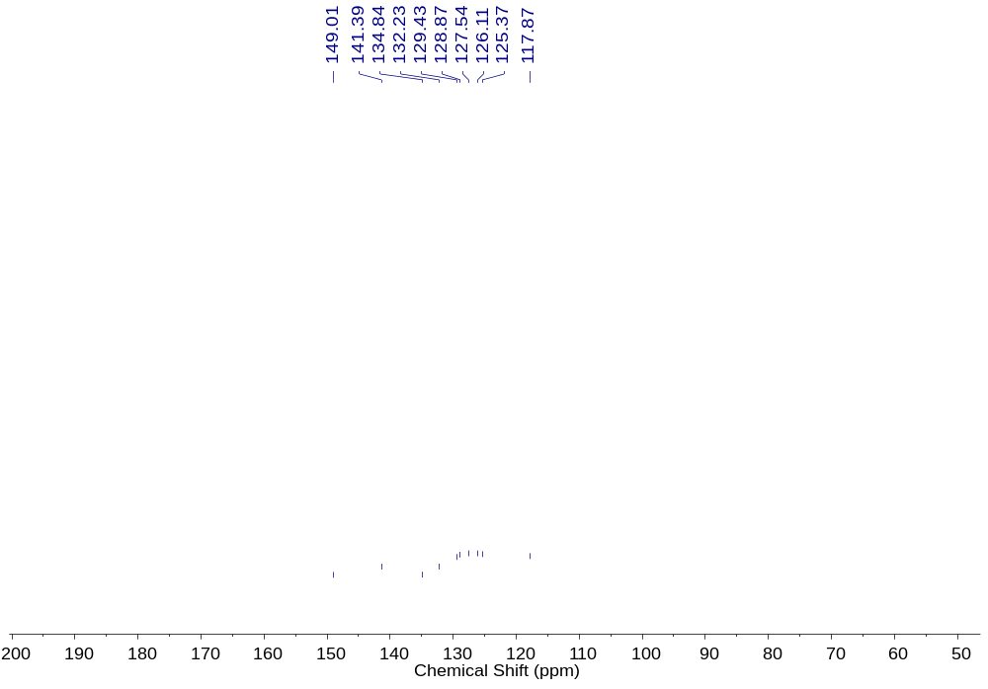
Figure S24. The ¹³C NMR spectrum of 9 in CDCl₃.
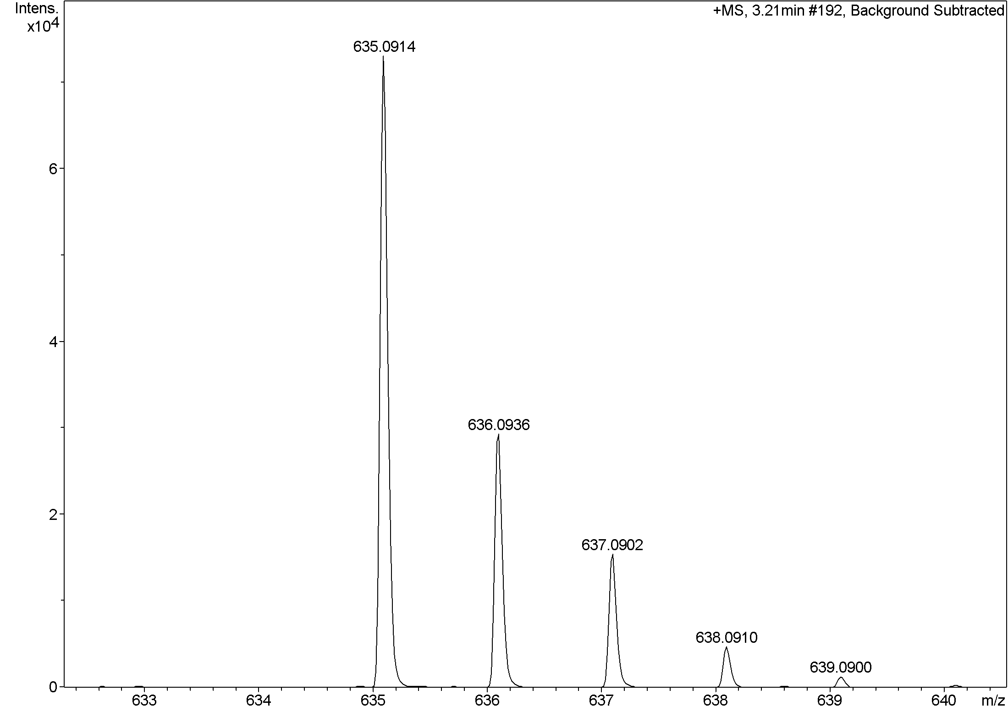
Figure S25. The HRMS spectrum of 9.
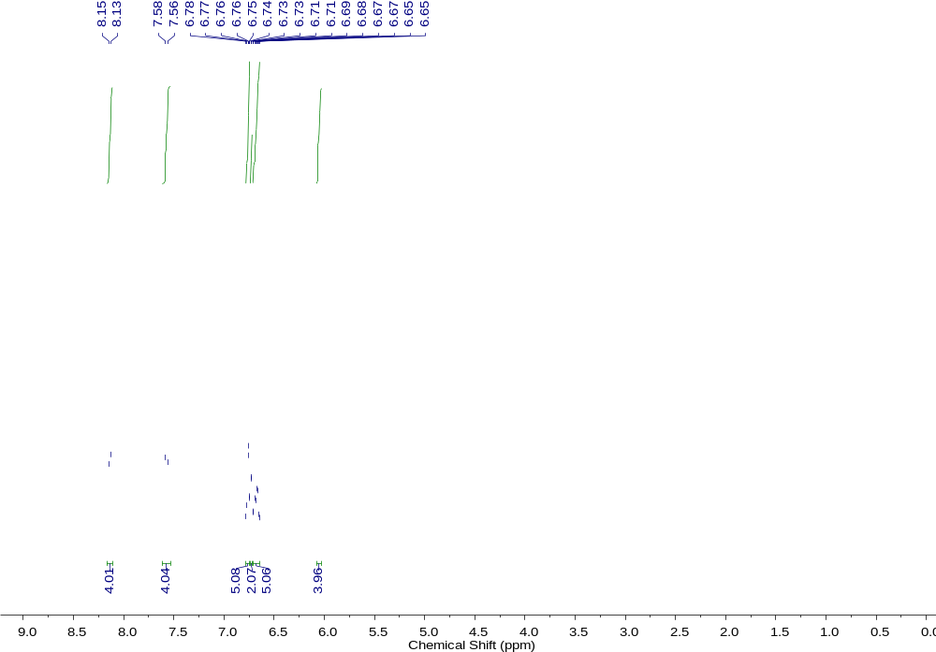
Figure S26. The ¹H NMR spectrum of 10 in CDCl₃.
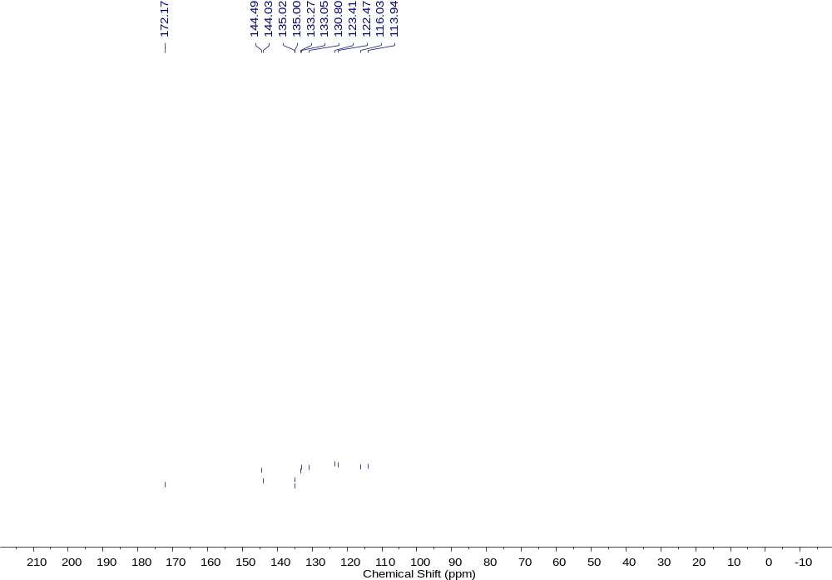
Figure S27. The ¹³C NMR spectrum of 10 in CDCl₃.
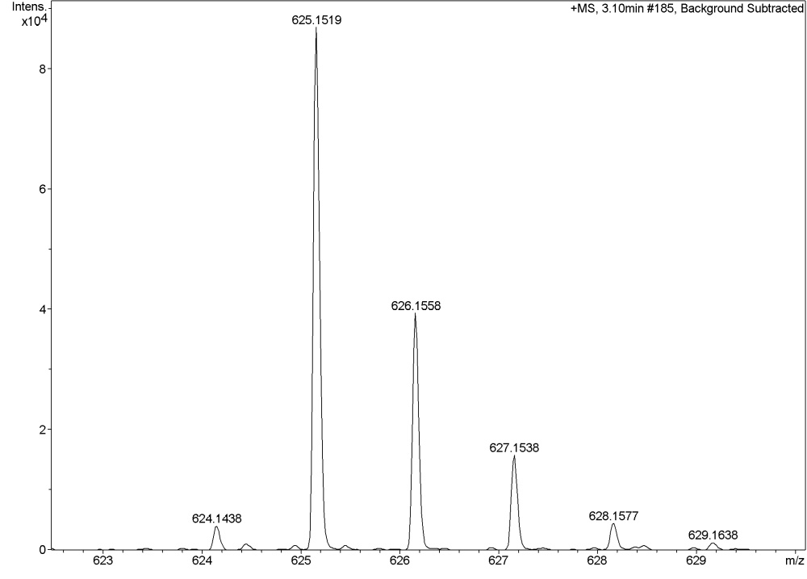
Figure S28. The HRMS spectrum of 10.
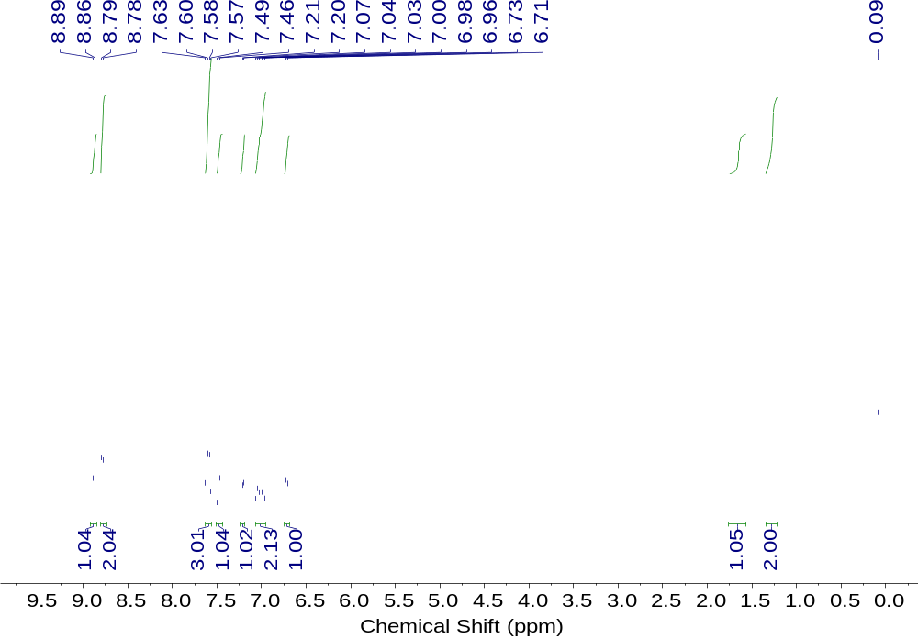
Figure S29. The ¹H NMR spectrum of 11 in CDCl₃.
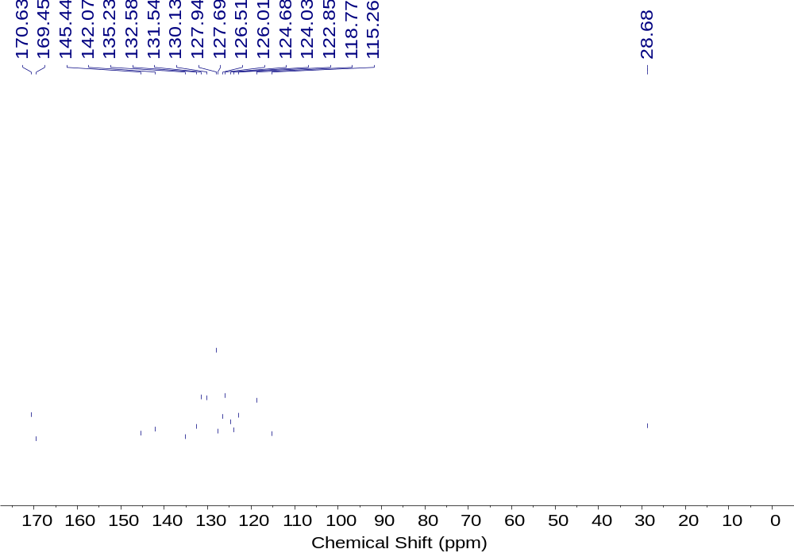
Figure S30. The ¹³C NMR spectrum of 11 in CDCl₃.
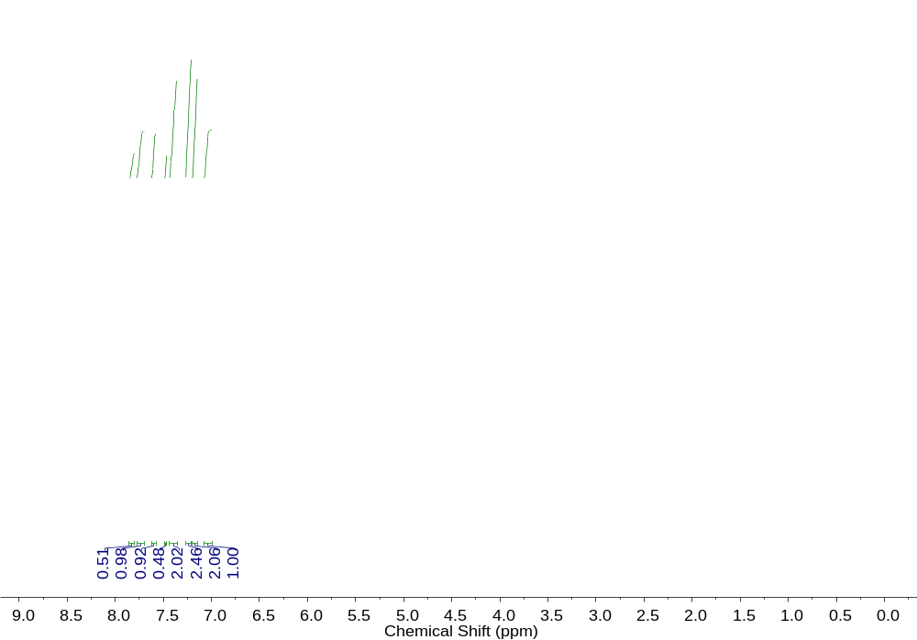
Figure S32. The HRMS spectrum of 12.
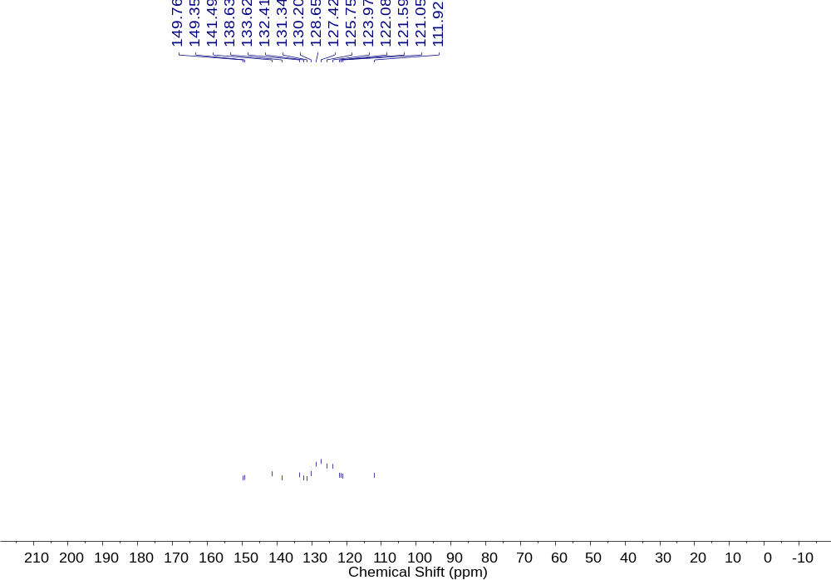
Figure S33. The ¹³C NMR spectrum of 12 in CDCl₃.
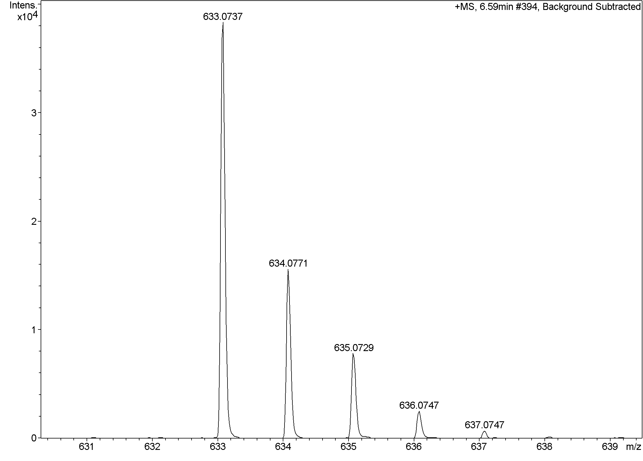
Figure S34. The HRMS spectrum of 12.
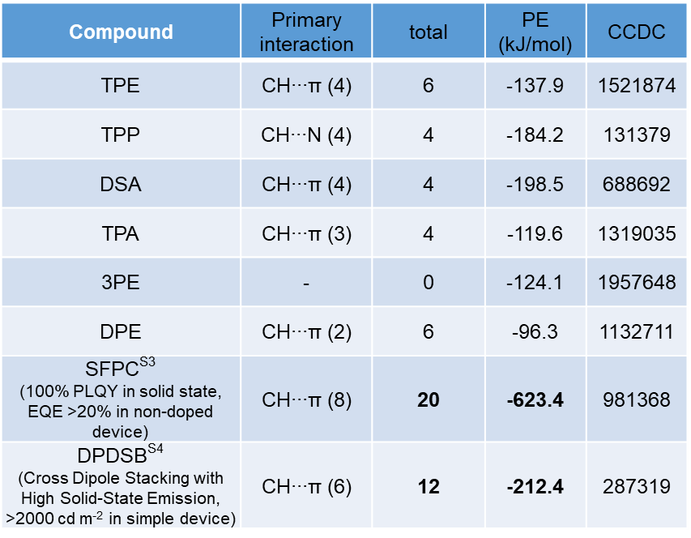
Table S1. Packing feature of twisted-pi (TPE, TPP, DSA, TPA, 3PE, DPE), SFPC and DPDSB: primary interaction in crytalline packing; total number of short contact (< sum of van-der-Waals radii) per molecule; PE, total packing energy.
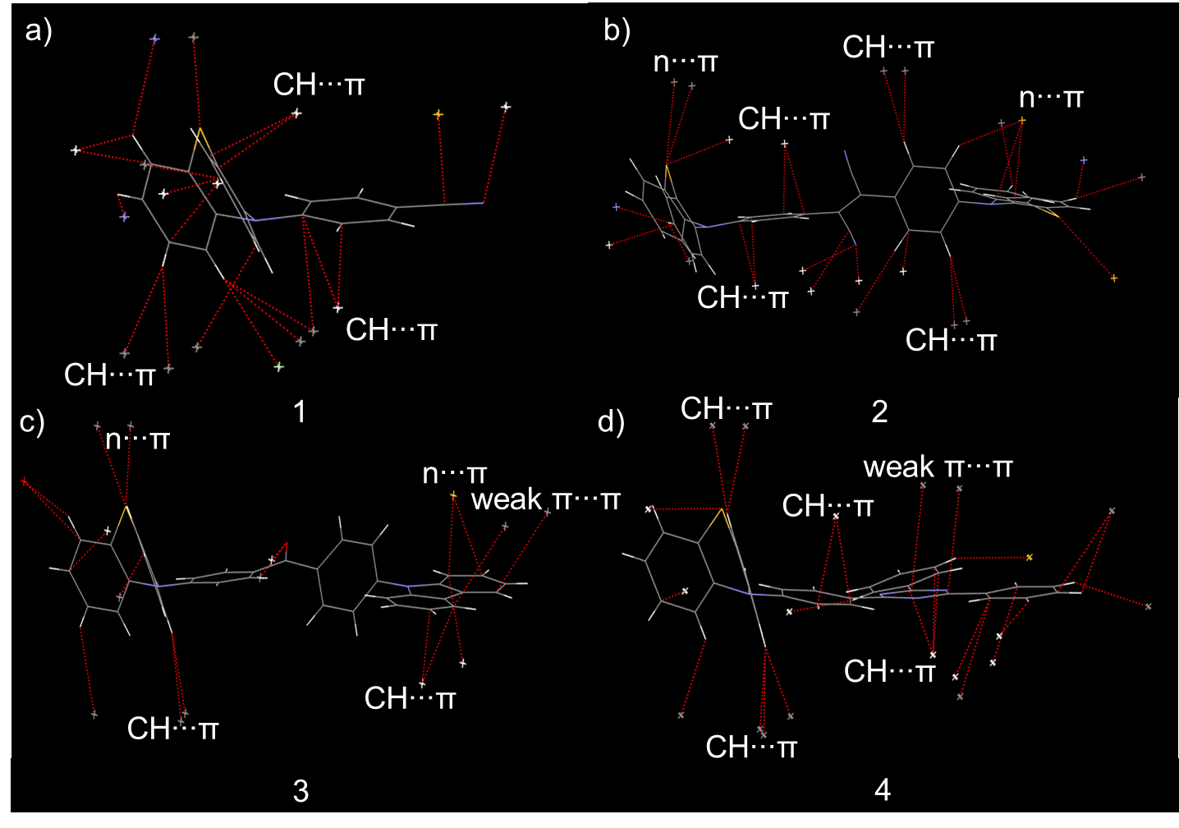
Figure S35. Wireframe structures and intermolecular short contacts (< sum of vdW radii, CCDC default definition, red dash line) and major intermolecular interactions of 1-4 (a-d) in the crystals.
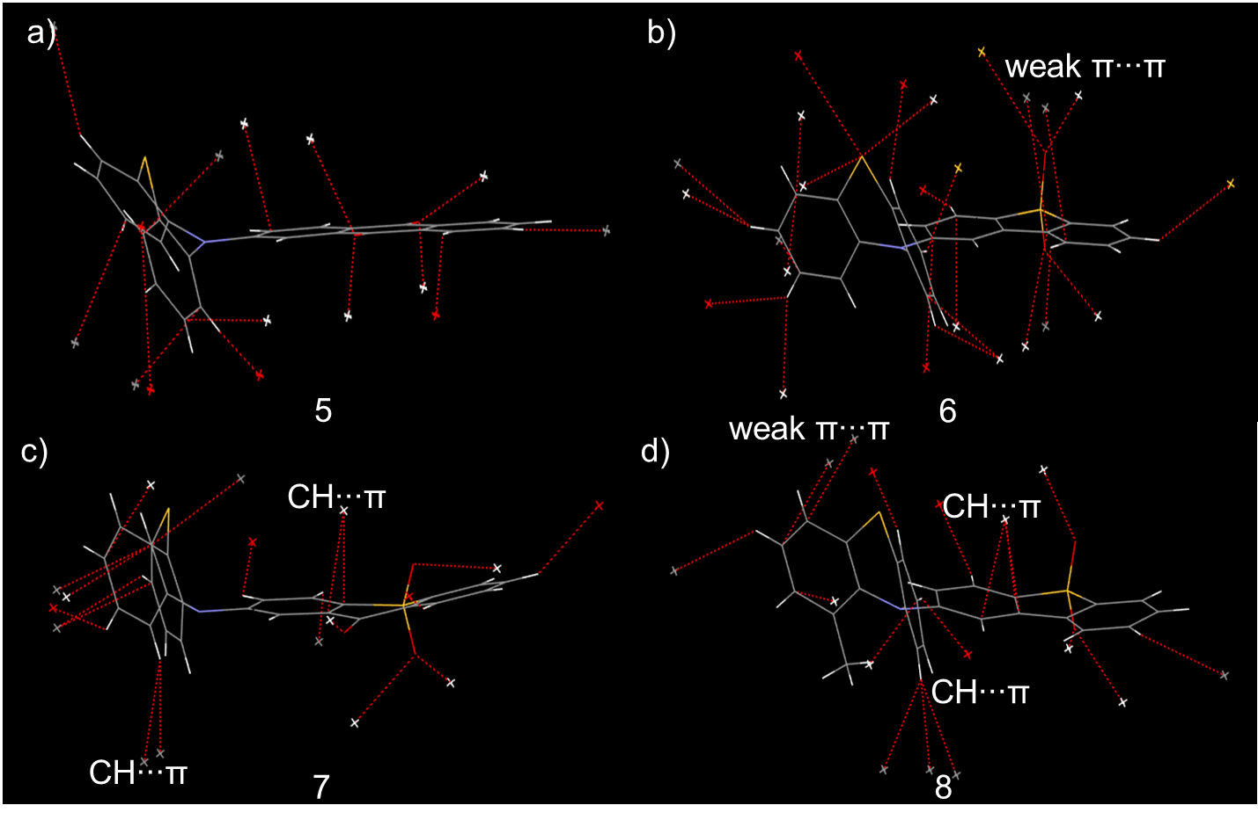
Figure S36. Wireframe structures and intermolecular short contacts (< sum of vdW radii, CCDC default definition, red dash line) and major intermolecular interactions of 5-8 (a-d) in the crystals.
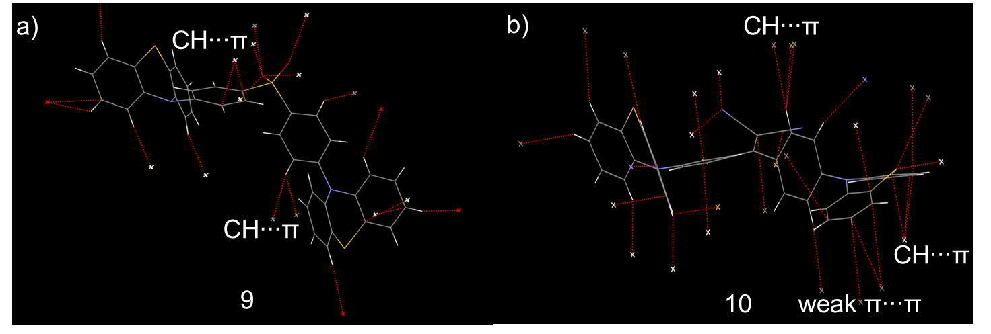
Figure S37. Wireframe structures and intermolecular short contacts (< sum of vdW radii, CCDC default definition, red dash line) and major intermolecular interactions of 9-10 (a-d) in the crystals.
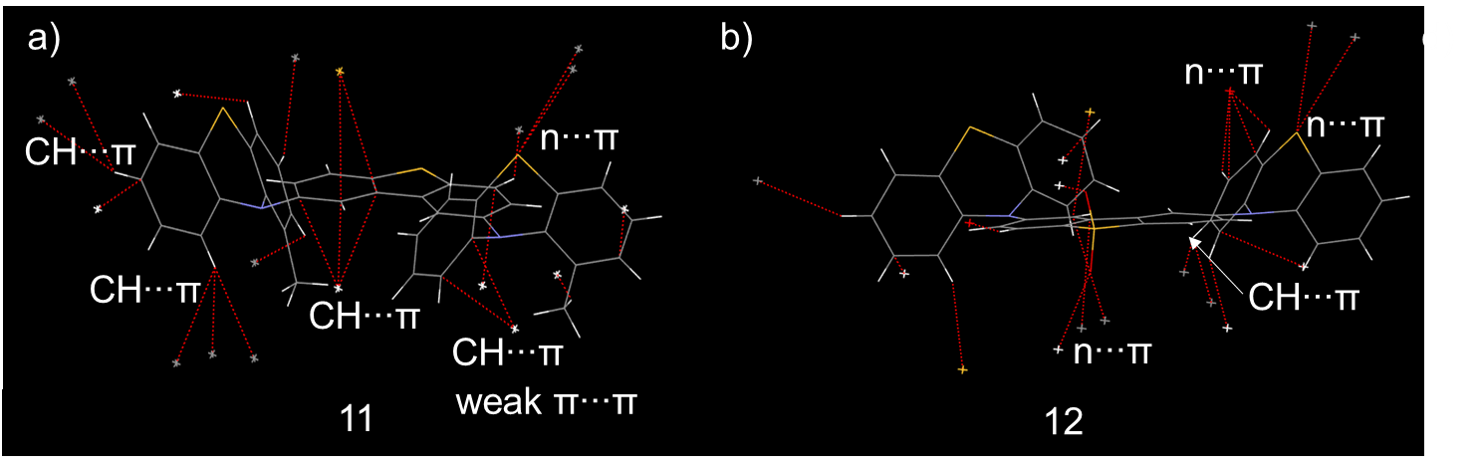
Figure S38. Wireframe structures and intermolecular short contacts (< sum of vdW radii, CCDC default definition, red dash line) and major intermolecular interactions of 11-12 (a-d) in the crystals.
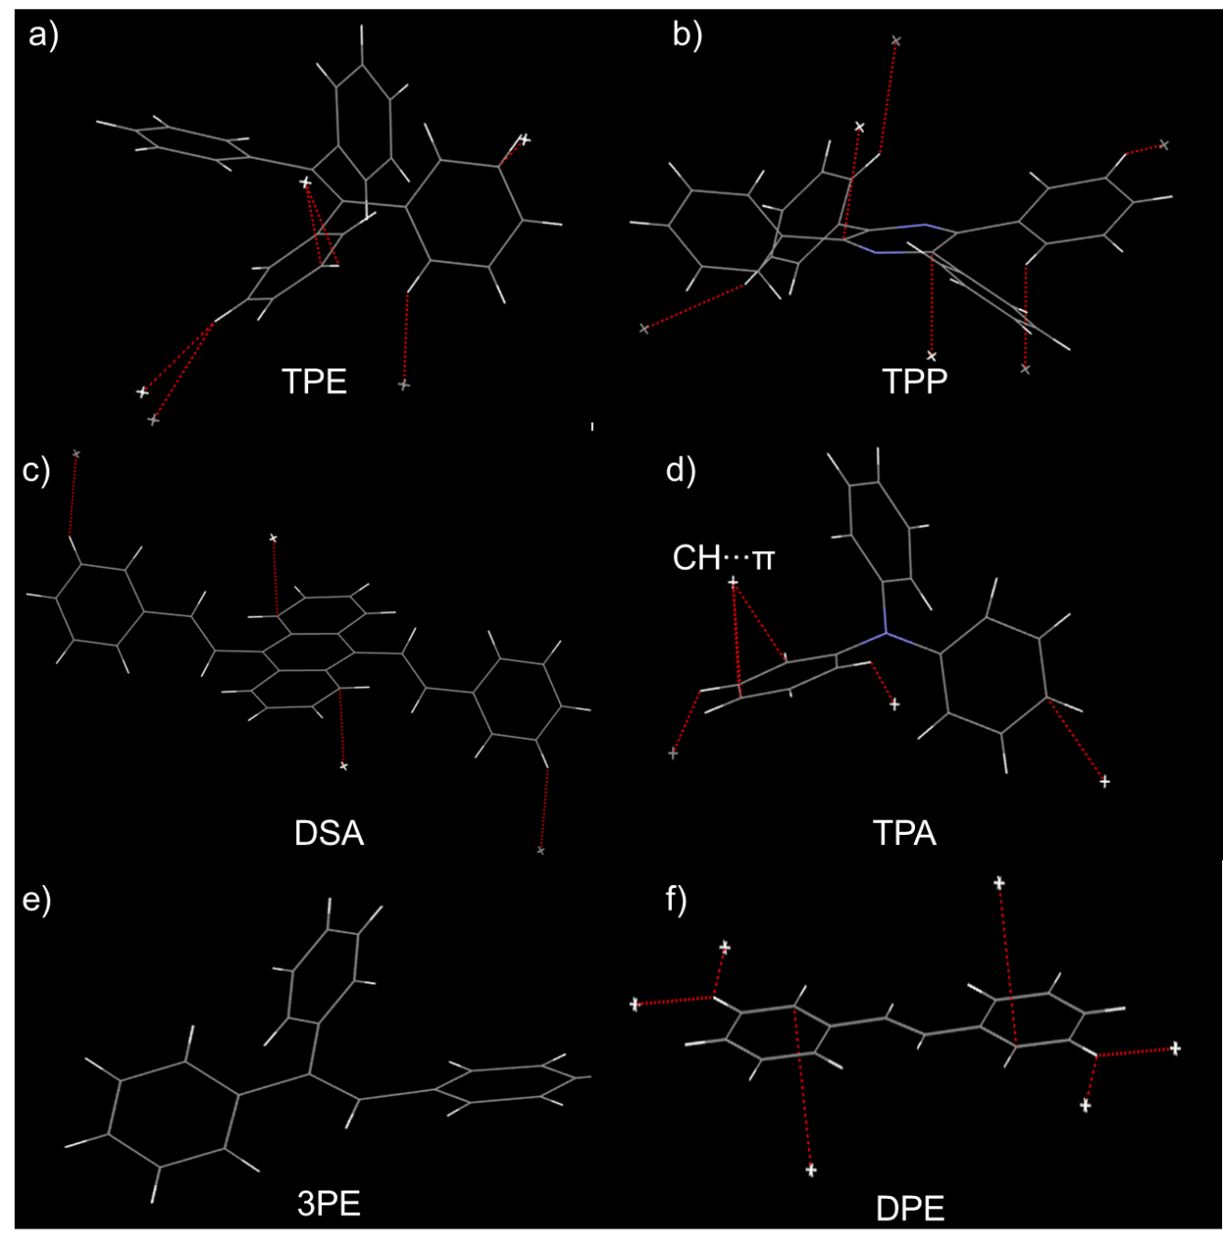
Figure S39 Wireframe structures and intermolecular short contacts (< sum of vdW radii, CCDC default definition, red dash line) and major intermolecular interactions of TPE (CCDC 1521874), TPP, DSA, TPA, 3PE and DPE (a-f) in the crystals.
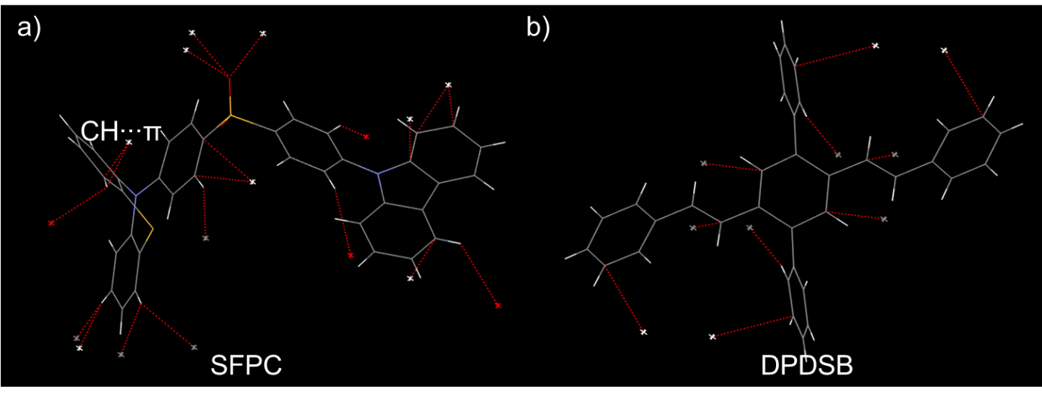
Figure S40. Wireframe structures and intermolecular short contacts (< sum of vdW radii, CCDC default definition, red dash line) and major intermolecular interactions of SFPC^{S3} and DPDSB^{S4} (a-b) in the crystals.
Table S2. Crystallographic data for single crystals 2, 3, 7 and 10.
Crystal | 2 | 3 | 7 | 10
Formula | C₄₀H₂₄N₄S₂ | C₃₇H₂₄N₂OS | C₂₅H₁₅NO₃S₂ | C₄₀H₂₄N₄S₂
Formula wt | 624.79 | 544.64 | 441.50 | 624.15
crystal system, | triclinic | monoclinic | monoclinic | monoclinic
T (K) | 101(2) | 101(2) | 100 (2) | 101(2)
space group | P-1 | P2(1)/c | P 1 2₁/n 1 | P 1 2₁/n 1
a/Å | 9.7622(2) | 9.43380(10) | 6.9277(4) | 8.0442(2)
b /Å | 20.0355(4) | 19.2193(2) | 27.1393(14) | 26.6541(7)
c/Å | 16.2251(4) | 15.1296(2) | 10.7792(6) | 14.6262(4)
α/ ˚ | 90 | 90.00 | 90 | 90
β/ ˚ | 99.8584(9) | 95.1050(10) | 99.043(2) | 99.7240(10)
γ/ ˚ | 90 | 90.00 | 90 | 90
V/Å³, Z | 3126.62(12), 1 | 2732.28(5), 4 | 2001.44(19), 4 | 3090.96(14), 4
F (000) | 1297 | 1136 | 912 | 1296
crystal size / mm³ | 0.31×0.17×0.10 | 0.40×0.40×0.20 | 0.32×0.29×0.14 | 0.24×0.19×0.15
Measured reflections | 30884 | 24893 | 38441 | 36662
Independent reflections | 16182 | 24893 | 5620 | 8643
Reflections with I>2σ(I) | 12197 | 3767 | 5021 | 6295
Parameters/restraints | 533 | 370 | 280 | 415
Goodness of fit | 1.816 | 1.048 | 1.221 | 1.040
R₁, wR₂, I>2σ(I) | 0.093, 0.251 | 0.040, 0.103 | 0.039, 0.109 | 0.091, 0.194
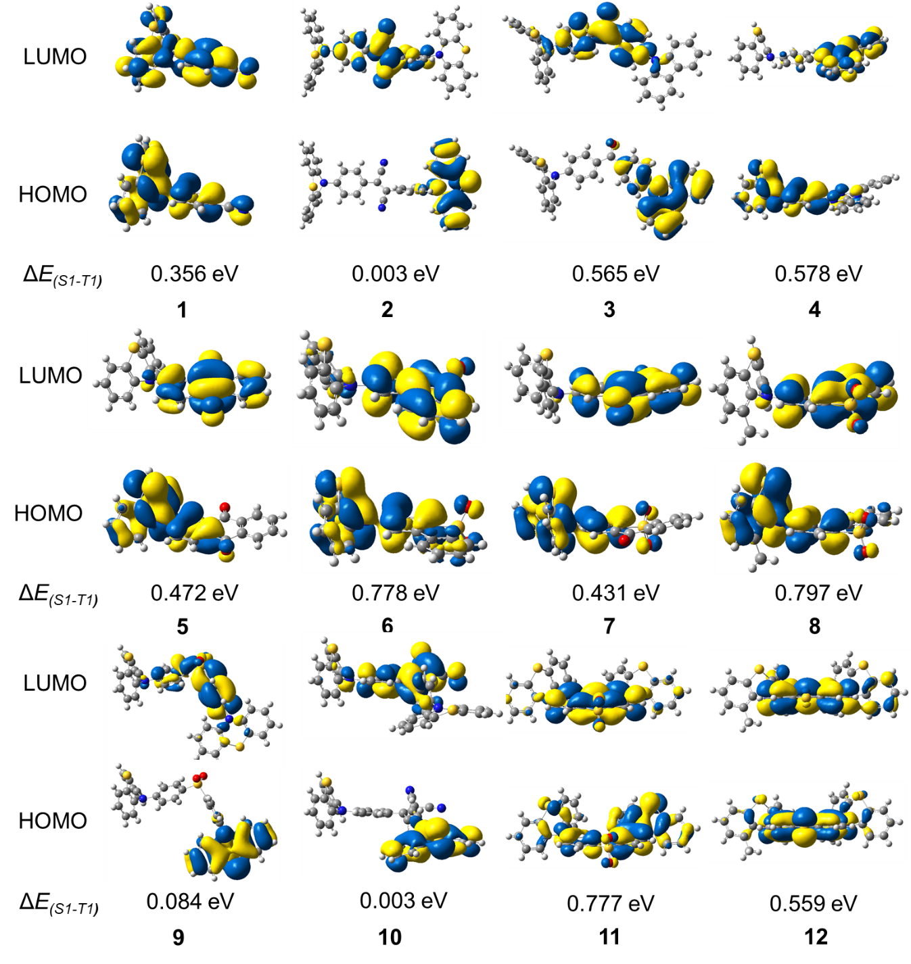
Figure S41. HOMO-LUMO distribution and ΔE_{ST} of 1-12, positive electron density in yellow, negative in blue (B3LYP/6-31G*). ^{S8}

Reference
S1. Gavezzotti, A., Acc. Chem. Res. 1994, 27, 309-314
S2. Gavezzotti, A., Filippini, G. J. Phys. Chem. 1994, 98, 4831-4837
S3. Yang, Z. et al. Chem. Sci. 2019, 10, 8129-8134
S4. Xie, Z. et al. J. Am. Chem. Soc. 2005, 127, 14152-14153
S5. Sheldrick, G. M. A short history of SHELX. Acta Crystallogr. Sect. A 2008, 64, 112-122.
S6. Sheldrick, G. M. Crystal structure refinement with SHELXL. Acta Crystallogr. Sect. C 2015, 71, 3-8.
S7 Dolomanov, O. V., Bourhis, L. J., Gildea, R. J., Howard, J. A. K., Puschmann, H. OLEX2: a complete structure solution, refinement and analysis program. J. Appl. Crystallogr. 2009, 42, 339-341.
S8. Frisch, M. J. et al. Gaussian 09 (Revision D.01), Gaussian Inc., Wallingford CT, 2009.

